Abdul Binrsheed, Craig Gardner, John St. John
Initial Project Plan- Software Engineering
2/8/2009

Problem Statement:
We are creating a system that will get the user to the exact position within a company phone tree that they would like to go, without having to navigate it themselves. The user may select a destination like a bank account balance, or one of many different departments within a company. The phone tree will be displayed in a graphical format so that the user can quickly see and determine the location they would like to be navigated to. Ideally this format will be both concise and informative, allowing for a quick decision. We plan on implementing this as an Android application that interfaces with fonolo, a free system that will take care of the navigation and keep the phone trees up to date for us.

Product Description:
Our project will be based on a currently available technology. fonolo is software program that allows for a user to search for a company, navigate the company’s phone tree and pick a destination in that phone tree. fonolo is in a beta state at this time but we feel confident in our decision to use this technology as we intend to make our code interchangeable with other technologies. We intend implement the get human database if time permits. Our product will provide; a login window to the fonolo server, a search function of the fonolo database of companies, a detailed display of company phone trees, and feedback for phone calls in progress.
Requirements:

Functional-
- Log into fonolo (fonolo sends receipt tokens to verify).
- Get phone call from fonolo after successfully choosing a phone number and desired location in phone tree.
- Send JSON (JavaScript Object Notation) formatted strings to fonolo's servers (fonolo sends receipt tokens to verify).
- Receive JSON formatted strings from fonolo's servers.
- Parse JSON strings.
- Display parsed strings of options visually the same as displayed on the fonolo website.
- Search fonolo company database and display a list of searched companies.
- Bookmark frequently used company/option
- Select a company and zoom into its subsequent phone tree locations
- Store user information (including favorites and call history)

Non-functional-
- Use Android
- Use fonolo API
- Use Java
- Have the option to add a company to your favorites list by clicking on a button displayed along side a company name, and have the ability to view, and remove companies from the list.
- Use Android’s sqlite3 database for storage.
- Given a 5-minute tutorial on how to use an android phone (without showing our application), a cell phone savvy user who has never seen our application will be able to request a call to a company and department we specify within 5 minutes 95% of the time.
- List all companies available on the Fonolo database.
- Given the shortest unambiguous character sequence for a company name that exists in the fonolo database, a user will be able to place a text request for that company and it will be retrieved and displayed from fonolo.
- Given a phone number of a company that exists in the fonolo database, a user will be able to place a text request for that company and it will be retrieved and displayed from fonolo.

Architecture:
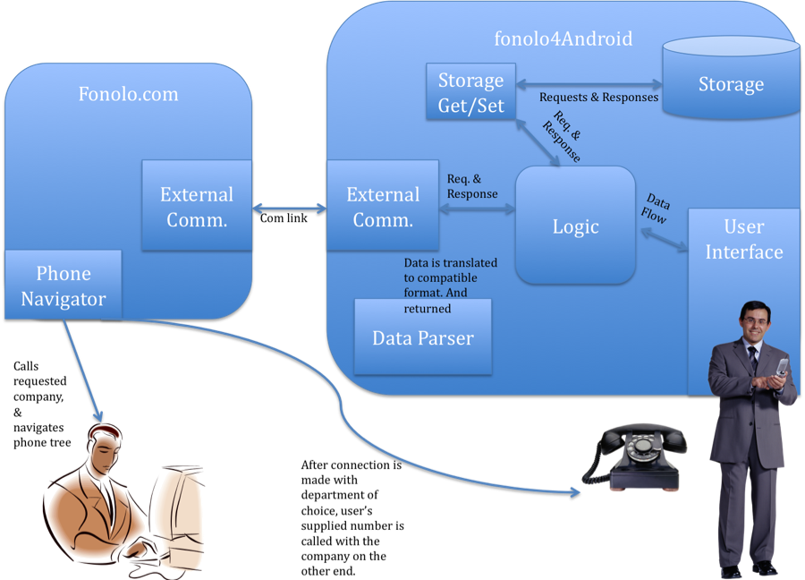

Design Description:
The product that we intend to build is an application for the Android OS, which allows the user to have the ability to view the fonolo database, and submit call requests to fonolo as well. Fonolo has a full map of the company’s phone trees that helps the user to place a call, and get directly to any location within the companies phone menu tree.
One major part of the project is to access the fonolo database. To do this we have authorize the fonolo’s user information with the fonolo server, and submit the API’s connection commands.
Another major part is to be able to have external communication with the fonolo servers, which works as a bridge between fonolo’s information and functionality, and our application. This will be done by using JSON (JavaScript Object Notation) because it is the data passing language understood, and issued by the fonolo servers.
Also, a response analyzer is a major part that is going to analyze the JSON responses from the fonolo server, and pull out relevant information based on what method was queried, and what the expected output from that query will be.
The last major part is the user interface. The user interface will contain a total of five layouts. These layouts will each act as a template to display a certain category of dynamically generated data. The five layouts are the login page, the home screen, the company name list, the company information list and the placing call page.

Logic (from diagram):
The login screen will be the first display the user interacts with. Before going on to any of the other functionality of the system, due to the fact that a correct fonolo user-name and password is required to access their services, we require that the user enters a correct user-name and password. If the information entered by the user on this page is accepted by the fonolo server, then the user is directed to the home screen. Otherwise a message appears on the screen notifying the user that they must enter valid fonolo credentials, and they are left at the login screen to re-enter their information and try again. This screen will also display a link to sign up for fonolo services if they aren’t already members. The link will take the user outside of our program and to the Android phone’s default browser to complete this process.
The home screen is the location the user will be able to access the main functionality of the program. The user may initiate a company search, initiate a request to simply begin listing companies in the fonolo database, choose to view their favorite companies that they have previously told the program to store (this is an option available on the company information page), click on a link that provides help, or log out of the system and return to the log-in page. This page also acts as the default home-screen that the user is returned to when they select to go home from any of the other screens that are displayed after the login screen.
The company list is the screen that will dynamically display the list of company names resulting from a company search, company list, or favorites list. This screen will allow the user to highlight a company name they are interested in, and then click the submit button to proceed on to the company information page for that specific company. The company list page will also provide the user with the ability to select a next page option if there are more than 10 results to a query or company list. They will also have the option to go back to the home screen.
The company information page lists the “popular directories” (provided by fonolo based on usage data) as well as the option to view all of the directories. The main functionality provided on this page is the ability to select a directory listing and then hit the call button. There is also a back button for the user to return to the company list page. Additionally next to the company name will be the “Add to Favorites” button which will allow the user to add that company to their favorites list for easy access at a later date. When a call request is placed with fonolo, the user is directed to the wait for call page.
The “wait for call” page acts mostly to let the user know that their request has been placed with fonolo. This page will also allow the user to check on the status of their call, and it will even allow them to cancel their call if they decide that the process is taking too long, or if something else comes up.

Storage (from diagram):
The sql database currently only requires one table which stores company id strings and company names. The company id allows for the precise query of the fonolo server for the company’s phone tree information, and the company name field will provide a quick way of populating the company list page when the user selects “Favorites” on the home screen.

External Communication (from diagram):
The methods that act behind the scenes to populate the five pages described previously, and handle the requests the user places on those pages will be broken into 4 main parts. There will be a main logic portion that handles the overall flow of information in the program, including populating the user interface pages with dynamic data. There will be an external communication portion that handles sending and receiving requests from the fonolo servers. There will be a data-parser that will handle extracting the relevant information from the JSON strings returned by fonolo’s servers. And finally there will be a database communication class that handles getting and setting fields in the program’s sql database.

Project Management:

Summary:
We will utilize Google Code to help with our project management and milestone completion. We will store our code on Google Code and utilize SVN to concurrently access and edit our portion of the code.

Management Plan
John St John is the Project Manager. Craig Gardner is the documentation manager. Abdul Binrasheed is the IO standards manager. John and Abdul will be lead coders for java. John will translate the fonolo API to java. Abdul will write the communication class. Craig will be the lead XML coder and UI designer. The decision making process will be as follows: All team members will discuss the problems at hand and ultimately John will decide how best to proceed. The team will check progress by regularly holding meetings, comparing the project against the build plan, and making sure our milestones are met. Our meetings will be physical meetings and we will communicate verbally. We have decided against online meetings because we want to be able to see each other’s code and provide input.

Milestones/Deliverables | Assigned to | Date due | Completed
Communication class must return JSON Objects | Abdul | 1/26/2009 | V1
Communication class has every method in fonolo API | Abdul | 1/26/2009 | V1
fonolo library class successfully submits request string and gets response string from fonolo.com | John | 1/25/2009 | V1
Login UI with success/failure response message | Craig | 1/26/2009 | V1
Custom icon for our program shows up on application menu | Craig | 1/24/2009 | V1
if login successful go to home screen | Abdul | 1/27/2009 | V1
program home screen with search box, favorite list link, help button, list all companies, and logout button | Craig | 1/27/2009 | V1
Make company list page | Craig | 2/1/2009 | V1
Populate company list page with results from search generated at home screen | Abdul/John | 2/3/2009 | V1
Make company information page | Craig | 2/3/2009 | V1
Populate company information page with results from company information query to fonolo generated based on user click in company list page. | Abdul/John | 2/4/2009 | V1
Create Node class to store company information for display on the company information page | Abdul/John | 2/4/2009 | V1
Make “call being placed” page | Craig | 2/4/2009 | V1
Generate a call request based on information provided from the company information send request page | Abdul/John | 2/5/2009 | V1
Add help buttons to the home screen and menu | Craig | 2/5/2009 | V1
Add help page that displays relevant information | Craig | 2/6/2009 | V1
Write up user documentation to be displayed in help page | Abdul | 2/6/2009 | V1
Add a dynamic pop-up window for help page | Craig | 2/8/2009 | V1
Add a dynamic pop-up window for message page | Craig/john | 2/8/2009 | V1
Write the SQL get-set class | John
Add company to favorites button to the company information page and have it submit a set call to the sql get-set class | Craig
Configure the favorites button on the home page to have the company list page populated with the data in the sql database | Abdul/John
Add the cancel call button/functionality to the “call being placed” page | Craig/John
Add the call status button/functionality to the “call being placed” page | Abdul/Craig
make SQL table that has a company ID and company name fields | John
Make SQL table with user, password field to store info
Make SQL table with user, phone number field to store user’s (Valid) phone numbers
Research android notebook tutorial to see how we may optimize our code further, present findings to group
Research crashing problem, and present findings to group | Craig
Implement findings from notebook tutorial research
Implement findings from crash problem research
Change info list to shift whole buttons to the right rather than just typing out dashes within the button | Craig
Change button graphics so they look more 3d | Craig
Change background so that it has some kind of cloud pattern like the fonolo website | Craig
Research ability to change global settings from within our program, present findings on this research
Implement any findings from global settings research
Build Plan:
Build # | Build Description | Build Date | Complete
1 | The android application loads on the emulator and the phone. We display the login screen and the response string from fonolo if we successfully send a message | 1/16/2009 | V1
2 | The library class successfully connects to fonolo and the returned JSON string is displayed on the login screen. | 1/25/2009 | V1
3 | The communication class simplifies the task of submitting queries to the library class by providing methods for each API query. The communication class also parses the response message into a JSON Object for ease of data access by whoever calls the Communication class. | 1/25/2009 | V1
4 | The Log-in screen queries the user's user name and password against the fonolo server and if the message is returned that the information is valid, the home screen is displayed, otherwise the login screen is displayed with an error message letting the user know that their credentials are invalid | 1/27/2009 | V1
5 | The home screen's search features successfully query the fonolo server, and the resulting company names are listed in a results page | 2/1/2009 | V1
6 | The resulting company names may be selected, and the companies specific information is queried and displayed on a company information results page that gives the user the ability to select a specific directory in the phone tree | 2/3/2009 | V1
7 | The company information list allows the user to actually submit a request to the fonolo server. A "Please wait for call from fonolo" page is displayed with the option for the user to view the status of the phone call. The program will finally be in a functional state. | 2/5/2009 | V1
8 | Help buttons are added to the phone's menu so that the user can pull up a user guide. | 2/5/2009 | V1
9 | Add to favorite button and functionality is added to the company information page to save favorite companies to the user's database. This list is then displayed on the company list page when the user selects "favorites" from the home page. | 2//2009
10 | Add cancel call functionality to the “call being placed” screen | 2//2009
11 | Add call status checking functionality to the “call being placed” screen | 2//2009

Project Rational:
We split up builds into stages based on the different stages of user interaction with the system. As the program builds up to its finished state, the program will get more features toward it being fully usable. It is important to note however that the application does give the user the ability to submit call requests until build 7. Until this point there isn’t a great way to do this, although it would be easy to throw in a line of code to test that it is possible to do.
It may be apparent that some milestones and builds are not completed. We have decided to cut these features for the sake of time. These features will be added for future projects.

