CS311 Yoshii - Week 2 Part 2 (Notes-2B) Review of Vectors
================================================
➔HW1P2
Q/A
Review of HW1P1 clients

Agenda:
- Review of memory allocation
- Review of vectors
- Summary of Space vs. Time with Data Structures
- Algorithm design exercise (30 minutes)

Review of Memory Allocation:

What does a compiler do?????
= translates into the target language which is assembly or machine
= checks syntax, lexical and some semantic errors that can be caught at compile time.
Syntactic == grammar
Lexical == word level
Semantic == meaning
Compiler can catch “static” problems/errors that are known at the compilation time.

Static == at the compilation time
Dynamic == at the run time
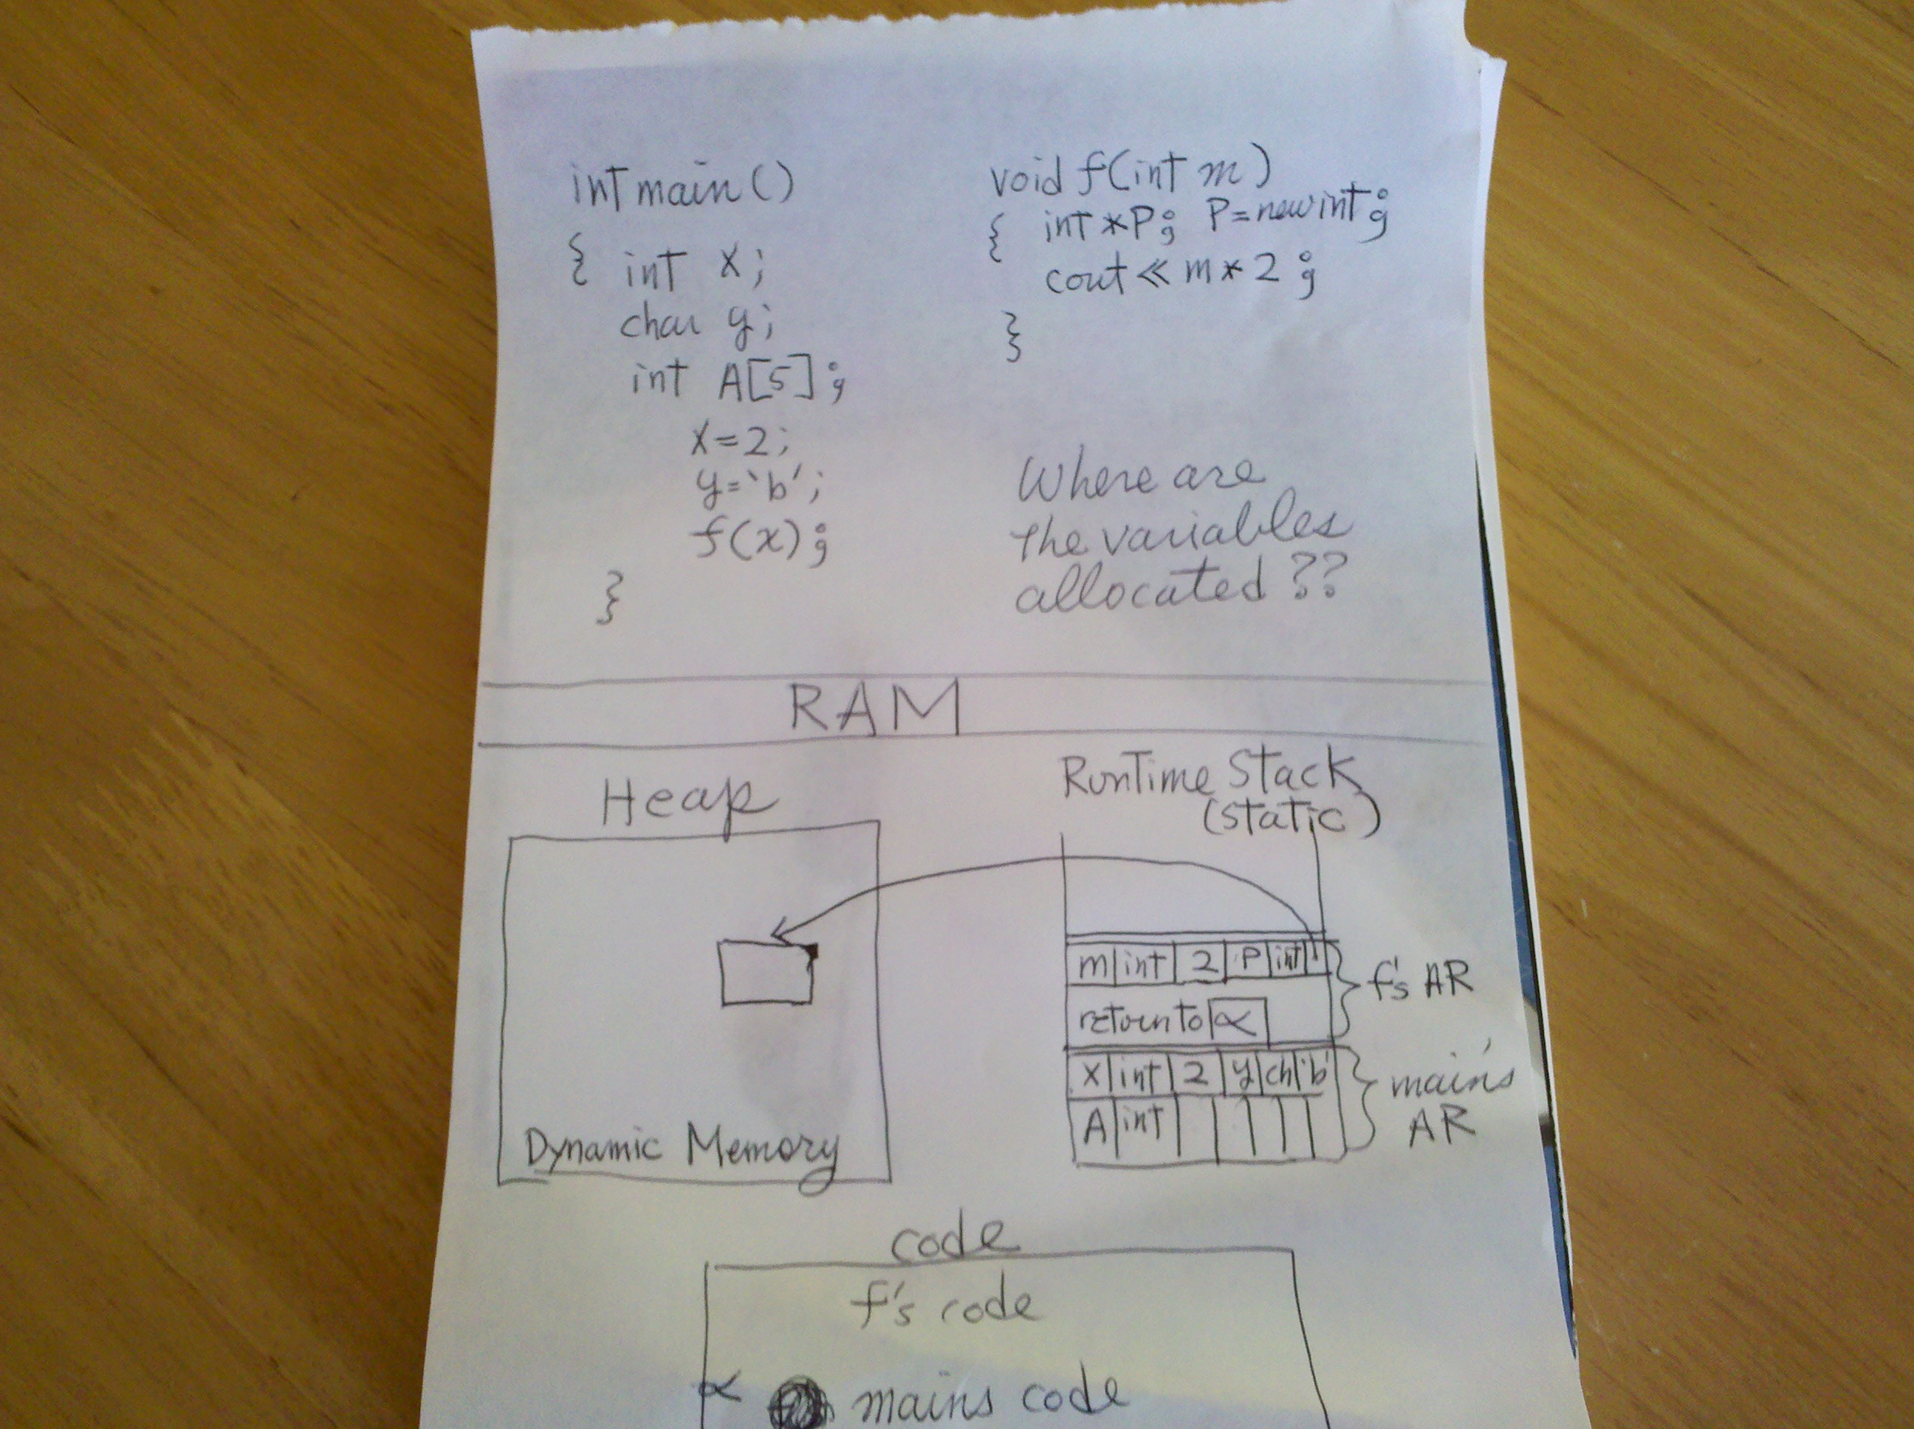

The Second Way to Implement a Stack

With the array implementation we have used, we can store a list of elements but only up to the fixed number (e.g. MAX_SIZE).

This type of memory allocation is called Static (Automatic) Storage Allocation where the memory requirements are determined and fixed before the program execution begins. (For local variables, the storage is actually allocated and de-allocated on the run time stack)

int L[10]; ➔ compiler to generate code that allocates 10 slots of L in an activation record on the Run Time stack for the current function;
when the current function is done, the activation record for it is popped off.
Thus, L is deallocated automatically

* What happens if you don't know how many elements will be entered by the user???
* Isn't it wasteful to allocate many slots but use only few of them???

Some programming languages may choose to use Semi Static Storage Allocation.
Here the size of your array can be determined when it is declared but cannot be changed.
i.e. use a variable in the array declaration e.g. int A[user_size];

The compiler will generate code to allocate A’s slots on top of the current function’s
Activation record. A will get popped off when the activation record gets popped off.

C++ goes one step further.

With C++, you may use the vector class to implement the functionality of an array but allowing the size to change during the execution of your program. This is different from what we normally call Dynamic Storage Allocation because we still use contiguous blocks of memory, and when more space is needed, a larger block is allocated and the entire vector elements are copied there. Thus, every time the vector size changes, a lot of work “behind the scene” is required.

On the other hand, looking up an element takes very little time. You do not have to search for the element. You can index it as with an array.

Disadvantage compared to a linked list: lot of work when you add a new slot
Advantage compared to a linked list: can index into the list to find an element

To use the C++ vector class,

#include <vector>

Then, you may declare a new vector by saying

vector<type> name(size);

For example

vector<int> myvec(20);

As with a static array, elements will be in slots 0 through 19.

vector<int> myvec; // this vector has no entries yet. The size is 0.

To increase the size of this vector as elements are added use push_back.

myvec.push_back(x); // append x to the end of the vector; increases the size

The current size of a vector can be obtained by the size() function.

for (i=0, i<5; i++)
{ myvec.push_back(i); } // adding 5 elements (to slots 0 through 4)

cout << myvec.size() << endl; // displays 5 as the size

*Inter* Please draw the contents

You can also decrease the size using pop_back (this does not tell you what was removed)

for (i=0, i<4; i++)
{ myvec.pop_back(); } // removing 4 entries from the back

cout << myvec.size() <<endl; // displays 1 as the size

*Inter* Please draw the contents.

For now, you can access the elements of a vector using the same syntax as that used for a static array.
e.g. cout << myvec[i] << endl;
e.g. myvec[i] = num;

Advantage over Arrays:

With vectors you do not waste space.
Another advantage of a vector over an array is that you can return it from a function.

e.g.
vector<int> addvec(vector<int> x, vector<int> y)
{ vector<int> z; // local vector
// add x and y and return the resulting vector z
return z;
}

You can also use assignment and comparison operators to work on vectors.
e.g. myvec1 = myvec2; // copy
e.g. myvec1 == myvec2 // equal?

Disadvantage over arrays? Lots of time when you add an element.

We may now see vectortest.C and vectortest2.C as examples and run them on empress.csusm.edu

*Inter* Let’s re-write the stack class using a vector.
What is the major data member?
How will you write push? pop?
Will it ever become full?
This will be your HW1P2.

http://www.cppreference.com/cppvector/index.html as descriptions of useful vector methods.

Summary: Time vs Space with Data Structures!!!!

Allocated and fixed at compile time – good in terms of Time
Allocated at run time and de-allocated at run time – good in terms of Space

In cs311, you will learn about other data structures besides just stacks and queues. You will have to determine when to use each one.
e.g. when should we use a priority queue?
e.g. when should we use a tree?
e.g. when should we use a hash table?
e.g. when should we use a graph?

Introduction: Algorithm Choice

“Time vs Space” also applies to algorithms as you will see starting next week. There are many other choices you will have to make when designing algorithms. Today, you will work on an algorithm for a system that you are familiar with.
(Problem Analysis 1.doc or Problem Analysis 2.doc)
- First, take 5 minutes to think about the problem on your own.
- Then, get together with your group members to discuss the group’s solution.
- Continue to work on it outside the class so that your group can present it at the next class meeting. Submit the sheet at the time of the presentation.
You will have to do the “other problem” as part of HW1P2.

The End of the Note Section:______________________________________
®Summarize here what you have learned in your own words and also write down your own thoughts/reactions/questions.

Email me now if you have any questions about what you read in this file.

End.

