Software Requirements Specification
For
Trivia Maze, Release 1.0

Version 1.0 approved

Prepared by: Jeffrey Stockman

Sriba Rajendran

Table of Contents
Table of Contents ii
Revision History ii
1. Introduction 1
1.1 Purpose 1
1.2 Project Scope and Product Features 1
1.3 Intended Audience & Use 1
2. Overall Description 1
2.1 Product Perspective 1
2.2 User Classes and Characteristics 1
2.3 Operating Environment 1
2.4 Design and Implementation Constraints 1
2.5 User Documentation 1
3. System Features 2
3.1 Game Play 2
4. External Interface Requirements 3
4.1 User Interfaces 3
4.2 Hardware Interfaces 4
4.3 Software Interfaces 4
4.4 Communications Interfaces 4
5. Other Nonfunctional Requirements 4
5.1 Performance Requirements 4
5.2 Safety Requirements 4
5.3 Security Requirements 4
5.4 Software Quality Attributes 4
Appendix A: Gameplay / Logic 5

Revision History
Name | Date | Reason For Changes | Version
JS, SR | 2/5/2021 | initial draft | 1.0

Introduction

Purpose
This SRS describes the software functional and nonfunctional requirements for release 1.0 of the Trivia Maze. This document is intended to be used by the members of the project team that will implement and verify the correct functioning of the system. Unless otherwise noted, all requirements specified here are high priority and committed for release 1.0.

Project Scope and Product Features
Trivia Maze is a game that will be developed for use on the Windows 10 platform. The project is a full-release version of the game. Full game details can be found in Section 2: Overall Description.

Intended Audience & Use
The intended audience is the general public, ages 8+. For entertainment purposes only.

Overall Description

Product Perspective
Trivia Maze is an entertainment software. The software is comprised of a game board where a single player will navigate a game board and answer questions. The GUI is shown in both Figure 1 (section 4.1) and the game play logic is shown in Figure 2 - Appendix A (Game Play / Logic).

User Classes and Characteristics
Player | Trivia Maze provides a single player experience; player should be able to read and use input devices (keyboard / mouse).

Operating Environment
OE-1: Trivia Maze will run on Windows 10 operating system
OE-2: The software shall require the .NET Framework versions 3.5/2.0.
OE-2: The computer shall have a sound card with an applicable hardware device attached.

Design and Implementation Constraints
CO-1: The system code shall conform to Python version 3.8 or later.
CO-2: The system shall use the SQLite relational database version 3.34 or later.

User Documentation
UD-1: The software will contain an embedded help menu and game instructions for the player from the GUI interface.

System Features

Game Play

3.1.1 Description and Priority
Trivia Maze allows a player to traverse a game board, where he/she will answer questions. Correct answers allows the player to continue along the game board; incorrect answers closes that path and the player must find an alternate route. The goal is for the player to reach the end before all paths are closed off.

3.1.2 Stimulus/Response Sequences
Stimulus: Player starts a new game.
Response: Software implements a new game; resetting all features.

Stimulus: Player exits the game.
Response: Software confirms the player wants to exit, then exits the game on successful prompt.

Stimulus: Player saves the game.
Response: Software saves the game for later retrieval.

Stimulus: Player loads the previously saved game.
Response: Software prompts the user and confirms he/she wants to load the previously saved game.
Stimulus: Player moves along the game board.
Response: Software allows the player to move along the game board based on available doors.

Stimulus: Player answers question(s).
Response: Software populates a question from database; based on answer, the player either 1) moves into new room (answers correctly) or the door closes to the new room (incorrect answer).

3.1.3 Functional Requirements
Game.Start: The software lets a player start a new game.
Game.Exit The software lets a player exit the game.
Game.Save The software lets a player save the game.
Game.Load The software lets a player load the previously saved game.
Game.Help The software loads a help menu with instructions and other
relevant information
Game.Over The software gives a game over notification if one of two criteria are met: 1) no traversable paths exists to get to the exit (blocked path based on incorrectly answering questions or 2) the player reaches the exit.
Board.Move: The software allows the player to move around the game board based on available paths.
Board.Question: The software loads a question once the player reaches a new location on the game board.
Board.Response: The software changes the status of the 1) player token and/or 2) available paths based on answering the question right/wrong.

External Interface Requirements

User Interfaces
UI-1: Th software GUI requires user input via the keyboard and/or mouse.
UI-2: The software shall provide a help link in the GUI interface / menu item.
UI-2: The software uses audio features; a sound card and associated sound device (speakers, headphones) must be enabled.
UI-2: The GUI design for the software is shown in figure 1.

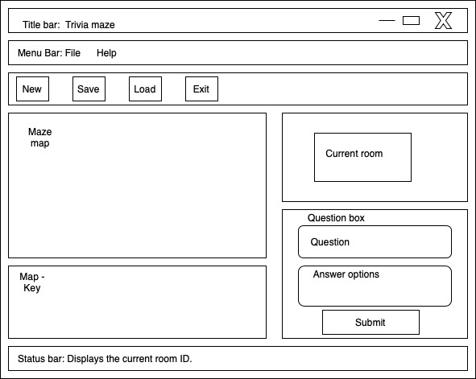

Figure 1: GUI Design

Hardware Interfaces
No hardware interfaces have been identified.

Software Interfaces
SI-1: Trivia Maze
SI-1.1: All actions and gameplay will be demonstrated via the GUI.
SI-2.1: The question bank will be stored in the SQLite database and automatically retrieved by the software without intervention.

Communications Interfaces
CI-1: Trivia Maze GUI shall have a menu bar with available system options.
CI-2: Additional system or gameplay communications can be demonstrated via pop-up windows.

Other Nonfunctional Requirements

Performance Requirements
PE-1: Responses to actions shall take no longer than 5 seconds to load onto the screen after the player submits the action.
PE-2: The software shall display confirmation messages to the player within 5 seconds after the player submits information to the system.

Safety Requirements
No safety requirements have been identified.

Security Requirements
No security requirements have been identified.

Software Quality Attributes
Availability-1: Trivia Maze shall be available ad hoc based on player’s desire to entertain him/herself.
Robustness-1: Software is generally free from defects. You get what you pay for…

Appendix A: Gameplay / Logic
The game play logic is illustrated in Figure 2.

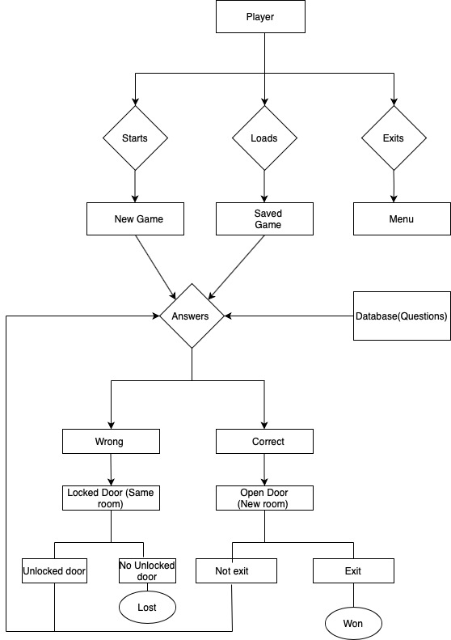

Figure 2: Gameplay Logic of the Trivia maze

