**THGEM abstract for the report**

S. Bressler & A. Breskin

**Introduction**

The Digital Hadronic Calorimeter (DHCAL) designed for the future ILC-SiD requires robust thin sampling elements with high detection efficiency at low pad multiplicity. The large detection area foreseen requires cost-effective solutions.

In the past two years, a Weizmann-Aveiro-Coimbra team has shown that sampling elements based on Thick Gaseous Electron Multipliers (THGEM) [1] could meet DHCAL requirements. Our THGEM concept has evolved from a cascade of double-sided electrodes coupled to a pad-anode through an induction gap [2], to thinner single-sided WELL detectors - coupled to the pads with and without resistive films [3,4].

The most recent and presently leading candidate is the Resistive Plate WELL (RPWELL). It was tested extensively in the laboratory [5,6] and at muon and high-rate pion beams at CERN-SPS. This very thin single-stage detector yielded a discharge-free operation in different gas mixtures, including Ne- and Ar-based ones, providing high detection efficiency at low pad multiplicity.

**The Resistive Plate WELL**

The Resistive Plate WELL (RPWELL) is a single-sided THGEM (with copper clad on one side only), coupled to the readout pads through a material sheet with high bulk resistivity (Figure 1). Materials with bulk resistivity in the 109 cm scale prevent significant gain-, and hence efficiency drops, at high particle flux [5].

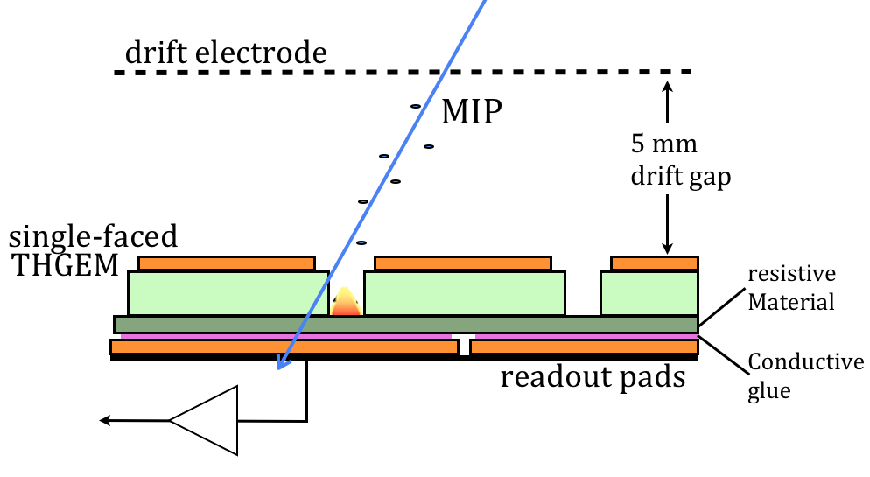

Figure 1: The RPWELL configuration with a resistive anode and a readout electrode. The WELL, a single-faced THGEM, is coupled to a readout anode (e.g. with strips or pads) via a resistive plate.

*Test beam results with first RPWELL prototypes*

Small (10x10 cm2) and medium size (30x30 cm2) RPWELL detector prototypes were built and tested in the laboratory and at the CERN-SPS. The 0.8 mm thick WELL electrodes were coupled to 1x1 cm2 copper pads through 0.4 mm thick Semitron ESD225 resistive polymer (~109 cm bulk resistivity). With a 5mm drift gap the sampling element had a total thickness of 6.2 mm (excluding readout electronics – here SRS-APV [7,8]).

The detection efficiency as a function of pad multiplicity (with low rate muons) is shown for the two prototypes in Figure 2. Both detectors reached high detection efficiency at low pad multiplicity when operated in our traditional Ne/5%CH4 (Figure 2 left; operation voltage, V, in the range 800-930 V) and in the cost-effective Ar/5%CH4 (Figure 2 right; V in the range 1500-1720 V) gas mixtures.

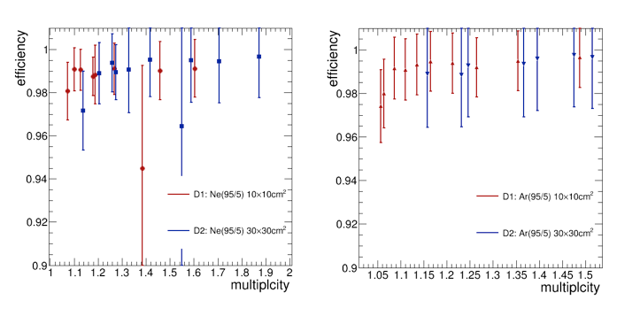

Figure 2: Efficiency as a function of the average pad multiplicity measured with the 10x10 cm2 and 30x30 cm2 detectors in muon beam. Left: Ne/5%CH4 gas mixture. Right: Ar/5%CH4 gas mixture

Figure 3 shows the measured gain as a function of the particle flux; the same operation voltage of 880 V was maintained throughout the measurements (with low rate muons as well as high rate pions). A moderate gain-drop of ~30% was measured while the flux was increased by 3 orders of magnitude (50 to 105 Hz/cm2). It resulted in negligible efficiency drop, since the pulse-over-threshold was sufficiently high.

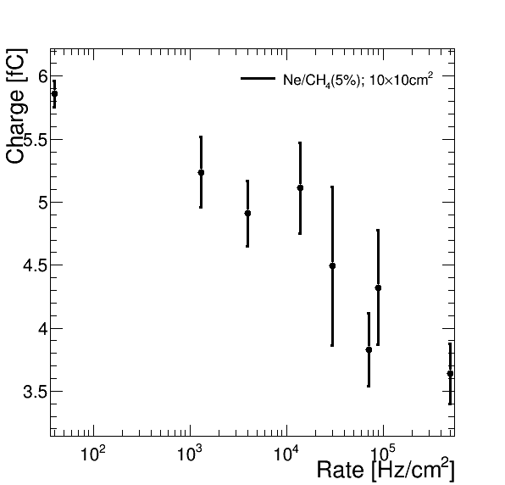

Figure 3: The charge (estimated from the spectra most probable value) as a function of the incoming particle flux. All the measurements were conducted at Ne/5%CH4 gas mixture at the same operation voltage of 880 V.

Most importantly, during the two weeks of in-beam operation (which included also long time operation under high rate, 105 Hz/cm2, pion beam), with both Ne-based and Ar-based gas mixtures, the small prototype was completely discharge-free. The resulting discharge probability is therefore below 10-8. Occasional discharges occurring in the medium-size prototypes were traced to be associated with defects in some support pins within the active area; these can be avoided in the next prototypes.

The RPWELL laboratory and test-beam results are the subject of two articles in preparation [9, 10].

1. R. Chechik, A. Breskin, D. Mörmann and C. Shalem, *Thick GEM-like hole multipliers: properties and possible applications*, Nucl. Instr. Meth. A535 (2004) 303.
2. L. Arazi, A. Breskin, R. Chechik, M. Cortesi, M. Pitt, A. Rubin, H. Natal da Luz, J. M. F. dos Santos, C. D. R. Azevedo, D. S. Covita, C. A. B. Oliveira, J. F. C. A. Veloso, M. Breidenbach, D. Freytag, G. Haller, R. Herbst, S. Park, A. White, J. Yu, E. Oliveri, “*THGEM-based detectors for sampling elements in DHCAL: laboratory and beam evaluation*”, JINST 7 C05011 2012
3. L. Arazi, M Pitt, S Bressler, L Moleri, A Rubin and A Breskin, “Laboratory studies of THGEM-based WELL structures with resistive anodes”, JINST 9 P04011 2014
4. S. Bressler, L. Arazi, H. Natal da Luz, C. D. A. Azevedo, L. Moleri, E. Oliveri, M. Pitt, A. Rubin, J. M. F. dos Santos, J. F. C. A. Veloso, A. Breskin, “Beam studies of novel THGEM-based potential sampling elements for Digital Hadron Calorimetry“, JINST 8 P07017 2013
5. A. Rubin, L. Arazi, S. Bressler, L. Moleri, M. Pitt, A. Breskin, “First studies with the Resistive-Plate WELL gaseous multiplier“, JINST 8 P11004 2013
6. S. Bressler, L. Arazi, L. Moleri, M. Pitt, A. Rubin, A. Breskin, “Recent advances with THGEM detectors“, JINST 8 C12012 2013
7. S. Martoiu, H. Muller, A. Tarazona and J. Toledo, Development of the scalable readout system for micro-pattern gas detectors and other applications, 2013 JINST 8 C03015.
8. M.J. French, et al., Design and results from the APV25, a deep sub-micron CMOS front-end chip for the CMS tracker, Nucl. Instrum. Meth. A 466 (2001) 359
9. S. Bressler, L. Moleri, M. Pitt, S. Kudella, C. D. A. Azevedo , F. Amaro, M. Jorge, J. M. F. dos Santos, J. F. C. A. Veloso and A. Breskin, “First in beam studies of Resistive-Plate WELL gaseous multiplier”, to be submitted to JINST
10. L. MolerI, C. D. A. Azevedo, F. Amaro, J. Schaarschmidt, M. Pitt, D. Shaked-Renous, J. M. F. dos Santos, J. F. C. A. Veloso and S. Bressler, “Performance studies of Resistive-Plate WELL gaseous multiplier in different gas mixtures”, in preparation