Justin Stryjewski

Ft3826

TODO Application

Functional Requirements

|  |  |  |  |
| --- | --- | --- | --- |
| Requirement ID | Statement | Must/Want | Comments |
| FR1 | The website will allow users to create additional to-do lists. | WANT | Name, Priority, Task, Status, Due Date. |
| FR2 | The website will allow users to add additional tasks to their to-do list. | MUST | Priority, Task, Status, Due Date. |
| FR3 | The website will allow users to view their to-do list. | MUST | Table format. |
| FR4 | The website will allow users to edit their task completion status. | WANT | Checkbox for complete and incomplete. |
| FR5 | The website will allow users to delete tasks from their to-do list. | MUST | Keeps name for to-do list but deletes selected task. |
| FR6 | The website will allow users to delete to-do lists completely. | WANT | Removes added names and tasks related to that person completely. |

Non-Functional Requirements

|  |  |  |  |
| --- | --- | --- | --- |
| Requirement ID | Statement | Must/Want | Comments |
| NFR1 | The system will not allow for duplicate named to-do lists to be made. | WANT |  |
| NFR2 | The system is user friendly and easy to use | MUST |  |
| NFR3 | The system interface will be consistent for the users | MUST |  |

Delete Task Sequence Diagram

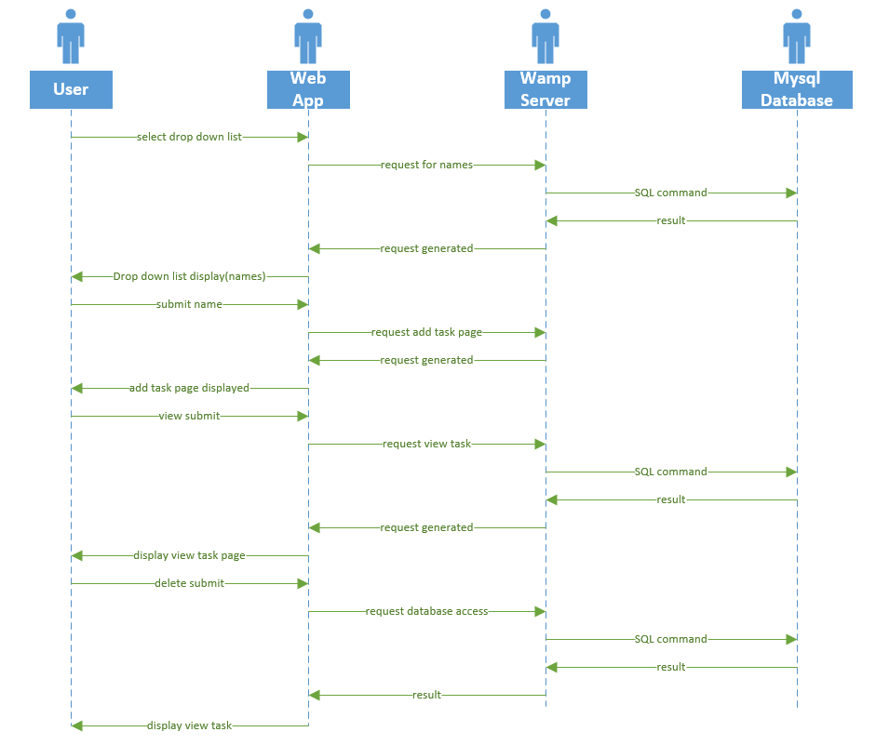

View Task Sequence Diagram

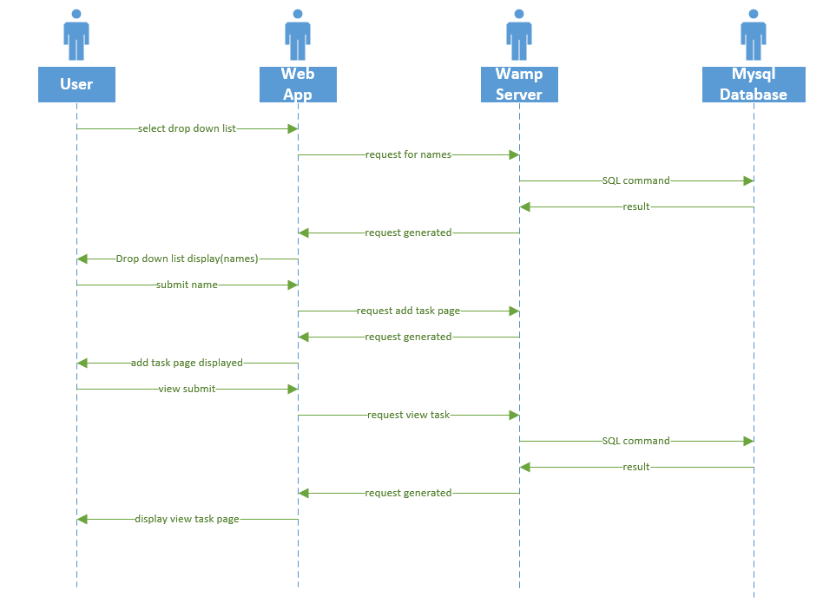

Add Task Sequence Diagram

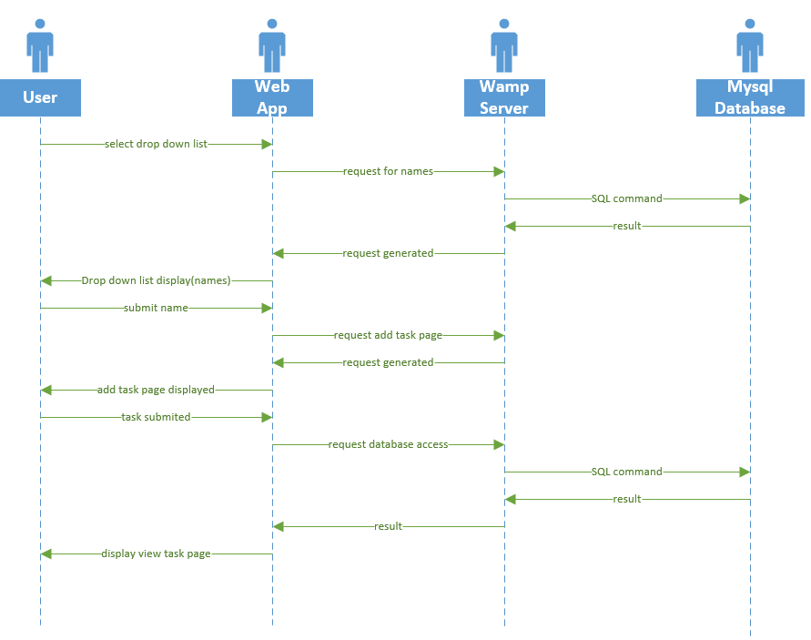

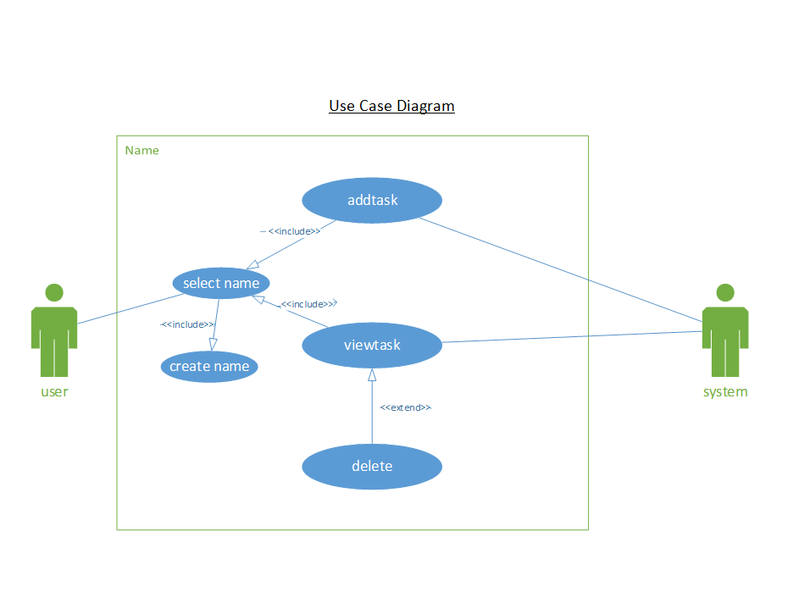

Database Diagram

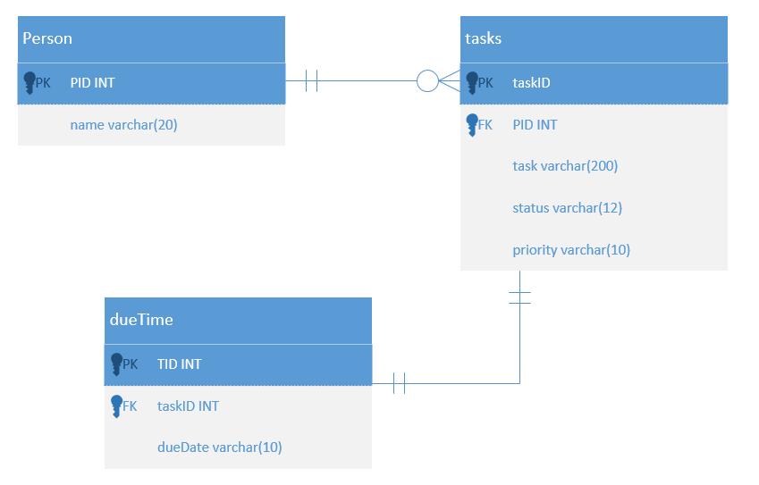

System Architecture Diagram

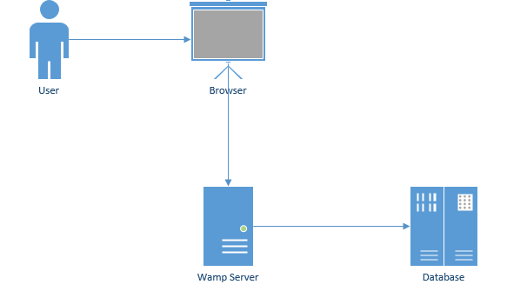

Dataflow Diagram

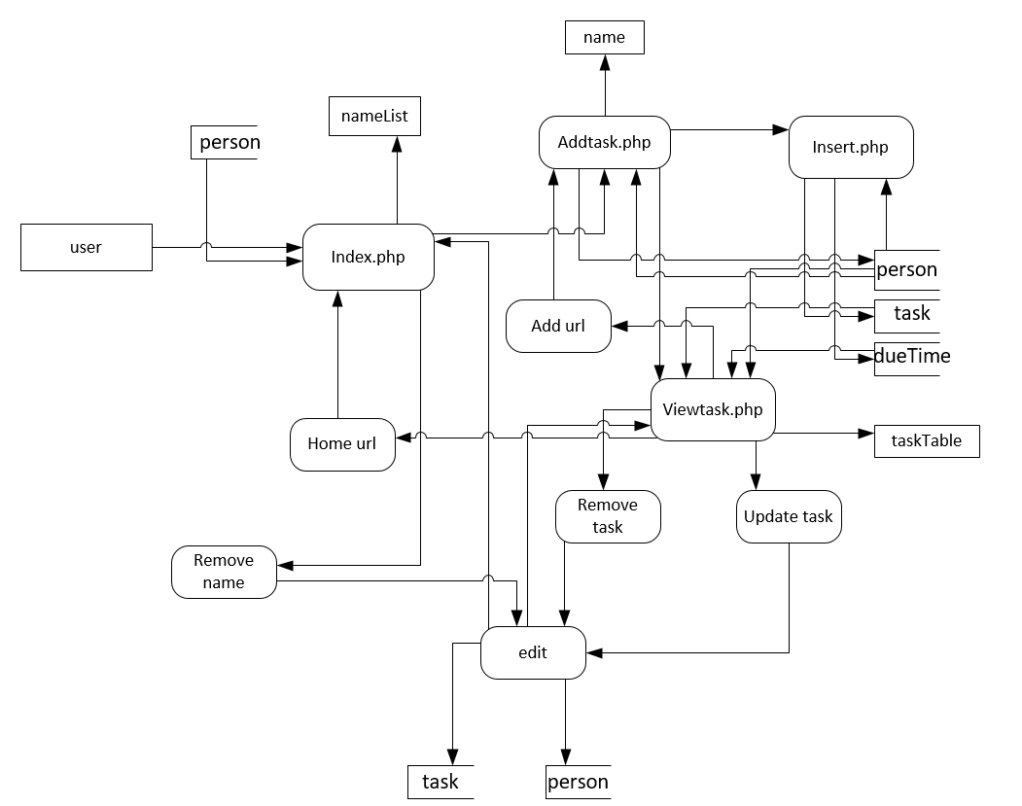

Test Case

|  |  |  |  |
| --- | --- | --- | --- |
| Case Number | Case description | Expected Results | Transaction Name |
| 1 | Add a new task, priority, and dueTime. | New task displayed in view | AddTask |
| 2 | Search a name for a to-do list and view the tasks available. | Table displaying all tasks for a given searched name | ViewTask |
| 3 | Checkbox the task you wish to delete from a to-do list. | Task is removed from the list and the new viewable list is displayed. | DeleteTask |

Assignment Breakdown

Name of the task: add task

Estimated No of hours: 1

Actual time spent:2

Notes:

Issues: Spent a lot of time learning specifics and correcting small mistakes

Name of the task: View task

Estimated No of hours: 1

Actual time spent: 4

Notes:

Issues: Had issues implementing checkboxes and passing global variables to delete or edit from the view page.

Name of the task: delete task

Estimated No of hours: 1

Actual time spent: 2

Notes: Not as many issues or problems once add and view were created

Issues:

Name of the task: Functional requirements

Estimated No of hours: 1

Actual time spent: 1

Notes: Not so hard to understand but took time to accept a format.

Issues: template issues

Name of the task: Non-functional requirements

Estimated No of hours: 1

Actual time spent:2

Notes:

Issues: Took a while to completely understand.

Name of the task: System Architecture Diagram

Estimated No of hours: 1

Actual time spent: 1

Notes: Not sure if it was made correctly

Issues: Searching to find a nice template to follow

Name of the task: Data Flow Diagram

Estimated No of hours: 1

Actual time spent: 2

Notes:

Issues: The amount of work put into 0,1,2 levels for the dataflow diagram was difficult to grasp

Name of the task: Use case

Estimated No of hours: 1

Actual time spent: 1

Notes:

Issues:

Name of the task: Sequence Diagram

Estimated No of hours: 1

Actual time spent: 2

Notes: Not entirely sure if I made them too descriptive

Issues:

Name of the task: Database Diagram

Estimated No of hours:1

Actual time spent:1

Notes: Made database diagrams before so it wasn’t difficult only having 3 tables to develop in visio

Issues:

Name of the task: Test Case

Estimated No of hours: 1

Actual time spent: 0.5

Notes: Did not seem difficult at all

Issues: