Jess Strzempko GEOG 190: Introduction to GIS

5.3.18 Final Project

**Black-capped Chickadee Breeding Habitat Distribution in MA: Natural vs. Manmade**

I. Introduction

As the state bird of Massachusetts and a well-known species in the northeast region of the United States, the black-capped chickadee is a ubiquitous element of the local environment. Chickadees, while friendly and vocal, are also versatile eaters, consuming plant matter, seeds, berries, and animal food like insects, suet, spiders, and pieces of meat throughout the year (1). Though their dietary needs are nonspecific, these birds are a bit more particular regarding their breeding and nesting habitat. Black-capped chickadees prefer deciduous or mixed composition forests either with substantial snags, or dead trees, where they can excavate new nesting holes or trees with cavities left behind by woodpeckers (2, 3). The need for snags or other rotting woody biomass with sites for excavation means that chickadees thrive in old-growth forests where the stand of trees has existed long enough to produce these conditions naturally. In a collaborative parenting effort, the female chickadee builds the nest while the male brings her food and water once the eggs are laid (4).

As reproduction is crucial to the survival of all species, and depends on proper nesting habitat for bird species, monitoring the factors that affect suitable breeding grounds will be important in the future. Notably, the direct and indirect consequences of anthropogenic actions have benefitted black-capped chickadees in the eastern United States, leading to an increase in local populations. While this study will focus solely on black-capped chickadee within their Massachusetts range, it should be noted that the uptick in population on the east coast of the United States was accompanied by a slight decrease in western (5). Since chickadee thrive in edge habitats created by disturbances, the prevalence of newly developed land in Massachusetts has been advantageous for this species. Accordingly, the purpose of this is study is less to discuss black-capped chickadee conservation and more to investigate this species’ interesting population dynamics in the context of changes in suitable breeding habitat.

II. Objective

The main intent of this study is to apply spatial analysis techniques to examine the natural breeding habitat of black-capped chickadee in Massachusetts based on criteria relevant to their nesting specifications. Additionally, land use data that provides information on land cover changes will be used to show how humans have increased viable breeding habitat for this bird species. By gauging the natural and manmade distribution of chickadee breeding grounds, further conclusions can be drawn about present and future population dynamics.

In summary, the research questions are:

1. What is the natural range of breeding habitat of black-capped chickadee in Massachusetts?
2. How does the additional consideration of manmade habitats affect the total area and distribution of suitable breeding habitat for black-capped chickadee in Massachusetts?

III. Data Description and Sources

Most of the data used in this project was obtained on the mass.gov Mass GIS Data Layers website, where shape files of geographical and political data can be directly downloaded. As Table 1 demonstrates, vector shape files of rivers and streams, ponds and lakes, open space, and land use were downloaded to be used as criteria in analysis of black-capped chickadee breeding habitat. The HYDRO100K_ARC.shp line file of rivers and streams in Massachusetts shows all flowing bodies of water across the state. The HYDRO100K_POLY.shp polygon file of ponds and lakes shows all static bodies of water in Massachusetts (Figure 1). The OPENSPACE_POLY.shp polygon file provides a representation of the protected and recreational open space in the state with information on site names, land managers, and level of protection (Figure 2). Lastly, though a bit outdated, the LANDUSE2005_POLY.shp polygon file is a layer with land cover information from 2005 (with uses such as commercial, cranberry bog, high density residential, etc.) (Figure 4). All files were downloaded and used in the GCS North American 1983 reference system. See below table 1 for proper data citation for all files from MassGIS.

Additionally, spatial data on forest composition and the matching legend were obtained from Dr. Rogan and student Tyler Anderson at Clark University. The received raster file contained information on forest cover type with values corresponding to coniferous, deciduous, and mixed forests as well as non-forest area and bodies of water (Figure 3). The resolution of the data in both the x and y coordinate directions was 30 meters which affected the resolution of the vector polygons created by the raster to polygon function in ArcGIS later in the analysis. The last dataset used to create a final map composition of the suitable breeding habitat was a dark gray canvas base map provided by Esri that allowed key data to come to the foreground by supplying a neutral background. The base map used was developed by Esri using HERE data, Garmin base map layers, OpenStreetMap contributors, Esri base map data, and select data from the GIS user community. See below Table 1 for a source citation.

Table 1. Description of datasets used in analysis.

|  |  |  |  |  |  |
| --- | --- | --- | --- | --- | --- |
| File Name | Variable | Data Source | Format | Original Reference System | Details |
| HYDRO100K_ARC.shp | Rivers and streams | Mass GIS | Vector (shapefile) | GCS_North_American_1983 | Line |
| HYDRO100K_POLY.shp | Ponds and lakes | Mass GIS | Vector (shapefile) | GCS_North_American_1983 | Polygon |
| OPENSPACE_POLY.shp | Conserved land | Mass GIS | Vector (shapefile) | GCS_North_American_1983 | Polygon, Land plots |
| 2015_ForestCover_Type.tif | Forest type/composition | Professor Rogan | Raster | GCS_North_American_1983 | Resolution: 30 m |
| LANDUSE2005_POLY.shp | Land Use | Mass GIS | Vector (shapefile) | GCS_North_American_1983 | Polygon |
| Dark Gray Canvas | Base map | ArcGIS | Raster | GCS_North_American_1983 | *See below |

**MassGIS data citation: Bureau of Geographic Information (MassGIS), Commonwealth of Massachusetts, Executive Office of Technology and Security Services. HYDRO Files: February 2013, OPEN SPACE File: March 2018, LAND USE File: June 2009.**

ArcGIS base map sources: Esri, HERE, Garmin, © OpenStreetMap contributors, and the GIS user community.

* In North America, coverage is provided from Level 11 (1:288k scale) through Level 16 (1:9k scale).

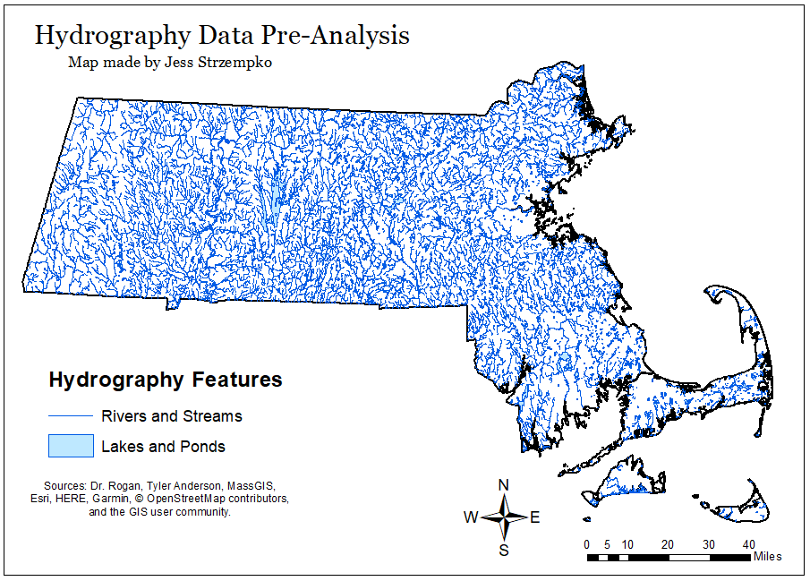

Figure 1. Map composition of Hydrography data pre-analysis.

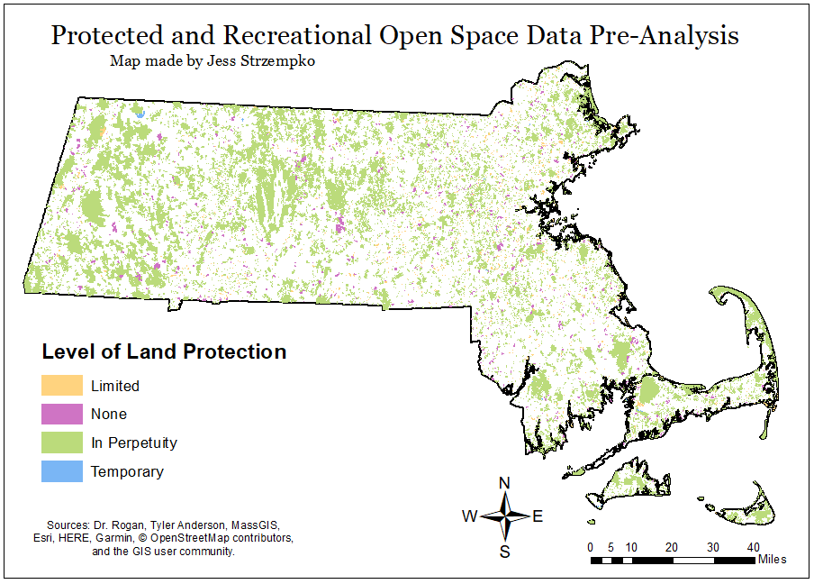

Figure 2. Map composition of Protected and Recreational Open Space data pre-analysis.

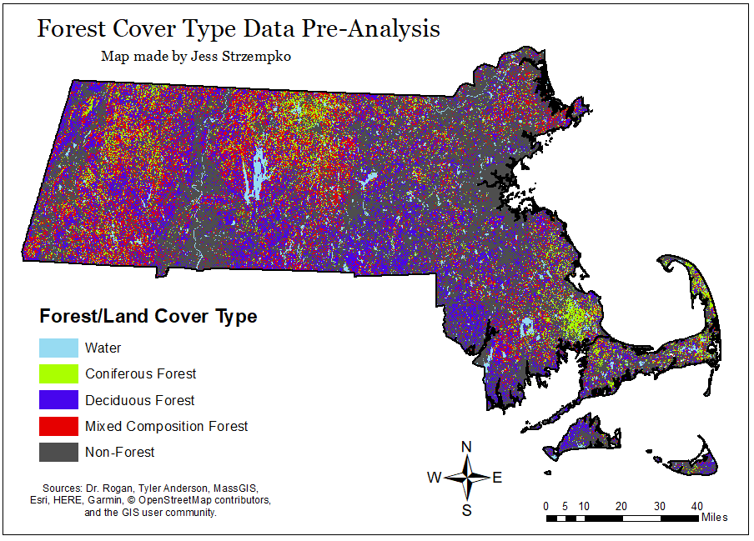

Figure 3. Map composition of Forest Cover Type data pre-analysis.

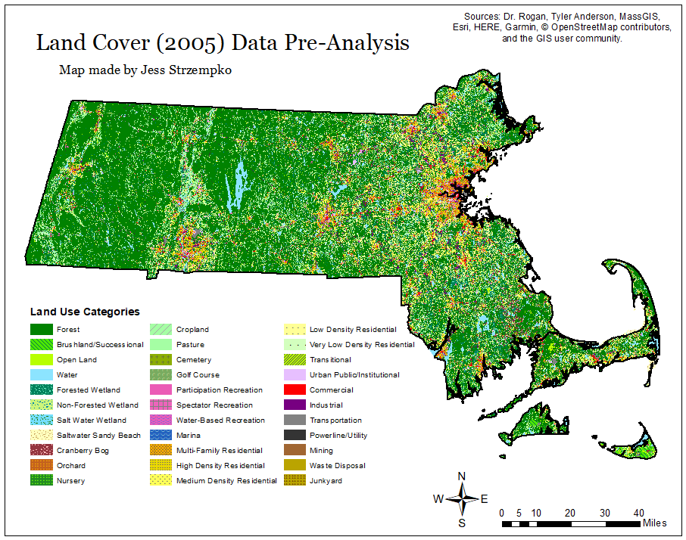

Figure 4. Map composition of Land Cover (2005) data pre-analysis.

IV. Methods

To create a map of suitable natural breeding habitat for black-capped chickadee in the wild, criteria related to accessibility to surface water, forest composition, and land conservation were used. The data for these three different criteria were obtained through Dr. Rogan from Clark University and the MassGIS data layers website and analyzed using ArcGIS software. For an area to be suitable for black-capped chickadee breeding, the birds must nest relatively close to surface water where the males can hydrate and bring back water for their families. Subsequently, a 500 m buffer was placed around all rivers and streams (HYDRO100K_ARC.shp) while a 1000 m buffer was extracted around ponds and lakes (HYDRO100K_POLY.shp) as can be seen in Figure 5. A larger buffer was placed around large bodies of water like ponds and lakes because they are static and offer a larger amount of the desired resource, meaning the chickadees would travel further for the higher benefit. Within these areas, the chickadees need at least one source of surface water to draw from, either a river or a lake or both. The union function was performed on the result of the two buffers, RivBuff500 and LakeBuff1000, to find the habitat with ideal hydrological conditions. The resulting file, idealwater, where all boundaries were dissolved, represents all the land that satisfies this condition.

The next variable used to find suitable natural breeding habitat for black-capped chickadee was spatial information about protected and recreational open space in Massachusetts, obtained from MassGIS. The OPENSPACE_POLY.shp file contains polygons of conservation land, recreation land, town forests, parkways, agricultural land, aquifer protection land, watershed protection land, cemeteries, and forested land. Typically, when chickadees look for proper nesting sites, they are most successful in areas containing trees with natural cavities or woodpecker holes that can be further excavated. A forest habitat generally gains these characteristics with age, meaning the longer a habitat has existed and will continue to exist in the future, the better for black-capped chickadees. A query by attribute, [LEV_PROT] = ‘P,’ was used to select areas that had a level of protection of “In Perpetuity.” The aim with this criterion was to find plots of forested land that won’t be bought and developed in the coming decades as to allow for the creation of these desirable breeding habitat features. Once selected, the create new layer from selection option was used to create the PermConserve (permanently conserved land) layer.

Finally, the last criterion for the natural breeding habitat was drawn from the Cornell Lab of Ornithology website where it states that black-capped chickadees are found most in deciduous and mixed composition forests and prefer alder and birch trees for nesting cavities. As of right now, MassGIS only has data on forest composition for a section of Cape cod meaning that data had to be obtained from another source. The spatial data on forest cover and type that Dr. Rogan provided, 2015_ForestCover_Type.tif, came in a raster file that had to be converted to a vector file with the raster to polygon tool once the spatial analyst (raster) toolbox was made available. In the new polygon file, ForestCover.shp, the values designated to each raster cell were changed to represent the value of the polygon they were now part of. See the cartographic model Figure 5 for the numeric value of each of the 5 types of land cover and forest composition. Another query by attribute, [gridcode] = ‘2’ OR [gridcode] = ‘3,’ was used to select for areas with deciduous forest (2) or mixed forest (3). Again, a new layer was created from the selection and named DecidMixed, thus completing all the analysis for the three criteria. In the last step, an intersect function where boundaries were dissolved was performed with idealwater, PermConserve, and DecidMixed to find the areas in Massachusetts that satisfied these three habitat needs. This file was named BlackCapHab and represented the areas of natural breeding habitat for the chickadee.

To create the manmade breeding habitat map for black-capped chickadee for comparison, a different set of criteria had to be used (Figure 5). In suburban settings, humans can create conditions ideal for chickadee nesting and breeding, such as the placement of a bird bath or bird feeder or the construction of an artificial nesting box. Because human actions can satisfy many of the habitat criteria, the presence of suburban land can essentially replace the needs that would have been met by the level of land protection as well as forest cover and type. The assumptions in this scenario are that suburban land will most likely remain as suburban land in the future and that trees preferred for nesting can be replaced by nest boxes with wood shavings inside that the chickadees can “excavate.” Since these two conditions are more likely to be met in lower density residential areas, these areas were chosen from the land cover layer obtained from MassGIS. With the LANDUSE2005_POLY.shp layer, select by attribute was used to choose very low, low, and medium density residential areas with the SQL expression [LU05_DESC] = ‘Very Low Density Residential’ OR [LU05_DESC] = ‘Low Density Residential’ OR [LU05_DESC] = ‘Medium Density Residential.’ Upon being selected, these selected areas were used to create a new layer, SuburbanLand. Since the criteria for surface water was not completely met by the presence of humans, SuburbanLand and idealwater (from the natural habitat criteria) were intersected and boundaries dissolved to create BlackcapManmade, which represents the area of manmade habitat for chickadee in MA.

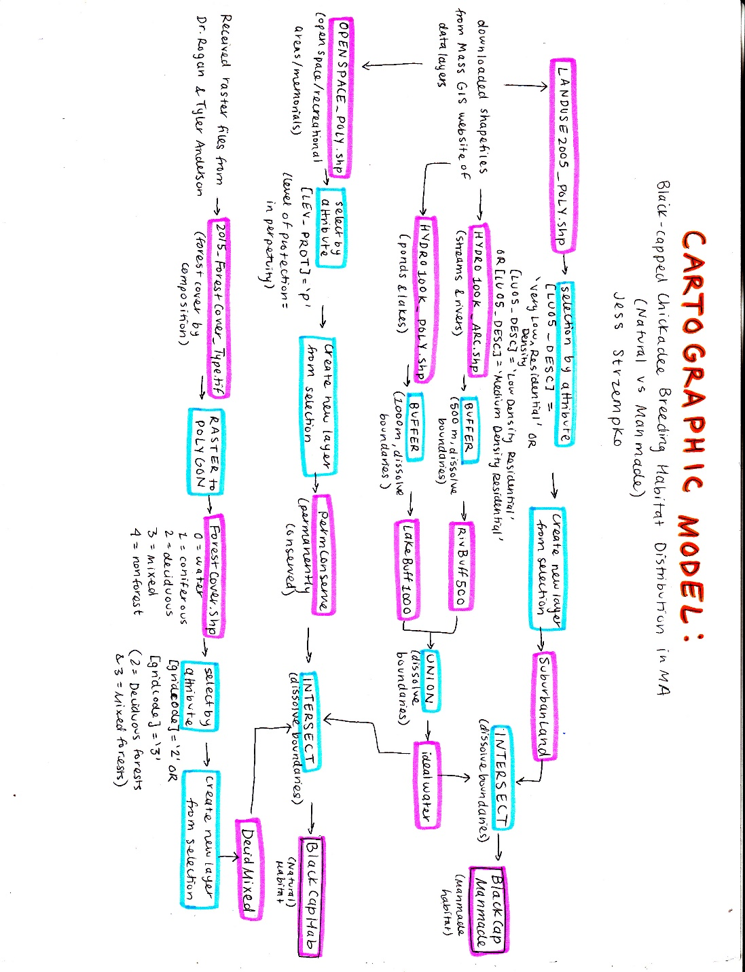

Figure 5. Cartographic model to find the natural and manmade breeding habitat distribution of black-capped chickadee in Massachusetts.

Further analysis, seen in Figure 6, was performed once the layers of natural and manmade black-capped chickadee breeding habitat were created to complete the overall analysis and quantitatively answer the second research question. In the attribute table for the BlackCapManmade layer, a float type field was added named AREA_SQKM. In this field, the calculate geometry tool was used to calculate the area of each of the plots in square kilometers which was then summarized by the [LU05_DESC] (land cover) column with an additional field containing the sum of the AREA_SQKM field by land cover (Figure 9). To find the total area of the natural black-capped chickadee breeding habitat, a float field was added in the attribute table of BlackCapHab named AREA_SQKM and calculate geometry was used to find the area of the polygon in square kilometers. The statistics tool was then used on this field to find the sum of all the values of the total natural breeding habitat (Figure 10). Lastly, an intersect function was performed on a combination of the BlackCapHab and BlackCapManmade layers to extract any potential overlap of area. In the attribute table of the resulting layer, BlackCapHab_Intersect, a float field named AREA_SQKM was added where the area in square kilometers was found using calculate geometry. The statistics tool was then used on this field to find the area of overlapping land, which was subtracted from the manmade habitat area to find the total area added by manmade habitat (Figure 11). Throughout the entire analysis, the state of Massachusetts was the extent of the study area and the spatial unit of analysis was the resolution of the raster and vector data used since no specific base unit like counties or towns was relied upon.

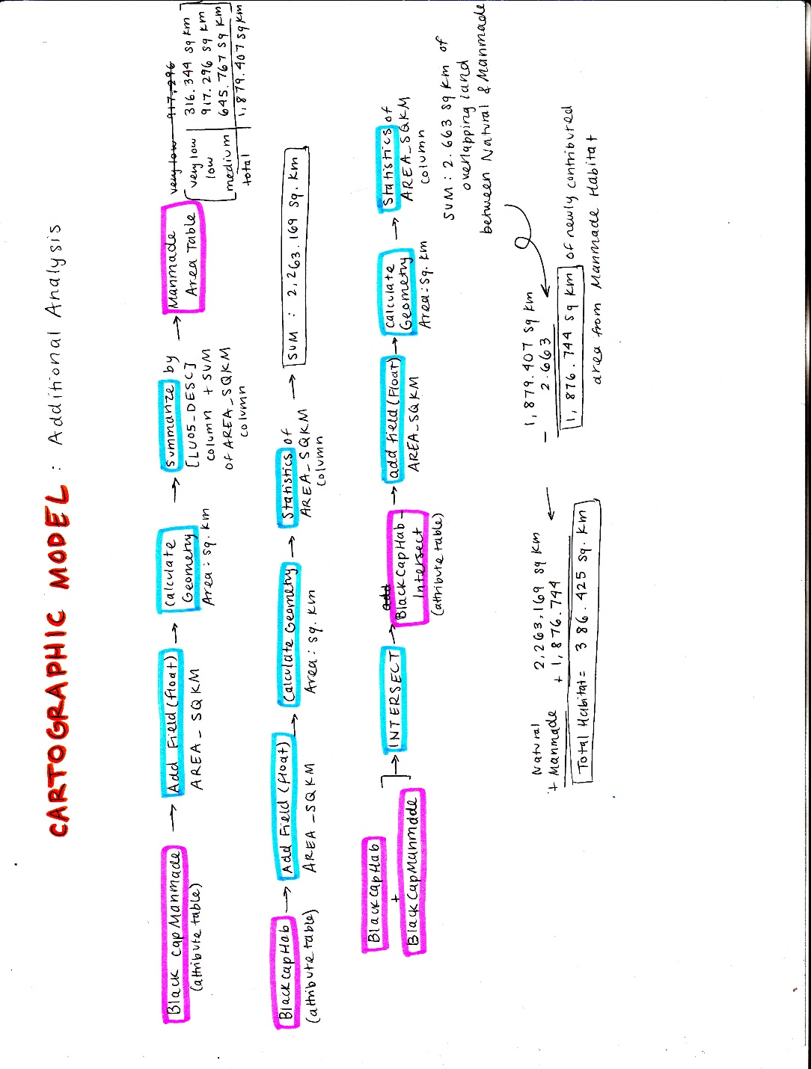

Figure 6. Cartographic model of additional analysis steps taken to compare the area of natural and manmade breeding habitat of black-capped chickadee in Massachusetts.

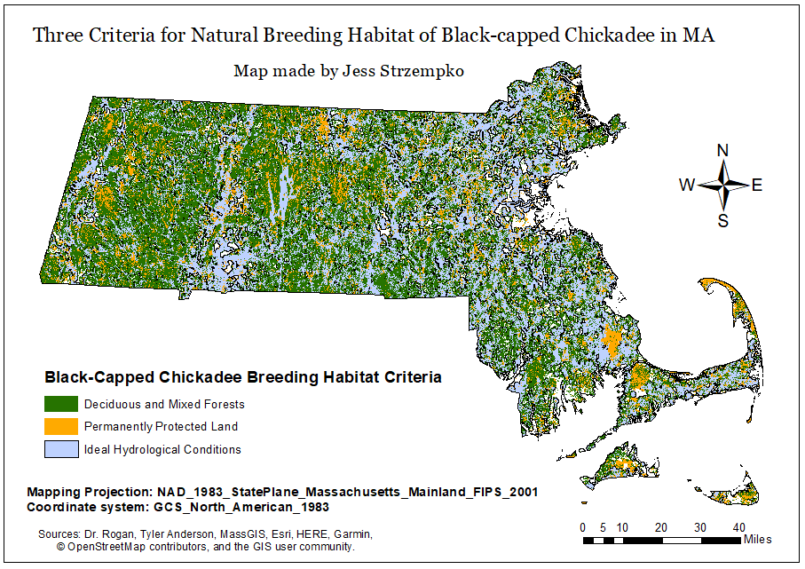

Figure 7. Map composition of three variables used to find natural breeding habitat of chickadee.

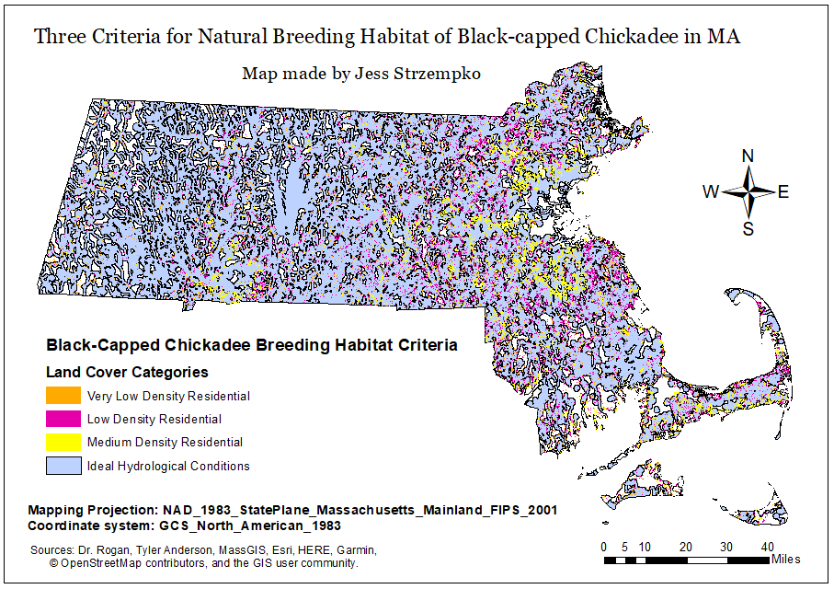

Figure 8. Map composition of two variables used to find manmade breeding habitat of chickadee.

V. Results

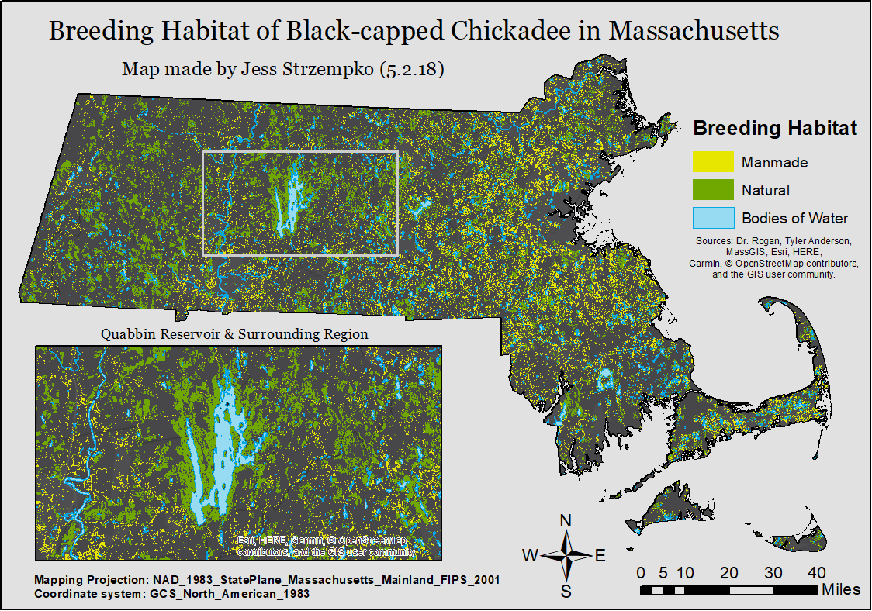

Figure 9. Final map composition of both natural and manmade breeding habitat distribution of black-capped chickadee in Massachusetts based on various environmental criteria.

The final map composition for the area and distribution of natural and manmade breeding habitat of chickadee in Massachusetts can be found in Figure 9. For the sake of clarity, rivers and streams were not included in the final map while bodies of water, like ponds and lakes, were included for context purposes. The most apparent pattern is that many of the areas suitable for breeding, natural or manmade, are small plots of land scattered across the state. The manmade breeding habitat is more scattered, which from Figure 8, seems to be more a consequence of the nature and distribution of suburban land than any other factor. Similarly, the manmade habitat is skewed toward the eastern part of the state while western Massachusetts has the most natural breeding habitat. These observations agree with general trends of land use in the state, where the coastal towns and cities near Boston are typically more urban while land to the west of the Quabbin Reservoir is mostly rural. Natural breeding habitat is mainly found in the central and western parts of Massachusetts in larger plots of land than manmade habitat. The larger plots may come as a result of forested conservation land, which is more abundant in western MA. Using forest composition as a criterion, with deciduous and mixed forests being selected while coniferous were not, probably caused most of the discontinuities between these bigger plots as the distinction between different types of forest stands is not always definite. There is also a large cluster of viable natural breeding habitat around the Quabbin Reservoir, shown in the inset in Figure 9, which is most likely maintained and conserved as forested land to protect this important source of drinking water.

The small, scattered amounts of suitable breeding habitat was surprising, but perhaps also beneficial to the black-capped chickadee that prefers edge habitat. With the added suburban land from the suitable manmade breeding habitat, the amount of edge habitat is increased and spread further into the eastern part of the state. Additionally, the spatial results displayed above can be demonstrated in a more quantitative, tangible manner. As described in the methods section, a combination of the calculate geometry and statistics tools were used to find the areas of each type of breeding habitat, as can be seen in Figures 9 (manmade), 10 (natural), and 11 (overlap). The overlap between the manmade and natural breeding habitat was found so that any spatial errors caused by resolution issues or conversion of data didn’t affect the area of each type of habitat found. As a percentage of the total breeding habitat, the natural habitat, with an area of 2,263.169 square kilometers, represented just over half of the total (Table 2). The manmade habitat, at 1,876.744 square kilometers was just under half of the total breeding habitat. This means that the consideration of non-natural settings for black-capped chickadee nesting, and possibly other native bird species, greatly increases the amount of useful and available breeding habitat.

Table 2. Breeding habitat area and percentage values.

|  |  |  |
| --- | --- | --- |
|  | Breeding Habitat Area (sq. km) | Percent of Total Breeding Habitat |
| Natural | 2,263.169 | 54.67% |
| Manmade | 1,876.744 | 45.33% |

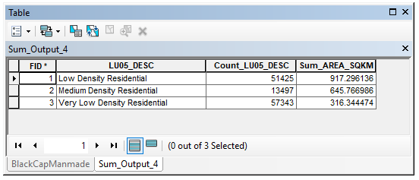

Figure 9. Table displaying the area in square kilometers of suitable manmade breeding habitat by the density of residents present on the land.

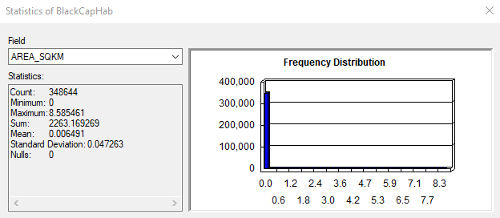

Figure 10. Statistics of natural breeding habitat for black-capped chickadee showing the sum of all the areas as well as bar graph displaying distribution of values.

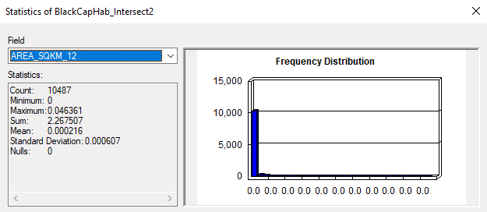

Figure 11. Statistics of the intersection of natural and manmade breeding habitat for black-capped chickadee showing the sum of all the areas as well as bar graph displaying distribution of values.

VI. Conclusion and Discussion

This study found that the breeding habitat of black-capped chickadee is distributed all across Massachusetts, with larger cluster of natural habitat to the west and smaller plots of manmade habitat to the east. Of course, these findings and the criteria they were derived from relied on many assumptions. A particularly evident one was the assumption that all suburban land of very low, low, and medium density would provide nesting sites for chickadees when, in reality, most suburban residents are unaware of the needs of native birds or unwilling to help. A more comprehensive look at the viability of manmade habitat, perhaps with actual data on the prevalence and success of nest boxes made by humans in Massachusetts, would be needed to form more solid conclusions about this aspect of the study. Also, if there had been more time, it would have been beneficial to compare the distribution of natural breeding habitat to real life data from the Mass Audubon Society or another similar organization. Lastly, the data used was perhaps too fine a resolution for such a large study area. As a result, the data loaded very slowly every time the map document was opened meaning that analysis took much longer than anticipated. Nonetheless, the study provided valuable information about the future of the black-capped chickadee in Massachusetts and the ways in which humans are altering breeding patterns.

VII. References

1. “Black-Capped Chickadee Life History.” Cornell Lab of Ornithology: All About Birds, Cornell University, 2017.
2. United States, Congress, Fish and Wildlife Service, and Richard L Schroeder. “Habitat Suitability Index Models: Black-Capped Chickadee.” Habitat Suitability Index Models: Black-Capped Chickadee, Western Energy and Land Use Team.
3. United States, Congress, Fish and Wildlife Service, and Richard L Schroeder. “Tests of a Habitat Suitability Model for Black-Capped Chickadees.” Tests of a Habitat Suitability Model for Black-Capped Chickadees, US Fish and Wildlife Service, 1990.
4. “Wildlife Guide: Black-Capped Chickadee.” The National Wildlife Federation, National Wildlife Federation.
5. “Black-Capped Chickadee.” BirdWeb, Seattle Audubon Society.