**Characterization of wetland scaling and influence in the Ipswich and Parker River watersheds of northeastern Massachusetts**

**Jessica Strzempko**

M.S. GIS Student

Graduate School of Geography

Clark University

Internship Report

Edna Bailey Sussman Foundation

October 2020

1. **Introduction**

Fluvial (riverine) wetlands play an important role in watershed nutrient cycling, nitrogen removal, and greenhouse gas production (Wollheim et al., 2014). For coastal watersheds that lie in rapidly urbanizing regions, quantification of wetland influence and scaling from headwaters to estuary is a crucial step in identifying the dynamics of a changing catchment (Gardner et al., 2019; Morse & Wollheim, 2014). My project developed such an understanding for the Ipswich and Parker River watersheds of northeastern Massachusetts (Figure 1). I compared results both within and between watersheds to assist in generating and expanding upon existing models of biogeochemical flow for improved future watershed management.

Figure 1. Map of freshwater wetlands in the Parker (green) and Ipswich (red) River watersheds.

1. **Study Area & Dataset**

This project focuses on the Ipswich and Parker River watersheds in northeastern Massachusetts and contributes to the Plum Island Ecosystems Long Term Ecological Research (PIE LTER) funded by the National Science Foundation. I acquired the Networked Hydro Centerlines and MassDEP Wetlands (2005) layers from the MassGIS website. Both are vector datasets with the former containing lines depicting the surficial hydrologic network and the latter polygons of all wetlands in Massachusetts. Professor Wilfred Wollheim at the University of New Hampshire’s Water Systems Analysis Group (UNH WSAG) provided additional raster imagery. These data comprise of layers of 120 m x 120 m spatial resolution with information on direct drainage stream order, river length, distance to ocean, flow direction, and upstream drainage area (Figure 2).

Figure 2. A selection of the raster layers provided by Professor Wollheim and UNH WSAG.

1. **Methods**

I conducted analysis in both QGIS and ArcMap software due to the availability of certain tools provided by each. To begin, I projected all layers into the EPSG Projection 26986: NAD83, which is best suited for analysis conducted on the Massachusetts Mainland. Additional pre-processing included clipping the downloaded vector layers to each of the watershed boundaries. Within the wetlands layer, I selected the attribute codes for all freshwater wetlands – bogs, wooded swamps, shrub swamps, shallow marsh meadow, and fens – and exported them for analysis. Where the surficial hydrologic network directly intersected with wetland polygons, I gave a designation of fluvial wetlands. Connected wetlands are those polygons adjacent to fluvial wetlands, but not directly crossed by the network. Isolated wetlands are those that do not connect to the network.

I created raster layers where each 120-m pixel contains a value representing the proportion of landcover area that is wetland, with values ranging from 0 to 1. This process was conducted for each type of wetland (fluvial, connected, and isolated) per watershed. Within ArcMap, I used the Flow Accumulation tool and flow direction layer to generate two maps per wetland-watershed combination – an unweighted and weighted output of accumulated flow per pixel. All runs used the default D8 flow modeling method. Unweighted flow accumulation multiplied by per pixel area gives cumulative upstream drainage area per pixel in kilometers squared. Weighted flow accumulation multiplied by per pixel area gives cumulative upstream wetland area per pixel in kilometers squared. Finally, for the areas designated to be of stream order 1 or higher, I extracted and plotted the values for the weighted and unweighted runs against each other using a log-log scale and exponential trendline.

For comparison, I also performed an analysis of wetland area aggregated by stream order per wetland type. First, I converted the direct drain order raster layer into polygons where each polygon contained the order of the stream that directly drains into it. I then multiplied the wetland proportion layer by the per pixel area in kilometers squared to obtain a wetland area layer. Inputting the stream order zones and wetland area layer into the zonal statistics tool and removing pixels outside the surficial hydrologic network, I obtained the average area of wetland per stream order per wetland type. I plotted these values on a log scale using exponential trendlines. I then computed the Area Ratio (RA), a scaling factor, per wetland-watershed combination according to Horton’s Law of Stream Areas.

1. **Results and Discussion**

Figures 3a and b show that fluvial wetlands in both the Ipswich and Parker River watersheds scale super-linearly with power regression slope values of 1.19 and 1.23, respectively. This means that upstream wetland area increases faster than upstream drainage area when moving downstream along the surficial hydrologic network. The coefficient of determination, R², for each watershed – 0.82 and 0.74, respectively – is the proportion of the variance of upstream wetland area explained by upstream drainage area with higher correlation seen in larger upstream drainage area values. Figure 4a and b and Figure 5a and b show that connected and isolated wetlands tend toward linear scaling with slope values of 0.99-1.08 and lower R² values. Table 1 summarizes the data. Figures 3c, 4c, and 5c demonstrate scaling relationships by stream order where the exponent of the trendline was used to compute the Area Ratio (RA) according to Horton’s Law of Stream Areas. Summarized in Table 2, RA values provide a scaling factor to quantify increases in average wetland area when moving from one river order to the next highest order. Values reaffirm our findings that fluvial wetlands demonstrate the most rapid growth between stream orders – 2.66 and 2.64, respectively - while connected and isolated wetlands in both watersheds scale at slower rates, i.e. RA < 2.5.

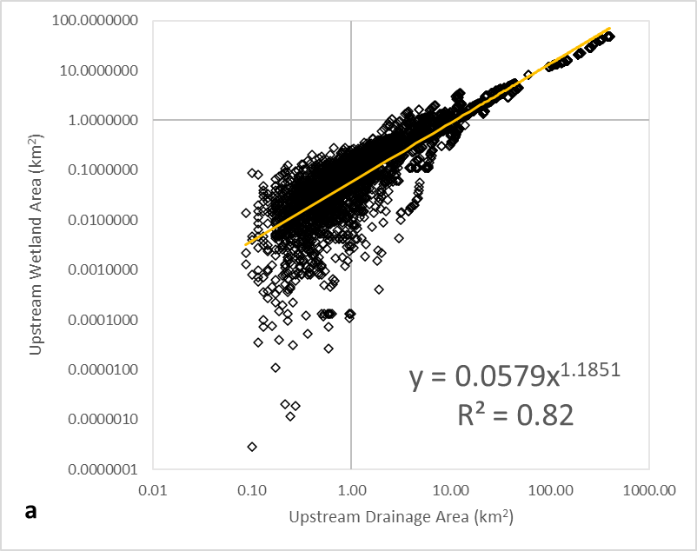 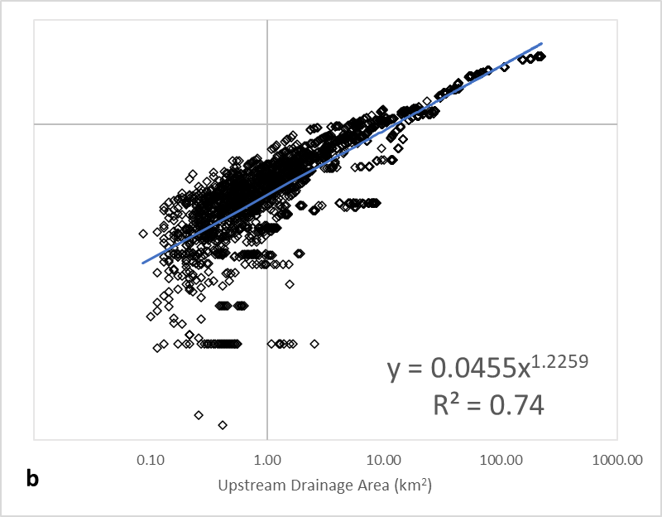

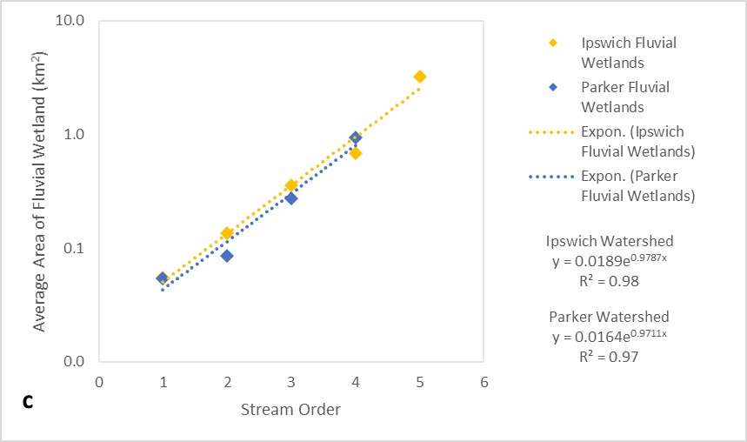

Figure 3. Scaling relationships for fluvial wetlands in the Ipswich (yellow) and Parker (blue) River watersheds.

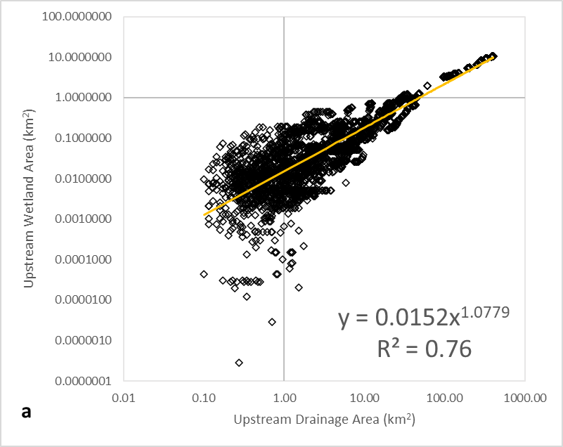 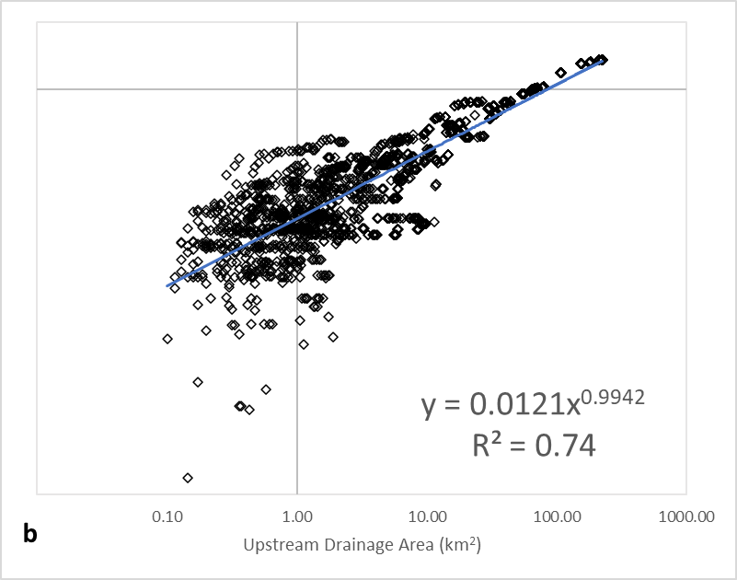

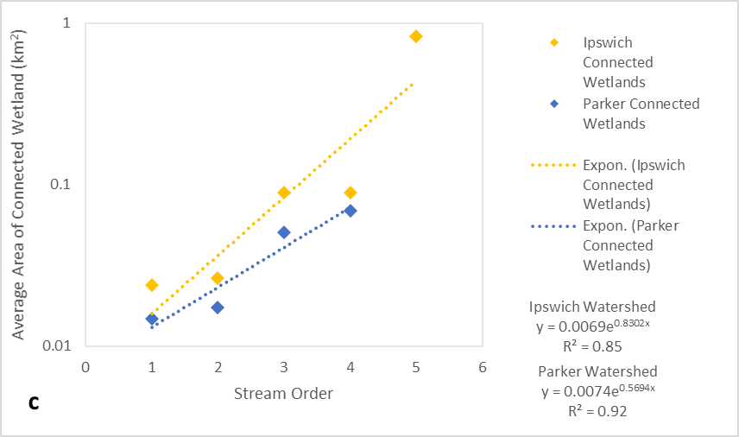

Figure 4. Scaling relationships for connected wetlands in the Ipswich (yellow) and Parker (blue) River watersheds.

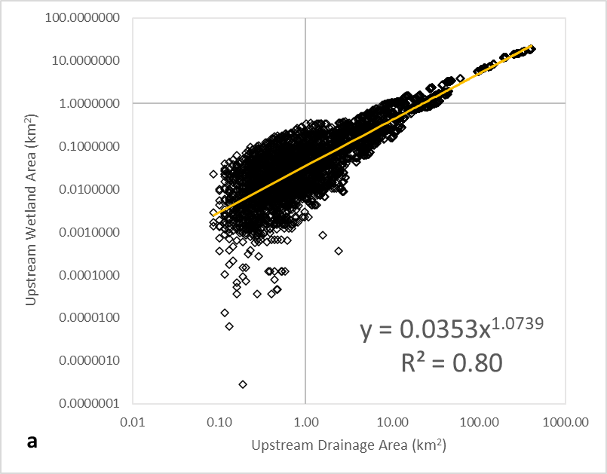 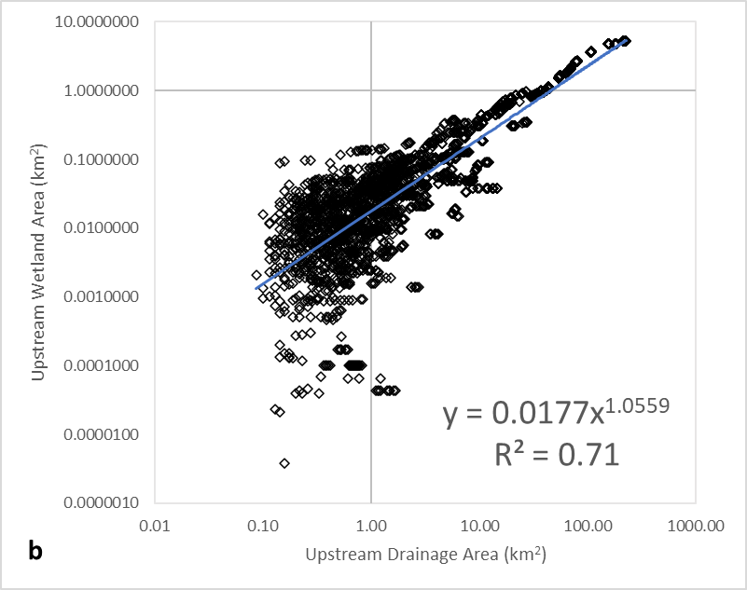

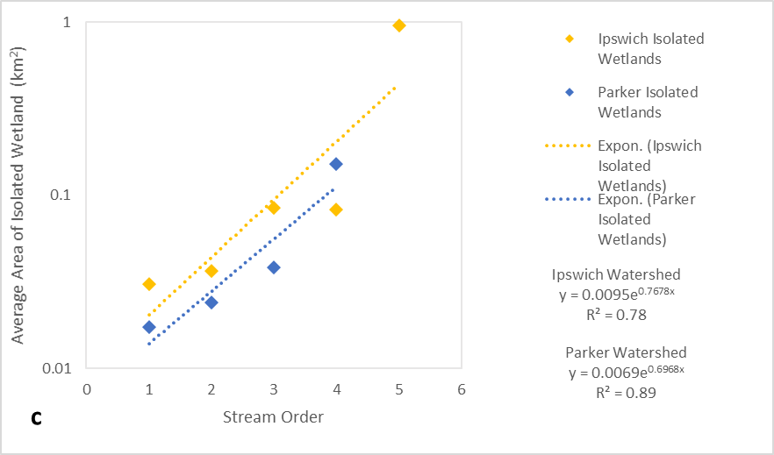

Figure 5. Scaling relationships for isolated wetlands in the Ipswich (yellow) and Parker (blue) River watersheds.

Table 1. Trendline slopes for each wetland type-watershed combination.

|  |  |  |
| --- | --- | --- |
| Regression Slopes | Ipswich | Parker |
| Fluvial | 1.1851 | 1.2259 |
| Connected | 1.0779 | 0.9942 |
| Isolated | 1.0739 | 1.0559 |

Table 2. Area Ratios for each wetland type-watershed combination.

|  |  |  |
| --- | --- | --- |
| Area Ratios (RA) | Ipswich | Parker |
| Fluvial | 2.6610 | 2.6408 |
| Connected | 2.2938 | 1.7672 |
| Isolated | 2.1550 | 2.0073 |

1. **Conclusion**

Similar scaling relationships appear to dominate the two adjacent watersheds and emphasize the influence of fluvial wetlands. By characterizing upstream drainage area for each pixel in the data, it is clear that greater variation in upstream wetland area occurs in the headwaters. The smaller Parker River watershed offers unique results due to the mouth of the river lying far inland with an abundance of saltwater wetlands. This project contributed to an important base of knowledge on the scaling of surface hydrologic processes in coastal watersheds for use in further explaining and modeling of nutrient dynamics and biogeochemical flows within the river network.

1. **Acknowledgements**

I thank the Edna Bailey Sussman Foundation for funding this project. Dr. Robert Gilmore Pontius, Jr. supplied advice and guidance throughout the process. Dr. Wilfred Wollheim from the Water Systems Analysis Group at the University of New Hampshire was the project supervisor. Dr. Karen Frey guided the application and reporting process of this internship.

1. **References**

Gardner, J. R., Pavelsky, T. M., & Doyle, M. W. (2019). The abundance, size, and spacing of lakes and reservoirs connected to river networks. *Geophysical Research Letters*, *46*(5), 2592-2601.

Morse, N. B., & Wollheim, W. M. (2014). Climate variability masks the impacts of land use change on nutrient export in a suburbanizing watershed. *Biogeochemistry*, *121*(1), 45-59.

Wollheim, W. M., Harms, T. K., Peterson, B. J., Morkeski, K., Hopkinson, C. S., Stewart, R. J., & Briggs, M. A. (2014). Nitrate uptake dynamics of surface transient storage in stream channels and fluvial wetlands. *Biogeochemistry*, *120*(1-3), 239-257.