flaskLearn folder

(venv)

pip freeze > requirements.txt 显示下载的包

pip install -r requirements.txt 下载requirements里面所有的包

POST

普通请求体

v2

postman

里

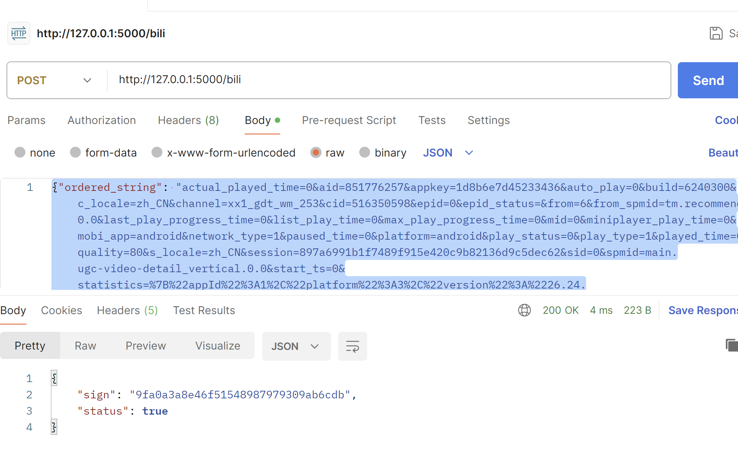

{"ordered_string": "actual_played_time=0&aid=851776257&appkey=1d8b6e7d45233436&auto_play=0&build=6240300&c_locale=zh_CN&channel=xx1_gdt_wm_253&cid=516350598&epid=0&epid_status=&from=6&from_spmid=tm.recommend.0.0&last_play_progress_time=0&list_play_time=0&max_play_progress_time=0&mid=0&miniplayer_play_time=0&mobi_app=android&network_type=1&paused_time=0&platform=android&play_status=0&play_type=1&played_time=0&quality=80&s_locale=zh_CN&session=897a6991b1f7489f915e420c9b82136d9c5dec62&sid=0&spmid=main.ugc-video-detail_vertical.0.0&start_ts=0&statistics=%7B%22appId%22%3A1%2C%22platform%22%3A3%2C%22version%22%3A%2226.24.0%22%2C%22abtest%22%3A%22%22%7D&sub_type=0&total_time=0&ts=1655220112&type=3&user_status=0&video_duration=232"}

json请求体

agents