L298N motor driver board module ( photoelectric isolation ) ( new original L298N chip )
http://www.nbglin.com/l298ng.htm

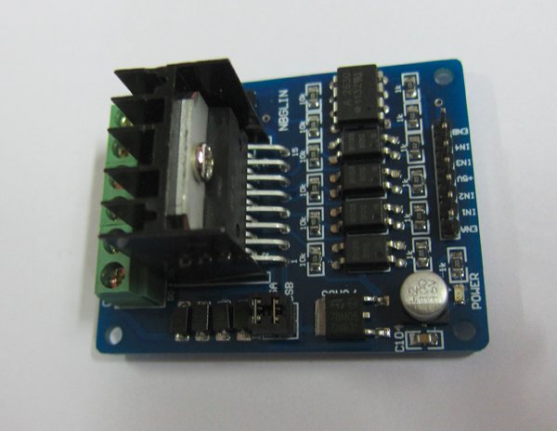

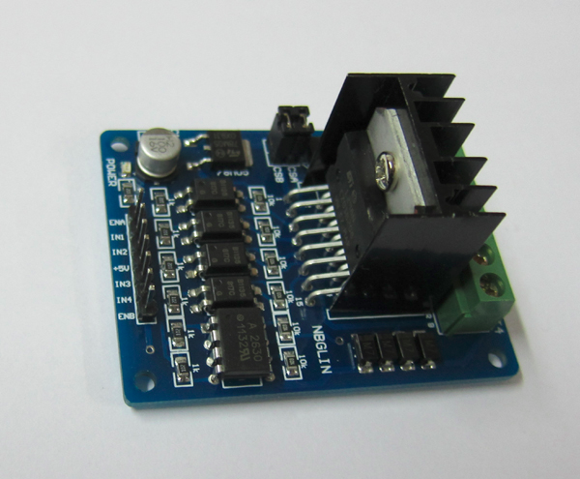

【Product features】
The L298N drive module, using the original L298N chip of ST company, can directly drive two 3-24V DC motor speed and direction, but also can control 1 4 line 2 phase stepper motor.Using high-speed optocoupler isolation circuit, control signal of support for 5V or 3.3V voltage.
Parameters are as follows:
1. motor drive chip: ST's original L298N double H bridge driver chip
2. L298N power supply voltage ( VCC GND ): + 5.5V ~ 24V
3. driving part of the peak current: 2A
4. control signal end of power supply voltage: 3-5.5V
5. control signal voltage: high 3-5.5V low 0V
6 maximum power consumption: 20W
7. PCB size ( length * width * height ): 58mm*45mm*30mm
8. Between the positioning hole distance: are 39mm and 52mm
9. weight: 28g
【The photoelectric isolation circuit】
Enable pins ( ENA, ENB ) high-speed optocoupler HCPL2630 isolation of PWM signal input,
support PWM frequencies up to 10MHz.
The IN1, IN2, IN3, IN4 use of PC817 photoelectric isolation, the motor drive part and a control
signal is completely isolated.
【about how to use】
1, Stepping motor driver：
Enable pins ENA and ENB is high or not effective, ENA IN1 ( A1 ) and IN2 ( A2 ) enables the end, ENB IN3
( B1 ) and IN4 ( B2 ) enables the end. OUT1, OUT2, OUT3, OUT4 are respectively connected to the stepper
motor ABCD 4 line.Stepper motor control logic as shown below, where A, B, C, D four coils of stepping
motor, 1 said the current through the, 0 means that there is no current flows through the. Coil connection
diagram as shown below (in the four phase stepper motor as an example ).
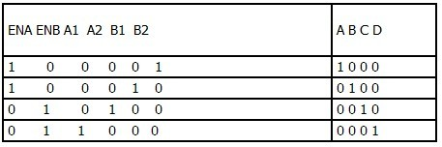

2, Drive 2 DC motor：
From the L298N enable pins ( ENA, ENB ) PWM input signal, can adjust the speed of DC motor.
CSA and CSB are current detecting foot, when using removable pin cap, in series with a current sensor.

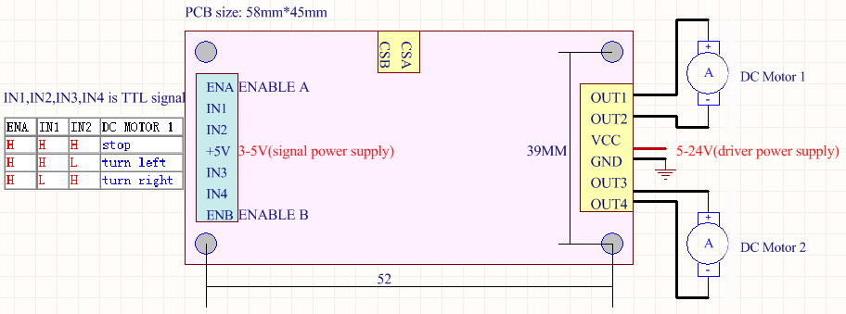

3,circuit diagram:

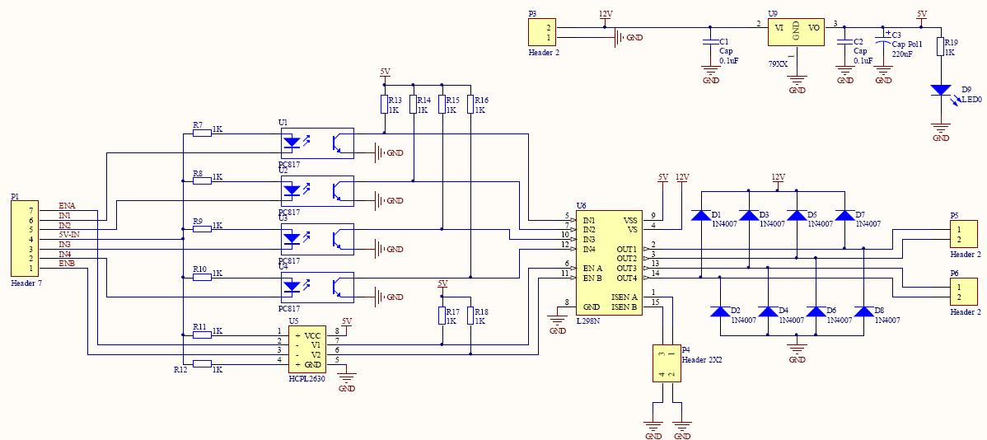
http://www.nbglin.com/cpjsimage/l298ngsch2.jpg

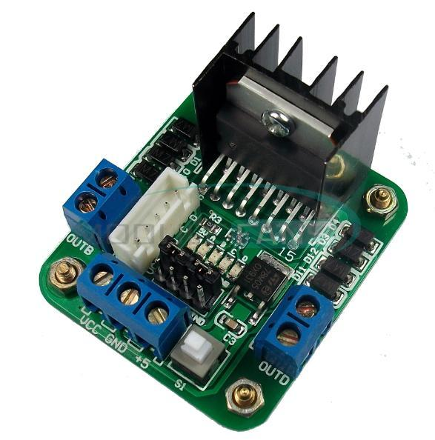

https://es.aliexpress.com/item/New-L298N-Dual-H-Bridge-DC-Stepper-Motor-L298N-Drive-Controller-Board-Module/1859102563.html?aff_platform=promotion&cpt=1499049648092&sk=zvN3jY3&aff_trace_key=24e4f597f5ae40d6bed29fcb447813bc-1499049648092-01351-zvN3jY3

