**Term Project- COMP214**

**Group Members:**

* Anupriya
* Isaac Ibiniyi
* Joan Suaverdez
* Kevin Morison

**Problem Domain:** Healthcare Data Management System

**Description:** The project aims to create a comprehensive patient file management system for a healthcare facility. It involves developing a relational database with tables for patient records, medical staff information, treatments, and billing. Sample data is inserted into these tables to simulate real-world scenarios. Stored procedures and functions are utilized for specific database activities, such as updating patient information and calculating billing amounts. A package called health_pkg is developed to organize and access patient-related information. Triggers are set up to automatically create billing records for new patient entries. The overall goal is to establish a robust healthcare data management system focusing on data integrity, security, and ease of use to enhance the quality of healthcare services provided by the facility.

**ER Diagram:**

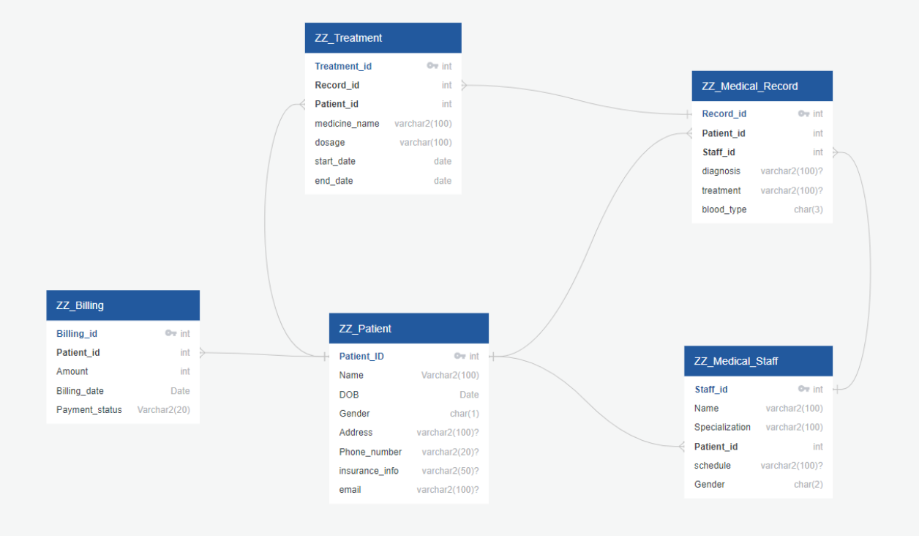

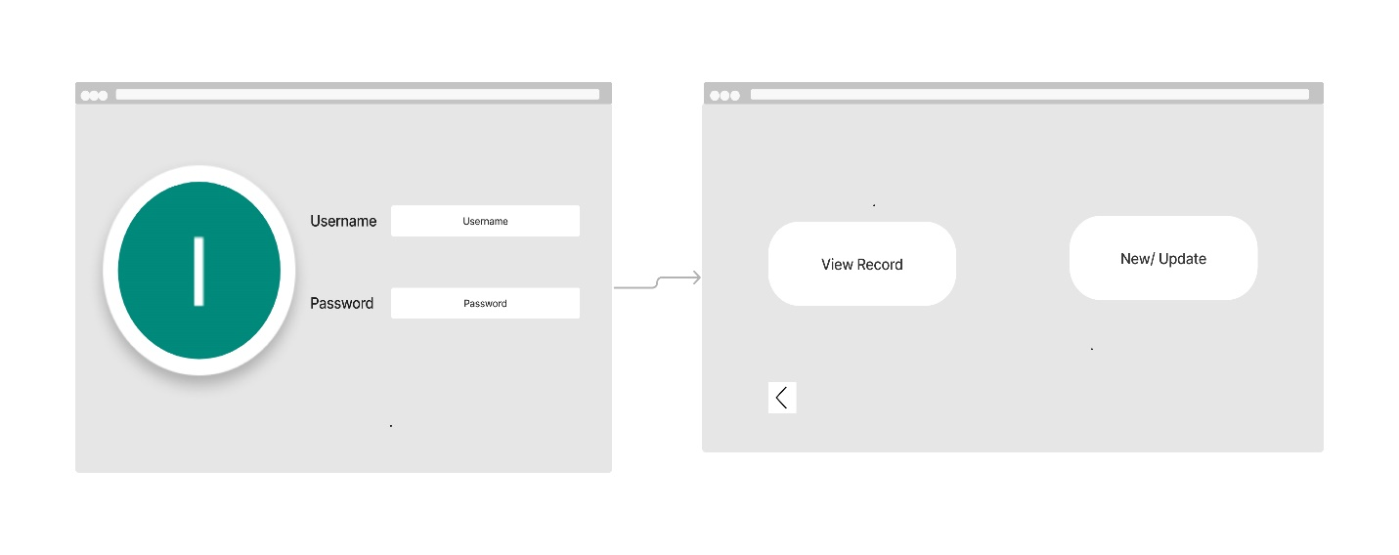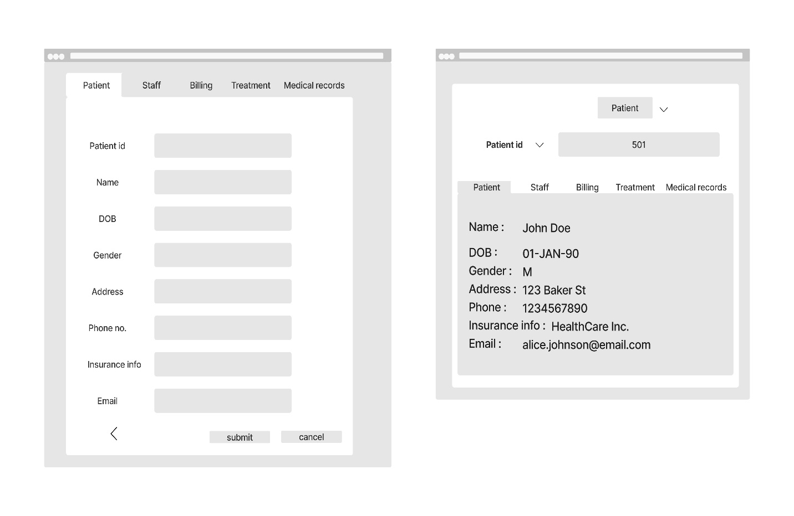**Print Screens of Mock up:**

