***"JUST AS ENERGY IS THE BASIS OF LIFE ITSELF, AND IDEAS THE SOURCE OF INNOVATION, SO IS INNOVATION A VITAL SPARK OF ALL HUMAN CHANGE, IMPROVEMENT AND PROGRESS. "***

***- TED LEVITT***

# Meals on Wheels!!!!

In this fast moving world robots can replace humans in providing reliable waitressing service in restaurants and hotels. Friendly and attentive waiters are a key ingredient in the running of a successful restaurant. There is a need for the food to be delivered in a faster and an efficient manner. This work is made easier with the help of a **SERVBOT**. This robot is designed to accomplish the task of serving the food to people in restaurants in a more systematic and an efficient manner.

This robot can be operated in two modes which can be controlled using a remote wirelessly. The first mode is the autonomous mode where the robot follows a particular path (**Line Follower**) reaches the destination, serves food and retraces its path. The second mode is the manually controlled mode where the user controls the **SERVBOT.**

The robot also manoeuvres its way along a safer path avoiding any obstacles (**Obstacle Avoider**) in the real world and is completely autonomous. This avoidance of obstacles is done with the help of infra-red (IR) sensors interfaced with the robot.

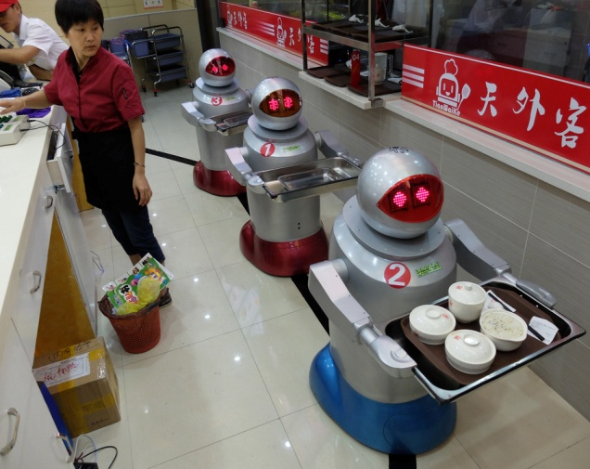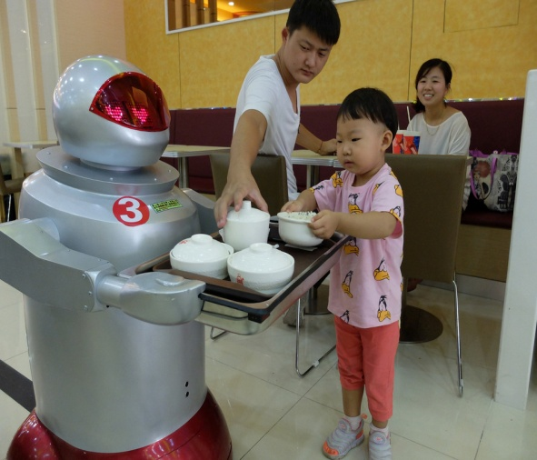

**BASIC PARTS OF THE ROBOT:**

**DESIGN BLOCKS OF THE SERVBOT:**

**BLOCK 1:**

SERVBOT with wheels and castor which can move.

**BLOCK 2:**

Embedded board to control unit -**Arduino board**

IR Receiver Module

Obstacle Avoidance and Line Follower

IR Sensors

DC Motors

**BLOCK 3:**

**CONTROL UNIT**-Laptop to control the SERVBOT and to communicate with the embedded board.

**BLOCK 4:**

**OUTPUT UNIT**

LCD Display

**Components required for the each design block of the robot:**

**Block 1: (**Model of the Servbot**)**

* Motor 60/ 9v x2.
* Suitable wheel with radius 4cm x2.
* Castor wheel.
* Arduino UNO board, Driver circuit.

**Block 2:** (Input Unit)

* IR Sensors (red LED and Photodiode) x4.
* IR Receiver Module 38KHz, TSOP 1738 Based (S/N: 113510).
* Analog Sound Sensor (Condenser MIC Type).
* Remote Control-5 (RC-5 TV remote).

**Block 3:** (Control unit)

* Minimum specification, 2GB RAM, Windows platform.

**Block 4:** (Output unit)

* LCD display (16x2).

**KIT CONTENTS:**

Mother Board LCD Module

Arduino Duemilanove (S/N: 129011) 16x2 Character LCD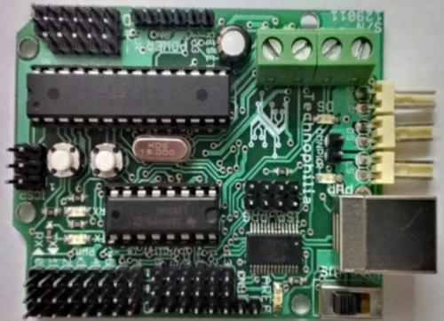 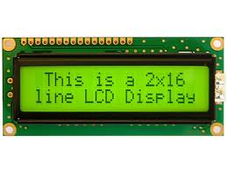

Analog Sound Sensor IR Receiver Module

Condenser MIC Type 38KHz, TSOP 1738 Based

(S/N: 113510)

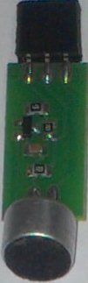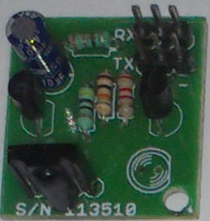

Geared DC Motors Caster Wheels

60RPM, BO Series L-Type 360 Degree free wheel

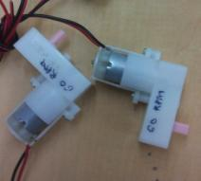 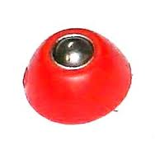

Batteries USB Cable

(9V, ZnC, Non-Rechargeable) (A-B Type)

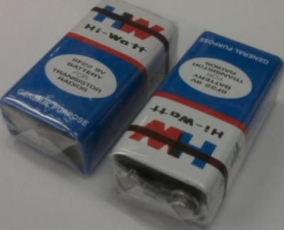 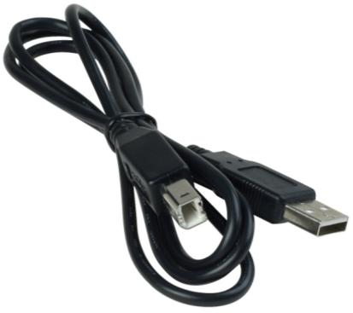

IR Receiver Module and Remote Control-5 (RC-5)

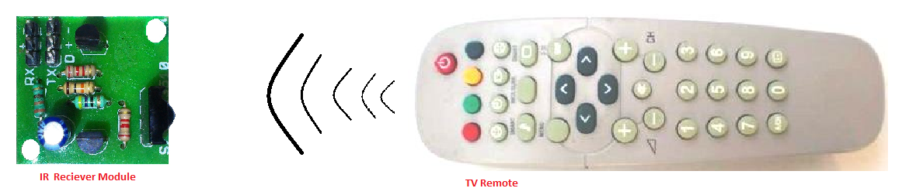

Wheels Sensor Cable

(3 to 3 core type)

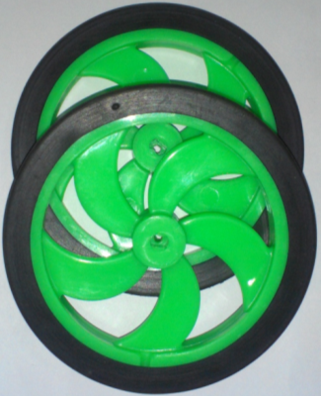 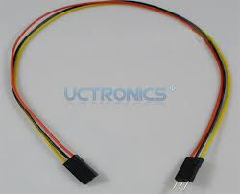

Audio Connector Screw Driver

3.5mm Universal

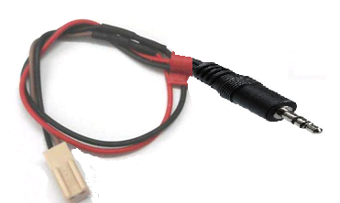 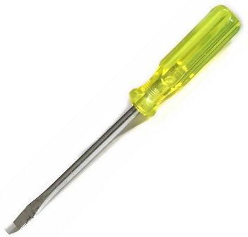

ARDUINO BOARD PIN DIAGRAM:

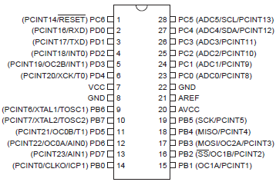

**Design and connection between different blocks of the robot:**

**BOT Assembling (Block 1) -**

The wheels to the shaft of the motors are fixed using the thin & long screw and the caster wheel is placed on the lower plate using nut & bolt.

The Batteries are placed at the upper side of the chassis.The Arduino board is then mounted on the robot.

**Input unit (Block 2) -**

The IR Receiver module is placed in the robot. The IR sensors are interfaced with the Arduino board using connecting jumper wires.

**Control unit (Block 3) -**

The Arduino board is connected with the computer with the help of USB cable (A-B type).

**Display unit (Block 4) -**

On top plate the LCD is mounted by using nut bolt and spacer. The LCD display is then interfaced with the Arduino board using jumper wires**.**

**KIT ASSEMBLING:**

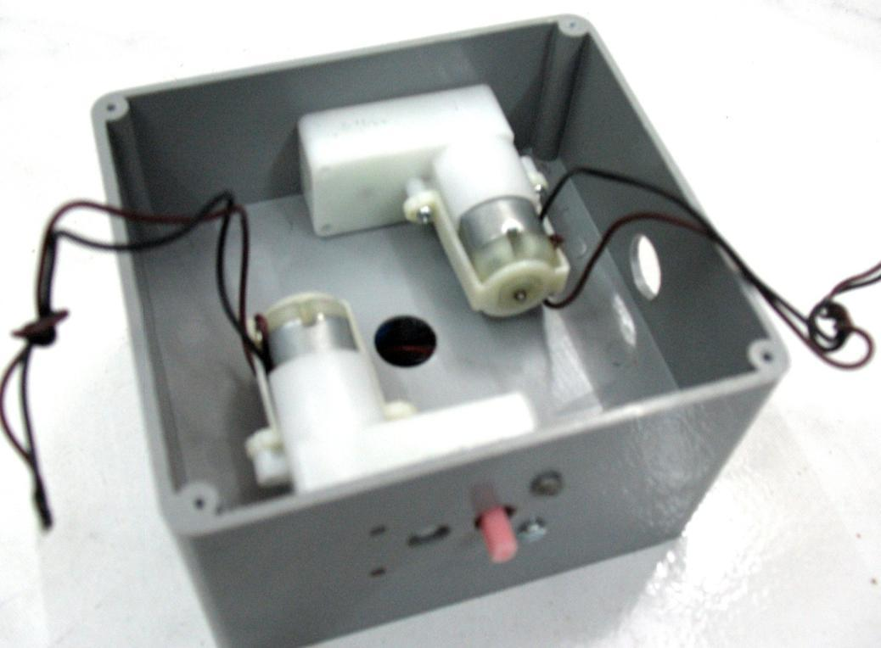 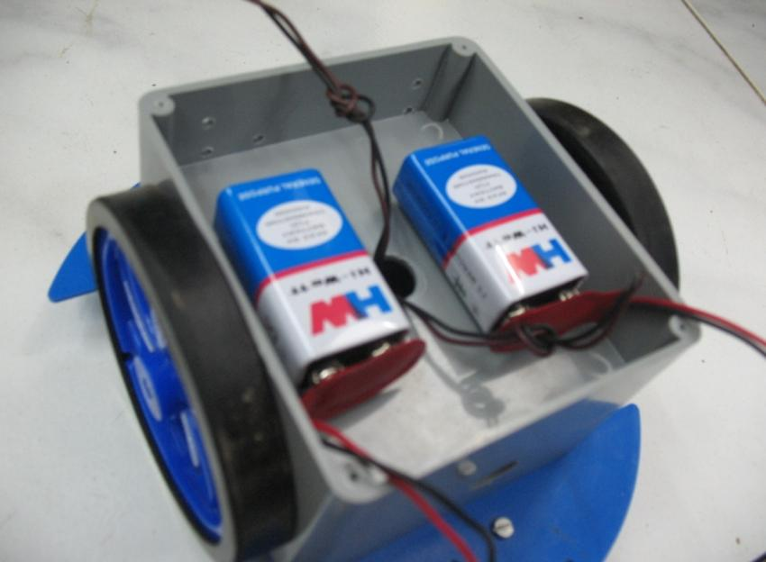

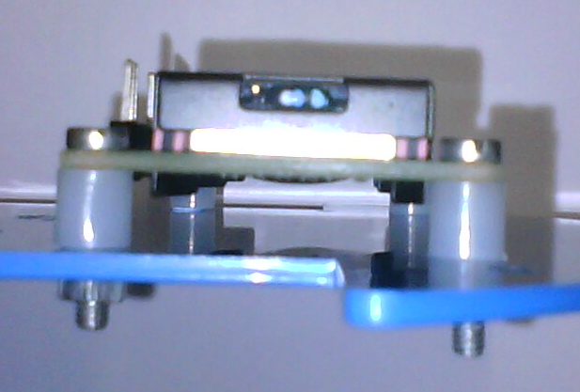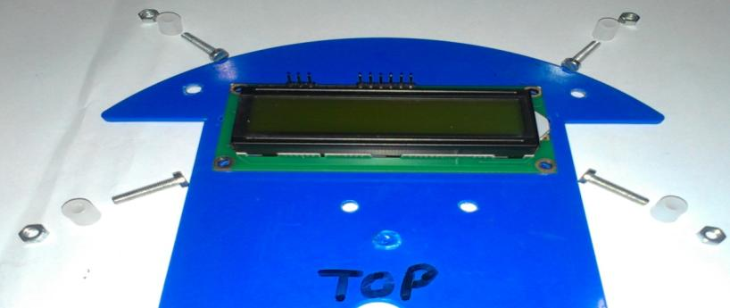

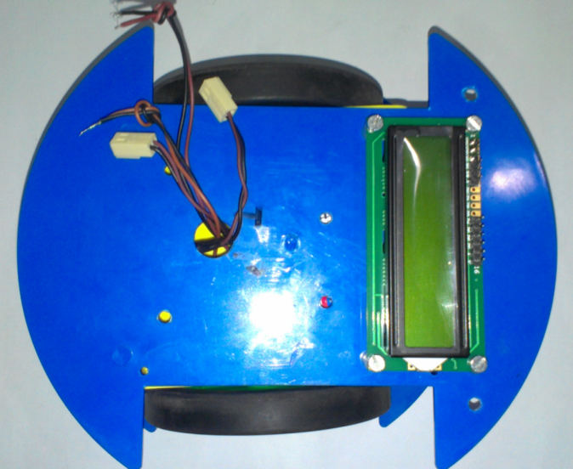 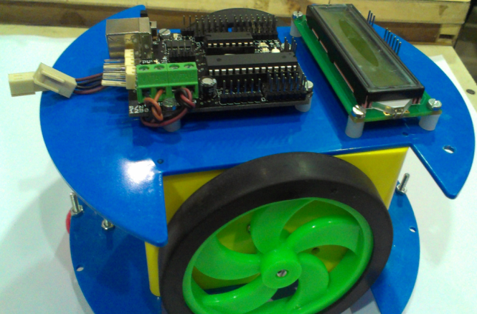

**THE FINAL LOOK OF THE ASSEMBLED BOT:**

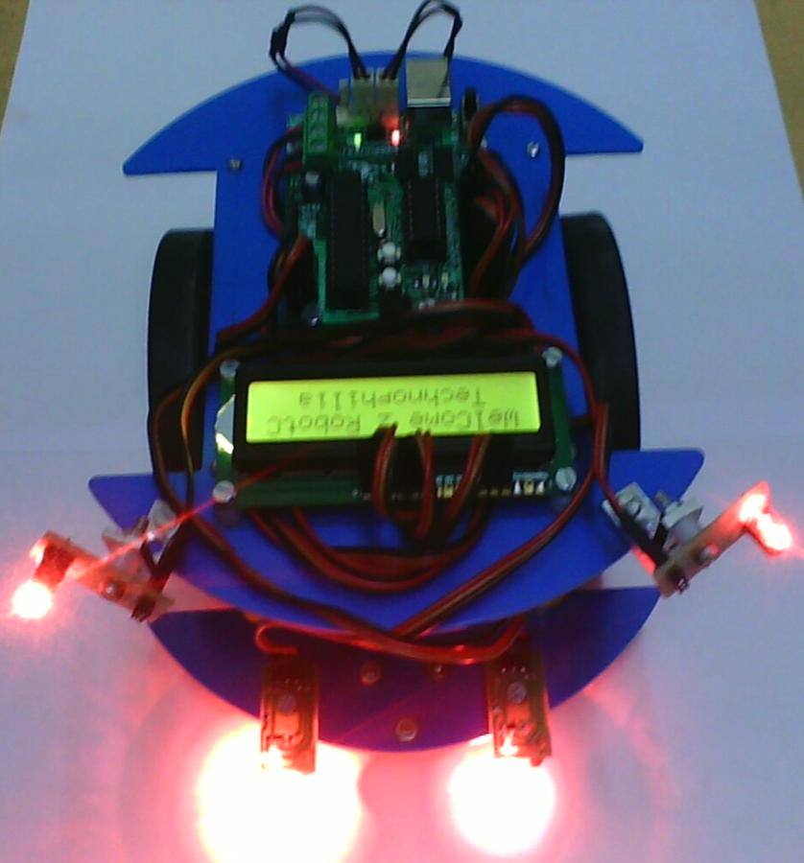

**OUR MULTIPURPOSE SERVBOT:**

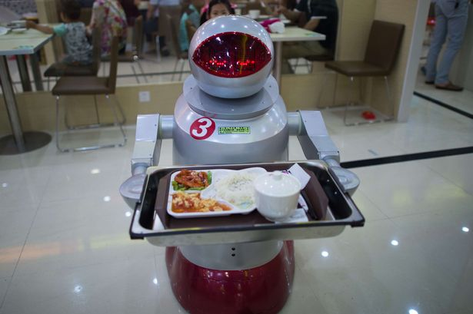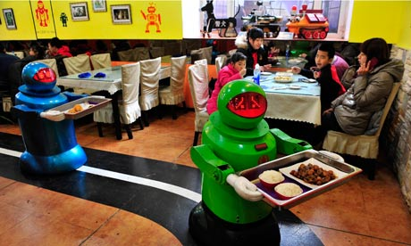

**CONCLUSION:**

The bot provides multiple ways for serving food to the customers in a restaurant. It can be both remote controlled by the user and also provide services along a particular path. Though our bot is restricted to serving food, its features can also be modified and updated for implementation in other fields like product distribution in industries, distributing medicines regularly after a specified time interval to patients in a hospital, etc. Hence, the future scope of this bot is immensely diverse as it can be made to adapt to any field possible. It can be utilised in Medical, Science, Industrial, Educational and many other fields. Thereby enabling the human resource to be implemented for more technical aspects instead of these simple and time consuming tasks.

This bot would provide the perfect solution for the increase in demand for human resource in industries and restaurants.