TASK 8: WEBSITE DEVELOPMENT

Jack Sun

Applied Information Technology

Como Secondary College



Table of Contents

Phase 1: Planning 2

* Brainstorm 2
* Task 3
* Purpose 3
* Target Audience Characteristics 3
* Target Audience Criteria 3
* Audience Requirements 4

Phase 2: Sitemap 4

Phase 3: Development 4

Phase 4: Evaluation 4

Bibliography 4

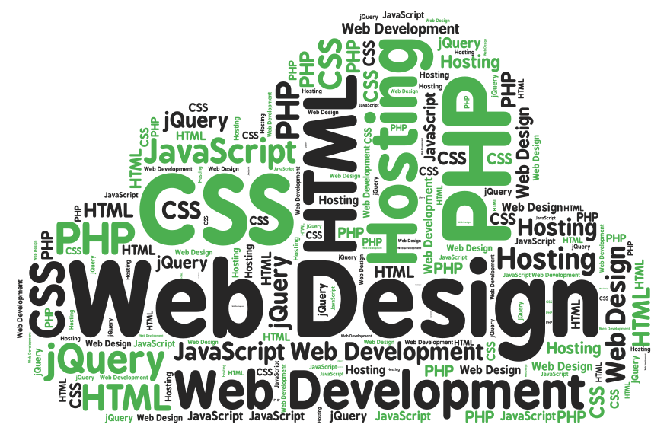

# Phase 1: Planning

## Brainstorm

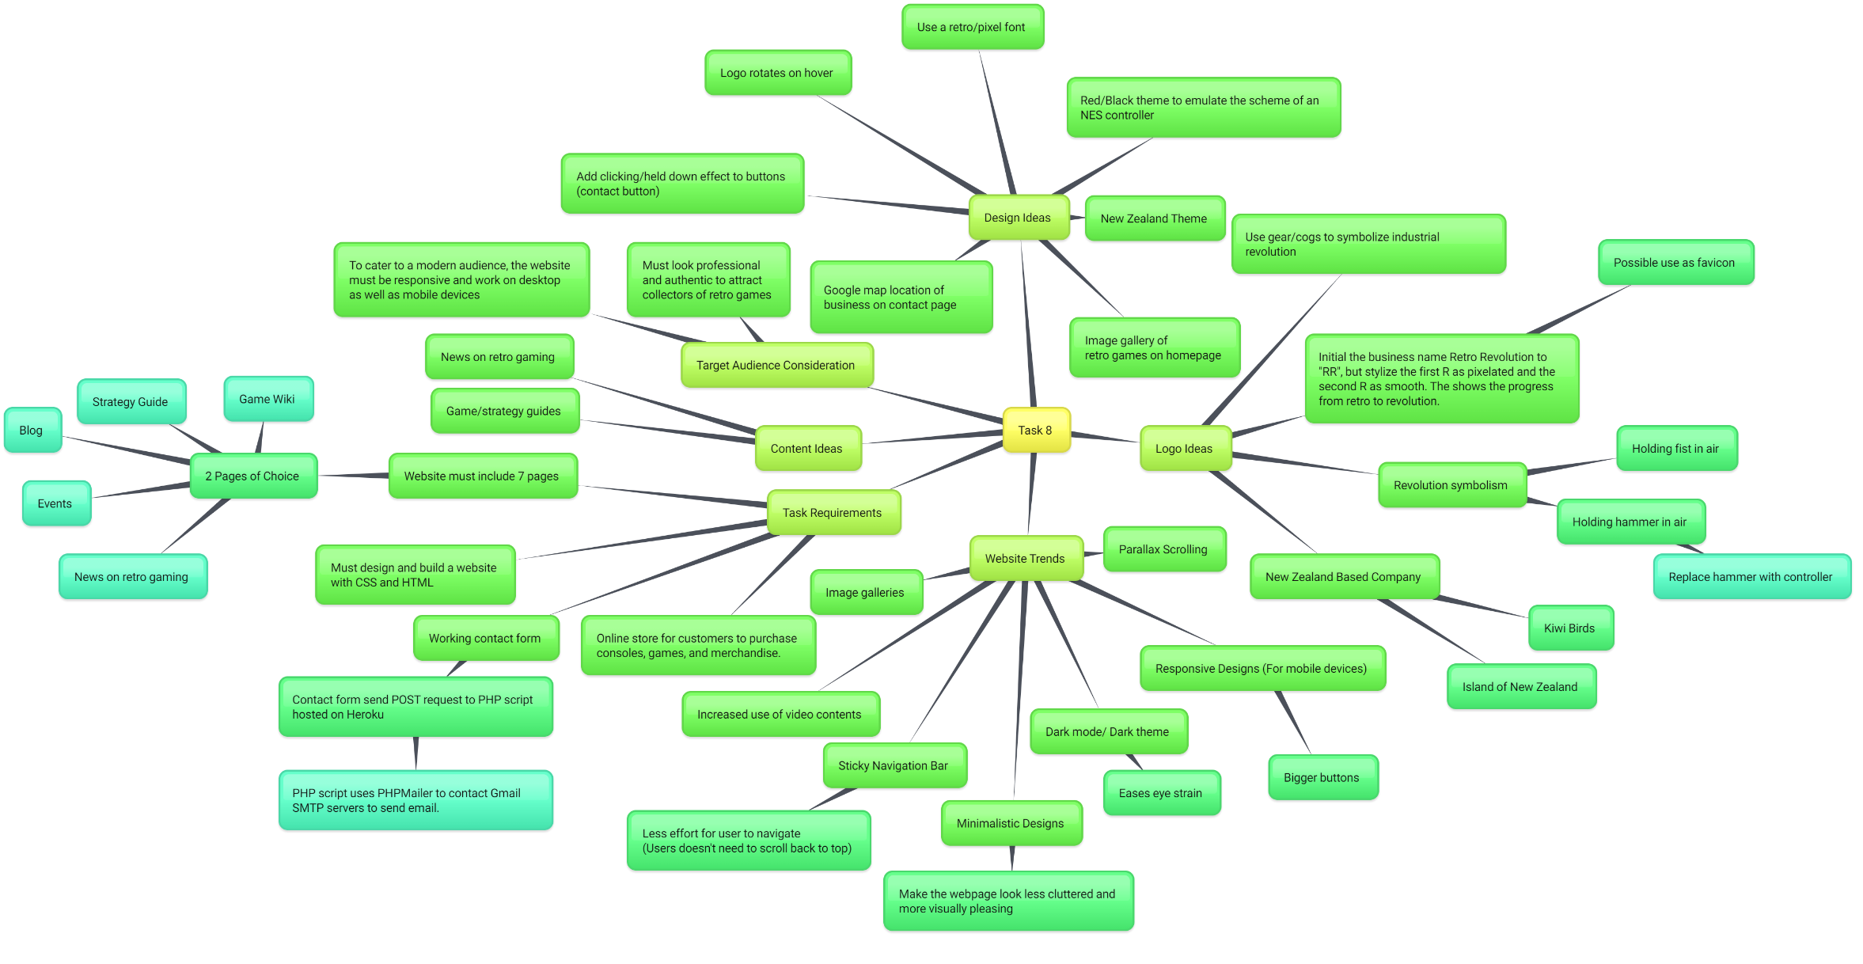

## Task

In this assignment, I will be developing a website for the business **Retro Revolution**.

## Purpose

The purpose of the website that I am building is to provide Retro Revolution with an accessible and effective platform to sell their merchandise, advertise their business and events, as well as be able to easily provide retro gaming enthusiasts with the latest news and information on retro gaming. By having a website, Retro Revolution is able to promote itself to potential customers worldwide and drastically increase their customer base by allowing most people in the world to be able to order products off their website and have it shipped out.

## Target Audience Characteristics

* Age: My website with be targeting adults between the ages of 25 to 35. Younger audiences are more likely attracted to newer generation game consoles such as the Nintendo Switch and the Sony PlayStation 5, due to high computation powers leading to more complex games and better graphics.
* Gender: According to extensive research, males are more predominantly interested in retro gaming and generally video games overall.
* Income: The business and the website will be targeting middle-upper class people. Authentic retro games are no longer in production
* Location: As the business is based in Auckland, New Zealand, the website will mainly advertise to audiences in the Auckland area. That being said, the website should also focus on a more generic worldwide audience, as one of the website’s goals is to sell products and merchandise, which, through the website, can be purchased by and shipped to international customers.

## Target Audience Criteria

* Age:
* Gender:
* Income:
* Location:

## Audience Requirements (Software)

* Operating System
  + First and foremost, users will need an operating system capable of supporting a web browser to access my website.
* Web browser
  + A web browser is a piece of software application that allows users to access the World Wide Web and display contents of webpage.
  + There are many different web browsers made by different companies. To maximise compatibility, the user should use a modern web browser like **Google Chrome**.
  + 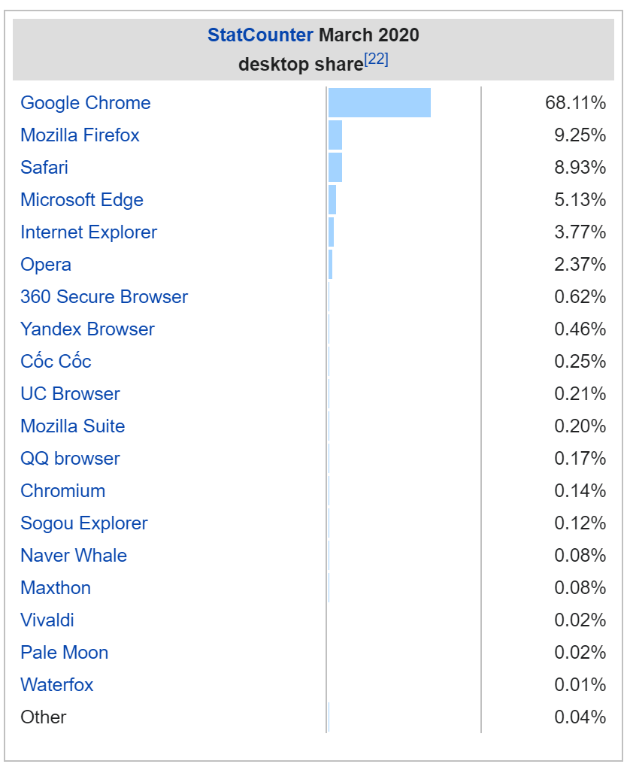

## Audience Requirements (Hardware)

* Computer (Desktop/Laptop)
* Mobile Device

# Phase 2: Sitemap

# Phase 3: Development

# Phase 4: Evaluation

# Bibliography