DataInsight Agent
COMPSCI 767 Assignment 2 - Intelligent CSV Cleaning and Analysis Agent
GitHub repository: https://github.com/dsfga/datainsight-agent
System Design
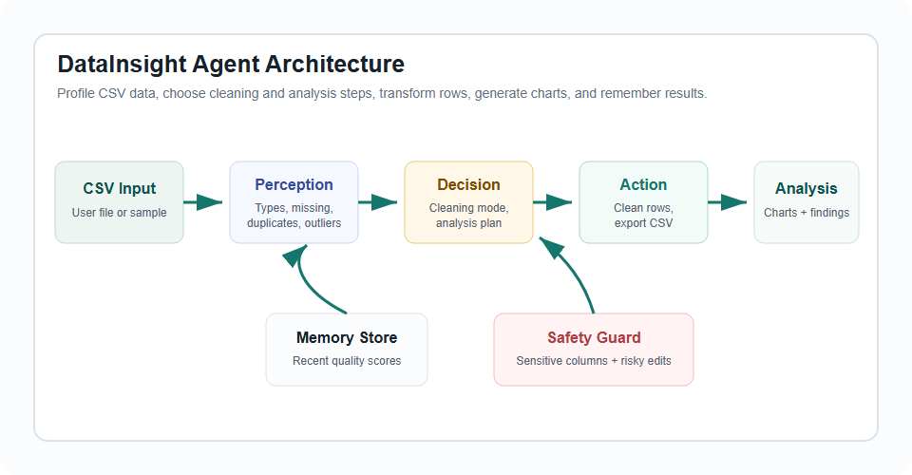
Design Explanation
- Perception parses CSV rows and profiles column types, missing values, duplicate rows, category variation, outliers, and possible sensitive columns.
- Decision logic chooses a cleaning plan from conservative, balanced, or aggressive mode and selects analysis steps from available numeric, categorical, and date fields.
- Action transforms the dataset, exports cleaned CSV, renders charts, summarizes findings, and records a lightweight memory checkpoint.
- Safety mechanisms keep processing local, flag possible sensitive columns, and raise risk when cleaning may change numeric meaning.

How the Prototype Works
Screenshots from the running local web app
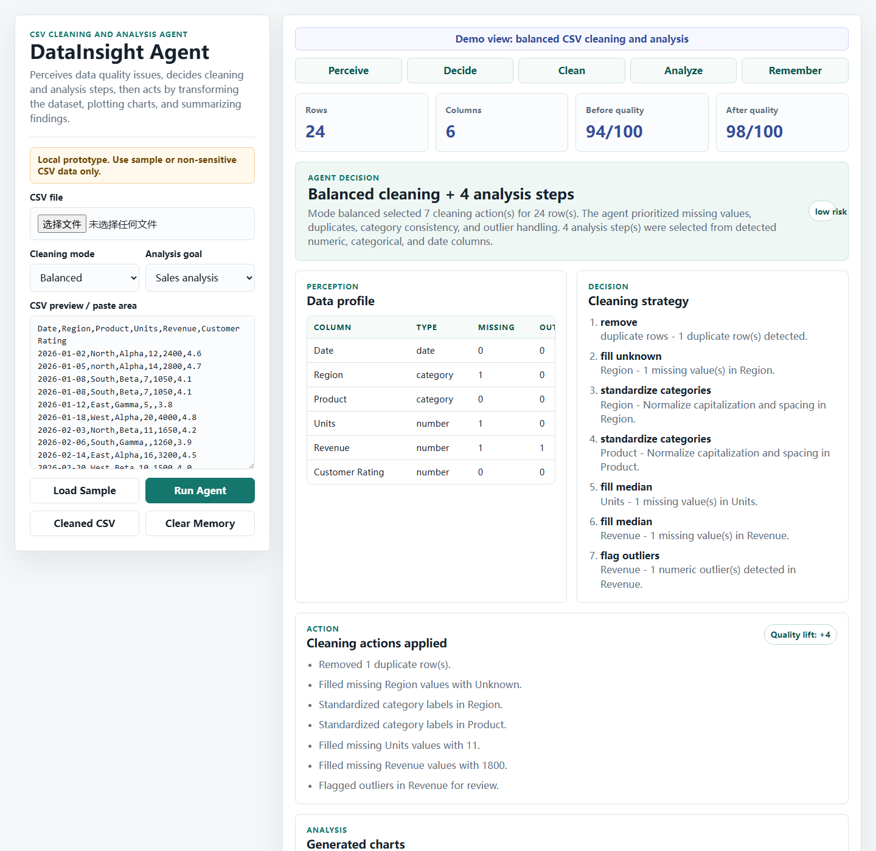 | 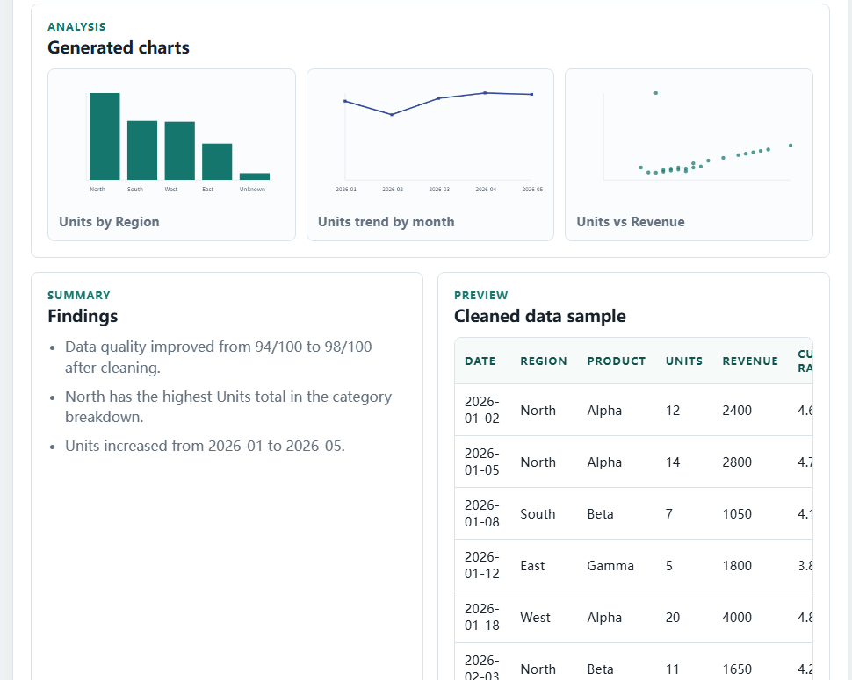
Balanced mode: the agent perceives data quality problems and chooses seven low-risk cleaning actions. | Results view: the agent acts by plotting charts, previewing cleaned data, and summarizing findings.
Workflow Evidence
- Run Agent produces a visible perceive-decide-act pipeline from the sample CSV.
- Balanced mode flags outliers for review; aggressive mode caps them and marks medium risk.
- The chart panel shows the agent selected analysis actions based on detected columns.
- The cleaned CSV export and memory log show concrete actions and stateful behavior.

