# Spring Boot:

Spring Boot has taken Spring framework to the next level. It has drastically reduced the configuration and setup time required for spring projects.

You can setup a project with almost zero configuration and start building the things for your application.

## Spring Initializer

With the help of Spring Initializr, we can easily generate the structure of the Spring Boot Project. It offers extensible API for creating JVM-based projects.

### Spring Initializr Modules

* **initializr-actuator**: It provides additional information and statistics on project generation. It is an optional module.
* **initializr-bom**: In this module, BOM stands for Bill Of Materials. In Spring Boot, BOM is a special kind of POM that is used to control the versions of a project's dependencies. It provides a central place to define and update those versions. It provides flexibility to add a dependency in our module without worrying about the versions.  
  Outside the software world, the BOM is a list of parts, items, assemblies, and other materials required to create products. It explains what, how, and where to collect required materials.
* **initializr-docs**: It provides documentation.
* **initializr-generator**: It is a core project generation library.
* **initializr-generator-spring**:
* **initializr-generator-test**: It provides a test infrastructure for project generation.
* **initializr-metadata**: It provides metadata infrastructure for various aspects of the projects.
* **initializr-service-example**: It provides custom instances.
* **initializr-version-resolver**: It is an optional module to extract version numbers from an arbitrary POM.
* **initializr-web**: It provides web endpoints for third party clients.

## Spring Boot Application

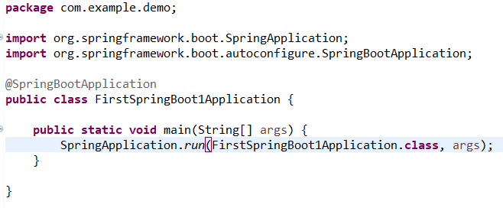

It contains a simple annotation called **@SpringBootApplication** which is a combination of the following more specific spring annotations –

**@Configuration** : Any class annotated with @Configuration annotation is bootstrapped by Spring and is also considered as a source of other bean definitions.

**@EnableAutoConfiguration** : This annotation tells Spring to automatically configure your application based on the dependencies that you have added in the pom.xml file. For example, If spring-data-jpa or spring-jdbc is in the classpath, then it automatically tries to configure a DataSource by reading the database properties from application.properties file.

**@ComponentScan** : It tells Spring to scan and bootstrap other components defined in the current package (com.example.easynotes) and all the sub-packages.

The main() method calls Spring Boot’s SpringApplication.run() method to launch the appli

cation.