AC11002 Assignment 3: Web Site Build & Demonstration :

**WeightLoss**

Javier, Jonathan & Scott (Team 20)

**Contents**

1. Introduction
2. Explanation of the Structure of the Site
3. Roles and Responsibilities
4. User Guide
5. Design Discussions
6. Personas
7. Attention to Standards
8. Improvements
9. Conclusion

**Introduction**

WeightLoss is an easy to use Website that provides an aid for those who find it difficult to lose weight or gain muscle on their own. We decided upon creating such a website as losing weight is an interest to a vast majority of people today. We feel the best way to losing weight is through a healthy diet and a few exercise tips that you can find within our website. The user may also find that a little bit of motivation from examples of those who have succeeded using the fitness plans in our website will encourage the user to achieve your goals.

Being able to accomplish what the project expected of us was a challenging task. Neither of us had ever coded html or css before, and had little coding experience in general. However, after tough work, we managed to work create a website which we think is suitable for the users we are targeting.

**Explanation of the structure of the site**

The Website consists of 4 easy to access pages. With the use of Tabs located at the top of each page, the user can effortlessly transfer from one page to another depending on their preference. The website was coded in HTML and CSS alone. Although no member of our team had coded either of the two before we still managed to overcome any problems and produce the final outcome.

Before talking about the design of each tab, we should mention that every page in the website was divided into three main parts; the header, the content area, and the footer. We accomplished this by using 3 divs which acted like blocks were we could insert all the information we needed. The header contained the name of the page and the navigation bars. The content was divided into either two or three columns, depending on the tab, and contained the main information the tab needed. Finally, the footer contains contact information for the user’s own use.

The Home Page contains the website name, ‘WeightLoss’, in large writing to be clear to the user and direct their attention to the top of the webpage. It also accommodates a large and colourful image of a healthy snack that fits in with the idea of our website of healthy eating and losing weight. Down the left-hand side of our homepage the user finds a variety of phrases that attempt to enhance the user into further pursuing the contents. At the foot of the webpage the user finds all the contact information needed for them to get in contact with the administrators.

The Exercise Page consists of 3 easy to read options that are also hyperlinks to other pages. The options displayed relate to what type of aid you are looking for: Maintaining Ones Fitness, Losing Weight and Fitness Aid for those with Disabilities. Each Link takes the user to very similar webpages. After the user has selected the type of Fitness Aid they are looking for, they are taken to a webpage that has 3 Different Rows. Headed: Beginner, Intermediate and Difficult. Under each heading the user would find different links to a list of the corresponding exercises allocated in order of difficulty.

The Diet Page consists of a simple easy to read tab which gives informs the user of which diet is the best to follow. It has some text informing the user of what diet they should follow and why. On the right side of the page, there is an image of a website that talks about the Diet. It is an interactive link that takes the user to the website, where they can look up more detailed information about the diet. We decided to make it this way since we thought it would be the best idea for the user. We are not a website that specifically tackles diet, so we thought that it would be better to have a small introduction explaining why the user should go and explore the diet.

The Motivation Page consists of Two Examples of Individuals who have previously used the website to lose weight. It shows clearly their transformation and also provides a quote from the individual praising the website.

**Roles & Responsabilities**

During the engineering of the website our group distributed roles to one another in order to spread the workload and reduce time taken.

Jonathan’s role was to come up with the design of the website before putting it into code. Using PowerPoint Presentation he was to come up with designs and colour schemes that he thought suited such a purpose. This was effective as due to already having a layout for the website, the coder was able to have a clear image in his head of the layout he had to put into code. He furthermore helped create 2 of the 3 personas that were needed, since Scott was unable to deliver his.

Javier’s was the one that coded the website using HTML and CSS. Due to being the most experienced coder in the group Javier stepped forward and used his expertise to put the design into code. Although being limited to only CSS, Javier was able to put most of the design ideas into code effectively. Furthermore, he helped come up with the original design together with Jonathan and created the persona he was assigned. Together with Jonathan, they wrote the report and made it look well presented.

Scott’s role was assigned to him at the start of the project, but his delivery was poor. He helped with a couple of ideas at the beginning of the project, but failed to complete what he was assigned.

**User Guide**

The website we created is a very simple and easy to navigate website. We believe that there is no need for a user guide. The website is self-explanatory and does not contain any complicated features which might confuse some users. Furthermore, we believe any user is capable of navigating WeightLoss, despite their level and knowledge of technology.

**Design Discussions**

We knew as a group we had to use a contrast of bright and dark colours in order to catch the user’s eye. We done a lot of research and gained many ideas from some the most popular Fitness Aid websites today. We decided to keep our home page simple and easy to comprehend:

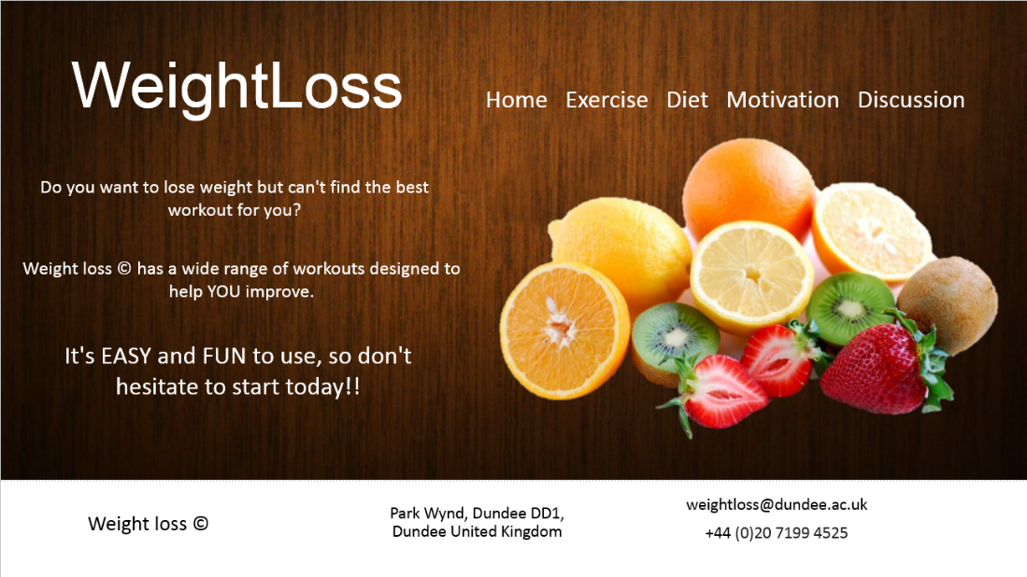

With the dark background contrasting to the vibrant colours of the fruit the home page certainly stands out. Due to it being simple and not overloaded with information we are able to get our main point across with the phrases shown.

Again, for the exercise page we wanted to keep it simple so that the user can easily find what workout they are looking for:

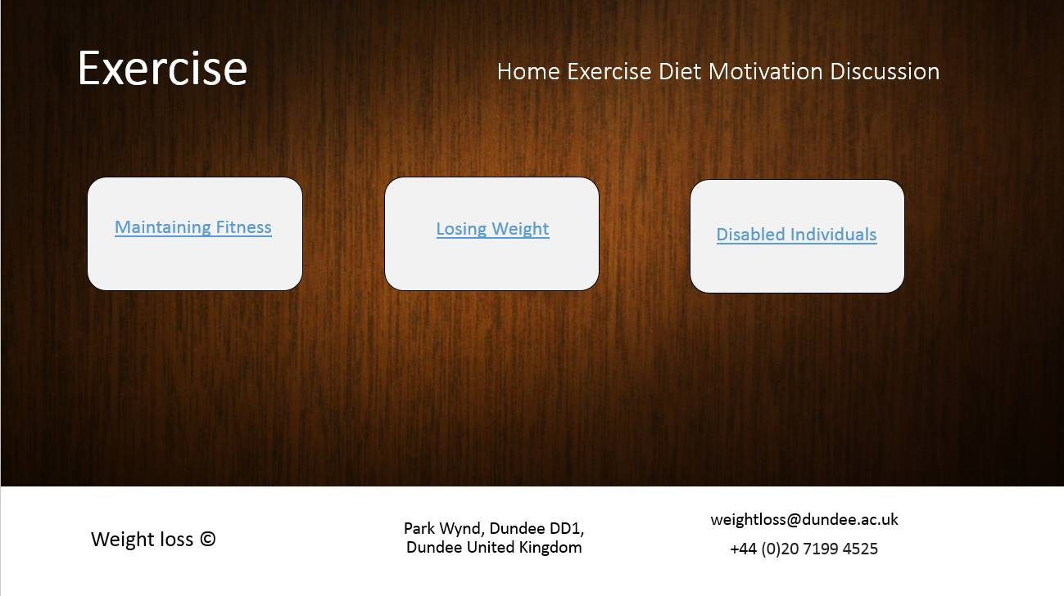

The Simplicity of this webpage allows the user to click on the Fitness Aid that they want. With only 3 options the user can’t go wrong. As you can see we have decided to keep the layout constant throughout the webpage in order not to confuse the user.

The colour scheme and layout is kept constant throughout each page of the website. The Tabs at the top of the page are also kept constant in order for the user’s ease of access throughout each webpage.

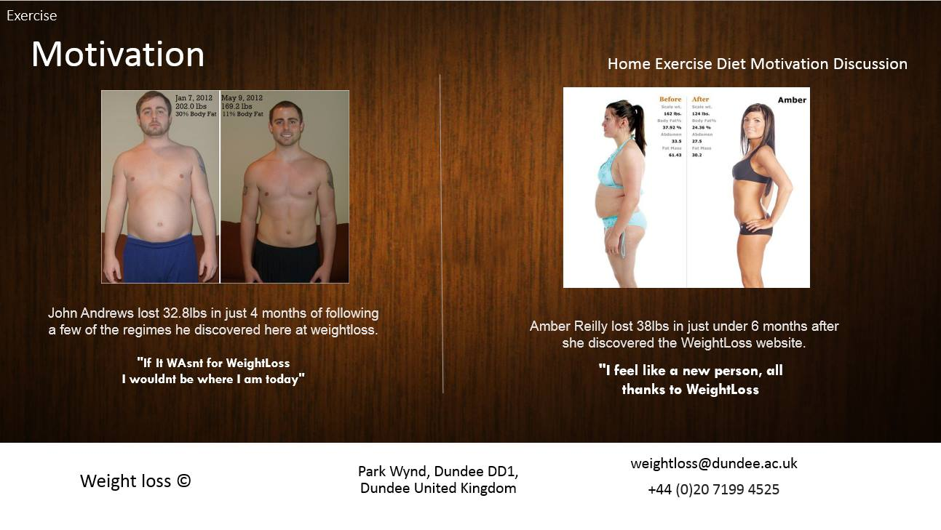

Each webpage has its similarities, with only the content being changed. This ensures the user can’t get lost within the Tabs. The constant footer allows the user to always have contact information at hand if they have any queries about the website.

**Personas**

We chose to have 3 personas that represented three different users that might want to lose weight or keep healthy. We also based our website on the three personas we chose. These were:

* Fit Persona
* Severely Overweight Persona
* Disabled Persona

These represented the range of users we wanted our website to target. Since it is a weight losing website we did not only focus it on those that have a problem with their weight, but also on those users who do not necessarily need to lose weight but want to maintain the fitness. Furthermore, we thought it would be a good idea to expand our user target and go beyond what most weight loss websites do. We attempted to include an area for those users who have any type of disabilities and who might not be able to use other weight loss plans.

**Attention to Standards**

While making the website, we made sure that we were keeping an eye on some of the standards needed. For example, we made sure that we used colours and their complementary when needed. For the Exercise tab, the three buttons in the middle were created using this approach. When you hover over them, the text changes into the complementary colour of the box’s background. This makes it simple to see and catches the user’s attention.

Furthermore, we went to a website called “validator.w3.org” in order to validate the website we created. If any errors were shown, we looked at them and tried to modify them as to achieve a validated website.

We also made sure the background was appropriate for the text that was displayed on top, and that everything was easy to read and understand. We also tried to represent the background as a table in the home page, were we added an image of fruit on it.

**Improvements**

There were a few improvements we could look forward in a better version of the website.

First of all, there were some cases in which the use of javascript was greatly needed. For the different workouts displayed, we managed to make a somewhat drop down list when clicking on the difficulty. However, we wanted to be able to click on all the difficulties and display the workouts simultaneously to be able to compare them. However, with css we were not able to accomplish this task, which is not the most important, but could still be considered an improvement.

Due to lack of time and experience, we could also improve in the layout of the website once the size of the screen is modified. As of right now, the website does not adapt to a smaller screen size, which really is an inconvenience. However, Javier has figured a way to fix and improve this problem, but as mentioned above, due to the lack of time he cannot implement it.

**Conclusion**

Each member found the task difficult throughout; even more so due to none of us having any CSS or HTML experience in the past. However, through a lot of team work and brain storming we managed to complete the task and produce a final outcome. There are many improvements that can be made, but under the time constraints and the lack of experience they could not be implemented in this project.

Overall, it has been a project that has helped us learn a lot about HTML and CSS, making us now capable of producing at least a simple easy to navigable website.