The tool is under ‘.net framework 4.0’,If you are using Windows 10 it has been installed,If using WIN7, you need download and install it yourself, If not a windows system, please use the simple version.
Function 1: Linked from FoxWeiqi/Tygem/Sina platform:
Way 1:
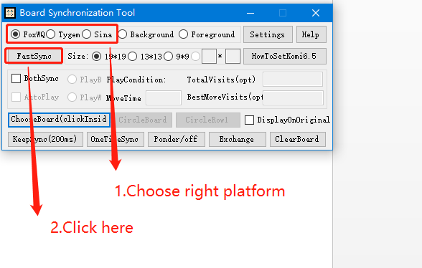

Way 2:
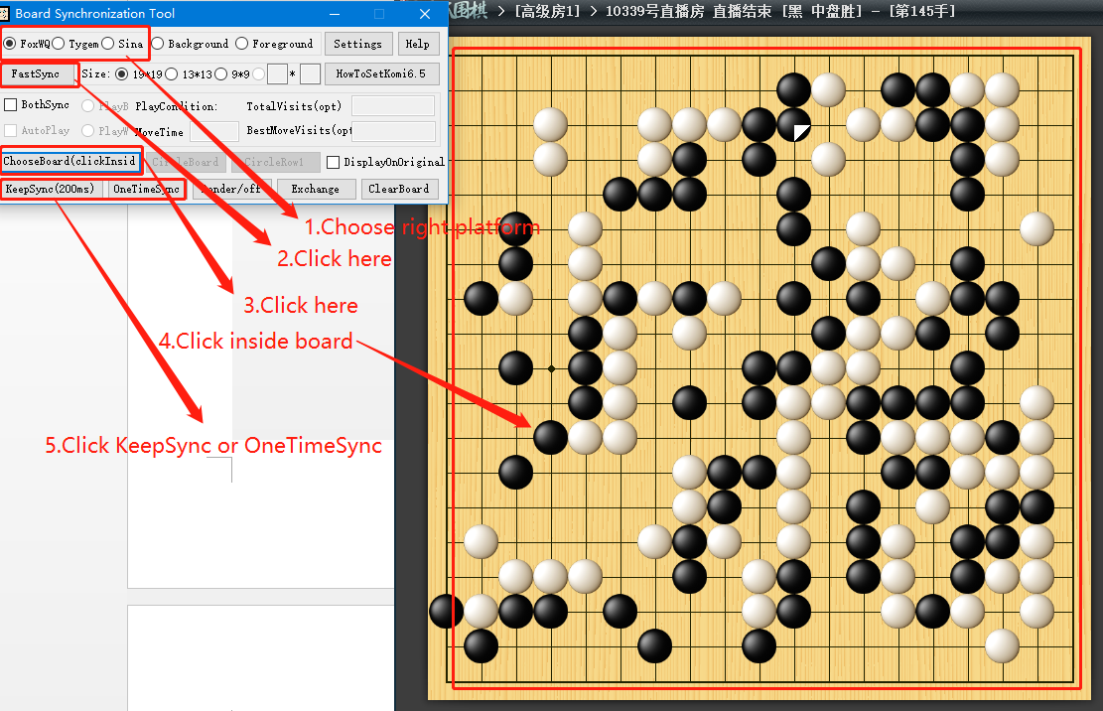

Function 2: Linked form other platform or a picture a browser etc…
Way 1:
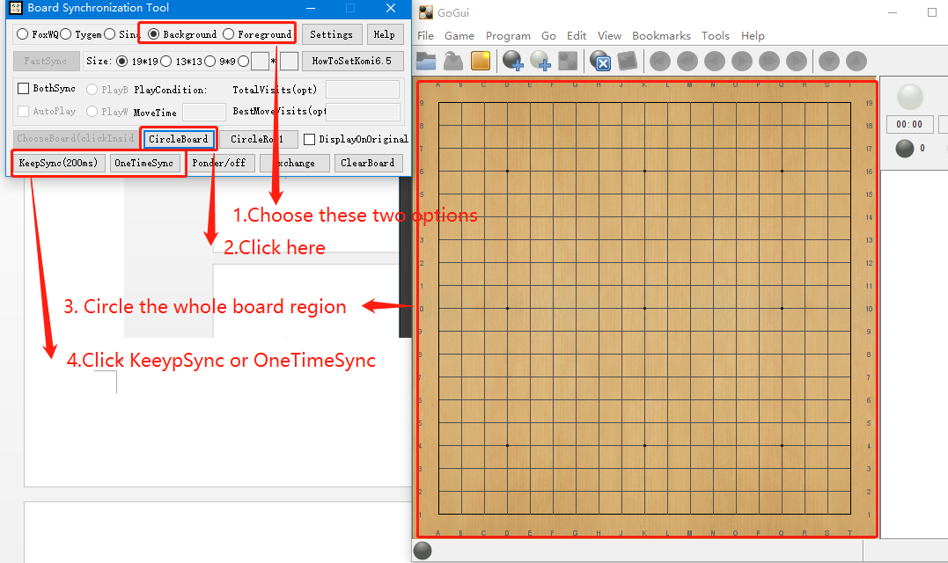
The difference between Background and Foreground: Foreground require the original board can not be moved or resized or coverd.Background does not require any thing but do not minimized the original board. Foreground have better compatibility.
More parameters can be found under settings to help get right result for ‘Background/Foreground’.
Way 2: Only if way 1 does not work.
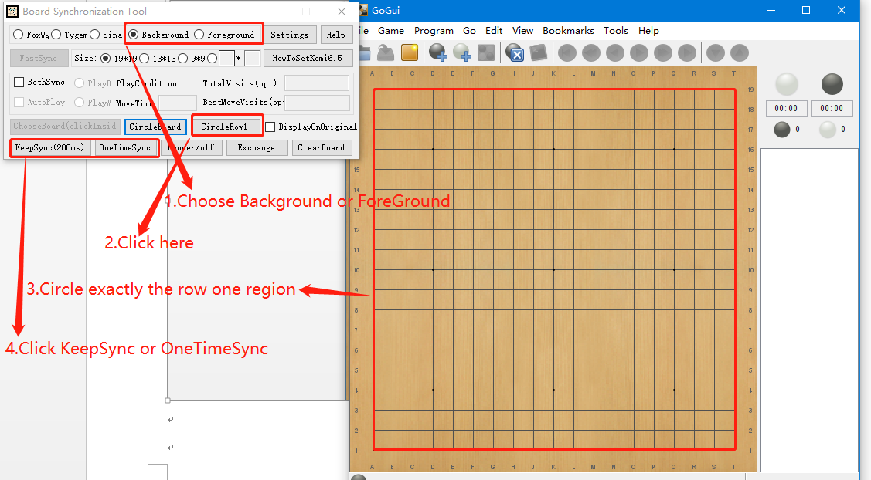

Other
- BothSync and AutoPlay: If selected ‘BothSync’, Synchronization Tool will place stone on the selected board when a stone placed in ‘LizzieYzy’,if ‘AutoPlay’ is selected,’LizzieYzy’ will automatically place stones on the condition of MaxTime/TotalVisits/Best MoveVisits.
- KataGo Rules Settings: Because of lack of move history,captures will be incorrectly,So we can only use area scoring.You can set area scoring+7.0komi+hasbutton to simulate Japanese rule.

