

Drive OpenOffice
with COM Automation
from Delphi
Provided by fr.OpenOffice.org Project

Table of Contents
1 Introduction 4
1.1 Intended Audience 4
1.2 Contents 4
1.3 Versions of the products used 4
1.4 Acknowledgements 4
1.5 References 4
1.6 Document evolution 5
1.7 Delphi_OOo evolution 5
2 Basics 6
2.1 OpenOffice.org and COM 6
2.2 COM configuration of OpenOffice 6
2.3 Programming principles 6
Connection, disconnection 6
Errors 7
2.4 Syntactic differences 7
3 Equivalences with OOoBasic 8
3.1 Null array 8
3.2 Uno structure 8
3.3 Properties (Property Value) 8
Array of properties 8
Single property 9
3.4 Array( ) 9
3.5 CreateUnoService 9
3.6 StarDesktop 10
3.7 HasUnoInterfaces 10
3.8 ConvertToURL 10
3.9 ConvertFromURL 11
3.10 Color functions 12
3.11 Functions not implemented in OOoTools 12
GetProcessServiceManager 12
ThisComponent 13
EqualUnoObjects 13
4 OOoTools specific routines 14
4.1 Miscellaneous helper functions 14
4.2 Dispatch 14
4.3 Clipboard 14
4.4 Calling an OOoBasic macro 15
4.5 Calling an OpenOffice script 15
5 API OpenOffice.org coding particularities 17
5.1 Types of data 17
5.2 Properties 17
5.3 Points similar to OOoBasic 17
5.4 Points differing from OOoBasic 18
Parentheses 18
Collections 18
Array of values 18
With 18
5.5 Empty/Null object returned by the API 19
5.6 Listener 19
6 OpenOffice.org API constants 20
Remark 20
7 Xray 21
7.1 Overview 21
Note 24
7.2 Comments on Xray implementation 24
7.3 Using Xray, version OOoBasic 25
8 Credits 26
8.1 Host servers for this toolbox 26
9 Licences 27
9.1 Documentation 27
9.2 Programs 27

Introduction

Intended Audience
This document is aimed at Delphi programmers who want to write and read OpenOffice.org documents.
You need at least a general knowledge of OpenOffice.org Basic (hereafter called OOoBasic) and of the API of OpenOffice.org.

Contents
Many tutorials, books, code snippets, can be found on OpenOffice programming, but they are mainly using OpenOffice.org Basic.
If you are asking : How do you program OpenOffice with Delphi ? here is the answer : with the toolbox described here you will be able to quickly translate most code examples written in OpenOffice.org Basic.
This toolbox helps drive the application OpenOffice.org from the programming language Delphi using COM Automation technology. As the latter is only available on MS-Windows, no effort was made to be compatible with Kylix.
It is quite feasible to use programming languages other than Delphi to drive OOo through COM. I have written similar toolboxes for VBA, VB.NET, VBScript and Delphi languages. Fans of other languages are invited to write and offer a similar toolbox for their favorite language, taking inspiration from the structure of this document and the names of the routines which are described here.
If you find an error or an improvement don’t hesitate to write to me, my email address is at the end of this document.

Versions of the products used
The toolbox was designed with Delphi 7 Personal Edition, french. It can probably work with older versions of Delphi.
Tests were done with OpenOffice.org versions 2.1 and 2.2.0. Due to various bug corrections since version 1.1.5 of OpenOffice.org, it is recommended to use version 2.1 or more recent of OpenOffice.org. For working with OpenOffice.org 1.1.5 or older please use version 1.1 of this toolbox.

Acknowledgements
This toolbox was inspired by the work of Danny Brewer (DannyB), pasha_golub, Cybb20, in OOoForum. You may in particular read the following pages :
- Using COM for OOo with different languages
http://www.oooforum.org/forum/viewtopic.php?t=9815
- Delphi + OOo.Draw
http://www.oooforum.org/forum/viewtopic.php?t=10866

References
The Software Development Kit (SDK) of OpenOffice.org is THE reference.
The SDK is available on the web site http://api.openoffice.org/ and it can be downloaded from the page http://www.openoffice.org/dev_docs/source/sdk/ . The Windows version of the SDK available at the date of this document is a file of 37 Mbytes. It installs into a tree structure of more than12 700 files. The SDK is a tool for developers of OpenOffice itself. We only use a small part of it, the documentation files.
Several english documents and books on OpenOffice.org API are listed on the page http://api.openoffice.org/TipsAndTricks/external.html .
In english you may read Andrew D. Pitonyak’s book OpenOffice.org Macros Explained or browse through OOoForum http://www.oooforum.org/, sections Code Snippets and Macro and API.
For french readers : on pourra lire divers HowTo disponibles gratuitement à l’adresse
http://fr.openoffice.org/Documentation/How-to/indexht-programmation.html
Le livre « Programmation OpenOffice.org 2 » disponible aux Éditions Eyrolles donne une information plus complète http://www.eyrolles.com/Informatique/Livre/9782212117639/livre-programmation-openoffice-org-2.php .

More information on the COM – OpenOffice.org bridge can be found in the SDK, in these chapters of the Developer’s Guide :
- 3.4.4 Automation Bridge
- 5.1.1 (or 6.1.1) Supported Programming Environments
The web site http://www.techvanguards.com/ will provide you with much more information on COM technology than I know myself.

Document evolution
Rev 1.1
Initial document and initial version of the toolbox, for the english version.
Rev 1.2
Some errors have been corrected. Document updated after Delphi_OOo evolution.

Delphi_OOo evolution
French and english versions use the same source files for the units. Messages are grouped in one unit.
New routines introduced in OOoTools : DisconnectOpenOffice, IsOpenOfficeConnected, runBasicMacro, runScript, BasicXray
Modified routines in OOoTools : ConvertToURL, ConvertFromURL
OOoConstants unit is now created with a Basic macro in a separate document. This new method handles complex cases produced by recent versions of the SDK.
Delphi Xray is now up to the level of Basic Xray version 5.2. However it is no longer compatible with OpenOffice.org version 1.1.5 and older.
Xray configuration data are clarified.
Units Unit1 and OOoExamples are rewritten to be similar to the toolboxes for other languages.

Basics

OpenOffice.org and COM
OpenOffice.org does not provide a « type library » for COM. Consequently you can only use IDispatch interface and « late binding », which implies that each COM call is validated at run time instead of compile time.
COM interfaces are not visible from the Delphi programmer. In fact interfaces are seen as objects with methods and properties, and you handle OpenOffice.org objects as Variant.
You cannot have auto-completion of code at edit time. You cannot display at edit time the available methods and properties of a Uno object. You can only do this at run-time, with help of Xray tool. This is not a limitation of Delphi but a consequence of the design of OpenOffice.org API.

COM configuration of OpenOffice
It is important that OpenOffice be correctly inscribed in the MS-Windows Registry.
If you have installed several versions of OpenOffice, only one can be called through COM. If you have updated it with a newer version, the Registry may be inconsistent even after an OpenOffice repair.
If you bump into COM problems you should inspect the registry :
- open the Registry editor (regedit.exe);
- do a Ctrl-F to search for :
- value 82154420 (this is the first numbers of the key for OpenOffice)
- check : Look into... Key
- uncheck all other checkboxes.
There are several appearances of this key.
In each key branch, open section LocalServer32. Verify that the called program address is correct, change the value if not. In the case of OpenOffice 2.2.x you should have :
C:\Program Files\OpenOffice.org 2.2\program\soffice.exe -nodefault -nologo
I had strange problems because one of the entries was still pointing at version 1.1.5 of OpenOffice.

Programming principles
A Delphi unit controlling OpenOffice must have in a uses clause the following units :
Uses ComObj, OOoMessages, OOoTools, OOoConstants;
The toolbox also includes several examples in the unit OOoExamples and a call to one of them.

Connection, disconnection
The Delphi program should first establish connection with OpenOffice by executing once this procedure from OOoTools :
ConnectOpenOffice;
If OpenOffice.org is not running it will be automatically loaded and this may take some time.
Depending on your needs, you may want to disconnect the COM connection to OpenOffice. This is done with this procedure from OOoTools :
DisconnectOpenOffice;
If you want to completely close OpenOffice, thereby releasing some memory, add an argument True :
DisconnectOpenOffice(True);
The processes soffice.bin and soffice.exe will then terminate, provided that :
- your OpenOffice does not have the QuickStarter activated ;
- there is currently no unsaved document (or else a message will prompt you to save).
Before resuming operations with OpenOffice you will then have to connect again. The routine ConnectOpenOffice recognizes if the connection is already working.
If your application uses OpenOffice intermittently you may use the function IsOpenOfficeConnected to verify the connection and possibly reset some of your variables before reconnecting.
It is not necessary to explicitly free resources at the end of the job because Delphi collects the garbage.

Errors
Procedures and functions from the toolbox may throw an exception of the class EOOoError.

Syntactic differences
Syntactic differences between OOoBasic and Delphi which produce the most frequent errors are grouped in this table.
Syntax | Delphi | OOoBasic
comment | // end of line  { . . . }  (* . . . *) | Rem end of line  ' end of line
instruction | instruction; | instruction
assignment | tata:= 123; | tata = 123
string | v:= 'Hello' | v = "Hello"
end of lines | ignored by the compiler | interpreted
instruction spread over several lines | accepted | need to type the continuation character _ at the end of each line
declaring variables | mandatory | optional

Equivalences with OOoBasic
OOoTools unit offers several routines providing capabilities similar to those of OOoBasic.

Null array
A « null » array is not same as Variant with a Null value. A « null » array has a dimension zero and contains nothing. It is often used to call a routine of OpenOffice.org API when no particular option is used.
The OOoTools function dummyArray returns a « null » array.
OOoBasic
Dim PropFich()
Delphi
var PropFich: Variant;
PropFich:= dummyArray;

Uno structure
OOoBasic, method 1
Dim Rect As New com.sun.star.awt.Rectangle
Dim thePoints(3) As New com.sun.star.awt.Point

Rect.Width = 10000
thePoints(1).Y = 5000
OOoBasic, method 2
Dim Rect As Object

Rect = CreateUnoStruct(As New com.sun.star.awt.Rectangle)
Rect.Width = 10000
Delphi
var Rect, thePoints: Variant;

Rect:= CreateUnoStruct('com.sun.star.awt.Rectangle');
thePoints:= CreateUnoStruct('com.sun.star.awt.Point', 3);
Rect.Width:= 10000;
thePoints[1].Y:= 5000;
If there is no second argument, the OOoTools function CreateUnoStruct returns a unique Variant containing the Uno structure. If the second argument is used it returns an array of structures where the upper value of the index is this argument ; the lower value of the index is always zero. In the example above thePoints is defined as an array of 4 structures Point, index 0 to 3.
Note : a Uno structure is handled in a similar manner as a Delphi record. However it is more than a Delphi record.

Properties (Property Value)

Array of properties
Arrays of Property Values are commonly used in OpenOffice.org API. Each array element is a structure. The OOoTools function CreateProperties simplifies the creation of an array of properties.
OOoBasic
Dim fileProp(1) As New com.sun.star.beans.PropertyValue

fileProp(0).Name = "Password"
fileProp(0).Value = "Arthur1987"
fileProp(1).Name = "Hidden"
fileProp(1).Value = True
Delphi
var fileProp: Variant;

fileProp:= CreateProperties(['Password', 'Arthur1987', 'Hidden', True]);
The list in CreateProperties must have an even number of arguments : Name, Value, Name, Value, and so on for each property to be created.

Single property
Function MakePropertyValue was proposed by Danny Brewer, see OOoForum, Code Snippets, http://www.oooforum.org/forum/viewtopic.php?t=5108 .
OOoBasic (Danny Brewer function)
Dim Prop1 As Variant

Prop1 = MakePropertyValue("Hidden", True)
Delphi
var Prop1: Variant;

Prop1:= MakePropertyValue('Hidden', True);
The two arguments of the OOoTools function are mandatory whereas they are optional in OOoBasic version.
In practice, CreateProperties is advisable to obtain an array of properties and MakePropertyValue only useful for a single property, not an array.

Array( )
OOoBasic function Array(a,b,c,etc) creates dynamically an array of Variant where each element of the array is an argument of the function.
The Delphi equivalent for an Automation object is the function VarArrayCreate(). But in fact OOoTools provides functions more adapted to the needs :
- A common use of Basic Array function is calling it without argument : Array() This results in a « null » array. With OOoTools you create a « null » array with function dummyArray.
- You create and initialize an array of Uno properties with function CreateProperties.
- You create an array of Uno structures with function CreateUnoStruct.

CreateUnoService
The OOoTools function is equivalent to the OOoBasic function.

StarDesktop
The OOoTools variable StarDesktop is equivalent to the OOoBasic object of the same name.
OOoBasic
Dim myDoc As Object

myDoc = StarDesktop.loadComponentFromURL( _
"private:factory/scalc", "_blank", 0, Array())
Delphi
var myDoc: Variant;

myDoc:= StarDesktop.loadComponentFromURL(
'private:factory/scalc', '_blank', 0, dummyArray);

HasUnoInterfaces
The OOoTools function is equivalent to the OOoBasic function for an object supporting introspection. Otherwise, as for example an API structure, an exception arises.
if HasUnoInterfaces(myDoc,
['com.sun.star.frame.XStorable',
'com.sun.star.style.XAutoStylesSupplier',
'com.sun.star.text.XTextGraphicObjectsSupplier']) then

ConvertToURL
Numerous code snippets available on the Internet convert a MS-Windows address to an URL by adding a prefix and replacing \ with / characters. This is correct only with addresses containing only strict ascii (non national) characters. Outside anglo-saxon world, use of national characters is common and your code will not work.
The OOoTools function ConvertToURL gives in general the same result as the OOoBasic function but differs in cases other than the simple conversion of a file address in the MS-Windows syntax. Also, the OOoTools function supposes that the provided address is not already in URL syntax (no use of escape %). The table below compares results in OOoBasic and Delphi.
Test | Address
argument | c:\Doc OpenOffice\Résumé.odt
OOoBasic | file:///c:/Doc%20OpenOffice/R%C3%A9sum%C3%A9.odt
OOoTools function | same as OOoBasic
argument | \\Johnny-PC\Finance\Debts.ods
OOoBasic | file://Johnny-PC/Finance/Debts.ods
OOoTools function | same as OOoBasic
argument | Mix of / and \ characters  File:///c:\Doc OpenOffice\Résumé.odt
OOoBasic | file:///c:%5CDoc%20OpenOffice%5CR%C3%A9sum%C3%A9.odt
OOoTools function | file:///c:/Doc%20OpenOffice/R%C3%A9sum%C3%A9.odt
argument | http://www.tata toto.com
OOoBasic | http://www.tata toto.com
OOoTools function | http://www.tata%20toto.com
argument | nobody@nospam.com
OOoBasic | mailto:nobody@nospam.com
OOoTools function | same as OOoBasic
argument | news:toto.tata
OOoBasic | news:toto.tata
OOoTools function | same as OOoBasic
argument | ftp://perso-ftp.club-internet.fr/License Agreement.txt
OOoBasic | ftp://perso-ftp.club-internet.fr/License%20Agreement.txt
OOoTools function | same as OOoBasic

ConvertFromURL
The OOoTools function ConvertFromURL gives in general the same result as the OOoBasic function but differs in cases other than the simple conversion of a file address in the MS-Windows syntax. The table below compares results in OOoBasic and Delphi.
Test | Address
argument | file:///c:/Doc%20OpenOffice/R%C3%A9sum%C3%A9.odt
OOoBasic | c:\Doc OpenOffice\Résumé.odt
OOoTools function | same as OOoBasic
argument | file://Johnny-PC/Finance/Debts.ods
OOoBasic | \\Johnny-PC\Finance\Debts.ods
OOoTools function | same as OOoBasic
argument | http://www.tata toto.com
OOoBasic | http://www.tata toto.com
OOoTools function | same as OOoBasic
argument | http://www.tata%20toto.com
OOoBasic | http://www.tata%20toto.com
OOoTools function | http://www.tata toto.com
argument | mailto:nobody@nospam.com
OOoBasic | mailto:nobody@nospam.com
OOoTools function | same as OOoBasic
argument | ftp://perso-ftp.club-internet.fr/License%20Agreement.txt
OOoBasic | ftp://perso-ftp.club-internet.fr/License%20Agreement.txt
OOoTools function | ftp://perso-ftp.club-internet.fr/License Agreement.txt

Color functions
OOoTools functions RGB, Red, Green, Blue, are equivalent to OOoBasic functions of the same names.
OOoBasic
Dim myColor As Long
Dim redPart As Integer, greenPart As Integer, bluePart As Integer

redPart = 120
bluePart = 60
greenPart = 220
myColor = RGB(redPart, greenPart, bluePart)

myColor = 8253534
bluePart = Blue(myColor)
greenPart = Green(myColor)
redPart = Red(myColor)
Delphi
var myColor, redPart, greenPart, bluePart: Integer;

redPart := 120;
bluePart := 60;
greenPart:= 220;
myColor:= RGB(redPart, greenPart, bluePart);

myColor:= 8253534;
bluePart := Blue(myColor);
greenPart:= Green(myColor);
redPart := Red(myColor);
Note that color coding differs between OpenOffice.org and MS-Windows.

Functions not implemented in OOoTools

GetProcessServiceManager
This OOoBasic function is not needed because OOoTools provides the variable OpenOffice which is a Service Manager. You may need a Service Manager in the rare cases where you have to invoke a service which needs arguments for its initialization.
OOoBasic
Dim aServManager As Object, aService As Object

aServManager = GetProcessServiceManager
aService = aServManager.createInstanceWithArguments( _
"com.sun.star.xxx.yyy.zzz", args())
Delphi
var aService: Variant;

aService:= OpenOffice.createInstanceWithArguments(
'com.sun.star.xxx.yyy.zzz', args);

ThisComponent
In OOoBasic this method returns the document from which the macro was started. This has no meaning outside Basic. Usually you will have created or loaded a document, so you have a reference to it. In some cases you may need access to the OpenOffice document currently open :
var
myDoc: Variant;

myDoc:= StarDesktop.CurrentComponent;
If several OpenOffice documents are open you get the document from the OpenOffice window at top. If this window is the Basic IDE or the Help window you will not be able to do anything with it.

EqualUnoObjects
This function has no equivalent in Delphi because it is not possible to know the address in memory of an Automation object. It will be necessary to compare the objects on properties having a specific content, e.g. the name of a table.

OOoTools specific routines

Miscellaneous helper functions
Function dummyArray returns an Automation array without dimension. This is used to provide an array of options without any option.
Function isNullEmpty checks if an Automation Variant is empty.
Object OOoIntrospect can introspect objects. It is currently used by function HasUnoInterfaces and by Xray.
Object OOoReflection gives access to the introspection mechanism to get information about an API object. It is currently used by Xray.

Dispatch
Function execDispatch invokes the dispatch mechanism of OpenOffice.org API. Usage is very simple compared to the code resulting of the macro recorder. You just need to use two arguments : the command string (slot name), and the array of properties.
This example writes Hello World on an open Writer document :
OOoBasic
rem ----------------------------------------------------------------------
rem define variables
dim document as object
dim dispatcher as object
rem ----------------------------------------------------------------------
rem get access to the document
document = ThisComponent.CurrentController.Frame
dispatcher = createUnoService("com.sun.star.frame.DispatchHelper")

rem ----------------------------------------------------------------------
dim args1(0) as new com.sun.star.beans.PropertyValue
args1(0).Name = "Text"
args1(0).Value = "Hello World"

dispatcher.executeDispatch(document, ".uno:InsertText", "", 0, args1())
Delphi
var args: Variant;

args:= CreateProperties(['Text', 'Hello World']);
execDispatch('.uno:InsertText', args);
Do not confuse the dispatch of OpenOffice.org API and IDispatch interface specific to the COM mechanism.
The dispatch can only work on a visible document.

Clipboard
Functions copyToClipboard and pasteFromClipboard can respectively copy to and paste from the MS-Windows clipboard.
These functions work only on a visible document, on the current position of the visible cursor.

Calling an OOoBasic macro
The routine runBasicMacro can transmit arguments to an OOoBasic macro installed in « My Macros » or in « OpenOffice.org Macros », or even in an already loaded OpenOffice document. There are however limitations :
- the Delphi program cannot get any returned result,
- the list of arguments is transmitted as one string, which can be a problem with some arguments,
- it is not possible to call a macro residing in « My Macros » or « OpenOffice.org Macros ».

Warning : in this description all strings are case sensitive !
The function runBasicMacro has up to 3 arguments.
The first argument, macroName, is a string composed of the library, the module and the name of the called macro, for example : Standard.Module1.myMacro
The second (optional) argument is a string where successive arguments are separated by a comma, for example : 123, Hello world, -7
Note that all arguments are received as strings in the OOoBasic macro. Then depending on the instructions, OOoBasic may interpret each as a string or an integer, etc.
The third (optional) argument is the short name of an already open document. For example if the document file name is HelloAll.odt then the short name is HelloAll.
If the called macro is not found the routine runs without any error.
This example calls an OOoBasic macro residing in a document testScript.odt. We have to load the document with an option allowing it to run macros, then call runBasicMacro indicating the short name of the document :
var adrDoc: String; args, myDoc: Variant;

adrDoc:= convertToURL('C:\OpenOffice docs\testScript.odt');
// API constant : com.sun.star.document.MacroExecMode.ALWAYS_EXECUTE_NO_WARN
args:= CreateProperties(['MacroExecutionMode',
_documentMacroExecModeALWAYS_EXECUTE_NO_WARN]);

myDoc:= StarDesktop.loadComponentFromURL(adrDoc, '_blank', 0, args);

runBasicMacro('MyLib.MyModule.MyMacro', '123, Hello world, -7', 'testScript');

Calling an OpenOffice script
The function runScript uses a feature introduced with OpenOffice.org 2.x. It will not work with older versions 1.1.x.
OpenOffice.org 2.x may execute scripts in various languages, currently : OOoBasic, compiled Java, Javascript, Beanshell, Python. These scripts may be stored in « My Macros » or in « OpenOffice.org Macros » or in an OpenOffice document. I will not explain here how to write such scripts.
Compared to runBasicMacro, the function runScript has these advantages :
- the Delphi program may get a result returned by the called script ; this result may be of any type, even a Uno object ;
- each argument is transmitted « as is », so it may be of any type acceptable to the called script, it may even be a Uno object ;
- the script may be an OOoBasic macro or it may be in other supported script languages.
Limitation : the function runScript cannot run a script from a document.

Warning : in this description all strings are case sensitive !
The function runScript has up to 4 arguments.
The first argument, scriptName, is a string composed of parts depending on the language of the called script :
- OOoBasic : the library, the module and the name of the called macro, for example : Standard.Module1.myMacro
- Compiled Java : the short name of the jar file containing the script, one dot, and the functionname value found in the file parcel-descriptor.xml of the script, for example : HelloWorld.HelloWorld.printHW
- Javascript : the name of the folder containing the script file, one dot, and the full name of the script file ; for example : HelloWorld.helloworld.js
- Beanshell : the name of the folder containing the script file, one dot, and the full name of the script file ; for example : HelloWorld.helloworld.bsh
- Python : the full name of the source script file, a dollar character, and the name of the called Python function ; for example : HelloWorld.py$HelloWorldPython
The second argument is a dynamic array containing zero or more values : the list of arguments transmitted to the script.
The third (optional) argument is a string expressing the script language. Currently it may be one of these : Basic, Java, JavaScript, BeanShell, Python. By default, language is Basic.
The fourth (optional) argument is a string expressing the location of the script.
- Basic language : accepted value is application. This is the default value for Basic. The script may be in « My Macros » or in « OpenOffice.org Macros » ;
- Other script languages :
- if the script is in « My Macros », the string value must be : user
- if the script is in « OpenOffice.org Macros », the string value must be : share
- The default value is : user
If the called script is not found the routine throws an API error.
Here is an example calling an hypothetical OOoBasic macro function which returns a numerical value :
var r: Double;

r:= runScript('MyLib.MyModule.MyMacro', [123, 'Hello world', -7]);
showMessage('Result = ' +FormatFloat('0,.000', r));
To run this other example you need to open a Writer document. This Beanshell script exists in « OpenOffice Macros » and will write Hello World.
runScript('HelloWorld.helloworld.bsh', [], 'BeanShell', 'share');

API OpenOffice.org coding particularities

Types of data
For a simple data type Delphi automatically makes the type conversion between the Variant obtained from an object and a variable of a compatible Delphi type. Here is a valid example :
var aName: String; myColor: Integer;

aName:= thisSheet.Name;
myColor:= myCell.CellBackColor;
In the same manner, arguments of an API method may be variables of Delphi types or values given directly.
The type Variant will be used to get a real object or an API structure.

Properties
In the OpenOffice.org API, services may have « properties ». These are object attributes which are data of a simple type (String, Integer...), or a complex type (structure, object).
Some Uno interfaces have attributes. These are similar to properties but are owned by an interface instead of a Uno service.
OpenOffice.org API objects usually have methods for read or write access to internal data. The COM bridge allows as in OOoBasic to use a pseudo-property XXX instead of methods getXXX and setXXX when they don’t use special arguments. This is in fact equivalent to the definition of a property in Delphi.
Delphi
var myText: String;

myText:= myCursor.String; // using the pseudo-property
myText:= myCursor.getString; // using the method

myText:= 'hello';
myCursor.String:= myText; // using the pseudo-property
myCursor.setString(myText); // using the method

Points similar to OOoBasic
API properties and methods names are case insensitive (no need to respect upper or lower case letters).
Strings obtained by method getString of some objects are restrained to about 64000 characters. Above the limit you get a null string.
Caution : when a string is used as argument of an API instruction, it is always case sensitive. This is the case for structures PropertyValue like in the example hereunder.
Delphi
var fileProp: Variant;

fileProp:= CreateProperties(['Password', 'Arthur1987', 'Hidden', True]);

Points differing from OOoBasic

Parentheses
In OOoBasic calling an API method without arguments may be done with empty parentheses or without parentheses.
In Delphi the call must be without parentheses.
OOoBasic
mySearch = myDoc.createReplaceDescriptor()
Delphi
mySearch:= myDoc.createReplaceDescriptor;

Collections
Some UNo objects are indexed collections, or named collections, or both.
In OOoBasic there are several variants of accessing a collection item.
In Delphi, direct indexation of an indexed collection is not supported, you must use the method getByIndex(). Access by name is only possible through method getByName().
OOoBasic, method 1
thisSheet = myDoc.Sheets(1)
thatSheet = myDoc.Sheets.June
OOoBasic, method 2
thisSheet = myDoc.Sheets.getByIndex(1)
thatSheet = myDoc.Sheets.getByName("June")
Delphi
thisSheet:= myDoc.Sheets.getByIndex(1);
thatSheet:= myDoc.Sheets.getByName('June');

Array of values
Some API functions return an array of values (documented as sequence of values). Index of these arrays are always zero based. You find the upper bound of the index like this :
OOoBasic
myValues = thisZone.getDataArray
indexMax = UBound(myValues)
Delphi
myValues:= thisZone.getDataArray;
indexMax:= VarArrayHighBound(myValues, 1);

With
Is is not possible to use With instruction in Delphi when handling an API object or structure because the properties and methods of the object are not known at compile time (late binding).

Empty/Null object returned by the API
Some API properties or methods may return an empty object. The OOoTools function IsNullEmpty will help to test this :
v:= myDoc.XForms;
if IsNullEmpty(v) then

Listener
In OpenOffice.org API the Listener mechanism is used to add a handler for a specific event. This is not possible from Delphi because the COM bridge does not support call-back primitives necessary for that purpose.
The Developer’s Guide (at end of Automation Bridge chapter) proposes a work-around :
- create an ActiveX dll
- implement in this dll a Uno listener interface, which will handle all events described in the listener interface dcumentation
- from your main Delphi program, register your listener to the Uno object which is the source of the events
- if necessary for your application, you will have to handle yourself the exchange of data between the main Delphi program and the ActiveX dll.

A Delphi user has described how he did this, see http://www.oooforum.org/forum/viewtopic.phtml?t=59046

OpenOffice.org API constants
The unit OOoConstants provided in the toolbox defines all the constants and enumerations with names starting with com.sun.star which are declared in the SDK, version 2.2.0. Currently there are more than 3800 constants.
You only need to put the name of this unit in the uses clause of the units needing an API constant. As they are compilation constants they do not generate useless bytes and don’t slow compilation.
In the unit OOoConstants the names of the constants have been changed to be compatible with Delphi syntax for constant names. The sequence com.sun.star was replaced by a character _ and the remaining dots were suppressed, which results in considerably shortened constant names.
OOoBasic
v = com.sun.star.sheet.CellFlags.VALUE
Delphi
v:= _sheetCellFlagsVALUE;

This unit was created by execution of a macro in the document ConstEnumsDelphi_en.odt, also present in the toolbox. It scans the IDL files of the SDK to extract the named constants (real constants and enumerations). You must have the SDK installed locally or on your network (see above, section 1.5). Just click the button on the document page and tell it the root directory of the SDK to use.
If you want constant names based on another naming rule, you will have to modify the fields « Replace com.sun.star with » and « Replace dots with » in the document.
With these values :
- Replace com.sun.star with : com_sun_star
- Replace dots with : _
you will get names more like the original but somewhat harder to write :
v:= com_sun_star_sheet_CellFlags_VALUE;
Remember that many API constants have very long names...

Remark
If you recreate OOoConstants unit with another naming rule you will have to modify all references to API constants in units Xray, Xray3, OOoExamples. Search for an underscore character preceded by a space.

Xray

Overview
The unit OOoXray is a programming tool which inspects a variable, in general an object of OpenOffice.org API. To use it you have to add it in the uses clause of the unit under study. At runtime you call Xray and give as argument the data to be analysed. This is an example extracted from a bigger code :
uses OOoXray;

var infos: Variant;

infos:= myDoc.DocumentInfo;
xray(infos);
As the example above shows, Xray works only by executing it. It is not an add-on to Delphi inspector.
A panel with several tabs is then displayed with various information about the object.
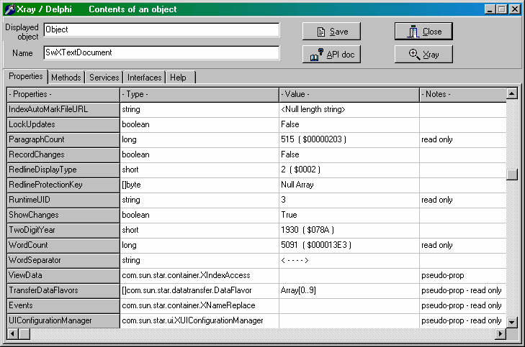
Characters [] ahead of a type means that it is an array of this type. Numeric values are displayed in decimal and hexadecimal.
Strings are usually displayed in the column Value. When they have special characters or are rather long, as here for property WordSeparator, the value is replaced by a special sequence. Then you have to further analyse to display the text.
The window is sizeable in width and height, and column width is adjustable with the mouse. This is especially useful for Methods tab which provides numerous information.
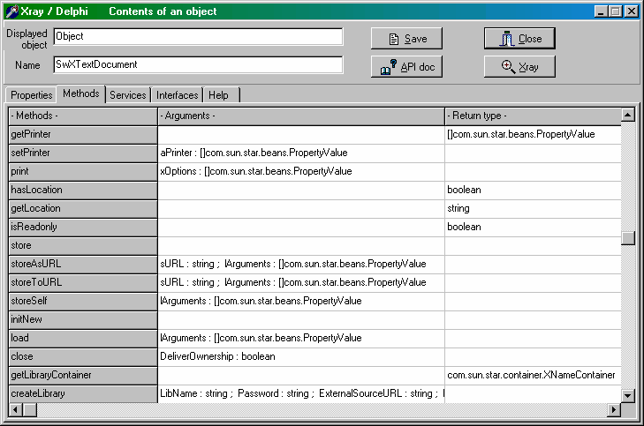
Note that each method argument is declared with a significant name and its type. The next columns shows the type of the returned value, if any. The last column shows the interface supporting the method.
In the Properties and Methods tabs, a right click in the table sorts the lines in alphabetical order of the names in the first column ; another click returns to the original order.
Button Xray is used to analyse the contents of a property of type String, Objet, Structure, or of an array. It can also analyse the reult of a method so long as it needs no argument and returns something. Before activating the button, click one cell of the concerned line. You may also trigger analysis with just a double-click on a cell of the line. A new modal window appears detailing the resulting contents, and so on.
Button API Doc can start an Internet browser on the SDK page corresponding to the property or method of the current line. For this feature you must have installed the SDK locally or on your network (see above, section 1.5).
For the display of SDK documentation Xray uses the internal constants SDKaddr, useDefaultBrowser, myBrowser. They are defined at the beginning of Xray unit. Initialize them depending on your configuration.

Button Save stores all the displayed information in a Calc file with an equivalent structure (sheets, contents on each column). The code used for doing this is a typical example of OpenOffice.org file creation with COM.

When the object or sub-object is a non-null array, i.e. having at least one element, the panel here after is displayed. Here also it is possible to further analyze one of the elements shown, in the same manner.
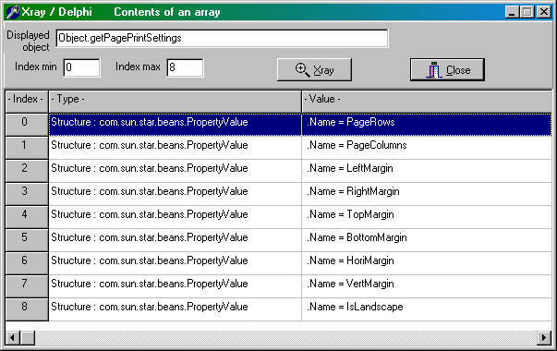
The sub-object displayed above is an array of « PropertyValue ». In this rather common special case, the name of the property is also shown.

Within the Services tab of the main panel, each column is sorted in alphabetical order.
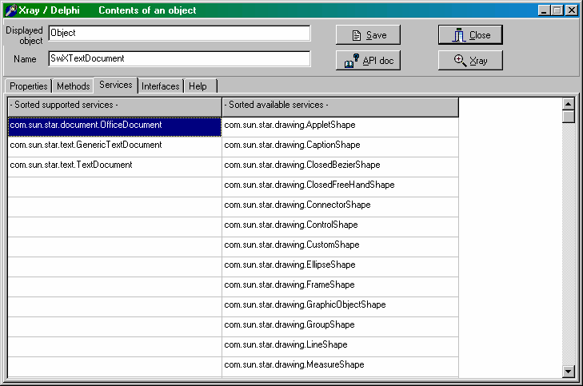
Button Xray is not used for this tab. But button API Doc displays the documentation of the service pointed at.

Interfaces tab displays in alphabetical order the interfaces supported by the object. Here also it is possible to ask for the documentation of the interface pointed at.

Note
Xray does not replace reading a good book or introduction to the API of OpenOffice.org. The API documentation is very comprehensive but its access is difficult and discouraging.

Comments on Xray implementation
API objects accessed through COM are analyzed thanks to the introspection and reflection services of the API.
As compared to the Basic version of Xray, some features could be added, mainly thanks to the more elaborate dialogs offered by Delphi, and some differences result from passing through the COM bridge, which has some limitations.
In order to avoid cumbersome messages from the IDE you should add in the debugging options of Delphi :
x ignore exceptions EOleException
Despite this precaution some objects may throw exceptions « The type does not fit » which are correctly treated by Xray but are still visible within the IDE.

Using Xray, version OOoBasic
You may easily call the Xray version written in OOoBasic, if you have installed it. You just have to use the OOoTools routine BasicXray :
var infos: Variant;

infos:= myDoc.DocumentInfo;
BasicXray(infos);

Credits
Author : Bernard Marcelly

Thanks to :

Integrated by : Tony Galmiche

Last modified : July, 25, 2007

Contacts : OpenOffice.org Documentation Project http://fr.openoffice.org

Translated by : Bernard Marcelly

Host servers for this toolbox
English version : OOoMacros.org, page For Developers
http://ooomacros.org/dev

Version française : fr.OpenOffice.org, page How-Tos Programmation
http://fr.openoffice.org/Documentation/How-to/indexht-programmation.html

Licences

Documentation

Appendix

Public Documentation License Notice

The contents of this Documentation are subject to the Public Documentation License Version 1.0 (the "License"); you may only use this Documentation if you comply with the terms of this License. A copy of the License is available at http://www.openoffice.org/licenses/PDL.html.

The Original Documentation is : Piloter OpenOffice avec COM Automation depuis Delphi
The Initial Writer of the Original Documentation is Bernard Marcelly
Copyright (C) 2004-2007. All Rights Reserved. (Initial Writer contact(s): marcelly@club-internet.fr )

Contributor(s): ______________________________________.
Portions created by ______ are Copyright (C)_________[Insert year(s)].
All Rights Reserved. (Contributor contact(s):________________[Insert hyperlink/alias]).

NOTE: The text of this Appendix may differ slightly from the text of the notices in the files of the Original Documentation. You should use the text of this Appendix rather than the text found in the Original Documentation for Your Modifications.

Programs
General information on LGPL is available on this Web site.

The programs and libraries described by this document constitute a toolbox to pilot OpenOffice.org from Delphi using COM Automation. Copyright (C) 2004-2007 Bernard Marcelly
This library is free software; you can redistribute it and/or modify it under the terms of the GNU Lesser General Public License as published by the Free Software Foundation; either version 2.1 of the License, or (at your option) any later version.
This library is distributed in the hope that it will be useful,but WITHOUT ANY WARRANTY; without even the implied warranty of MERCHANTABILITY or FITNESS FOR A PARTICULAR PURPOSE. See the GNU Lesser General Public License for more details.
You should have received a copy of the GNU Lesser General Public License along with this library; if not, write to the Free Software Foundation, Inc., 59 Temple Place, Suite 330, Boston, MA 02111-1307 USA

