Features
- Groups have members
- Groups have Parameters that determine how to match
- Members have parameters that affect group matching
- Groups can be altered after creation

Explanation
1) Groups are made up by a number of members, students, determined by an initiator, Prof.

2) Initiator can set parameters: such as skills/grades, force match, force apart, size, ect. That can determine how members will be matched into a group

3) Member’s have parameters: Skills/grades preferred matches , That are determined by a self evaluation that determine how to match them together.

4) The initiator has the option to swap members from groups if he sees the need to.

Explanation for priorities:

If there are no members to place into groups then the factors that determine groups are pointless.
The parameters such as group size important skills and grades and force matches are next in priority as they determine how to place students into groups.
Member parameters are important as they are used to make groups that match certain parameters.
Altering the groups afterwards has lowest priority as it doesn’t always happen as the Professor may be fine with the auto matched groups.

Use Case Diagrams
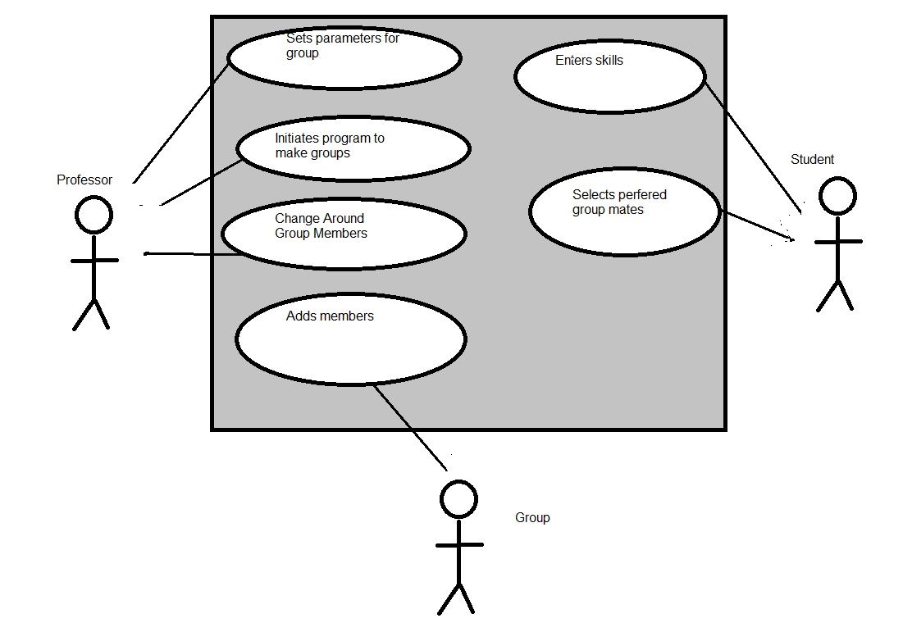

Explanation:
As we learned in class not all actors have to be alive. The groups use the system to get the members they need to fill up their empty spots.The professor still sets all the parameters for a group such as if skills/grades are important, group size, deadlines, who must/must not be matched. After this the students will be able to fill out a self evaluation where they can give what skills they have and preferred partners. The professor then starts the main matching method which will add all students Into groups.

Tracibilty matrix:
 | Groups have members | Groups have Parameters that determine how to match | Members have parameters that affect group matching | Groups can be altered after creation
Set parameters for groups |  | Match | Match
Initiates program to make groups | Match
Alter members in group | Match |  |  | Match
Enter Skills |  | Match | Match
Selects preferred partner(s) |  | Match | Match
Adds members | Match

Modules need for functionality:
- Group
- Member
- Match
- Overview

These modules will handle the design of our system as they will cover the features we need to fulfil
Group:
This module will handle things like the groups themselves, the parameters that are set to help make matches (Skills/Grades, Size and such). This is essential to the system as it is the output.

Member:
This will handle the students and the parameters from the self evaluation

Match:
This will handle the comparisons and matching Members. This is a source of risk as we are a little unfamillar with matching algorithms.

Overview:
This will handle the case when the Instructor wishes to alter groups and when a user enters parameters.

Key Features needed for the system to work:
We need a way to match students to a group
We need to be able to add students to a Group
We need to be able to alter groups

We can match members to group by a comparison of values. For the Prototype we will use a simple single value match and add students to a group by where they fit best.

When adding members we need to be sure that there Is room in the group for them otherwise we need to add them to a new group

Since all groups will be full when the auto matching is done the initiator will only have the option to swap members between 2 groups.

