**Ⅱ MEC-enable vehicle network**

**A.系统模型**

In this paper, We consider A IoV edge computing network, consisting of a cloud computing layer, MEC layer, as shown in Fig. 1. For MEC layer,which has moderate computation capacity and deploys close to networks, can be used to assist the vehicles. Cloud computing layer,can be used to process the large-scale, delay-insensitive data that MEC layer can not process。

《Reinforcement Learning》。numerous vehicle-to-RSU (V2I) cells underlay a cell. in which each RSU is equipped with a MEC server to provide computation offloading services to the vehicles，To avoid inter-cell interference, the time division multiple access (TDMA) communication technology is adopted. Time resource is divided into multi-frames, and each frame is divided into several time slots. Different VUEs access its time slots when they communicate with the RSU, and signal transmission in different time slots will produce no interference [10].《su03》.We denote the set of vehicles and MEC servers in the mobile system as V = {1, 2,...,V} and M = {1, 2,...,M}, respectively. 《joint》Some notations are given in Table II.

**B. 通信模型**

Different from the traditional cellular communication,Due to the fast mobility of vehicles, their CSIs are hard to be estimated precisely. In particular, RSU can only achieve the accurate knowledge of large-scale fading $ $L_{v,m}^{2}$ $ of vehicular to RSU links while the small-scale fading $ $h_{v,m}$ $ is greatly influenced by the fast channel variations caused by the Doppler effect. We assume that such CSIs is obtained through channel estimation 《eeh》, Therefore, we model the small-scale fading channel estimation of $ $h_{v,m}$ $ by using the first-order Gauss–Markov process [27] in each TTI as follows.《小帅》



$h_{v,m}=ξ_{v,m}{\tilde{h}}_{v,m}+\sqrt{1-{ξ_{v,m}}^{2}}ζ_{v,m}$ $h_{v,m}=ξ_{v,m}{\tilde{h}}_{v,m}+\sqrt{1-{ξ_{v,m}}^{2}}ζ_{v,m}$

we assume that the estimated channel gain ${\tilde{h}}_{v,m}$ denotes the estimate of $h_{v,m}$ and ${\tilde{h}}_{k,m}^{2}$ is exponentially distributed with unit mean [33]. Furthermore, $ξ_{v,m}ϵ\left(0,1\right)$ represents the correlation coefficient over v → m link, and $ζ_{v,m}$ stands for the channel gain and follows a complex Gaussian distribution $ζ_{v,m}∼CN\left(0,δ^{2}\right)$ and independent and uncorrelated of ${\tilde{h}}_{v,m}$. The coefficient (0 < $ζ_{v,m}$ < 1) quantifies the channel correlation between the two consecutive time slots and we assume that time correlation coefficient $ζ_{v,m}$ is same for all VUEs. According to the Jakes statistical model for the fading channel [28], $ζ_{v,m}$ is given as

$ζ_{v,m}=J_{0}\left(2πf_{max}T_{s}\right)$ (4) where $J_{0}$ is the zero-order Bessel function of the first kind.

$f_{max}$ = $\overline{ν}f_{c}∕c$ is the maximum Doppler frequency, where $\overline{ν}$ indicates the vehicle speed, $f_{c}$ indicates the carrier frequency at 5.9 Ghz, and ${ c=3×{10}^{8}m}/s$， $T_{s}$ is a period feedback latency. erally,both transmitter vehicles and RSU can know the accurate $ζ_{v,m}$.

Based on the aforementioned discussion, the mobile V2I channel power gain of the effective links and interference links in kth time slot from ith transmitter to jth receiver can be expressed as a shared expression:

$G_{i,j}^{k}={\hat{g}}_{i,j}^{k}+{\tilde{g}}_{i,j}^{k}$

Where$ ${\hat{g}}_{i,j}^{k}=L_{i,j}^{2}{\tilde{h}}_{i,j}^{2}ξ_{i,j}^{2}$ $ ，$ ${\tilde{g}}_{i,j}^{k}=L_{i,j}^{2}\left(1-ξ_{i,j}^{2}\right)$ $, $ $ζ_{i,j}^{2}$ $and $ ${L_{i,j}^{k}}^{2}$ $denotes the kth time slot large-scale fading effects including shadow-fading and path loss from ith transmitter to jth receiver on the road section。Moreover, $ ${\hat{g}}_{i,j}^{k}$ $is an observed value. $ ${\tilde{g}}_{i,j}^{k}$ $ denotes an exponential random variable with parameter $ $E\left(\frac{1}{{L_{i,j}^{k}}^{2}\sqrt{1-{ζ_{i,j}^{k}}^{2}}}\right)$ $

To improve the spectrum utilization and realize multi-vehicles joint communication, V2I communications reuse the same uplink channel. In this case, the Signal-to-Interference-plus-Noise Ratio (SINR) from vehicle$ $i$ $to RSU can be formulated as, $ $γ_{i}^{v}=\frac{p_{i}g_{i,j}}{{\sum_{j=1,j≠i}^{M}{p_{j}g_{j,i}}+σ}^{2}}$ $where $p_{j}$ denotes the transmit power of the jth vehicles，where $σ^{2}$ is the background noise。Therefore, the deterministic equivalent transmission rate of VUEs calculated by Shannon’s theorem is$ ${R_{i}\left(P\right)=log}_{2}\left(1+\frac{p_{i}g_{i,j}}{{\sum_{j=1,j≠i}^{M}{p_{j}g_{j,i}}+σ}^{2}}\right)$ $,Hence, the transmission time of vehicle u when sending its task input$ $d_u$ $in the uplink can be calculated as, $ $t_{i,up}=\frac{d_{i,up}}{R_{i}\left(P\right)}$ $， where W is the bandwidth of the reused channel. Therefore, the upload time of each V2I link can be formulated as$ $t_{i,up}=\frac{d_{i,up}}{W\log_{2}\left(1+\frac{p_{i}g_{i,j}}{\sum_{j=1,j≠i}^{M}{p_{j}g_{j,i}}+σ^{2}}\right)}$ $,And$ $d_{i,up}$ $is the amount of input data including system settings, program codes, and input parameters ，which is necessary to transfer the program execution.

Communication delay is another significant index that affects the performance of wireless networks. The packets to V2I receivers must be in the queue before they transmit at the speed of$ $R_{i}$ $. It is assumed that the process of a packet arriving at the ith V2I receiver is a Poisson process with parameter$ $k_{i}$ $, and the length of the data packet obeys the exponential distribution of parameter$ $τ_{i}$ $. Under the M/M/1 model [34], the relationship between the expected delay and transmission rate of the ith V2I links can be expressed as $ $D_{i}=\frac{1}{{τ_{i}R}_{i}-k_{i}}$ $.

**C. 计算资源分配**

vehicle computation task

we consider that each vehicle$ $v∈V$ $has one different computation task at a time. denoted as$ $c_{v}$ $, [cycles] specifies the workload, i.e., the amount of computation to accomplish the task,that is atomic and cannot be divided into subtasks. The values of$ $c_{v}$ $can be obtained through carefully profiling of the task execution [7],[32]. Each task should be offloaded to the MEC server and then transmission to the cloud server. By offloading the computation task to the MEC server, the vehicles would get more computing resources,however, it would consume additional time for sending the task input in the uplink.

The MEC server at each RSU is able to provide computation offloading service to a vehicle at a time slot .The computing resources are quantified by the fixed rate$ $\overline{f}$ $, expressed in terms of number of CPU cycles/s. the vehicle n uploads the input data of task to the nearest RSU，the RSU process the small-scale, delay-sensitive data first, then the RSU forward the remaining data to the remote cloud server. the cloud is able to provide computation offloading service to multiple RSU concurrently. The computing resources made available by cloud to be shared among the associating users are quantified by the computational rate $f_{i}$, it is still expressed in terms of number of CPU cycles/s ,Thus, the latency for computing offloading can be written as$ $t_{i,exe}=\frac{c_{i,e}}{\overline{f}+f_{i}}$ $.

**效用函数**

Given the computing resource allocation$ $f_{i}$ $, the total delay experienced by vehicle u when offloading its task is given by$ $t_{i}=\frac{c_{i,e}}{\overline{f}+f_{i}}+T_{c}$ $. The transmission latency between RSU and cloud server is defined as$ $T_{c}$ $, usually it is set to a fix value. 《Reinforcement Learning》 so the relative improvement in task completion time is characterized by $ $U_{i,exe}=\frac{t_{max}-t_{i,exe}}{t_{max}}$ $,where$ $t_{max}$ $ is the maximum tolerable threshold of the task completion time，If a task can be completed ahead of deadline$ $t_{max}$ $, the vehicle can get a higher utility, otherwise, it will produce the corresponding loss.Therefore, we define the offloading utility of vehicle u as, $ $\frac{U_{i,exe}}{t_{i,up}}$ $denote offloading time cost utilities at a unit .

**优化问题的制定**

The joint task offloading and resource allocation will be formulated as an optimization problem in this section. And the goal is to obtain the minimum total system cost composed of latency and transmission rate for all vehicles in the networks. For a given uplink power allocation P, and computing resource allocation F, we define the system utility as the weighted-sum of all the users’ offloading utilities, $ $U=max\sum_{i=1}^{M}{\frac{U_{i,exe}}{t_{i,up}}}$ $This utility means getting a more enormous execution time utility with a minor upload time cost ,We now formulate the Joint Resource Allocation and Task Offloading problem as a system utility maximization problem, i.e. The robust optimization problem is formulated as follows

优化函数 *max $EE=max\sum_{i=1}^{N}{\frac{U_{i,exe}}{t_{i,up}}}$*

$$s.t. \left\{ \begin{aligned}&Pr\left\{γ_{i}≤γ_{th}\right\}≥1-ε_{1}& \\ &Pr\left\{\frac{1}{τ_{i}R_{i}-k_{i}}+\frac{c_{i,e}}{\overline{f}+f_{i}}≤D_{max}\right\}≥1-ε_{2} \\ &\sum_{i=1}^{N}{f_{i}}≤f_{total} \\ &0≤p≤p_{max}\end{aligned}\right.$$

$C1$ $Pr\left\{γ_{i}≤γ_{th}\right\}≥1-ε_{1}$

$C2$ $Pr\left\{\frac{1}{τ_{i}R_{i}-k_{i}}+\frac{c_{i,e}}{\overline{f}+f_{i}}≤D_{max}\right\}≥1-ε_{2}$

$C$ 3 $\sum_{i=1}^{N}{f_{i}}≤f_{total}$

$C$ 4 $0≤p≤p_{max}$

where U denotes the network utility,The constraints in the formulation above can be explained as follows:

Constraints (8c) is used to guarantee the QoS requirements of VUEs,however,due to Large amount of computation caused by time varying network topologies，the real-time SINR is hard to obtain in vehicular communication scenario, and it can be replaced with the long-term SINR since the CSI feedback time interval is very small.$ $γ_{i}$ $denotes the average SINR of the ith V2I link when a small CSI feedback time interval is used，In order to ensure that the task is successfully offloaded to the RSU,its SINR should be guaranteed to be no less than the SINR threshold.《su02》$ $γ_{th}$ $ is the SINR threshold for successful detecting the V2I communication.$ $p_{r}\left\{⋅\right\}$ $ defines the probability of the input，In this case, we introduce the outage probability constraint (8c) to guarantee the reliability of vehicular links.《小帅》Di,max is the upper delay bound of the ith D2D pair in the process of data transmission. $ $ε_{1}$ $,$ $ε_{2}$ $ are the outage probability thresholds of SINR and delay constraint respectively, where $ $ε_{1},ε_{2}∈\left(0,1\right)$ $ .constraints (12g) state that each MEC server must allocate a positive computing resource to each user associated with it and that the total computing resources allocated to all the associated users must not excess the server’s computing capacity.C6 states that the number of applications served by a particular edge cloud should be within its capacity.C2 denote the total latency of communication and computing should be guaranteed to be no less than the time threshold , $ $p_{max}$ $ is the maximum transmit power of the transmit vehicle in vehicle communication network,and the transmit power is greater than zero.

**Ⅲ PROBLEM SOLUTIONS 问题的分解**

**A．Uplink power allocation**

In this section, we proposed a BCD-based algorithm to solve the problem (7). The BCD method enables the complex original problem to be decomposed into a series of simpler subproblems [13]. Motivated by this fact, all variables are divided into two blocks and optimized alternatively.

Robust power control Optimization Algorithm

By fixing F, the problem (7) can be transformed into the following problem.

优化函数 *max $EE=max\sum_{i=1}^{M}{\frac{U_{i,exe}}{t_{i,up}}}$*

$C1$ $Pr\left\{γ_{i}≤γ_{th}\right\}≥1-ε_{1}$

$C2$ $Pr\left\{\frac{1}{τ_{i}R_{i}-k_{i}}+\frac{c_{i,e}}{f_{i}}≤D_{max}\right\}≥1-ε_{2}$

$C$ 4 $0≤p≤p_{max}$

Successive Convex Approximation of the Objective Function

Since the original problem is a non-convex and NP-hard because of the logarithmic function in the objective function, here, the method of successive convex approximation is adopted to relax the original problem and make objective function solvable. We can use the lower bound to approach the original function as follows.

$$\begin{aligned}A\ln\left(z\right)+B≤\ln\left(1+z\right) \\ \left\{\begin{aligned}A=\frac{z_{0}}{1+z_{0}} \\ B=\ln\left(1+z_{0}\right)-\frac{z_{0}}{1+z_{0}}\ln\left(z_{0}\right)\end{aligned}\right.\end{aligned}$$

Each term of (5) can be represented by $ $A_{k}ln\left(γ_{k}\left(e^{\tilde{p}}\right)\right)+B_{k}$ $ through successive convex approximation, where $ $A_{k}$ $ and $ $B_{k}$ $ can be chosen as $ $A_{k}=γ_{i}/\left(1+γ_{i}\right)$ $, $ $B_{k}=\ln\left(1+γ_{i}\right)-A_{k}\ln\left(γ_{i}\right)$ $, $ $A_{k}$ $=1, $ $B_{k}\$$ =0, and each term of objective function can be written as Follows

$$\frac{1}{\ln{2}*d_{i,up}}*\sum_{i=1}^{M}{\left.U_{i,exe}\left[{A_{k}\ln\left(γ\left(p\right)\right)+B}_{k}\right.\right]}$$

it is still hard to directly calculation because of fractional from of SINR, we use variable substitution, i.e. $ ${\hat{p}}_{i}=\ln{p_{i}}$ $,$ $p_{i}=e^{{\hat{p}}_{i}}$ $, then $$C2:{\hat{p}}_{i}≤\ln{p_{max}}, ∀ 1≤i≤M$$

$$EE=max\frac{1}{\ln{2}*d_{i,up}}*\sum_{i=1}^{M}{\left.U_{i,exe}*\left[{A_{k}\ln\left(γ\left(ⅇ^{\tilde{P}}\right)\right)+B}_{k}\right.\right]}$$

**Extension to Error Channel Gain With Unbounded Support 处理概率约束 xie02**

中断概率约束表示为

$$Pr\left\{φ_{0}\left(p\right)+\sum_{k=1}^{K}{ξ_{k}φ_{k}\left(p\right)}≤0\right\}≥1-ε_{1}$$

It is obvious that the constraint (6) includes uncertainties and the objective function is a non-convex problem in (5). The objective function and constraints are difficult to deal with when determining the optimal solutions. it is necessary to design an algorithm with lower complexity to solve the problem. In this paper, For the uncertain channel gain. Considering the fast fading, Two common forms are adopted to describe the uncertainty mentioned above, i.e. the statistical constraints and deterministic constraints. to pursue a simple form of (d),a matrix form is introduced,the general form the channel gain is described as,

$$Pr\left\{{\left(G_{m}\right)}^{T}ⅇ^{\tilde{p}}+σ^{2}≤0\right\}≥1-ε_{1}$$

Where$ $G_{m}={\left[G_{1,m},G_{2,m},…,-\frac{G_{m,m}}{γ_{th}},…,G_{M,m}\right]}^{T}$ $,Furthermore, the Bernstein method is adopted to approximate the probability constraint with channel uncertainty

Theorem 1: The outage probability of all cochannel V2I links$ $Pr\left\{γ_{i}≤γ_{th}\right\}≥1-ε_{1}$ $

is reformulated as the separable constraints (26)

$$σ^{2}+\sum_{i=1}^{M}{χ_{i,j}e^{{\tilde{p}}_{i}}}+\sqrt{2ln\left(\frac{1}{ε_{1}}\right)}{\left(\sum_{m=1}^{M}{{\left(σ_{i,j}β_{i,j}p_{i}\right)}^{2}}\right)}^{\frac{1}{2}}≤0$$

Where $ $χ_{i,j}=μ_{i,j}^{+}α_{i,j}+β_{i,j}+{\overset{ˆ}{g}}_{i,j}$ $, these parameters (i. e., $ $σ_{i,j}$ $ and $ $α_{i,j}$ $ )are deduced to be positive in Appendix A.Suppose that the truncated distributions of$ $G_{i,j}$ $have bounded supports$ $\left[{\tilde{g}}_{i,j}^{k}+α_{i,j},{\tilde{g}}_{i,j}^{k}+β_{i,j}\right]$ $，$ ${\tilde{g}}_{i,j}^{k}$ $is an estimate of$ $G_{i,j}$ $,Introduce constants $ $α_{i,j}=\frac{1}{2}\left(b_{i,j}-a_{i,j}\right)$ $,$ $β_{i,j}=\frac{1}{2}\left(b_{i,j}+a_{i,j}\right)$ $ to normalize the supports to$ $\left[-1,1\right]$ $ as follows,

$ξ_{i,j}=\frac{G_{i,j}-{\tilde{g}}_{i,j}^{k}-β_{i,j}}{α_{i,j}}∈\left[-1,1\right]$

In the last term of (15), the variables$ $p$ $are coupled nonlinearly. Hence, directly finding an acceptably good solution to (9) by the Bernstein method is time consuming when the K increases and the number of vehicles is large. Therefore, it is necessary to Introduced a l2-norm approximate problem for any$ $x∈R^{k}$ $，Hence, The last term in (12) containing l2-norm of the vector is further approximated by$ ${\left\|x\right\|}_{2}≤{\left\|x\right\|}_{1}$ $ , Based on these, the constraint in (12) is further formulated as$ $σ^{2}+\sum_{i=1}^{M}{χ_{i,j}e^{{\tilde{p}}_{i}}}+\sqrt{2ln\left(\frac{1}{ε_{1}}\right)}\sum_{i=1}^{M}{\left|σ_{i,j}β_{i,j}\right|e^{{\tilde{p}}_{i}}}≤0$ $with lower complexity and higher reliability.

The constraint (9a) can be handled by an Integral transformation method,According to constraint (9a)), where$ $D_{max}=D_{1}+D_{2}$ $,$ $D_{1}=\frac{1}{τ_{i}R_{i}-k_{i}}$ $,$ $D_{2}=\frac{c_{i,e}}{f_{i}}$ $,$ $a=\frac{1}{{L_{i,j}^{k}}^{2}\sqrt{1-{ζ_{i,j}^{k}}^{2}}}$ $ we can get the feasible power region of the communication delay probability as follows

$$\left(I_{th}+σ^{2}\right)\left(2^{\frac{1+kD}{Dτ}}-1\right)+ {\hat{g}}_{2}ⅇ^{\tilde{P}}≤0$$

$$\left(\frac{1}{D_{max}-D_{2}}+k_{i}\right)\left(I_{th}+σ^{2}\right)+ τ_{i}\left.\left[\ln\left(1-ε_{2}\right)-{\hat{g}}_{2}\right.\right]ⅇ^{\tilde{P}}≤0$$

The proof of the feasible region can be found in Appendix B

The probability constraint of C2 can be transformed to the deterministic one according to the following inference

$$Pr\left\{\frac{1}{τ_{i}R_{i}-k_{i}}+\frac{c_{i,e}}{f_{i}}≤D_{max}\right\}$$

$$=Pr\left\{R_{i}≤\frac{1}{R_{i}\left(D_{max}-D_{2}\right)}+\frac{k_{i}}{τ_{i}}\right\}$$

$$≤1-Pr\left\{p_{i}{\tilde{g}}_{i,j}^{k}≤\left(I_{th}+σ^{2}\right)2^{\frac{1+k_{i}\left(D_{max}-D_{2}\right)}{τ_{i}\left(D_{max}-D_{2}\right)}}-p_{i}{\hat{g}}_{i,j}^{k}\right\}$$

$$=1-\exp\left({a\hat{g}}_{i,j}^{k}-a\frac{\left(I_{th}+σ^{2}\right)2^{\frac{1+k_{i}\left(D_{max}-D_{2}\right)}{τ_{i}\left(D_{max}-D_{2}\right)}}}{p_{i}}\right)≤aε_{2}$$

In summary, we can obtain a deterministic optimization problem of robust power allocation by transforming the objective function, outage probability constraints, delay constraints. It is expressed as,

P1 $\max{EE\left(\tilde{P}\right)}=max\frac{1}{\ln{2}*d_{i,up}}*\sum_{i=1}^{N}{\left.U_{i,exe}*\left[{A_{k}\ln\left(γ\left(ⅇ^{\tilde{P}}\right)\right)+B}_{k}\right.\right]}$

$$C1σ^{2}+\sum_{i=1}^{M}{χ_{i,j}e^{{\tilde{p}}_{i}}}+\sqrt{2ln\left(\frac{1}{ε_{1}}\right)}\sum_{i=1}^{M}{\left|σ_{i,j}β_{i,j}\right|e^{{\tilde{p}}_{i}}}≤0$$

$C$ 2 $\left(I_{th}+σ^{2}\right)\left(2^{\frac{1+kD}{Dτ}}-1\right)+ {\hat{g}}_{2}ⅇ^{\tilde{P}}≤0$

$C$ 4 $-∞≤{\tilde{p}}_{i}≤\ln{p_{i,max}}$

OPTIMAL POWER CONTROL AND PRICING SOLUTIONS

Optimal Power Control Algorithm

To pursue an iterative algorithm for solving the problem,Lagrange dual decomposition technique [39] is used to maximize the lower bound of the original objective under given coefficients Xi and Yi. It’s noted that these two coefficients should be updated to guarantee amonotonic increase in the lower bound performance.

Hence, the Lagrangian function of (17) under fixed coefficients Xi and Yi can be expressed as

$$L\left(\tilde{p},λ,μ\right)=\frac{1}{\ln{2}*d_{i,up}}\sum_{i=1}^{M}{U_{i,exe}\left[A_{k}ln\left({\overline{γ}}_{k}\left(e^{\tilde{p}}\right)\right)+B_{k}\right]}$$

$$-λ_{k}\left[σ^{2}+\sum_{i=1}^{M}{χ_{i,j}e^{{\tilde{p}}_{i}}}+\sqrt{2ln\left(\frac{1}{ε_{1}}\right)}\sum_{i=1}^{M}{\left|σ_{i,j}β_{i,j}\right|e^{{\tilde{p}}_{i}}}≤0\right]$$

$-μ_{k}\left[\left(I_{th}+σ^{2}\right)\left(2^{\frac{1+kD}{Dτ}}-1\right)+ {\hat{g}}_{2}ⅇ^{\tilde{P}}≤0\right]$

Maximization of the inner dual function,D μ, λ , can be performed by determining the stationary point of (27) with respect to λ and ˜ p:

$\frac{U_{i,exe}}{\ln{2}*d_{i,up}}A_{k}-\left[\frac{U_{i,exe}}{\ln{2}*d_{i,up}}\sum_{j=1,j≠k}^{K}{A_{j}\frac{{\overline{γ}}_{j}\left(e^{\tilde{p}}\right){\overline{G}}_{k,j}}{e^{{\tilde{p}}_{j}}{\overline{G}}_{j,j}}}+λ_{k}\left(σ^{2}+\sqrt{2ln⁡\left(\frac{1}{θ}\right)}\sum_{i=1}^{K}{\left|σ_{i,k}β_{i,k}\right|}\right)+μ_{k}\hat{g}\right]e^{{\tilde{p}}_{k}}=0$

Based on (33), the iteration for the power allocation , can be formulated as,

${\tilde{p}}^{\left(t+1\right)}={\left[\ln{\frac{A_{j}U_{i,exe}}{\ln{2}*d_{i,up}}}-\ln\left(\frac{U_{i,exe}}{\ln{2}*d_{i,up}}\sum_{j=1,j≠k}^{K}{A_{j}\frac{{\overline{γ}}_{j}\left(e^{\tilde{p}}\right){\overline{G}}_{k,j}}{e^{{\tilde{p}}_{j}}{\overline{G}}_{j,j}}}+λ_{k}\left(σ^{2}+\sqrt{2ln\left(\frac{1}{θ}\right)}\sum_{i=1}^{K}{\left|σ_{i,k}β_{i,k}\right|}\right)+μ_{k}\hat{g}\right)\right]}_{-∞}^{\ln{p_{max}}}$

The Lagrangian multiplier λ, ν, are updated through the sub-gradient method, which are formulated as

$$λ_{i,j}^{\left(t+1\right)}={\left[λ_{i,j}^{\left(t\right)}+σ^{2}+\sum_{i=1}^{M}{χ_{i,j}e^{{\tilde{p}}_{i}}}+\sqrt{2ln\left(\frac{1}{ε_{1}}\right)}\sum_{i=1}^{M}{\left|σ_{i,j}β_{i,j}\right|e^{{\tilde{p}}_{i}}}\right]}^{+}$$

$μ_{i,j}^{\left(t+1\right)}={\left[μ_{i,j}^{\left(t\right)}+\left(I_{th}+σ^{2}\right)\left(2^{\frac{1+kD}{Dτ}}-1\right)+ {\hat{g}}_{2}ⅇ^{\tilde{P}}\right]}^{+}$

where Kλ, Kν, Kϕ denote the step-size, and Kλ > 0, Kν > 0, Kϕ > 0. t denotes the iteration index. X + 0,X .

**B .computing resource allocation**

After obtaining P, the formulated problem with respect F reformulated by:

*max $EE=max\sum_{i=1}^{N}{\frac{U_{i,exe}}{t_{i,up}}}$*

$C2$ $\frac{1}{τ_{i}R_{i}-λ_{i}}+\frac{c_{i,e}}{\overline{f}+f_{i}}≤D_{max}$

$C$ 3 $\sum_{i=1}^{N}{f_{i}}≤f_{total}$

Notice that the constraints in (25b) and (25c) are convex, by calculating the second-order derivatives of Λ(X,F) w.r.t. $f_{i}$ the Lagrangian function is constructed to seek the optimal powers.

目标函数求导了 $\frac{c_{i,e}}{\ln{2}*d_{i,up}t_{max}{\left(\bar{f}+f_{i}\right)}^{2}}$

$L\left(F,ξ,φ\right)=\frac{1}{\ln{2}*d_{i,up}}\sum_{i=1}^{N}{R_{i}\left(P\right)\left[1-\left(\frac{c_{i,e}}{t_{max}\left(\overline{f}+f_{i}\right)}+\frac{T_{c}}{t_{max}}\right)\right]}-ξ_{k}\left(\frac{1}{τ_{i}R_{i}-λ_{i}}+\frac{c_{i,e}}{\overline{f}+f_{i}} ≤D_{max}\right)-φ_{k}\left[\sum_{i=1}^{N}{f_{i}}-f_{total}\right]$

In order to prove the concavity of P5, the following research is taken.The first-order derivative of U0 c with respect to $f_{i}$ is,

$\frac{∂u\left(F,ξ,φ\right)}{∂f_{i}}=\frac{c_{i,e}}{\ln{2}*d_{i,up}t_{max}{\left(\overline{f}+f_{i}\right)}^{2}}=\frac{Ω_{i}}{{\left(\overline{f}+f_{i}\right)}^{2}}$ $\frac{∂u}{∂y}$

in which, for simplicity $Ω_{i}=\frac{c_{i,e}}{\ln{2}*d_{i,up}*t_{max}}$

The second-order derivative of is obtained further as,

$\frac{∂^{2}U}{∂f_{i}^{2}}=-\frac{2⋅Ω_{i}}{{\left(\overline{f}+f_{i}\right)}^{3}}≤0$

it is obvious that The second-order derivative of U0 c with respect to ci is always less than 0. Therefore, U0 c is a concave function about ci, Hence, (25) is a convex optimization problem and can be solved using Karush-Kuhn-Tucker (KKT) conditions.

$$\frac{∂u\left(F,ξ,φ\right)}{∂f_{i}}=\frac{Ω_{i}R_{i}\left(P\right)}{{\left(\overline{f}+f_{i}\right)}^{2}}-ξ_{k}\frac{c_{i,e}}{{\left(\overline{f}+f_{i}\right)}^{2}}-\sum_{i=1}^{N}{φ_{k}}=0$$

Let, $\frac{∂u\left(F,ξ,φ\right)}{∂f_{i}}=0$ the optimal computing resource allocation is:obtained by $\frac{U_{i,exe}}{t_{i,up}}$

$${f_{i}}^{*}=\sqrt{\frac{Ω_{y}R_{i}\left(P\right)-{c_{i,e}ξ}_{k}}{\sum_{i=1}^{N}{φ_{k}}}}-\overline{f}$$

The iterative expression is as follows,

$${\tilde{f}}^{\left(t+1\right)}={\left[\sqrt{\frac{Ω_{y}R_{i}\left(P\right)-{c_{i,e}ξ}_{k}}{\sum_{i=1}^{N}{φ_{k}}}}-\overline{f}\right]}_{-∞}^{f_{total} }$$

The Lagrangian multiplier $η$, $φ$, are updated through the sub-gradient method, which are formulated as

**算法伪代码**

where P∗ and F can be obtained through Algorithm 1

Algorithm 1: Joint Robust Power Control and Task Offloading Scheduling Algorithm

Input Set the maximal iterative number Tmax, the fixed price C and the step size φ.

Initialize the log-domain power vector $p$,computing resource allocation $f$ and the Lagrangian multiplier vector $λ$ $μ$ $η$ $φ$

repeat

Calculate

Given feasible points $p_{i,j}^{\left(t\right)}$, $f_{i,j}^{\left(t\right)}$

Solve problem P4, and obtain the current optimal solution ${\tilde{p}}^{\left(t+1\right)}$.

Update ˜ p and λ using (20) and (23), respectively. $λ_{i,j}^{\left(t+1\right)}$ $μ_{i,j}^{\left(t+1\right)}$

Given feasible points $p_{i,j}^{\left(t+1\right)}$, $f_{i,j}^{\left(t\right)}$

Solve problem P4, and obtain the current optimal solution ${\tilde{f}}^{\left(t+1\right)}$.

Update ˜ f and λ using (20) and (23), respectively. $η$ $φ$

Until synchronously converge to the optimal solutions $p$ $f$ $\tilde{P}\tilde{f}$ $p$ $f$**f p**

Output:

**Ⅳ SIMULATION AND PERFORMANCE EVALUATION**

在这一节中，数值仿真被提出用来证明我们提出的算法是有效的

In this section, numerical simulations are presented to evaluate the performance of the proposed Algorithms 1.A mec-based vehicular network system which includes five clusters under a certain time slot is selected as our fundamental simulation scenario. The major system parameters are listed in Table III. It is noted that the carrier frequency f and the bandwidth W are set as 2 GHz and 10 MHz respectively in the numerical simulations,We assume that both the vehicles and rsus use a single antenna for uplink transmission and reception, respectively.Unless stated otherwise, the parameter value of $ $γ_{th}$ $ is set to 10−6, the outage probability threshold $ $ε_{1}=ε_{2}=0.1$ $.

假设车速在某个较小的时隙内为常数[85]。

Assume the variation of the vehicles’ speed is negligible within the reference time interval,

除非特别说明，车辆速度与计算所需要的CPU周期数如下表所示task workloads.

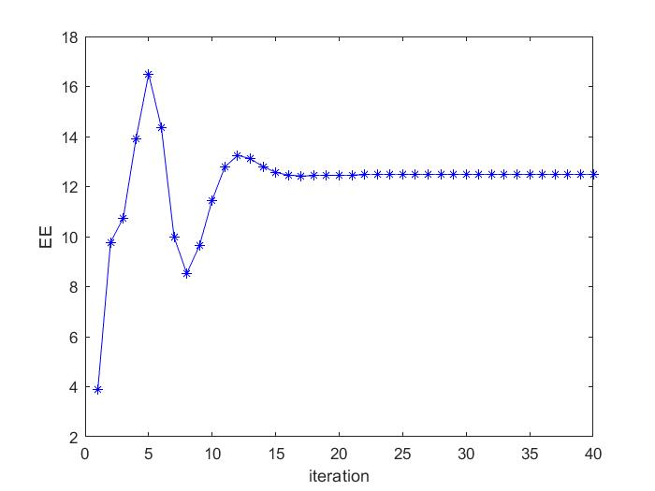

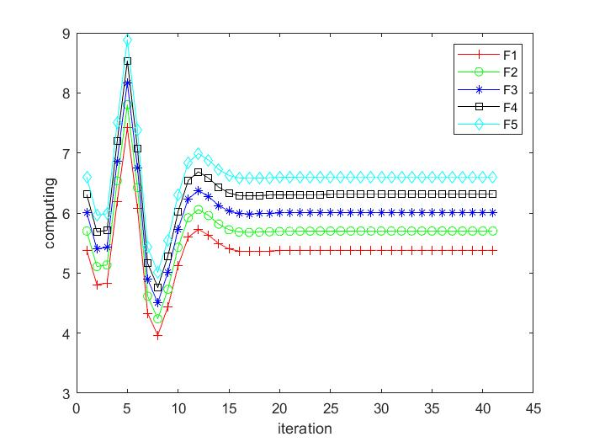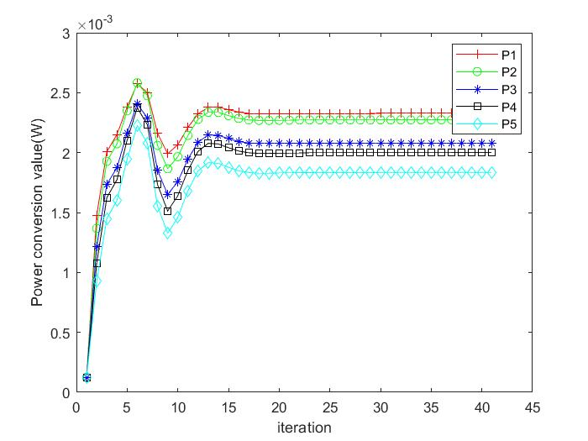

Fig. 3(a) and Fig. 3(b) show that the power of each vehicle transmitter and the corresponding computing resource which cloud allocation to RSU in Algorithm2, respectively. It can be seen that the computing resources allocated in the cloud peak at the fifth iteration and begin to decline because of the limitation of total computing resources $ $f_{total}$ $ from the cloud. The corresponding power resource allocation also changes due to computing resources allocation under Joint Robust Power Control and Task Offloading Scheduling.

可以看出云端分配的计算资源在第五次迭代时到达峰值并开始下降，其原因是因为收到了总的计算能力total的限制，由于是联合优化，因此，相应的功率资源分配也随之改变。Fig. 3(a)展示了在联合优化下系统总效用的收敛情况，可以看到，网络系统的总效用的收敛趋势与功率分配和计算资源分配是相关的，根据式(4-24)中EE的定义，这种现象是合理的。由于R随着功率向量p的增加而对数增加，导致作为E分母部分的上传时间随着功率的增加而减小，作为分子部分的执行效用，texe随着计算能力f的增加而反比例下降，导致分子随着f的增加而增加。

This phenomenon is reasonable due to the definition of ηEE in (24). $ $R_{i}$ $ increases logarithmically as the power vector $ $p$ $ increases, the upload time $ $t_{i,up}$ $, as the denominator of ηEE, will decrease with the increase of power vector $ $p$ $ and as the executive utility of the numerator part, $ $t_{i,exe}$ $ decreases inversely proportional with the increase of computing power $ $f$ $,causing the numerator to increase with the increase of $ $f$ $. $p$ $f$

As the upload time of the E denominator part, R increases logarithmically with the increase of the power vector p, causing the denominator to decrease with the increase of power,

在车联网移动边缘计算系统中，不考虑车辆的移动性是不现实的，因此我们研究了车辆的移动性对系统性能的影响.红线表示了当速度引起的不确定性忽略不计的时的基准值，我们可以看出图中随着车辆速度的提升，系统性能会下降，这是由于车辆快速移动导致的多普勒响应会影响到车辆的通信，可以看出车辆的移动性是会对系统性能产生影响的

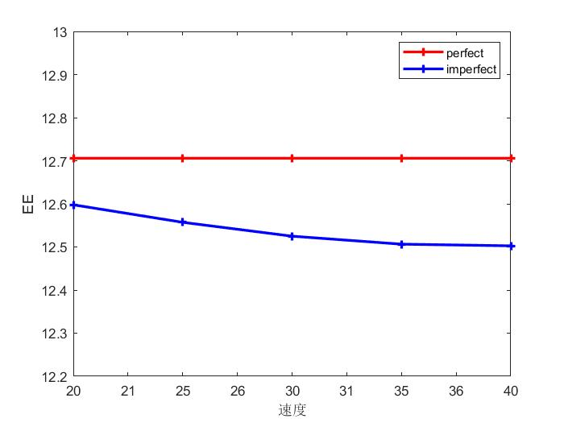为了进一步说明速度引起的多普勒频移对系统性能的影响，在系统中模拟了车速不变情况下的基准值与测速不断提高时的对比实验，车速改变的仿真实验拓扑中将所有车速依次从20 m/s增加到60 m/s。这种配置导致一个事实，随着车辆速度的提升，系统性能会下降，与基准值对比可以知道，车速引起的多普勒效应对系统性能是不利的，蓝色实线结果也证明了倾向于较小相对速度的方法是有更好的结果的。

仿真中车速不变时所有 CHs的速度设置为0（即 0 m/s），并且所有车的速度在相同的网络中相同

In the Mec-Enabled vehicular cloud system. It is unrealistic not to take into account the mobility of the vehicle, We then investigated the impact of vehicle mobility on system performance, Assume the variation of the vehicles’ speed is negligible within the reference time interval,

In order to further illustrate the influence of speed-induced Doppler shift on system performance, the comparison experiment between the benchmark value and the increasing speed measurement under the condition of constant vehicle speed is simulated in the system.

Since the relative speed in the V-RSU link is zero, And the speed of all vehicles is the same in the same network there is no Doppler effect. Then the vehicle speed on the road is set to 20 m/s, 30 m/s, 40 m/s, 50 m/s and 60 m/s, respectively，It can be seen from Fig. 11 that with the increase of vehicle speed, the utility value of the v2e network decreases, This is because the higher speed will cause a greater Doppler frequency shift in the network, increase channel uncertainty, The solid blue line result also proves that methods that tend to obtain a better utility when the vehicle speed Is low.

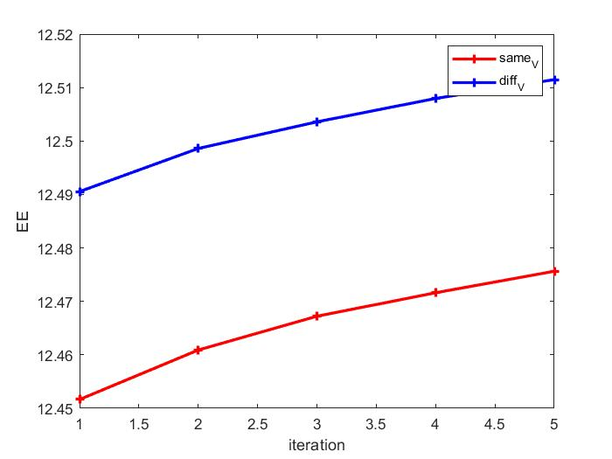

为了进一步验证考虑了车辆移动性后所提出方案的性能，下图描述了不同 $ε_{1}$ 值下的每辆车相同速度与不同速度的时候对总效用的影响，从图中可以看出随着 $ε_{1}$ 的改变，系统效用也随之变化，在每辆车速度不同时的效用要高于所有车相同的速度，表征了提出的方法在复杂的动态车辆环境下具有较高的鲁棒性

In order to further verify the performance of the proposed scheme after considering the mobility of the vehicle, the figure below describes the effect of the same speed and different speeds of each vehicle under different $ $ε_{1}$ $ on the total utility, and it can be seen from the figure that with the change of $ $ε_{1}$ $, the system utility also changes, and the utility at different speeds of each vehicle is higher than that of all vehicles at the same speed, which characterizes the high robustness of the proposed method in complex dynamic vehicle networks.

**In terms of computing resources** allocation**,** we choose the default task input size as du = 420KB (following [4], [10]),

We now evaluate the system utility performance against different numbers of users wishing to offload their tasks, as shown in Fig. 4(a, b, c).我们根据du的不同来评估

为了验证联合优化算法具有更好的有效性，我们找了三种方式做了对比

The purpose of this section is to show the convergence of our proposed algorithm and its performance is better than three benchmark schemes through some simulation results. The benchmark schemes are described as follow

“Without vehicle power control” (denoted as “Without-VPC”): The transmit power of the vehicles is set as average power during the offloading.

这里可以改成不考虑车辆的移动性

将改成分别优化功率与计算资源,就是说明不知道另一个的决策

“Non-robust”: Similar to [? ],Independent Offloading and power control，the vehicles independently make power control and the **computing resources** allocation

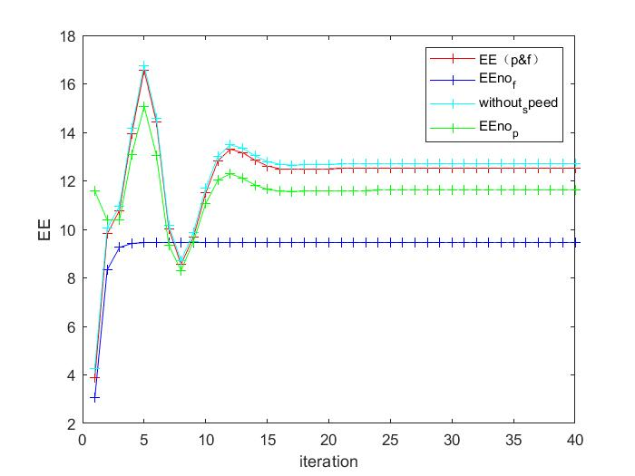

首先是不同情况下系统总效用的迭代收敛，从图中可以看出，鲁棒的联合优化性能优于其余三种情况。可以看出随着迭代次数的增加，四种方法都收敛到了稳定值，其中联合优化的性能最好

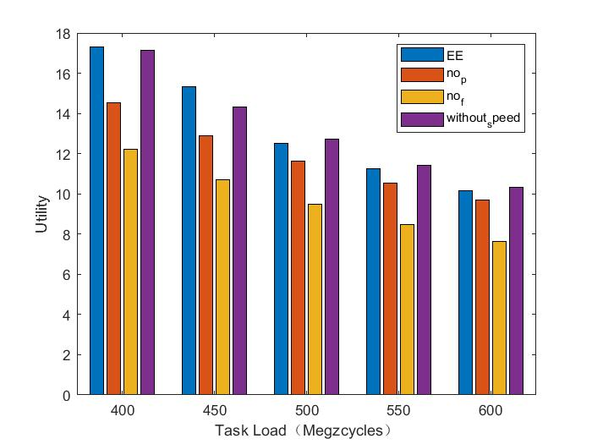

然后是在不同上传任务下四种方式的对比，可以看出随着上传任务的增加系统性能会随之下降，联合优化相比较于其他方式依然具有优越性

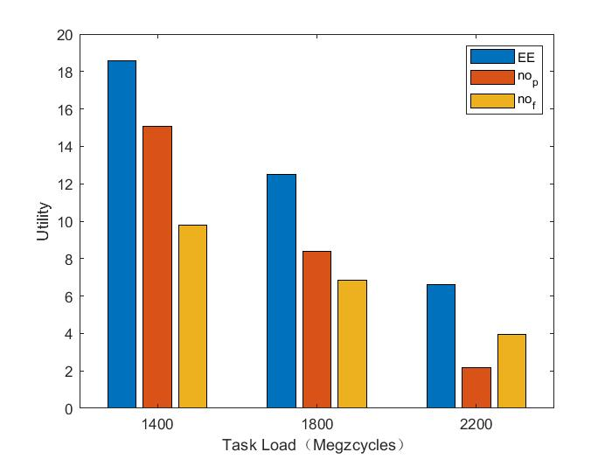

然后是在不同的CPU处理周期数的情况下的对比，可以看出，随着所需要的CPU的周期数的增加系统性能会随之下降，联合优化相比较于其他方式依然具有优越性

定性的分析

为什么联合优化系统性能会优于，固定变量，或者单独优化，

单独优化就是首先优化功率P，得到结果后，将结果用于计算资源的优化，然后对计算资源进行优化，最终得到系统的效用。

但是如果使用的是联合优化，那么两个变量都能取到最优值。

**Ⅰ INTRODUCTION**

随着汽车保有量的逐年攀升，城市交通拥堵日趋严重，交通事故日渐频发，同时也引发了诸多环境和能源问题。为了提升交通效率并保障交通安全，缓解相应的环境和能源危机，智能、灵活及可提供多样化服务的车联网应运而生。

车联网是指用先进的传感器技术，并行计算机技术以及无线通信技术为基础，实现车与车

近年来，随着道路交通车辆密度的不断增大，道路交通安全以及车辆通信拥堵等问题日益凸显。随着智能化、联网化程度的不断发展，智能交通系统（Intelligent Traffic Systems, ITS）正在世界各地得到广泛开发和部署，尤其是车辆对车(Vehicle-to-Vehicle, V2V)通信。

Channel reuse model 信道复用模型

our objective is to design a holistic solution for joint task offloading and resource allocation in a multi-server MEC-assisted network，Specifically, we consider amulti-cell ultra-dense network where each BS is equipped with a MEC server to provide computation offloading services to the mobile users.

5G网络的引入有希望解决日益增长的车联网用户对系统低时延高可靠传输的问题。与此同时，由于开放的频谱资源远远不能满足车联网通信的需求，为应对“频谱危机”，频谱共享技术是提高频谱资源利用效率的有效手段。在频谱共享的模式下。大多数前人的研究都考虑一个车辆用户复用一个授权用户信道的情况[10,11]，这种情况相对来说比较容易实现。然而，在车辆密度较大的场景中，多个车辆用户同时复用一个授权用户信道的设想更佳，且相对于一复用一的复用方式，多复用一更能够提升频谱利用率[12,13]。

V2X protocol is established in IEEE 802. 11p [14]. Intelligent vehicle transmission capacity is improved by V2V communication. V2V technology is based on Device-to-Device (D2D) communications. D2D connects two geographically close devices to achieve low latency communication. D2D can improve spectrum efficiency, reduce cellular network pressure and optimize network performance [15].

车辆的移动性

我们将综合考虑5G通信环境的不确定性以及车辆用户的动态行为，建立更为接近中继场景下的5G车联网特性的动态通信模型以及信道模型。

The vehicle speed is fast and the network topology changes constantly under the car-road synergy environment.The data can be transmitted through V2I and V2V to complete the intelligent driving task: the vehicle can communicate with the base station directly, and relay vehicle can help to forward the data.

在高动态的车联网环境下，信息传播过程中存在诸多不确定因素，如路侧建筑物的阻挡、十字路口等复杂通信场景以及车辆的高速和快速移动等都会导致信道增益的不确定，车辆用户所受到的总干扰通常由背景噪声干扰和其它用户对他产生的干扰组成。前人针对信道衰落模型的研究多假设其为某一固定形式，如平坦衰落信道，而忽略了网络环境的动态变化。因此在分析和仿真中多简化为用户间的干扰增益仅与他们的距离有关，即根据实际情况取 2~5。但是在 5G 车联网通信场景中，车辆用户的频繁移动，传输信号的反射、遮挡、绕射、散射现象，多普勒效应，信号传输损耗受距离、载波频率、车辆移动、障碍物遮挡，多径衰落现象以及测量噪声等诸多因素的影响，都是需要综合考虑的。 此外还存在着车联网内参与用户的不确定性和网络拓扑的不确定性。由于车联网网络通信节点数量多、种类复杂，当这些非授权节点复用授权用户信道时，要等待可复用信道的释放，伺机接入或重新调整发射功率以获得更好的通信质量，这使得参与通信的车辆节点和路测节点存在着较大的不确定性，即参与用户不确定性。网络拓扑不确定性主要由车辆用户的移动性导致，随着车辆用户的加入与退出以及车辆用户的频繁移动，导致拓扑切换频繁并伴随着功率调整和干扰变化，频谱资源也会根据拓扑变换重新分配，以实现每个车联网用户的效用最大化。因此本项目将针对路测节点与车辆节点之间、车辆节点与中继节点之间、车辆节点与车辆节点之间的网络结构，将5G车联网高动态环境进行参数化表示，考虑车联网高动态环境下信道参数的不确定性，分析制约信息传输可靠性的主要因素，建立基于高动态环境下车路信息协同的数学模型。

The transmission of low delay is required in intelligent driving tasks.

边缘计算 edge computing model

Different from traditional mobile cloud computing (MCC), MEC migrates remote cloud computing resources to the edge of the network to reduce the end-to-end transmission delay of data and to relieve the computing and storage pressure of vehicles or intelligent roadside

infrastructures.

Traditional cloud computing can no longer meet the stringent low latency requirement of smart driving。Emerging computing mode represented by MEC is rising rapidly.

不同于传统的云计算，MEC将计算资源迁移到网络边缘以减小数据的端到端延时，并且缓解车辆或智能路边基础设施的计算和存储压力。

《Smart Network 》propose a hybrid transmission and reputation management strategy to accommodate the fast-changing IOV topology and to meet the low latency requirements of intelligent driving tasks.

Edge computing, which is an information hinge for vehicles and roadside facilities [1], can enhance the level of vehicle intelligence in the scene of vehicle-road synergy sensing [2]

Therefore, multiaccess edge computing (MEC) [3] or formerly mobile-edge computing, as new architecture and key technology for the emerging 5G networks, has been proposed to address this problem [4]. Different from traditional mobile cloud computing (MCC), MEC migrates remote cloud computing resources to the edge of the network to reduce the end-to-end transmission delay of data and to relieve the computing and storage pressure of vehicles or intelligent roadside infrastructure

本文研究了一种车路云协同的车辆网络，联合优化了功率控制与计算资源分配，首先车辆用户上行链路传输信息向路边单元RSU，然后路边单元处理一部分，传到云处理一部分，路边单元与云端的信息传输使用的是有线传输。固定时间是0.01秒，本文只考虑了上行链路，使用TDMA的方式多址接入车辆。使得在每个时隙有多个汽车在向路边单元通信，

你相对的离中心较远，在顺义怀柔有一些数据要用北京城里的机器必须把数据也传输过来，传输比较费劲，在怀柔，也就是在边缘那能算的算的差不多了，或者算到中间的结果。减少了传输的时间，云计算与边缘计算原理上基本上是一样的，但是边缘不需要这么大，他只解决怀柔这儿附近的一些数据的计算，算出一个结果来再把数据传输到云端的计算机，如果这里到云的线很快，那么云计算也没关系的，你传过来就行了。但是这条传输起来更慢，数据量也很多

Time Division Multiple Access (TDMA) is widely used and assigns the collision-free spectrum resources to different vehicles by a flexible time-slot scheduling [12].

We consider a 高速公路路边拥有N个路边单元RSU，每个RSU服务周围M个汽车，每辆汽车以TDMA的方式接入周围的路边单元，在同一个时隙，向路边单元通信的车辆会对共用信道的车辆产生干扰，

在这篇文章中，一种联合功率控制与移动边缘计算资源分配的方案被提出，

In recent years,

几年来，随着智能交通系统和自动驾驶技术的不断发展，移动边缘计算

国内外研究现状及分析

**A. Related Works**

Recently, some works have been devoted to solving problems of computation offloading of mobile devices in MEC or MCC-enable vehicle network architectures. Several works have focused on exploiting the benefits of computation offloading in MEC network [24]. Note that similar problems have been investigated in【6】the horizontal and vertical cooperations between MEC cloud servers are utilized for balancing the workload distribution in dynamic vehicular environment.

Some papers investigated the computation offloading of mobile terminals in single-user scenarios.Aliyu et al. [6] proposed a systematic review of MCC energy-aware issues and grouped some research works on battery energy in MCC into dynamic and nondynamic energy-aware task offloading.《A Probabilistic Approach for》investigate the service scenario of cooperative computation offloading in MEC-assisted service architecture, where multiple MEC servers and remote cloud offload computation-intensive tasks in a collaborative way.

In the V2I networks, the authorized vehicular users with spectrum resources can directly communicate to the RSU. However, the scarce spectrum resources appear inadequate in high-density vehicular networks. To realize more V2X communication under the limited spectrum resources,Chen et al. [30] proposed a Device-to-Device (D2D) Crowd framework where a massive crowd of devices at the network edge leverage network-assisted D2D collaboration for computation and communication resource sharing.D2D connects two geographically close devices to achieve low latency communication. D2D can improve spectrum efficiency, reduce cellular network pressure and optimize network performance [15].Zhou et al. [17] investigated dynamic sharing of the 5G spectrum and proposed a sharing architecture of DSRC and the 5G spectrum for immersive experience-driven vehicular communications. Zhou et al. [17] design a holistic solution for joint task offloading and resource allocation in a multi-server MEC-assisted network，As the users transmitting to the same BS use different sub-bands, the up-link intra-cell interference is well mitigated. It can be see effective channel reusing is crucial [10], [11]，[12] and [13] studies resource allocation problems under the one-to-one reusing mode, but the spectrum efficiency of the whole system is low. In response to the defects of one to one reusing mode, the authors propose a many-to-one reusing mode where the spectrum utilization is well improved [14].

The moving vehicles, can communicate with different MEC servers in different time slots, and each MEC can only connect with vehicles within its coverage. For the high-speed V2I communication, the generated Doppler effect has a significant influence on the small-scale fading of CSI and thereby causes the fast channel variations. Since temporal correlation coefficient ρ (Ts) is a function of v and decreases as v increases, the average sum-rate degenerates as v grows larger, which implies that a larger speed presumably endows the acquisition of real-time CSI with more difficulty. In other words, the CSIs used are outdated. Nemirovski and Shapiro have proposed a convex approximation approach in [28]. Therein, the Bernstein approximation method has commonly been used to approximate the chance constraint [29]. To deal with the interference constraint, the probability constraint is constructed to depress the uncertain co-channel interference. And the Bernstein approximation method is used to transform it into a solvable closed form. To deal with the outage probability constraint, we assume that such CSIs is obtained through channel estimation [31]. the outage constraint is transformed according to the Bernstein-type inequality to make it a deterministic optimization problem. Based on the characteristics of our constraints, Bernstein method is also used in this paper.

It is assumed in [31] that the vehicles always use a constant transmit power while our approach optimizes vehicles’ transmit power.

In summary, most of the existing works did not consider a holistic approach that jointly determines the task offloading decision and the radio and computing resource allocation in a multi-cell, multi-server system as considered in this article.

**B. Challenges and Contributions**

**We reduce the problem to a submodular maximization problem and prove its NP-hardness by decomposing it into two subproblems: 1) optimization of communication and computation resources and 2) offloading decision.**

**In this paper,**

**The main contributions are summarized as follows:**

* 车辆的高速移动过程中的多普勒效应会影响到车辆与路边单元的通信质量，不同于以往的研究，本文在研究车联网边缘计算系统中考虑了车辆的移动性，通过对比仿真验证了车辆的移动性会产生不良的影响The Doppler effect in the process of high-speed movement of vehicles will affect the communication quality between vehicles and roadside units, different from previous studies, this paper considers the mobility of vehicles in the research of the edge computing system of the Internet of Vehicles, and verifies the adverse effects of vehicle mobility through comparative simulation
* 联合考虑了高动态车联网环境下的云边协同计算资源分配与功率优化，缓解了车载系统计算能力不足的缺陷，在达到系统容量最大化的同时以最优卸载策略使车辆中的计算资源得到充分利用。We propose an efficient hybrid transmission task scheduling strategy. The transmission mode is predicted, and the task is scheduled according to the vehicle context. V2V transmission is adopted to minimize the delay when the task-initiating vehicle cannot complete the task independently
* 考虑了车联网场景中由车辆高速移动所引起的信道不确定性，引入一阶马尔可夫过程。构建了合理可行的车联网络场景，使之更真实地描述车联网动态特性。改进并推广了之前用于干扰约束中的贝恩斯坦近似方法，将其运用于中断概率的矩阵形式中以处理大规模动态车辆网络环境下非凸的信干噪比约束以保证网络通信服务质量。Considering the channel uncertainty caused by the high-speed movement of vehicles in the scenario of the Internet of Vehicles, the first-order Markov process is introduced. A reasonable and feasible IoV network scenario is constructed to more realistically describe the dynamic characteristics of the Internet of Vehicles. The Bernstein approximation method previously used in interference constraints is improved and generalized, and it is applied to the matrix form of interruption probability to deal with non-convex signal-to-interference noise ratio constraints in large-scale dynamic vehicle network environments to ensure the quality of network communication services

The remainder of this article is organized as follows: a vehicular communication model based on D2D technology is established in Section II, the channel model and Stackelberg game formulation are also presented. In Section III, the game equilibrium is defined, and the transformation of the non-convex Stackelberg game is finished. We give the optimal solution of the Stackelberg game and propose a power control and nonuniform price bargaining algorithm in Section IV. In Section V, simulation results and performance analysis are presented. Finally, we draw a conclusion in Section VI.

开题报告

研究的目的及意义

随着我国汽车制造水平与经济实力的不断提升，国民汽车保有量持续攀升。根据中华人民共和国公安部公布的数据：截至目前，全国机动车保有量达4.08亿辆，其中汽车3.12亿辆；机动车驾驶人4.94亿人，其中汽车驾驶人4.56亿人。2022年上半年全国新注册登记机动车1657万辆，新领证驾驶人1103万人。据世界卫生组织 2018年 12月发布的《2018 年全球道路安全现状报告》[1]强调，每年死于道路交通事故的人数高达 135 万，造成的经济损失大约5180 亿美元，相当于各个国家生产总值的 1%-3%。高德地图在2021年度中国主要城市交通分析报告指出：同比2020年，2021年全国50个主要城市中有60%的城市路网高峰行程延时指数上升，24%的城市基本持平，16%的城市拥堵下降。因此得益于计算机技术的发展，智能驾驶辅助系统乃至于将来的完全自动驾驶逐渐成为当下的热点话题，除了在汽车上安装雷达感知周围信息之外，车辆通信也将发挥越来越大的作用，但是，车辆使用的蜂窝网络进行数据传输时受到带宽的限制，工业和信息化部关于印发《车联网（智能网联汽车）直连通信使用5905-5925MHz频段管理规定（暂行）》的通知公布了车联网（智能网联汽车）直连通信频率，因此如何在有限的带宽容量下支持更多的网联汽车接入网络成为当下学术界与工业界讨论的话题。

汽车自动驾驶过程中会产生大量的数据需要处理。车载CPU受限于体积与电源能量难以完成大量的数据计算，因此云计算与移动边缘计算将成为解决此问题的关键，云计算（cloud computing）是分布式计算的一种，指的是通过网络“云”将巨大的数据计算处理程序分解成无数个小程序，然后，通过多部服务器组成的系统进行处理和分析这些小程序得到结果并返回给用户。边缘计算与云计算原理上基本上是一样的，但是边缘计算可以更加灵活的部署在网络边缘的路边单元上，更加适合有着低延时与可靠传输的车联网的服务要求

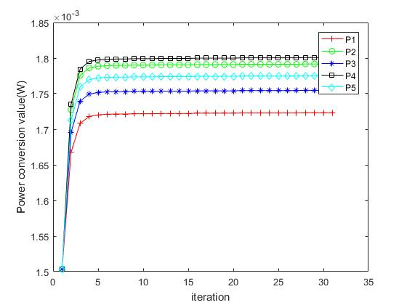

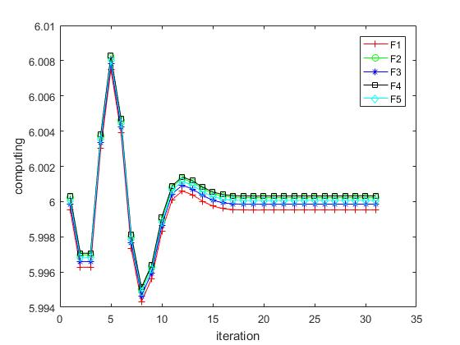

在图1中，每辆车向路边单元的发射功率与云分配给相应的路边单元的计算资源随着迭代次数的收敛情况

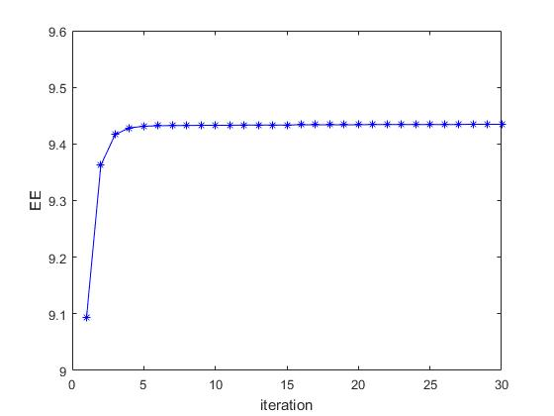

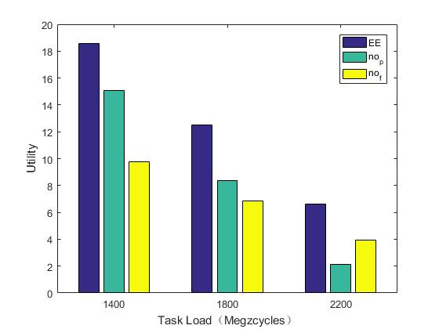

在不同的任务量下不同的处理方式得到的不同的效用最优值



$$\int_{0}^{\frac{\left(1+λD_{i,max}\right)\left(I_{th}+σ^{2}\right)}{g_{j,0}p_{j}D_{i,max}}}{ⅇ^{-x}ⅆx}≤ε_{2}$$

$$\ln\left(1-ε_{2}\right)$$

$$\frac{\left(1+λD_{i,max}\right)\left(I_{th}+σ^{2}\right)}{g_{j,0}p_{j}D_{i,max}}$$

$$\int_{0}^{\frac{\left(1+λD_{i,max}\right)\left(I_{th}+σ^{2}\right)}{g_{j,0}p_{j}D_{i,max}}}{ⅇ^{-x}ⅆx}$$

$$\frac{\left(1+λD_{i,max}\right)\left(I_{th}+σ^{2}\right)}{ln\left(1-ε_{2}\right)D_{i,max}}+g_{j,0}p_{j}≤0$$

联合功率控制和移动边缘计算资源分配的高动态车联网

上传时间 $t_{i,up}=\frac{d_{i,up}}{R_{i}\left(P\right)}$ $\frac{up data}{rate}.$.

the achievable rate [bits/s] of user i sending data to RSU

${R_{i}\left(P\right)=log}_{2}\left(1+\frac{p_{i}g_{i,0}}{{\sum_{j=1,j≠i}^{M}{p_{j}g_{j,0}}+σ}^{2}}\right).$*.*

$d_{i,up}$ is the amount of input data necessary to transfer the program execution (including system settings, program codes, and input parameters)

处理时间 $t_{i,exe}=\frac{c_{i,e}}{\overline{f}+f_{i}}+T_{c}$ $\frac{workload}{RSU+cloud allocates to MEC}$

The transmission latency between RSU and cloud server is defined as Tc, usually it is set to a fix value.

**Reinforcement Learning for Joint Optimization of Communication and Computation in Vehicular Networks**

$\overline{f}$ =5 denote the RSU computing capability in terms of CPU cycles/s.

$f_{i}$ denote the Cloud computing capability allocates to MEC in terms of CPU cycles/s

处理的效用 $U_{i,exe}=\frac{t_{max}-t_{i,exe}}{t_{max}}$

优化函数 *max $EE=max\sum_{i=1}^{N}{\frac{U_{i,exe}}{t_{i,up}}}$*

$C1$ $Pr\left\{SINR_{n}≤SINR_{th}\right\}≥1-ε_{1}$

$C2$ $Pr\left\{\frac{1}{τ_{i}R_{i}-λ_{i}}+\frac{c_{i,e}}{\overline{f}+f_{i}}≤D_{max}\right\}≥1-ε_{2}$

$C$ 3 $\sum_{i=1}^{N}{f_{i}}≤f_{total}$

$C$ 4 $0≤p≤p_{max}$

优化问题的转化

*max $EE=max\frac{1}{\ln{2}*d_{i,up}}*\sum_{i=1}^{N}{\left.U_{i,exe}*\left[{A_{k}\ln\left(γ\left(ⅇ^{\tilde{P}}\right)\right)+B}_{k}\right.\right]}$*

$C1$ $Pr\left\{{\left(G_{k}\right)}^{T}*ⅇ^{\tilde{p}}+σ^{2}\right\}≥1-ε_{1}$

$$G_{k}={\left[G_{1,k},G_{2,k},…,-\frac{G_{k,k}}{γ_{th}},…,G_{K,k}\right]}^{T}$$

$$σ^{2}+\sum_{i=1}^{K}{ }χ_{k}p_{i}+\sqrt{2ln⁡\left(\frac{1}{ε_{1}}\right)}\sum_{i=1}^{K}{ }\left|σ_{i,k}β_{i,k}p_{i}\right|≤0$$

$C$ 2 $\left(\frac{1}{D_{i,max}-\frac{c_{i,e}}{\overline{f}+f_{i}}}+λ\right)\left(I_{th}+σ^{2}\right)+ τ\left.\left[\ln\left(1-ε_{1}\right)-\hat{g}\right.\right]ⅇ^{\tilde{P}}≤0$

$C$ 3 $\sum_{i=1}^{N}{f_{i}}≤f_{total}$

$C$ 4 $-∞≤{\tilde{p}}_{k}≤\text{ln}p_{k,max}$.

两个子问题

P1 $\max{E}E\left(\tilde{P}\right)=max\frac{1}{\ln{2}*d_{i,up}}*\sum_{i=1}^{N}{}\left.U_{i,exe}*\left[A_{k}\ln\left(γ\left(e^{\tilde{P}}\right)\right)+B_{k}\right.\right]$

$C1σ^{2}+\sum_{i=1}^{K}{}χ_{k}e^{{\tilde{p}}_{i}}+\sqrt{2\text{ln}\left(\frac{1}{ε_{1}}\right)}\sum_{i=1}^{K}{}\left|σ_{ik}β_{i,k}\right|e^{{\tilde{p}}_{i}}≤0$

2 $\left(\frac{1}{D_{i,max}-\frac{c_{i,e}}{\bar{f}+f_{i}}}+λ\right)\left(I_{\text{th}}+σ^{2}\right)+ τ\left.\left[\ln\left(1-ε_{2}\right)-\hat{g}\right.\right]e^{\tilde{P}}≤0$

4 $-∞≤{\tilde{p}}_{k}≤\text{ln}p_{k,max}$

P2 $\max{E}E\left(f_{i}\right)=max\frac{1}{\ln{2}*d_{i,up}}*\sum_{i=1}^{N}{}\frac{t_{max}-\left(\frac{c_{i,e}}{\bar{f}+f_{i}}+T_{c}\right)}{t_{max}}\left[A_{k}\ln\left(γ\left(e^{\tilde{P}}\right)\right)+B_{k}\right]$

2 $\left(\frac{1}{D_{i,max}-\frac{c_{i,e}}{\bar{f}+f_{i}}}+λ\right)\left(I_{\text{th}}+σ^{2}\right)+ τ\left.\left[\ln\left(1-ε_{2}\right)-\hat{g}\right.\right]e^{\tilde{P}}≤0$

3 

拉格朗日乘子

P1

令导数为零



两边取对数得.

P2

目标函数求导了 $\frac{c_{i,e}}{\ln{2}*d_{i,up}*t_{max}}*\frac{1}{{\left(\bar{f}+f_{i}\right)}^{2}}$.

2 $\frac{1}{τ_{i}R_{i}-λ_{i}}+\frac{c_{i,e}}{\bar{f}+f_{i}} ≤D_{max}$

$C2f_{i}+λ*\left(f_{i}*D_{i,max}-c_{i,e}\right)+\frac{τ\left.\left[\ln\left(1-ε_{2}\right)-\hat{g}\right.\right]e^{\tilde{P}}}{\left(I_{\text{th}}+σ^{2}\right)}\left(f_{i}*D_{i,max}-c_{i,e}\right)≤0$.

$$\left[1+λD_{i,max}+\frac{τ\left.\left[\ln\left(1-ε_{2}\right)-\hat{g}\right.\right]e^{\tilde{P}}}{\left(I_{\text{th}}+σ^{2}\right)}D_{i,max}\right]f_{i}-c_{i,e} λ-c_{i,e}\frac{τ\left.\left[\ln\left(1-ε_{2}\right)-\hat{g}\right.\right]e^{\tilde{P}}}{\left(I_{\text{th}}+σ^{2}\right)}≤0$$

拉格朗日 $L\left(F,ξ,φ\right)= \frac{1}{\ln{2}*d_{i,up}}*\sum_{i=1}^{N}{}\left[1-\left(\frac{c_{i,e}}{t_{max}\left(\bar{f}+f_{i}\right)}+\frac{T_{c}}{t_{max}}\right)\right]*R_{i}\left(P\right)-ξ_{k}\left\{\left[1+λD_{i,max}+\frac{τ\left.\left[\ln\left(1-ε_{2}\right)-\hat{g}\right.\right]e^{\tilde{P}}}{\left(I_{\text{th}}+σ^{2}\right)}D_{i,max}\right]f_{i}-c_{i,e} λ-c_{i,e}\frac{τ\left.\left[\ln\left(1-ε_{2}\right)-\hat{g}\right.\right]e^{\tilde{P}}}{\left(I_{\text{th}}+σ^{2}\right)}\right\}-φ_{k}\left[\sum_{i=1}^{N}{}f_{i}-f_{total}\right]$.

$\frac{∂L\left(F,ξ,φ\right)}{∂f_{i}}=\frac{c_{i,e}}{\ln{2}*d_{i,up}*t_{max}}*\frac{1}{{\left(\bar{f}+f_{i}\right)}^{2}}*R_{i}\left(P\right)-ξ_{k}\left[1+λD_{i,max}+\frac{τ\left.\left[\ln\left(1-ε_{2}\right)-\hat{g}\right.\right]e^{\tilde{P}}}{\left(I_{\text{th}}+σ^{2}\right)}D_{i,max}\right]-\sum_{i=1}^{N}{}φ_{k}=0$.