**Ⅰ INTRODUCTION**

Urban traffic congestion is becoming more and more serious, traffic accidents are becoming more frequent, and many environmental and energy problems are also caused. Vehicular networks are envisioned to deliver data transmission services ubiquitously, especially in the upcoming autonomous driving era. Accordingly, the high data traffic load poses a heavy burden to the terrestrial network infrastructure. The vehicle speed is fast and the network topology constantly changes under the car-road synergy environment. The data can be transmitted through V2I and V2V to complete the intelligent driving task, the vehicle can communicate with the base station directly or the relay vehicle can help to forward the data. The transmission of low delay is also required in intelligent driving tasks.

Considering the rich computing resources provided by the Internet, cloud-based in-car networks have been proposed to address the explosive growth of computing task requirements of vehicles. Traditional cloud computing can no longer meet the stringent low latency requirement of smart driving. Emerging computing mode represented by MEC is rising rapidly. Roadside units (RSUs), which have strong computing capability and are close to vehicle nodes, have been widely used to process delay and computation-intensive tasks of vehicle nodes. Edge computing, which is an information hinge for vehicles and roadside facilities [1], can enhance the level of vehicle intelligence in the scene of vehicle-road synergy sensing [2]. Therefore, multiaccess edge computing (MEC) [3] or formerly mobile-edge computing, as new architecture and key technology for the emerging 5G networks, has been proposed to address this problem [4]. Different from traditional mobile cloud computing (MCC), MEC migrates remote cloud computing resources to the edge of the network to reduce the end-to-end transmission delay of data and to relieve the computing and storage pressure of vehicles or intelligent roadside infrastructure. Our objective is to design a holistic solution for joint task offloading and resource allocation in a multi-server MEC-assisted network，Specifically, we consider a multi-cell ultra-dense network where each BS is equipped with a MEC server to provide computation offloading services to the mobile vehicles.

**A. Related Works**

Recently, some works have been devoted to solving problems of computation offloading of mobile devices in MEC or MCC-enable vehicle network architectures. Several works have focused on exploiting the benefits of computation offloading in MEC network [24]. Note that similar problems have been investigated in【6】the horizontal and vertical cooperations between MEC cloud servers are utilized for balancing the workload distribution in dynamic vehicular environment.

Some papers investigated the computation offloading of mobile terminals in single-user scenarios. Aliyu et al. [6] proposed a systematic review of MCC energy-aware issues and grouped some research works on battery energy in MCC into dynamic and nondynamic energy-aware task offloading. \cite{Dai2022} investigate the service scenario of cooperative computation offloading in MEC-assisted service architecture, where multiple MEC servers and remote cloud offload computation-intensive tasks in a collaborative way. \cite{Pang2021} propose a hybrid transmission and reputation management strategy to accommodate the fast-changing IOV topology and to meet the low latency requirements of intelligent driving tasks. In the V2I networks, the authorized vehicular users with spectrum resources can directly communicate to the RSU. However, the scarce spectrum resources appear inadequate in high-density vehicular networks. To realize more V2X communication under the limited spectrum resources, Chen et al. [30] proposed a Device-to-Device (D2D) Crowd framework where a massive crowd of devices at the network edge leverage network-assisted D2D collaboration for computation and communication resource sharing. D2D connects two geographically close devices to achieve low latency communication. D2D can improve spectrum efficiency, reduce cellular network pressure and optimize network performance [15]. Zhou et al. [17] investigated dynamic sharing of the 5G spectrum and proposed a sharing architecture of DSRC and the 5G spectrum for immersive experience-driven vehicular communications. Zhou et al. [17] design a holistic solution for joint task offloading and resource allocation in a multi-server MEC-assisted network, As the users transmitting to the same BS use different sub-bands, the up-link intra-cell interference is well mitigated. It can be see effective channel reusing is crucial [10], [11]，[12] and [13] studies resource allocation problems under the one-to-one reusing mode, but the spectrum efficiency of the whole system is low. In response to the defects of one to one reusing mode, the authors propose a many-to-one reusing mode where the spectrum utilization is well improved [14].

The moving vehicles, can communicate with different MEC servers in different time slots, and each MEC can only connect with vehicles within its coverage. For the high-speed V2I communication, the generated Doppler effect has a significant influence on the small-scale fading of CSI and thereby causes the fast channel variations. Since temporal correlation coefficient ρ (Ts) is a function of the speed $ $ν$ $ and decreases as $ $ν$ $ increases, the average sum-rate degenerates as $ $ν$ $ grows larger, which implies that a larger speed presumably endows the acquisition of real-time CSI with more difficulty. In other words, the CSIs used are outdated. Nemirovski and Shapiro have proposed a convex approximation approach in [28]. Therein, the Bernstein approximation method has commonly been used to approximate the chance constraint [29]. To deal with the interference constraint, the probability constraint is constructed to depress the uncertain co-channel interference. And the Bernstein approximation method is used to transform it into a solvable closed form. To deal with the outage probability constraint, we assume that such CSIs is obtained through channel estimation [31]. the outage constraint is transformed according to the Bernstein-type inequality to make it a deterministic optimization problem. Based on the characteristics of our constraints, Bernstein method is also used in this paper.

It is assumed in [31] that the vehicles always use a constant transmit power while our approach optimizes vehicles’ transmit power. In summary, most of the existing works did not consider a holistic approach that jointly power control and the computing resource allocation in a multi-vehicles, multi-MEC system as considered in this paper.

**B. Challenges and Contributions**

**Generally, for the low-speed V2X communication case, the Doppler effect is not noticeable, thereby being ignored, but the high mobility of vehicles poses a challenge to V2X communication. it is analyzed that the original stochastic optimization problem with two variables can be transformed into a deterministic non-convex optimization problem. It is likely to bring a new difficulty.**

**In this paper, The main contributions are summarized as follows:**

* The Doppler effect in the process of high-speed movement of vehicles will affect the communication quality between vehicles and roadside units, different from previous studies, this paper considers the mobility of vehicles in the research of the edge computing system of the Internet of Vehicles, and verifies the adverse effects of vehicle mobility through comparative simulation
* We propose an efficient hybrid transmission task scheduling strategy. The transmission mode is predicted, and the task is scheduled according to the vehicle context. V2V transmission is adopted to minimize the delay when the task-initiating vehicle cannot complete the task independently
* Considering the channel uncertainty caused by the high-speed movement of vehicles in the scenario of the Internet of Vehicles, the first-order Markov process is introduced. A reasonable and feasible IoV network scenario is constructed to more realistically describe the dynamic characteristics of the Internet of Vehicles. The Bernstein approximation method previously used in interference constraints is improved and generalized, and it is applied to the matrix form of interruption probability to deal with non-convex outage constraint in large-scale dynamic vehicle network environments to ensure the quality of network communication services

The remainder of this article is organized as follows: the model of computation offloading in MEC-assisted vehicular networks is established deﬁnes in Section II, In Section III, the probability constraints and the objective function of the primal problem are formulated, and the optimization is proposed. In Section IV, simulation results and performance analysis are presented. Finally, we draw a conclusion in Section V.

**Ⅱ SYSTEM MODEL**

In this paper, we consider A IoV edge computing network, consisting of a cloud computing layer, MEC layer, as shown in Fig. 1. For MEC layer, which has moderate computation capacity and deploys close to networks, can be used to assist the vehicles. Cloud computing layer, can be used to process the large-scale, delay-insensitive data that MEC layer can not process. \cite{Cui2021} Numerous vehicle-to-RSU (V2I) cells underlay a cell. In which each RSU is equipped with a MEC server to provide computation offloading services to the vehicles. To avoid inter-cell interference, the time division multiple access (TDMA) communication technology is adopted. Time resource is divided into multi-frames, and each frame is divided into several time slots. Different vehicles access its time slots when they communicate with the RSU, and signal transmission in different time slots will produce no interference [10]. We denote the set of vehicles and MEC servers in the mobile system as $ $V=\left\{1, 2,...,V\right\}$ $ and $ $M=\left\{1, 2,...,M\right\}$ $, respectively. Some notations are given in Table II.

**A. Communication Model**

Different from the traditional cellular communication, Due to the fast mobility of vehicles, their CSIs are hard to be estimated precisely. In particular, RSU can only achieve the accurate knowledge of large-scale fading $ $L^{2}$ $ of vehicular to RSU links while the small-scale fading $h$ is greatly influenced by the fast channel variations caused by the Doppler effect. We assume that such CSIs is obtained through channel estimation \cite{Xiao2020}, Therefore, we model the small-scale fading channel estimation of $ $h$ $ by using the first-order Gauss-Markov process [27] in each TTI as follows.

$$h=ξ\tilde{h}+\sqrt{1-ξ^{2}}ζ$$

We assume that the estimated channel gain $ $\tilde{h}$ $ denotes the estimate of $ $h$ $ and $ ${\tilde{h}}^{2}$ $ is exponentially distributed with unit mean [33]. Furthermore, $ $ξϵ\left(0,1\right)$ $ represents the correlation coefficient over v-m link, and $ $ζ$ $ stands for the channel gain and follows a complex Gaussian distribution $ $ζ∼CN\left(0,δ^{2}\right)$ $ and independent and uncorrelated of $ $\tilde{h}$ $. The coefficient $ $\left(0<ζ<1\right)$ $ quantifies the channel correlation between the two consecutive time slots and we assume that time correlation coefficient $ $ζ$ $ is same for all VUEs. According to the Jakes statistical model for the fading channel [28], $ $ζ$ $ is given as $ $ζ=J_{0}\left(2πf_{max}T_{s}\right)$ $ (4) where $ $J_{0}$ $ is the zero-order Bessel function of the first kind. $ $f_{max}$ = $\overline{ν}f_{c}∕c$ $ is the maximum Doppler frequency, where $ $\overline{ν}$ $ indicates the vehicle speed, $ $f_{c}$ $ indicates the carrier frequency at 5.9 Ghz, and $ $c=3×{10}^{8}m/s$ $, $ $T_{s}$ $ is a period feedback latency. erally, both transmitter vehicles and RSU can know the accurate $ $ζ$ $.

Based on the aforementioned discussion, the mobile V2I channel power gain of the effective links and interference links in $ $k_{th}$ $ time slot from $ $i_{th}$ $ transmitter to $ $j_{th}$ $ receiver can be expressed as a shared expression:

$G_{i,j}^{k}={\hat{g}}_{i,j}^{k}+{\tilde{g}}_{i,j}^{k}$

Where $ ${\hat{g}}_{i,j}^{k}=L_{i,j}^{2}{\tilde{h}}_{i,j}^{2}ξ_{i,j}^{2}$ $, $ ${\tilde{g}}_{i,j}^{k}=L_{i,j}^{2}\left(1-ξ_{i,j}^{2}\right)ζ_{i,j}^{2}$ $, and $ ${L_{i,j}^{k}}^{2}$ $ denotes the kth time slot large-scale fading effects including shadow-fading and path loss from $ $i_{th}$ $ transmitter to $ $j_{th}$ $ receiver on the road section. Moreover, $ ${\hat{g}}_{i,j}^{k}$ $ is an observed value. $ ${\tilde{g}}_{i,j}^{k}$ $ denotes an exponential random variable with parameter,

$ $E\left(\frac{1}{{L_{i,j}^{k}}^{2}\sqrt{1-{ζ_{i,j}^{k}}^{2}}}\right)$ $

To improve the spectrum utilization and realize multi-vehicles joint communication, V2I communications reuse the same uplink channel. In this case, the Signal-to-Interference-plus-Noise Ratio (SINR) from vehicle $ $i$ $ to RSU can be formulated as,

$ $γ_{i}^{v}=\frac{p_{i}g_{i,j}}{{\sum_{j=1,j≠i}^{M}{p_{j}g_{j,i}}+σ}^{2}}$ $

Where $ $p_{j}$ $ denotes the transmit power of the jth vehicles, where $ $σ^{2}$ $ is the background noise. Therefore, the deterministic equivalent transmission rate of VUEs calculated by Shannon’s theorem is,

$ ${R_{i}\left(P\right)=log}_{2}\left(1+\frac{p_{i}g_{i,j}}{{\sum_{j=1,j≠i}^{M}{p_{j}g_{j,i}}+σ}^{2}}\right)$ $

Hence, the transmission time of vehicle $ $i$ $ when sending its task input $ $d_{i,up}$ $ in the uplink can be calculated as,

$ $t_{i,up}=\frac{d_{i,up}}{R_{i}\left(P\right)}$ $

Where $ $W$ $ is the bandwidth of the reused channel. Therefore, the upload time of each V2I link can be formulated as,

$ $t_{i,up}=\frac{d_{i,up}}{W\log_{2}\left(1+\frac{p_{i}g_{i,j}}{\sum_{j=1,j≠i}^{M}{p_{j}g_{j,i}}+σ^{2}}\right)}$ $

And $ $d_{i,up}$ $ is the amount of input data including system settings, program codes, and input parameters, which is necessary to transfer the program execution.

Communication delay is another significant index that affects the performance of wireless networks. The packets to V2I receivers must be in the queue before they transmit at the speed of $ $R_{i}$ $. It is assumed that the process of a packet arriving at the $ $i_{th}$ $ V2I receiver is a Poisson process with parameter $ $k_{i}$ $, and the length of the data packet obeys the exponential distribution of parameter $ $τ_{i}$ $. Under the M/M/1 model [34], the relationship between the expected delay and transmission rate of the $ $i_{th}$ $ V2I links can be expressed as,

$ $D_{i}=\frac{1}{{τ_{i}R}_{i}-k_{i}}$ $

**B. Vehicle Computation Mode** l

We consider that each vehicle $ $v∈V$ $ has one different computation task at a time. denoted as $ $c_{v}$ $ [cycles] specifies the workload, i.e. the amount of computation to accomplish the task, that is atomic and cannot be divided into subtasks. The values of $ $c_{v}$ $ can be obtained through carefully profiling of the task execution [7],[32]. Each task should be offloaded to the MEC server and then transmission to the cloud server. By offloading the computation task to the MEC server, the vehicles would get more computing resources, however, it would consume additional time for sending the task input in the uplink.

The MEC server at each RSU is able to provide computation offloading service to a vehicle at a time slot. The computing resources are quantified by the fixed rate $ $\overline{f}$ $, expressed in terms of number of CPU cycles/s. the vehicle $ $i_{th}$ $ uploads the input data of task to the nearest RSU, the RSU process the small-scale, delay-sensitive data first, then the RSU forward the remaining data to the remote cloud server, the cloud is able to provide computation offloading service to multiple RSU concurrently. The computing resources made available by cloud to be shared among the associating users are quantified by the computational rate $ $f_{i}$ $, it is still expressed in terms of number of CPU cycles/s. Thus, the latency for computing offloading can be written as,

$ $t_{i,exe}=\frac{c_{i,e}}{\overline{f}+f_{i}}$ $

**C. Problem Definition**

Given the computing resource allocation $ $f_{i}$ $, the total delay experienced by vehicle $ $i$ $ when offloading its task is given by,

$ $t_{i}=\frac{c_{i,e}}{\overline{f}+f_{i}}+T_{c}$ $

The transmission latency between RSU and cloud server is defined as $ $T_{c}$ $, usually it is set to a fix value \cite{Xiao2020}, so the relative improvement in task completion time is characterized by,

$ $U_{i,exe}=\frac{t_{max}-t_{i,exe}}{t_{max}}$ $,

Where $ $t_{max}$ $ is the maximum tolerable threshold of the task completion time, if a task can be completed ahead of deadline $ $t_{max}$ $, the vehicle can get a higher utility, otherwise, it will produce the corresponding loss. Therefore, we define the offloading utility of vehicle u as, $ $\frac{U_{i,exe}}{t_{i,up}}$ $ denote offloading time cost utilities at a unit.

The joint task offloading and resource allocation will be formulated as an optimization problem in this section. And the goal is to obtain the minimum total system cost composed of latency and transmission rate for all vehicles in the networks. For a given uplink power allocation $ $p$ $, and computing resource allocation $ $f$ $, we define the system utility as the weighted-sum of all the vehicles’ offloading utilities,

$ $U=max\sum_{i=1}^{M}{\frac{U_{i,exe}}{t_{i,up}}}$ $.

This utility means getting a more enormous execution time utility with a minor upload time cost. We now formulate the Joint Resource Allocation and Task Offloading Problem as a system utility maximization problem, i.e. The robust optimization problem is formulated as follows,

优化函数 $U=max\sum_{i=1}^{M}{\frac{U_{i,exe}}{t_{i,up}}}$

$$s.t. \left\{ \begin{aligned}&Pr\left\{γ_{i}≥γ_{th}\right\}≥1-ε_{1}& \\ &Pr\left\{\frac{1}{τ_{i}R_{i}-k_{i}}+\frac{c_{i,e}}{\overline{f}+f_{i}}≤D_{max}\right\}≥1-ε_{2} \\ &\sum_{i=1}^{M}{f_{i}}≤f_{total} \\ &0≤p_{i}≤p_{max}\end{aligned}\right.$$

$C1$ $Pr\left\{γ_{i}≥γ_{th}\right\}≥1-ε_{1}$

$C2$ $Pr\left\{\frac{1}{τ_{i}R_{i}-k_{i}}+\frac{c_{i,e}}{\overline{f}+f_{i}}≤D_{max}\right\}≥1-ε_{2}$

$C$ 3 $\sum_{i=1}^{N}{f_{i}}≤f_{total}$

$C$ 4 $0≤p_{i}≤p_{max}$

Where $ $U$ $ denotes the network utility, the constraints in the formulation above can be explained as follows: Constraints (13a) is used to guarantee the QoS requirements of VUEs, however, due to Large amount of computation caused by time varying network topologies, the real-time SINR is hard to obtain in vehicular communication scenario, and it can be replaced with the long-term SINR since the CSI feedback time interval is very small. $ $γ_{i}$ $ denotes the average SINR of the $ $i_{th}$ $ V2I link when a small CSI feedback time interval is used, in order to ensure that the task is successfully offloaded to the RSU, the SINR should be guaranteed to be no less than the SINR threshold \cite{liu2021}. $ $γ_{th}$ $ is the SINR threshold for successful detecting the V2I communication. $ $p_{r}\left\{⋅\right\}$ $ defines the probability of the input. In this case, we introduce the outage probability constraint (13a) to guarantee the reliability of vehicular links \cite{Li2020}. $ $D_{max}$ $ is the delay bound of the $ $i_{th}$ $ V2I link in the process of data transmission. $ $ε_{1}$ $, $ $ε_{2}$ $ are the outage probability thresholds of SINR and delay constraint respectively, where $ $ε_{1},ε_{2}∈\left(0,1\right)$ $. constraints (13c) state that each MEC server must allocate a positive computing resource to each user associated with it and that the total computing resources allocated to all the associated users must not excess the server’s computing capacity, in another word, the number of applications served by a particular edge cloud should be within its capacity. (13b) denote the total latency of communication and computing should be guaranteed to be no less than the time threshold, $ $p_{max}$ $ is the maximum transmit power of the transmit vehicle in vehicle communication network, and the transmit power is greater than zero in (13d).

**Ⅲ PROBLEM SOLUTIONS**

In this section, we proposed a BCD-based algorithm to solve the problem (13). The BCD method enables the complex original problem to be decomposed into a series of simpler subproblems [13]. Motivated by this fact, all variables are divided into two blocks and optimized alternatively.

By fixing $ $f$ $, the problem (13) can be transformed into the following problem.

优化函数 $U=max\sum_{i=1}^{M}{\frac{U_{i,exe}}{t_{i,up}}}$

$C1$ $Pr\left\{γ_{i}≥γ_{th}\right\}≥1-ε_{1}$

$C2$ $Pr\left\{\frac{1}{τ_{i}R_{i}-k_{i}}+\frac{c_{i,e}}{f_{i}}≤D_{max}\right\}≥1-ε_{2}$

$C$ 4 $0≤p≤p_{max}$

**A．Successive Convex Approximation of the Objective Function**

Since the original problem is a non-convex and NP-hard because of the logarithmic function in the objective function, here, the method of successive convex approximation is adopted to relax the original problem and make objective function solvable. We can use the lower bound to approach the original function as follows.

$$\begin{aligned}A\ln\left(z\right)+B≤\ln\left(1+z\right) \\ \left\{\begin{aligned}A=\frac{z_{0}}{1+z_{0}} \\ B=\ln\left(1+z_{0}\right)-\frac{z_{0}}{1+z_{0}}\ln\left(z_{0}\right)\end{aligned}\right.\end{aligned}$$

Each term of (14) can be represented by $ $A_{k}ln\left(γ_{k}\left(e^{\tilde{p}}\right)\right)+B_{k}$ $ through successive convex approximation, where $ $A_{k}$ $ and $ $B_{k}$ $ can be chosen as $ $A_{k}=γ_{i}/\left(1+γ_{i}\right)$ $, $ $B_{k}=\ln\left(1+γ_{i}\right)-A_{k}\ln\left(γ_{i}\right)$ $, $ $A_{k}$ $=1, $ $B_{k}\$$ =0, and each term of objective function can be written as follows,

$$\frac{1}{\ln{2}}\sum_{i=1}^{M}{\frac{U_{i,exe}}{d_{i,up}}\left.\left[{A_{k}\ln\left(γ\left(p\right)\right)+B}_{k}\right.\right]}$$

It is still hard to directly calculation because of fractional from of SINR, we use variable substitution, i.e. $ ${\hat{p}}_{i}=\ln{p_{i}}$ $, $ $p_{i}=e^{{\hat{p}}_{i}}$ $, then $$C2:{\hat{p}}_{i}≤\ln{p_{max}}, ∀ 1≤i≤M$$

$$EE=max\frac{1}{\ln{2}}\sum_{i=1}^{M}{\left.\frac{U_{i,exe}}{d_{i,up}}\left[{A_{k}\ln\left(γ\left(ⅇ^{\tilde{P}}\right)\right)+B}_{k}\right.\right]}$$

**B．Approximate of the Outage Probability Constraint**

中断概率约束表示为

$$Pr\left\{φ_{0}\left(p\right)+\sum_{k=1}^{K}{ξ_{k}φ_{k}\left(p\right)}≤0\right\}≥1-ε_{1}$$

It is obvious that the constraint (14a) includes uncertainties and the objective function is a non-convex problem in (14), so the objective function and constraints are difficult to deal with when determining the optimal solutions. It is necessary to design an algorithm with lower complexity to solve the problem. In this paper, For the uncertain channel gain. Considering the fast fading. Two common forms are adopted to describe the uncertainty mentioned above, i.e. the statistical constraints and deterministic constraints. to pursue a simple form of (14a), a matrix form is introduced, the general form the channel gain is described as,

$$Pr\left\{{\left(G_{m}\right)}^{T}ⅇ^{\tilde{p}}+σ^{2}≤0\right\}≥1-ε_{1}$$

Where$ $G_{m}={\left[G_{1,m},G_{2,m},…,-\frac{G_{m,m}}{γ_{th}},…,G_{M,m}\right]}^{T}$ $,

$${\text{G}}_{m}={\left[G_{1,m},G_{2,m},…,-\frac{G_{m,m}}{γ_{th}},…,G_{M,m}\right]}^{T}$$

Furthermore, the Bernstein method is adopted to approximate the probability constraint with channel uncertainty

Theorem 1: The outage probability of all cochannel V2I links $ $Pr\left\{γ_{i}≤γ_{th}\right\}≥1-ε_{1}$ $

is reformulated as the separable constraints (14a)

$$σ^{2}+\sum_{i≠j}^{M}{χ_{i,j}e^{{\tilde{p}}_{i}}}+\sqrt{2ln\left(\frac{1}{ε_{1}}\right)}{\left(\sum_{i≠j}^{M}{{\left(σ_{i,j}β_{i,j}p_{i}\right)}^{2}}\right)}^{\frac{1}{2}}≤0$$

Where $ $χ_{i,j}=μ_{i,j}^{+}α_{i,j}+β_{i,j}+g_{i,j}$ $, these parameters (i. e. $ $σ_{i,j}$ $ and $ $α_{i,j}$ $) are deduced to be positive in Appendix A. Suppose that the truncated distributions of $ $G_{i,j}$ $ have bounded supports $ $\left[{\tilde{g}}_{i,j}^{k}+α_{i,j},{\tilde{g}}_{i,j}^{k}+β_{i,j}\right]$ $, $ ${\tilde{g}}_{i,j}^{k}$ $ is an estimate of $ $G_{i,j}$ $, Introduce constants $ $α_{i,j}=\frac{1}{2}\left(b_{i,j}-a_{i,j}\right)$ $, $ $β_{i,j}=\frac{1}{2}\left(b_{i,j}+a_{i,j}\right)$ $ to normalize the supports to $ $\left[-1,1\right]$ $ as follows,

$ξ_{i,j}=\frac{G_{i,j}-{\tilde{g}}_{i,j}^{k}-β_{i,j}}{α_{i,j}}∈\left[-1,1\right]$

In the last term of (19), the variables $ $p$ $ are coupled nonlinearly. Hence, directly finding an acceptably good solution to (14a) by the Bernstein method is time consuming when the K increases and the number of vehicles is large. Therefore, it is necessary to Introduced a l2-norm approximate problem for any $ $x∈R^{k}$ $. Hence, the last term in (19) containing l2-norm of the vector is further approximated by $ $∥x∥_{1}≤∥x∥_{2}$ $. Based on these, the constraint in (14a) is further formulated as fellow with lower complexity and higher reliability,

$ $σ^{2}+\sum_{i≠j}^{M}{χ_{i,j}e^{{\tilde{p}}_{i}}}+\sqrt{2ln\left(\frac{1}{ε_{1}}\right)}\sum_{i≠j}^{M}{\left|σ_{i,j}β_{i,j}\right|e^{{\tilde{p}}_{i}}}≤0$ $

To pursue a simple form of (21), we define $ $Π_{i}=σ^{2}+\sqrt{2ln\left(\frac{1}{ε_{1}}\right)}\sum_{i≠j}^{M}{\left|σ_{i,j}β_{i,j}\right|e^{{\tilde{p}}_{i}}}$ $.

The constraint (14b) can be handled by an Integral transformation method, According to constraint (14b), where $ $D_{max}=D_{1}+D_{2}$ $, $ $D_{1}=\frac{1}{τ_{i}R_{i}-k_{i}}$ $, $ $D_{2}=\frac{c_{i,e}}{f_{i}}$ $, $ $a=\frac{1}{{L_{i,j}^{k}}^{2}\sqrt{1-{ζ_{i,j}^{k}}^{2}}}$ $, $ $X={\tilde{h}}^{2}$ $ is an exponential random variable with unit mean, i.e., $ $X∼\exp\left(1\right)$ $.

we can get the feasible power region of the communication delay probability as follows,

$$\left.\left[ln\left(1-ε_{2}\right)-{\hat{g}}_{i,j}^{k}\right.\right]e^{{\tilde{p}}_{i}}+D^{*} ≤0$$

The proof of the feasible region can be found in Appendix B

The probability constraint of (14b) can be transformed to the deterministic one according to the following inference

$$Pr\left\{\frac{1}{τ_{i}R_{i}-k_{i}}+\frac{c_{i,e}}{f_{i}}≤D_{max}\right\}$$

$$=Pr\left\{R_{i}≥\frac{1}{τ_{i}\left(D_{max}-D_{2}\right)}+\frac{k_{i}}{τ_{i}}\right\}$$

$$≤1-Pr\left\{p_{i}X≤\left(I_{th}+σ^{2}\right)2^{\frac{1+k_{i}\left(D_{max}-D_{2}\right)}{τ_{i}\left(D_{max}-D_{2}\right)}}-p_{i}{\hat{g}}_{i,j}^{k}\right\}$$

$$=1-\int_{0}^{\left(I_{th}+σ^{2}\right)2^{\frac{1+k_{i}\left(D_{max}-D_{2}\right)}{τ_{i}\left(D_{max}-D_{2}\right)}}-p_{i}{\hat{g}}_{i,j}^{k}}{e^{-x}ⅆx}≥1-ε_{2}$$

Then, we have the equivalent result of the inequality function in (24) as

$$\left.\left[ln\left(1-ε_{2}\right)-{\hat{g}}_{i,j}^{k}\right.\right]e^{{\tilde{p}}_{i}}+D^{*} ≤0$$

Where $D^{*}=\left(I_{th}+σ^{2}\right)2^{\frac{1+k_{i}\left(D_{max}-D_{2}\right)}{τ_{i}\left(D_{max}-D_{2}\right)}}$

In summary, we can obtain a deterministic optimization problem of robust power allocation by transforming the objective function, outage probability constraints, delay constraints. It is expressed as,

P1 $\max{EE\left(\tilde{P}\right)}=max\frac{1}{\ln{2}}\sum_{i=1}^{M}{\left.\frac{U_{i,exe}}{d_{i,up}}\left[{A_{k}\ln\left(γ\left(ⅇ^{\tilde{P}}\right)\right)+B}_{k}\right.\right]}$

$$C1\sum_{i=1}^{M}{χ_{i,j}e^{{\tilde{p}}_{i}}}+Π_{i}≤0$$

$C$ 2 $\left.\left[ln\left(1-ε_{2}\right)-{\hat{g}}_{i,j}^{k}\right.\right]e^{{\tilde{p}}_{i}}+D^{*} ≤0$

$C$ 4 $-∞≤{\tilde{p}}_{i}≤\ln{p_{i,max}}$

**C．Optimal Power Control Algorithm**

To pursue an iterative algorithm for solving the problem, Lagrange dual decomposition technique [39] is used to maximize the lower bound of the original objective under given coefficients $ $X_{i}$ $ and $ $Y_{i}$ $. It is noted that these two coefficients should be updated to guarantee a monotonic increase in the lower bound performance.

Hence, the Lagrangian function of (26) under fixed coefficients $ $X_{i}$ $ and $ $Y_{i}$ $ can be expressed as,

$$L\left(\tilde{p},λ,μ\right)=\frac{1}{\ln{2}}\sum_{i=1}^{M}{\frac{U_{i,exe}}{d_{i,up}}\left[A_{k}ln\left({\overline{γ}}_{k}\left(e^{\tilde{p}}\right)\right)+B_{k}\right]}$$

$$-λ_{k}\left[\sum_{i=1}^{M}{χ_{i,j}e^{{\tilde{p}}_{i}}}{+Π}_{i}\right]$$

$-μ_{k}\left[\left(ln\left(1-ε_{2}\right)-{\hat{g}}_{i,j}^{k}\right)e^{{\tilde{p}}_{i}}+D^{*}\right]$

Where $ $λ_{k}$ $ and $ $μ_{k}$ $ are the Lagrangian multipliers, and $ $λ_{k}≥0$ $, $ $μ_{k}≥0$ $.

The power vector $ $p$ $ iteration function is obtained by

$\frac{∂L\left(p,λ,μ\right)}{∂p_{i}}=A_{i}-\left[\sum_{j=1,j≠i}^{M}{\left(A_{j}\frac{{\overline{γ}}_{j}\left(e^{\tilde{p}}\right){\overline{G}}_{k,j}}{e^{{\tilde{p}}_{j}}{\overline{G}}_{j,j}}\right)}+λ_{i}Π_{i}e^{-{\tilde{p}}_{i}}+μ_{i}{\hat{g}}_{i,j}^{k}\right]e^{{\tilde{p}}_{i}}=0$ 28

Based on (28), the iteration for the power allocation, can be formulated as,

${\tilde{p}}^{\left(t+1\right)}={\left[\ln{A_{i}}-\ln\left(\sum_{j=1,j≠i}^{M}{\left(A_{j}\frac{{\overline{γ}}_{j}\left(e^{\tilde{p}}\right){\overline{G}}_{k,j}}{e^{{\tilde{p}}_{j}}{\overline{G}}_{j,j}}\right)}+λ_{i}Π_{i}e^{-{\tilde{p}}_{i}}+μ_{i}\hat{g}\right)\right]}_{-∞}^{\ln{p_{max}}}$ 29

The Lagrangian multiplier $ $λ$ $, $ $μ$ $, are updated through the sub-gradient method, which are formulated as,

$$λ_{i}^{\left(t+1\right)}={\left[λ_{i}^{\left(t\right)}+K_{λ}^{\left(t\right)}\left(\sum_{j≠i}^{M}{χ_{i,j}e^{{\tilde{p}}_{j}}}+Π_{i}\right)\right]}^{+}$$

$μ_{i,j}^{\left(t+1\right)}={\left[μ_{i,j}^{\left(t\right)}+K_{μ}\left(\left(ln\left(1-ε_{2}\right)-{\hat{g}}_{i,j}^{k}\right)e^{{\tilde{p}}_{i}}+D^{*}\right)\right]}^{+}$

Where $ $K_{λ}$ $, $ $K_{μ}$ $ denote the step-size, and $ $K_{λ}≥0$ $, $ $K_{μ}≥0$ $. $ $t$ $ denotes the iteration index. $ ${\left[x\right]}^{+}=\max\left[0,x\right]$ $.

**D. Computing Resource Allocation**

After obtaining $ $p$ $, the formulated problem with respect $ $f$ $ reformulated by:

max $EE=max\sum_{i=1}^{M}{\frac{U_{i,exe}}{t_{i,up}}}$

$C2$ $\frac{1}{τ_{i}R_{i}-λ_{i}}+\frac{c_{i,e}}{\overline{f}+f_{i}}≤D_{max}$

$C$ 3 $\sum_{i=1}^{M}{f_{i}}≤f_{total}$

Notice that the constraints in (32a) and (32b) are convex, by calculating the second-order derivatives of $ $f_{i}$ $, the Lagrangian function is constructed to seek the optimal powers. Hence, (32) is a convex optimization problem and can be solved using Karush-Kuhn-Tucker (KKT) conditions. The Lagrangian function of (32) is formulated as,

目标函数求导了 $\frac{c_{i,e}}{\ln{2}*d_{i,up}t_{max}{\left(\bar{f}+f_{i}\right)}^{2}}$

$U\left(f,ξ,φ\right)=\frac{t_{i,up}}{\ln{2}}\sum_{i=1}^{M}{\left[1-\left(\frac{c_{i,e}}{t_{max}\left(\overline{f}+f_{i}\right)}+\frac{T_{c}}{t_{max}}\right)\right]}-ξ_{k}\left(\frac{1}{τ_{i}R_{i}-λ_{i}}+\frac{c_{i,e}}{\overline{f}+f_{i}} ≤D_{max}\right)-φ_{k}\left[\sum_{i=1}^{N}{f_{i}}-f_{total}\right]$

Based on (33), the iteration for the computing resource allocation, can be formulated as, In order to prove the concavity of (32), the following research is taken. The first-order derivative of $\$U\left(f,ξ,φ\right)$ $ with respect to $ $f_{i}$ $ is,

$\frac{∂U\left(f,ξ,φ\right)}{∂f_{i}}=\frac{c_{i,e}}{\ln{2}*d_{i,up}t_{max}{\left(\overline{f}+f_{i}\right)}^{2}}=\frac{Ω_{i}}{{\left(\overline{f}+f_{i}\right)}^{2}}$ $\frac{∂u}{∂y}$

in which, for simplicity $Ω_{i}=\frac{c_{i,e}}{\ln{2}*d_{i,up}t_{max}}$

The second-order derivative of is obtained further as,

$\frac{∂^{2}U}{∂f_{i}^{2}}=-\frac{2⋅Ω_{i}}{{\left(\overline{f}+f_{i}\right)}^{3}}≤0$

it is obvious that the second-order derivative of $\$U\left(f,ξ,φ\right)$ $ with respect to $ $f_{i}$ $ is always less than zero. Therefore, $\$U\left(f,ξ,φ\right)$ $ is a concave function about $ $f_{i}$ $, Hence, (32) is a convex optimization problem and can be solved using Karush-Kuhn-Tucker (KKT) conditions.

$$\frac{∂U\left(f,ξ,φ\right)}{∂f_{i}}=\frac{Ω_{i}R_{i}\left(P\right)}{{\left(\overline{f}+f_{i}\right)}^{2}}-ξ_{k}\frac{c_{i,e}}{{\left(\overline{f}+f_{i}\right)}^{2}}-\sum_{i=1}^{M}{φ_{k}}=0$$

Let, $\frac{∂U\left(f,ξ,φ\right)}{∂f_{i}}=0$ the optimal computing resource allocation is obtained by $\frac{U_{i,exe}}{t_{i,up}}$

$${f_{i}}^{*}=\sqrt{\frac{Ω_{y}R_{i}\left(P\right)-{c_{i,e}ξ}_{k}}{\sum_{i=1}^{M}{φ_{k}}}}-\overline{f}$$

The iterative expression is as follows,

$${\tilde{f}}^{\left(t+1\right)}={\left[\sqrt{\frac{Ω_{y}R_{i}\left(P\right)-{c_{i,e}ξ}_{k}}{\sum_{i=1}^{M}{φ_{k}}}}-\overline{f}\right]}_{0}^{f_{total} }$$

The Lagrangian multiplier $ $ξ$ $, $ $φ$ $, are updated through the sub-gradient method, which are formulated as,

$$ξ_{i}^{\left(t+1\right)}={\left[ξ_{i}^{\left(t\right)}+K_{ξ}^{\left(t\right)}\left(\frac{1}{τ_{i}R_{i}-λ_{i}}+\frac{c_{i,e}}{\overline{f}+f_{i}}-D_{max}\right)\right]}^{+}$$

$$φ_{i,j}^{\left(t+1\right)}={\left[φ_{i,j}^{\left(t\right)}+K_{φ}\left(\sum_{i=1}^{M}{f_{i}}-f_{total}\right)\right]}^{+}$$

With the above efforts, we successfully transform the original problem into two convex subproblems. Then, an alternative iterative algorithm which is summarized in Algorithm 1 is proposed to solve them.

**算法伪代码**

where P∗ and F can be obtained through Algorithm 1

Algorithm 1: Joint Robust Power Control and Task Offloading Scheduling Algorithm

Input Set the maximal iterative number Tmax, the fixed price C and the step size φ.

Initialize the log-domain power vector $p$,computing resource allocation $f$ and the Lagrangian multiplier vector $λ$ $μ$ $η$ $φ$

repeat

Calculate

Given feasible points $p_{i,j}^{\left(t\right)}$, $f_{i,j}^{\left(t\right)}$

Solve problem P4, and obtain the current optimal solution ${\tilde{p}}^{\left(t+1\right)}$.

Update ˜ p and λ using (20) and (23), respectively. $λ_{i,j}^{\left(t+1\right)}$ $μ_{i,j}^{\left(t+1\right)}$

Given feasible points $p_{i,j}^{\left(t+1\right)}$, $f_{i,j}^{\left(t\right)}$

Solve problem P4, and obtain the current optimal solution ${\tilde{f}}^{\left(t+1\right)}$.

Update ˜ f and λ using (20) and (23), respectively. $η$ $φ$

Until synchronously converge to the optimal solutions $p$ $f$ $\tilde{P}\tilde{f}$ $p$ $f$**f p**

Output:

**Ⅳ SIMULATION AND PERFORMANCE EVALUATION**

In this section, numerical simulations are presented to evaluate the performance of the proposed Algorithms 1.A MEC-based vehicular network system which includes five clusters under a certain time slot is selected as our fundamental simulation scenario. The major system parameters are listed in Table III. It is noted that the carrier frequency f and the bandwidth W are set as 2 GHz and 10 MHz respectively in the numerical simulations. We assume that both the vehicles and RSUs use a single antenna for uplink transmission and reception, respectively. Unless stated otherwise, the parameter value of $ $γ_{th}$ $ is set to 10−6, the outage probability threshold $ $ε_{1}=ε_{2}=0.1$ $.

假设车速在某个较小的时隙内为常数[85]。

Assume the variation of the vehicles’ speed is negligible within the reference time interval,

除非特别说明，车辆速度与计算所需要的CPU周期数如下表所示task workloads.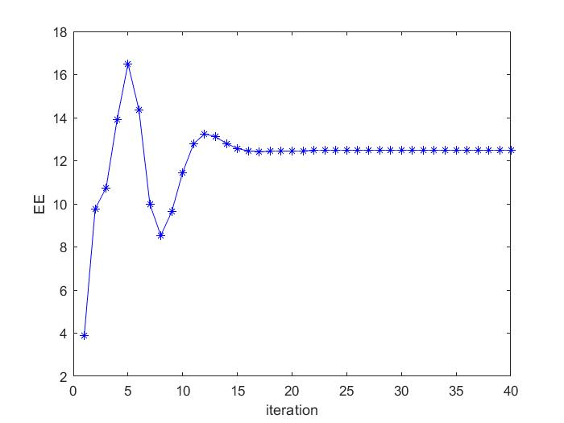

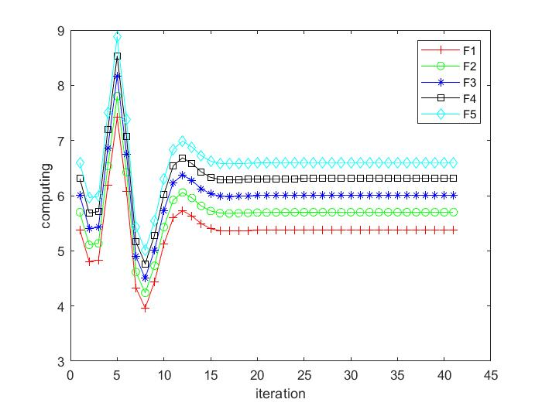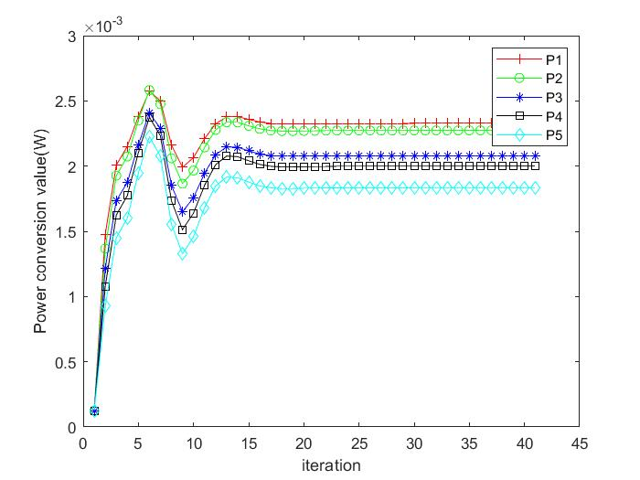

Fig. 3(a) and Fig. 3(b) show that the power of each vehicle transmitter and the corresponding computing resource which cloud allocation to RSU in Algorithm2, respectively. It can be seen that the computing resources allocated in the cloud peak at the fifth iteration and begin to decline because of the limitation of total computing resources $ $f_{total}$ $ from the cloud. The corresponding power resource allocation also changes due to computing resources allocation under Joint Robust Power Control and Task Offloading Scheduling.

可以看出云端分配的计算资源在第五次迭代时到达峰值并开始下降，其原因是因为收到了总的计算能力total的限制，由于是联合优化，因此，相应的功率资源分配也随之改变。Fig. 3(a)展示了在联合优化下系统总效用的收敛情况，可以看到，网络系统的总效用的收敛趋势与功率分配和计算资源分配是相关的，根据式(4-24)中EE的定义，这种现象是合理的。由于R随着功率向量p的增加而对数增加，导致作为E分母部分的上传时间随着功率的增加而减小，作为分子部分的执行效用，texe随着计算能力f的增加而反比例下降，导致分子随着f的增加而增加。

This phenomenon is reasonable due to the definition of ηEE in (24). $ $R_{i}$ $ increases logarithmically as the power vector $ $p$ $ increases, the upload time $ $t_{i,up}$ $, as the denominator of ηEE, will decrease with the increase of power vector $ $p$ $ and as the executive utility of the numerator part, $ $t_{i,exe}$ $ decreases inversely proportional with the increase of computing power $ $f$ $,causing the numerator to increase with the increase of $ $f$ $. $p$ $f$

As the upload time of the E denominator part, R increases logarithmically with the increase of the power vector p, causing the denominator to decrease with the increase of power,

在车联网移动边缘计算系统中，不考虑车辆的移动性是不现实的，因此我们研究了车辆的移动性对系统性能的影响.红线表示了当速度引起的不确定性忽略不计的时的基准值，我们可以看出图中随着车辆速度的提升，系统性能会下降，这是由于车辆快速移动导致的多普勒响应会影响到车辆的通信，可以看出车辆的移动性是会对系统性能产生影响的

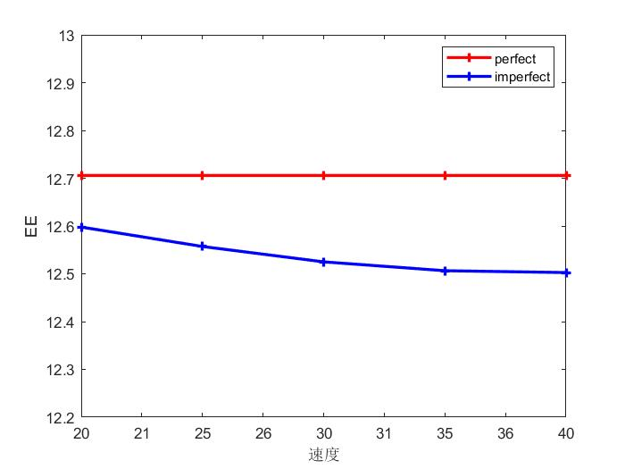为了进一步说明速度引起的多普勒频移对系统性能的影响，在系统中模拟了车速不变情况下的基准值与测速不断提高时的对比实验，车速改变的仿真实验拓扑中将所有车速依次从20 m/s增加到60 m/s。这种配置导致一个事实，随着车辆速度的提升，系统性能会下降，与基准值对比可以知道，车速引起的多普勒效应对系统性能是不利的，蓝色实线结果也证明了倾向于较小相对速度的方法是有更好的结果的。

仿真中车速不变时所有 CHs的速度设置为0（即 0 m/s），并且所有车的速度在相同的网络中相同

In the MEC-Enabled vehicular cloud system. It is unrealistic not to take into account the mobility of the vehicle. We then investigated the impact of vehicle mobility on system performance, Assume the variation of the vehicles’ speed is negligible within the reference time interval,

In order to further illustrate the influence of speed-induced Doppler shift on system performance, the comparison experiment between the benchmark value and the increasing speed measurement under the condition of constant vehicle speed is simulated in the system.

Since the relative speed in the V-RSU link is zero, And the speed of all vehicles is the same in the same network there is no Doppler effect. Then the vehicle speed on the road is set to 20 m/s, 30 m/s, 40 m/s, 50 m/s and 60 m/s, respectively，It can be seen from Fig. 11 that with the increase of vehicle speed, the utility value of the v2e network decreases, This is because the higher speed will cause a greater Doppler frequency shift in the network, increase channel uncertainty, The solid blue line result also proves that methods that tend to obtain a better utility when the vehicle speed Is low.

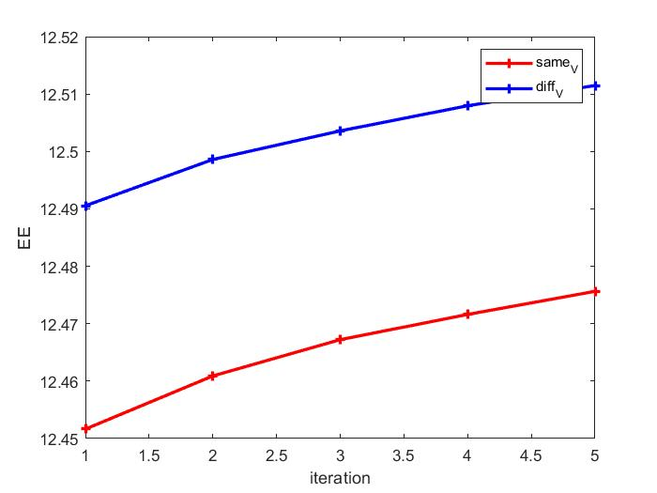

为了进一步验证考虑了车辆移动性后所提出方案的性能，下图描述了不同 $ε_{1}$ 值下的每辆车相同速度与不同速度的时候对总效用的影响，从图中可以看出随着 $ε_{1}$ 的改变，系统效用也随之变化，在每辆车速度不同时的效用要高于所有车相同的速度，表征了提出的方法在复杂的动态车辆环境下具有较高的鲁棒性

In order to further verify the performance of the proposed scheme after considering the mobility of the vehicle, the figure below describes the effect of the same speed and different speeds of each vehicle under different $ $ε_{1}$ $ on the total utility, and it can be seen from the figure that with the change of $ $ε_{1}$ $, the system utility also changes, and the utility at different speeds of each vehicle is higher than that of all vehicles at the same speed, which characterizes the high robustness of the proposed method in complex dynamic vehicle networks.

In terms of computing resources allocation, we choose the default task input size as $ $ⅆ_{u}=420KB$ $ (following [4], [10]), We now evaluate the system utility performance against different benchmark schemes. The purpose of this section is to show the convergence of our proposed algorithm and its performance is better than three benchmark schemes through some simulation results. The benchmark schemes are described as follow

“Independent Offloading and power control” (denoted as “IOP”), the vehicles independently make power control and the computing resources allocation

“Without vehicle power control” (denoted as “Without-VPC”): The transmit power of the vehicles is set as average power during the offloading.

“Without computing resources allocation”: Similar to [? ] (denoted as “Without-CRA”),The transmit power of the vehicles is set as average power during the offloading.

首先是不同情况下系统总效用的迭代收敛，从图中可以看出，鲁棒的联合优化性能优于其余三种情况。可以看出随着迭代次数的增加，四种方法都收敛到了稳定值，其中联合优化的性能最好

Fig. 6 is the iterative convergence of the total utility of the system in different cases, and it can be seen from the figure that the robust joint optimization performance is better than the other three cases. It can be seen that with the increase of the number of iterations, the four methods converge to a stable value, among which the performance of proposed scheme is the best.

为了反应更加真实的情况，每个车辆所需要的CPU处理周期往往是不同的，因此我们设置了了5辆车的分别为1600,1700,1800,1900,2000

In order to reflect a more realistic situation, the CPU task lode (Megzcycles) required for each vehicle are often different, so we set the CPU task lode (Megzcycles) of the five vehicles to 1600, 1700, 1800, 1900, 2000.

As we can see, with the increase of the ratio of iteration, the average system utility of vehicles changes gradually and tends to be stable.In the independent optimization process, the computing resource allocation is carried out first, and the optimal power allocation is not known at this time, and the power and computing resource alternate optimization method is used, and the corresponding optimal value can be obtained for each iteration. Individual optimization is to first optimize the power $ $p$ $, and after obtaining the result, the result is used for the optimization of computing resources, and then the computing resources are optimized, and finally, the utility of the system is obtained.However, if joint optimization is used, then both variables can get the optimal value.

在独立的优化过程中，首先进行计算资源分配此时不知道最优的功率分配，而使用功率与计算资源交替优化的方式，每次迭代都可以得到相应的最优值。单独优化就是首先优化功率P，得到结果后，将结果用于计算资源的优化，然后对计算资源进行优化，最终得到系统的效用。

但是如果使用的是联合优化，那么两个变量都能取到最优值。

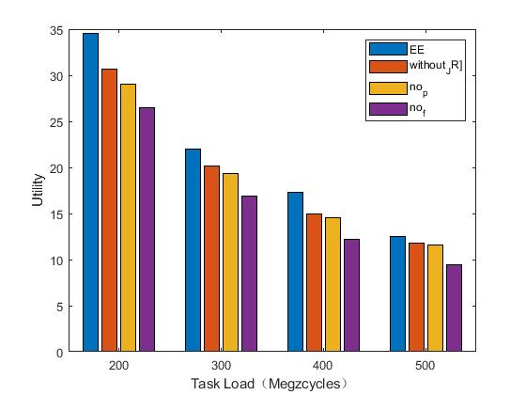然后是在不同上传任务下四种方式的对比，可以看出随着上传任务的增加系统性能会随之下降，联合优化相比较于其他方式依然具有优越性

The average system utility of the four competing schemes are plotted in Fig. 6(a) with different values of $ $ⅆ_{u}$ $. It can be seen that the average system utilities of all schemes decrease with the task input size. Moreover, we observe that the performance gains of the proposed scheme over the other schemes also follow the similar trend.

We can see that the larger the data size or the higher processing density of each application, the higher the maximum service delay in each considered case. MQA always performs the best among all the considered cases. Moreover, local-processing is most significantly affected by a large data size or a high processing density of an application, due to the limited computation capability at each V-UE.

We now evaluate the system utility performance against different number of users wishing to offload their tasks, as shown in Fig. 4(a, b, c). In particular, we vary the number of users per cell from 1 to 10 and perform the comparison in three scenarios with different task workloads. Note that the number of sub-bands N is set equal to the number of users per cell, thus the bandwidth allocated for each user decreases when there are more users in the system. Observe from Fig. 4(a, b, c) that hJTORA always performs the best, and that the performance of all schemes significantly increases when the tasks’ workload increases. This is because when the tasks require more computation resources, the users will benefit more from offloading their tasks to the MEC servers. We also observe that, when the number of users is small, the system utility increases with the number of users; however, when the number of users exceeds some thresholds, the system utility starts to decrease. This is because, when there are many users competing for radio and computing resources for offloading their tasks, the overheads of sending the tasks and executing them at the MEC servers will be higher, thus degrading the offloading utility.

我们注意到，当云端有更强大的计算能力时，也会使得系统总效用提升

The total system cost comparisons with different $ $f_{total}$ $ are shown in Fig. 5. Due to the limited computation capability at the cloud, when the computation capability is small, the system utility tend to small.

在不同的上传任务量下

We can clearly see that as the data size increases, the system utility tend to small. This is because when the tasks require more upload time with more data size.

Fig. 5 depicts the variation in average offloading probability as a function of the ratio of task execution deadline to its local execution time under different task arrival rates and pricing factors with ten vehicles in the game.

Fig. 5(a), (b) and (c) show the average computation overhead, average delay and average energy consumption versus the data size. We do not consider the maximum delay tolerance

τ . From Fig. 5(a), (b) and (c), we can clearly see that as the data size increases, the average computation overhead, the average delay and the average energy consumption increases

accordingly. Moreover, the COMO algorithm, TM algorithm and VCMO algorithm, which take into account task migration, perform better than MEC without considering task migration.

When the data size is large, the COMO algorithm performs best

**Ⅴ CONCLUSION**

This paper focuses on the Joint Task Offloading and Resource Allocation for Mobile-Edge Computing Enable Vehicular Networks with channel uncertainty and co-channel interference.

The optimization scheme attempt to guarantees vehicles’ QoS when there exists a maximized utility requirement. Due to the existence of channel uncertainty, the probability forms of interference, delay, and delivery rate constraints are performed. The underlying optimization problem was formulated as a Mixed-Integer Non-linear Program (MINLP), which is very difficult to solve to optimal, then the SCA technique is applied to transform the non-convex problem of variables coupling into a treatable convex problem. The Task Offloading and power allocation algorithm is developed to achieve practical execution scheme. Simulation results showed that our heuristic algorithm performs closely to the optimal solution and significantly improves the average system offloading utility over traditional approaches.

In this paper, we have proposed a mobility and queueing-based offloading decision optimisation algorithm, in conjunction with a bisection method-based FN computation resource allocation algorithm to minimise the maximum service delay of all V-UEs in an IoV system, where each V-UE may offload its task to a fog or cloud computing server or process it locally. The simulation results demonstrate that the proposed algorithms achieve a much lower maximum service delay than local-processing, fog-processing, cloud-processing, and random-processing.

In this work, the joint optimization problem in a multi-IR and multi-Eve terrestrial communication system is studied.In addition, we consider more practical scenarios where the

location of Eves are not perfectly available and existing some NFZs. In order to maximize the minimum average secrecy rate, the SCA technique and S-Procedure are applied to transform the non-convex problem of variables coupling into a treatable convex problem. Then, an alternating iterative algorithm is proposed to solve it effectively. Theoretical derivations and simulation results showed that the proposed scheme has stronger PLS and robustness compared with the benchmark schemes in the worst-case. Interesting, we found that recklessly increasing the jamming power will not enhance the secrecy rate effectively. The most effective method to improve the secrecy rate is to match the transmit power of GBS with the interference power.

We proposed a holistic strategy for a joint task offloading and resource allocation in a multi-cell Mobile-Edge Computing (MEC) network. The underlying optimization problem was formulated as a Mixed-Integer Non-linear Program (MINLP), which is very difficult to solve to optimal. Our approach decomposes the original problem into a Resource Allocation (RA) problem with fixed task offloading decision and a Task Offloading (TO) problem that optimizes the optimal-value function corresponding to the RA problem. We further decouple

the RA problem into two independent subproblems, namely the uplink power allocation and the computing resource allocation,and address them using quasi-convex and convex optimization techniques, respectively. Finally, we proposed a novel heuristic algorithm that achieves a suboptimal solution for the TO problem in polynomial time. Simulation results showed that our heuristic algorithm performs closely to the optimal solution and significantly improves the average system offloading utility over traditional approaches.

This paper focuses on the optimal power allocation based on game and pricing in vehicular communication networks with channel uncertainty and co-channel interference. To improve

the reliability and stability of the D2D-V system, the distributed robust power control and nonuniform price bargaining algorithm is proposed to realize a novel optimization scheme, which is based on the Stackelberg game. The optimization scheme attempt to guarantees users’ QoS when there exists a maximized utility requirement. Due to the existence of channel uncertainty, the probability forms of interference, delay, and delivery rate constraints are performed. Due to the original probability constraints are non-convex and intractable, the Bernstein approximation and exponential integral methods are introduced in the convex optimization process. The power allocation algorithm is developed to achieve practical execution scheme. Simulation results validate the converges of the proposed algorithm under dynamic communication environment. It also demonstrates that the proposed power control scheme has better robustness, and the D2D-V transmission rates also get a promotion. It is validated that the proposed algorithm is effective under the complex vehicular scenarios with channel uncertainty and co-channel interference.

**Abstract—**

In order to support delay-sensitive applications of vehicle equipment (V-UE) in the Internet-of-Vehicles (IoV) systems, it is necessary to allow V-UEs to offload their computationally intensive applications to a cloud or fog computing server. Where the uplink channel is reused by multiple vehicles. For the current D2D-V networks, interference in the dense vehicle scene often leads to extremely poor communication quality. Moreover, a vehicle’s mobility leads to an uncertain channel state and further affects the stability of communication. The resulting optimization problem corresponds to nonconvex fractional programming, and the block coordinate descent (BCD) algorithm and the successive convex approximation (SCA) technique is adopted to solve it. Furthermore, we decompose the problem into two subproblems for distributed and parallel problem-solving. Numerical simulations are performed to evaluate the algorithm performances, and the results indicate that the proposed algorithm is effective in high mobility under uncertain channel MEC-enable vehicular network environments.

This paper studies how to apply game theory to realize a well-function device-to-device enabled vehicular (D2D-V)communication system, where the uplink channel allocated to the cellular user (CU) is reused by multiple D2D-V users. Considering a non-cooperative setting where the CU and D2D-V users are selfish and profit-driven, a novel Stackelberg game framework is proposed to model the single-leader-multiple-follower hierarchical competition, where the CU and D2D-V users act as the leader and the followers, respectively. For the current D2D-V networks, the interference in the dense vehicle scene often leads to extremely poor communication quality. Moreover, a vehicle’s mobility leads to an uncertain channel state and further affects the stability of communication. To achieve effective communication, robust Stackelberg game-based resource allocation is developed, and a price-penalty mechanism is further proposed. Unlike previous Stackelberg games, the robust game is highlighted by handling the channel uncertainty which is embedded in the interference probability constraints. Besides, a game equilibrium (GE) is considered to be the solution and its existence and uniqueness are investigated.Also, a distributed robust power control and nonuniform price bargaining algorithm is proposed to approach the GE. Numerical simulations are performed to evaluate the algorithm performances,and the results indicate that the proposed algorithm is effective in high mobility vehicular networks under uncertain channel environments.

Mobile-edge computing (MEC) is an emerging paradigm that provides a capillary distribution of cloud computing capabilities to the edge of the wireless access network, enabling rich services and applications in close proximity to the end users. In this paper, an MEC enabled multi-cell wireless network is considered where each base station (BS) is equipped with a MEC server that assists mobile users in executing computation-intensive tasks via task offloading. The problem of joint task offloading and resource allocation is studied in order to maximize the users’ task offloading gains, which is measured by a weighted sum of reductions in task completion time and energy consumption. The considered problem is formulated as a mixed integer nonlinear program (MINLP) that involves jointly optimizing the task offloading decision, uplink transmission power of mobile users, and computing resource allocation at the MEC servers. Due to the combinatorial nature of this problem, solving for optimal solution is difficult and impractical for a large-scale network. To overcome this drawback, we propose to decompose the original problem into a resource allocation (RA) problem with fixed task offloading decision and a task offloading (TO) problem that optimizes the optimal-value function corresponding to the RA problem. We address the RA problem using convex and quasi-convex optimization techniques, and propose a novel heuristic algorithm to the TO problem that achieves a suboptimal solution in polynomial time. Simulation results show that our algorithm performs closely to the optimal solution and that it significantly improves the users’ offloading utility over traditional approaches.