Preface

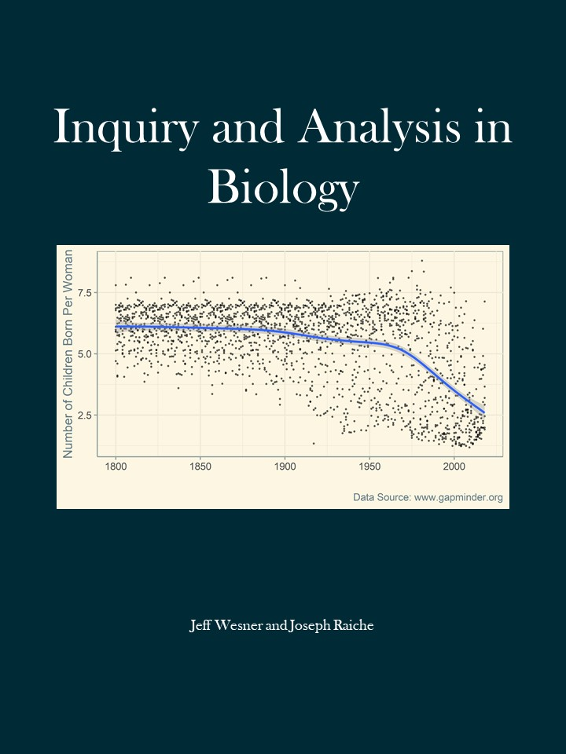

This book is intended for undergraduate students who are writing their first scientific papers. The book was developed using materials from a course taught by Wesner to sophomores (mostly) at the University of South Dakota - BIOL 280 Inquiry and Analysis in Biology.

We thank the 100’s of students that have taken this course previously. Many of the chapters of this book were written from drafts of course handouts. Feedback from the students was essential for improving the materials. This book was written with support from an Online Textbook Fellowship from the University of South Dakota.