Size spectra in freshwater streams are consistent across temperature and resource supply

Vojsava Gjoni ¹| Justin P. F. Pomeranz² | James R. Junker³ | Jeff S. Wesner¹

Smaller individuals are more abundance than larger ones in ecological communities. This pattern, known as individual body size distributions (ISD) refer to the relationship between the abundance of organisms and their body size within a given community. ISD is appearing to be constant and because of this is emerging as a powerful tool to access impacts on ecological communities. This is because is influenced by a multitude of factors, including temperature and resource supply. Warmer temperatures have been associated with smaller body sizes, while cooler temperatures have been associated with larger body sizes. Limited resources, drive competition for those resources to be intense, leading to smaller body sizes, whereas abundant resources, may favor larger body sizes. Here, we have tested how temperature and resources interact to affect ISD and total biomass of steam ecosystem food webs. Despite strong environmental variation, complete species turnover, and changes in mean body size, increased temperature, and resource supply caused no change in ISD value. Similarly total biomass showed no important changes with exception under limited where increasing temperature caused greater total biomass. The differences in temperature and resource supply disappeared, and communities of different sized organisms and compositions converged on similar ISD value and a stable biomass. The converge in a constant ISD of food webs in streams may reflects on the fact that within spatial distinct wood webs, trophic interaction seem to be more important than environmental conditions after given time of community development.
Earth supports ~550 gigatons of living carbon biomass (Bar-On et al. 2018; Elhacham et al. 2020) and a fundamental challenge for ecologists is to understand how that biomass is distributed from individuals to ecosystems (Cyr and Pace 1993). Two common metrics of biomass are total standing stock biomass (Biard et al. 2016), an index of the amount of biomass that an ecosystem can support, and the individual size distribution (ISD; Perkins et al. 2019), which is shaped by the flux of energy through food webs (Jennings and Blanchard 2004; Petchey and Belgrano 2010; Blanchard et al. 2017; Barnes et al. 2018). Size-based ecosystem modeling, such as individual size distributions (ISD; also known as the abundance size spectrum) is emerging as a powerful tool to access ecosystems impacts (i.e., from individual level physiological processes to ecosystem-level ones) complementing more traditional taxonomic or trophic approaches (Brose et al. 2017, Blanchard et al. 2017). This is because many fundamental aspects of an organism’s biology are controlled by body size, including metabolic rate, life history, diet breadth, and trophic position (Brown et al. 2004; Woodward et al. 2005; White et al. 2007). Therefore, changes in the ISD reflect changes in ecosystem function, providing a simple but powerful way to measure variation in size-based community structure across spatial and temporal scales (Woodward et al. 2010; Edwards et al. 2017; Sprules and Barth 2015; Blanchard et al. 2017; O’Gorman et al. 2017).
The shape of the ISD is described by a power law, N ~ M^{λ}, which is predicted to hold when the energy use of individuals in a community approximates the resource flow available from the environment (Enquist et al. 1998; Enquist and Niklas 2001). Therefore, the exponent λ varies as a function of the efficiency of energy flow through the food web (Dickie, Kerr, and Boudreau 1987; Jonsson, Cohen, and Carpenter 2005; Sprules and Barth 2015; O’Gorman et al. 2017). The exponent λ is almost always negative and typically ranges from ~ -1 to -2, indicating a remarkably consistent pattern across earth’s ecosystems (Cyr 2000; Brown and Gillooly 2003; Sprules and Barth 2015; Blanchard et al. 2017).
Because of this apparent consistency, ecologists have begun using the ISD to indicate fundamental shifts in ecosystem functioning in response to environmental changes (Jennings and Blanchard 2004). For example, there is a clear expectation that future warmer temperatures will generate reductions in body size from the individual to the community level (Forster, Hirst, and Atkinson 2012). Warming is predicted to favor smaller organisms (Petchey 1999) and produce steeper ISD exponent (Yvon-Durocher et al. 2011). Empirical estimates are varied, showing that ISD exponents decline with temperature (Pomeranz et al. 2022) or increase with temperature (O’Gorman et al. 2017). Similarly, while is predicted a less efficient transfer of total biomass through the food web with temperature (Jennings and Blanchard 2004), empirical estimates have estimated increases (Pomeranz et al. 2022). Crucially, most empirical, and theoretical predictions do not account for temperature driven changes in the supply of resources at the base of the food web (O’Gorman et al. 2017). Excessive resource supply is well known to strongly influence body size and potentially ISD’s exponent (O’Gorman et al. 2017). However, how temperature and resources interact to impact ISD, and total biomass is almost completely overlooked, including the ensuing possibility for size-based effects on ecosystem function (Cross et al. 2015).
Accounting for the interaction between temperature and resource supply is critical for predicting ecosystem changes to global temperatures. Although, temperature induces higher metabolic costs, leading to reduced transfer efficiency, this reduction can be counteracted by increases in resource supply (Brown et al. 2004; O’Gorman et al. 2017; Junker et al. 2020). Yet testing these interactions at the macroecological scale is logistically challenging because it requires data-intensive measures of individual body sizes, along with accurate (daily or sub daily) temperature measures along with estimates of resource supply in the form of gross primary production and allochthonous subsidies (O’Gorman et al. 2017; Perkins et al. 2018). Here, overcome these logistical challenges using data from the National Ecological Observatory Network (NEON) to provide a critical test of how ecosystem function responds to realistic temperature scenarios at macroecological scales, while critically accounting for co-variation in resource supply (Cross et al. 2015). NEON is a unique dataset worldwide because it repeats collections include automated instrument recordings and observational field sampling throughout the year (from 2017 to 2022). For this reason, NEON dataset allowed us to test how temperature and resource supply interact to shape ISD and total biomass at macroecological scales, as well as how ecosystem functioning might respond to future temperature scenarios, while critically accounting for co-variation in resource supply at macroecological scales. Specifically, we examined the response of 145 size-spectra using fish and macroinvertebrates collected from 24 freshwater streams in North America that varied by 25 degrees C and by orders of magnitude in resource supply (i.e., gross primary production and litter input).
Despite strong environmental variation, complete species turnover, and variation in mean body size and standing stock biomass, the ISD exponent was invariant to increased temperature and resource supply (i.e., GPP and OM) (Fig 2). Similarly, total standing stock biomass varied with temperature only under low GPP where increasing temperature caused greater total biomass (Fig. 3 and 4). The invariance of λ is consistent with predictions of the energy equivalence rule (Damuth 1981, 1987, 1991) and other allometric theory (Enquist et al. 1998, 1999; Enquist & Niklas 2001; Niklas & Enquist 2001) within a trophic level. Nonetheless, our results reflect on multiple trophic levels and extent the constant λ value beyond the one trophic level allometric theory predictions. It seems that for stream spatial distinct food webs under comparable rates of resource supply and temperature should converge converged on similar λ value despite differences in the size and species composition of organisms among different food webs. This implies that the interaction among multiple trophic roles may be more important than the environmental conditions after given time of community development.
In addition, λ value and total biomass suggested no change across years as well (Fig. 4). Across all samples, λ averaged -1.2, shallower than theoretical predictions, suggesting a higher proportion of larger individuals in stream ecosystems. This seem to be true for benthic communities that show shallower λ than pelagic communities (Blanchard et al. 2008; Blanchard et al. 2027). This may be because of high flow of detritus that falls directly in the stream ecosystems supplying more resource versus pelagic communities. Therefore, the system can support a high number of large sized benthic macroinvertebrates, and in turn large sized fish predator through time. Furthermore, dimensionality (i.e., spatial complexity) may also mediate the λ value for benthic (i.e., 2D) versus pelagic (i.e., 3D) in the same way (e.g., λ of 2D versus 3D communities is shallower). Where the spatial complexity of the habitat affects the interaction among trophic levels (e.g., consumers vs. resource species) and in turn ISD exponent (Pawar et al. 2012). Nonetheless, the different function of organismal type and their interaction or no interaction with other trophic levels may also mediated the ISD exponent (Perkins et al. 2019).
Our finding that the ISD is invariant across a large temperature and resource gradient contradicts previous empirical findings that demonstrated a positive or negative change in ISD’s across temperature (Yvon-Durocher et al. 2011; Dossena et al. 2012; O’Gorman et al. 2017; Pomeranz et al. 2022). Several explanations for this contradiction exist. For example, previous studies of the ISD changing across temperature have measured single taxonomic groups (phytoplankton: Yvon-Durocher et la. 2011, macroinvertebrates: Pomeranz et al. 2022), had smaller temperature ranges (Dossenta et al. 2012, Yvon-Durocher et al. 2011), and limited spatial and temporal scales (O’Gorman et al. 2017). Those are not weaknesses of the particular studies, but simply present challenges in scaling up to understand how the ISD changes at broader spatial, taxonomic, and temporal scales. Indeed, when we re-ran our analyses on only macroinvertebrates, we found that the ISD became steeper at higher temperatures, reconfirming previous studies on individual taxonomic groups. This suggests that the more complete food web in our study, along with the broader range of taxonomic and environmental conditions yielded results that are an emergent property of the more limited previous studies.
However, the empirical studies above that focus on single trophic levels may not explain relationships between size-based diversity and ecosystem functioning observed over entire food webs, such as in this study. Our results suggest that total biomass increase with temperature only when GPP is low, whereas is stable under the other conditions. This reflects in food webs where other factors such as resource shortage or competition (Hayward et al 2009) under natural conditions in food webs (e.g., size-dependent resource competition; Ernest 2005), may change turn ecosystem-level standing stock biomass. This may be because of shifts in size structured communities towards smaller species that have a competitive advantage at higher temperatures (Reuman et al. 2014). This is because, at high temperatures, large consumer species (i.e., consumer species are usually larger than resources species) run a risk of starvation (Petchey et al. 1999). However, species competition likely depends also on resource supply (e.g., size dependent resource access; Tilman et al 1981). Therefore, small species are favored at high temperatures, but this advantage is lost with increasing resources. At high temperature, increasing resources save large consumer species from starvation, having a beneficial effect on them. Additionally, at high resources and low temperatures larger consumer species have a competitive advantage (Binzer et al. 2012). Thus, temperature and resources have interactive effects on the dynamics of the food webs may destabilize (increasing total biomass oscillation) food webs by shifting biomass up the trophic level. Therefore, the competitive advantage of small or large species, depending on the temperature and resource conditions, is more complex for food webs. So far, the simultaneous effect of temperature and resources on ISD and total biomass of food webs are poorly tested.
In addition, community size spectra including both fish and macroinvertebrates may result from methodological issues influencing the results. This is because of the inclusion of largest body sizes with fish and the smallest with macroinvertebrates that may lead to different ISD exponents respect to when fish and invertebrates are divided or excluded. Indeed, in marine food webs ISD exponent have shown different results when excluding macroinvertebrates (Blanchard et al. 2021), relative to when included them (Heather et al. 2021). This suggest that inclusion of both fishes and invertebrates body sizes should be considered in a more realistic approach of food webs as they are important components of the underlying body size distribution in nature.
This implies that after sufficient time for development of the community, the amount of biomass or energy in a spatially distinct food webs are constant across time and independent of body size distribution (Damuth 1981). This reflects that after sufficient time for community development any there are no differences in ecosystem functioning that resulted from the effect of temperature and resource supply. Where community structures in stream ecosystems is constant across sites and through time, the trophic interactions determine the amount of energy used per individual and in turn the proportion of the individuals that can be supported in stream ecosystems. Furthermore, accounting for seasonal and spatial variation at each site (because of the unique continuous measurements of NEON dataset across season over six years) we predicted the future λ value and future total biomass distribution of 2023 across stream ecosystems. The no variation in ISD exponents and total biomass we observed is consistent with the allometric theory, as well as the prediction that ISD is a stable pattern of food webs. One implication of this stability we observe is that deviations in ISD exponent may be used as a biomonitoring tool that detects future changes in community structure and ecosystem functioning in response to a range of environmental stressors (Petchey and Belgrano, 2010; Pomeranz et al., 2019).

Fig. 1 | The theoretical basis for ISD scaling in ecosystems is underpinned by a number of empirical studies and fundamental “rules” in ecology. (1) The rate of metabolism is intimately linked to organism size and can be described by the equation (i) where, I is individual metabolic rate, 𝑖₀ is a body size independent normalization constant, M is individual body mass, and 𝑏 is an allometric exponent, often ~0.75). Inserting temperature by scaling its effect on subcellular kinetics to individual metabolism, through the inclusion of an Arrhenius relationship, whereby the initial description of 𝐼 is modified to equation (ii) here, 𝑖₀ is a body size and temperature independent normalization constant, 𝐸 is the activation energy of the metabolic process (usually 0.6 – 0.7 for heterotrophic metabolism), 𝐾 is Boltzmann’s constant, and 𝑇 is absolute temperature in Kelvin. Furthermore, a finite amount of energy can support many small, cool individuals or fewer large, warm individuals because energy use per individual is higher for larger or warmer organisms. As such, it is predicted that the carrying capacity, 𝐾, given a supply of resources, [𝑅], decreases with body size and temperature in an equal and opposite pattern as individual metabolic rate shown in equation (iii). This formulation predicts the equivalence in population energy use with body size and temperature supported by empirical and theoretical work (e.g., energy equivalence), if we assume energy supply is constant. Therefore, for communities within a trophic level that share a common, equitably distributed energy source, the value of the ISD exponent is predicted to be invariant. (2) Our study includes a diversity of trophic roles (i.e., from small prey invertebrate to large fish predators) allowed us to investigate effects of temperature and resource supply across multiple trophic levels, and to extend the analysis beyond the within tropic level allometric theory predictions. (3) Empirical studies have shown that increasing temperature should increase the proportion of small species present in the community whereas decreasing temperature. In addition, when resources increase the proportion of large species should increase, whereas when resource availability decrease the proportion of small species should increase. Therefore, A. ISD is expected to be steeper with increasing temperature and shallower with increasing resource supply. Where B. λ values decreases with increasing temperature (yellow color) and decreases with increasing resource suppl (purple color) (4) Modelling predictions by Binzer et al. (2012) show that under extreme conditions, such as high resource supply and low temperature, as well as low resource supply and high temperature (purple color), the system destabilizes the total biomass and larger predators are in starvation risk (i.e., unstable states). Whereas under moderated temperature and resource supply, the system is expected to be highly productive, and the total biomass may achieve the maximum productivity (yellow color).

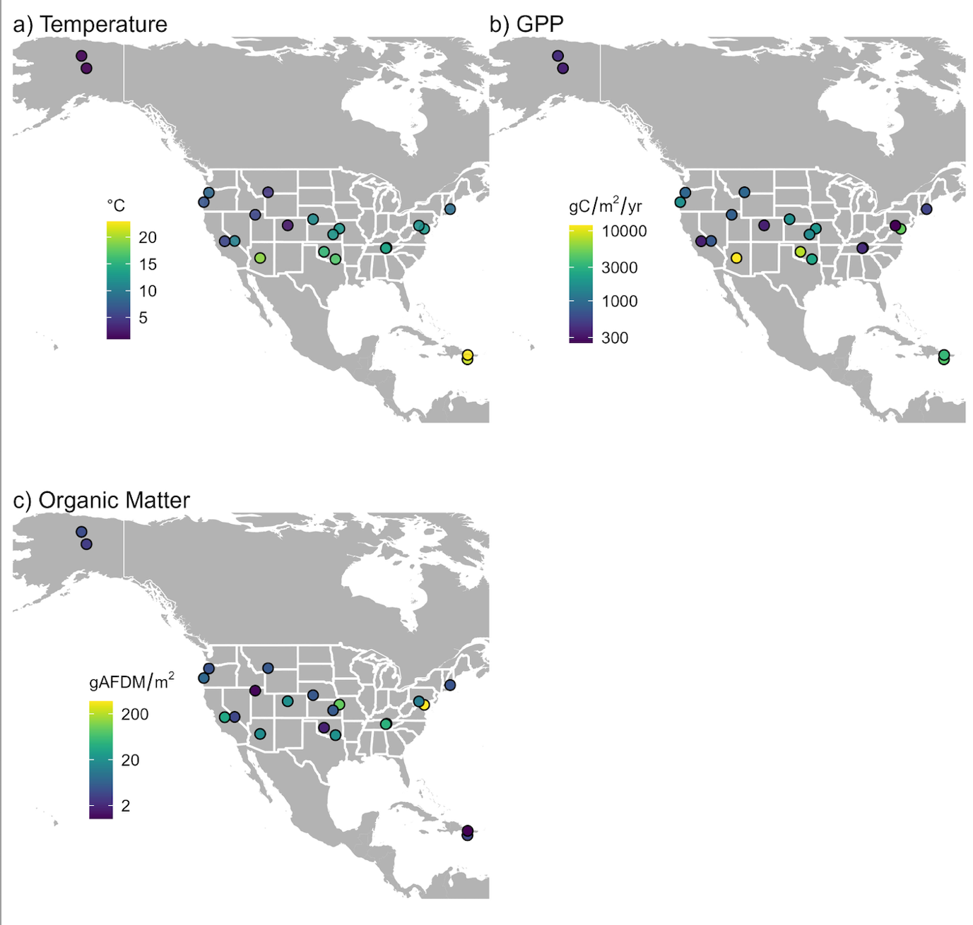
Fig. 2 | Variation in temperature, gross primary production (GPP), and organic matter across NEON stream sites (n = 22). The points are jittered slightly to remove visual overlap. Values for temperature and GPP are annual means. Values for organic matter represent standing stocks averaged over 2-4 samples per site.

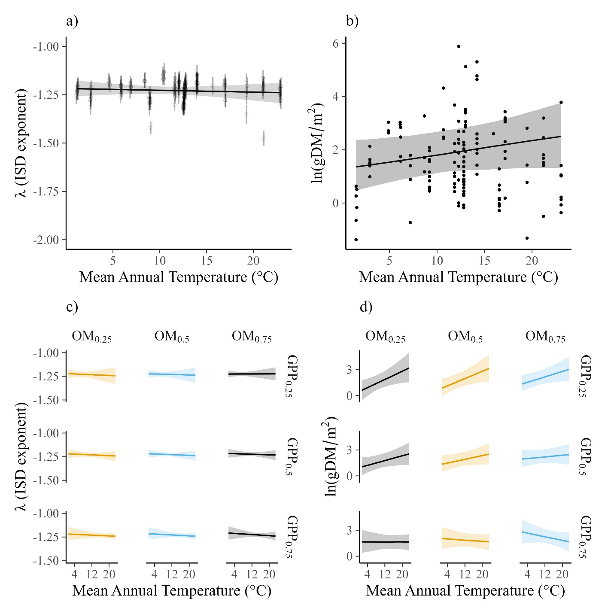

Fig. 3 | Relationships of the ISD and standing stock biomass across mean annual stream temperature, annual gross primary production, and organic matter when consider the whole benthic food web. a. mean temperature causes no change in ISD exponent, b. whereas caused an increase in standing stock biomass. In addition, c. temperature causes no change in ISD across 25th, 50th, and 75th quantiles of organic matter (ln OM) and gross primary production (ln GPP). However, d. temperature caused an increase in standing stock biomass only under low ln GPP and no change under the other combined conditions of ln OM and ln GPP. Our temperature and resource gradient are substantial for global stream ecosystems. Our temperature range 20°C covers the global gradient in stream ecosystems globally (biblio). In addition, organic matter is consistent with the two order of magnitude range in streams of North America (Webster and Meyer 1997), as well GPP, with a range from 300 to 11000 g Cm-2/yr, that is more than twice the observed GPP in North America (Bernhardt et al. 2022). Therefore, our finding may contribute to a more general understanding of stream ecosystems ranging from resource-poor to resource-rich stream, as well as from cool to warm ones.

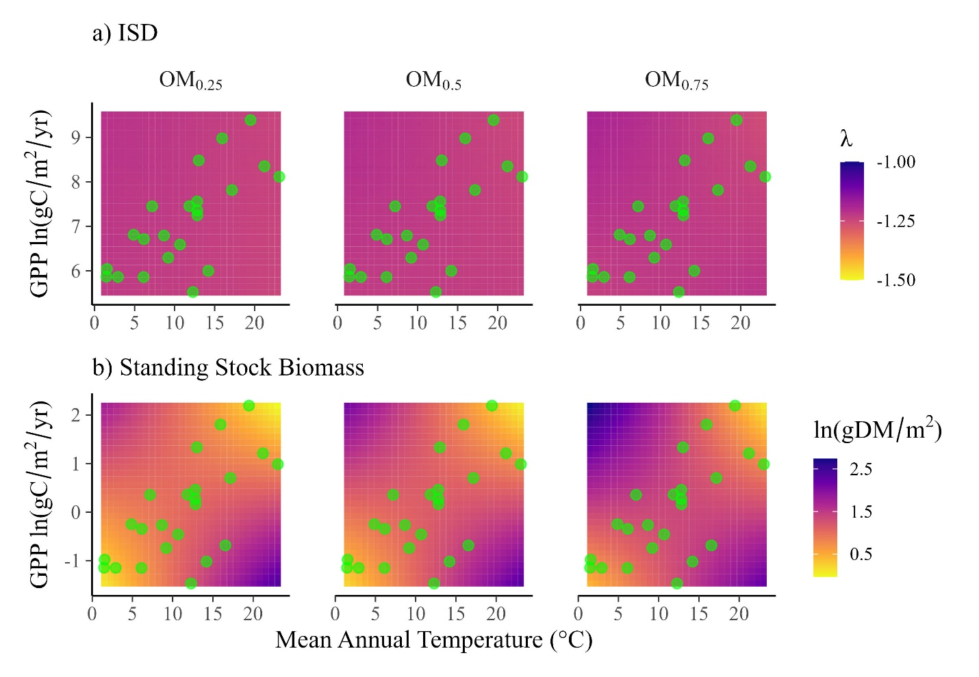

Fig. 4 | Model predictions of the ISD exponent and standing stock biomass. a. increasing mean annual stream temperature (°C) cause no change in ISD exponent (no color changes) across continuous values of annual gross primary production (ln GPP) and mean annual stream temperature at three levels of standing stock organic matter (OM; 25th, 50th, and 75th quantiles). b. increasing temperature increased standing stock biomass only under low ln GPP, whereas caused no changes under the other conditions (green dots correspond values of ln GPP and mean annual stream temperature across the 22 NEON sites). This is because the strongest changes (color changes) occur for environmental conditions that are not present in the NEON sites (e.g., high GPP/low temperature or low GPP/high temperature).
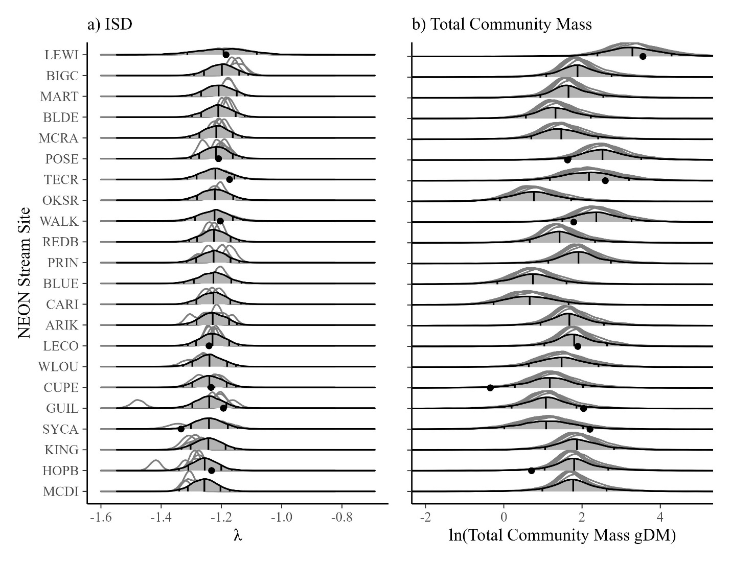
Fig. 5 | Forecasts of ISD’s and total community biomass based on models trained on data from 2016 through 2021. a. the 2016 to 2021 the yearly ISD showed no changes across stream sites The forecast for 2022 (gray-filled densities) shows the future ISD exponent value (the dots are data collected in 2022). Posterior predictive distribution was used for the forecasts, with vertical lines at the 50th, 75th, and 95th quantile, where 95th is difficult to see. b. the 2016 to 2021 the yearly total biomass showed no changes across stream sites. The forecast for 2022 (gray-filled densities) shows the future total community biomass (the dots are data collected in 2022). In each case where 2022 data are available for both a. and b., the observed values (dots) fall within the 95% prediction intervals of the forecasts.

Methods
Body Size Data
We analyzed size spectra using 2,468,683 individual body masses of fish and macroinvertebrates collected by the National Ecological Observatory Network (NEON) between 2016 and 2021. This included 64,940 measures from 157 fish species and 2,403,743 measures from 1,155 macroinvertebrates taxonomic groups (typically genus or species). The samples were collected once or twice per year at each of 23 sites, resulting in a total of 123 unique collection events.

Macroinvertebrates
NEON collected macroinvertebrate data via fixed-area samplers (e.g., Surber/Core/Kicknet) and measured insect body lengths to the nearest mm along with estimates of their density (no/m²). The macroinvertebrate data are available as data product DP1.20120.001 (NEON 2023). While the samplers vary, all mesh sizes are the same (243 um). Macroinvertebrate length measurements ranging from 1 to 86 mm, which we converted to dry mass using published length-mass regressions for each order or family (Pomeranz et al. 2021). After converting to dry mass, we excluded insects that were smaller than 0.0026 mgDM, as previous analyses showed these sizes to be under sampled (Pomeranz et al. 2021).

Fish
Fish were collected from each site twice per year (typically) using 3-pass removal electrofishing. The fish data are available as data product DP1.20107.001 (NEON 2022). For each collection, the first 50 fish per taxon were measured for total length in mm and wet mass in mg (Monahan et al. 2020). The remaining fish were tallied as a bulk count per species (without mass measures).

Using the three-pass depletion data, we estimated fish population density (no/m²) in each collection using a multinomial Poisson depletion model (Royle et al. 2004). We specified the model in R using the ubms package (Kellner et al. 2021). The response variable was the number of fish caught per pass and the predictor variable was the collection id (site_date_reach). The model resulted in a population estimate for each collection, which we converted to no/m² by dividing each estimate by the sampled area. We then multiplied that population estimate by the relative abundance of each fish species, resulting in an estimated density (no/m²) of each fish species in each collection. Finally, we merged those estimates with the dry mass measurements and resampled the dry mass measures with replacement, weighted by the relative abundance of each fish species (in units of number of individuals/10,000 m²). Weighting by no/10,000m² instead of no/m² was necessary to ensure that enough body sizes were sampled (i.e., no/m² was typically <1). For each collection, we then summed the total number of individual body sizes, along with their density estimates, resulting in a dataset containing individual size estimates and their associated density for each collection.

Combining fish and macroinvertebrates
Fish and macroinvertebrates were collected on different dates, with macroinvertebrates collected three times per year and fish collected twice. Therefore, to combine fish and macroinvertebrate samples, we limited the data to only collections that occurred within 30 days of each other. For example, if macroinvertebrates were collected on June 10 and fish collected on June 20, those samples were treated as one. If more than one sample was in this window (e.g., another fish collection on June 21), we included only the most recent collection. The resulting data set contains body sizes ranging nine orders of magnitude (0.003 to 200,000 mg) along with their densities. We used this dataset to estimate individual size distributions, total community biomass.

Environmental Data
Temperature
To estimate mean annual stream temperature for each of the 23 sites, we obtained water temperature readings collected every four hours from 2016 to 2021 using the NEON data product DP1.20053.001 (NEON 2023b). We removed data that did not pass quality checks as noted by NEON. We also removed data that appeared unreasonably low (< -5°C) or high (> 50°C). Some data for Alaskan streams is missing when the water is frozen. For those data, we assumed a temperature of 0°C. The resulting dataset contained 93,930 temperature readings. To reduce the data size for modeling, we estimated the mean weekly temperature and modeled that as a function of date and site using a generalized additive model with a Gaussian likelihood and year as a varying intercept. Mean weekly temperature was centered prior to modeling. This approach allowed us to have a posterior distribution of temperature predictions on each day over three years. From that posterior distribution, we calculated the mean annual temperature and standard deviation (Table X) for each site.

Gross Primary Production

Organic Matter
We estimated the standing stock of organic matter by directly estimated organic matter mass from 49 unsorted bulk samples in the NEON biorepository (at least two samples per site). The samples were collected at the same time as macroinvertebrate samples, using the same collection techniques (i.e., Surber sampler, core sampler). We obtained the raw samples from NEON and first removed macroinvertebrates from them. We then combusted the remainder…

Data Analysis
To examine how size spectra varied as a function of temperature and resources, we used a Bayesian generalized linear mixed model with a truncated Pareto likelihood. A description and justification of this modelling approach for ISD’s is given in Wesner et al. (2023). The model structure was:

$y_{ijkl}∼paretocounts\left(λ,y_{min,k},y_{max,k},counts_{ijkl}\right)$ [likelihood]

$$λ=α+η_{j}+η_{k}+η_{l}+β_{1}x_{1}+β_{2}x_{2}+…β_{n}x_{n} [linear model]$$

$α∼Normal\left(-1.3, 0.1\right)$ $[priors]$
$${[η}_{j},η_{k},η_{l}]∼Normal(0, {[σ}_{j},σ_{k},σ_{l}])$$
$${[σ}_{j},σ_{k},σ_{l}]∼Exponential(2)$$
$$[β_{1}x_{1},… β_{n}x_{n}]∼Normal\left(0, 0.5\right)$$

where y_{ijkl} is a single i^{th} body size from sample j in site k and year l. The likelihood is a truncated Pareto with a single free parameter$λ$, often called the “exponent” of the ISD. $y_{min,k}$ and $y_{max,k}$ are the minimum and maximum body sizes in each k site. Each body size has a corresponding density in units of number per m², represented by counts_{ijkl}, as described in Edwards et al. (2020). $λ$is modeled as a linear function of an intercept $α$ and three x_{n} predictors (median annual stream temperature, median annual GPP, and mean organic matter mass) and their two and three-way interactions. All predictors were standardized as z-scores prior to fitting. Varying intercepts are included for individual sample ($η_{j}$), site $η_{k})$, and year $\left(η_{l}\right)$. Brackets (e.g., ${[η}_{j},η_{k},η_{l}]$) are included for brevity; each parameter in the bracket was given an independent prior. To improve sampling efficiency, the varying intercepts were modeled using non-centered parameterization, which is excluded here for clarity, but is present in the Stan model code.

Priors for the intercept were chosen based on a previous analysis of ISD values in NEON streams (Pomeranz et al. 2022). All other priors were chosen using prior predictive simulation (Wesner and Pomeranz 2021), which restricted the range of ISD values to have high probabilities of $λ$ between ~ -2 to -1 while still allowing probabilities at very large (e.g., 1) or small values (e.g., -4)

Biblio
1. Brown, J. H., Gillooly, J. F., Allen, A. P., Savage, V. M. & West, G. B. Toward a Metabolic Theory of Ecology. Ecology 85, 1771–1789 (2004).
2. Woodward, G. et al. Body size in ecological networks. Trends in Ecology & Evolution 20, 402–409 (2005).
3. White, E. P., Ernest, S. K. M., Kerkhoff, A. J. & Enquist, B. J. Relationships between body size and abundance in ecology. Trends in Ecology & Evolution 22, 323–330 (2007).

Brose, U., Blanchard, J. L., Eklöf, A., Galiana, N., Hartvig, M., R. Hirt, M., ... & Jacob, U. (2017). Predicting the consequences of species loss using size‐structured biodiversity approaches. Biological Reviews, 92(2), 684-697.

Wesner, J. S., & Pomeranz, J. P. (2021). Choosing priors in Bayesian ecological models by simulating from the prior predictive distribution. Ecosphere, 12(9), e03739.

Supplementary Information

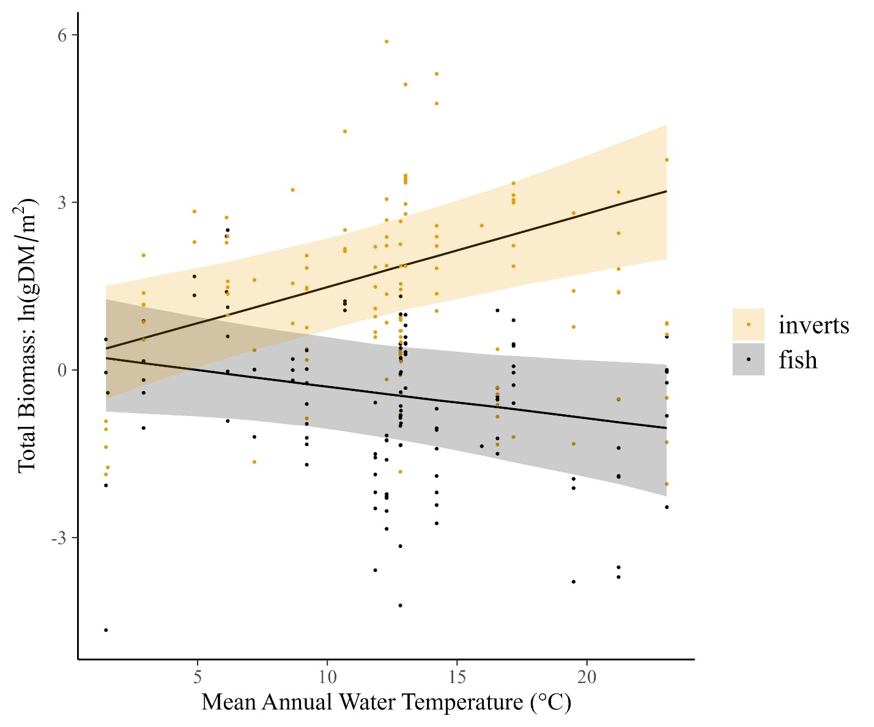
Figure S1 | Marginal relationship between temperature and the standing stock of natural log-transformed total biomass of fish and invertebrates. Lines are posterior medians and shading is the 95% Credible intervals.

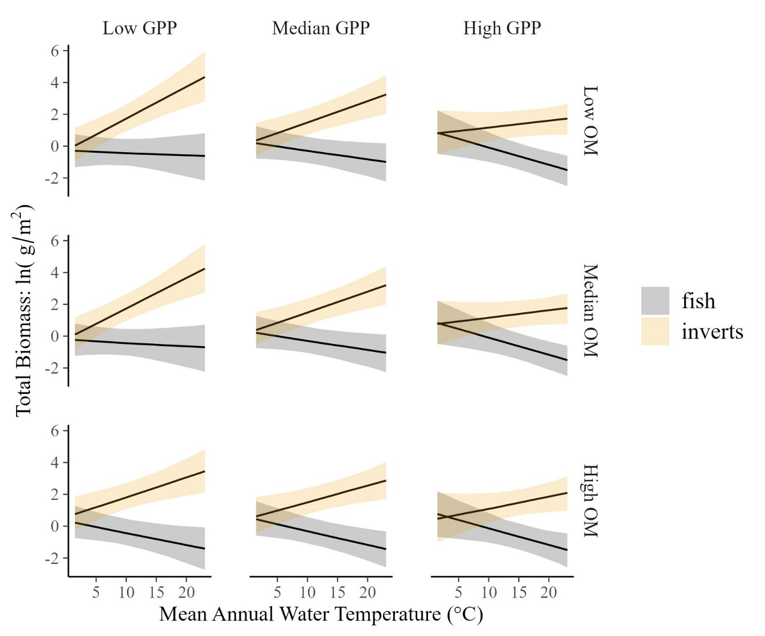
Figure S2 | Interactions of the marginal relationship between temperature and the standing stock of natural log-transformed total biomass of fish and invertebrates across three values of resource supply (gross primary production and standing stock organic matter). Lines are posterior medians and shading is the 95% Credible intervals.

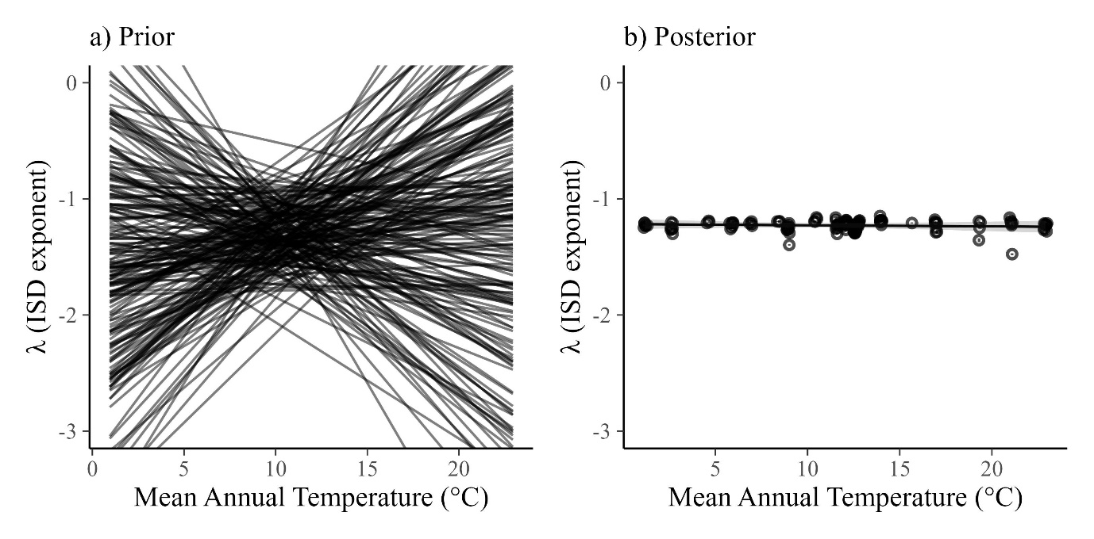
Figure S3 | Two-hundred simulations from the prior predictive distribution (a) compared to the fitted posteriors (b). Both models show the relationship between lambda and temperature with GPP and organic matter set to their median values.

We checked the implications of our priors using prior predictive simulation. The result is shown in Figure S1a, indicating that the priors largely limit λ to values between ~-2 to -1, but allow for a wide range of possible relationships with mean annual temperature. By comparison, the posterior (Figure S1b) remains in a much more constricted space. The difference between the prior and posterior is an index of how much information was learned from the data.

