**Temperature and resources interact to influence individual size distributions across North American streams**

Vojsava Gjoni 1| Justin P. F. Pomeranz2 | James R. Junker3 | Jeff S. Wesner1

**Introduction**

Understanding macroecological patterns of ecological function remains a challenge for ecologists. One important ecosystem function, the flux of energy through food webs (Barnes et al. 2018), is reflected by the size distribution of individuals within ecological communities (Jennings and Blanchard 2004; Petchey and Belgrano 2010; Blanchard et al. 2017). Therefore, size-based ecosystem modeling, such as individual size distributions (ISD; also known as the abundance size spectrum) is emerging as a powerful tool to access ecosystems impacts (i.e., from individual level physiological processes to ecosystem-level ones) complementing more traditional taxonomic or trophic approaches (Brose et al. 2017, Blanchard et al. 2017). This is because many fundamental aspects of an organism’s biology are controlled by body size, including metabolic rate, life history, diet breadth, and trophic position (Brown et al. 2004; Woodward et al. 2005; White et al. 2007). Therefore, changes in the ISD reflect changes in ecosystem function, providing a simple but powerful way to measure variation in size-based community structure across spatial and temporal scales (Woodward et al. 2010; Edwards et al. 2017; Sprules and Barth 2015; Blanchard et al. 2017; O’Gorman et al. 2017).

The shape of the ISD is described by a power law, N ~ Mλ, which is predicted to hold when the energy use of individuals in a community approximates the resource flow available from the environment (Enquist et al. 1998; Enquist and Niklas 2001). Therefore, the exponent λ varies as a function of the efficiency of energy flow through the food web (Dickie, Kerr, and Boudreau 1987; Jonsson, Cohen, and Carpenter 2005; Sprules and Barth 2015; O’Gorman et al. 2017). The exponent λ is almost always negative and typically ranges from ~ -1 to -2, indicating a remarkably consistent pattern across earth’s ecosystems (Cyr 2000; Brown and Gillooly 2003; Sprules and Barth 2015; Blanchard et al. 2017).

Because of this apparent consistency, ecologists have begun using the ISD to indicate fundamental shifts in ecosystem functioning in response to environmental changes (Jennings and Blanchard 2004). For example, there is a clear expectation that future warmer temperatures will generate reductions in body size at the community and individual level (Forster, Hirst, and Atkinson 2012). Yet whether this will in turn alter the shape of ISD is unclear. Empirical estimates are varied, showing that ISD exponents decline with temperature (Pomeranz et al. 2022) or increase with temperature (O’Gorman et al. 2017). Both directional changes are conflict with predictions from metabolic theory, which predicts no change of ISD with temperature. Similarly, while metabolic theory predicts a decline in total community biomass with temperature, empirical estimates have estimated increases (Pomeranz et al. 2022). Crucially, most empirical, and theoretical predictions do not account for temperature driven changes in the supply of resources at the base of the food web (O’Gorman et al. 2017). Excessive resource supply is well known to strongly influence body size and potentially ISD’s (O’Gorman et al. 2017). However, how temperature and resources interact to impact ISD and total biomass is almost completely overlooked, including the ensuing possibility for size-based effects on ecosystem function (Cross et al. 2015).

Accounting for the interaction between temperature and resource supply is critical for predicting ecosystem changes to global temperatures. In particular, while temperature induces higher metabolic costs, leading to reduced transfer efficiency, this reduction can be counteracted by increases in resource supply (Brown et al. 2004; O’Gorman et al. 2017; Junker et al. 2020). Yet testing these interactions at the macroecological scale is logistically challenging because it requires data-intensive measures of individual body sizes, along with accurate (daily or sub daily) temperature measures along with estimates of resource supply in the form of gross primary production and allochthonous subsidies (O’Gorman et al. 2017; Perkins et al. 2018). Here, overcome these logistical challenges using data from the National Ecological Observatory Network (NEON) to provide a critical test of how ecosystem function responds to realistic temperature scenarios at macroecological scales, while critically accounting for co-variation in resource supply (Cross et al. 2015). NEON is a unique dataset worldwide because it repeats collections include automated instrument recordings and observational field sampling throughout the year (from 2017 to 2022). For this reason, NEON dataset allowed us to test how temperature and resource supply interact to shape ISD and biomass at macroecological scales, as well as how ecosystem function might respond to future temperature scenarios, while critically accounting for co-variation in resource supply at macroecological scales.

Despite strong environmental variation, complete species turnover, and changes in mean body size, preliminary results suggest no change in λ across the temperature or GPP gradients of the stream food web. Across all samples, λ averaged -1.4, shallower than theoretical predictions, suggesting a higher proportion of larger individuals in stream ecosystems. Our findings are consistent with benthic marine systems and suggests that ISD and biomass are stable across North American streams considering the whole benthic food web. However, considering separated macroinvertebrate fish trophic levels we observed different patterns across temperature and resource gradients. Specifically, fishes suggest no change in λ whereas macroinvertebrates suggest a decline with temperature only for low GGP conditions. Last, NEON data allowed us to account for seasonal and yearly variation at each site and predict the future size spectra of 2023 across all samples.

**Discussion**

Changes in temperature and resource supply, for example, are known to modify physiological processes which, in turn, shape ecosystem structure and dynamics. On one hand, temperature influence various volume-related and energy-demanding processes such as metabolism, growth, and activity (reviewed by Glazier 2005), therefore individual’s body size shifts with temperature (Atkinson et al. 1994, Daufresne et al. 2009, Finkel et al. 2010, Sheridan and Bickford 2011, Gardner et al. 2011, Adams et al. 2013). This is because smaller organisms have lower absolute energy requirements (Gillooly et al. 2001) and hence a higher number of smaller organisms that can be sustained (Reiman et al. 2014). This implies that increasing temperature may increase the proportion of the smaller individuals in the ecological communities and vice versa. On the other hand, changes in resource supply cause changes in body maintenance, metabolism growth and reproduction that modify the body size of the individuals (McNab 2010, Huston and Wolverton 2011, O’Connor 2008), therefore giving a competitive advantage to the large individuals relative to the small ones.

ISD due to the fact that derive form the individual physiological process, and also predicts biomass turnover at the ecosystems (Brown et a. 2004), it is able to infer the consequences of temperature and resources effects from individual to the level of entire ecosystem level. Therefore, changes in ISD, that may arise due to resource shortage or competition (Hayward et al 2009) under natural conditions in food webs (e.g., size-dependent resource competition; Ernest 2005), may change ecosystem-level biomass turnover. Elevated temperatures, for example, may lead to shifts in size structured communities towards smaller species that have a competitive advantage at higher temperatures (Reumanet al. 2014). This is because, at high temperatures, large consumer species (consumer species are usually larger than resources species) run a risk of starvation(Petchey et al. 1999). However, species competition likely depends also on resource supply (e.g., size dependent resource access; Tilman et al 1981). Therefore, small species are favored at high temperatures, but this advantage is lost with increasing resources. At high temperature, increasing resources save large consumer species from starvation, having a beneficial effect on them. Additionally, at high resources and low temperatures larger consumer species have a competitive advantage. Thus, temperature and resources have interactive effects on the dynamics of the food webs. Therefore, the competitive advantage of small or large species, depending on the temperature and resource conditions, may alter ISD, but also destabilize (increasing biomass oscillation) food webs by shifting biomass up the trophic levels. This may move the species towards unstable equilibria and in turn change total biomass. So far, the simultaneous effect of temperature and resources on ISD and biomass within communities are poorly tested.

Therefore, we tested how temperature and resource supply interact to affect ISD exponent and ecosystem level properties (i.e. total biomass) in aquatic food webs. First, it is well known that ISD exponent become steeper with increasing temperatures, because larger organisms become rarer relative to smaller organisms at higher temperatures. Theoretical support for this hypothesis is driven by ecological rules that describe temperature-size relationships at different levels of organization (Daufresne, Lengfellner, and Sommer 2009; Forster, Hirst, and Atkinson 2012; O’Gorman et al. 2012) and expected decline in trophic transfer efficiency with warming (Vucic-Pestic et al. 2011). Empirical support comes from mesocosm studies with zooplankton and phytoplankton, in which a 4°C increase in temperature caused exponent to become steeper at elevated temperatures (Yvon‐Durocher et al. 2011), though the effect was also seasonally dependent (Dossena et al. 2012). Another empirical support comes from stream microinverters showing that increasing temperature, make the ISD exponent to become steeper and total biomass to increase (Pomeratz et al 2022). Second, ISD may have a shallower exponent with increasing temperatures, because resource supplies increase at warmer temperatures, thereby making up for increased metabolic/nutrient demand of primary producers. Thus, community biomass at lower trophic levels declines but increases at intermediate and top trophic levels. Empirical support for this hypothesis comes from a study in reefs in open ocean have shown a positive relationship of the temperature with the ISD exponent and community biomass (Robinson et al. 2017). Another empirical support comes from streams that vary from 5-25°C due to different supplies of naturally heated groundwater. Across this gradient, nonetheless the size-spectra exponent became shallower, the total biomass was higher in warm waters (O’Gorman et al. 2017). This unexpected result was explained by increasing rates of nitrogen fixation at higher temperatures in these nitrogen limited streams. As a result, resource production at lower trophic levels overcame an expected decline in resource standing stock, allowing higher trophic levels (fish) to persist when macroecological theory suggested they should decline (O’Gorman et al. 2017). Third, ISD exponent may be unrelated to environmental temperature, because body size scaling with temperature is inconsistent among taxa. This hypothesis is not expected under macroecological theory, nor by the mechanisms of increasing nutrient supply described above. However, it is supported by a study of marine benthic macroinvertebrates, in which size spectra exponents did not change across sites with mean temperatures ranging from -2 to 8°C (Mazurkiewicz et al. 2020). While community composition across the gradient changed, the relative abundance of size classes did not, resulting in consistent size spectra exponents. This hypothesis is also supported implicitly by (Dossena et al. 2012), who found opposite effects of temperature on size spectra exponents in winter and spring, which would cancel each other out on average, generating no long-term shift in size spectra over time. Fourth, ISD exponents may change in response to environmental temperature, but the change may be mediated by resource supply. This hypothesis is non-mutually exclusive with previous hypotheses in the sense that any of the univariate relationships with temperature described above could be masked by non-constant rates of resource supply. This is supported from metabolic theory which suggests that increases in resource supply can compensate for expected increases in metabolic rates at higher temperatures (Cross et al. 2015; Perkins et al. 2018). The importance of resource supply for size spectra relies on the expectation of reduced efficiency of trophic transfer to larger consumers. This would generally lead to a reduction or extinction of large consumers, but that can be mediated if the production of lower trophic levels is increased due to increases in resource supply or larger organisms can access allochthonous energy sources. We tested this by estimating gross primary production and canopy cover (as a proxy for allochthonous inputs) at each site and including these as covariates in candidate models.

[*Dataset used:* To explore how temperature and resources interact to ISD and total biomass of aquatic food webs we used and existing dataset on the within-year temperature and resource dynamics of the food webs in stream ecosystems. The steam sites a large coordinated ecological observation project, the National Ecological Observatory Network (NEON). In addition to testing the above hypotheses, our analysis will characterize natural variation in abundance size spectra among seasons, sites, and years. We estimate generating a minimum of ~576 abundance size spectra (3 samples per year (for macroinvertebrates and fishes) x 24 sites x 4 years). To our knowledge, this will be the largest collection of size spectra to date.

[*Conclusion paragraph:* Therefore, our study has potentially important implications for not only an improved of how environmental factor interact to modify the distribution of the individual body size and biomass in a community but also the total biomass that aquatic ecosystems can support….]

**Methods**

***Body Size Data***

We analyzed size spectra using 2,468,683 individual body masses of fish and macroinvertebrates collected by the National Ecological Observatory Network (NEON) between 2016 and 2021. This included 64,940 measures from 157 fish species and 2,403,743 measures from 1,155 macroinvertebrates taxonomic groups (typically genus or species). The samples were collected once or twice per year at each of 23 sites, resulting in a total of 123 unique collection events.

*Macroinvertebrates*

NEON collected macroinvertebrate data via fixed-area samplers (e.g., Surber/Core/Kicknet) and measured insect body lengths to the nearest mm along with estimates of their density (no/m2). The macroinvertebrate data are available as data product DP1.20120.001 (NEON 2023). While the samplers vary, all mesh sizes are the same (243 um). Macroinvertebrate length measurements ranging from 1 to 86 mm, which we converted to dry mass using published length-mass regressions for each order or family (Pomeranz et al. 2021). After converting to dry mass, we excluded insects that were smaller than 0.0026 mgDM, as previous analyses showed these sizes to be under sampled (Pomeranz et al. 2021).

*Fish*

Fish were collected from each site twice per year (typically) using 3-pass removal electrofishing. The fish data are available as data product DP1.20107.001 (NEON 2022). For each collection, the first 50 fish per taxon were measured for total length in mm and wet mass in mg (Monahan et al. 2020). The remaining fish were tallied as a bulk count per species (without mass measures).

Using the three-pass depletion data, we estimated fish population density (no/m2) in each collection using a multinomial Poisson depletion model (Royle et al. 2004). We specified the model in R using the *ubms* package (Kellner et al. 2021). The response variable was the number of fish caught per pass and the predictor variable was the collection id (site_date_reach). The model resulted in a population estimate for each collection, which we converted to no/m2 by dividing each estimate by the sampled area. We then multiplied that population estimate by the relative abundance of each fish species, resulting in an estimated density (no/m2) of each fish species in each collection. Finally, we merged those estimates with the dry mass measurements and resampled the dry mass measures with replacement, weighted by the relative abundance of each fish species (in units of number of individuals/10,000 m2). Weighting by no/10,000m2 instead of no/m2 was necessary to ensure that enough body sizes were sampled (i.e., no/m2 was typically <1). For each collection, we then summed the total number of individual body sizes, along with their density estimates, resulting in a dataset containing individual size estimates and their associated density for each collection.

*Combining fish and macroinvertebrates*

Fish and macroinvertebrates were collected on different dates, with macroinvertebrates collected three times per year and fish collected twice. Therefore, to combine fish and macroinvertebrate samples, we limited the data to only collections that occurred within 30 days of each other. For example, if macroinvertebrates were collected on June 10 and fish collected on June 20, those samples were treated as one. If more than one sample was in this window (e.g., another fish collection on June 21), we included only the most recent collection. The resulting data set contains body sizes ranging nine orders of magnitude (0.003 to 200,000 mg) along with their densities. We used this dataset to estimate individual size distributions, total community biomass, and the cross-community scaling relationship.

***Environmental Data***

*Temperature*

To estimate mean annual stream temperature for each of the 23 sites, we obtained water temperature readings collected every four hours from 2016 to 2021 using the NEON data product DP1.20053.001 (NEON 2023b). We removed data that did not pass quality checks as noted by NEON. We also removed data that appeared unreasonably low (< -5°C) or high (> 50°C). Some data for Alaskan streams is missing when the water is frozen. For those data, we assumed a temperature of 0°C. The resulting dataset contained 93,930 temperature readings. To reduce the data size for modeling, we estimated the mean weekly temperature and modeled that as a function of date and site using a generalized additive model with a Gaussian likelihood and year as a varying intercept. Mean weekly temperature was centered prior to modeling. This approach allowed us to have a posterior distribution of temperature predictions on each day over three years. From that posterior distribution, we calculated the mean annual temperature and standard deviation (Table X) for each site.

*Gross Primary Production*

*Organic Matter*

We estimated the standing stock of organic matter by directly estimated organic matter mass from 49 unsorted bulk samples in the NEON biorepository (at least two samples per site). The samples were collected at the same time as macroinvertebrate samples, using the same collection techniques (i.e., Surber sampler, core sampler). We obtained the raw samples from NEON and first removed macroinvertebrates from them. We then combusted the remainder…

***Data Analysis***

To examine how size spectra varied as a function of temperature and resources, we used a Bayesian generalized linear mixed model with a truncated Pareto likelihood. A description and justification of this modelling approach for ISD’s is given in Wesner et al. (2023). The model structure was:

 [likelihood]



 $[priors]$







where *yijkl* is a single *i*th body size from sample *j* in site *k* and year *l*. The likelihood is a truncated Pareto with a single free parameter $λ$, often called the “exponent” of the ISD. and are the minimum and maximum body sizes in each *k* site. Each body size has a corresponding density in units of number per m2, represented by counts*ijkl*, as described in Edwards et al. (2020). is modeled as a linear function of an intercept and three xn predictors (median annual stream temperature, median annual GPP, and mean organic matter mass) and their two and three-way interactions. All predictors were standardized as z-scores prior to fitting. Varying intercepts are included for individual sample ($η_{j}$), site $η_{k})$, and year. Brackets (e.g., ${[η}_{j},η_{k},η_{l}]$) are included for brevity; each parameter in the bracket was given an independent prior. To improve sampling efficiency, the varying intercepts were modeled using non-centered parameterization, which is excluded here for clarity, but is present in the Stan model code.

Priors for the intercept were chosen based on a previous analysis of ISD values in NEON streams (Pomeranz et al. 2022). All other priors were chosen using prior predictive simulation (Wesner and Pomeranz 2021), which restricted the range of ISD values to have high probabilities of $λ$ between ~ -2 to -1 while still allowing probabilities at very large (e.g., 1) or small values (e.g., -4).

|  |  |  |  |  |
| --- | --- | --- | --- | --- |
| Table X. Parameter values from the lambda and biomass regression models. Values indicate the posterior median and 95% CrI. | | | | |
| Response | Parameter | Median | Q2.5 | Q97.5 |
| ISD lambda | Intercept | -1.23 | -1.25 | -1.21 |
|  | Temp | -0.01 | -0.03 | 0.01 |
|  | GPP | -0.01 | -0.03 | 0.02 |
|  | GPP:Temp | 0.00 | -0.01 | 0.02 |
|  | sigma_sample | 0.05 | 0.04 | 0.05 |
|  | sigma_site | 0.02 | 0.01 | 0.04 |
|  | sigma_year | 0.01 | 0.00 | 0.03 |
|  |  |  |  |  |
| ln(Total Biomass) | Intercept | 2.55 | 2.19 | 2.93 |
|  | Temp | 0.58 | 0.17 | 0.99 |
|  | GPP | 0.12 | -0.36 | 0.61 |
|  | GPP:Temp | -0.40 | -0.71 | -0.07 |
|  | sigma_year | 0.14 | 0.01 | 0.61 |

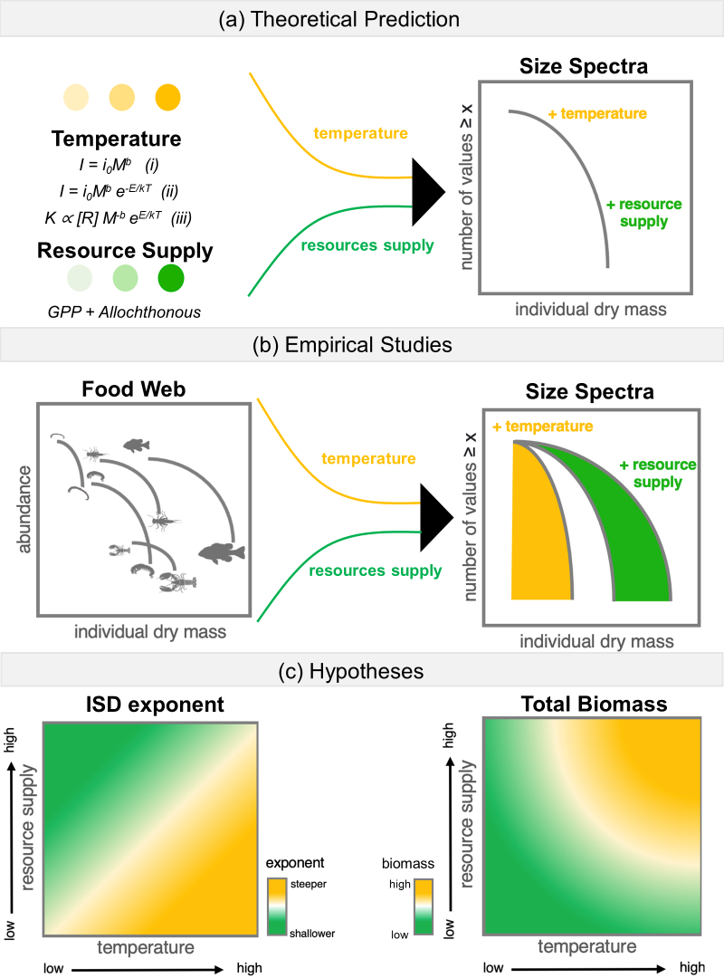

**Figure 1 – (a)** The theoretical basis for ISD scaling in ecosystems is underpinned by a number of fundamental “rules” in ecology. First, all organisms take in, transform, and expend energy through metabolic processes. The rate of metabolism is intimately linked to organism size and can be described by the equation (i) where, I is individual metabolic rate, 𝑖0 is a body size independent normalization constant, M is individual body mass, and 𝑏 is an allometric exponent, often ~0.75). Inserting temperature by scaling its effect on subcellular kinetics to individual metabolism, through the inclusion of an Arrhenius relationship, whereby the initial description of 𝐼 is modified to equation (ii) here, 𝑖0 is a body size and temperature independent normalization constant, 𝐸 is the activation energy of the metabolic process (usually 0.6 - 0.7 for heterotrophic metabolism), 𝐾 is Boltzmann’s constant, and 𝑇 is absolute temperature in Kelvin. Furthermore, a finite amount of energy can support many small, cool individuals or fewer large, warm individuals because energy use per individual is higher for larger or warmer organisms. As such, it is predicted that the carrying capacity, 𝐾, given a supply of resources, [𝑅], decreases with body size and temperature in an equal and opposite pattern as individual metabolic rate shown in equation (iii). This formulation predicts the equivalence in population energy use with body size and temperature supported by empirical and theoretical work (e.g., energy equivalence), if we assume energy supply is constant. Therefore, for communities within a trophic level that share a common, equitably distributed energy source, the value of the ISTD exponent is predicted to be invariant.

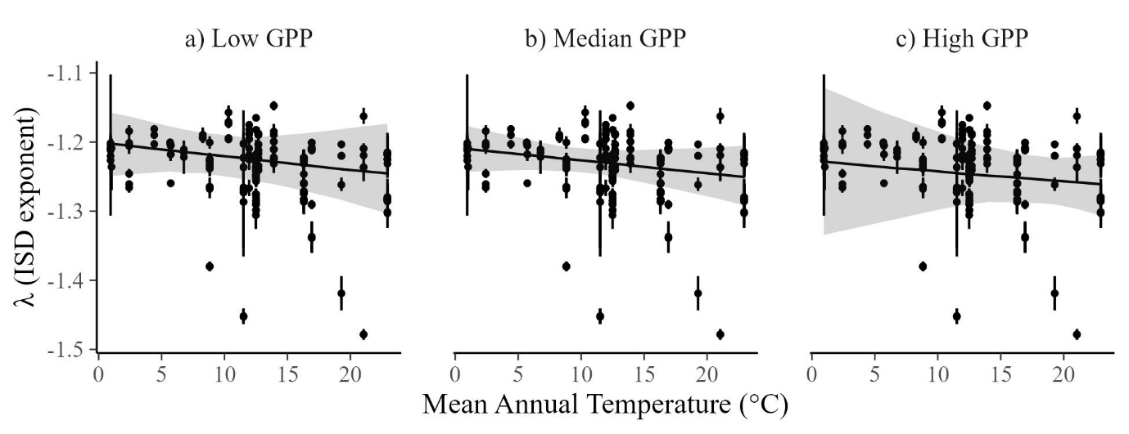

Figure X. Scaling of the ISD exponent with mean annual stream temperature across 22 NEON streams sites. Each dot is a posterior mean (± 95% CrI) of lambda from one of 264 samples as estimated from the regression model. The regression slopes show the mean and 95% CrI when GPP is fixed at low (25th percentile), median (50th percentile) and high (75th percentile) values.

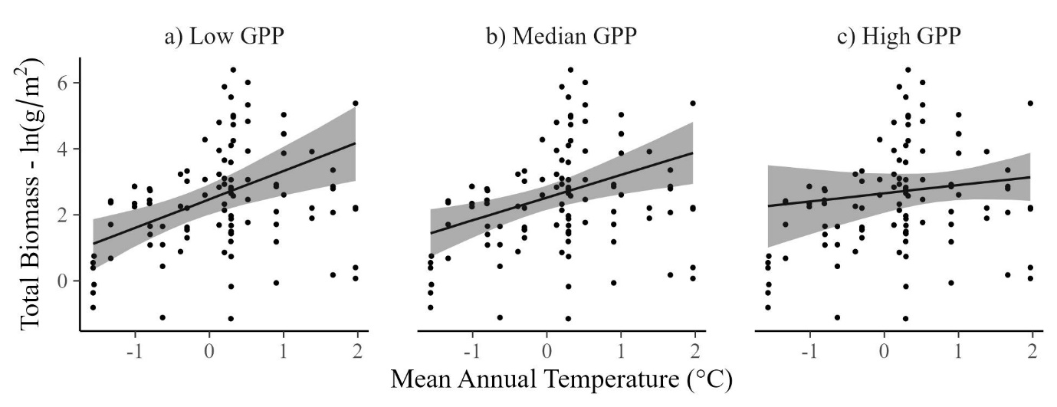

Figure X. Scaling of the total community biomass (fish + macroinvertebrates) with mean annual stream temperature across 22 NEON streams sites. Each dot is the natural log transformed total biomass per sample (n = 264 samples). The regression slopes show the mean and 95% CrI when GPP is fixed at low (25th percentile), median (50th percentile) and high (75th percentile) values.

Biblio

Brose, U., Blanchard, J. L., Eklöf, A., Galiana, N., Hartvig, M., R. Hirt, M., ... & Jacob, U. (2017). Predicting the consequences of species loss using size‐structured biodiversity approaches. Biological Reviews, 92(2), 684-697.

Wesner, J. S., & Pomeranz, J. P. (2021). Choosing priors in Bayesian ecological models by simulating from the prior predictive distribution. *Ecosphere*, *12*(9), e03739.

**Supplementary Information**

We checked the implications of our priors using prior predictive simulation. The result is shown in Figure S1a, indicating that the priors largely limit λ to values between ~-2 to -1, but allow for a wide range of possible relationships with mean annual temperature. By comparison, the posterior (Figure S1b) remains in a much more constricted space. The difference between the prior and posterior is an index of how much information was learned from the data.

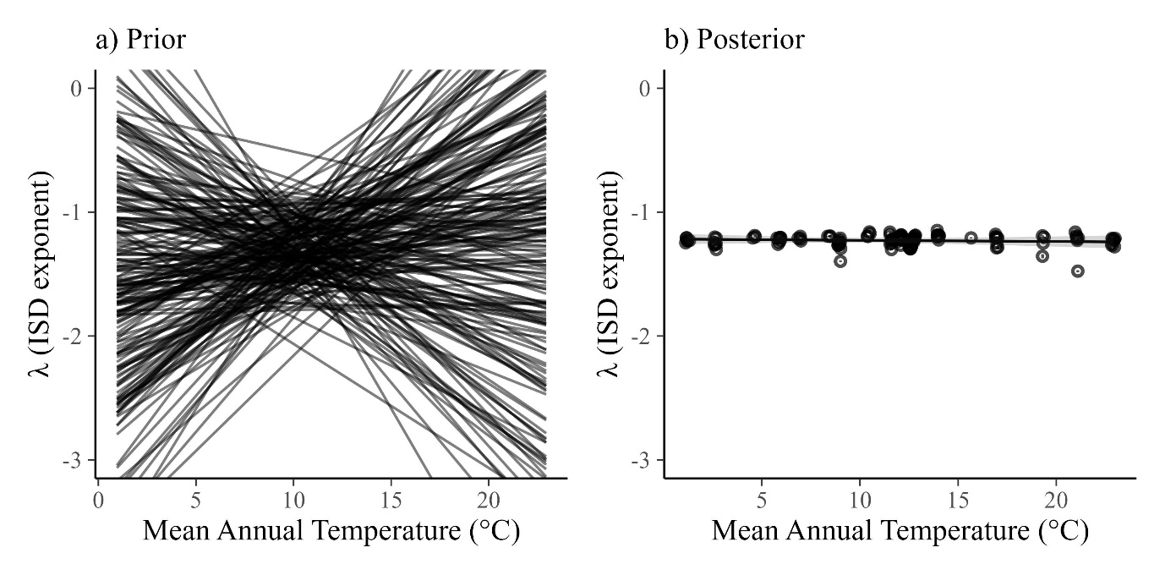

Figure S1. Two-hundred simulations from the prior predictive distribution (a) compared to the fitted posteriors (b). Both models show the relationship between lambda and temperature with GPP and organic matter set to their median values.