**Temperature and resources interact to influence individual size distributions across North American streams**

Vojsava Gjoni 1| Justin P. F. Pomeranz2 | James R. Junker3 | Jeff S. Wesner1

**Introduction**

Understanding the impact of human and environment-driven changes on ecosystem function remains a challenge for ecologists. One important ecosystem function, the flux of energy through food webs (Barnes et al. 2018), is reflected by the size distribution of individuals within ecological communities (Jennings and Blanchard 2004; Petchey and Belgrano 2010; Blanchard et al. 2017). Therefore, size-based ecosystem modeling, such as individual size distributions (ISD; also known as abundance size spectrum) is emerging as a powerful way to assess ecosystem level impacts of environmental changes from individual level physiological processes to ecosystem-level ones. This is because many fundamental aspects of an organism’s biology are controlled by body size, including metabolic rate, life history, diet breadth, and trophic position (Brown et al. 2004; Woodward et al. 2005; White et al. 2007). Therefore, changes in ISD reflect changes in ecosystem function, providing a simple but powerful way to measure variation in size-based community structure across spatial and temporal scales (Woodward et al. 2010; Edwards et al. 2017; Sprules and Barth 2015; Blanchard et al. 2017; O’Gorman et al. 2017).

The shape of this ISD relationship is described by a power law, N ~ Mb, which is predicted to hold when the energy use of the individuals presents in the community approximate the resource flow available from the environment (Enquist et al. 1998; Enquist and Niklas 2001). Therefore, the exponent 𝑏 varies as a function of the efficiency of energy flow through the food web (Dickie, Kerr, and Boudreau 1987; Jonsson, Cohen, and Carpenter 2005; Sprules and Barth 2015; O’Gorman et al. 2017). The exponent 𝑏 is almost always negative and typically ranges from ~ -1 to -2 for the ISD, indicating a remarkably consistent pattern (Cyr 2000; Brown and Gillooly 2003; Sprules and Barth 2015; Blanchard et al. 2017). Because of this apparent consistency, ecologists have begun using ISD exponent changes to indicate fundamental shifts in ecosystem functioning in response to environmental changes (Jennings and Blanchard 2004). For example, a less steep ISD exponent may occur if large individuals use more energy that the smaller ones. In contrast, a steeper ISD exponent may occur if small individuals use more energy than the larger ones. These changes in ISD exponent imply the amount of energy used is not the same with the energy available in the system, which may result from the effect of environmental factors.

ISD in ecosystems is underpinned a fundamental and well-supported theory in ecology (Metabolic Theory in Ecology – MTE, Brown et al. 2004), where all organisms take in, transform, and expend energy through metabolic processes. The rate of metabolism is intimately linked to organism size and can be described by the allometric relationship between body size and individual energy use: 𝐼 ~ 𝑀𝑏. This has been interpreted to mean that the ISD is a consequence of the size-dependence of metabolism, and that population energy flux per unit area or volume is invariant across ecosystems (Nee 1991, Brown et al. 2004). However, variation have been reported, but little attention has been paid to whether these are systematic. Systematic variation in ISD would provide evidence against the invariant ISD across ecosystems universality of the “rules”, with important consequences for our understanding of nature (Enquist et al 1998). Because the “rules” predict that ISD arise from metabolic demands, processes that alter physiological processes may alter ISD.

Changes in temperature and resource supply, for example, are known to modify physiological processes which, in turn, shape ecosystem structure and dynamics. On one hand, temperature influence various volume-related and energy-demanding processes such as metabolism, growth, and activity (reviewed by Glazier 2005), therefore individual’s body size shifts with temperature (Atkinson et al. 1994, Daufresne et al. 2009, Finkel et al. 2010, Sheridan and Bickford 2011, Gardner et al. 2011, Adams et al. 2013). This is because smaller organisms have lower absolute energy requirements (Gillooly et al. 2001) and hence a higher number of smaller organisms that can be sustained (Reiman et al. 2014). This implies that increasing temperature may increase the proportion of the smaller individuals in the ecological communities and vice versa. On the other hand, changes in resource supply cause changes in body maintenance, metabolism growth and reproduction that modify the body size of the individuals (McNab 2010, Huston and Wolverton 2011, O’Connor 2008), therefore giving a competitive advantage to the large individuals relative to the small ones.

Although their independent effects on different levels of ecological organization (i.e., from individual to ecosystem) are relatively well studied(Cross et al. 2015) much less is known about how these factors interact to influence ecological communities from the individual to the whole ecosystem level(Tabi et al. 2019). Here, we…

ISD due to the fact that derive form the individual physiological process, and also predicts biomass turnover at the ecosystems (Brown et a. 2004), it is able to infer the consequences of temperature and resources effects from individual to the level of entire ecosystem level. Therefore, changes in ISD, that may arise due to resource shortage or competition (Hayward et al 2009) under natural conditions in food webs (e.g., size-dependent resource competition; Ernest 2005), may change ecosystem-level biomass turnover. Elevated temperatures, for example, may lead to shifts in size structured communities towards smaller species that have a competitive advantage at higher temperatures (Reumanet al. 2014). This is because, at high temperatures, large consumer species (consumer species are usually larger than resources species) run a risk of starvation(Petchey et al. 1999). However, species competition likely depends also on resource supply (e.g., size dependent resource access; Tilman et al 1981). Therefore, small species are favored at high temperatures, but this advantage is lost with increasing resources. At high temperature, increasing resources save large consumer species from starvation, having a beneficial effect on them. Additionally, at high resources and low temperatures larger consumer species have a competitive advantage. Thus, temperature and resources have interactive effects on the dynamics of the food webs. Therefore, the competitive advantage of small or large species, depending on the temperature and resource conditions, may alter ISD, but also destabilize (increasing biomass oscillation) food webs by shifting biomass up the trophic levels. This may move the species towards unstable equilibria and in turn change total biomass. So far, the simultaneous effect of temperature and resources on ISD and biomass within communities are poorly tested.

Therefore, we tested how temperature and resource supply interact to affect ISD exponent and ecosystem level properties (i.e. total biomass) in aquatic food webs. First, it is well known that ISD exponent become steeper with increasing temperatures, because larger organisms become rarer relative to smaller organisms at higher temperatures. Theoretical support for this hypothesis is driven by ecological rules that describe temperature-size relationships at different levels of organization (Daufresne, Lengfellner, and Sommer 2009; Forster, Hirst, and Atkinson 2012; O’Gorman et al. 2012) and expected decline in trophic transfer efficiency with warming (Vucic-Pestic et al. 2011). Empirical support comes from mesocosm studies with zooplankton and phytoplankton, in which a 4°C increase in temperature caused exponent to become steeper at elevated temperatures (Yvon‐Durocher et al. 2011), though the effect was also seasonally dependent (Dossena et al. 2012). Another empirical support comes from stream microinverters showing that increasing temperature, make the ISD exponent to become steeper and total biomass to increase (Pomeratz et al 2022). Second, ISD may have a shallower exponent with increasing temperatures, because resource supplies increase at warmer temperatures, thereby making up for increased metabolic/nutrient demand of primary producers. Thus, community biomass at lower trophic levels declines but increases at intermediate and top trophic levels. Empirical support for this hypothesis comes from a study in reefs in open ocean have shown a positive relationship of the temperature with the ISD exponent and community biomass (Robinson et al. 2017). Another empirical support comes from streams that vary from 5-25°C due to different supplies of naturally heated groundwater. Across this gradient, nonetheless the size-spectra exponent became shallower, the total biomass was higher in warm waters (O’Gorman et al. 2017). This unexpected result was explained by increasing rates of nitrogen fixation at higher temperatures in these nitrogen limited streams. As a result, resource production at lower trophic levels overcame an expected decline in resource standing stock, allowing higher trophic levels (fish) to persist when macroecological theory suggested they should decline (O’Gorman et al. 2017). Third, ISD exponent may be unrelated to environmental temperature, because body size scaling with temperature is inconsistent among taxa. This hypothesis is not expected under macroecological theory, nor by the mechanisms of increasing nutrient supply described above. However, it is supported by a study of marine benthic macroinvertebrates, in which size spectra exponents did not change across sites with mean temperatures ranging from -2 to 8°C (Mazurkiewicz et al. 2020). While community composition across the gradient changed, the relative abundance of size classes did not, resulting in consistent size spectra exponents. This hypothesis is also supported implicitly by (Dossena et al. 2012), who found opposite effects of temperature on size spectra exponents in winter and spring, which would cancel each other out on average, generating no long-term shift in size spectra over time. Fourth, ISD exponents may change in response to environmental temperature, but the change may be mediated by resource supply. This hypothesis is non-mutually exclusive with previous hypotheses in the sense that any of the univariate relationships with temperature described above could be masked by non-constant rates of resource supply. This is supported from metabolic theory which suggests that increases in resource supply can compensate for expected increases in metabolic rates at higher temperatures (Cross et al. 2015; Perkins et al. 2018). The importance of resource supply for size spectra relies on the expectation of reduced efficiency of trophic transfer to larger consumers. This would generally lead to a reduction or extinction of large consumers, but that can be mediated if the production of lower trophic levels is increased due to increases in resource supply or larger organisms can access allochthonous energy sources. We tested this by estimating gross primary production and canopy cover (as a proxy for allochthonous inputs) at each site and including these as covariates in candidate models.

[*Dataset used:* To explore how temperature and resources interact to ISD and total biomass of aquatic food webs we used and existing dataset on the within-year temperature and resource dynamics of the food webs in stream ecosystems. The steam sites a large coordinated ecological observation project, the National Ecological Observatory Network (NEON). In addition to testing the above hypotheses, our analysis will characterize natural variation in abundance size spectra among seasons, sites, and years. We estimate generating a minimum of ~576 abundance size spectra (3 samples per year (for macroinvertebrates and fishes) x 24 sites x 4 years). To our knowledge, this will be the largest collection of size spectra to date.

[*Conclusion paragraph:* Therefore, our study has potentially important implications for not only an improved of how environmental factor interact to modify the distribution of the individual body size and biomass in a community but also the total biomass that aquatic ecosystems can support….]

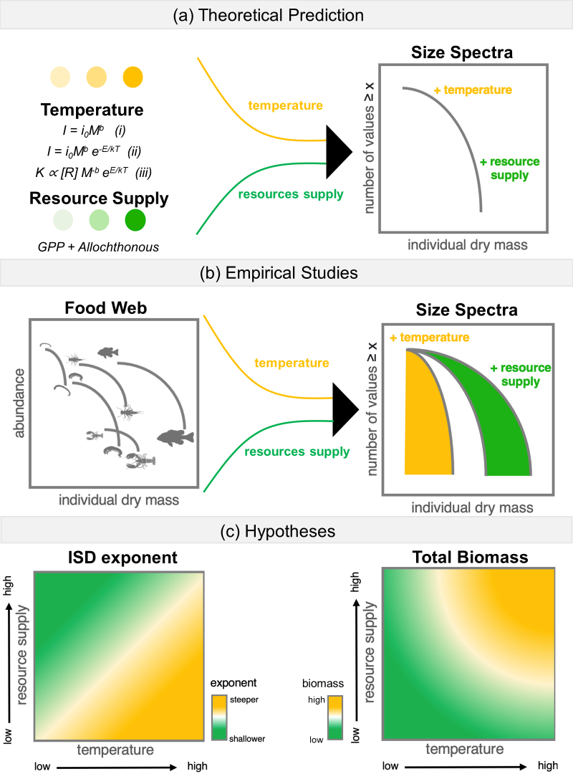

**Figure 1 – (a)** The theoretical basis for ISD scaling in ecosystems is underpinned by a number of fundamental “rules” in ecology. First, all organisms take in, transform, and expend energy through metabolic processes. The rate of metabolism is intimately linked to organism size and can be described by the equation (i) where, I is individual metabolic rate, 𝑖0 is a body size independent normalization constant, M is individual body mass, and 𝑏 is an allometric exponent, often ~0.75). Inserting temperature by scaling its effect on subcellular kinetics to individual metabolism, through the inclusion of an Arrhenius relationship, whereby the initial description of 𝐼 is modified to equation (ii) here, 𝑖0 is a body size and temperature independent normalization constant, 𝐸 is the activation energy of the metabolic process (usually 0.6 - 0.7 for heterotrophic metabolism), 𝐾 is Boltzmann’s constant, and 𝑇 is absolute temperature in Kelvin. Furthermore, a finite amount of energy can support many small, cool individuals or fewer large, warm individuals because energy use per individual is higher for larger or warmer organisms. As such, it is predicted that the carrying capacity, 𝐾, given a supply of resources, [𝑅], decreases with body size and temperature in an equal and opposite pattern as individual metabolic rate shown in equation (iii). This formulation predicts the equivalence in population energy use with body size and temperature supported by empirical and theoretical work (e.g., energy equivalence), if we assume energy supply is constant. Therefore, for communities within a trophic level that share a common, equitably distributed energy source, the value of the ISTD exponent is predicted to be invariant.

