**Choosing priors in Bayesian ecological models by simulating from the prior predictive distribution**

Jeff S. Wesner and Justin P.F. Pomeranz

University of South Dakota, Department of Biology, Vermillion, SD 57069

[Jeff.Wesner@usd.edu](mailto:Jeff.Wesner@usd.edu)

**Abstract**

Bayesian data analysis is increasingly used in ecology, but prior specification remains focused on choosing non-informative priors (e.g., flat or vague priors). One barrier to choosing more informative priors is that priors must be specified on model parameters (e.g., intercepts, slopes, sigmas), but prior knowledge often exists on the level of the response variable. This is particularly true for common models in ecology, like generalized linear mixed models that have a link function and potentially dozens of parameters, each of which needs a prior distribution. We suggest that this difficulty can be overcome by simulating from the prior predictive distribution and visualizing the results on the scale of the response variable. In doing so, some common choices for non-informative priors on parameters can easily be seen to produce biologically impossible values of response variables. Such implications of prior choices are difficult to foresee without visualization. We demonstrate a workflow for prior selection using simulation and visualization with two ecological examples (predator-prey body sizes and spider responses to food competition). This approach is not new, but its adoption by ecologists will help to better incorporate prior information in ecological models, thereby maximizing one of the benefits of Bayesian data analysis.

Keywords: *Bayesian, prior predictive distribution, GLMM, simulation*

**Introduction**

The distinguishing feature between Bayesian and non-Bayesian statistics is that Bayesian statistics treats unknown parameters as random variables governed by a probability distribution, while non-Bayesian statistics treats unknown parameters as fixed and unknown quantities (Ellison 2004, Hobbs and Hooten 2015). A common misconception is that only Bayesian statistics incorporates prior information. However, non-Bayesian methods can and often do incorporate prior information, either informally in the choices of likelihoods and model structures, or formally as penalized likelihood or hierarchical modeling (Hobbs and Hooten 2015, Morris et al. 2015).

While prior information is not unique to Bayesian models, it is required of them. For example, in a simple linear regression of the form , the intercept , slope , and standard deviation are unknown parameters that each need a prior probability distribution. There are differing opinions and philosophies on the best practices for choosing priors (Lindley 1961, Edwards et al. 1963, Morris et al. 2015, Wolf et al. 2017, Gelman et al. 2017, Lemoine 2019, Banner et al. 2020). In ecology, a common practice is to assign so-called non-informative priors that effectively assign equal probability to all possible values using either uniform or diffuse normal priors with large variances (Lemoine 2019). These priors allow Bayesian inference to proceed (i.e., produce a posterior distribution), but with presumably limited influence of the priors (Lemoine 2019).

Reasons for using non-informative priors are varied but are at least in part driven by a desire to avoid the appearance of subjectivity and/or a reliance on default settings in popular software (Gelman and Hennig 2017, Banner et al. 2020). There are several arguments against this approach. First, “non-informative” is a misnomer. All proper priors influence the posterior distribution to some extent (Hobbs and Hooten 2015). As a result, a prior cannot just be assumed as non-informative based on default settings or a wide variance (Seaman III et al. 2012). Its implications for the model should be checked just like any other subjective assumption in data analysis, whether Bayesian or not (Gelman et al. 2017, Banner et al. 2020). Second, adhering to non-informative priors removes a major potential benefit of Bayesian analysis, which is to explicitly incorporate prior research and expertise into new science (Hobbs and Hooten 2015, Lemoine 2019, Rodhouse et al. 2019). Third, informative priors can help to reduce spurious conclusions due to errors in magnitude or sign of a relationship by treating extreme values in the data skeptically (Gelman et al. 2012, Lemoine 2019). Finally, informative priors make computational algorithms like MCMC run more efficiently, which can save hours or days of computing time in complex models (Hobbs and Hooten 2015). An additional way to improve efficiency can come from different choices of prior distributions, such as an inverse-gamma distribution on the variance rather than the exponential prior on the standard deviation that we use in the models here, for example. For more complete discussion on this, see Gelman and others (2006).

While there are clear arguments for why ecologists *should* use more informative priors, it is often difficult to know *how* to use them. Even for seemingly simple and routine models, like logistic or Poisson regression, it can be difficult to understand *a priori* how priors affect the model, because they must be assigned in the context of likelihood with a linearizing link-function (Seaman III et al. 2012, Gelman et al. 2017). In other words, prior specification takes place on model parameters (e.g., slopes, intercepts, variances), but prior knowledge is often easier to assess on the model outcomes (Kadane et al. 1980, Bedrick et al. 1996, Gabry et al. 2019). This is particularly true for models that are commonly used in ecology, such as generalized linear mixed models with interactions. These models may have dozens of parameters and hyperparameters, each of which require a prior probability distribution (Bedrick et al. 1996, McElreath 2020).

We suggest that ecologists can address this problem by simulating from the prior predictive distribution and visualizing the implications of the priors on outcomes of interest (e.g., means and confidence intervals of treatment groups, simulated data, or regression lines). In this paper, we demonstrate this approach using two case studies with ecological data (Figure 1). All data and code are available at: <https://github.com/jswesner/prior_predictive>.

**Prior Predictive Simulation**

An attractive feature of the Bayesian approach is that the models are generative. This means that we can simulate potential data from the model so long as the parameters are assigned a proper probability distribution (Gelman et al. 2013). This feature is routinely used to check models and prior influence *after* fitting the data using the posterior predictive distribution (Lemoine 2019, Gelman et al. 2020), but it can also be used before seeing the data using the prior predictive distribution (Gabry et al. 2019).

The general workflow for prior predictive simulation is:

1. Draw N realizations from a prior distribution
2. For each draw, simulate a model outcome or new data from the likelihood
3. Plot the results
4. Use domain knowledge to assess whether simulated values reflect prior knowledge
5. If simulated values do not reflect prior knowledge, change the prior distribution, likelihood, or both and repeat the simulation from step 1
6. If simulated values reflect prior knowledge, add the data and estimate the posterior distribution

This amounts to a prior predictive check to satisfy the expectation that “simulations from the full Bayesian model…should be plausible data sets” (Kennedy et al. 2019). We demonstrate it with two motivating examples.

**Example 1: Predator-Prey Body Sizes - Simple Linear Regression**

*Data* - Understanding predator-prey interactions has long been a research interest of ecologists. Body size is related to a number of aspects that influence these interactions. For example, predators are often gape-limited, meaning that larger predators should be able to eat larger prey. The data set of Brose et al. (2006) documents 13,085 predator-prey interactions, including the mean mass of each (Figure 1a).

*Model* - We examined the hypothesis that the prey body mass increases log-linearly with predator body mass using a simple linear model:

\begin{align} \text{log} (y_i) \sim \text{Normal}(\mu_i, \sigma)\\ \mu_i = \alpha + \beta \text{log}(x_i)\\ \alpha \sim \text{Normal}(0, \sigma_{\alpha})\\ \beta \sim \text{Normal}(0, \sigma_{\beta})\\ \sigma \sim \text{Exponential}(\phi) \end{align} where is natural log transformed prey mass and is natural log transformed predator mass.

*Priors* - For the and priors, we first assign a mean of 0 with a “non-informative” standard deviation of 1000 [] (Table 1). These prior values are often used as defaults, especially in earlier Bayesian software to generate “flat” prior distributions and are commonly used in the ecological literature (McCarthy and Masters 2005, Banner et al. 2020). The mean of 0 in a normal distribution implies that the intercept and slope have equal probability of being positive or negative. For the exponential distribution, we specify an initial of 0.00001, chosen by plotting 100 simulations from the exponential function in R (R Core Team 2020) with varying values of [e.g., plot(rexp(100, 0.00001)]. A value of 0.00001 generated an average deviance of ~1,000 with values up to ~5,000, indicating the possibility of producing extremely large values.

After simulating regressions from these initial priors, we specified successfully tighter priors and repeated the simulations (Table 1; Figure 2). Those simulations were compared to reference points representing prior knowledge (Mass of earth, a Blue Whale, a virus, and a Carbon-12 atom). The goal was to use these reference points to find a joint prior distribution that produced reasonable values of potential prey masses. We did this using two levels of the model ( and ). For , we simulated 100 means across each value of and plotted them as regression lines. For , we simulated a fake data set containing simulated values of log prey mass for each of the 13,085 values of log predator mass () in the Brose et al. (2006) data.

*Results* - The weak “non-informative” priors make nonsense predictions (Figure 2a-c). In Figure 2a, all of the lines are impossibly steep, suggesting that predators could plausibly eat prey that are larger than earth or smaller than an atom. The stronger priors in Figure 2b suffer from the same problem, though the effect is less severe. The strongest priors (Figure 2c) produce more reasonable predictions, though they are still quite vague, with positive probability that predators could eat prey larger than an adult Blue Whale. The simulated fake data sets tell a similar story (Figure 2d-f), but with the added influence of (Equation 1).

We fit the model using the strongest prior set and overlaid these on the prior simulations (Figure 2c,f). As expected, there is a strong positive relationship between log predator and log prey size (Figure 2c - orange line), despite the uncertainty in the prior. The intercept is -4.8 ± 0.04 (mean ± sd), indicating that a predator weighing 1 gram (wet or dry mass) would eat prey 2-3 orders of magnitude smaller than the predator. The slope is 0.6 ± 0.01, indicating a reliably positive relationship such that an increase in 1 log unit of predator mass corresponds with an increase in prey mass of 0.6 log units on average. Sigma is 3.7 ± 0.02, indicating an average residual for individual predator-prey data or +/- 3.7 log-units of prey mass. This is reflected in the simulated data, which show a wide range of simulated predator-prey size pairings, but all are within a reasonable range compared to prior predictions (Figure 2f).

There are several benefits to choosing a stronger prior. First, it is difficult to justify the two weakest priors on biological grounds. They place large amounts of prior probability on impossible values. This can matter when priors need to be justified to a granting agency or to reviewers. More critically, specification of priors can have conservation or legal implications, and the ability to justify priors with simulation helps to improve transparency (Crome et al. 1996, Banner et al. 2020). Stronger priors also improve computational efficiency (McElreath 2020). We fit these models using the *brms* package (Burkner 2017). The algorithms associated with models that had the stronger or strongest priors were up to 50% faster than the model with weak priors, taking 56 vs 28 seconds on a standard laptop (compilation time + warmup time + sampling time). For more complex models with algorithms that take longer to run, this improvement can save hours or days of computing time.

*Caveats* - We know from the literature that predators are generally larger than their prey by 2-3 orders of magnitude (Trebilco et al. 2013). Therefore, it would make sense to alter the prior mean of the intercept to a value below zero, perhaps using an average predator/prey mass comparison from the literature. That is apparent from the prior versus posterior comparison in Figure 2c. Similarly, the fact that larger predators tend to eat larger prey is well-known, so the prior on the slope could be changed to a positive mean. Another option is to standardize the predictor variable(s) () so that the regression slopes can be interpreted as units of standard deviation. This also improves interpretation of the intercept when values of zero (e.g., prey mass = 0) do not make sense (McElreath 2020). This would be most relevant in the current model if prey mass was included as raw mass, rather than log mass.

**Example 2: Spider Abundance - Generalized Linear Mixed Model**

*Data* - This data set comes from Warmbold and Wesner (2018), who measured terrestrial spider responses to different combinations of freshwater fish using fish enclosure cages in a backwater of the Missouri River, USA. They hypothesized that fish would reduce the emergence of adult aquatic insects by eating the larvae of those insects in the water, causing a reduction in terrestrial spiders that feed on the adult forms of those insects. The original experiment contained six treatments. We present a simplified version comparing spider abundance above three treatments that contain either Smallmouth Buffalo (*Ictiobus bubalus*), Green Sunfish (*Lepomis cyanellus*), or a fishless control. Each treatment had four replicates for a total of 12 cages (each 2.3 m). The cages were arranged in two rows, one on either side of the shoreline of the backwater. The treatments were then randomly assigned to cages while ensuring that each treatment was represented at least once in each row. The number of occupied spider webs above each cage was counted on four dates over the 29-day experiment (Figure 1b).

*Model* - We fit a generalized linear mixed model with a Poisson likelihood, since the response variable (# webs per cage) is a non-negative integer. The predictor variables were date, treatment, and a date treatment interaction with a random intercept for cages. The interaction is included because it was expected that the effect of fish on spider counts would vary across sampling dates in response to variation in insect emergence. Date was a categorical variable with four levels representing four sampling dates. Treatment was a categorical variable with three levels representing the Smallmouth Buffalo, Green Sunfish, or fishless control. Describing the model as having two main effects and an interaction is deceptively simple. In reality, the model has 13 parameters that require a prior specification: 11 “fixed” effects that indicate all combinations of date treatment, plus 1 intercept and a hyperprior on the intercept:

\begin{gather} y_i \sim \text{Poisson}(\lambda_i)\\ \text{log} (\lambda_i) = \alpha + \alpha_{[cage]} +\beta_1x_{trt_i = fishless} + \beta_2x_{trt_i = green} + …\beta_{11}x_{trt_i = green:date_i = 4}\\ \alpha \sim \text{Normal}(0, \sigma_{\alpha})\\ \alpha_{[cage_{1-12}]} \sim \text{Normal}(0, \sigma_{cage})\\ \beta_{1…11} \sim \text{Normal}(0, \sigma_{\beta_{1…11}})\\ \sigma_{cage} \sim \text{Exponential}(\phi) \end{gather} where each is described by a Poisson distribution with mean . Because the likelihood is not normal, we specify a log link, , so that the mean can be estimated as a linear function of predictors. The intercept represents the predicted log mean number of spiders in the treatment with Smallmouth Buffalo on the first sample date. The choice of reference treatment is arbitrary. Choosing Smallmouth Buffalo and the first date as the intercept is the default choice in R (R Core Team 2020) because the treatment is coded first alphabetically (“buffalo”) and first numerically (“2015-06-08”).

The random effect for cage represents the average deviation of each cage from the global mean intercept . It allows us to account for the fact that individual cages may vary in their starting densities of spiders (i.e., in their intercepts) for reasons beyond random sampling. One way in which cages could vary is their proximity to the shoreline or in their microclimates that cause variation in wind dispersal of spiders. These unmeasured differences mean that the cages are not independent and identically distributed, thus violating the exchangeability assumption. The random effect (i.e., varying intercept) allows us to overcome this assumption by allowing each cage to have its own mean intercept (Hobbs and Hooten 2015).

*Priors* - As before, we simulated outcomes under three model scenarios, each with different priors (Table 1; Figure 3a-c). Another complication in this model is the log-link, which changes the biological interpretation of the parameters. With a Poisson likelihood and log-link, parameter values must be exponentiated and then interpreted as a multiplier. Thus, a value of 1.5 for the indicates that the treatment contains exp(1.5) = 4.5 *times* more spiders than the reference treatment on the first sample date. This is an example of the principle that the prior can only be understood in the context of the likelihood (Gelman et al. 2017).

*Results* - If all we knew was that spiders were counted above 2.32 m cages but we did not know anything else about the experiment (i.e., the ecosystem, the question, the spider taxa), then we could still use the prior predictive distribution to select more informative priors. The weakest priors place substantial probabilities on values of >100,000 spiders per cage *on average* (Figure 3a), and include a small number of predictions on the final sample date with more than 100 million spiders (Figure 3c). We looked up the range of spider masses (~0.0005 to 170 grams). If we assume our spiders are relatively small, say 0.01 grams, then 100 million spiders would equal 30 tons of spiders. This is approximately equal to the mass of ~6 adult hippopotamus’s (each ~4 tons).

However, in this case we do have prior information. In a previous study using the same cages in the same backwater, Warmbold (2016) counted between 0 and 2 spiders per cage. The present experiment had a slightly different design, in which a small rope was added to the center of each cage to increase the area of attachment (Warmbold and Wesner 2018). If we assume that the rope will double the number of spiders that could colonize, then it seems reasonable to expect ~ 4 spiders per cage. There is obvious error associated with this, since the experiment was conducted in a different year and a different month. For that reason, we chose the moderate prior (Figure 3b,d) to use in the final model. It places most of the prior probability on values between ~1 to 100 spiders, but also allows for some extreme possibilities of >1000 spiders per cage (Figure 3d). The strongest priors also appear reasonable, placing most of the prior probability between ~1 to 10 spiders, while allowing for up to ~100 spiders in extreme cases (Figure 3c,e).

Figure 3b,e shows the results after fitting the model to data. Spider counts ranged from 0 to 5 spiders per cage, resulting in mean spider densities of ~1 to 4 spiders among the date treatment combinations (Supplementary Data). Simulating from the prior and posterior predictive distributions shows the model predictions for the number of spiders we might expect at a new cage (i.e., a cage sampled from this site at another time). Before seeing the data, the model suggested reasonable probabilities of collecting 10 to >100 spiders. After seeing the data, the model suggests that finding ~10 or more spiders would be surprising (Figure 3e).

In addition to the computational and logical benefits of stronger priors as mentioned above, the stronger prior specifications in this model have a clear influence on the posterior (Figure S1). In particular, the stronger prior used in the model is more conservative, pulling the posterior means away from extreme high or low values. As such it acts to prevent overconfidence in large or small effect sizes (e.g., Type M errors) (Lemoine 2019). This skepticism of stronger priors is a benefit that is most apparent with small sample sizes, which are common in ecological studies.

*Caveats* - Each of the 11 s was assigned an independent prior. An alternative approach would be to assign priors from a multivariate normal distribution (Hobbs and Hooten 2015). In addition, the likelihood assumes that the variance is equal to the mean. An alternative likelihood, such as a negative binomial, would allow us to model variances independently. Finally, the strongest priors we specified overwhelmed the small data set, pulling all treatments towards the same mean, regardless of the data (Figure S1). Whether that is a problem or not depends on how skeptical we are that the cages or treatments would have different numbers of spiders.

**Discussion**

Bayesian statistics is increasingly used by ecologists (Ellison 2004, McCarthy and Masters 2005, Hooten and Hobbs 2015, Touchon and McCoy 2016), yet the preponderance of studies continue to rely on diffuse and/or default priors (Lemoine 2019, Banner et al. 2020). Using two case studies with a linear regression and a generalized linear mixed model - two common types of models in ecology (Touchon and McCoy 2016) - we demonstrated how visualization on the scale of the outcome can improve prior choices. The most important result of this study is that simulating and visualizing prior distributions on the outcome scale can improve ecologists’ choices of priors on individual parameters in statistical models. Doing so helps to advance ecology by demystifying the influence of prior distributions and improving ecologists’ ability to incorporate prior ecological research in a way that both experts and non-experts can better understand (Kadane et al. 1980, Bedrick et al. 1996, James et al. 2010).

Choosing priors based on their implications on the outcome scale is not new. Kadane et al. (1980) described a similar approach with normal linear regressions to elicit prior information from experts. Bedrick et al. (1996) expanded it to generalized linear models. More recently, Gabry et al. (2019) used it in a model with random effects to measure global air quality and Kennedy et al. (2019) used a similar approach for models in cognitive science. A primary difference between the earlier and later uses of prior predictive simulation is improvement in visualization techniques (Gabry et al. 2019), which makes it easier evaluate prior choices on a visual *distribution* of outcome measures, rather than only point estimates. Based on our own experience teaching Bayesian statistics to graduate students (JSW), reviewing Bayesian papers, and the experiences of others (James et al. 2010, Gabry et al. 2019), we suspect that this approach will help to remove confusion over choosing more informative priors by aligning the choices more closely to the domain expertise of the users (Bedrick et al. 1996, James et al. 2010).

Assessing and visualizing priors on the outcome scale of a model makes clear what many current Bayesian approaches emphasize: it is almost never the case that we have absolutely zero prior information (Hobbs and Hooten 2015, Lemoine 2019, Banner et al. 2020). For example, it does not take expertise in ecology to know that predators cannot eat prey larger than earth. Yet this type of impossible prior belief is exactly what many Bayesian models encode with non-informative priors. It *does* take ecological expertise to know whether it is more probable for predators to eat prey that are 2 times larger or 2 times smaller, or whether the log-linear model should have a different functional form (e.g., non-linear). Critiquing priors in this way would, we argue, lead to better use of Bayesian methods than current practices that focus on finding the least informative prior (Lemoine 2019, Banner et al. 2020). Even for models with more abstract outcomes than body size (e.g., gene methylation, stoichiometric ratios, pupation rates of a new insect species), it is almost always the case that ecologists have some sense of what reasonable measures might be. After all, it would be impossible to do a study without first knowing what we will measure.

Visualizing simulations from the prior predictive distribution represents one aspect of the overall Bayesian modeling workflow (Gelman et al. 2020, Schad et al. 2020). Like any approach to data analysis, the Bayesian workflow involves iteratively checking assumptions and implications of a model, from data collection and model design to prior choices and model inference (Hooten and Hobbs 2015, Gelman et al. 2020). Traditionally, the role of priors in this workflow has focused on choosing the least informative priors possible (Hobbs and Hooten 2015). When prior criticism is used, it is usually done after the model is fit with prior sensitivity analyses and/or plots of prior versus posterior parameters (Korner-Nievergelt et al. 2015). The approach we demonstrate does not obviate the need for these techniques. Rather, it adopts the approaches that are generally reserved for exploring the implications of the posterior distribution and applies them to the prior distribution. In doing so, it helps to lessen the impact of poor prior distributions later in the analysis workflow.

An added benefit to choosing more informative priors is that it reduces computational time, because it limits the parameter space that an MCMC algorithm needs to explore. In the relatively simple models we used here, computational improvements are minimal. But ecologists are using increasingly sophisticated models (Touchon and McCoy 2016), for which improvements in computational efficiency are likely to be important. An irony in this improvement is that it contradicts a common justification of using non-informative priors to “let the data speak for themselves.” In a model with such priors, much of the “speaking” is done by the priors in the sense of sampling parameter spaces that are incompatible with reasonable data. To rearrange the statement, data can only speak for themselves if the microphone is properly tuned.

**Acknowledgements**

This material is based upon work supported by the National Science Foundation under Grant No. 1837233. JSW thanks the students in his graduate Bayesian class for asking challenging questions. We thank Brose et al. (2006) for making their data publicly available.

**References**

Banner, K. M., K. M. Irvine, and T. J. Rodhouse. 2020. The use of Bayesian priors in Ecology: The good, the bad and the not great. Methods in Ecology and Evolution 11:882–889.

Bedrick, E. J., R. Christensen, and W. Johnson. 1996. A new perspective on priors for generalized linear models. Journal of the American Statistical Association 91:1450–1460.

Brose, U., T. Jonsson, E. L. Berlow, P. Warren, C. Banasek-Richter, L.-F. Bersier, J. L. Blanchard, T. Brey, S. R. Carpenter, M.-F. C. Blandenier, and others. 2006. Consumer–resource body-size relationships in natural food webs. Ecology 87:2411–2417.

Burkner, P.-C. 2017. Brms: An R Package for Bayesian Generalized Linear Mixed Models using Stan:22.

Crome, F., M. Thomas, and L. Moore. 1996. A novel Bayesian approach to assessing impacts of rain forest logging. Ecological Applications 6:1104–1123.

Edwards, W., H. Lindman, and L. J. Savage. 1963. Bayesian statistical inference for psychological research. Psychological review 70:193.

Ellison, A. M. 2004. Bayesian inference in ecology. Ecology letters 7:509–520.

Gabry, J., D. Simpson, A. Vehtari, M. Betancourt, and A. Gelman. 2019. Visualization in Bayesian workflow. Journal of the Royal Statistical Society: Series A (Statistics in Society) 182:389–402.

Gelman, A., J. B. Carlin, H. S. Stern, D. B. Dunson, A. Vehtari, and D. B. Rubin. 2013. Bayesian data analysis. CRC press.

Gelman, A., and C. Hennig. 2017. Beyond objective and subjective in statistics (with discussion). Journal of the Royal Statistical Society, Series A 180:967–1033.

Gelman, A., J. Hill, and M. Yajima. 2012. Why we (usually) don’t have to worry about multiple comparisons. Journal of Research on Educational Effectiveness 5:189–211.

Gelman, A., and others. 2006. Prior distributions for variance parameters in hierarchical models (comment on article by Browne and Draper). Bayesian analysis 1:515–534.

Gelman, A., D. Simpson, and M. Betancourt. 2017. The Prior Can Often Only Be Understood in the Context of the Likelihood. Entropy 19:555.

Gelman, A., A. Vehtari, D. Simpson, C. C. Margossian, B. Carpenter, Y. Yao, L. Kennedy, J. Gabry, P.-C. Bürkner, and M. Modrák. 2020. Bayesian workflow. arXiv preprint arXiv:2011.01808.

Hobbs, N. T., and M. B. Hooten. 2015. Bayesian models: A statistical primer for ecologists. Princeton University Press.

Hooten, M. B., and N. T. Hobbs. 2015. A guide to Bayesian model selection for ecologists. Ecological Monographs 85:3–28.

James, A., S. L. Choy, and K. Mengersen. 2010. Elicitator: An expert elicitation tool for regression in ecology. Environmental Modelling & Software 25:129–145.

Kadane, J. B., J. M. Dickey, R. L. Winkler, W. S. Smith, and S. C. Peters. 1980. Interactive elicitation of opinion for a normal linear model. Journal of the American Statistical Association 75:845–854.

Kennedy, L., D. Simpson, and A. Gelman. 2019. The Experiment is just as Important as the Likelihood in Understanding the Prior: A Cautionary Note on Robust Cognitive Modeling. Computational Brain & Behavior 2:210–217.

Korner-Nievergelt, F., T. Roth, S. Von Felten, J. Guélat, B. Almasi, and P. Korner-Nievergelt. 2015. Bayesian data analysis in ecology using linear models with R, BUGS, and Stan. Academic Press.

Lemoine, N. P. 2019. Moving beyond noninformative priors: Why and how to choose weakly informative priors in Bayesian analyses. Oikos 128:912–928.

Lindley, D. V. 1961. The use of prior probability distributions in statistical inference and decision. Pages 453–468 Proc. 4th Berkeley Symp. On Math. Stat. And Prob.

McCarthy, M. A., and P. Masters. 2005. Profiting from prior information in Bayesian analyses of ecological data. Journal of Applied Ecology:1012–1019.

McElreath, R. 2020. Statistical rethinking: A Bayesian course with examples in R and Stan. CRC press.

Morris, W. K., P. A. Vesk, M. A. McCarthy, S. Bunyavejchewin, and P. J. Baker. 2015. The neglected tool in the Bayesian ecologist’s shed: A case study testing informative priors’ effect on model accuracy. Ecology and Evolution 5:102–108.

R Core Team. 2020. R: A Language and Environment for Statistical Computing. R Foundation for Statistical Computing, Vienna, Austria.

Rodhouse, T. J., R. M. Rodriguez, K. M. Banner, P. C. Ormsbee, J. Barnett, and K. M. Irvine. 2019. Evidence of region-wide bat population decline from long-term monitoring and Bayesian occupancy models with empirically informed priors. Ecology and evolution 9:11078–11088.

Schad, D. J., M. Betancourt, and S. Vasishth. 2020. Toward a principled Bayesian workflow in cognitive science. Psychological methods.

Seaman III, J. W., J. W. Seaman Jr, and J. D. Stamey. 2012. Hidden dangers of specifying noninformative priors. The American Statistician 66:77–84.

Touchon, J. C., and M. W. McCoy. 2016. The mismatch between current statistical practice and doctoral training in ecology. Ecosphere 7:e01394.

Trebilco, R., J. K. Baum, A. K. Salomon, and N. K. Dulvy. 2013. Ecosystem ecology: Size-based constraints on the pyramids of life. Trends in Ecology & Evolution 28:423–431.

Warmbold, J. 2016. Effects of fish on aquatic and terrestrial ecosystems. University of South Dakota.

Warmbold, J. W., and J. S. Wesner. 2018. Predator foraging strategy mediates the effects of predators on local and emigrating prey. Oikos 127:579–589.

Wolf, C., M. Novak, and A. I. Gitelman. 2017. Bayesian characterization of uncertainty in species interaction strengths. Oecologia 184:327–339.

**Tables**

**Figure Captions**

Figure 1. Data sets used for model examples. a) 13,085 measures of the average log mass of prey against the average log mass of a predator. Data from Brose et al. (2006). b) Counts of spiders above experimental cages containing either a fishless control, Green Sunfish, or Smallmouth Buffalo. Spiders were counted above each cage on each of four dates. Data are integers, but are jittered horizontally and vertically to avoid overlap. Data from Warmbold and Wesner (2018).

Figure 2. Prior predictive simulations showing the implications of the priors on predictions of log prey mass. The top row (a-c) shows prior simulations of regression lines with the posterior (c) in orange (95% credible intervals). The bottom row (d-f) shows prior predictive simulation of one data set out of many possibilities with the actual data from Brose et al. (2006) (f) in orange.

Figure 3. Prior predictive simulations showing the implications of the priors on spider densities above mesocosm cages. Top row: Prior predictive distribution of the mean number of spiders above treatments with either Smallmouth Buffalo, no fish, or Green Sunfish. a) wide priors, b) stronger priors with the posterior overlaid in orange, or c) the strongest priors. Bottom row: 500 simulations from the prior predictive distribution of the total number of spiders expected for a new cage. Simulations come from the same priors as described above as d) wide priors, e) stronger priors with the posterior in orange, and f) the strongest priors. To improve visualization, the y-axis for a) is clipped at 0.00001 and 1e9. Prior specifications are listed in Table 1.

**Figure 1**

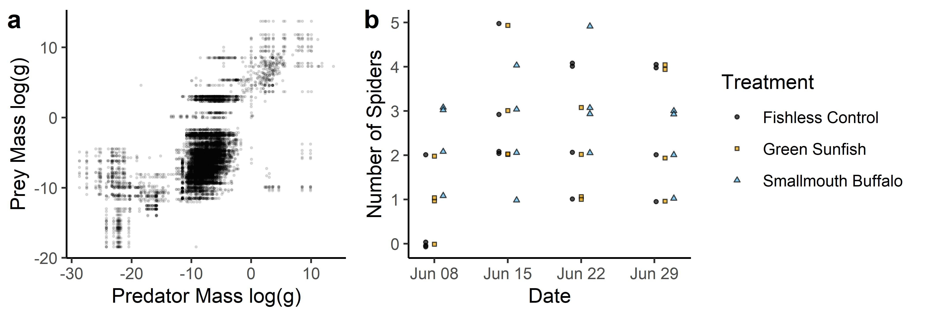

**Figure 2**

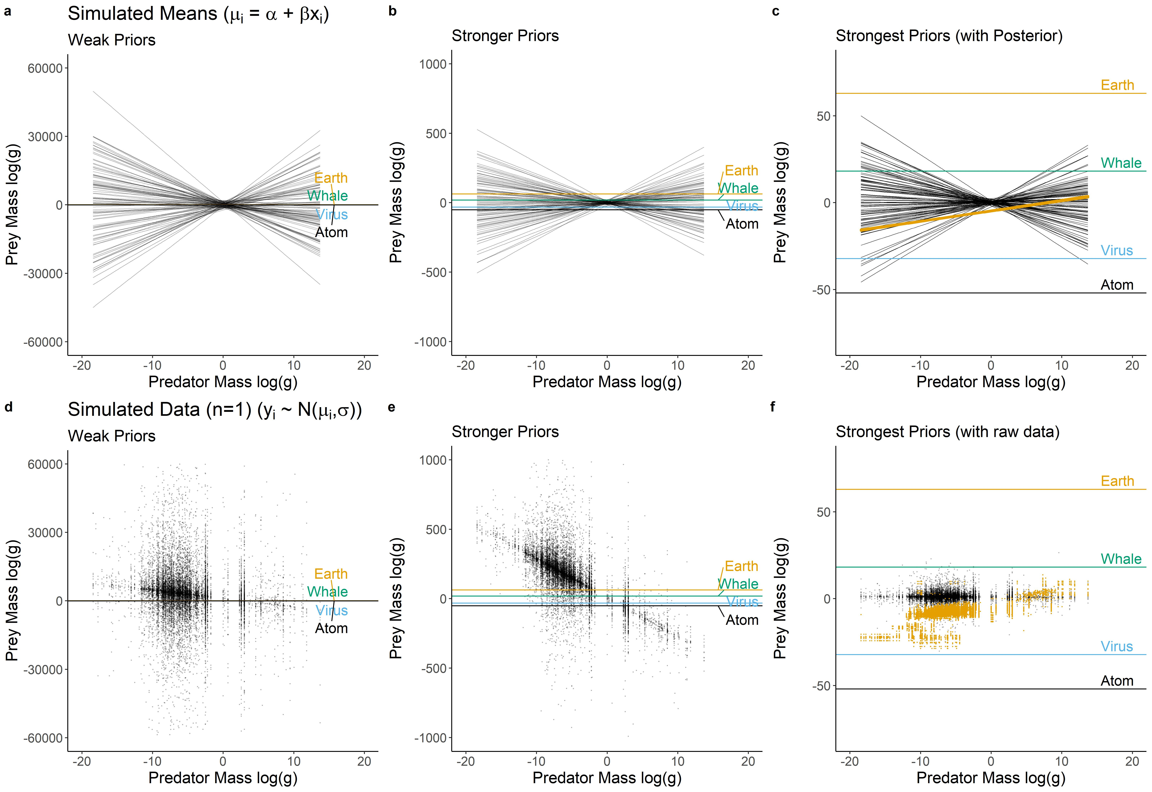

**Figure 3**

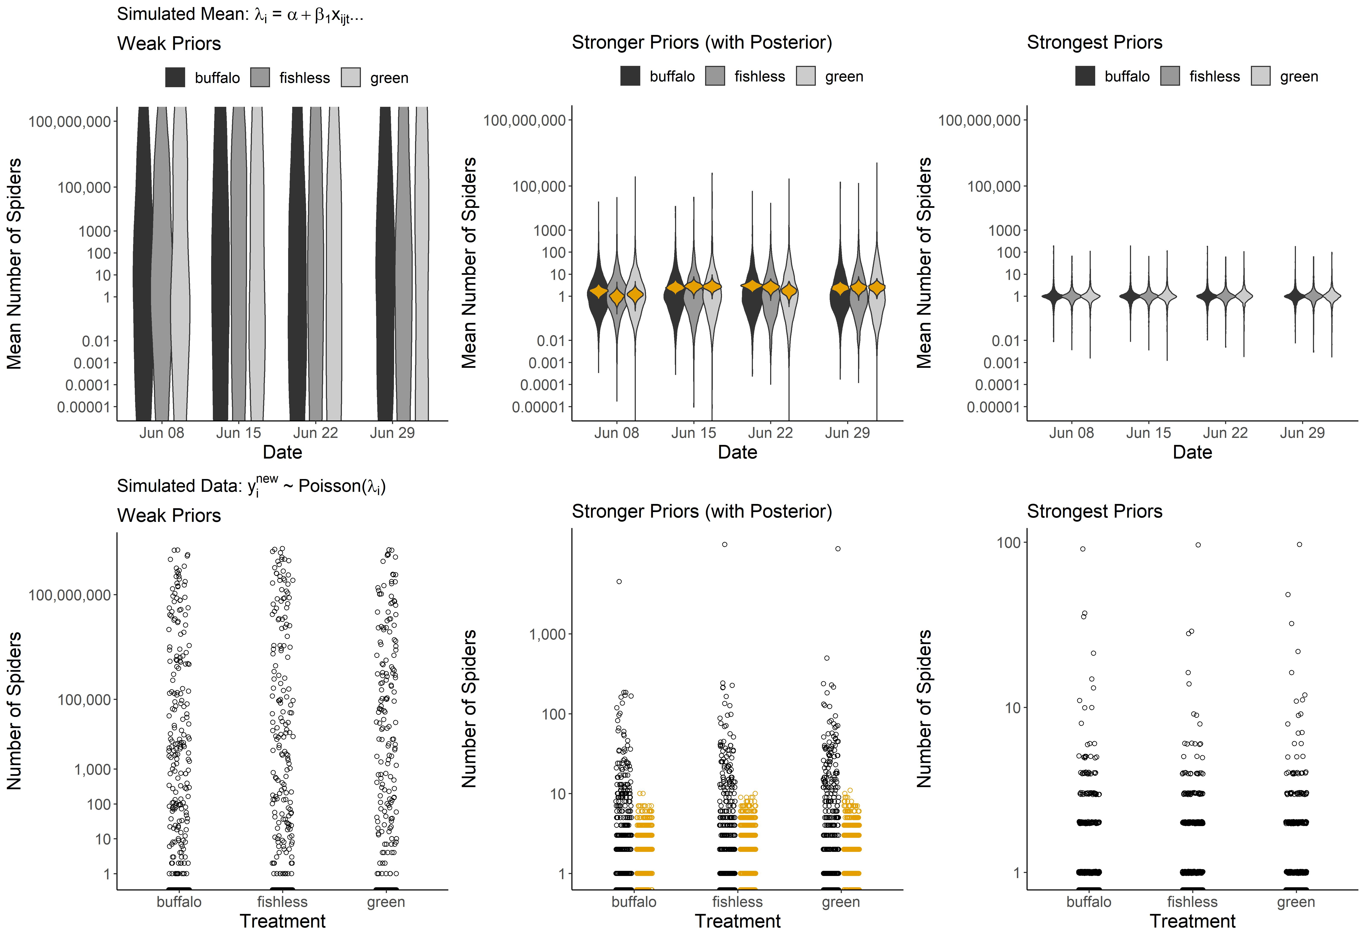

**Supplementary Information**

Data and code are submitted as separate files. They are also available here: <https://github.com/jswesner/prior_predictive>.

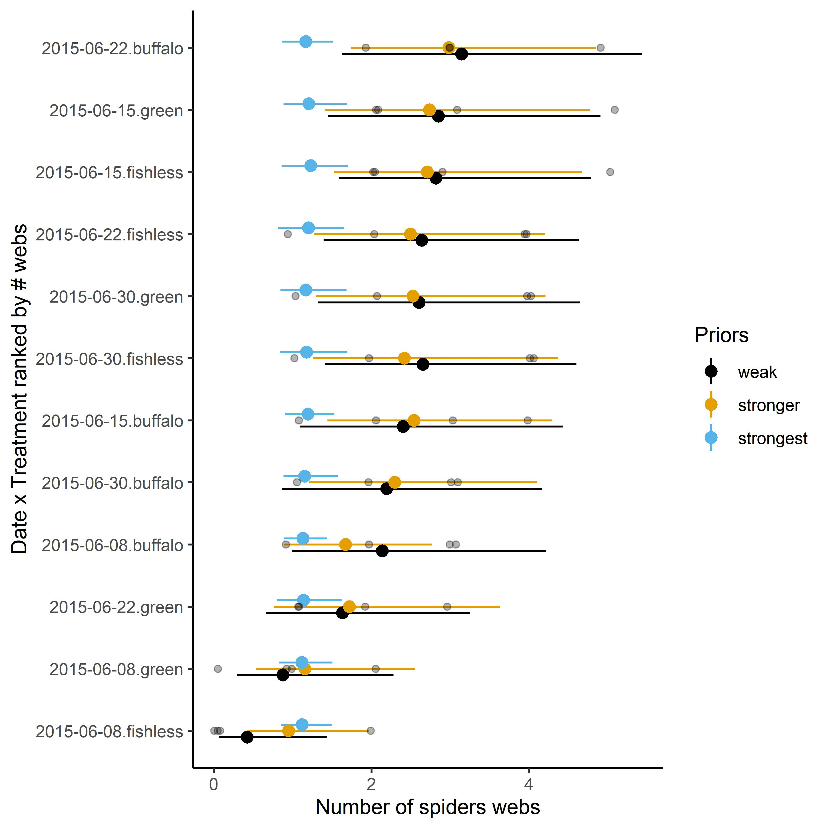

Figure S1. The influence of the prior distributions on models estimating spider density using data in Warmbold and Wesner (2018). Because of the small sample size (n = 4 replicates), the prior specifications affect the posterior. Compared to the weakest prior, the stronger prior is more conservative, pulling each mean towards the prior mean. The strongest prior (blue) is too strong, essentially swamping any information in the data. Gray dots are raw data.