1. What are the scales of ocean derived nutrint/contaminant fluxes to freshwater ecosystems by migrating salmon? **Tables for total flux added over all years and for average annual flux. Units in metric tons.**

|  |  |  |  |  |  |  |  |
| --- | --- | --- | --- | --- | --- | --- | --- |
| Table X. Mean ± standard deviation of the total export (metric tons) of nutrients and contaminants by salmon between 1976-2014. | | | | | | | |
| Chem | All | Chinook | Chum | Coho | Pink | Sockeye |
| N | 186725 ± 54304 | 10231 ± 3014 | 47780 ± 14032 | 9310 ± 2739 | 72607 ± 21193 | 46797 ± 13703 |
| P | 16811 ± 2732 | 921 ± 153 | 4300 ± 711 | 838 ± 140 | 6538 ± 1079 | 4214 ± 706 |
| DHA | 647 ± 308 | 33 ± 21 | 166 ± 78 | 35 ± 38 | 232 ± 188 | 182 ± 77 |
| EPA | 418 ± 275 | 27 ± 19 | 115 ± 78 | 27 ± 40 | 147 ± 167 | 101 ± 51 |
| Hg | 0.191 ± 0.03 | 0.018 ± 0.003 | 0.06 ± 0.01 | 0.011 ± 0.002 | 0.051 ± 0.013 | 0.052 ± 0.009 |
| DDT | 0.033 ± 0.005 | 0.005 ± 0.001 | 0.004 ± 0.001 | 0.003 ± 0.001 | 0.005 ± 0.002 | 0.016 ± 0.003 |
| PBDE | 0.005 ± 0.002 | 0.002 ± 0.001 | 0.001 ± 0.001 | 0 ± 0 | 0.001 ± 0.001 | 0.001 ± 0 |
| PCBS | 0.1 ± 0.061 | 0.01 ± 0.006 | 0.012 ± 0.009 | 0.007 ± 0.005 | 0.014 ± 0.015 | 0.057 ± 0.035 |

|  |  |  |  |  |  |  |
| --- | --- | --- | --- | --- | --- | --- |
| Table X. Mean ± standard deviation of the average annual export (metric tons) of nutrients and contaminants by salmon between 1976-2014. | | | | | | |
| Chem | All | Chinook | Chum | Coho | Pink | Sockeye |
| N | 2334 ± 679 | 128 ± 38 | 597 ± 175 | 116 ± 34 | 908 ± 265 | 585 ± 171 |
| P | 210 ± 34 | 12 ± 2 | 54 ± 9 | 10 ± 2 | 82 ± 13 | 53 ± 9 |
| DHA | 8 ± 4 | 0 ± 0 | 2 ± 1 | 0 ± 0 | 3 ± 2 | 2 ± 1 |
| EPA | 5 ± 3 | 0 ± 0 | 1 ± 1 | 0 ± 1 | 2 ± 2 | 1 ± 1 |
| Hg | 0.0024 ± 0.00037 | 2e-04 ± 3.6e-05 | 7e-04 ± 0.000126 | 1e-04 ± 2.4e-05 | 6e-04 ± 0.000169 | 6e-04 ± 0.000112 |
| DDT | 4e-04 ± 5.6e-05 | 1e-04 ± 9e-06 | 0 ± 1.3e-05 | 0 ± 6e-06 | 1e-04 ± 2e-05 | 2e-04 ± 3.9e-05 |
| PBDE | 1e-04 ± 2.4e-05 | 0 ± 1e-05 | 0 ± 8e-06 | 0 ± 1e-06 | 0 ± 1e-05 | 0 ± 5e-06 |
| PCBS | 0.0013 ± 0.000756 | 1e-04 ± 7.6e-05 | 2e-04 ± 0.000115 | 1e-04 ± 5.8e-05 | 2e-04 ± 0.000186 | 7e-04 ± 0.000441 |

1. How do differences in species compositions, sizes, and abundances influence nutrient and contaminant loading among regions of the eastern Pacific.

**SEAK**: Pink salmon dominated nutrient and contiminant flux in this region, making up at least 58% of all nutrient flux (range: 58 to 81%) and at least 40% of all contaminant flux (range: 40 to 78%) (Figure SX2). No other species contributed more than 33% of nutrients or contaminants.

**CentralAK**: In central Alaska, Pink salmon again dominated nutrient flux, making up at least 39% of nutrient flux. Pink salmon also contributed at least 41% of PBDE flux and 33% of Hg flux. In contrast, Sockeye salmon dominated flux of DDT (> 51%) and PCBs (>57%).

**BCWC**: In BCWC, Pink, Chinook, and Chum salmon contributed relatively similar amounts of nutrients, with the share of Pink contributions increasing steadily over time (Figure SX2). In contrast, Sockeye dominated contributions of DDT (41%) and PCBs (45%).

**BCWC**: In BCWC, export of PBDE’s by Chinook salmon declined from 39% of total export in 1976 to 16% in 2014, with the difference made up for by a similar proportional increase in export by Chum salmon. Overall, export in nutrients and contaminants was dominated by Sockeye and Chum salmon, thouthg the share of Chum exports has declined somewhat for all chemicals.

Figure 1

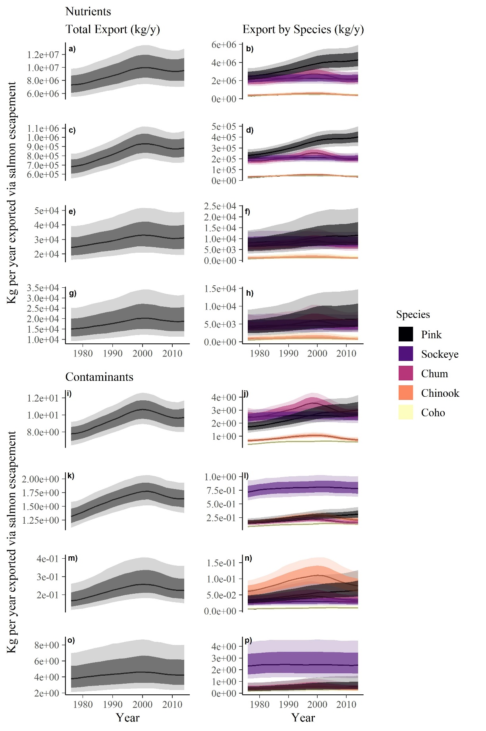

Figure 2

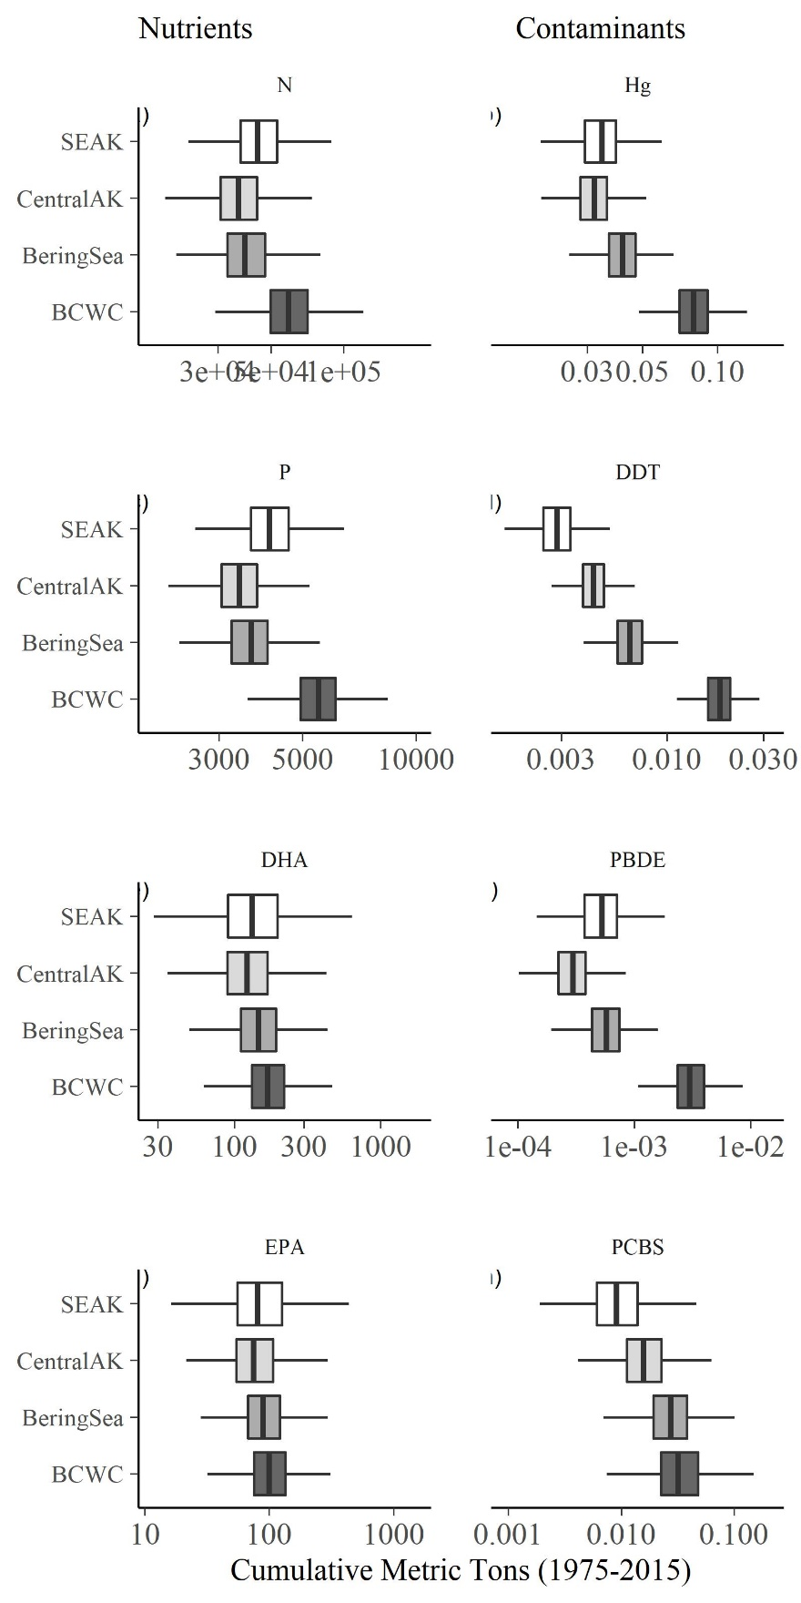

Figure SX1. Salmon escapement

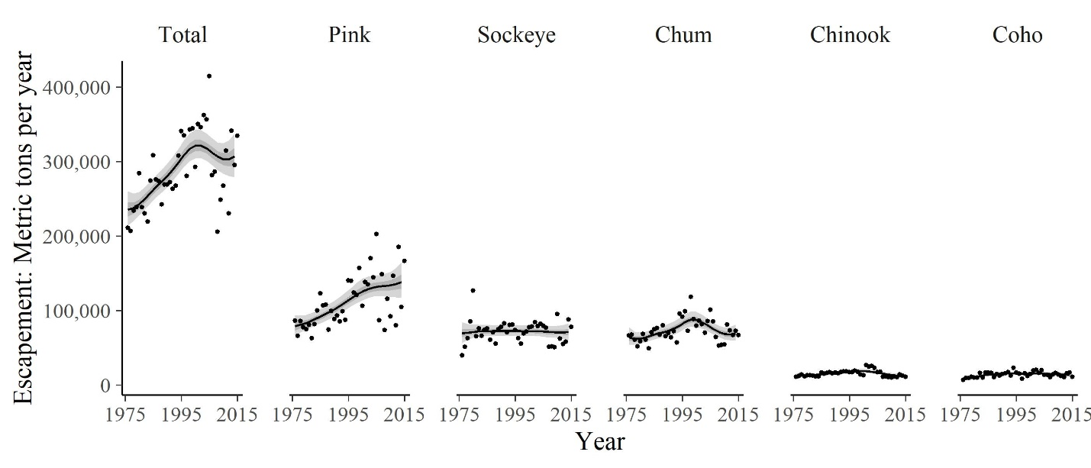

Figure SX2

