Supplementary Information: Bayesian hierarchical modeling of size spectra

Jeff S. Wesner1,, Justin P.F. Pomeranz2, James R. Junker3,4, and Vojsava Gjoni1

Journal: *Ecology*

1 University of South Dakota, Department of Biology, Vermillion, SD 57069  
2 Colorado Mesa University, Environmental Science and Technology, Grand Junction, CO 81501  
3 Great Lakes Research Center, Michigan Technological University, Houghton, MI 49931  
4 Louisiana Universities Marine Consortium, Chauvin, LA 70344

Correspondence: [Jeff S. Wesner <[Jeff.Wesner@usd.edu](mailto:Jeff.Wesner@usd.edu)>](mailto:Jeff.Wesner@usd.edu)

**Appendix S1**

*Translating to Stan and brms*

*Model Assessment*

Model assessment is a key part of the Bayesian workflow, one goal of which is to assess prior influence and model fit (Conn et al. 2018, Gelman et al. 2020). Here, we provide examples of model assessment using the prior predictive distribution, a prior sensitivity analysis, and the posterior predictive distribution (Gabry et al. 2018). As model assessment is a broad and developing area (Conn et al. 2018), we do not intend this demonstration to be exhaustive, but merely to demonstrate it for the *paretocounts* lpdf models developed in the main manuscript.

*Prior Predictive*

Prior implications are often best understood through visualizations of the prior predictive distribution (Gabry et al. 2017; Wesner and Pomeranz 2021). We demonstrate that here by comparing prior and posterior distributions of a single ISD (Figure S1a,b). Figure S1a shows 30 ISD’s simulated from a prior of *Normal*(-1.75, 0.2) (mean, sd). For this prior, most of the prior probability is centered between ~ -2.1 to -1.3, making it relatively weak prior that includes most of the empirical ranges of ISD λ’s. Using this prior, we fit the model to data simulated from a known = -1.5, with *x*min = 1 and *x*max = 1000. After fitting, the posterior is updated to *Normal*(-1.5, 0.02) (Figure S1b), recapturing the true with apparent minimal influence of the prior. Thirty draws from the prior or posterior are shown in Figure 1a,b.

Similarly, to understand the implications of a covariate prior in a regression model, we plotted 100 simulations of from the model:

where *x*ijis the *i*th individual from year *j* (with years standardized) and all other parameters as defined in the main text. The data for this model represent body sizes of fish captured over multiple years from the IBTS surveys as described in Edwards et al. (2017). The focus of this analysis is on the slope parameter , which indicates the change in over time (years). Figure S1c shows the implied changes of from the prior for of Normal (0, 0.1). This is a fairly informative prior as it keeps the predictions of within reasonable values (between ~-2 to -0.8) but is ambivalent on the direction of change (positive or negative). After fitting the model to data, the posterior is much more precise with the sd an order of magnitude smaller, indicating some support for a negative slope of -0.1.

*Prior Sensitivity*

The previous section demonstrated how to compare prior and posterior predictions. A separate question about priors is to understand how sensitive the resulting posteriors are to prior specifications. We can test sensitivity to prior choices by altering the prior for any or all parameters in the model and comparing the outcomes. Here, we created increasingly informative priors for λ by setting the Gaussian mean to -1.8 and reducing the standard deviation by orders of magnitude from 2 to 0.2, to 0.02. We then fit three ISD’s to simulated data with a known λ of -1.98. With prior standard deviations of 2 and 0.2, the posterior λ‘s were similar, with credible intervals including the true value (Table S1). By contrast, when the prior is highly informative with a standard deviation of 0.01, it has a clear influence on the posterior, reducing it to a mean of -1.86 with 95% CrI that exclude both the true λ of the data and the prior λ.

*Model Fit*

Because Bayesian models are generative, we can assess model fit by simulating data from the posterior distribution and comparing it to the raw data (Gabry et al. 2018). The motivation for this approach is that a model that faithfully recaptures the data generation process should generate data that resemble the raw data in at least some aspects. We did this by first fitting ISD’s to data generated from three known λ’s (-2, -1.6, -1.3). Then we used the posterior predictive distribution to simulate 500 datasets and compare them to the raw data. We did this visually using boxplots (Figure S2a-c) of the raw data compared to the first 10 simulations of data from the posterior. In addition, we calculated the geometric mean (GM) of each simulation and the raw data using

Where *xij* is the *i*th body size from the *j*th group, represented here by the different known lambdas used to simulate data (-2, -1.6 or -1.3). We generated a unique geometric mean for each of 500 posterior draws (*k*). We visualized discrepancies to the raw geometric mean using histograms compared to the raw geometric means (Figure S2d-f).

The results indicate good fit, showing that the posteriors generated from *paretocounts()* models strongly resemble the raw data (Figure S2a-c). In addition, the geometric means of the raw data were captured by the geometric means simulated from the posteriors (Figure S2d-f). One possible discrepancy appears in Figure S2f, where the true geometric mean is in the upper tail of the posterior histogram. A likely explanation for this is that the prior λ is set to *N*(-1.8, 2), while the true λ in Figure S2f is -1.3. It is possible that the discrepancy is due to the prior influence, though this should be explored. The most important result of this is simply to demonstrate that standard model assessment applies to the power-law models presented here. For a more thorough treatment of model checking, see Gelman et al. (2014) and Conn et al. (2018).

**Tables**

|  |  |  |  |  |  |
| --- | --- | --- | --- | --- | --- |
| Table S1: Prior sensitivity analysis showing how the posterior estimate of lambda changes as the prior standard deviation becomes more restrictive. The posteriors are summarized for models run on the same dataset containing 1000 simulated individuals from a true lambda of -1.98, xmin = 1, and xmax = 1000. | | | | | |
|  |  | Posterior | | | |
| True lambda | Prior(mean, sd) | Mean | SD | 2.5% | 97.5% |
| -1.98 | N(-1.8, 2.00) | -2.02 | 0.03 | -2.08 | -1.96 |
| -1.98 | N(-1.8, 0.10) | -2.01 | 0.03 | -2.07 | -1.94 |
| -1.98 | N(-1.8, 0.01) | -1.86 | 0.02 | -1.90 | -1.83 |

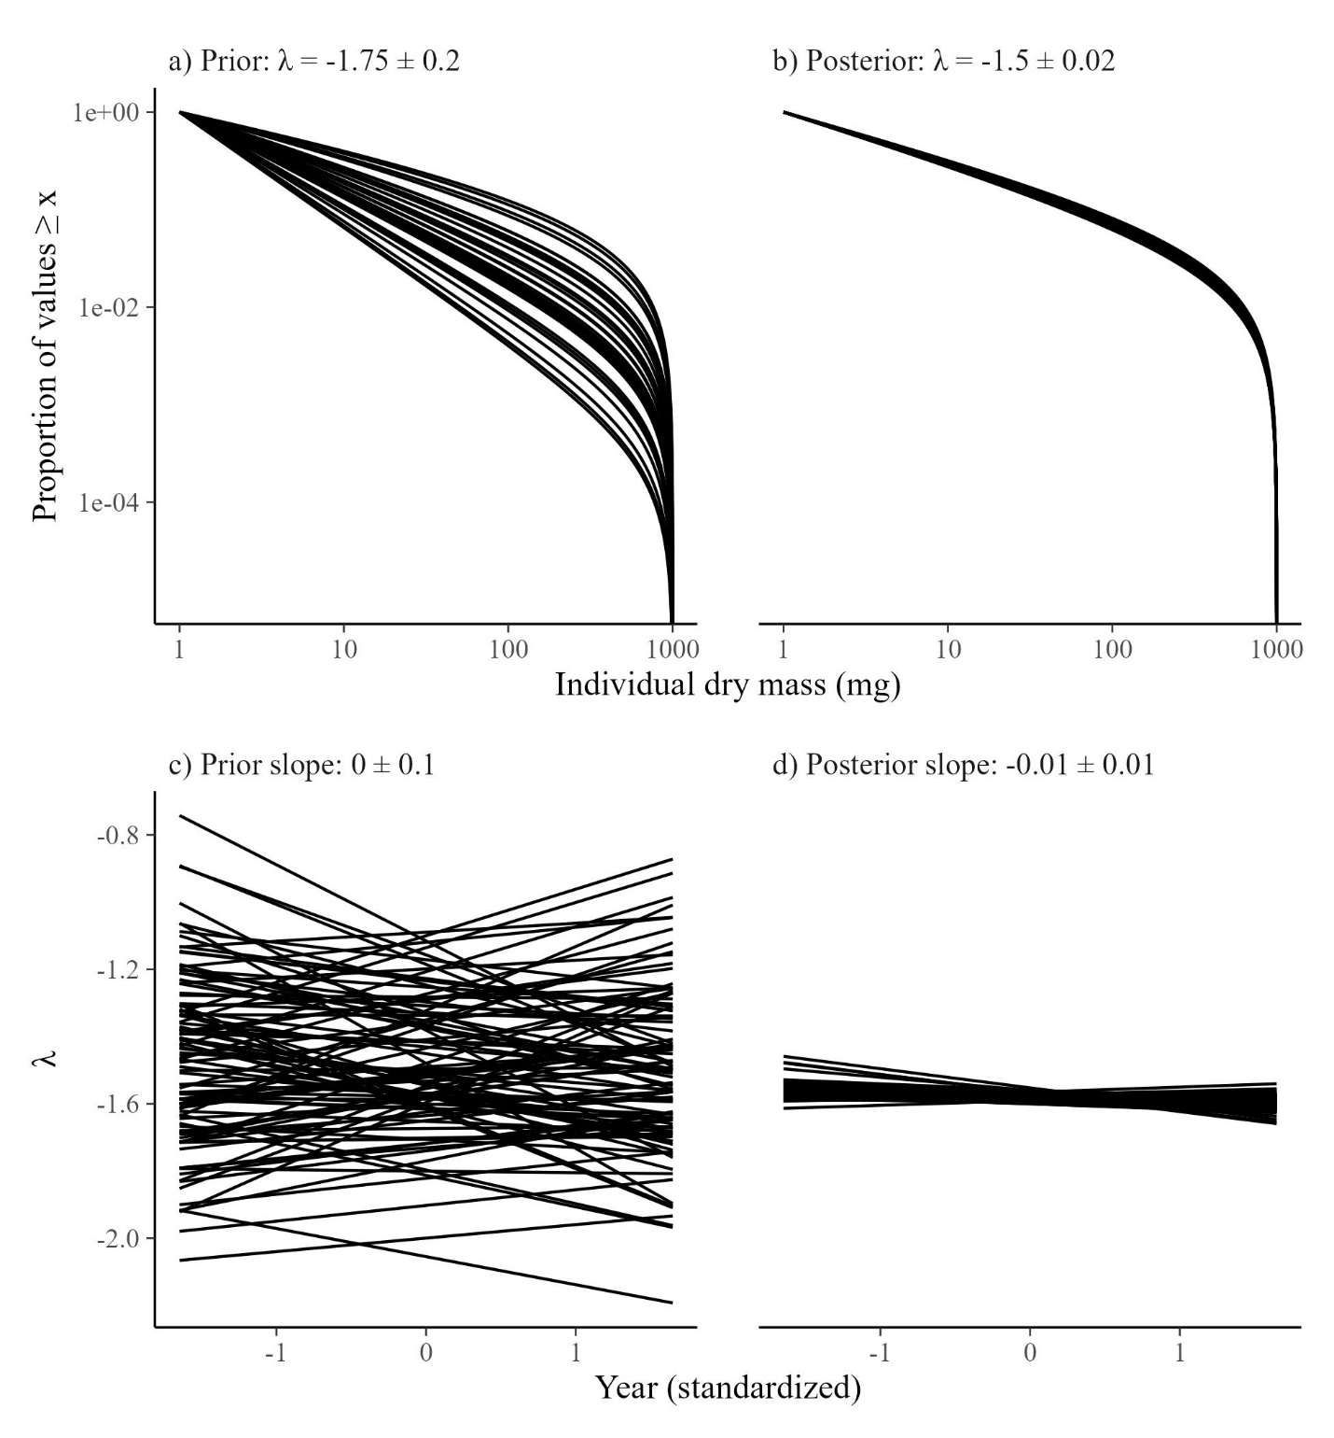

Figure S1. Thirty simulations from a) the prior distribution and b) the posterior distribution after fitting the model to data. Each line represents a single draw from the prior or posterior distributions (mean ±) sd).

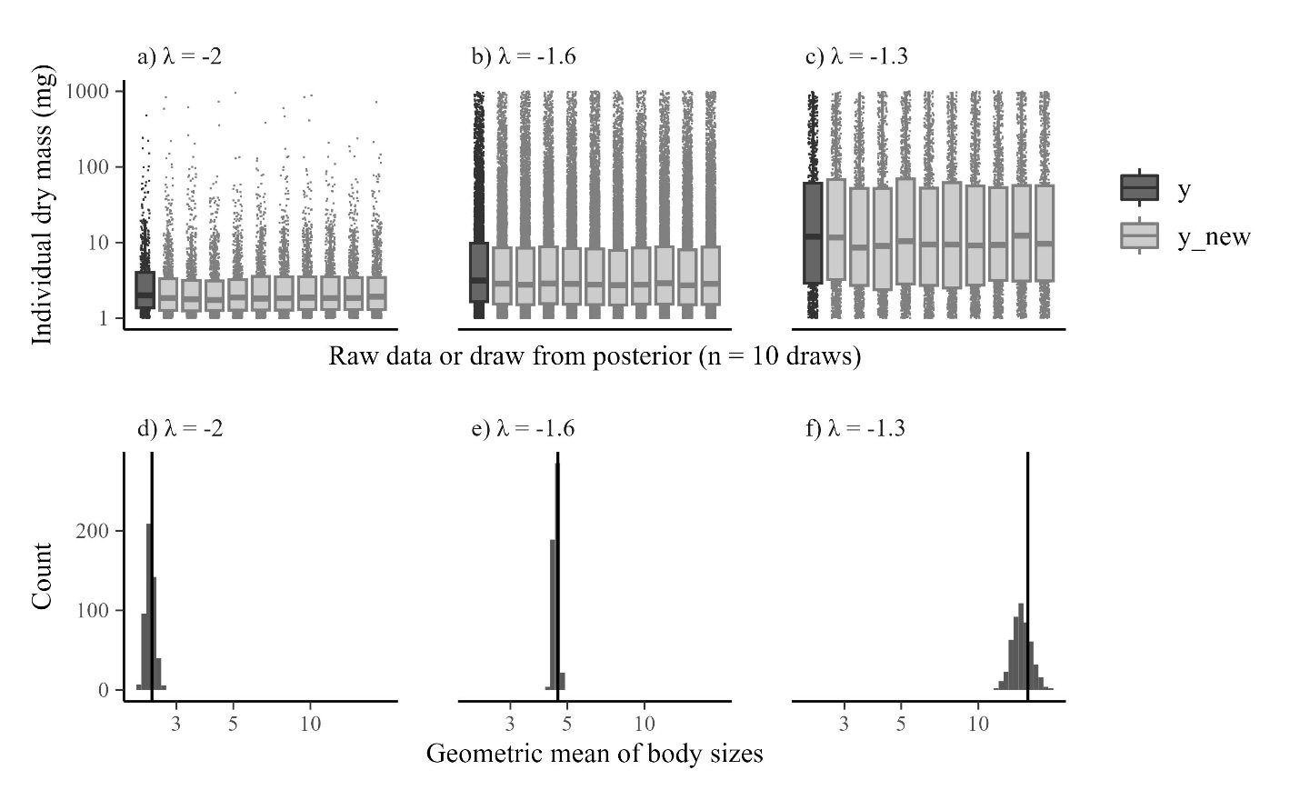

Figure S2. Posterior predictive checks of models estimating three ISD’s with true λ’s ranging from -2 to -1.3. a-c) Raw data and boxplots from the original data (y) and 10 simulated datasets from the posterior (y_new). d-f) Histograms of the geometric mean from 500 simulated datasets from the posterior compared to the geometric mean of the raw data (vertical line).

# References

Conn, P. B., Johnson, D. S., Williams, P. J., Melin, S. R., & Hooten, M. B. (2018). A guide to Bayesian model checking for ecologists. *Ecological Monographs*, *88*(4), 526-542.

Edwards, A. M., Robinson, J. P., Plank, M. J., Baum, J. K., & Blanchard, J. L. (2017). Testing and recommending methods for fitting size spectra to data. *Methods in Ecology and Evolution*, *8*(1), 57-67.

Gabry, J., Simpson, D., Vehtari, A., Betancourt, M., & Gelman, A. (2019). Visualization in Bayesian workflow. *Journal of the Royal Statistical Society Series A: Statistics in Society*, *182*(2), 389-402.

Gelman, A., Carlin, J. B., Stern, H. S., Dunson, D. B., Vehtari, A., & Rubin, D. B. (2013). *Bayesian data analysis*. CRC press.

Gabry, J., Simpson, D., Vehtari, A., Betancourt, M., & Gelman, A. (2019). Visualization in Bayesian workflow. *Journal of the Royal Statistical Society Series A: Statistics in Society*, *182*(2), 389-402.

Wesner, J. S., & Pomeranz, J. P. (2021). Choosing priors in Bayesian ecological models by simulating from the prior predictive distribution. *Ecosphere*, *12*(9), e03739.