Dear Editor:

This is a cover letter for submission of our article titled: *Bayesian Hierarchical Modeling of Size Spectra*.

The most important result of this work is the ability to analyze how predictor variables impact power-law relationships, such as individual size distributions (or size spectra), using a proper likelihood (truncated pareto) in a generalized (non)-linear modeling framework. Previous work in this area has separated the modeling into two steps: 1) fit power-laws independently to estimate the exponents of multiple size spectra (or other power laws), and 2) use those exponents as response variables in regression models. The current paper describes the downsides of separating those steps and develops a solution by analyzing multiple power-law exponents and their relationship to predictors and random effects in a single model.

Given the widespread importance of power-laws in ecology and size spectra in particular, we suspect that this paper will be of broad interest to ecologists. For this reason, we are submitting in the hopes that you might send it for review

Sincerely,

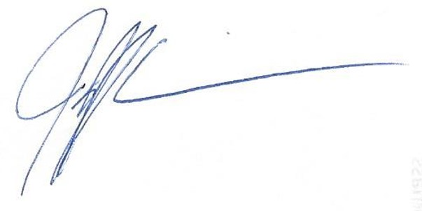

Jeff Wesner, Ph.D.

Associate Professor

Department of Biology

(Corresponding Author)