Jacob Wise
September 24, 2018
EECS 373
Dr. W. Newman

Assignment P1

Changing variables in minimal_controller and minimal_simulator

In minimal_simulator, dt can be adjusted to affect how often the velocity is updated given a force from the controller. The closer the value is to 0, the faster/more often the velocity is updated, providing a smoother simulation.

In minimal_controller, dt can be adjusted to affect how often the force value is updated given velocity from the simulator. Additionally, Kv can be adjusted to change the “reaction” magnitude of the force calculation in response to velocity and a velocity command.

The dt of both nodes should be as close to 0 as the hardware will allow, such that the velocity and force calculations are updated in quicker intervals. In contrast, Kv should be maximized to the limits of the hardware so the velocity reacts to the command quickly.

Result using sin_commander

The new node sin_commander was used to command vel_cmd to the other minimal nodes. For the demo, dt of minimal_simulator was set to 0.001 and dt and Kv of minimal_controller was set to 0.001 and 200 respectively. The user was asked for the amplitude and frequency of the wave for the sin_commander, which was set to 5 and 1 respectively.

The following image shows velocity superimposed with the vel_cmd:
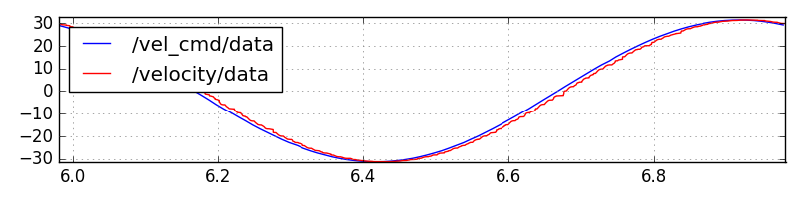
Limits of performance

I found that pushing dt and Kv to more “ideal” values significantly beyond the ones set above resulted in bad results, presumably due to hardware limitations. However, I the resulting waves are very close in resemblance.

