Java JDBC and REGEX Assignment: An Overview

The purpose of the assignment is to read an input file and use REGEX to find the no of occurrences od the patterns (see test cases on what patterns) and use JDBC to save it into database.

So, all-in-all, you need to write implementations for following interfaces -

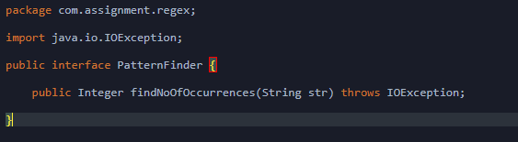

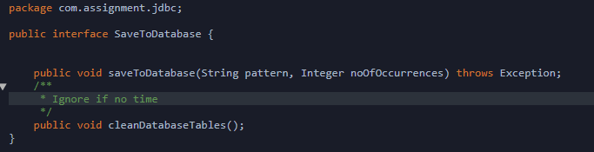

What’s Provided

1. Input file to read – regex.txt
2. Database Schema – petclinic
   1. Database User – perclinic
   2. Database Password – password
3. SQL Init Data Script – init-data.sql
4. Database Conect Info

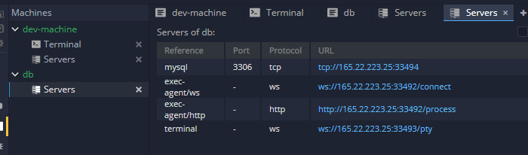

Note that port info will change every time you launch a new session.

1. Data Storage

Table Structure – See init-data.sql

What You need to do

Just write implementation for PatternFinder & SaveToDatabase

What You don’t need to do

Test cases are already provided. You can debug or run the test cases for your satisfaction. Once through, click on the Submit button on the test window and the system will auto run the test cases and submit the results to appropriate authority.

(Test Cases cannot be edited and hence are read-only)

Test Cases

See TestPatternFinder.java