Java Assignment: An Overview

The Salary processor module is a core Java application with a public interface exposed to outer world

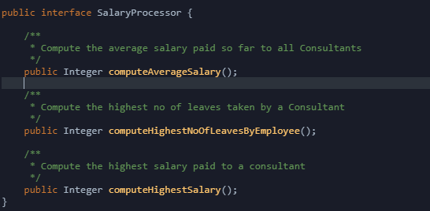

You need to start writing implementaion to above methods in SalaryProcessorImpl.java

What’s Provided

1. Model Entities –

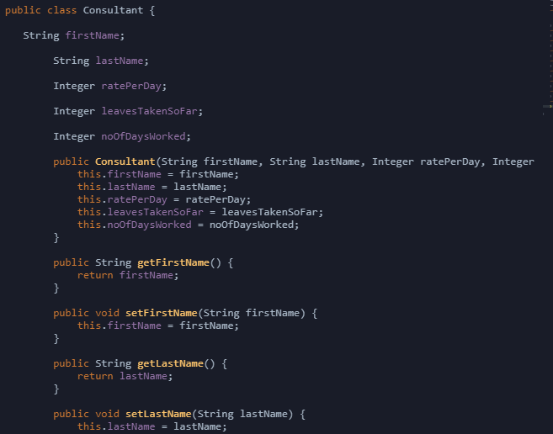

1. Data Storage

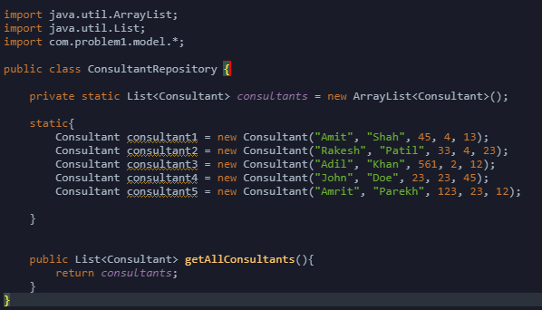

What You need to do

Just write implementation for SalaryProcessorImpl

What You don’t need to do

Test cases are already provided. You can debug or run the test cases for your satisfaction. Once through, click on the Submit button on the test window and the system will auto run the test cases and submit the results to appropriate authority.

Test Cases

See TestProblem1.java