Integrated Assignment : An Overview

**The Politician Rating Single Page Application** allows you to rate development activities done by elected politician. The solution allows user to manage politician, manage political party, and manage development activity.

* Add/Edit/View/Delete Political Party
* Add/Edit/View/Delete Political Leader. Each Political Leader belongs to one party.
* Add/Edit/View/Delete Development Activity.

User can up-vote and down-vote each development activity.

Find Wireframes and Database Tables below:

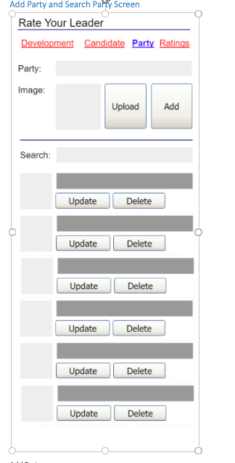

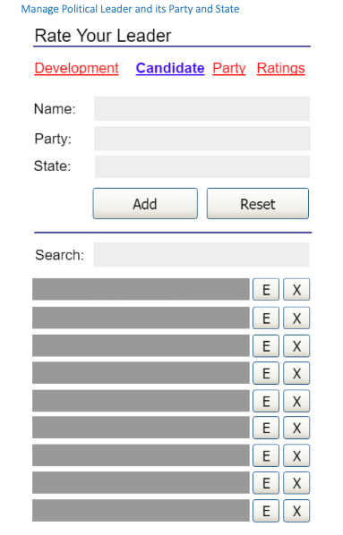

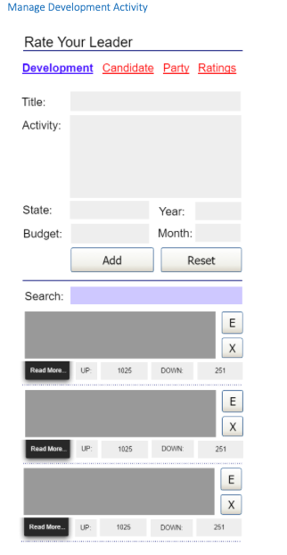

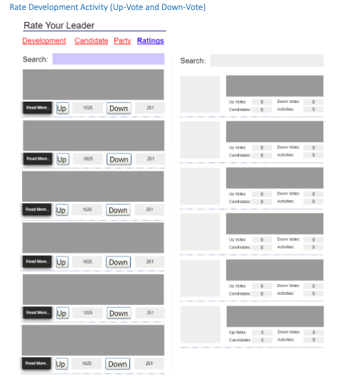

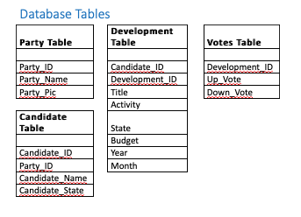

Software Requirements

The technologies included in Integrated Assignment are not limited to following but may consist of:

* UI Layer (HTML5, CSS3, JavaScript, AngularJS)
* Middleware (Java)
* Database layer (MySQL)

You can use this Single Page Application as an Integrated Assignment across the Comprehensive Learning Path in our Digital Learning Platform as and when required. The Workspace will autosave any code or project you create. You can also submit the workspace to assist in Static Code Analysis, to gain more insights.