1. Overview 1

2. Deployment Diagram 1

3. Data Flow 1 2

4. Data Flow 2 2

5. Data Flow 3 2

## Overview

Yaksha is a fully blown Assessment platform that tests learners on following type of tests

1. McQ
2. SPA – Single Page Applications
3. Full Stack assignments

This document is a summary of deployment specifics for Yaksha Assessment platform as it is now and listing of all data flows. Each data flow is distinguished by a set of common software component involved irrespective of function – There might be multiple features that might be using the same component flow.

## Deployment Diagram

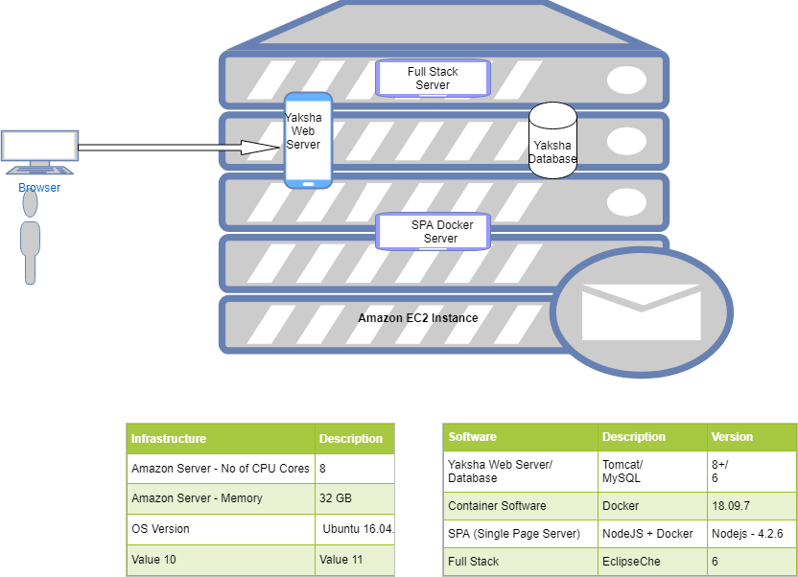

## Data Flow 1

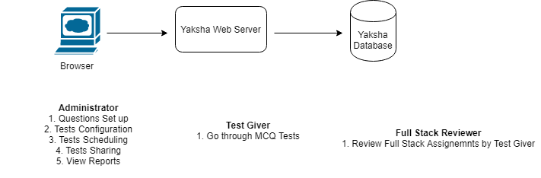

Actors for this flow – Test Admin / Test Giver / Reviewer

## Data Flow 2

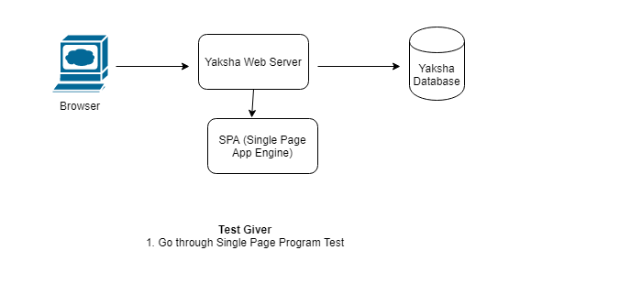

SPA – Single Page Application Test : Yaksha has a capability to ask test givers to code a problem statement in one of many programming languages that Yaksha supports. Single page programs are basically, as name suggests, 1 file isolated programs – e.g: Write a Fibonicci series, Arm strong number or so. Single page programs does not depend on third party libraries nor do they require more than 1 files to code a solution.

## Data Flow 3

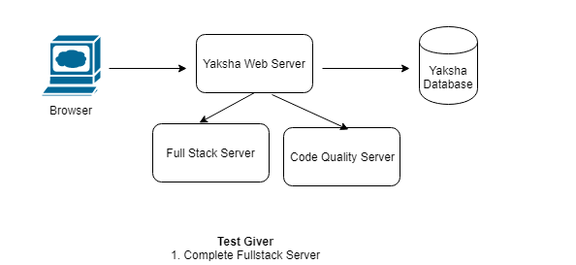

1. Test Givers are also asked to complete a full stack test based on Java/.NET/JavaScript/Python/etc languages. Full stack assignments are different vis-à-vis SPA assignments in a way wherein the expectation from test givers is to develop an application spanning front/middle and data tiers. Test givers are allowed full liberty to use any third party library(s) as they deem fit for the purpose of the assignment.
2. Post the submit of the assignment there are 2 types of reviews that happen
   1. Automated Code Quality Check through Sonar Code Quality Server
   2. Manual review on functional and programming/architectural parameters by a manual reviewer (See Data flow 1)