## Yaksha Overview

Yaksha is an online Assessment Platform that facilitates assessing Software Engineers on various technologies through a variety of assessment types

These are the different assessment types Yaksha supports –

1. MCQ Exams
2. Single File Assignments (SFA) – Aimed to test associates on data structures/algorithms/logic problems. As the name suggests typically the test givers complete the assignment in a single file. Example – Write a Program to determine whether a number is Armstrong or not?, Calculate Fibonacci Series, etc
3. Full Stack Assessment (FSA) – please see below

Scope of this document is to enable Full stack Content developers to understand the full stack creation process and create/upload content on Yaksha.

## Full Stack Assignments (FSA)

FSA are more comprehensive assignments with a larger business scope. Essentially these full stack assignments come in following flavours -

1. Middle tier Assignments – Back End Programs that may interact with database. Example – Write a Program using REGEX to find out the number of occurrences of a key term and save the count in database.
2. All layer Assignments with UI, Middle tier and database. Example – Build a HR Payroll app with different roles login and so…

As of now, point b is not in scope.

FSA assignments typically spawn an IDE embedded in a browser with access to embedded web server/database as well.

## Process to create Full Stack Assessments on Yaksha

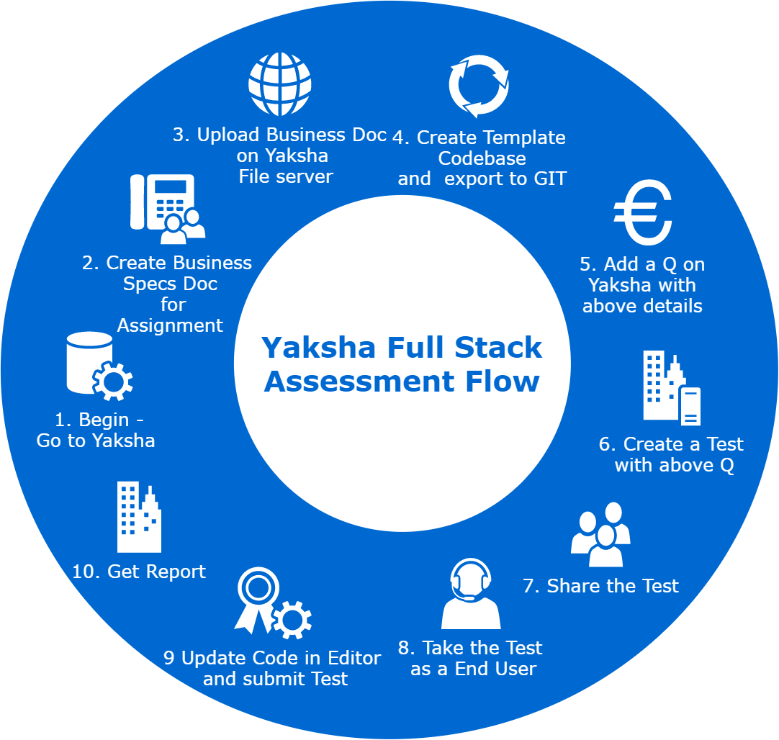

1. Go to Yaksha – <http://yaaksha.com/> . Login through following credentials –
   1. User - [system@iiht.com](mailto:system@iiht.com)
   2. Password – 1234
   3. Company – IIHT
2. In an offline mode create a Project Specification document on lines of this - <http://165.22.223.25/file-server/assessment/docs/Java_REGEX_JDBC_v1.docx>

Once the document is created, share it with Operations team. They will upload the document on to Yaksha file server and share the document URL.

1. As of now Yaksha supports creating full stack assignments that doesn’t involve UI. Idea is to come up with a document that translates into interfaces and telling the end user to code the implementation to these interfaces.

Example –

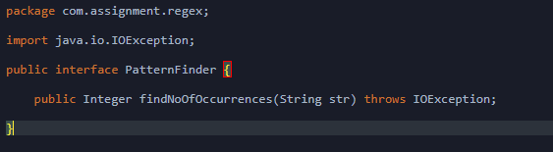

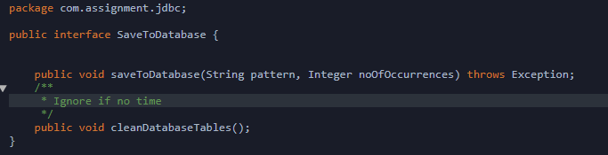

The business document talks of end user writing a program to read an input file using REGEX to find out the count of no of occurrences of a key word and save the count into database.

1. Once the business document is written, we, as Content creators, should come up with a template code base for the business specification document. The template code base should comprise of following –
   1. Interfaces
   2. Implementation classes with do nothing methods (to be updated by end user)
   3. Test Cases with full implementation (End Users can’t edit the test cases as that area is read only)
   4. Input files
2. Since the Content Writer also shares the input files, if any, as needed for the assignment (in this case the file with dummy text on which regex is applied), **he need to share a file called problem.txt with Operations team that lists the mapping between test case and supposed correct expected output.** E,g, below

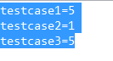

Above means there are 3 test cases in the assignment and the values are the expected output.

So imagine the end user completing and submitting the assignment will trigger an automation program running to run the test cases again. Automation Program will compare the results of the test cases run with the values stored in the problem.txt to figure out if test cases indeed succeeded.

1. The template code base created need to be exported into Github (public repository) and the link be noted. Now the offline tasks needed to be created to support creating a Yaksha full stack assessment are done.
2. The template code base must have at their root location 2 files (if the assignment requires a database connect support)
   1. Init-data.sql (Database tables creation script)
   2. Jdbc.properties

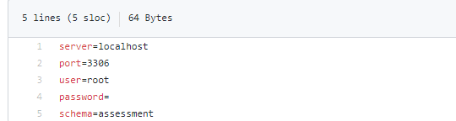

Use the same values in your jdbc properties file. For every new browser session, port info will change and it is the end user responsibility to update the file. User/Password/Schema info will be provided to end user as a part of another document (not in scope) that can be downloaded from the exam window.

1. **Steps below are more to do with linking the tasks with an online Yaksha FSA test.**
2. Through Step 1, you have already logged into Yaksha. Post login, Yaksha would look like this - 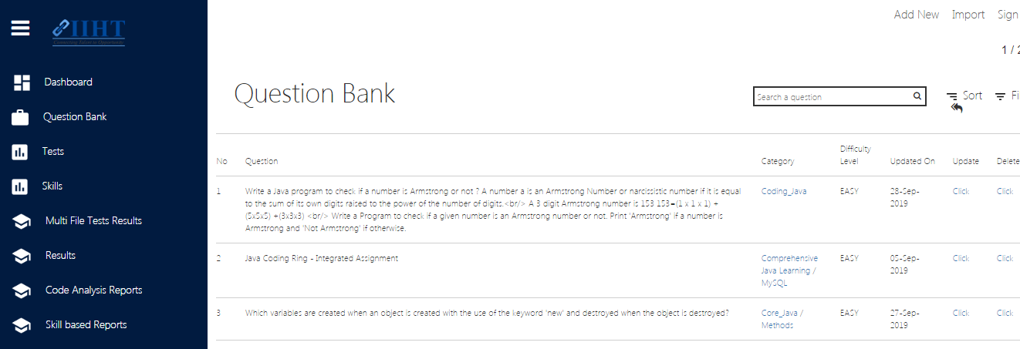
3. Question Creation - Default view post login would show the Question listing.

Click on Add new

A full stack Question will look like this –

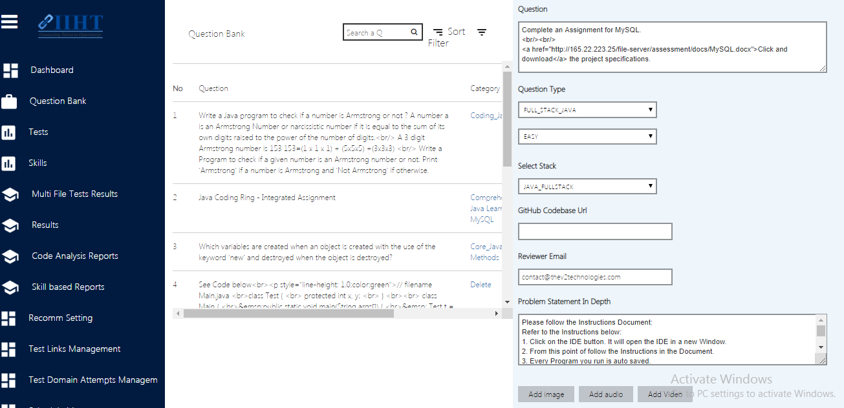

1. Enter the Question text in a HTML format. (See the HTML tags in the Q). Include the business Specification document link in the Question.
2. If you are creating a Java full stack assignment, select Question type as Full_Stack_Java and stack as Java_FullStack
3. If you are creating a full stack assignment for a different technology, select QuestionType as FullStack and stack as the technology whose stack you are creating.

These are the stack options available - 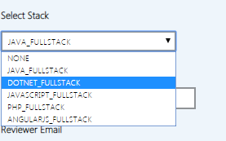

1. Enter the Github link url for your template code base.
2. Enter the Reviewer Email Id. Contact Operations for the reviewer for this case.
3. While adding instructions in the instructions text area, make sure they are HTML formatted.
4. Add an appropriate category for the Question
5. Save the Questions
6. Test Creation

Test Creation in Yaksha is a straight forward process than enlists adding basic information of test, searching Questions and adding them to test and sharing test with internal users