Trimflow
User manual
Step by step, for everyone who sells, buys, makes, stores, inspects, ships or gets paid for garment accessories with it.
Version 1.0 · October 2026

Contents
Contents
1. Getting started
1.1 Signing in
1.2 The screen
1.3 Search: find anything fast
1.4 Help menu and keyboard shortcuts
1.5 Your profile and password
1.6 Lists, filters and tables
2. Setting the system up (administrator)
2.1 Company details and settings
2.2 Lists: the values forms choose from
2.3 Operations: the steps a factory runs
2.4 Number sequences
2.5 Users, roles and permissions
2.6 Accounting periods (month-end close)
3. Products and materials (master data)
3.1 Materials and items
3.2 Activating an item
3.3 Products
3.4 Routings: the steps a product goes through
3.5 Bills of materials
3.6 Artwork
3.7 Tools and machines
3.8 Customers and suppliers
4. Selling: inquiry, quotation, order
4.1 Inquiries
4.2 Quotations
4.3 Sales orders
4.4 Price lists
5. Buying: requisition, RFQ, purchase order, receipt
5.1 Purchase requisitions
5.2 Requests for quotation
5.3 Purchase orders
5.4 Goods receipts
5.5 Supplier bills and payments
5.6 Imports: shipments and letters of credit
6. Inventory
6.1 On-hand stock
6.2 Lots
6.3 Material issues to jobs
6.4 Transfers between warehouses
6.5 Adjustments
6.6 Physical counts
6.7 Chain of custody and certified stock
6.8 Material plan (MRP)
7. Production
7.1 Raising a job card
7.2 Planning: putting steps on machines
7.3 Releasing a job: the gate
7.4 Following a job
7.5 Finished goods receipt and closing
7.6 The shop floor terminal
8. Quality
8.1 Inspections
8.2 Non-conformance reports
8.3 Laboratory
8.4 Compliance and chain of custody
9. Dispatch
9.1 Packing lists
9.2 Delivery notes
9.3 Trips
9.4 Customer returns
10. Costing: three stages
10.1 Marketing costing on the quotation
10.2 Pre-production costing at order confirmation
10.3 Post-production costing on the job card
11. Money
11.1 Invoices
11.2 Receipts
11.3 Credit notes and refunds
11.4 Expenses
11.5 Month-end
12. Reports and the audit log
12.1 Reports
12.2 Audit log
13. Reference
13.1 Document statuses
13.2 Who does what
13.3 Words used in this manual

1. Getting started
Trimflow is the system your factory uses to sell, buy, make, store, inspect, ship and get paid for garment accessories: labels, tapes, zippers, buttons, cords, moulded parts, packaging and decoration. This manual walks through every screen in the order a day's work happens. Each section says what the screen is for, how to use it step by step, and what the system will stop you from doing and why.
You do not need to read it front to back. Find the chapter for the job you are doing. Chapter 2 is for the person setting the system up; everyone else starts at chapter 3 or later.

1.1 Signing in
- Open the address your administrator gave you in Chrome, Edge or Firefox.
- Type your email and password. Tick "Show password" if you want to check what you typed.
- Tick "Keep me signed in" on a computer only you use.
- Press Sign in. If you forgot your password, use "Forgot your password?" and follow the email.
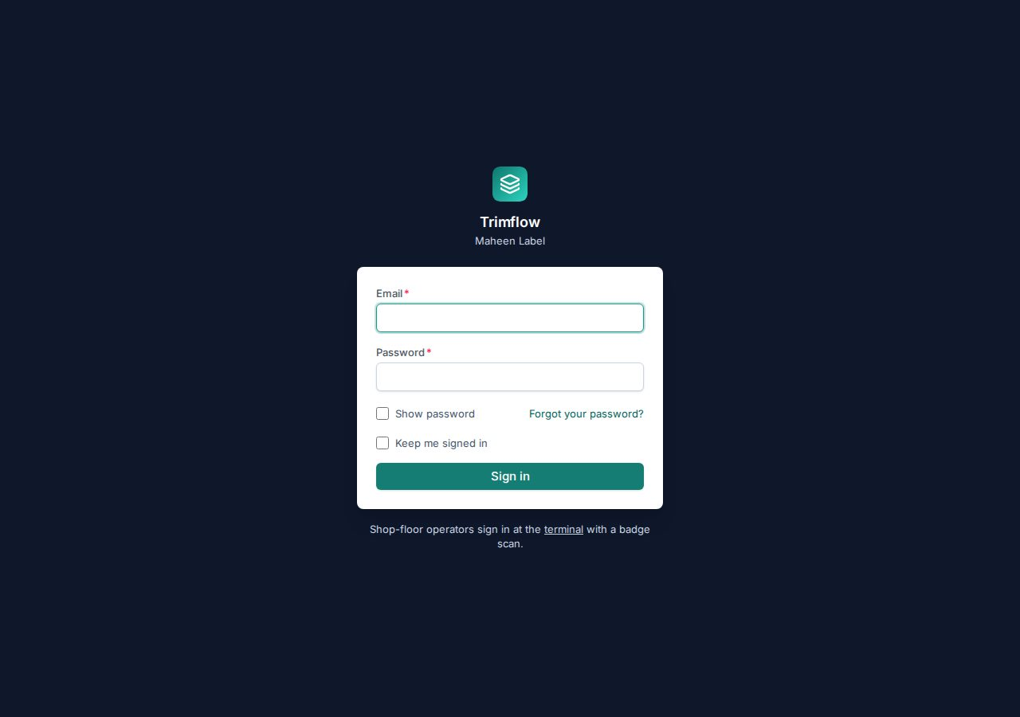
The sign-in screen. Shop-floor operators do not sign in here; they use the terminal with a badge (see 7.6).
Good to know
- Every new account starts on the password the administrator gave you. Change it on your profile the first time you sign in (see 1.5).
- If a page says "You do not have permission", your role does not include that screen. Ask your administrator; the system never hides a screen by mistake, it hides what your role may not do.

1.2 The screen
Every screen has the same three parts: the menu on the left, the page title with its buttons at the top, and the content. The menu follows the order of the factory's work: Sales, Buying, Production, Products, Inventory, Quality, Dispatch, Money, Reports. The last four groups, Setup, Settings, Access and Activity, configure the system and are used mostly by the administrator.
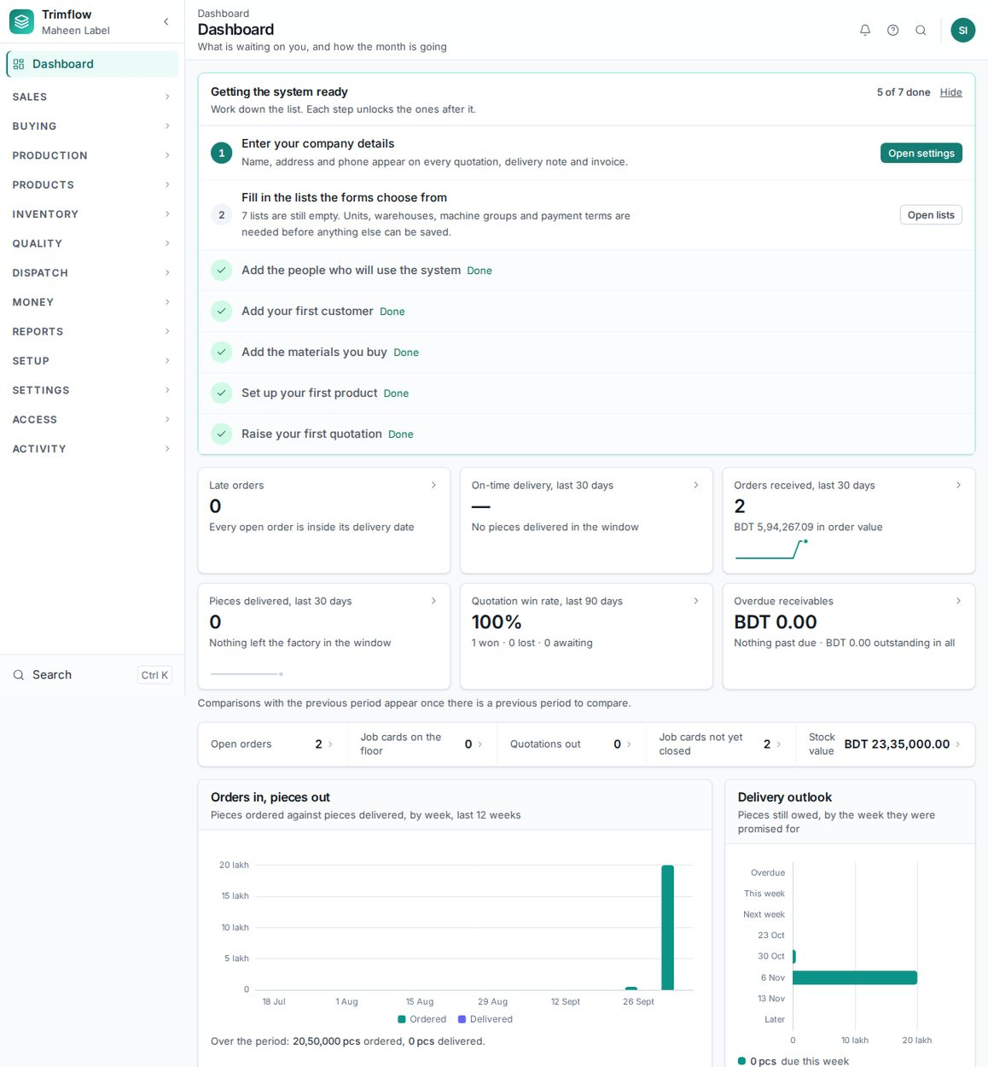
The dashboard: what is waiting on you and how the month is going. The first-run checklist at the top disappears once setup is complete.
- Click a group name in the menu (for example PRODUCTION) to open it. Only one group stays open at a time, so the menu never becomes a long list.
- Click a row inside the group to open that screen. The row of the screen you are on is highlighted.
- Click the small arrow at the top of the menu to shrink it to icons. Click again to bring the names back.
- The line under the page title (for example "Production › Job cards › JC-26-000001") always shows where you are. Click any part of it to go back up.
Good to know
- The buttons at the top right of a page are the actions you can take on it. Grey buttons that cannot be pressed show why when you point at them.
- The bell shows notifications addressed to you: an approval waiting, a job released, a delivery due.
- The small ⓘ beside a card title explains the rule that screen follows. Point at it or tap it.

1.3 Search: find anything fast
- Press Ctrl K (⌘K on a Mac), or press / when you are not typing in a field, or click the magnifying glass.
- Type part of a screen name, a document number, a product code, a material or a customer.
- Use the arrow keys to move and Enter to open. Press Esc to close.
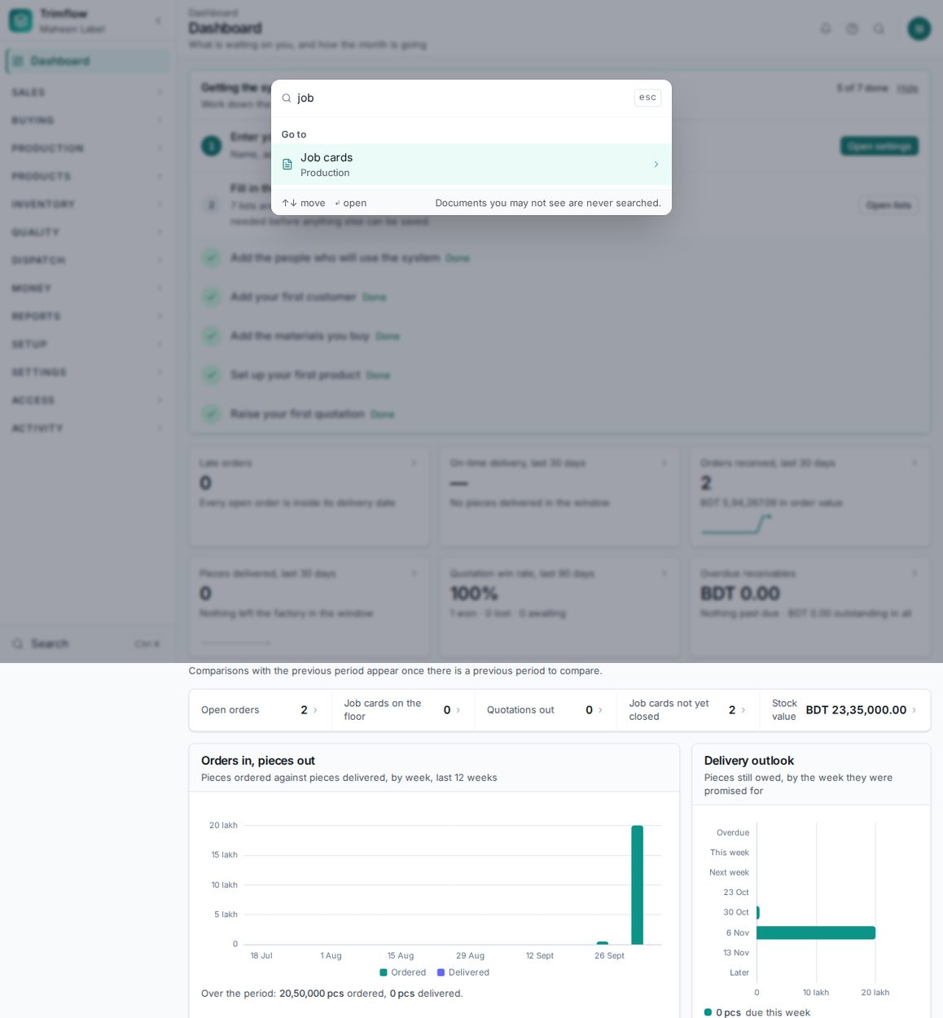
Search opens over any page. Screens are found instantly; documents are searched on the server.

1.4 Help menu and keyboard shortcuts
The ? button in the top bar lists the keyboard shortcuts, explains the ⓘ markers, links to the setup screens you may open, and tells you who to ask when you are stuck.
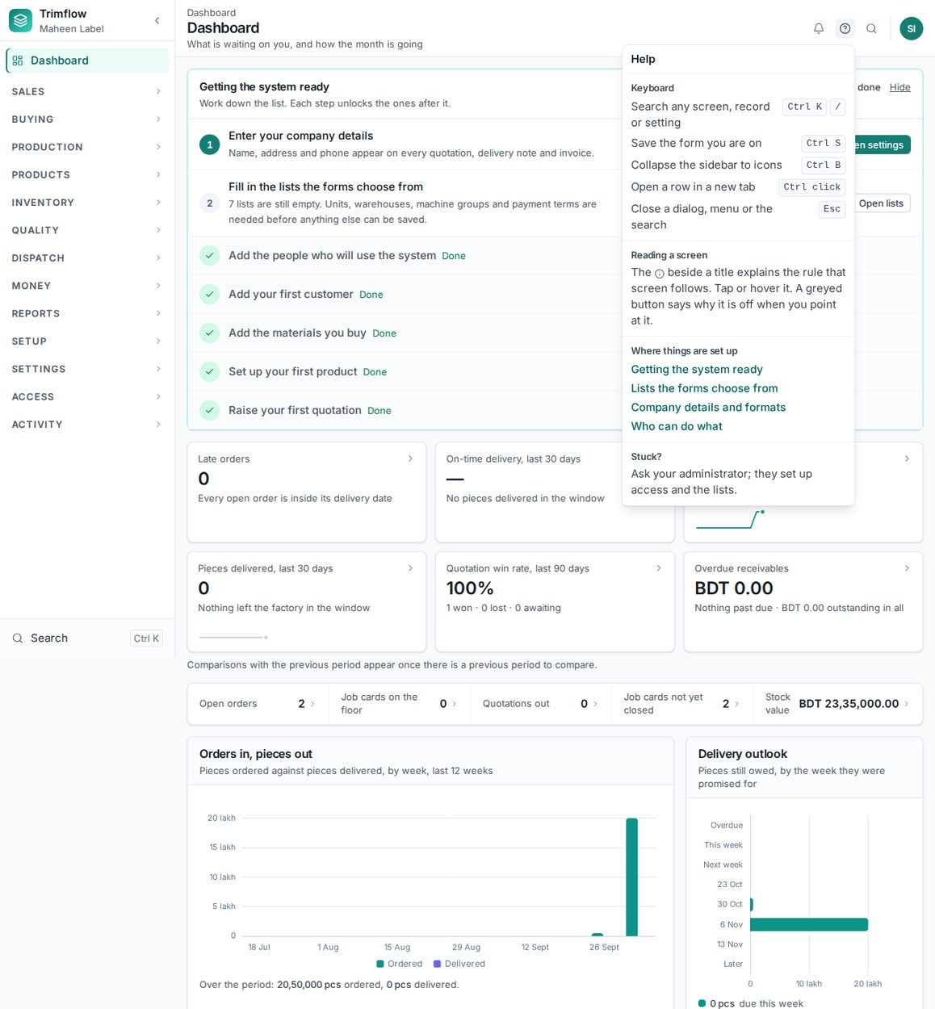
The help menu.
Keys | What it does
Ctrl K or / | Search any screen, record or setting
Ctrl S | Save the form you are on
Ctrl B | Shrink the menu to icons, or bring it back
Ctrl + click on a row | Open that row in a new browser tab
Esc | Close a dialog, a menu or the search

1.5 Your profile and password
- Click your initials at the top right and choose Profile.
- Change your name, language or password and press Save.
- Log out from the same menu when you leave a shared computer.
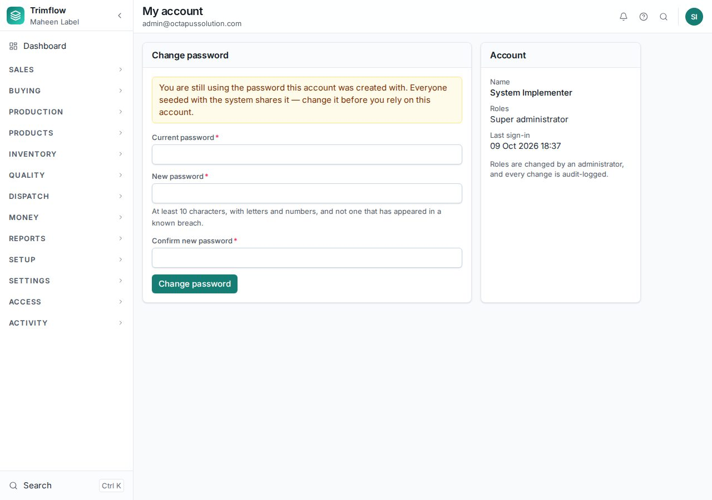
Your profile.

1.6 Lists, filters and tables
Most screens start with a list. Every list works the same way.
- Type in the search box to narrow the list. The search looks at numbers, names, products and customers at once.
- Use the drop-downs beside the search to filter by status, customer, type and so on. Active filters appear as chips under the search; click the × on a chip to remove it.
- Click a column heading to sort by it; click again to reverse.
- Click a row to open the record. Use "Rows" at the bottom to show more rows per page.
- Press Export to download the list as a spreadsheet, with the filters you set applied.
Good to know
- The address bar carries your filters. Copy the address and send it to a colleague and they see the same list.
- A list that is empty tells you why and what to do next, not just "no results".

2. Setting the system up (administrator)
Do this once, before anyone else starts work. The dashboard shows a checklist of these steps and ticks them off as you go.

2.1 Company details and settings
- Open Settings › Settings.
- On the Organisation tab enter the company name, address, phone, email, tax number and logo. These appear on every printed document.
- On the Costing tab set the factory overhead %, administrative overhead %, default margin %, margin floor %, labour rate per hour and electricity tariff. The costing screens use these.
- Review the other tabs: consumption defaults, sales tolerances, planning allowances, approval bands.
- Press Save on each tab you change.
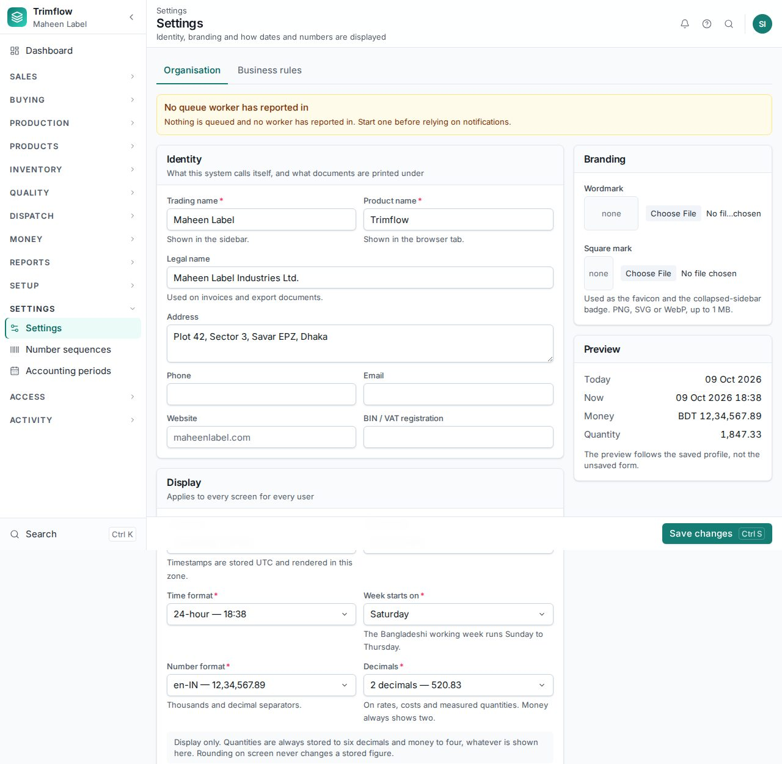
Settings, grouped by what they affect.
Good to know
- Settings take effect on the next screen you open. Nothing needs restarting.

2.2 Lists: the values forms choose from
The Setup group of the menu holds every list the forms draw on: factory units, departments, shifts, employees, buying houses, payment terms, units of measure, currencies, warehouses, machine groups, operations, defect codes and so on. Open the group in the menu and pick a family of lists, then the list itself.
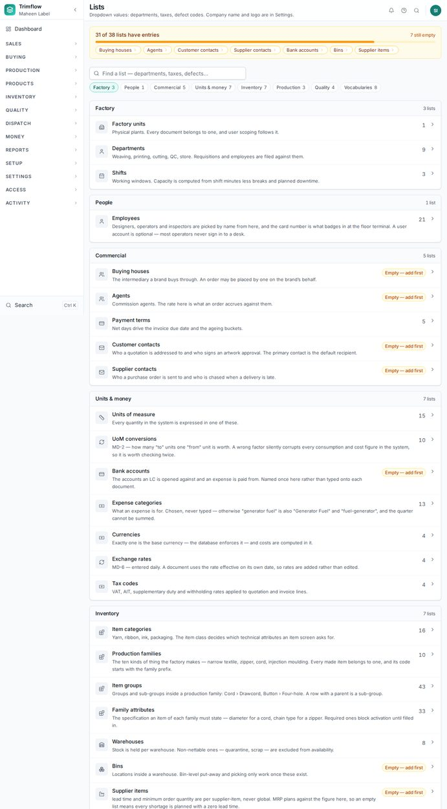
The lists directory. Lists still empty are flagged so you know what to fill first.
- Open Setup in the menu, then the family (for example Factory), then the list (for example Departments).
- Press New to add a row. Fill the fields and press Save.
- Click a row to edit it. A row something still points at cannot be deleted; make it inactive instead.
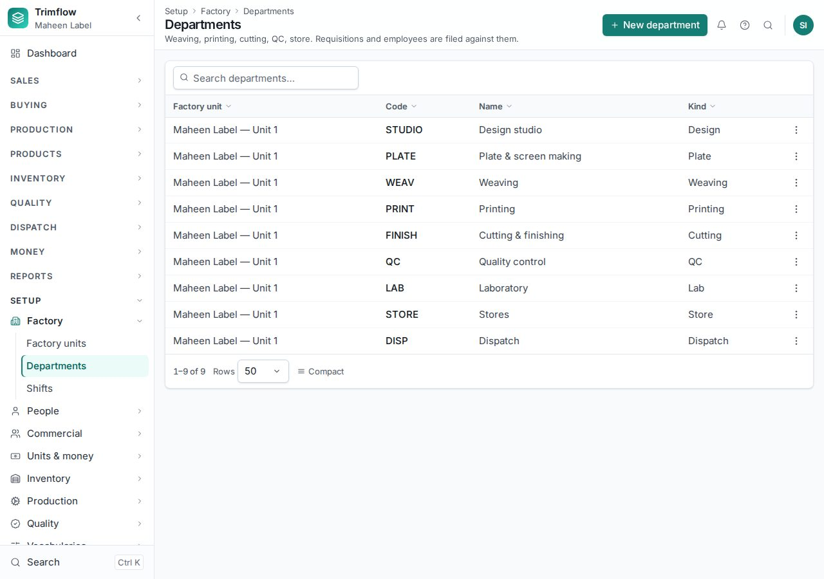
A list screen. Every list looks like this.
Fill these first, in this order, because later screens depend on them: Units of measure, Factory units, Departments, Shifts, Warehouses, Machine groups, Payment terms, Currencies, Employees.

2.3 Operations: the steps a factory runs
The Operations list (Setup › Production › Operations) is the master list of every production step: warping, weaving, dyeing, printing, die cutting, moulding, plating, assembly, inspection, packing. A step several product families share, such as dyeing or printing, is one operation here; every routing that runs it points to the same row.
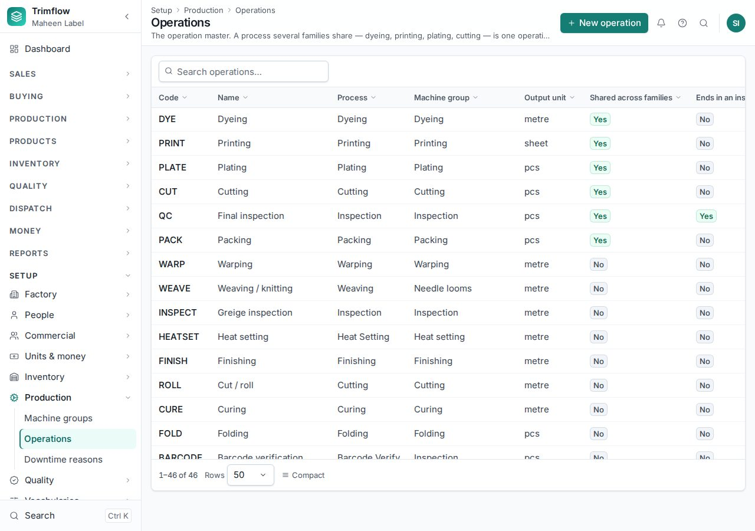
The operation master. "Shared across families" marks the steps more than one family uses.

2.4 Number sequences
Every document gets its number automatically when it is confirmed, from a sequence per document type. Settings › Number sequences shows what the next number will be. It is read-only on purpose: a number series edited by hand ends up with duplicates.
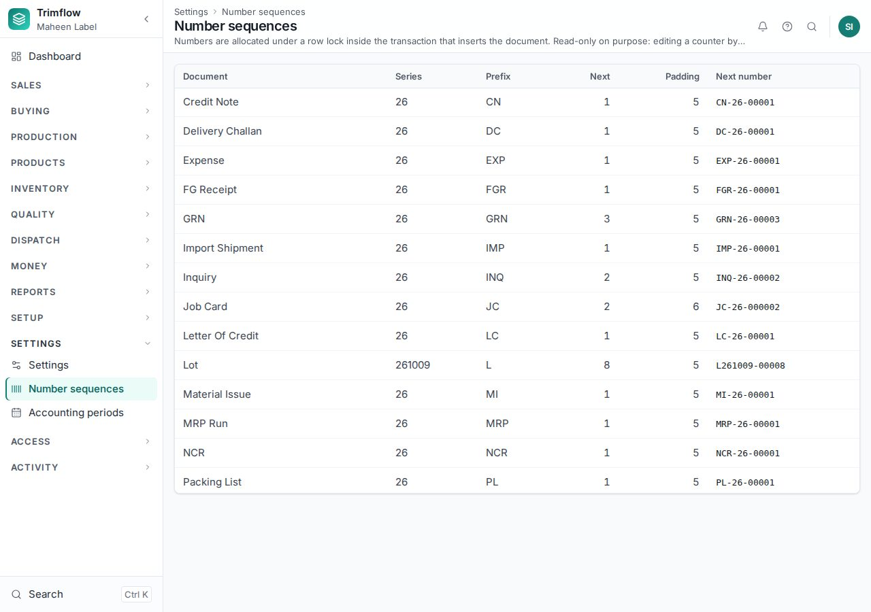
Number sequences.

2.5 Users, roles and permissions
- Open Access › Users and press New user. Enter the name, email, the factory unit they belong to and the roles they hold. Press Save; the user receives the starter password.
- Open Access › Roles & permissions to see what each role may do. A role is a set of permissions: view, create, update, delete, export, and the actions of each document (confirm, approve, post, release).
- Give a person the smallest role that covers their job. The Managing Director role reads everything and approves exceptions but enters nothing.
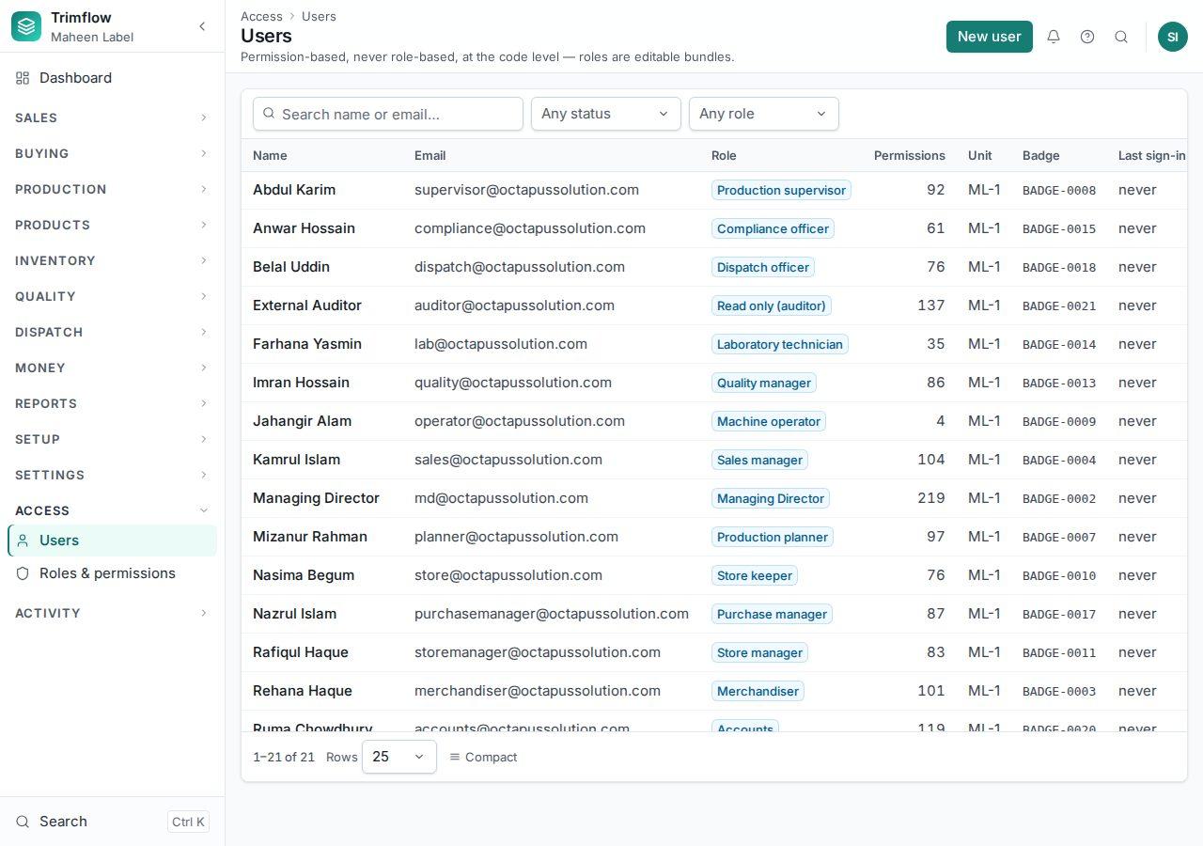
Users.
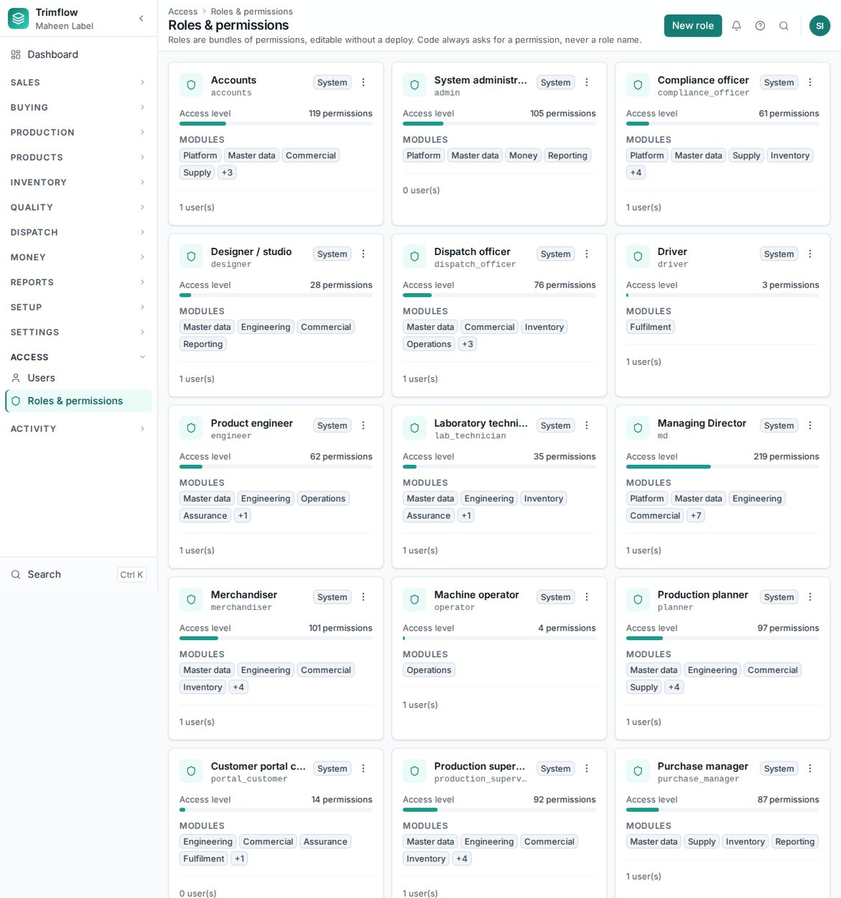
Roles and what each may do.
Good to know
- Some rights are never included in a role's wildcard and must be granted by name, for example confirming an order below the margin floor.
- Every change to a user or a role is on the audit log (chapter 12).

2.6 Accounting periods (month-end close)
A month that accounts has reported must not change afterwards. Settings › Accounting periods lets accounts close a month. Once closed, no stock movement, invoice, bill, receipt, payment, refund, expense or goods receipt can be dated into it. Reopening needs its own right and a reason, and both are written to the audit log.
- Open Settings › Accounting periods. Every month from the first document to today is listed, open or closed.
- Press Close on the month, add a note if you wish, and confirm. The month cannot be a future one.
- To reopen, press Reopen, type the reason, and confirm.
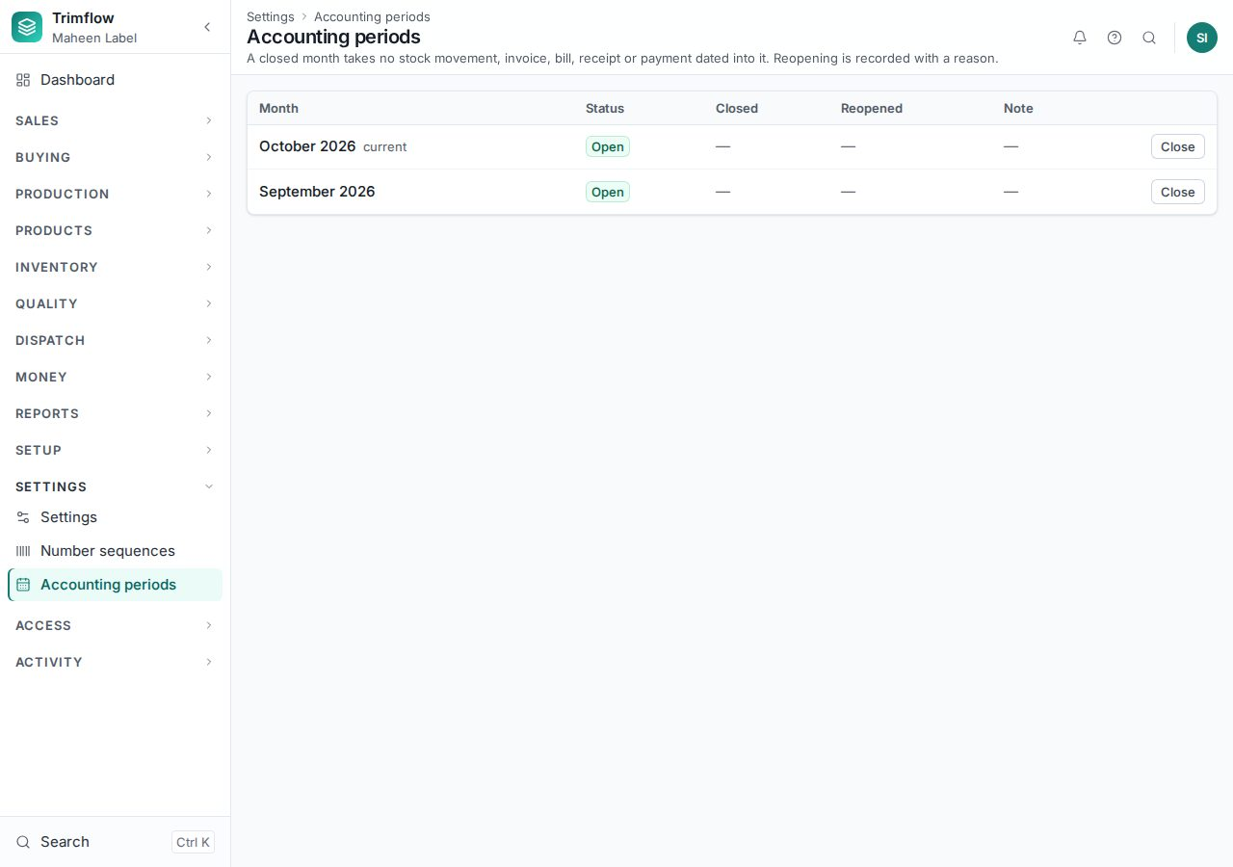
Accounting periods.

3. Products and materials (master data)
Everything the factory buys, makes, consumes or charges for is an item. A made item also has a product page holding its engineering details: customer, style, routing, bill of materials, artwork. Set these up before selling or making.

3.1 Materials and items
- Open Inventory › Materials. The list shows every item with its type, family, unit and status.
- Press New item.
- Identity: name, item type (raw material, consumable, component, semi-finished, finished good, tool, service, packaging) and whether it is made here or bought. The code is assigned when you save.
- Made for: Standard (any customer may order it) or Buyer-specific (belongs to one customer; then choose the customer).
- Classification: the production family (01 Narrow textile to 10 Decoration), group and sub-group, and the garment type. A made item must have a family. The family decides which specification fields appear below.
- Specification and variants: the family's own fields (width, construction, chain type, diameter…) and which variants the item comes in: colour, size, length.
- Units, purchasing and stock: the stock unit, the buying and ordering units with their conversions, pack sizes, default warehouse and supplier, minimum order, reorder level and maximum stock.
- Costing and quality: standard rate, valuation method, standard wastage %, lot tracking, QC plan reference.
- Press Create item. The item is saved as a Draft.
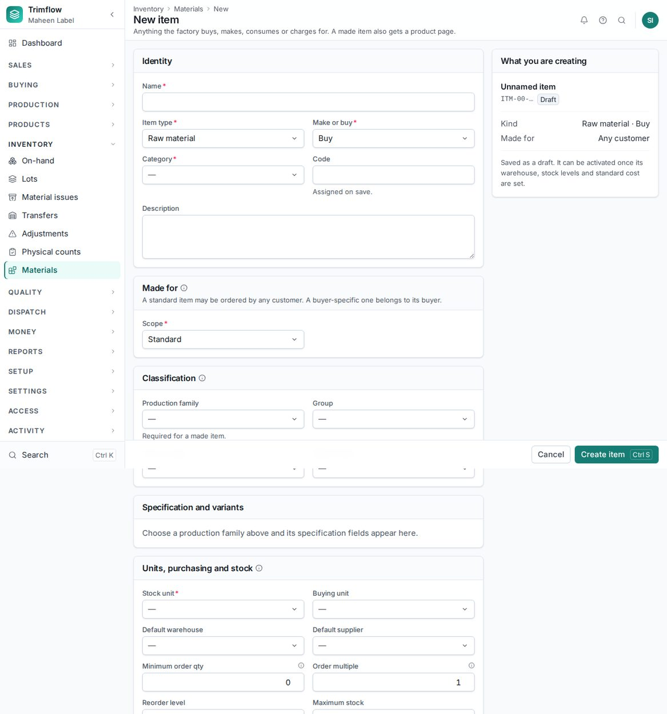
The new item form. Sections appear as they become relevant to what you chose.
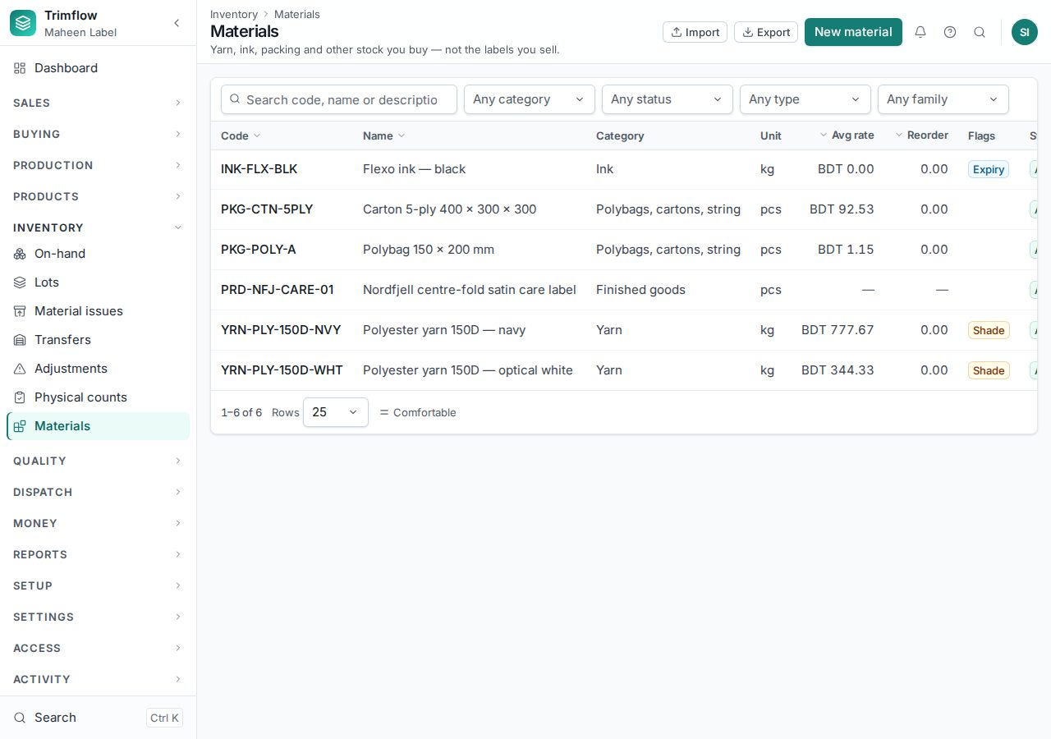
The materials list.

3.2 Activating an item
A draft item cannot be bought, put on a bill of materials, quoted or ordered. The item page shows a checklist of what it still needs: family and units, a routing and bill of materials for a made item, standard wastage, a warehouse, stock levels, a standard cost. Once every required step is done, a person with the activate right presses Activate.
- Open the item. Read the "Ready to activate" panel on the right.
- Work down the list. Each line links to where it is fixed.
- Press Activate. The item becomes Active and appears in pickers.
- Later, Hold stops new orders without deleting anything; Discontinue retires it for good.
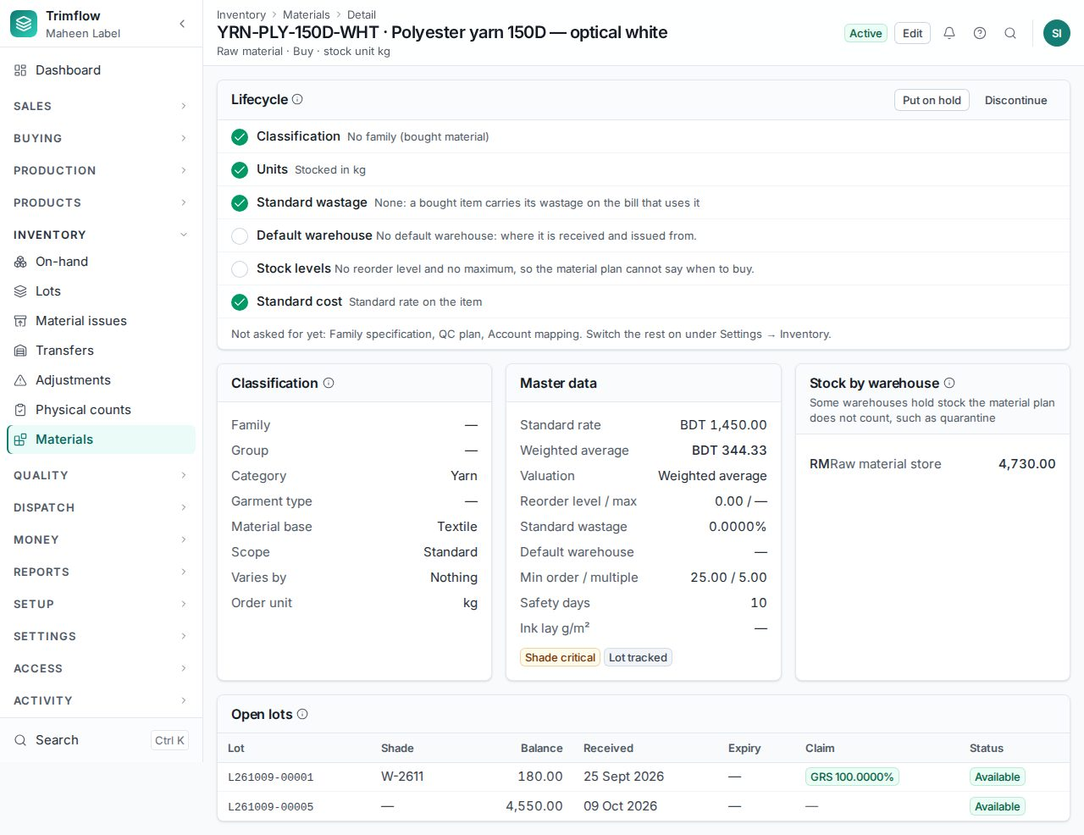
An item page with its activation checklist.

3.3 Products
Products › Products lists every made item with its product page. The product page is where the engineering lives: the routing it runs down, its specification, artwork, bills of materials and tools.
- Press New product. The form is the item form with the finished-good details first: customer, brand, style reference, process type and routing.
- Save. The product page opens with a setup checklist: specification, artwork, bill of materials, routing, price.
- Work down the checklist. Each step opens the right screen.
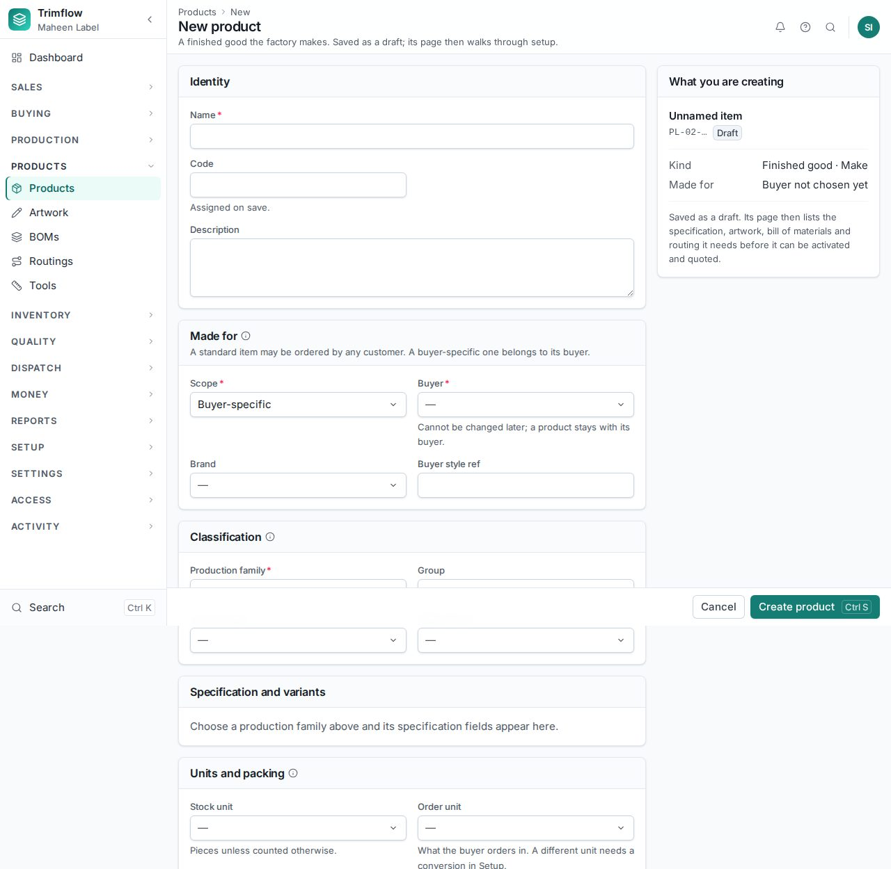
The new product form.
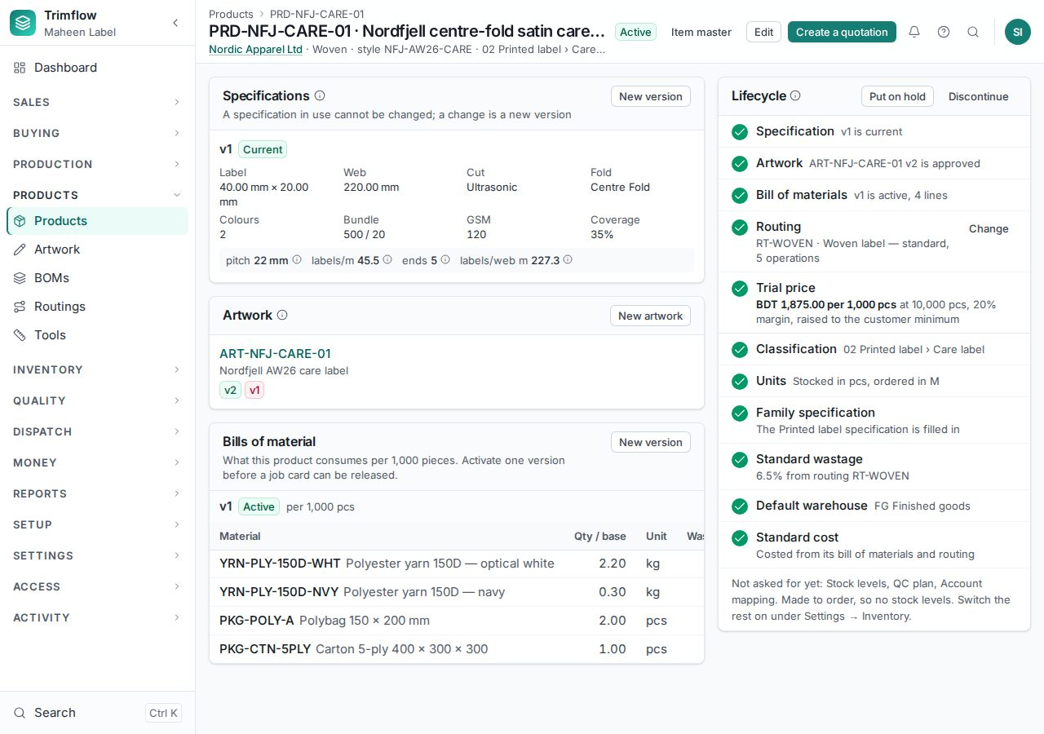
A product page with its setup checklist, specification, artwork and bills of materials.
Good to know
- A label product (woven, flexo, screen, heat transfer, offset, thermal) is costed by its geometry and needs a specification and approved artwork. A product of any other family (zipper, cord, button, moulded part, packaging) is costed from its bill of materials and routing and needs artwork only if its family says so (paper, packaging and decoration do).

3.4 Routings: the steps a product goes through
A routing is the list of operations a product runs through, in order, with the machine group, rate per hour, setup time, wastage and people each step needs. Every production family has a standard routing already seeded: narrow textile, printed label, paper, zipper, plastic and metal fastener, cord, injection, polybag, carton, tissue, textile support and decoration.
- Open Products › Routings. Filter by family to find the family's standard process.
- Open a routing to read its steps. "Shared" marks a step that is the same operation on several families; "optional" marks a step a job may skip.
- To make your own, press New routing. Choose the family (or the label type), then add steps. Picking a step "From master" fills in its name, machine group and whether it ends in an inspection; you then set the rate, setup and wastage for your factory.
- Tick "Default for this family or type" on the routing new products should get automatically.
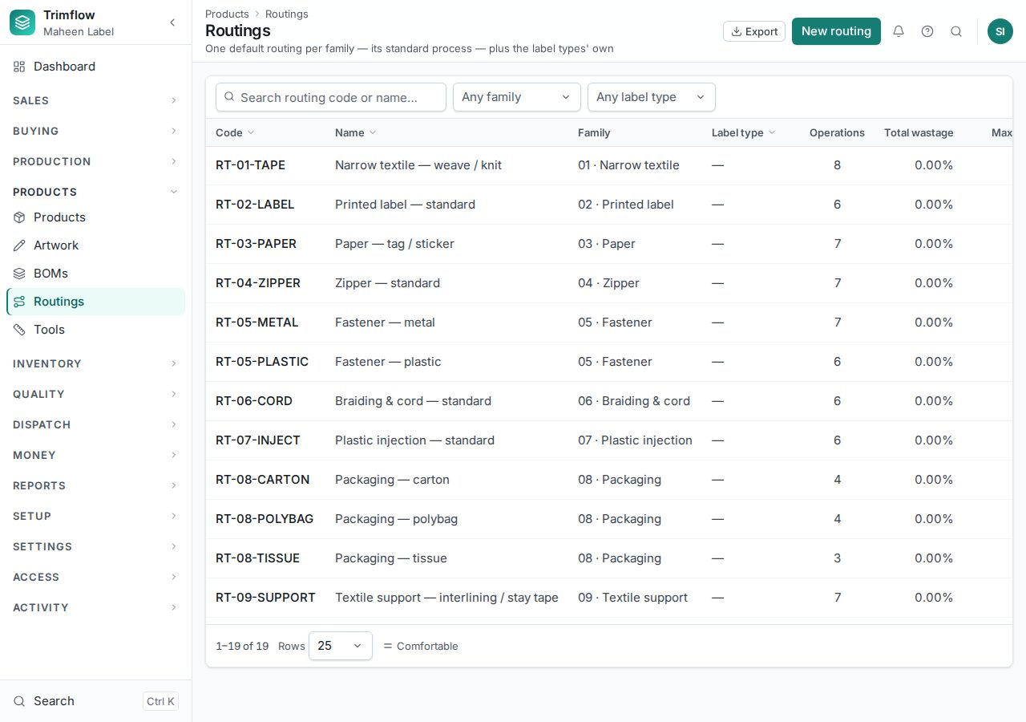
Routings, one default per family.
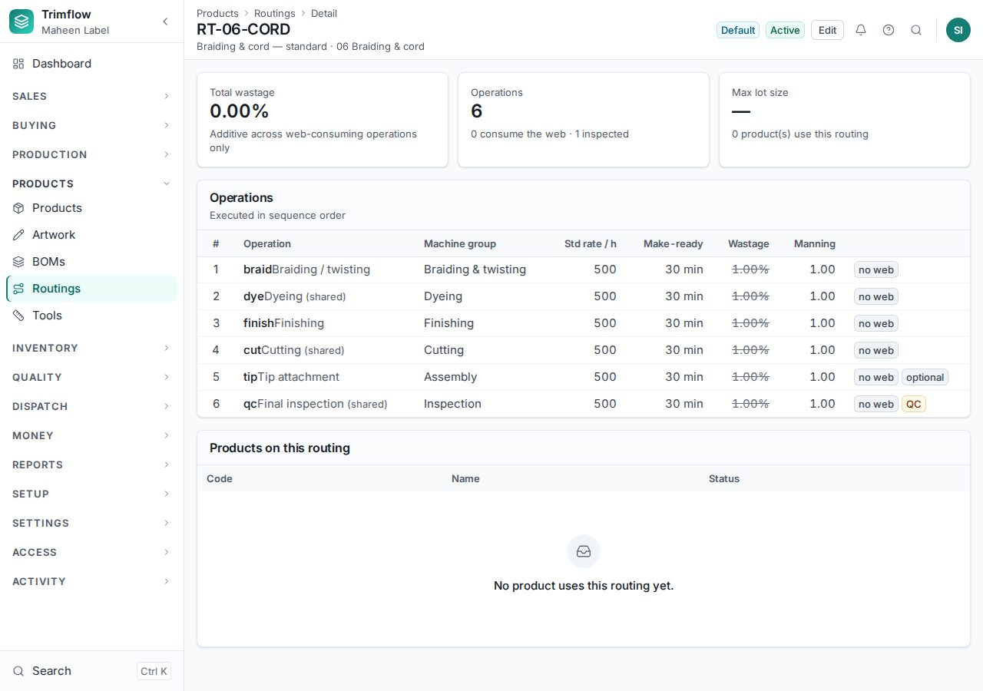
A family routing: shared steps and optional steps marked.
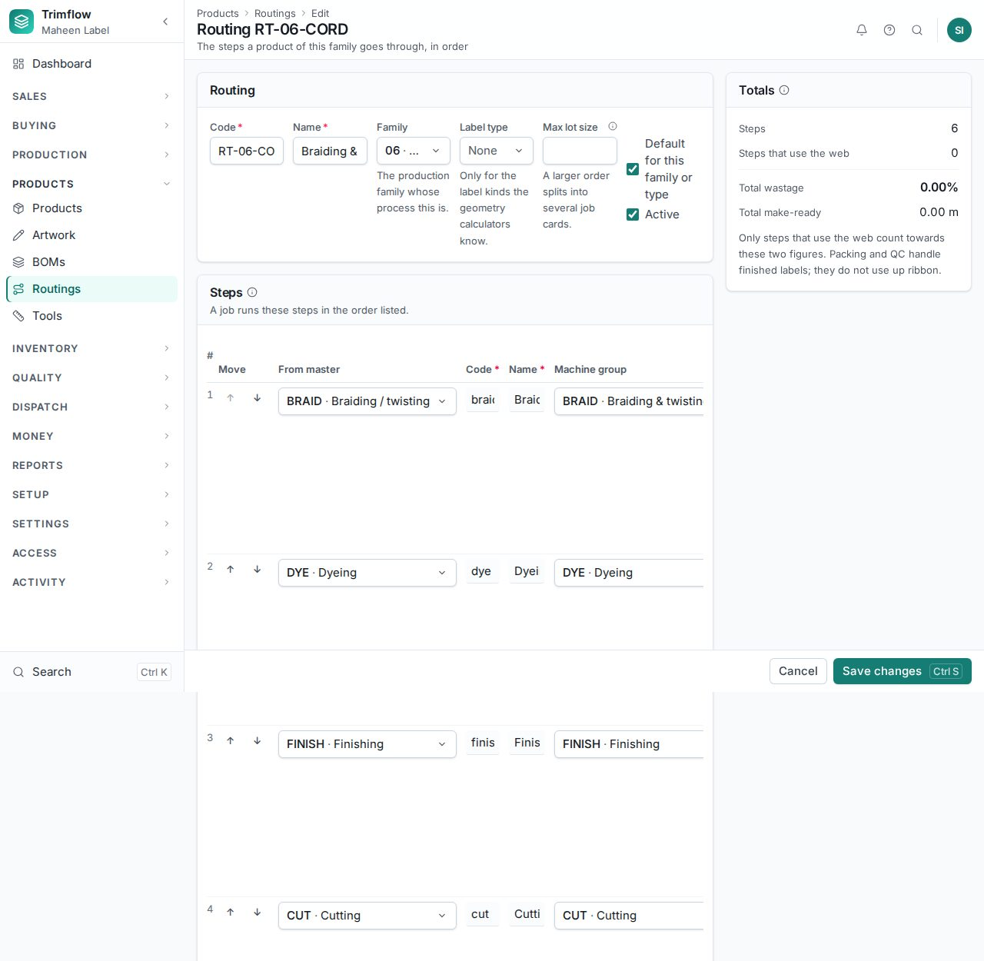
Editing a routing. Steps are picked from the operation master.

3.5 Bills of materials
A bill of materials (BOM) says what a product is made of: each material, how much per base quantity, and the wastage on it. A made item can be on another product's bill, so a zipper lists the tape another family makes.
- Open the product and press New bill of materials, or open Products › BOMs.
- Set the base quantity (for example per 1,000 pcs) and add a line per material with the quantity and wastage %.
- Save as a draft, then Activate it. Only one bill is active per product; activating a new one retires the old.
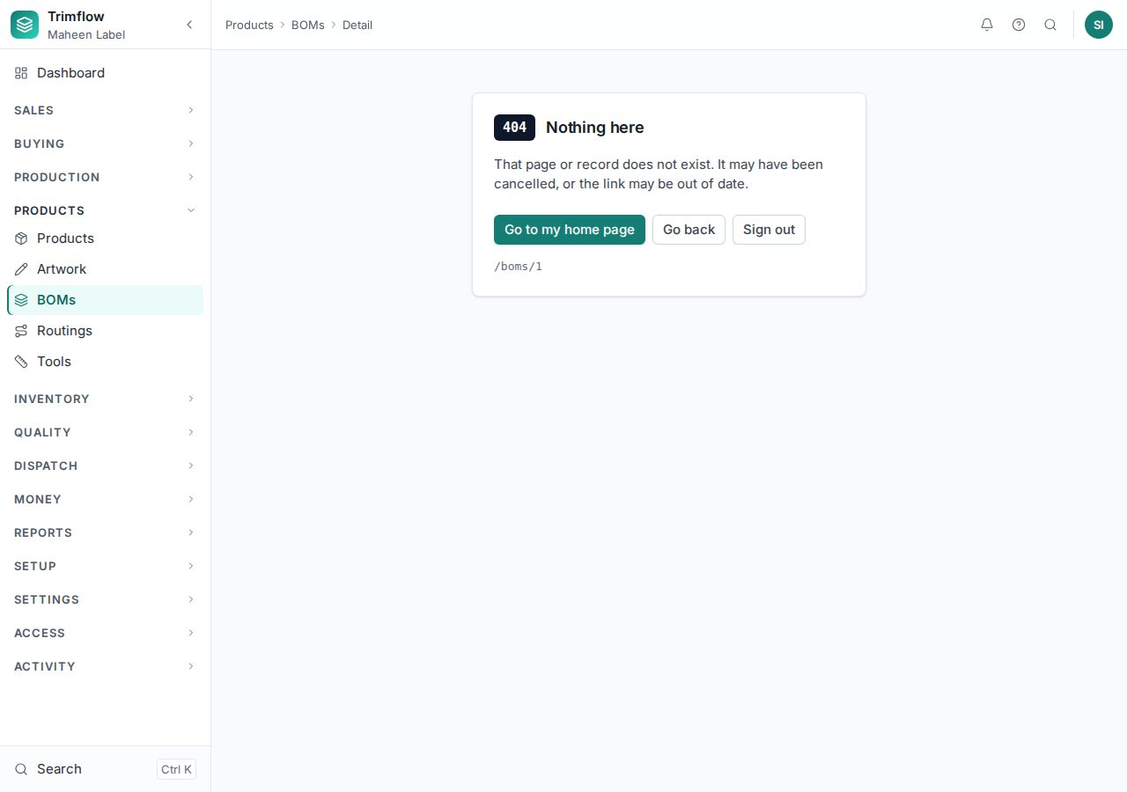
A bill of materials.

3.6 Artwork
Artwork is the design file a printed product is made from. Each artwork has versions; a version is uploaded, checksummed, submitted and approved. A job for a product whose family needs artwork cannot be raised until a version is approved, and a superseded version cannot be used.
- Open Products › Artwork and press New artwork, or start from the product page.
- Upload the file as a new version. Submit it for approval.
- The approver (often the customer through the portal, or the designer's manager) opens it and presses Approve.
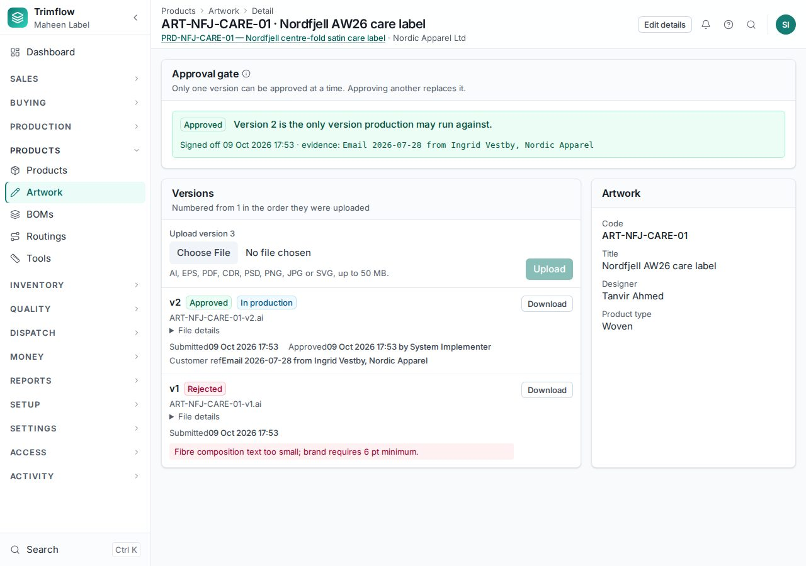
An artwork with its versions.

3.7 Tools and machines
Tools are the plates, screens, dies, moulds, loom settings, shade cards and files a product needs. A mould records its cavities and press tonnage, and its life in shots; every job that runs on it adds the shots it took, and a worn-out tool blocks the release of the next job.
- Open Products › Tools and press New tool. Choose the kind, give it a code, and for a mould enter the cavities and tonnage. Set who owns it (the factory or a customer) and its life.
- Open Production › Machines to add machines. Every machine belongs to a machine group; a routing step is scheduled on a group and run on one of its machines.
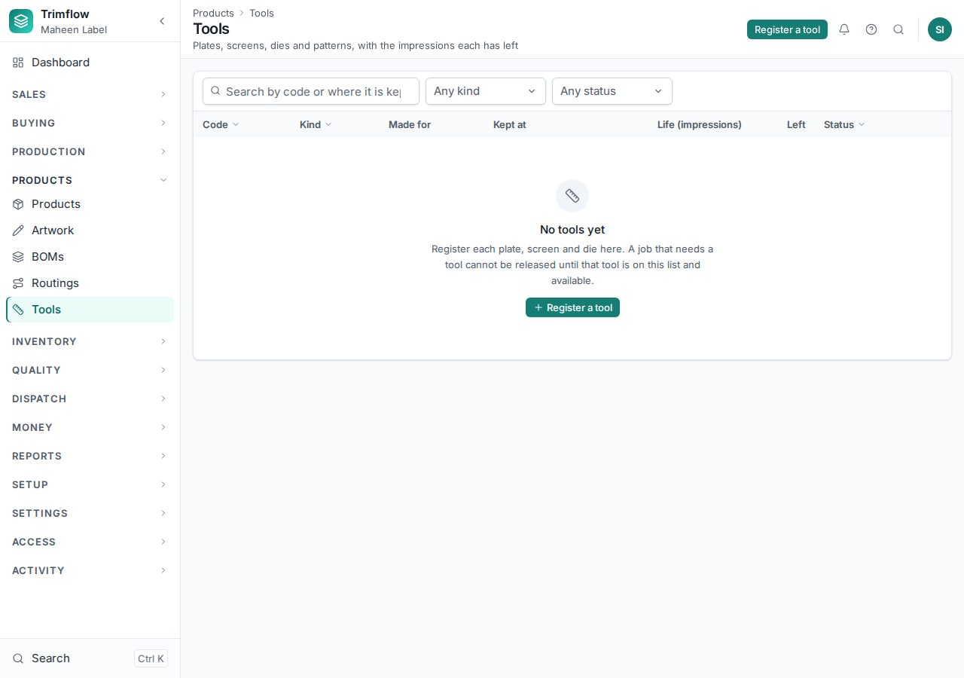
Tools.
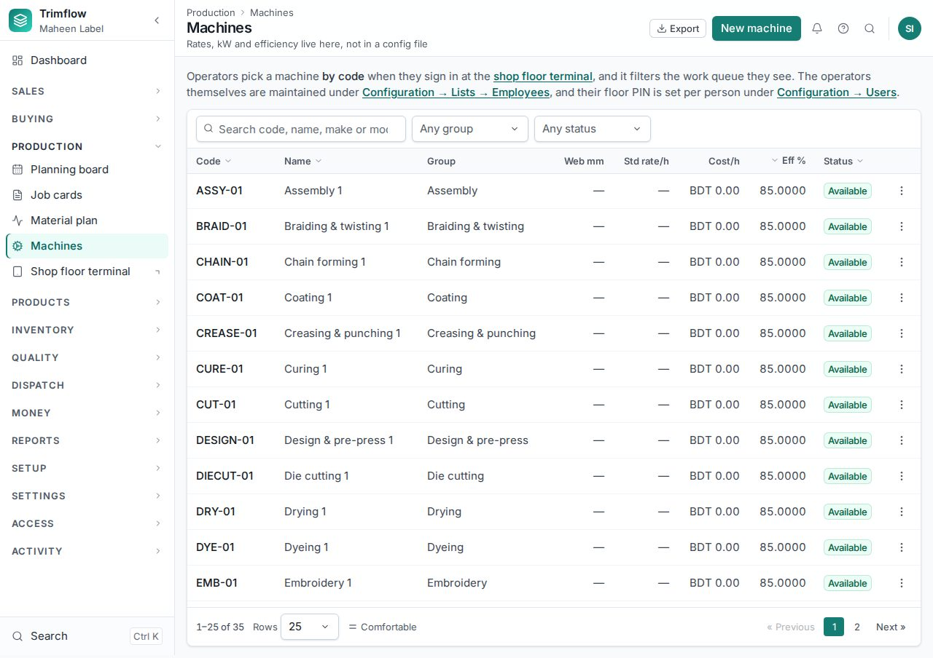
Machines.

3.8 Customers and suppliers
- Open Sales › Customers (or Buying › Suppliers) and press New.
- Enter the code, name, kind, currency, payment terms, credit limit, tax numbers, email and phone.
- On the customer page add contacts, brands and delivery addresses. On the supplier page add contacts and the materials they supply with lead time and last rate.
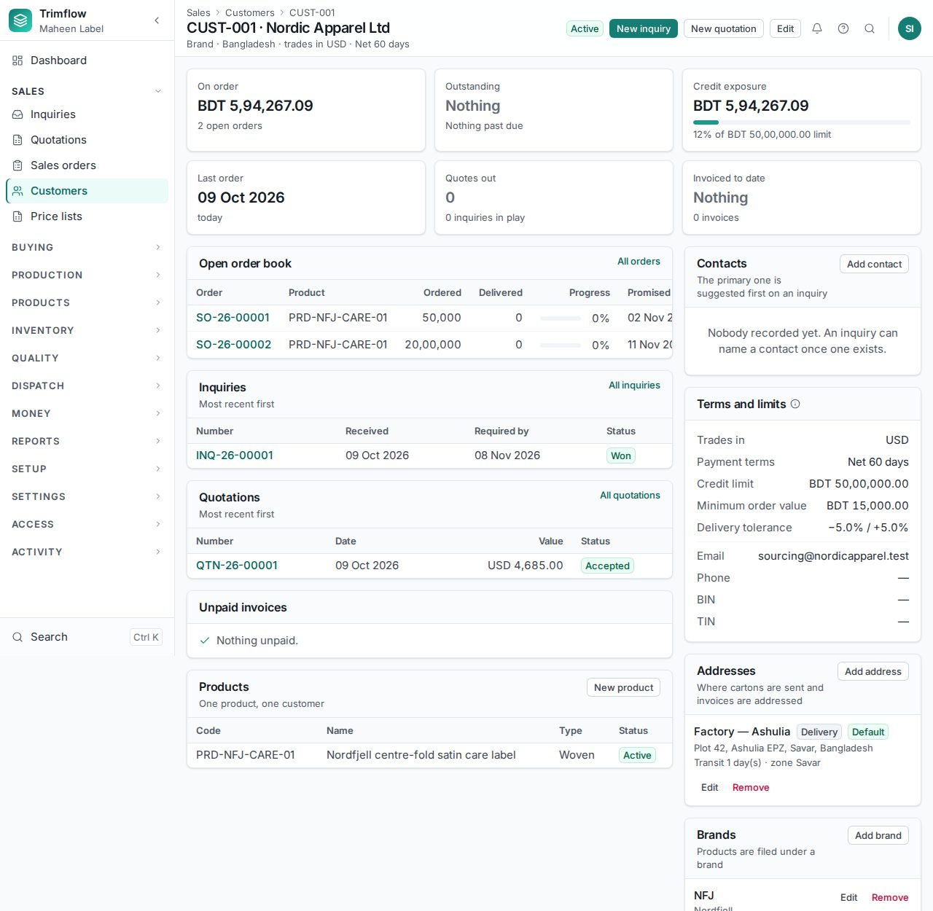
A customer page: details, contacts, orders, invoices and credit exposure.
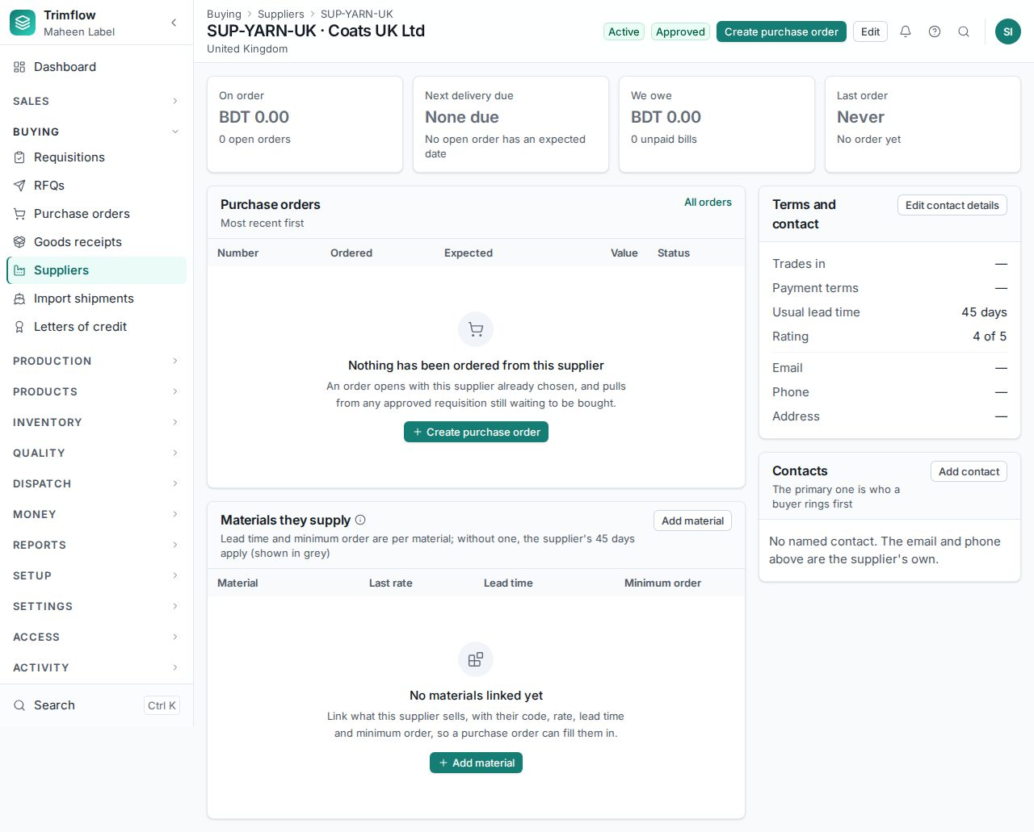
A supplier page.

4. Selling: inquiry, quotation, order
The commercial chain is Inquiry → Quotation → Sales order. A quotation carries a cost sheet; an order carries a locked pre-production cost; the job that fills it carries the actual cost. Chapter 10 explains the costing.

4.1 Inquiries
- Open Sales › Inquiries and press New inquiry.
- Choose the customer, how the inquiry came in, and add a line per product or description with the quantity and the date wanted.
- Save. From the inquiry page press Raise quotation when you are ready to price it.
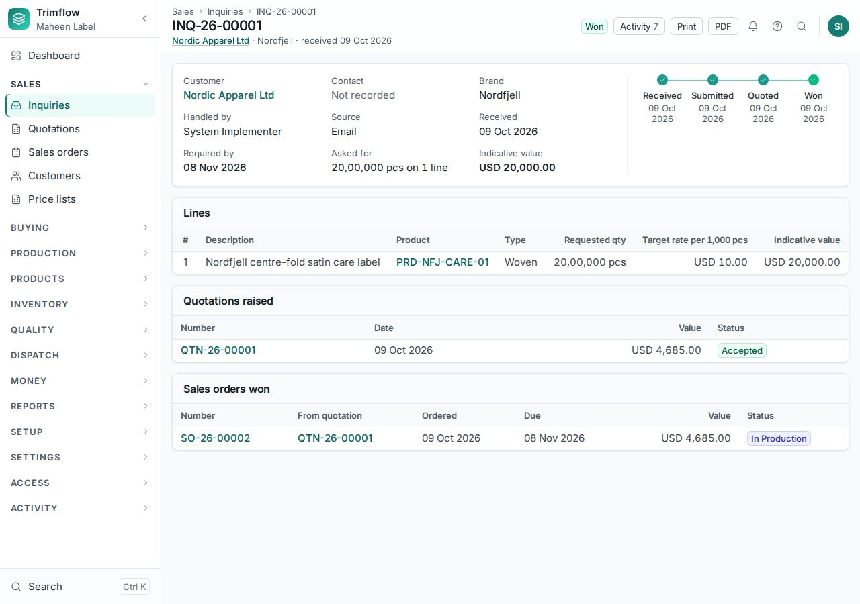
An inquiry.

4.2 Quotations
- Open Sales › Quotations and press New quotation, or raise it from an inquiry.
- Choose the customer and currency. Add a line per product. The product list shows only products this customer may buy.
- For each line the system builds a cost sheet from the product's specification, bill of materials and routing, applies the overheads and the margin, and proposes the rate. Change the margin on the line if the negotiation needs it. A margin below the floor needs someone with the override right.
- Save the draft, then Send. A sent quotation and its cost sheet are locked. Revise creates a new revision.
- When the customer agrees, press Accept; when they decline, Reject with a reason.
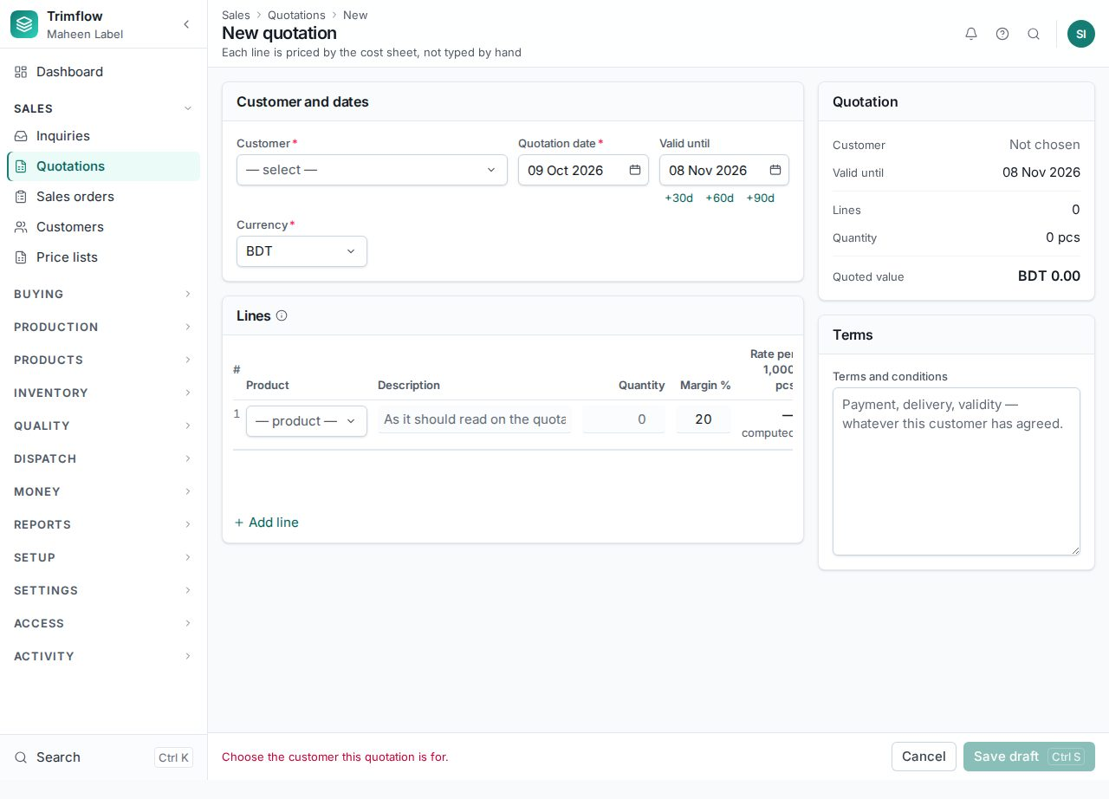
A new quotation.
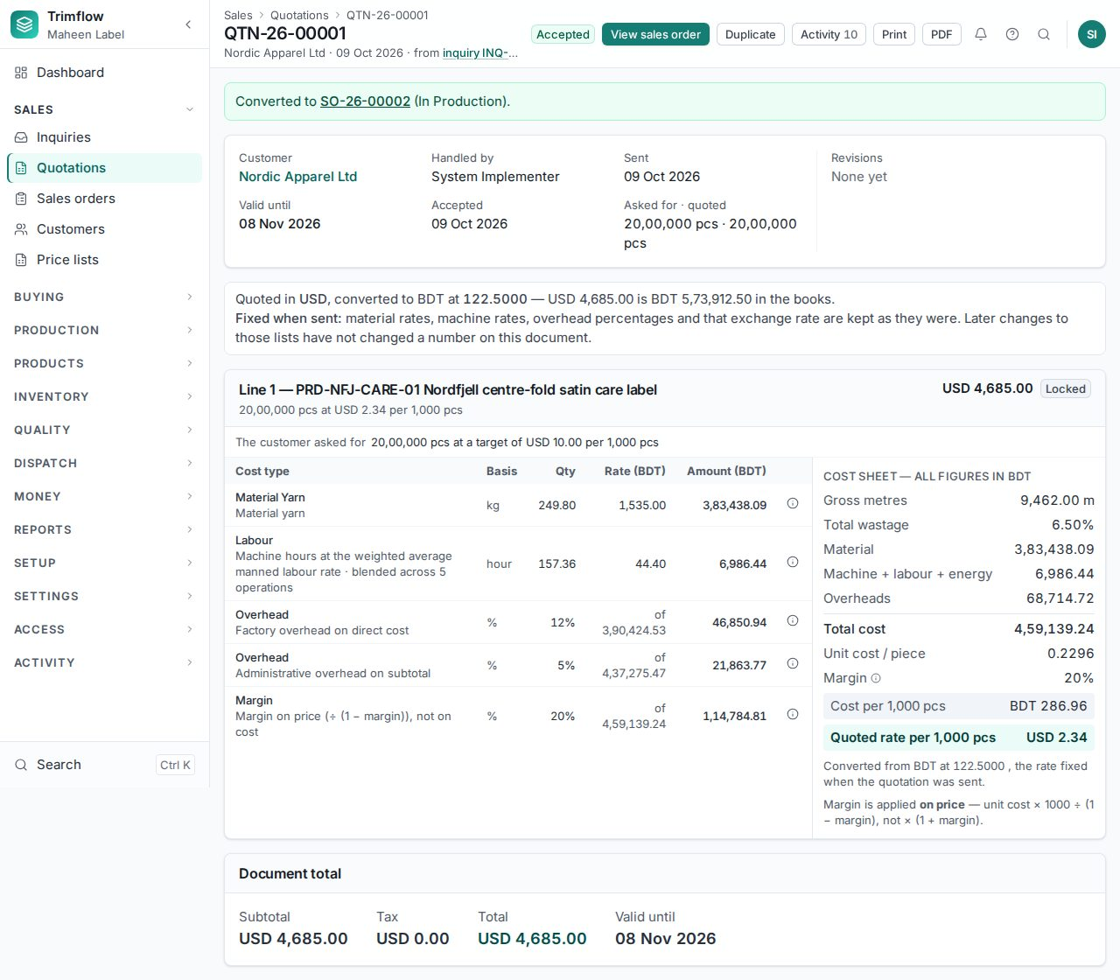
A quotation with its lines and cost sheet.

4.3 Sales orders
- Open Sales › Sales orders and press New sales order, or press Convert on an accepted quotation.
- Enter the customer's purchase order number, the delivery date and the lines: product, quantity and rate.
- Save the draft. The page lists what each line still needs before confirming: an active item, a current specification, approved artwork.
- Press Confirm. The order gets its number, every line is costed again at today's rates and locked as the benchmark, and a promised date is computed. If a line's expected margin is below the floor, only a person allowed to accept that margin can confirm.
- After confirmation the order moves by itself: In production when a job card is raised, Partially delivered and Delivered as challans go out, Closed when invoiced. Changes after confirmation are amendments with a reason.
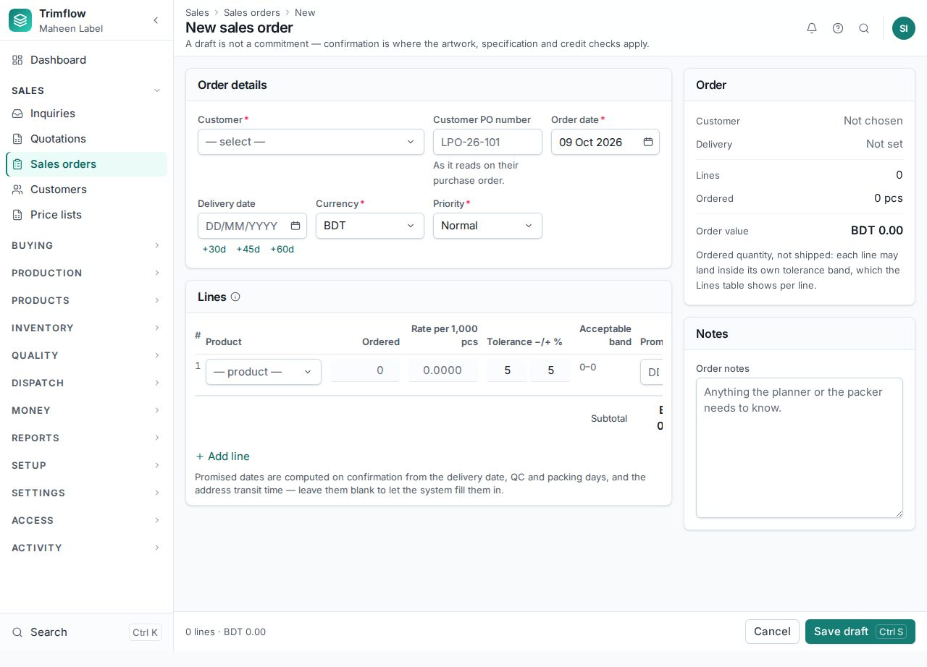
A new sales order.
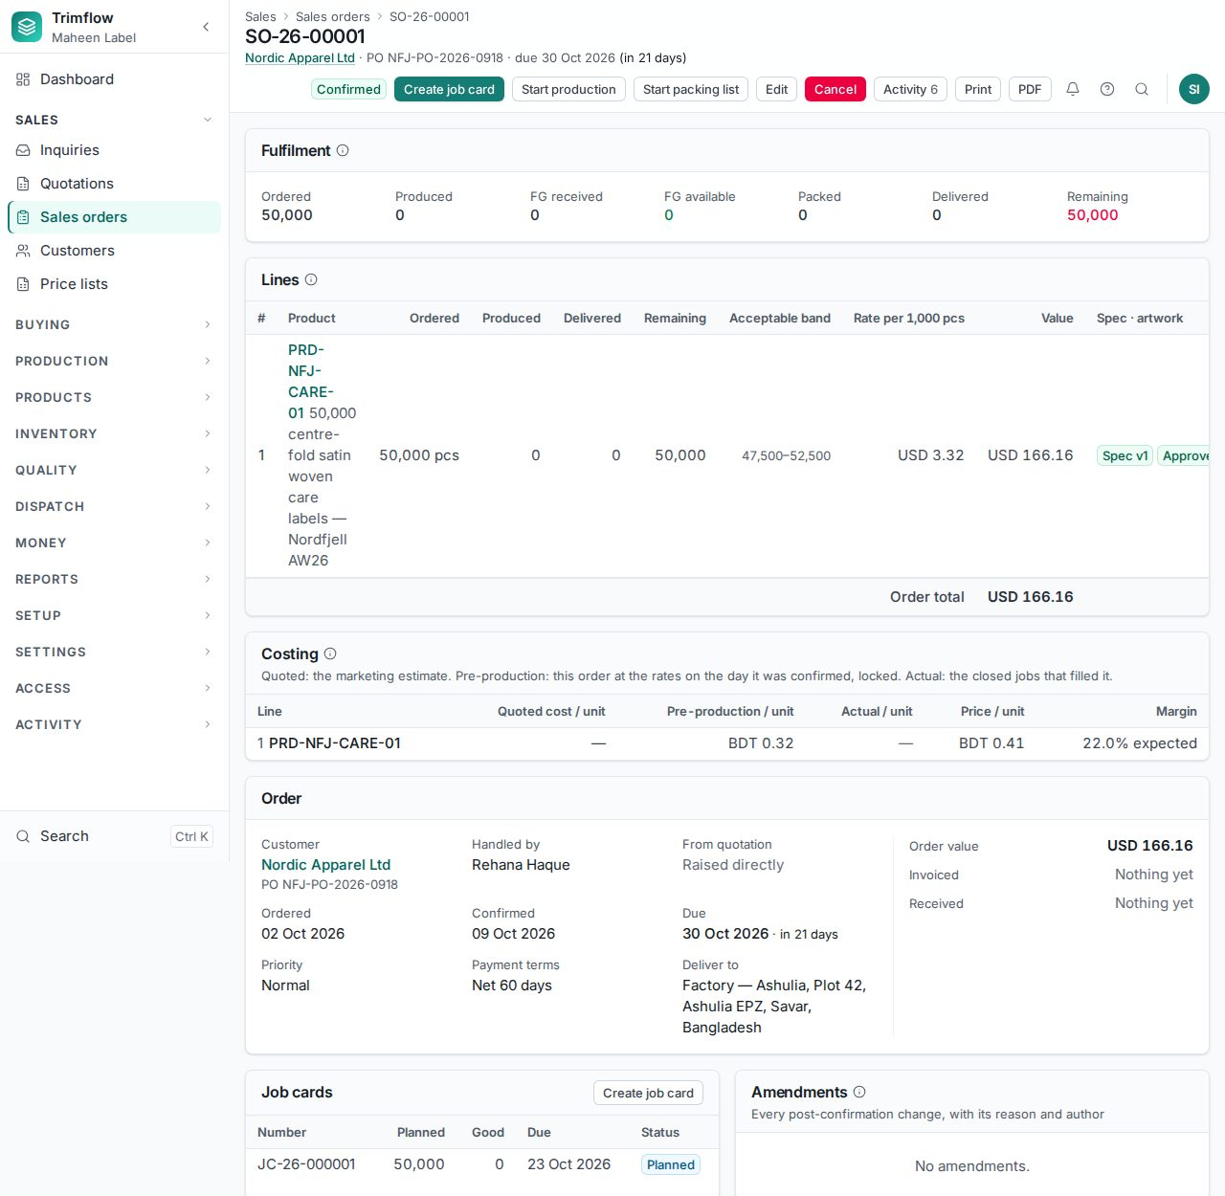
A confirmed order: fulfilment strip, lines, costing per line, job cards, amendments.
Good to know
- An order over the customer's credit limit goes to Credit hold instead of Confirmed. Accounts releases it.
- The "Acceptable band" on a line is how much over or under the ordered quantity the customer accepts. Dispatch is held to it.

4.4 Price lists
Sales › Price lists holds rates agreed with a customer by quantity break and validity dates. A quotation for a customer with a current price list reads the agreed rate instead of recomputing it.
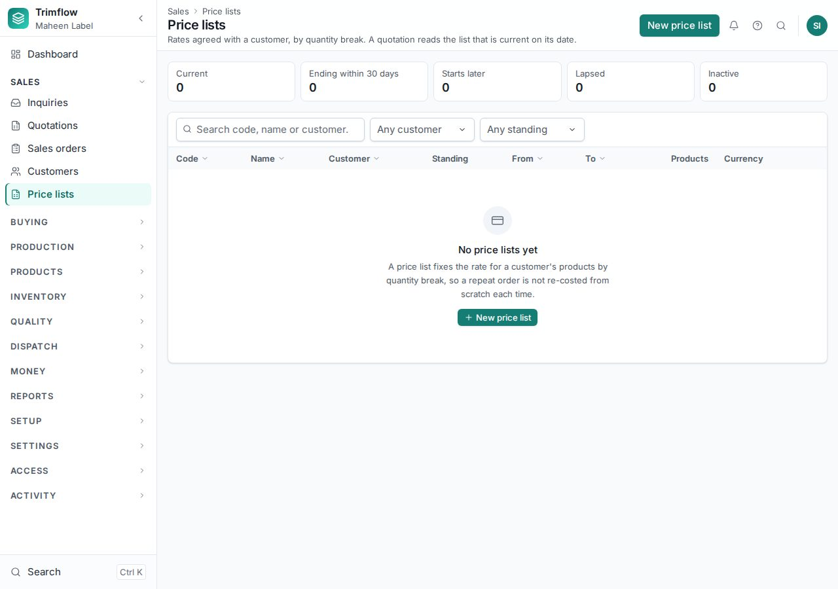
Price lists, with their standing today.

5. Buying: requisition, RFQ, purchase order, receipt

5.1 Purchase requisitions
- Open Buying › Requisitions and press New, or press Raise requisition on the material plan (see 6.8) to turn shortages into a requisition.
- Add a line per material with the quantity and the date needed. Submit for approval.
- The approver presses Approve. An approved requisition becomes an RFQ or a purchase order.
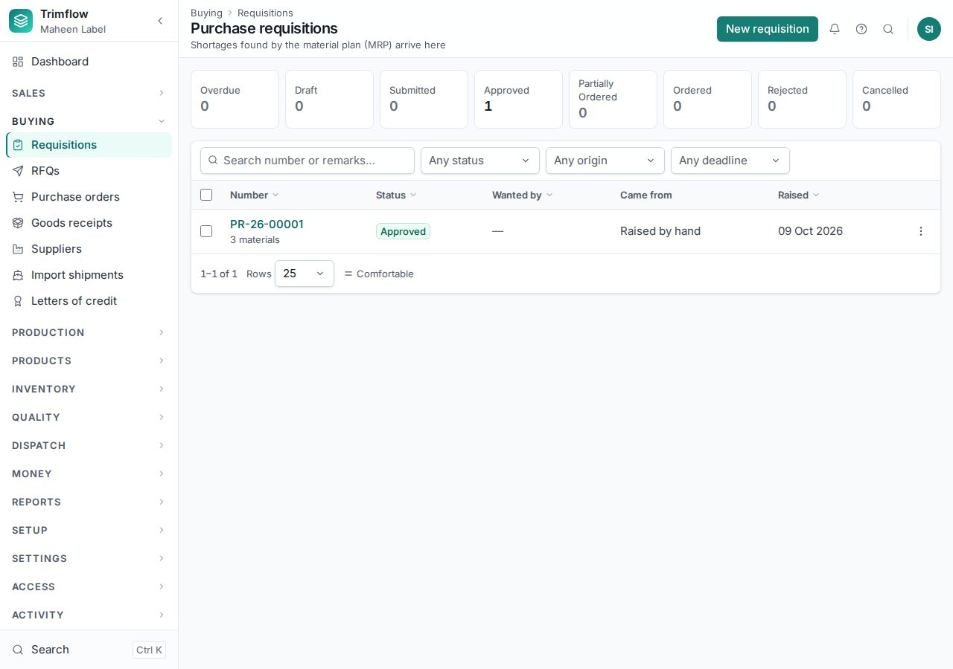
Requisitions.

5.2 Requests for quotation
An RFQ asks several suppliers to quote. Above the three-quote threshold in Settings, at least three supplier quotes are required before a winner is chosen.
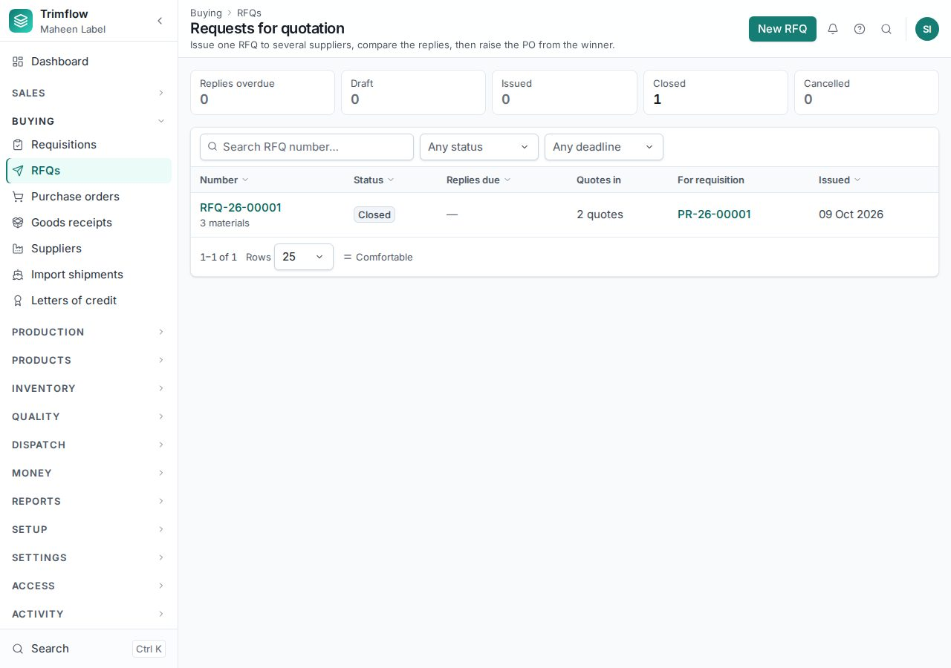
RFQs.

5.3 Purchase orders
- Open Buying › Purchase orders and press New, or create it from an approved requisition or a won RFQ.
- Choose the supplier, currency and terms. Add lines with the quantity, unit and rate.
- Submit. Orders above the manager band in Settings need the Managing Director's approval.
- Send the approved order to the supplier with Print or PDF.
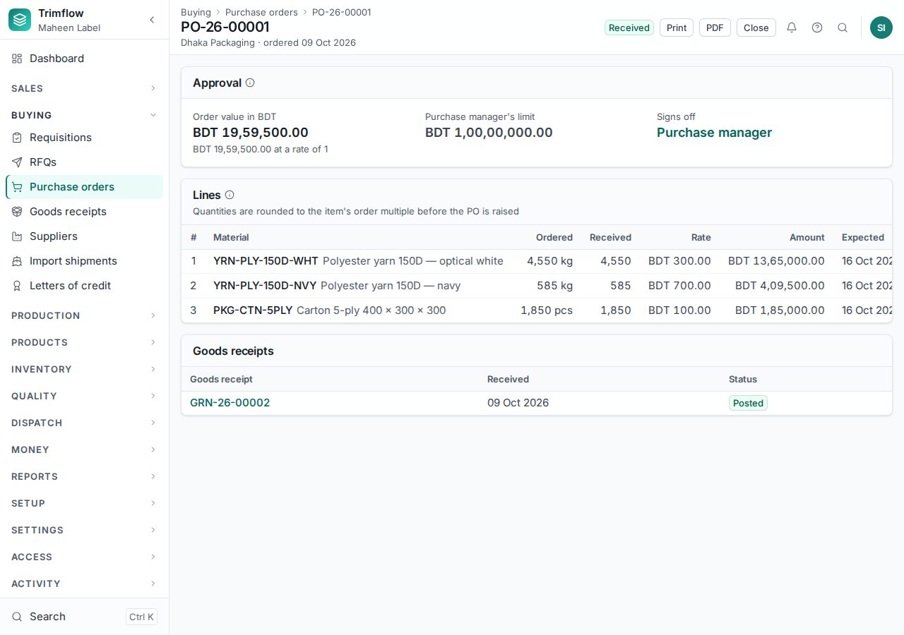
A purchase order.

5.4 Goods receipts
- Open Buying › Goods receipts and press New, choosing the purchase order the goods arrived against.
- For each line enter the quantity received, the warehouse, and for lot-tracked materials the lot details: supplier lot, shade, roll length, certification claim.
- Save, inspect if the material needs QC, then press Post. Posting creates the stock lots and the stock movements. A receipt dated into a closed month is refused.
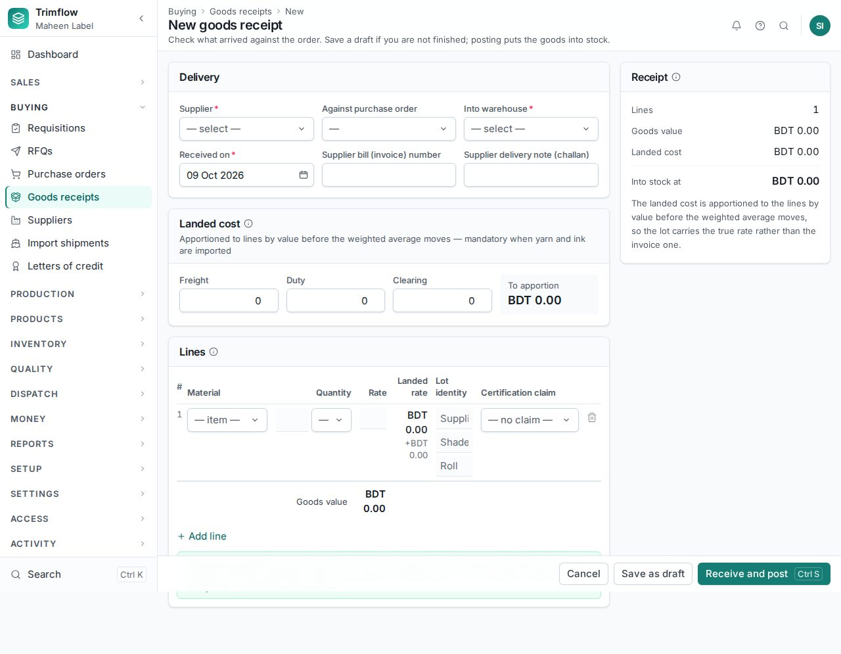
A new goods receipt.
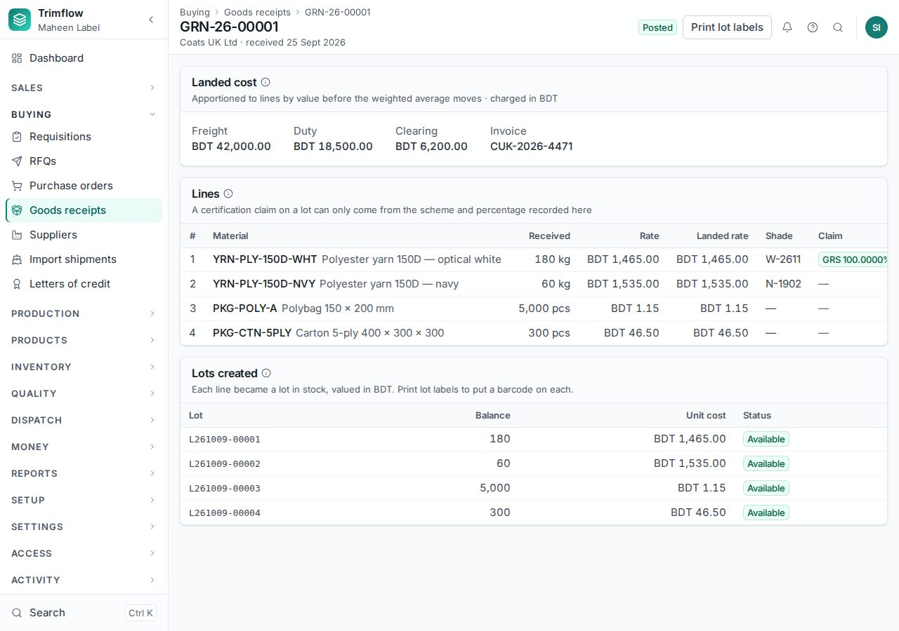
A posted goods receipt with its lots.

5.5 Supplier bills and payments
- Open Money › Supplier bills and press New. Match the bill to its goods receipts; a rate that differs from the order beyond the tolerance needs approval.
- Approve the bill. Open Money › Payments to pay it, allocating the payment to one or more bills.
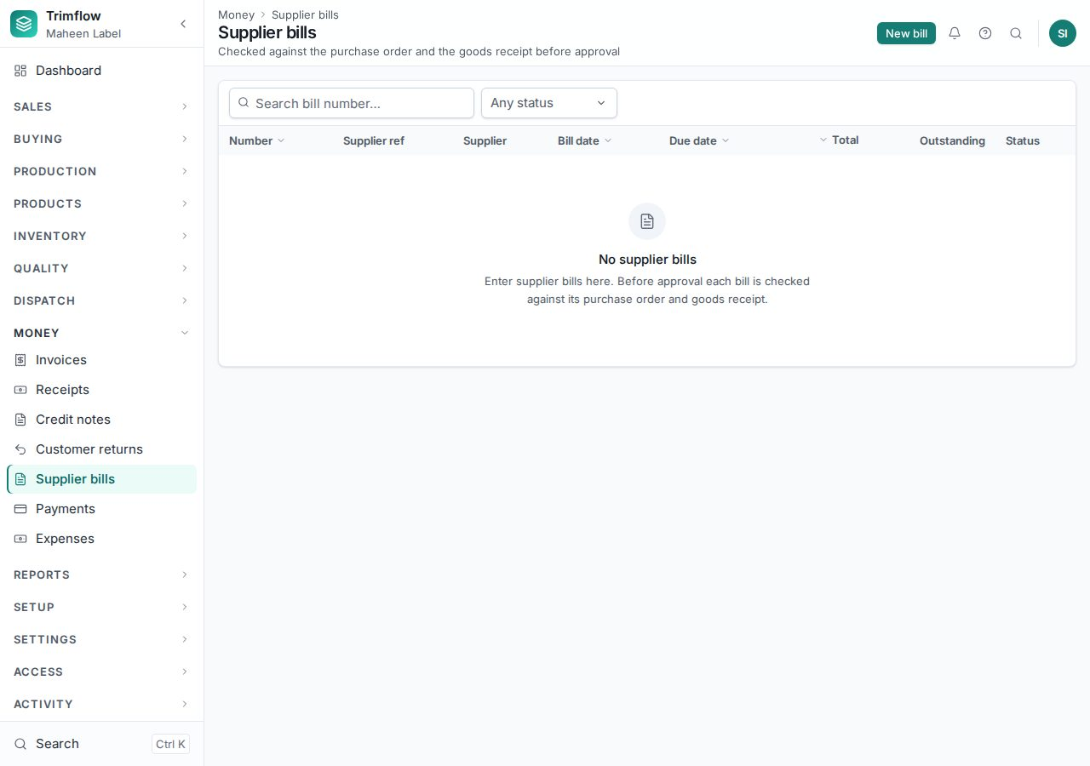
Supplier bills.

5.6 Imports: shipments and letters of credit
Buying › Import shipments tracks a consignment from the supplier to the warehouse and allocates its freight, duty and clearing costs onto the goods, so the stock carries its landed cost. Buying › Letters of credit records the credits those shipments are paid under.

6. Inventory
Stock is held in lots: a lot is one receipt of one material into one warehouse, with its own cost, shade and certification. Every movement in or out is a line in the stock ledger that is never edited; a correction is a new movement.

6.1 On-hand stock
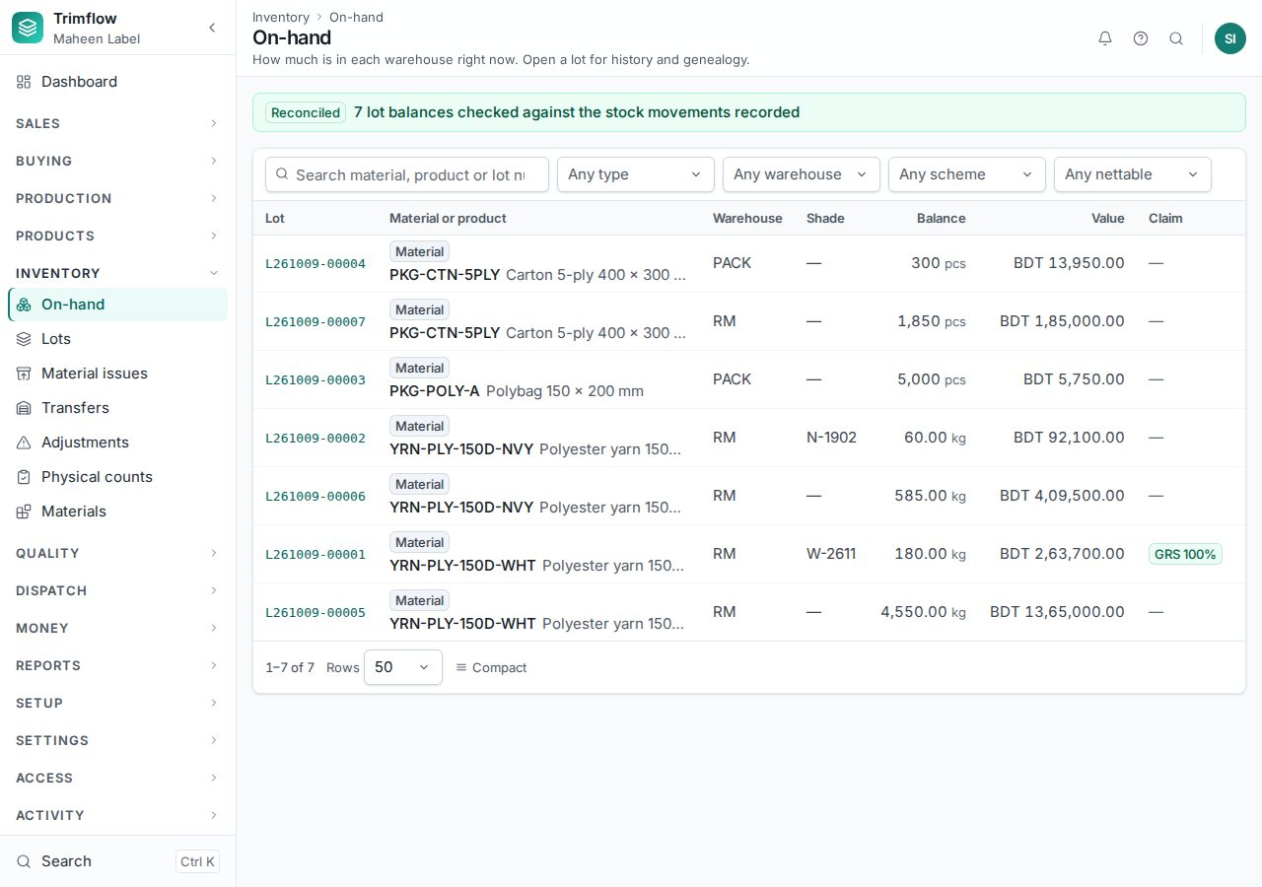
On-hand: what is in stock per material and warehouse, with what is reserved for jobs.

6.2 Lots
- Open Inventory › Lots. Filter by warehouse, material or status.
- Open a lot to see its balance, cost, shade, certification claim and every movement with the document that caused it.
- Print label prints the barcode the scan fields read. Transfer and Adjust open those forms with this lot already chosen.
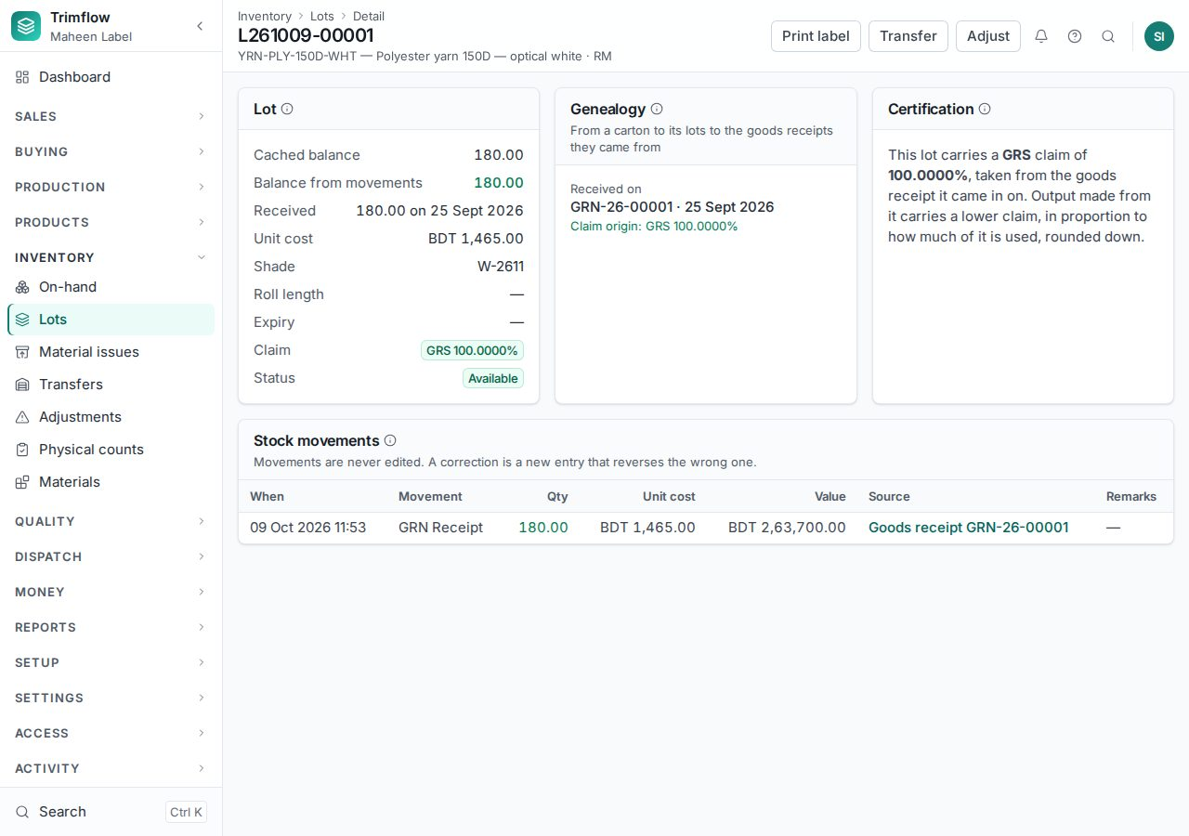
A lot with its history.

6.3 Material issues to jobs
- Open Inventory › Material issues and press New issue, or press Issue material on the job card.
- Choose the job card. The form lists what the job's bill of materials needs against what has already been issued, and suggests lots oldest first, same shade first.
- Pick the lots and quantities. Save, then Post. Posting moves the stock to the job.
- Material left over comes back with a Return issue.
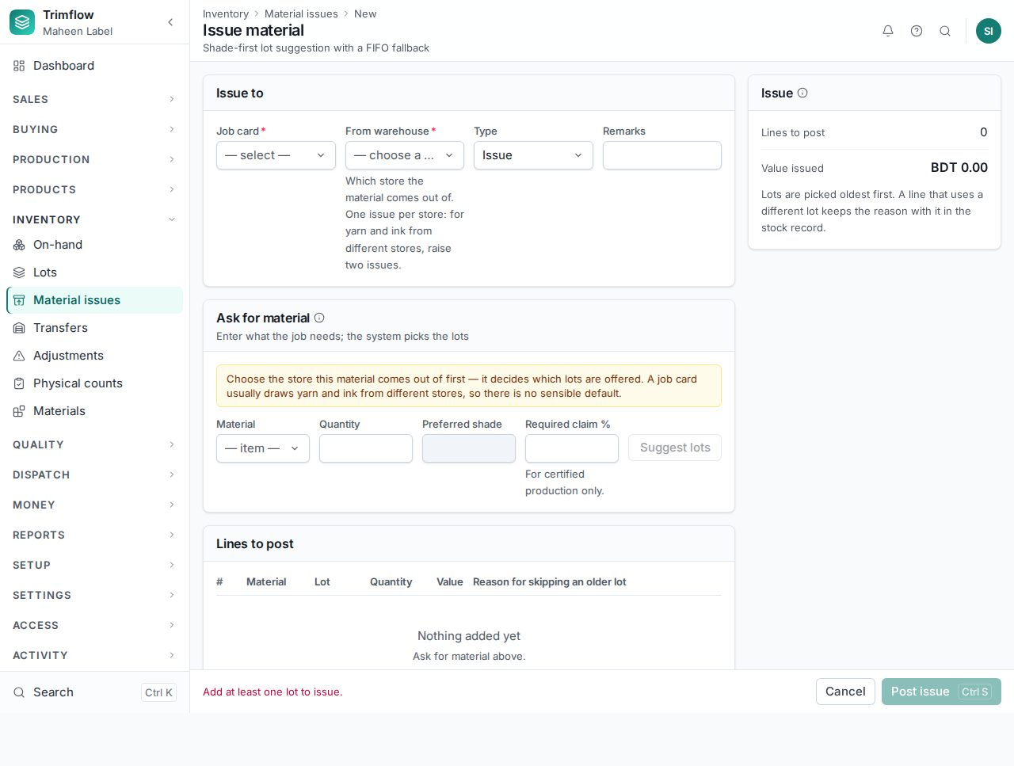
Issuing material to a job.

6.4 Transfers between warehouses
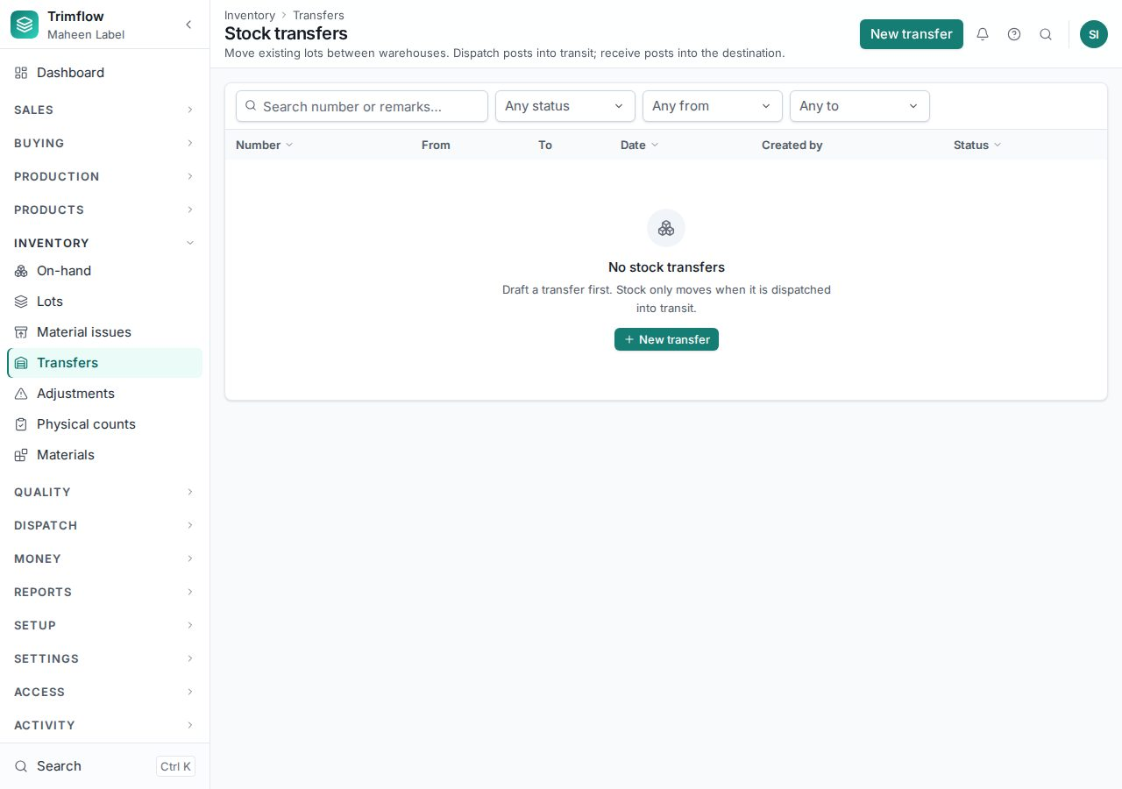
Stock transfers.
- Press New transfer. Choose the source warehouse; find the lots by scanning or typing; set the destination warehouse.
- Post. The lots move with their cost.

6.5 Adjustments
An adjustment corrects a lot's balance after a count or a damage, with a reason. It needs its own right because it changes stock value.
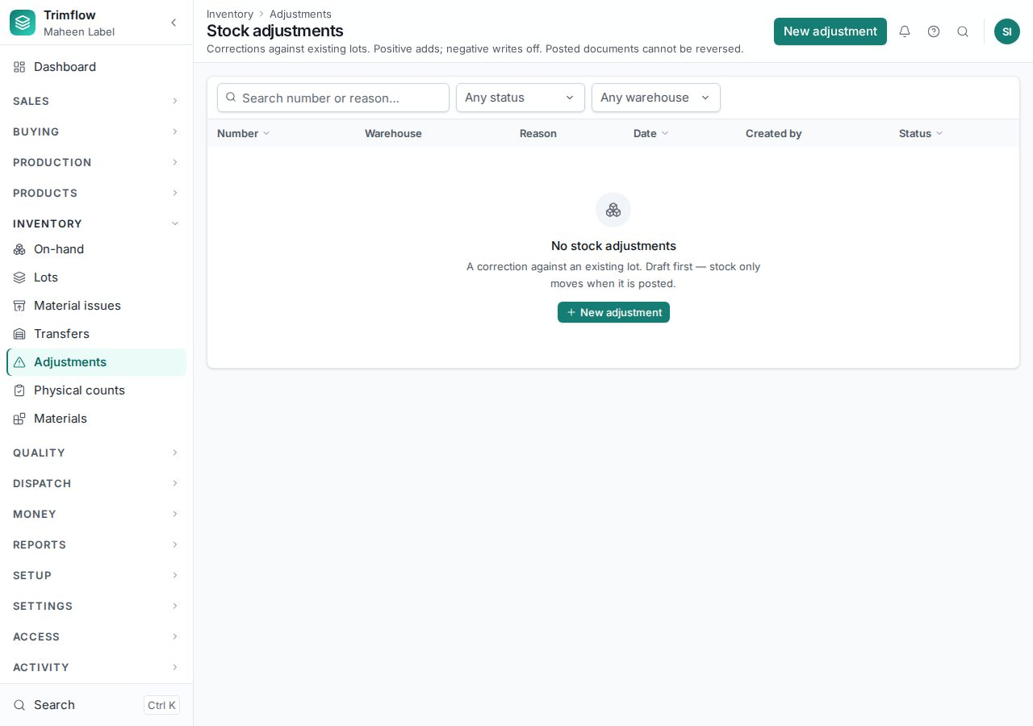
Adjustments.

6.6 Physical counts
- Open Inventory › Physical counts and press New count for a warehouse. The lots in it are frozen: no issue or transfer while counting.
- Enter the counted quantity per lot. Save partway and continue later.
- Press Complete. Differences become adjustments.
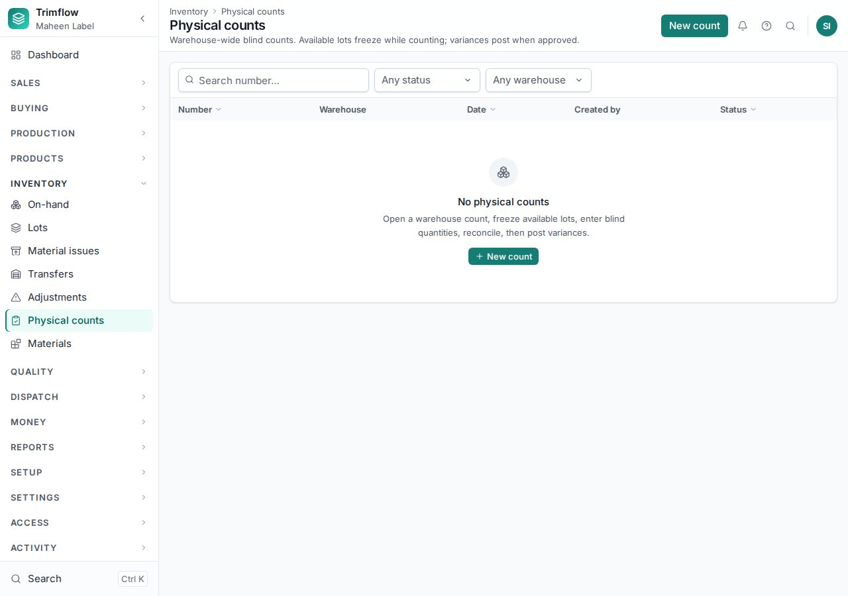
Physical counts.

6.7 Chain of custody and certified stock
Certified material (GRS, OCS, FSC) carries its claim from the goods receipt through the lot to the finished goods. Quality › Compliance & CoC shows the certificates, the certified stock on hand and the reconciliation of certified input against certified output per period (see 8.4).

6.8 Material plan (MRP)
- Open Production › Material plan and press Run with a horizon in days.
- The run takes every open job card, explodes its bill of materials, nets what is on hand, reserved and on order, and lists the shortages with the date each is needed and the date to place the order by.
- For bought materials, press Raise requisition to turn the shortages into a purchase requisition.
- For made components the plan suggests a quantity to make and offers Raise job card, which opens the job card form with the product and quantity filled in.
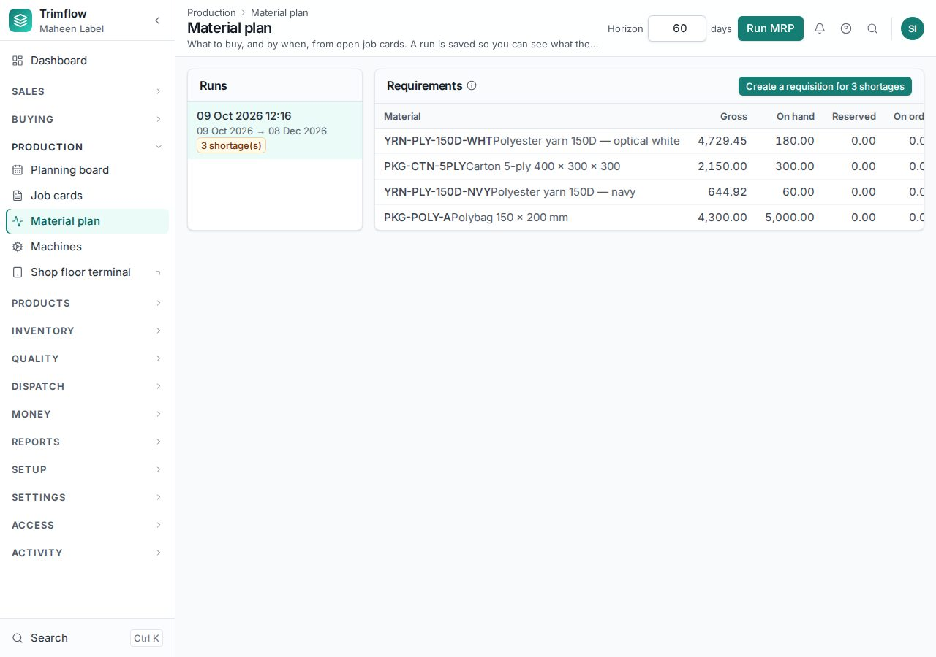
The material plan after a run.

7. Production
Work on the floor is driven by job cards. A job card makes one product, from one order line or for stock, down one routing, with one step per operation. The planning board puts each step on a machine; the terminal is where operators book what they did.

7.1 Raising a job card
- Open Production › Job cards and press New job card, or press Create job card on the sales order.
- Choose what the card is for: an order line, or a product to make for stock or for another job.
- For an order line: pick the line. The list shows how much of it can still be planned, allowing the customer's over-delivery tolerance. Lines that cannot be planned yet say what the product lacks.
- For stock: pick the product. A family that needs artwork is listed with what it lacks.
- Enter the factory unit, the quantity, the colourway, due date and priority. Press Create draft.
- The card is created as a draft with one step per routing operation, each planned with its wastage on top of the next step's need.
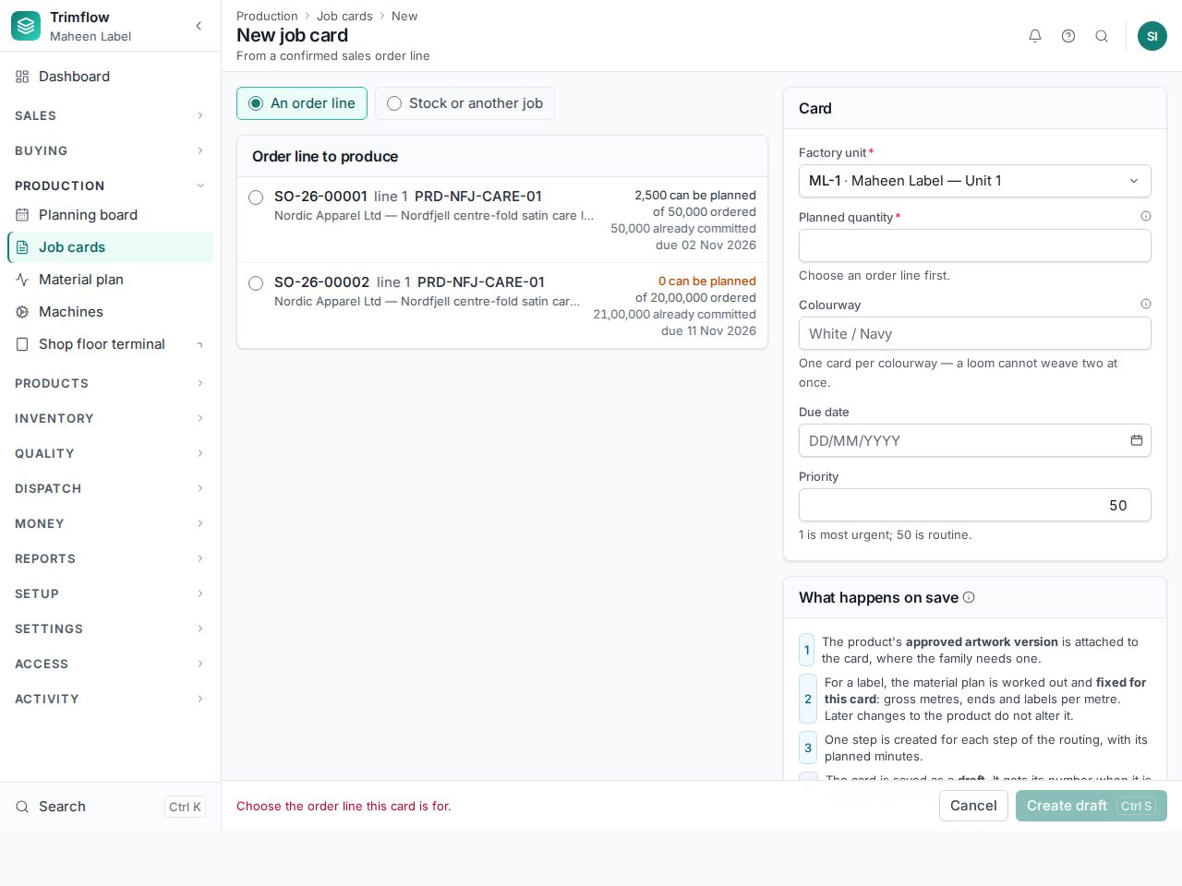
The new job card form. The "Stock or another job" choice is for components and running programmes.

7.2 Planning: putting steps on machines
- Open Production › Planning board. Draft cards appear in the backlog; machines are the rows.
- Drag a step onto a machine of its group, or press Schedule on the job card. Set the start; the finish follows from the planned minutes.
- Once every step is scheduled the card is Planned.
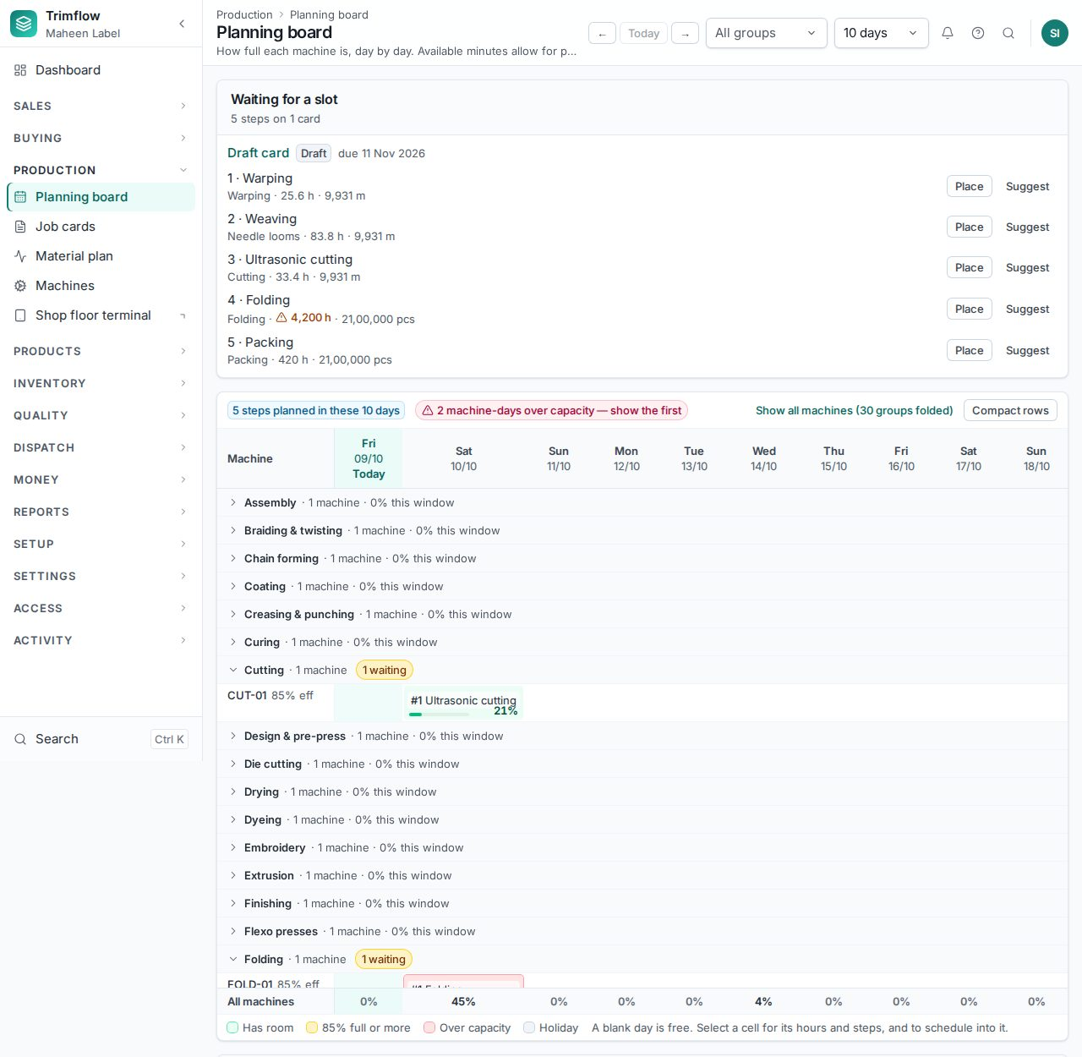
The planning board.

7.3 Releasing a job: the gate
A job is released to the floor only when everything it needs is in place. The job card page shows six checks: approved artwork (where the family uses it), an active bill of materials, the required tools available and not worn out, a machine on every operation, a QC plan (an inspection step on the routing or a QC plan on the item), and material in stock. The Release button says which check fails and what to do.
- Open the planned job card. Read the checks at the top. Each failing one names its fix.
- Issue the material (6.3) or, if the material is arriving, release with a waiver: give the reason; only a production manager may.
- Press Release. The card gets its number and the first step becomes ready on the terminal.
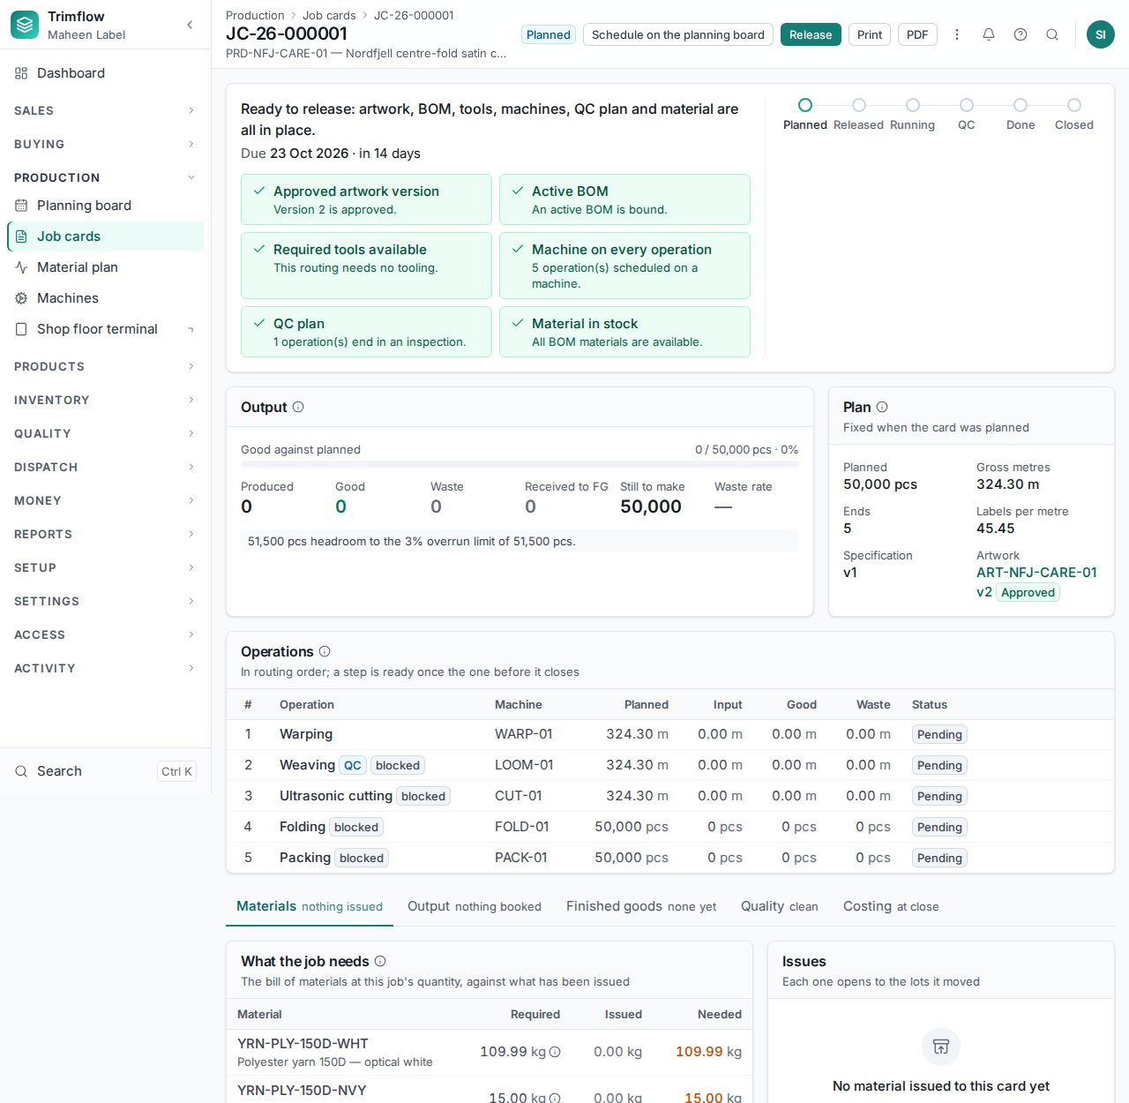
A job card: the release checks, the plan, the steps and the tabs.

7.4 Following a job
The tabs on the job card follow the job: Materials (what it needs against what was issued), Output (what each step booked, waste by cause), Finished goods (what was received into stock), Quality (inspections and NCRs), Costing (chapter 10). Hold pauses a job with a reason; the planning board frees the machine.

7.5 Finished goods receipt and closing
- When the last step is finished the card goes to QC pending by itself. Record the final inspection (8.1).
- Press Receive finished goods. The quantity goes into stock as a lot of the product's item, in quarantine until the inspection is accepted.
- Press Complete, then Close. Closing strikes the actual cost (10.3) and releases any leftover reservations. A job that produced more than the planned quantity plus the overrun tolerance cannot close.

7.6 The shop floor terminal
The terminal is a separate screen for the operator beside the machine, in Bangla and English. It runs on a tablet or an old PC, works offline and sends bookings when the network returns.
- Open the terminal address. Scan or type the badge, type the PIN, choose the machine (or "any" for the unit).
- The queue lists the steps ready on this machine. Tap one to start it.
- Book output as you go: good pieces or metres, waste with its cause. Tap Downtime when the machine stops and pick the reason.
- Tap Finish when the step is done. The next step becomes ready. If nothing was produced, give the reason.
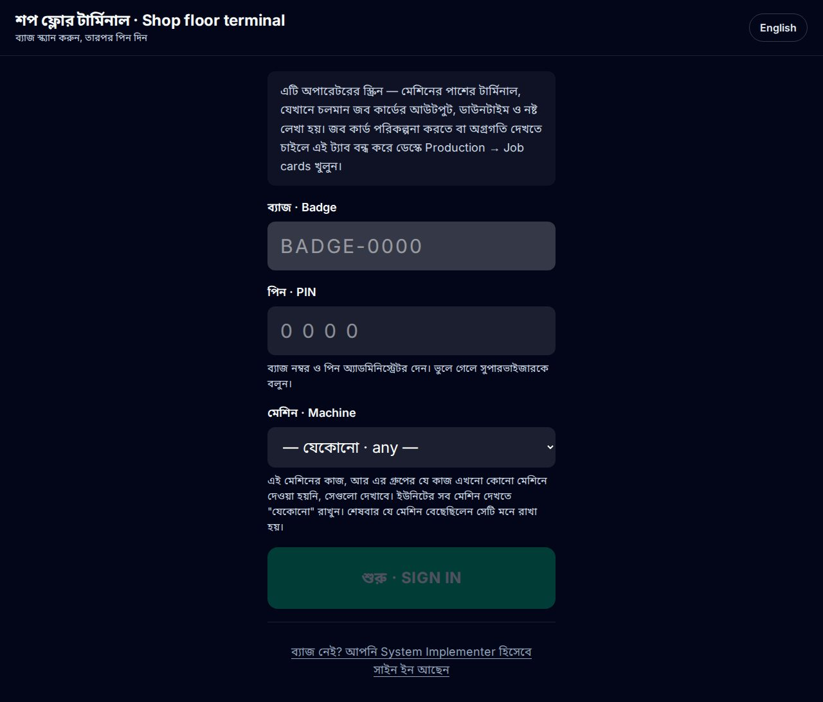
The terminal sign-in.
Good to know
- Bookings are never lost: if the network is down they queue on the device and send later, in order, exactly once.

8. Quality

8.1 Inspections
- Open Quality › Inspections and press New inspection, or start it from the job card or the goods receipt.
- Choose what is inspected (a job's output, a receipt, a lot) and the AQL plan. The sample size comes from the plan and the lot size.
- Count the defects by code. The result is computed against the plan: accepted or rejected.
- Save. An accepted final inspection releases the finished goods from quarantine; a rejected one raises an NCR.
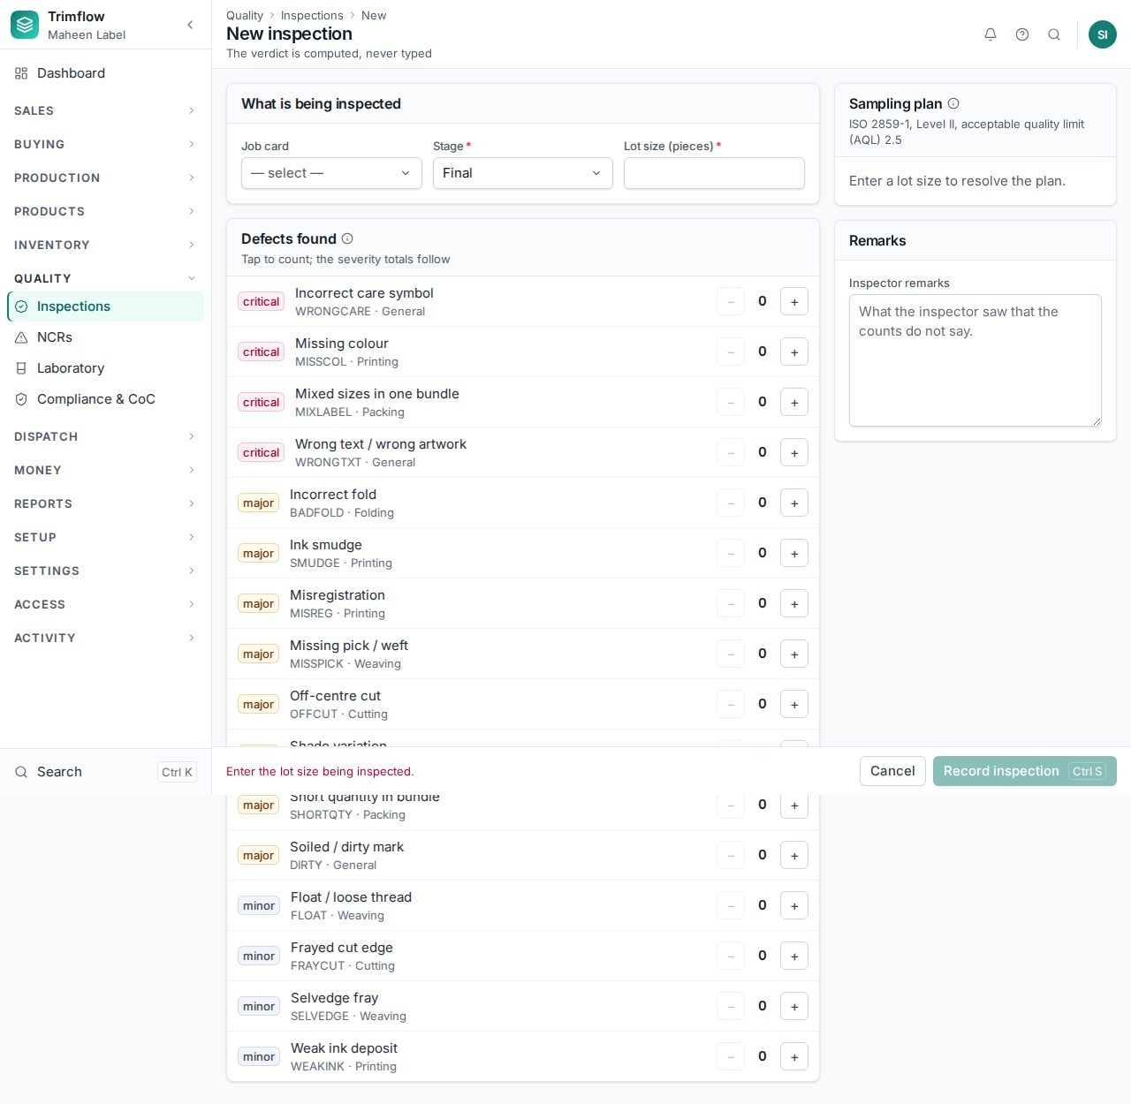
An inspection. The defect counters are large enough to tap on a tablet.

8.2 Non-conformance reports
An NCR records what was rejected, why, who is responsible, and the corrective action, with a due date. Quality › NCRs lists them; the NCR / CAPA report (chapter 11) summarises them.
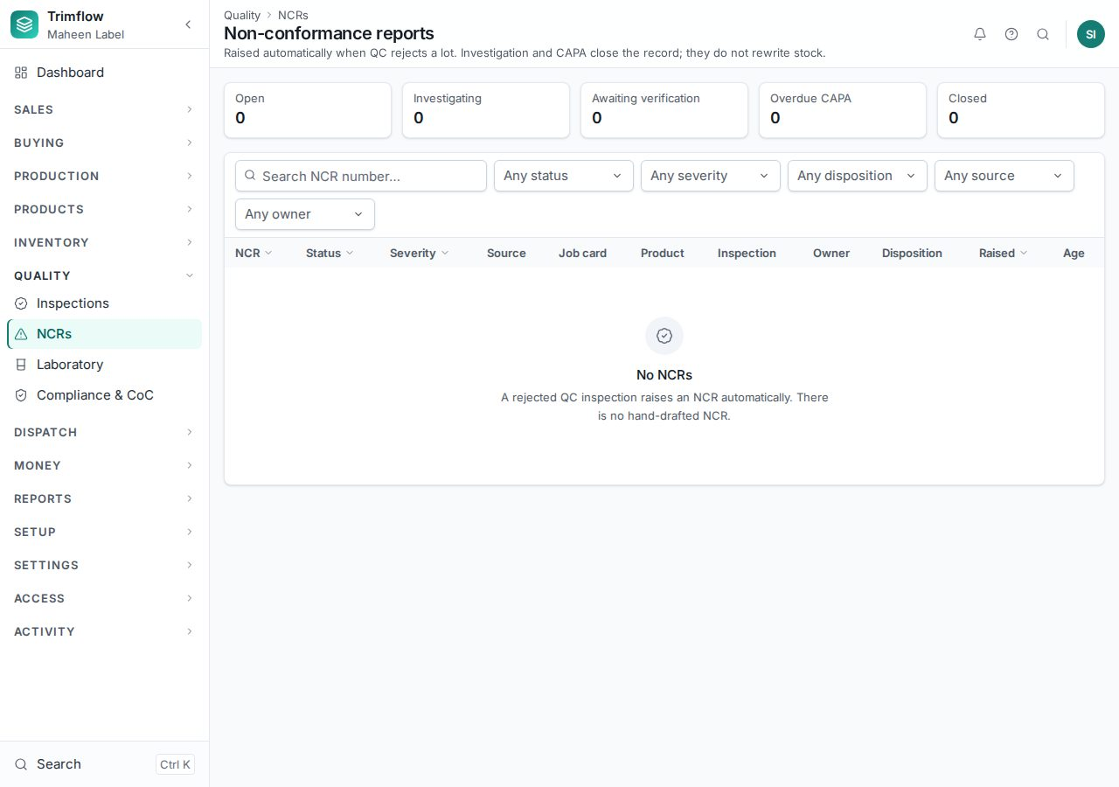
NCRs.

8.3 Laboratory
Quality › Laboratory records test reports (wash fastness, rub fastness, shrinkage) against products and lots, with the standard, the result and the certificate file.
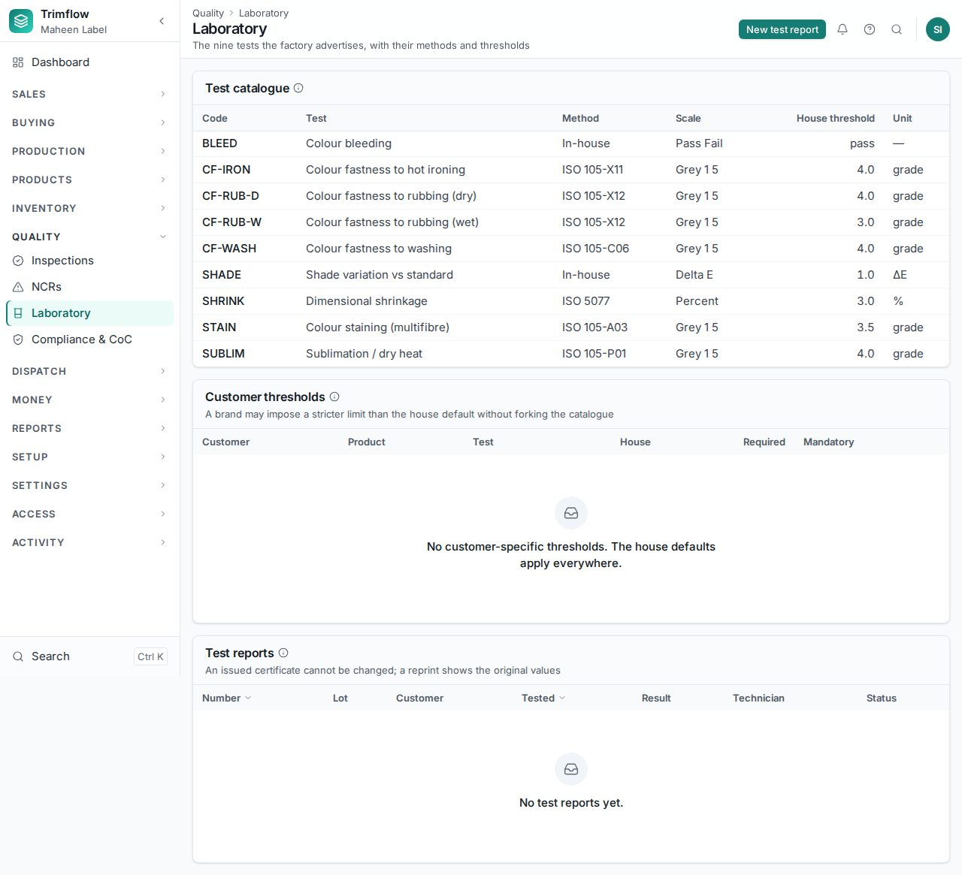
Laboratory tests.

8.4 Compliance and chain of custody
- Open Quality › Compliance & CoC. The certificate register shows each scheme, its validity and its claims. A shipment cannot claim a scheme whose certificate has lapsed.
- Press Reconciliation report. For each scheme and month, certified input is set against certified output; a month that shipped more certified goods than it took in is flagged.
- The compliance officer closes a reconciled month. Closing is final: it locks the movements and refuses new ones dated into it. Read the movements first from the link in the dialog.
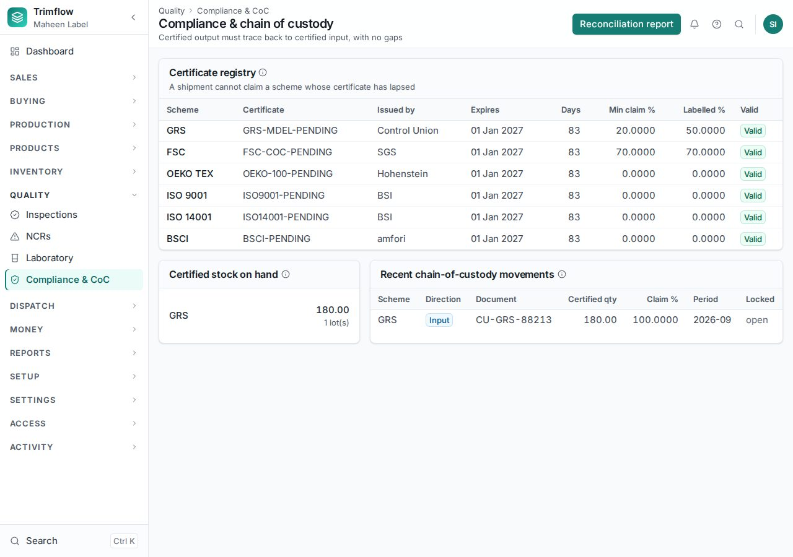
Compliance: certificates, certified stock, recent movements.
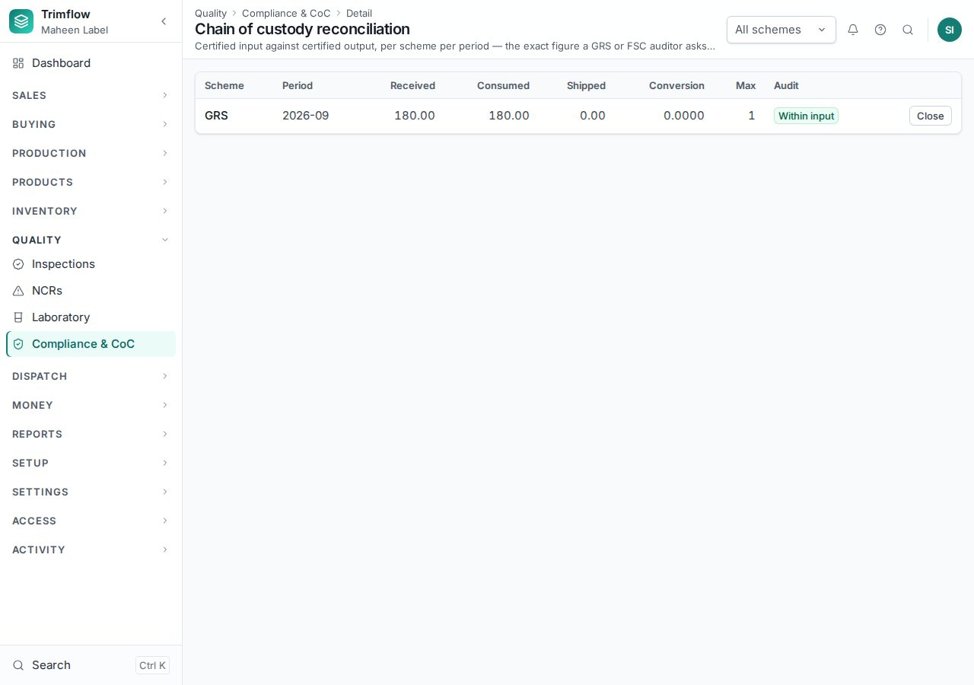
The chain-of-custody reconciliation.

9. Dispatch

9.1 Packing lists
- Open Dispatch › Packing lists and press New. Choose the order and the finished-goods lots to pack.
- Enter the cartons: how many pieces per carton, carton numbers, weights. Press Pack.
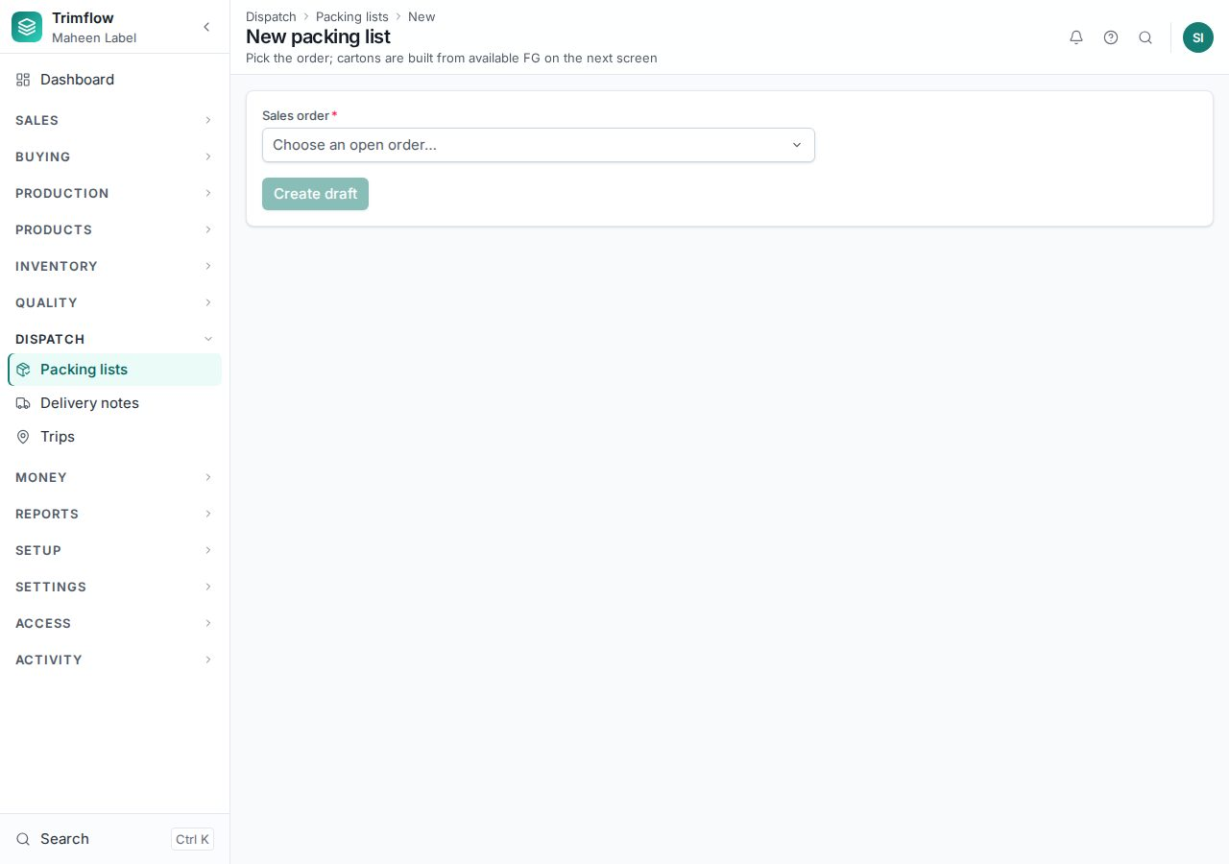
A new packing list.

9.2 Delivery notes
- Open Dispatch › Delivery notes and press New, choosing the packing lists to ship.
- Press Issue. The goods leave stock; the order's delivered quantity moves. A delivery outside the order's acceptable band is refused.
- Print the delivery note for the driver. Mark it Delivered when the customer signs, and record a failed delivery if it comes back.
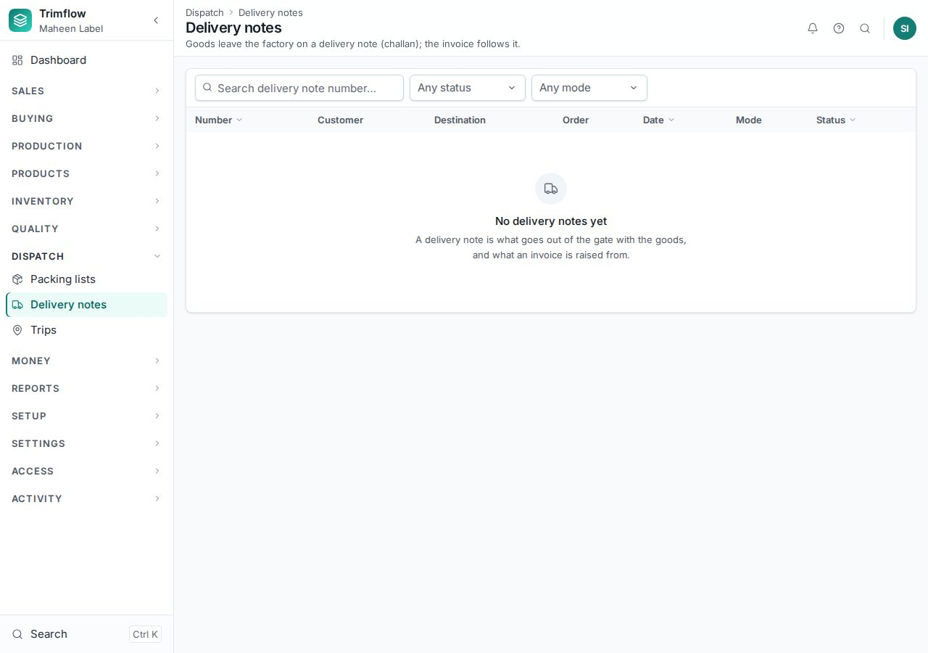
Delivery notes.

9.3 Trips
Dispatch › Trips groups delivery notes onto a vehicle and driver with stops in order. The driver sees their own trips and records proof of delivery at each stop.
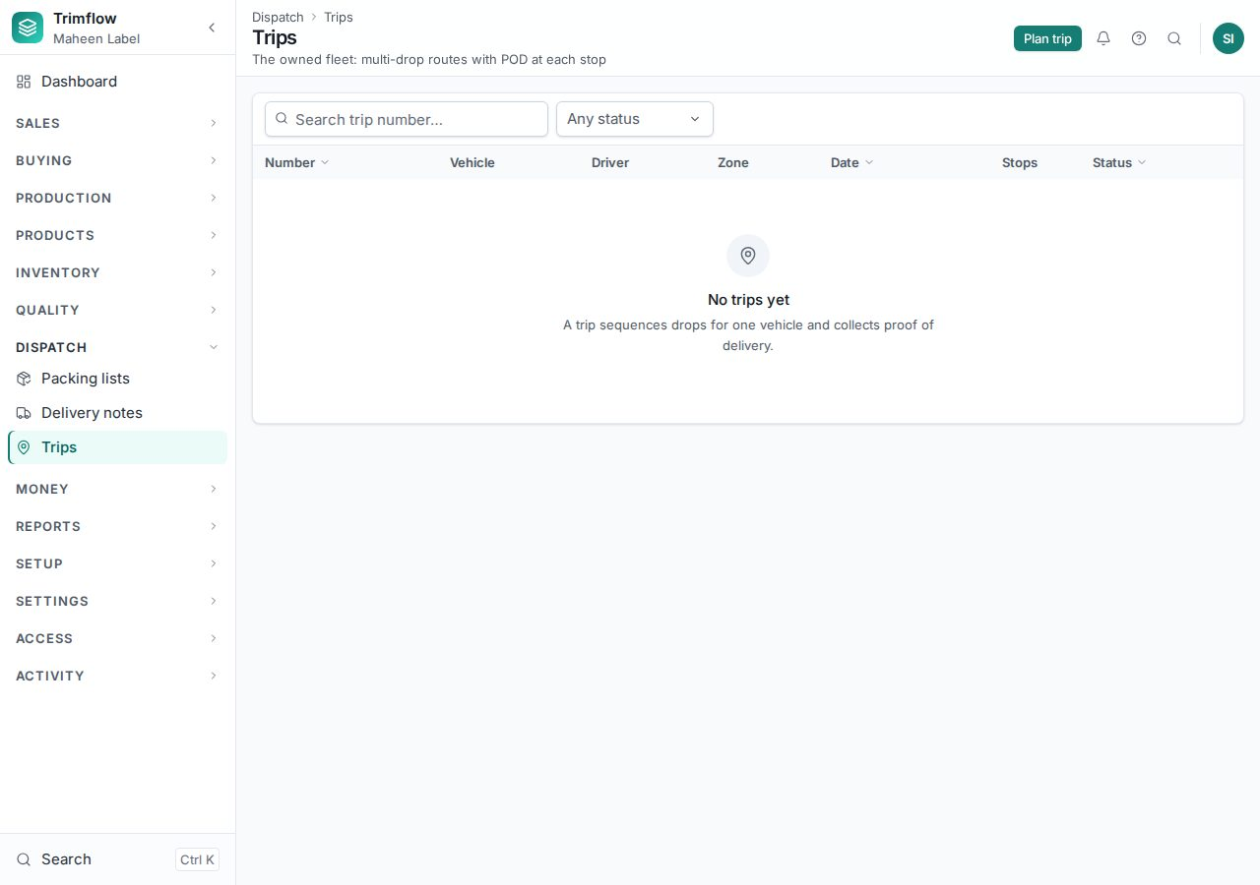
Trips.

9.4 Customer returns
Money › Customer returns records goods a customer sends back after delivery: against the invoice, by line and quantity, with the reason. Approving the return puts the stock back; the credit note it produces is in Money.

10. Costing: three stages
The system costs an order three times, each at the right moment, and shows the three side by side.
Stage | When | Based on | Locked? | Shows
Marketing | On the quotation, before the order | Standard rates, one piece, estimated quantity | When the quotation is sent | Quoted price and margin
Pre-production | The moment the order is confirmed | Today's material and machine rates, the confirmed quantity | Yes, as the benchmark | Expected margin against the agreed price
Post-production | When the job card is closed | Material actually issued at lot cost, minutes actually run, waste, overhead | Yes | Actual cost, actual margin, variance against the benchmark

10.1 Marketing costing on the quotation
Each quotation line has a cost sheet: material from the bill of materials with its wastage, conversion from the routing's machine, labour and energy hours, overheads at the settings, tooling where a plate or mould has to be bought, and the margin. The rate on the line comes from it. Change the margin on the line to see the price move; the margin floor in Settings needs the override right to go under.

10.2 Pre-production costing at order confirmation
When an order is confirmed, every line is costed again with the rates of that day and the quantity the buyer confirmed, and locked. The order page shows, per line, the quoted cost, the pre-production cost, the agreed price and the expected margin. If the expected margin is below the floor, confirming the order needs a person with the "confirm below margin" right, usually the Managing Director.
The order's Costing card: quoted, pre-production and actual cost per unit, with the margin each implies.

10.3 Post-production costing on the job card
- Open the job card and the Costing tab. Before the job closes it shows the benchmark alone.
- When the job is closed the actuals are struck: every material issued, net of returns, at the lot's cost; every operation's minutes on the machine it ran on; waste by cause; overhead at the same rates as the benchmark.
- The table shows each element per unit — material, tooling, machine, labour, energy, packing, subcontract, overhead — for the benchmark and the actual, and the variance per unit and for the job. Red is over the benchmark, green under.
- The costing clerk writes the reason for the variance in their own words: price, usage, yield, efficiency, overhead, subcontract, exchange.
- Under "Back to the standards", compare the wastage the job ran at with the item's standard. Press Adopt to make the job's wastage the item's new standard, so the next quotation is more accurate.
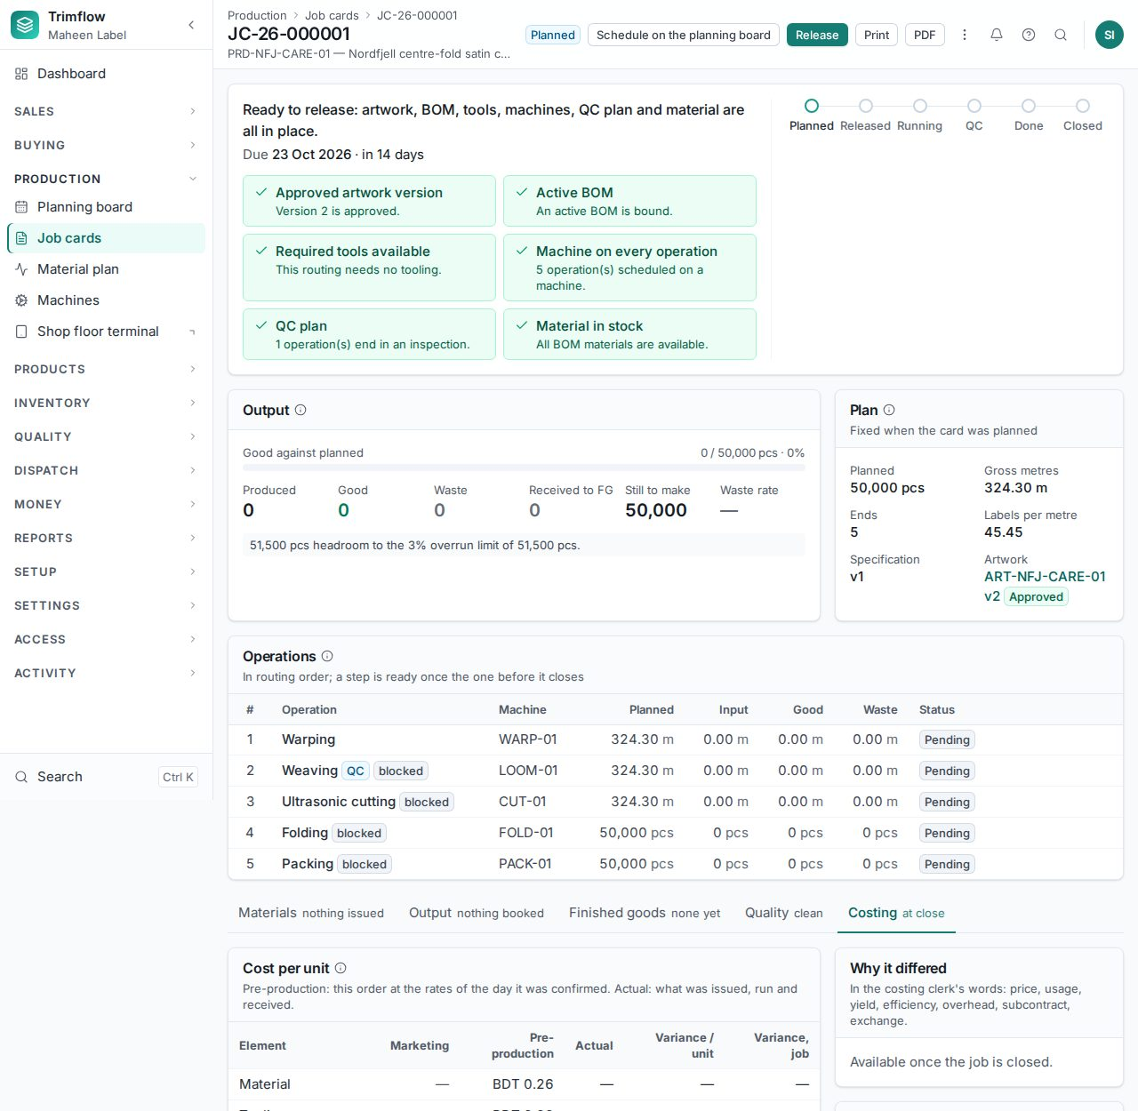
The Costing tab of a job card.

11. Money

11.1 Invoices
- Open Money › Invoices and press New invoice, choosing the delivery notes to bill.
- Check the lines, taxes and currency. Save the draft, then Issue. The invoice gets its number; an invoice dated into a closed month is refused.
- Print or PDF it for the customer. Credited, paid and overdue states follow from the receipts and the due date.
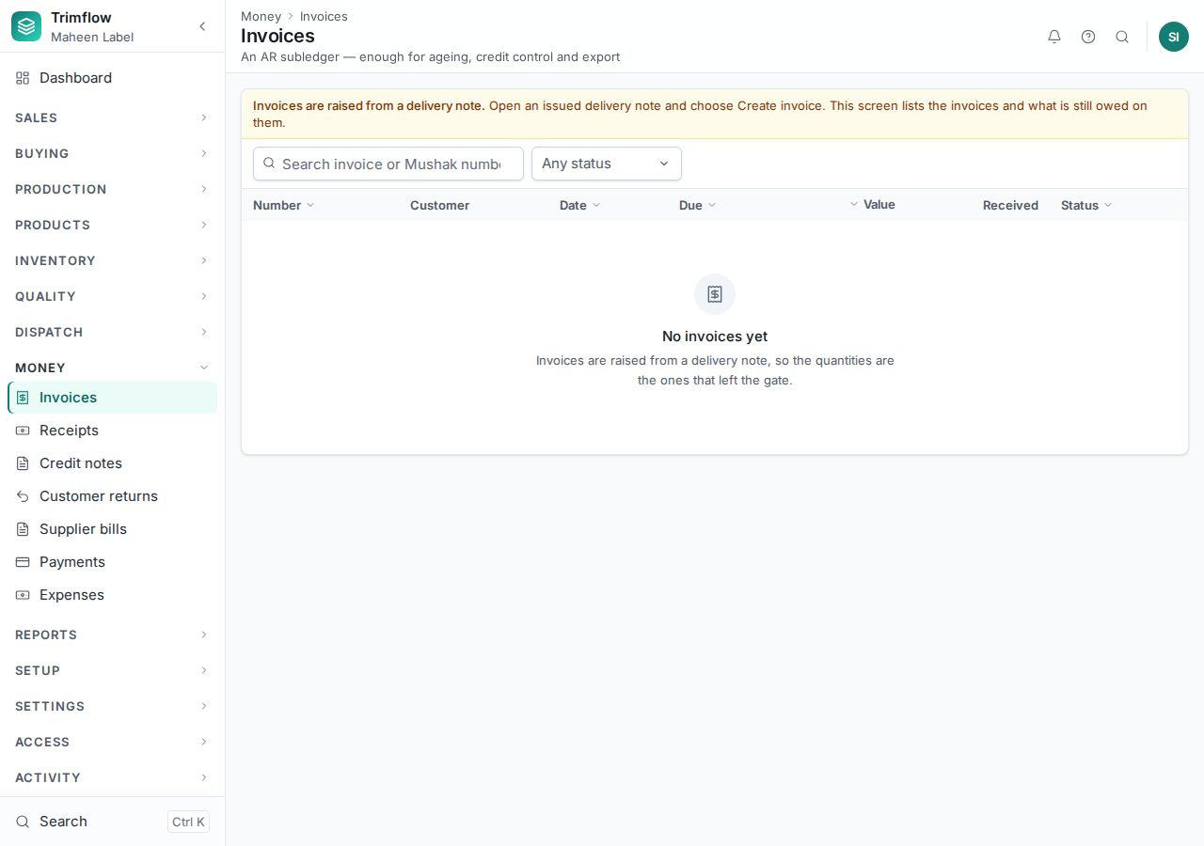
Invoices.

11.2 Receipts
- Open Money › Receipts and press New receipt. Choose the customer, the date, the method and the amount.
- Allocate the amount to one or more invoices. The receipt posts at once.
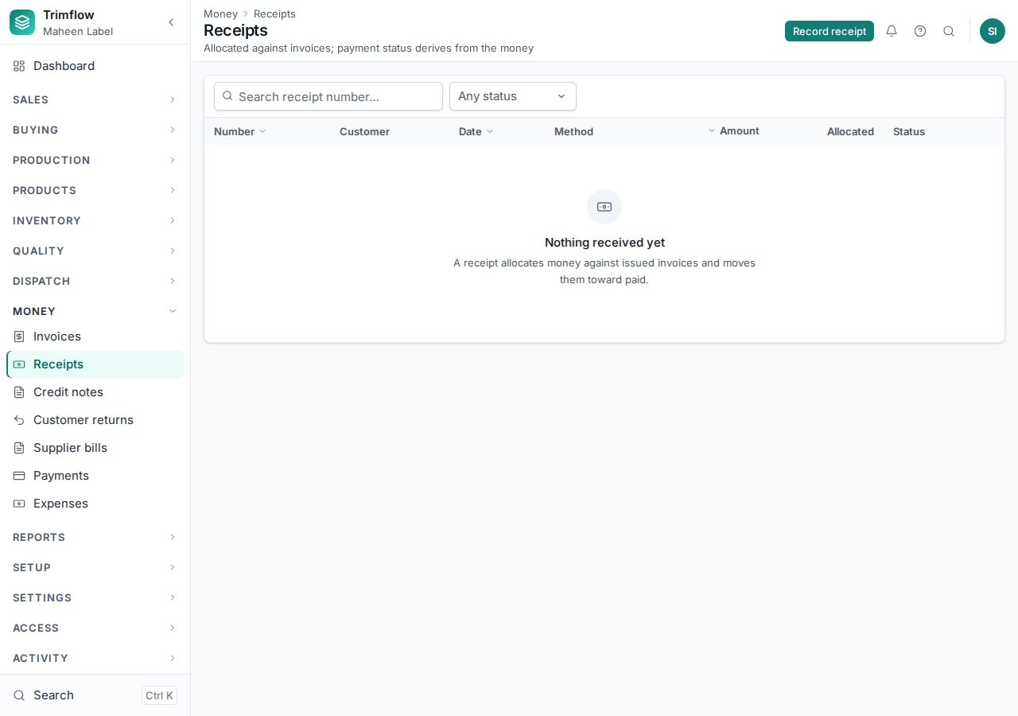
Receipts.

11.3 Credit notes and refunds
A credit note reduces what a customer owes, for a quality claim or a return. It is approved within a band, applied to an invoice, or refunded. Each is a separate right.
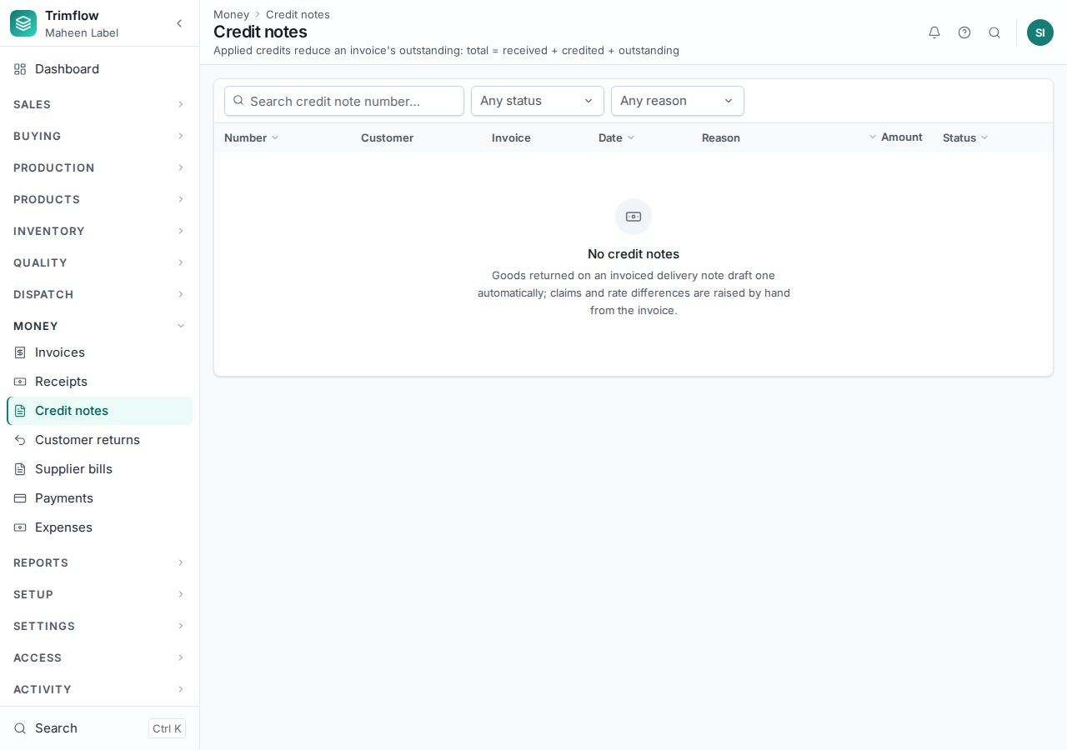
Credit notes.

11.4 Expenses
Money › Expenses records costs not tied to a supplier bill: transport, repairs, utilities. An expense is approved by somebody other than the person who raised it, then paid.
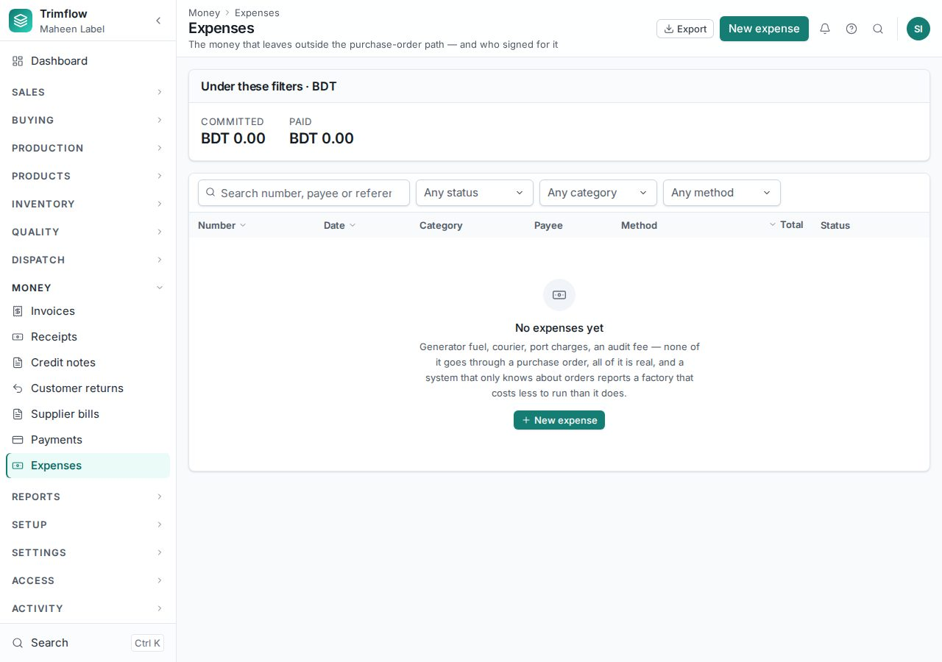
Expenses.

11.5 Month-end
When the month is reported, accounts closes it in Settings › Accounting periods (2.6). After that nothing can be dated into it. The receivables and payables reports (chapter 12) are the month's statements.

12. Reports and the audit log

12.1 Reports
Reports › All reports lists every report you may read: fulfilment, production, stock, dispatch register, receivables, payables, purchases, NCR / CAPA. Each report filters by date and the usual keys, and exports to a spreadsheet.
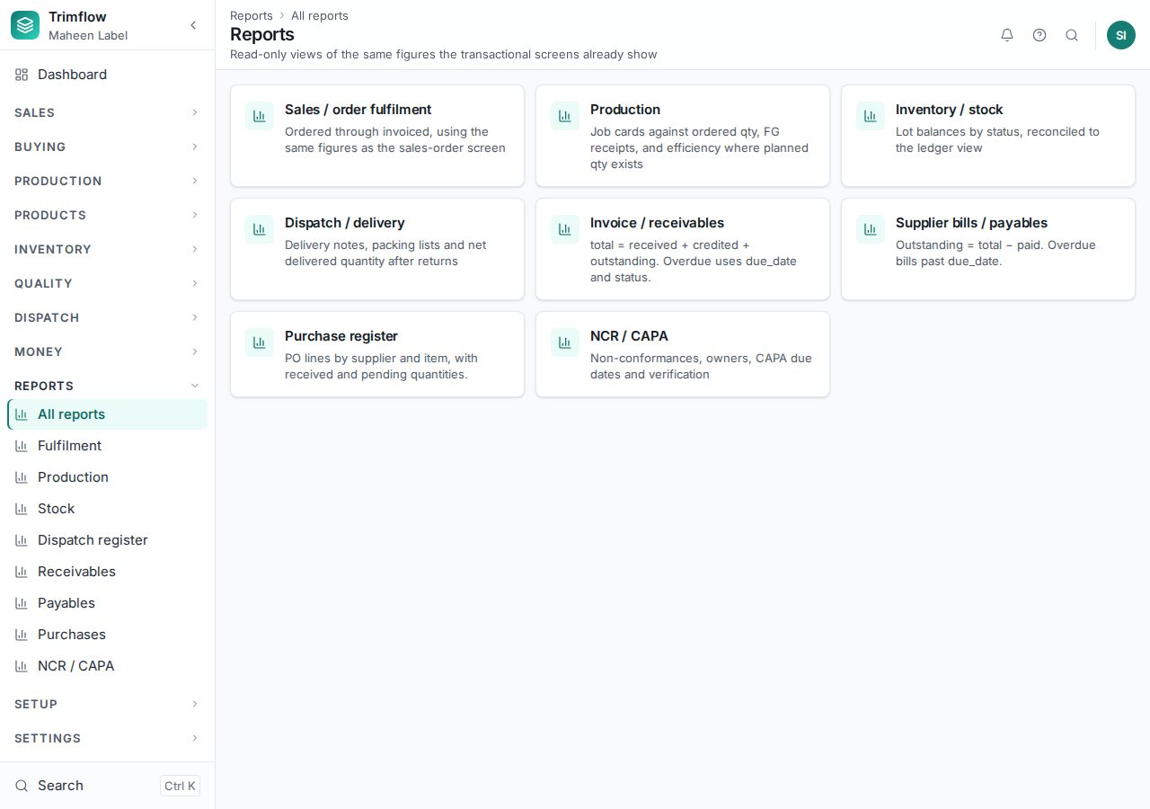
All reports.
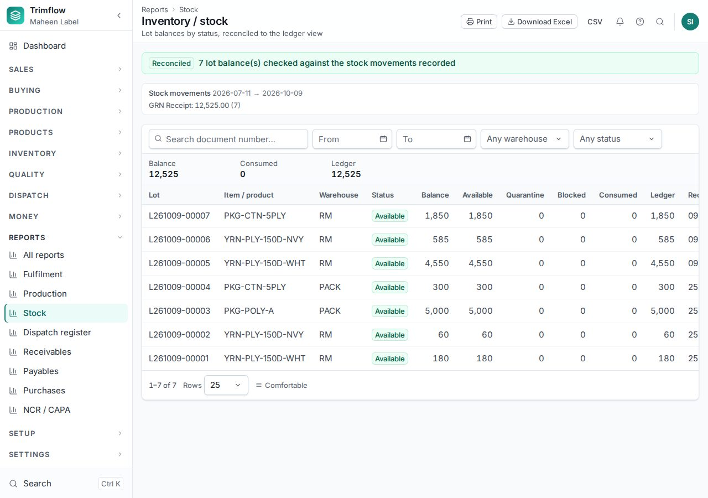
The stock report.

12.2 Audit log
Activity › Audit log shows who changed what and when: every create, update, status change, print and export, with the old and new values. Filter by person, record type or day, and click the record to open it.
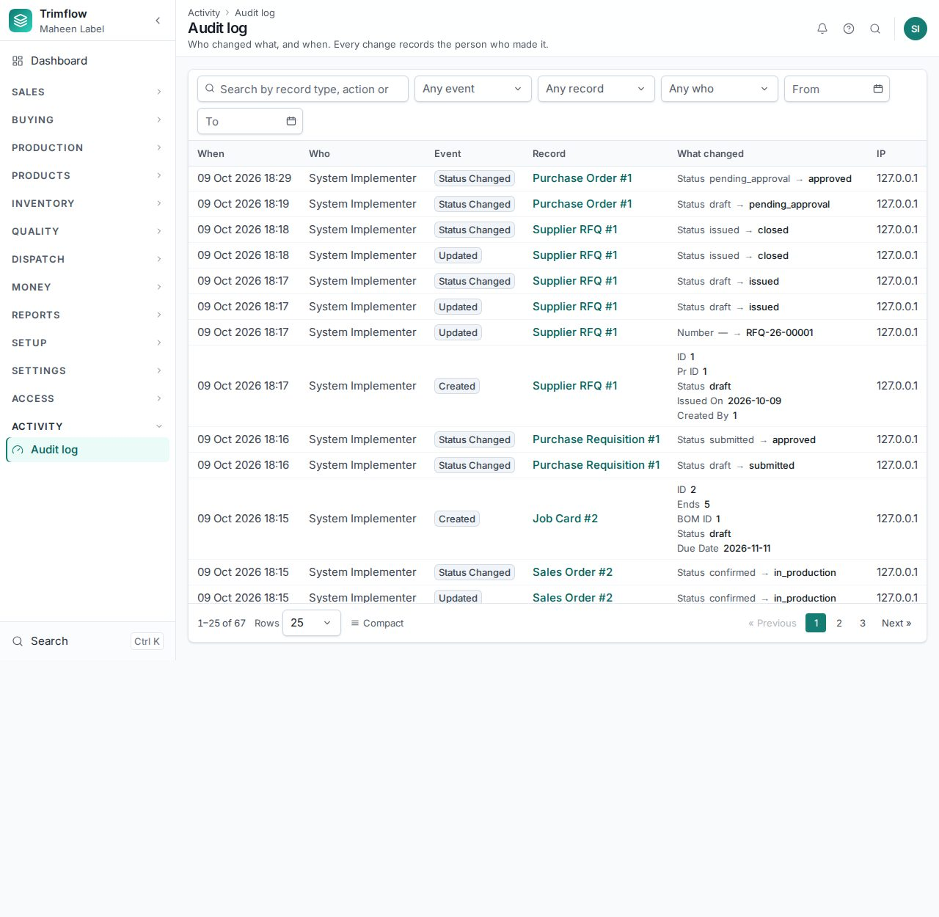
The audit log.

13. Reference

13.1 Document statuses
Document | Statuses, in order
Item | Draft → Active → On hold / Discontinued
Quotation | Draft → Sent → Accepted / Rejected / Expired; Revised creates a new revision
Sales order | Draft → Confirmed (or Credit hold) → In production → Partially delivered → Delivered → Closed; Cancelled
Purchase order | Draft → Submitted → Approved → Sent → Partially received → Received → Closed
Goods receipt | Draft → Inspected → Posted
Job card | Draft → Planned → Released (or Material pending) → In production → QC pending → Completed → Closed; On hold; Cancelled
Invoice | Draft → Issued → Partially paid → Paid; Overdue; Credited; Cancelled
Credit note | Draft → Approved → Applied / Refunded

13.2 Who does what
Role | Typical work
Merchandiser | Inquiries, quotations, sales orders, customers, products and their setup
Sales manager | Approves margins under the floor on quotations; releases credit holds
Designer / Engineer | Artwork, specifications, bills of materials, routings, item activation
Planner | Job cards, planning board, material plan
Production supervisor | Releases jobs, waives material, books output at the desk, holds and closes jobs
Operator | Books output, waste and downtime at the terminal
Store keeper | Goods receipts, issues, transfers, counts, lots
QC inspector | Inspections, NCRs, laboratory tests
Purchase officer | Requisitions, RFQs, purchase orders, suppliers
Accounts | Invoices, receipts, bills, payments, credit notes, expenses, month-end close
Compliance officer | Certificates, chain-of-custody reconciliation and close
Managing Director | Reads everything; approves exceptions: high-value orders, margins under the floor, credit notes above the band
Administrator | Settings, lists, users and roles, number sequences

13.3 Words used in this manual
Word | Meaning
Item | Anything the factory buys, makes, consumes or charges for. A made item also has a product page.
Product | The engineering side of a made item: customer, style, routing, specification, artwork, bills of materials.
Production family | One of the ten kinds of thing the factory makes: narrow textile, printed label, paper, zipper, fastener, cord, injection, packaging, textile support, decoration.
Routing | The ordered steps a product runs through, with the machine group, rate and wastage of each.
Operation | One step in the master list of steps. Shared operations appear on several routings.
Bill of materials (BOM) | What a product is made of, per base quantity, with wastage.
Lot | One receipt of one material into one warehouse, with its own cost and certification.
Job card | The instruction to make a quantity of one product down its routing.
Release gate | The checks a job must pass before it reaches the floor.
Benchmark | The pre-production cost locked when the order was confirmed.
Variance | The difference between actual cost and the benchmark, per element.
AQL plan | The sampling plan an inspection uses: sample size and the number of defects that reject a lot.
Chain of custody (CoC) | Tracking certified material from receipt to shipment so a certified claim can be proved.
Accounting period | A calendar month. Once closed, nothing can be dated into it.

