JSXGraph – Dynamic Mathematics with JavaScript

By Michael Gerhäuser, Bianca Valentin, Alfred Wassermann

Department of Mathematics, University of Bayreuth, D-95440 Bayreuth, Germany
alfred.wassermann@uni-bayreuth.de

Received: date Revised: if applicable

JSXGraph is a cross-browser library for interactive geometry, function plotting, graphs, and data visualization in a web browser. It is implemented completely in JavaScript and uses the vector graphics formats SVG and VML.

1 INTRODUCTION
Since the early days of computer graphic displays Dynamic Geometry software has been used to teach and learn Geometry. In the beginning, Dynamic Geometry software consisted of standalone binaries, like Geometer's Sketchpad and Cabri. With the introduction of the celebrated programming language Java in 1996, the implementation of interactive Geometry software in Java immediately started. Suddenly it was possible to display and enable experiments with Geometry in every web browser. There was no need to install additional software, there are no problems with different operation systems. The teacher can give the material to the students easily. Everything which works in the computer laboratory in school works at home, too.
The first Java-based Geometry systems were Cinderella and Geonet. Later, GEONExT and GeoGebra followed. Also, the vendors of standalone binaries offered Java-viewer of their software. It was possible to prepare a geometrical construction with one of these binaries and publish it on the world wide web using its Java-viewer. At that time it became also clear that the business model of Geometry software has to be reconsidered.
In theory at that time all the well known problems of software use in schools were solved. There was no need to install software, a geometrical construction could be explored in school and at home, regardless of the computer system. And since constructions could be embedded in web pages, it was possible to develop “dynamic worksheets”, also called “interactive learning environments”. The text in these worksheets could be connected with the construction.
But unfortunately, the practice never could fulfill the promises of the theory. Because of incompatibility issues between different version of the Java Runtime Environment (JRE), lack of support on various platforms it was often unpredictable whether the software would run in a certain computing environment. This was especially annoying for the developers of Geometry software that were giving workshops in schools.
The incompatibility issues finally led the web developers to abandon Java from the web page and use Flash or JavaScript for interactivity.
The situation in the moment, which certainly may change again, is that practically no Java applet outside of the educational sector is used. In the business sector very few banks still offer online banking through a Java applet. For navigation in the web page Java applets have disappeared completely. For small multimedia devices like smart mobile phones the situation is even more clear. Nearly no system supports fully fledged Java applets in the browser.
For the Dynamic Geometry systems this means that an alternative for the time after the Java applet has to be offered. We try to do this with our new library JSXGraph.
2 DYNAMIC MATHEMATICS WITH JAVASCRIPT
The library for Dynamic Geometry JSXGraph is implemented in the script language JavaScript. Even if the names are similar, JavaScript has nothing in common with Java. Today, every modern web browser has included a JavaScript interpreter or JavaScript Just-In-Time compiler (JIT). JavaScript is the default way to incorporate interactivity on the web page.
But JavaScript itself has no support for graphics (beside the recently introduced canvas element). Fortunately, all browsers are able to display graphics in an XML-based vector graphics format. But, different browsers support different vector graphics formats. The majority of browsers (Firefox, Safari, Opera) support the format SVG (Scalable Vector Graphics). On the other side, the Internet Explorer supports VML (Vector Markup Language). JSXGraph is able to support both formats and automatically detects the supported graphics formats.
There are other differences between the JavaScript implementations of the browsers, which makes cross-browser software development a nightmare. But fortunately there exist open source framework libraries which free the JavaScript developer from this burden. JSXGraph supports the two popular frameworks prototype and jQuery.
JSXGraph is an open source project, released under the Lesser GNU General Public License (LGPL). The source code is hosted by Sourceforge. In order to use JSXGraph the developer has to include only three files in the HTML file: the framework library, the JSXGraph code and a CSS file. The size of the JSXGraph code is about 380 kByte. If the web server delivering the content has data compression enabled (which should be the default) the size of the transmitted code is about 80 kByte. To compare it with Java software, for example the size of the GEONExT archive is about 1 Mbyte.
JavaScript has the reputation that it is slow. This is no longer true. Even if JavaScript code still needs much more execution time than code written in Java or C, the JavaScript interpreters have been improved enormously, recently. Also, the small code size is an advantage of JavaScript, and the initialization time of an application is zero, since the JavaScript engine is started with the opening of the web browser. This is in sharp contrast with Java applets, where the initialization time is very tedious, since many MBytes have to be loaded from the hard disk into the computer memory.
Another advantage of using JavaScript for visualization is the perfect interaction with the rest of the web page. Texts, images, every element of a geometrical construction is a DOM element and can be manipulated.
JSXgraph is not meant to be used directly by the teacher or student. Rather, it is a software library used transparently in a web page to display Geometry resources, or to work internally as the mathematical visualization engine in a Web 2.0 application. For example the successor of GEONExT will be based ojn JSXGraph. Nevertheless, for the dauntless teacher having some experience in JavaScript programming it should be no problem to cretae her own constructions with JSXGraph.
3 RANGE OF APPLICATIONS
3.1 How to use JSXGraph
JSXGraph may be used in a variety of settings. First, it can be used as a web viewer for content developed with existing software. At the time of writing, JSXGraph is able to display files containing GEONExT constructions, see Figure 1. JSXGraph supports the Intergeo format, and the implementation of GeoGebra file format has been started. Other file formats may follow.
<div id="box" class="jxgbox" style="width:500px; height:500px;"></div>
<script type="text/javascript">
var b2 = JXG.JSXGraph.loadBoardFromFile('box',
'geonextConstruction.gxt', 'Geonext');
</script>
Fig. 1. JavaScript code to display a GEONxT construction.
Second, JSXGraph can be used on server side, for example to create online charts. For this, an API in PHP or Python has to be developed.
At last, a JavaScript programmer can create mathematical constructions directly using JavaScript and JSXGraph. Figure 2 contains the source code for the construction of the Euler line, the result can be seen in Figure 3. The example area on the JSXGraph home page contains more than 100 examples of such constructions.
/* triangle */
A = brd.createElement('point',[1,0]);
B = brd.createElement('point',[-1,0]);
C = brd.createElement('point',[0.2,1.5]);
triangle = brd.createElement('polygon',[A,B,C]);

/* heights */
hc = brd.createElement('perpendicular',[pol.borders[0],C],{name:['','H_c']});
ha = brd.createElement('perpendicular',[pol.borders[1],A],{name:['','H_a']});
hb = brd.createElement('perpendicular',[pol.borders[2],B],{name:['','H_b']});
h = brd.createElement('intersection',[hc[0],hb[0],0],{name:'H'});

/* median lines */
mc = brd.createElement('midpoint',[A,B],{name:'M_c'});
ma = brd.createElement('midpoint',[B,C],{name:'M_a'});
mb = brd.createElement('midpoint',[C,A],{name:'M_b'});
sa = brd.createElement('segment',[ma,A]);
sb = brd.createElement('segment',[mb,B]);
sc = brd.createElement('segment',[mc,C]);
/* centroid */
s = brd.createElement('intersection',[sa,sc,0],{name:'S'});

/* circumcircle */
[cPoint,cCirc] = brd.createElement('circumcircle',[A,B,C],{name:['U','']});
cCirc.setProperty({strokeColor:'#000000',dash:3,strokeWidth:1});

eulerLine = brd.createElement('line',[s,cPoint],{strokeWidth:2,strokeColor:'#901B77'});
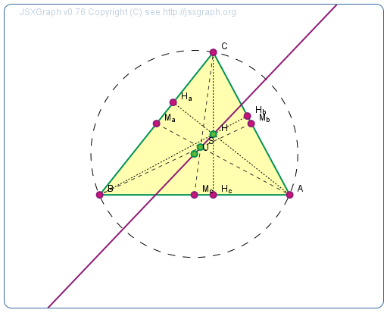
Fig. 2. JavaScript construction of the Euler line.
Fig. 3. The Euler line displayed with JSXGraph.
3.2 Elements of JSXGraph
JSXGraph supports geometric constructions, function graphs and curves, turtle graphics and charts.
The most important geometric elements supported by JSXGraph are point, line, ray, segment, circle, arc, sector, parallel line, perpendicular line, midpoint, angle bisector.
JSXGraph supports function graphs, polar curves, parametric plots, data plots, and Riemann sums, compare Figure 4. Figure 5 shows the space-filling Hilbert curve. It is an example of a data plot. With the slider in the bottom the recursion depth can be changed dynamically.
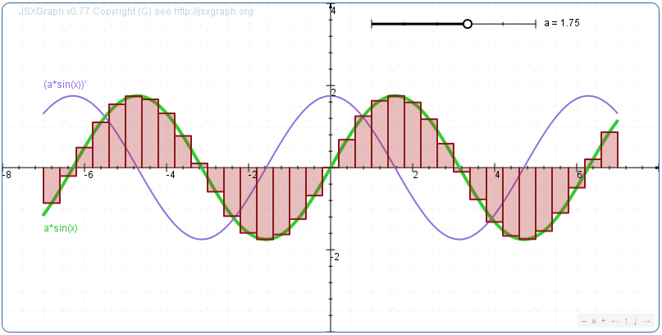
Fig. 4. The sine curve, together with its derivative and Riemann sums.
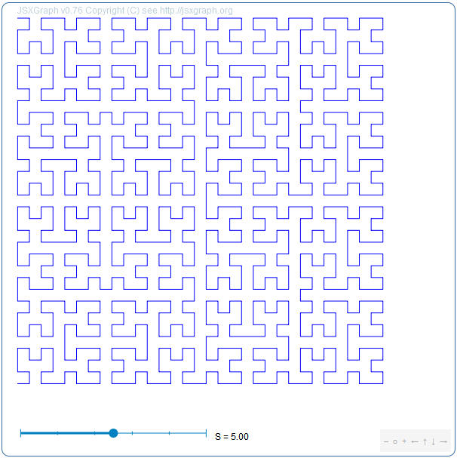
Fig. 5. The Hilbert curve as data plot.
Moreover, JSXGraph supports curves generated with turtle graphics commands. This is especially useful for exploring recursive constructions, see Figure 6.
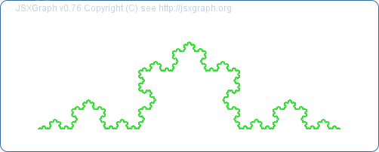
Fig. 6. The Koch curve with turtle graphics.
Glider points, also called semi free points, can be positioned on all types of lines, circles and curves, even on turtle graphics. Through every glider point, regardless of the type of object it lives on, tangents and normals can be constructed.
Turtle graphics can be used to visualize Lindenmayer systems, see Figure 7.
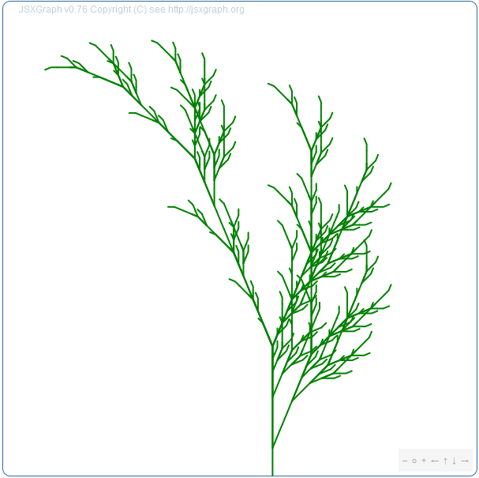
Fig. 7. A plant constructed created by a Lindenmayer system.

3.3 Mathematical functions
JavaScript itself provides some elementary functions, like Math.sin(), Math.tan(). JSXGraph contains some more advanced functions. Examples are Lagrange interpolation, polynomial interpolation of curves. Further, there are elementary statistics functions and regression polynomials of arbirtrary degree.
The dynamic language features of JavaScript enable without great effort a very high degree of interactivity in JSXGraph. For example in the Lagrange interpolation construction (Fig. 8) it is easy to add or remove defining points and change in that way the degree of the polynomial curve. Therefore, dynamic Lagrange interpolation offers new didactical possibilities in calculus.
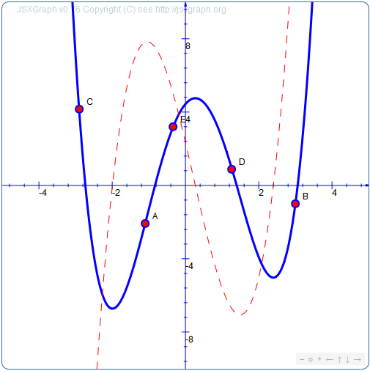
Fig. 8. Lagrange interpolation.

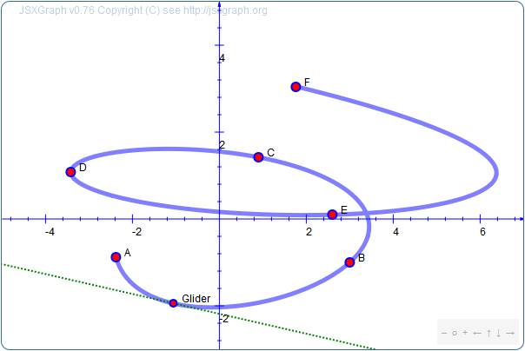
Fig. 9. Curve Lagrange interpolation.
Even more advanced functions in JSXGraph are the Runge-Kutta solver of differential equations and cubic spline interpolation.
3.4 Charts
JSXGraph also supports various types of charts. With the AJAX technology JavaScript enables the easy access of data from web servers. A possible scenario is the online display of charts generated from live data from sensors or stockquotes. This makes the library applicable in a much wider setting.

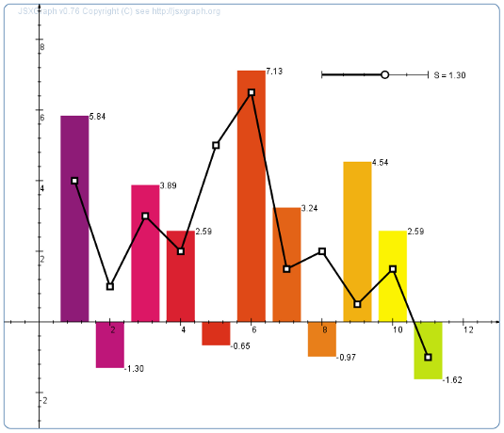
Fig. 9. Chart example.

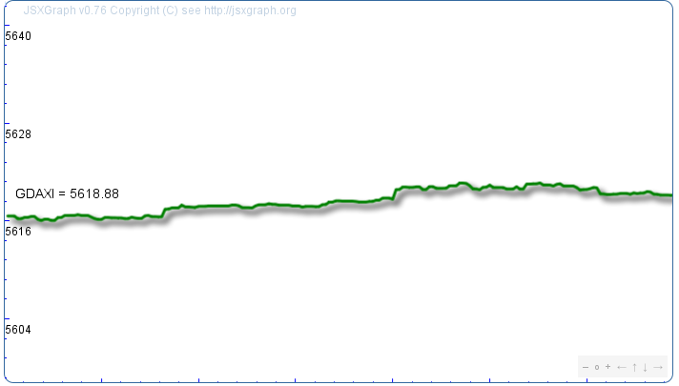
Fig. 10. Online display of the german DAX index.

Font size Times New Roman point 10. Single line spacing for final camera ready copy. 10pt spacing after each section and subsection.
2 SECTION TITLE(s) IN CAPITALS AND NUMBERED
2.1 Subsections in lower case

Figures/Tables to be numbered and titled. Centred in columns or page. Figures/tables can go across one or two columns depending on size.
REFERENCES
Crockford, D. (2008) JavaScript: The good parts, Sebastopol, CA, O'Reilly.
Prusinkiewicz, P. and Lindenmayer, A. (1990) The Algorithmic Beauty of Plants, New York, NY, Springer.

BIOGRAPHICAL NOTES

http://www.keypress.com/x5521.xml
http://cabri.com
http://cinderella.de
http://geonext.de
http://geogebra.org
See http://prototypejs.org and http://jquery.com
http://sourceforge.net

