**Index**

Project Overview 2

Instructions Overview 2

User Auth Instructions 3

Endpoints Reference 4

DBMS ER Diagram 7

UML Diagram 8

**Project Overview**

This project is a RESTful Food Ordering API developed using php Laravel. The system enables admin users to post restaurants and menus; it also enables customers to access and order posted items.

**Instructions Overview**

This user guide shows you 1. how to pass the authentication to the system; 2. the list of all endpoints you may access; 3. UML and database design diagrams.

**User Auth Instructions**

The API makes use of Middleware, which requires the client to authenticate into the system. To get the authentication, you may want to

1. install the passport package:

*php artisan passport:install*

Store the **client_id** and **client_secret** from the return value.

2. Fetch the **username** and **password** from the “users” table at mysql database

3. Send a **Post** request at <http://localhost:8000/oauth/token>.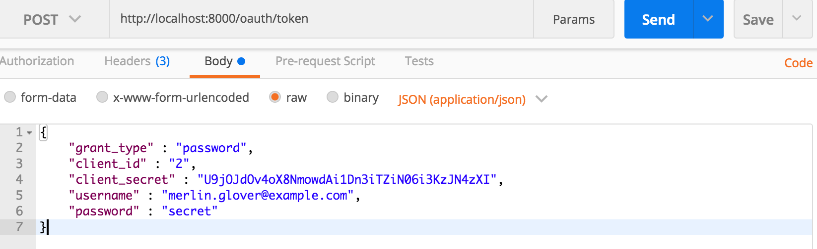

Replace **client_id,** **client_secret, username, password** with your own fields.

Send the request and store the **Bearer Token** from the response.

4. Whenever you need authentication in the API, replace the value of **Authentication** to the **Bearer Token** found in step 3.

5. You’re all set. Enjoy!

**Endpoints Reference**

Here are all endpoints you may want to use. This information is also available at:

*php artisan route:list*

| | GET|HEAD | api/accounts | accounts.index | App\Http\Controllers\CustomerController@index | api,auth:api |

| | POST | api/accounts | accounts.store | App\Http\Controllers\CustomerController@store | api,auth:api |

| | DELETE | api/accounts/{account} | accounts.destroy | App\Http\Controllers\CustomerController@destroy | api,auth:api |

| | GET|HEAD | api/accounts/{account} | accounts.show | App\Http\Controllers\CustomerController@show | api,auth:api |

| | PUT|PATCH | api/accounts/{account} | accounts.update | App\Http\Controllers\CustomerController@update | api,auth:api |

| | GET|HEAD | api/accounts/{account}/orders | orders.index | App\Http\Controllers\OrderController@index | api,auth:api |

| | POST | api/accounts/{account}/orders | orders.store | App\Http\Controllers\OrderController@store | api,auth:api |

| | DELETE | api/accounts/{account}/orders/{order} | orders.destroy | App\Http\Controllers\OrderController@destroy | api,auth:api |

| | PUT|PATCH | api/accounts/{account}/orders/{order} | orders.update | App\Http\Controllers\OrderController@update | api,auth:api |

| | GET|HEAD | api/accounts/{account}/orders/{order} | orders.show | App\Http\Controllers\OrderController@show | api,auth:api |

| | GET|HEAD | api/accounts/{account}/orders/{order}/items | | App\Http\Controllers\OrderController@indexItems | api,auth:api |

| | GET|HEAD | api/accounts/{account}/orders/{order}/items/{item} | | App\Http\Controllers\OrderController@showItem | api,auth:api |

| | PUT | api/accounts/{account}/orders/{order}/items/{item} | | App\Http\Controllers\OrderController@updateItem | api,auth:api |

| | DELETE | api/accounts/{account}/orders/{order}/items/{item} | | App\Http\Controllers\OrderController@destroyItem | api,auth:api |

| | POST | api/accounts/{account}/orders/{order}/{restaurant}/{item}/{option}/{multicheckoption} | | App\Http\Controllers\OrderController@storeItem | api,auth:api |

| | POST | api/restaurants | restaurants.store | App\Http\Controllers\RestaurantController@store | api,auth:api |

| | GET|HEAD | api/restaurants | restaurants.index | App\Http\Controllers\RestaurantController@index | api |

| | GET|HEAD | api/restaurants/{restaurant} | restaurants.show | App\Http\Controllers\RestaurantController@show | api |

| | PUT|PATCH | api/restaurants/{restaurant} | restaurants.update | App\Http\Controllers\RestaurantController@update | api,auth:api |

| | DELETE | api/restaurants/{restaurant} | restaurants.destroy | App\Http\Controllers\RestaurantController@destroy | api,auth:api |

| | POST | api/restaurants/{restaurant}/contact | contact.store | App\Http\Controllers\ContactController@store | api,auth:api |

| | GET|HEAD | api/restaurants/{restaurant}/contact | contact.index | App\Http\Controllers\ContactController@index | api |

| | DELETE | api/restaurants/{restaurant}/contact/{contact} | contact.destroy | App\Http\Controllers\ContactController@destroy | api,auth:api |

| | PUT|PATCH | api/restaurants/{restaurant}/contact/{contact} | contact.update | App\Http\Controllers\ContactController@update | api,auth:api |

| | GET|HEAD | api/restaurants/{restaurant}/contact/{contact} | contact.show | App\Http\Controllers\ContactController@show | api |

| | GET|HEAD | api/restaurants/{restaurant}/menus | menus.index | App\Http\Controllers\MenuController@index | api |

| | POST | api/restaurants/{restaurant}/menus | menus.store | App\Http\Controllers\MenuController@store | api,auth:api |

| | GET|HEAD | api/restaurants/{restaurant}/menus/{menu} | menus.show | App\Http\Controllers\MenuController@show | api |

| | DELETE | api/restaurants/{restaurant}/menus/{menu} | menus.destroy | App\Http\Controllers\MenuController@destroy | api,auth:api |

| | PUT|PATCH | api/restaurants/{restaurant}/menus/{menu} | menus.update | App\Http\Controllers\MenuController@update | api,auth:api |

| | POST | api/restaurants/{restaurant}/menus/{menu}/items | items.store | App\Http\Controllers\ItemController@store | api,auth:api |

| | GET|HEAD | api/restaurants/{restaurant}/menus/{menu}/items | items.index | App\Http\Controllers\ItemController@index | api |

| | PUT|PATCH | api/restaurants/{restaurant}/menus/{menu}/items/{item} | items.update | App\Http\Controllers\ItemController@update | api,auth:api |

| | GET|HEAD | api/restaurants/{restaurant}/menus/{menu}/items/{item} | items.show | App\Http\Controllers\ItemController@show | api |

| | DELETE | api/restaurants/{restaurant}/menus/{menu}/items/{item} | items.destroy | App\Http\Controllers\ItemController@destroy | api,auth:api |

| | GET|HEAD | api/restaurants/{restaurant}/menus/{menu}/items/{item}/options | options.index | App\Http\Controllers\OptionController@index | api |

| | POST | api/restaurants/{restaurant}/menus/{menu}/items/{item}/options | options.store | App\Http\Controllers\OptionController@store | api,auth:api |

| | GET|HEAD | api/restaurants/{restaurant}/menus/{menu}/items/{item}/options/{option} | options.show | App\Http\Controllers\OptionController@show | api |

| | PUT|PATCH | api/restaurants/{restaurant}/menus/{menu}/items/{item}/options/{option} | options.update | App\Http\Controllers\OptionController@update | api,auth:api |

| | DELETE | api/restaurants/{restaurant}/menus/{menu}/items/{item}/options/{option} | options.destroy | App\Http\Controllers\OptionController@destroy | api,auth:api |

| | GET|HEAD | api/restaurants/{restaurant}/menus/{menu}/items/{item}/options/{option}/multicheckoptions | multicheckoptions.index | App\Http\Controllers\MultiCheckOptionController@index | api |

| | POST | api/restaurants/{restaurant}/menus/{menu}/items/{item}/options/{option}/multicheckoptions | multicheckoptions.store | App\Http\Controllers\MultiCheckOptionController@store | api,auth:api |

| | DELETE | api/restaurants/{restaurant}/menus/{menu}/items/{item}/options/{option}/multicheckoptions/{multicheckoption} | multicheckoptions.destroy | App\Http\Controllers\MultiCheckOptionController@destroy | api,auth:api |

| | PUT|PATCH | api/restaurants/{restaurant}/menus/{menu}/items/{item}/options/{option}/multicheckoptions/{multicheckoption} | multicheckoptions.update | App\Http\Controllers\MultiCheckOptionController@update | api,auth:api |

| | GET|HEAD | api/restaurants/{restaurant}/menus/{menu}/items/{item}/options/{option}/multicheckoptions/{multicheckoption} | multicheckoptions.show | App\Http\Controllers\MultiCheckOptionController@show | api |

| | GET|HEAD | api/user | | Closure | api,auth:api |

| | GET|HEAD | home | home | App\Http\Controllers\HomeController@index | web,auth |

| | POST | login | | App\Http\Controllers\Auth\LoginController@login | web,guest |

| | GET|HEAD | login | login | App\Http\Controllers\Auth\LoginController@showLoginForm | web,guest |

| | POST | logout | logout | App\Http\Controllers\Auth\LoginController@logout | web |

| | POST | oauth/authorize | | Laravel\Passport\Http\Controllers\ApproveAuthorizationController@approve | web,auth |

| | DELETE | oauth/authorize | | Laravel\Passport\Http\Controllers\DenyAuthorizationController@deny | web,auth |

| | GET|HEAD | oauth/authorize | | Laravel\Passport\Http\Controllers\AuthorizationController@authorize | web,auth |

| | GET|HEAD | oauth/clients | | Laravel\Passport\Http\Controllers\ClientController@forUser | web,auth |

| | POST | oauth/clients | | Laravel\Passport\Http\Controllers\ClientController@store | web,auth |

| | PUT | oauth/clients/{client_id} | | Laravel\Passport\Http\Controllers\ClientController@update | web,auth |

| | DELETE | oauth/clients/{client_id} | | Laravel\Passport\Http\Controllers\ClientController@destroy | web,auth |

| | POST | oauth/personal-access-tokens | | Laravel\Passport\Http\Controllers\PersonalAccessTokenController@store | web,auth |

| | GET|HEAD | oauth/personal-access-tokens | | Laravel\Passport\Http\Controllers\PersonalAccessTokenController@forUser | web,auth |

| | DELETE | oauth/personal-access-tokens/{token_id} | | Laravel\Passport\Http\Controllers\PersonalAccessTokenController@destroy | web,auth |

| | GET|HEAD | oauth/scopes | | Laravel\Passport\Http\Controllers\ScopeController@all | web,auth |

| | POST | oauth/token | | Laravel\Passport\Http\Controllers\AccessTokenController@issueToken | throttle |

| | POST | oauth/token/refresh | | Laravel\Passport\Http\Controllers\TransientTokenController@refresh | web,auth |

| | GET|HEAD | oauth/tokens | | Laravel\Passport\Http\Controllers\AuthorizedAccessTokenController@forUser | web,auth |

| | DELETE | oauth/tokens/{token_id} | | Laravel\Passport\Http\Controllers\AuthorizedAccessTokenController@destroy | web,auth |

| | POST | password/email | password.email | App\Http\Controllers\Auth\ForgotPasswordController@sendResetLinkEmail | web,guest |

| | GET|HEAD | password/reset | password.request | App\Http\Controllers\Auth\ForgotPasswordController@showLinkRequestForm | web,guest |

| | POST | password/reset | | App\Http\Controllers\Auth\ResetPasswordController@reset | web,guest |

| | GET|HEAD | password/reset/{token} | password.reset | App\Http\Controllers\Auth\ResetPasswordController@showResetForm | web,guest |

| | GET|HEAD | register | register | App\Http\Controllers\Auth\RegisterController@showRegistrationForm | web,guest |

| | POST | register | | App\Http\Controllers\Auth\RegisterController@register | web,guest |

**DBMS ER Diagram**

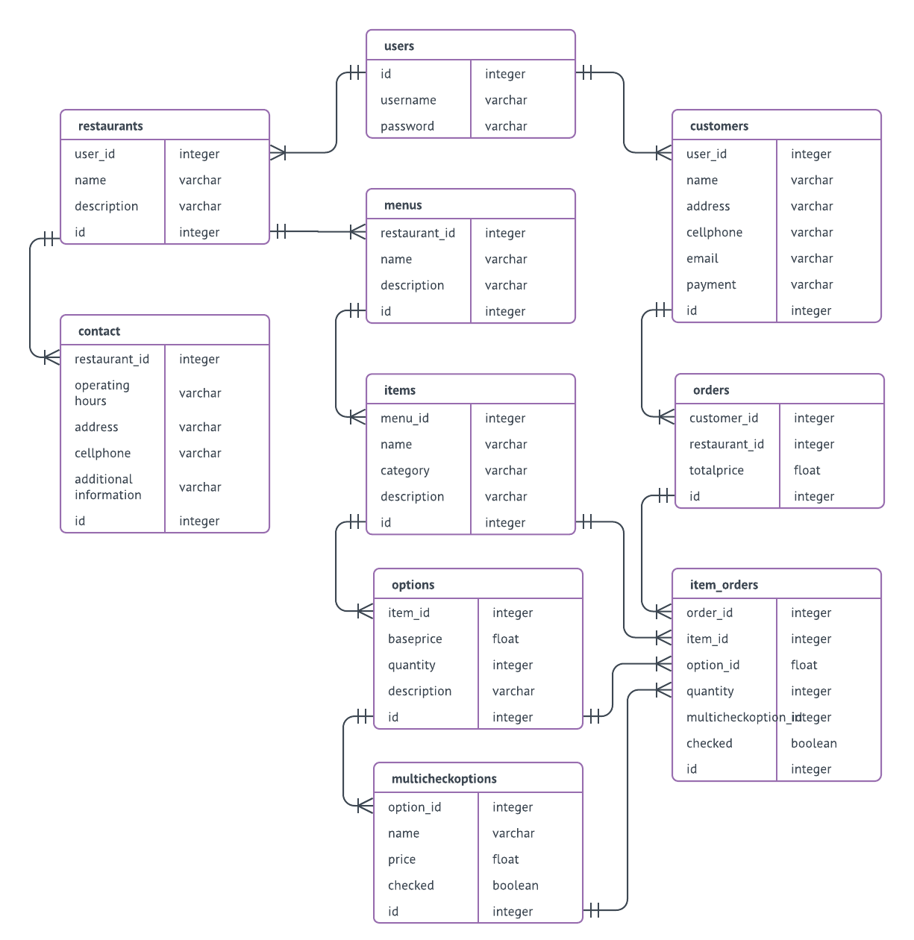

**UML Diagram**