Identification of Standards of Living and Poverty in South Africa

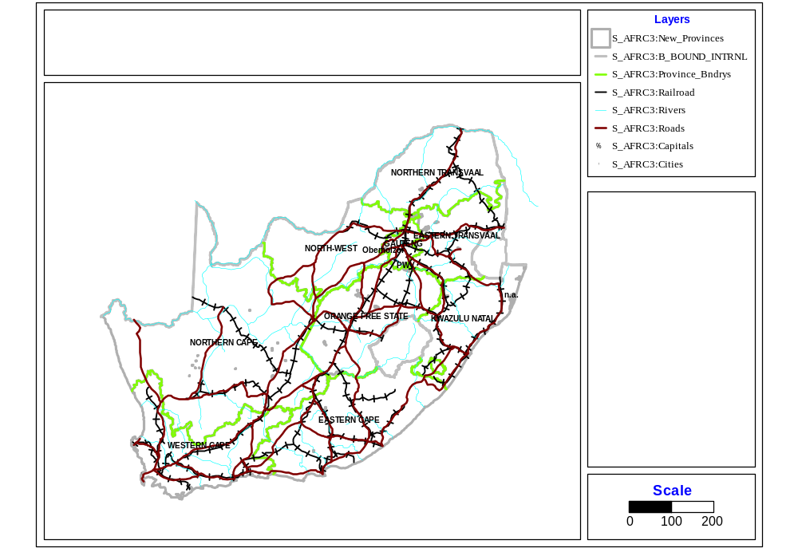

Venanzio Vella, The World Bank, 1818 H Street, NW Washington DC, 20433 USA, AFTH4, J-9-068.
e-mail: vvella@worldbank.org

Maurizio Vichi,
University of Chieti
V.le Pindaro 42, 65127, Pescara, Italy
e-mail: vichi@dmqte.unich.it

December 1997

Contents

Summary. 3
List of acronyms. 4
- Introduction. 5
- Methodology. 6
2.1 Non Linear Principal Component Analysis. 6
2.2 Cluster Analysis. 7
2.3 Depth of poverty. 9
2.4 Validation. 9
- Data Source. 9
- Results. 9
4.1 Non Linear Principal Component Analysis. 9
4.2 Cluster Analysis. 15
4.3 Profile of the five clusters. 18
4.4 Validation of the Cluster Analysis. 20
4.5 Depth of Poverty. 21
4.6 Questionnaire. 25
- Conclusions. 28
References. 29
Annex 1: Rural Areas. Prevalence distribution of key variables. 30
Annex 2: Urban Areas. Prevalence distribution of key variables. 32
Annex 3: Questionnaire Rural Area. 34
Annex 4: Questionnaire Urban Area. 36

Summary

This paper deals with three major areas of poverty analysis: (a) the computation of composite indices capturing different dimensions of poverty and deprivation; (b) the identification of socioeconomic groups; and (c) the development of simple questionnaires to identify poor households for targeting purposes.

The objective of this paper is to describe and identify poor households to ensure that they are reached by poverty alleviation strategies, but it does not have the objective to suggest such strategies. Therefore, this analysis should provide a practical tool, to extension workers and other service providers, to identify and target poor households with interventions suggested by other analysis not considered in this paper.

The results of the analysis, based on the 1993 South Africa Living Standards and Development Survey (LSDS), include:

- The computation of composite indices of deprivation, based on a defined set of socioeconomic indicators.
- The identification of groups (clusters) of households with similar standards of living according to the socioeconomic indicators.
- The construction of simple questionnaires for urban and rural areas to identify households belonging to the poorest groups.

The questionnaires should provide a quick and inexpensive tool to monitor poverty and target interventions. The statistical techniques used in this study are descriptive of the standards of living of South Africa and the results cannot be generalized to other countries.

List of acronyms

CA | Cluster Analysis
Debt | The Household has a debt (proxy for access to credit)
Deprat | Dependency Ratio
DPH | Depth of Poverty of the Household
Hh | Head of the household
H migrated | Head of the household had traveled for work during the last year
HPI | Human Poverty Index
LSDS | Living Standards and Development Survey
LS | Living Standards
NLPCA | Non Linear Principal Component Analysis
UNDP | United Nations Development Programme
1. Introduction

A major problem in poverty analysis is to define and measure poverty. Single indicators, such as expenditure or income, are frequently used to define poverty, but they do not always capture the whole dimension of poverty. As quoted by the 1997 UNDP Human Development Report “For policy-makers, the poverty of choices and opportunities is often more relevant than the poverty of income, for it focuses on the causes of poverty and leads directly to strategies of empowerment and other actions to enhance opportunities for everyone. Poverty must be addressed in all its dimensions, not income alone. ⁽⁾”

Rather than measuring poverty by income or expenditure alone, it is possible to build composite socioeconomic indices that are based on proxies of deprivation such as education of the head of the household. An example is the UNDP human poverty index ⁽⁾ (UNDP, 1997), which is computed through the average of the percentages of: a) people not expected to reach age 40, b) adults who are illiterate and c) other proxies of deprivation. Other examples of composite indices are described in Sen (1992) and Klasen (1996). However, each composite poverty index, computed as an average of variables, has the following methodological problems:
- The variables are given the same weight in defining the composite poverty index, which may create problems. For example, in a country with a high literacy rate and low income, it may be inappropriate to assign the same weight to each variable because a variation in income has a higher impact on poverty than the same variation in education; and
- Variables determining the index may be correlated with each other, duplicating the same information. For example, people with high education have also high income, thus the two variables are correlated and their use in building an index produces a duplication of information summarized by the index.

This suggests the need to use a statistical technique, such as the non linear principal component analysis. This combines the different variables and, at the same time, takes into account the relative weight and the correlation existing among pairs of variables.

Another problem, related to poverty assessments, is the identification of socioeconomic groups with different standards of living to identify inequalities among groups of households and detect those at risk of deprivation. A socioeconomic classification can be obtained by using defined cut-off points for income or expenditure. However, in rural Africa, which is less based on the cash economy, expenditure may have a low variability and may be unsuitable to differentiate standards of living. A methodological problem in using expenditures or income is also the definition of cut-off points under which poverty is classified. For example, using the 20th or the 40th percentile of the total expenditure distribution, may be subjective and not very meaningful. This is especially true if expenditures are low, have a low variation and cannot sustain even the basic needs.

Another problem in poverty analysis, is the assessment of the depth of poverty. Usually, the depth of poverty of a household is measured as the distance of the household from an absolute poverty line, using an univariate approach that is based on expenditures or income. Since the method focuses on expenditures or income, it omits other important characteristics of well-being in the assessment of poverty.

The objectives of the analysis described in this paper are to: (i) build composite indices of poverty based on socioeconomic indicators which are proxies of wealth, health and living conditions; (ii) partition the sample of the 1993 South Africa Living Standards and Development Survey (LSDS), into clusters of households with similar characteristics, i.e., which are homogeneous within the clusters and heterogeneous among the clusters; (iii) validate the goodness of the analysis in classifying deprived households; and (iv) build a questionnaire to identify the most deprived households.

This paper reaches the above objectives using a multivariate-based definition of poverty and standards of living built on a set of indicators of well-being. The analytical steps to construct such indices include: (i) the Non-Linear Principal Component Analysis, which transforms the original indicators into new composite indices, which are optimally quantified and standardized; (ii) the Cluster Analysis, which is applied on the new quantified indices to detect groups of households with similar standards of living; and (iii) the estimation of the Euclidean distance between a given household and the household with the worst living conditions that define the depth of poverty .

The paper is divided into the following sections: methodology, data source, results and conclusions.

2. Methodology

The methodology is divided into the following sections: Non Linear Principal Component Analysis, Cluster Analysis, Depth of poverty and Validation.

2.1. Non linear Principal Component Analysis

The Non Linear Principal Component Analysis (NLPCA) was used to achieve the followings: (i) to remove variables that were correlated with each other; (ii) to remove variables that were not correlated with the most important factors (generally the first two or three) defined by the NLPCA; (iii) to transform the original variables into a few composite indices (factors) which were proxies of the original variables; and (iv) to give category quantifications of the original variables.

The NLPCA produces a set of new composite indices or factors. Each factor takes into account the original variables, summarizing a decreasing part of the total variance of the original variables. The model for the estimation of the i-th factor, is a non linear function f

F_{i} = f(w_{i1} X₁ , w_{i2} X₂ , ... , w_{ip} X_{p}) (1)

where w_{j}’s is the weight (factor score coefficients) given to variable X_{j} and F_{i} is the i-th factor. Usually, the information of the set of original variables can be summarized by the first two or three factors, which are independent from each other and explain most of the total variability.

Each factor is a combination of a subset of the original variables. Each factor is characterized by those variables that are more correlated with it and it is a composite index of those variables. Therefore, only variables correlated with the factor influence the variation of the factor. For example, if the first factor is characterized by socioeconomic variables (e.g. ownership of goods) only their variation influences the change of the factor.

Each factor is a standardized new variable (composite index), with a standardized score (factorial score). This allows to compare variables characterized by different units and levels of measurement such as nominal (e.g. gender, marital status, etc.), ordinal (e.g. level of education) and discrete numeric (e.g. age class, quintiles of expenditures) variables.

This method of constructing a composite index is different from other methods that compute the average of the normalized original variables, such as the UNDP Human Poverty Index (HPI) mentioned in the introduction. The HPI is the average prevalence of three socioeconomic variables, which are given the same weight without taking into account the correlation among each other. On the other hand, the standardized composite index (factor) created by the NLPCA gives different weights to the socioeconomic variables according to the level of their correlation with the factor.

We can estimate the quantified scores of the j-th variable with the following model:

X_{j} = a_{j1} F₁ + a_{j2} F₂ + ... + a_{jk} F_{k} + U_{j} (2)

where F’s are the factors, U_{j} is the error of the model for the j-th variable and a’s are the coefficients called factor loadings . To be noted that the F’s and U are uncorrelated with each other.

After applying the NLPCA each household has its profile,⁽⁾ which is transformed into factorial scores, and the categories of the variables (e.g. protected, unprotected water supply) are optimally quantified into scores.

2.2. Cluster Analysis

The Cluster Analysis (CA) was used to partition the total sample of the 1993 LSDS into socioeconomic groups. In the present analysis, five clusters were used and the initial center of each cluster was the household with the average profile of the households belonging to the first, second, third, fourth and fifth quintile of the per capita total monthly expenditure.

The CA partitions (hierarchically or not-hierarchically) a set of objects (households) into relatively homogeneous clusters based on the similarity of their observed characteristics. The first step of a cluster analysis algorithm is the selection of a measure to evaluate the degree of dissimilarity between objects (e.g. households). The measure used is the squared Euclidean distance between objects described by the standardized variables (). Figure 2 gives an example of how the squared Euclidean distance is used to measure the distance between two households (A and B) characterized by two variables (X and Y) whose different units of measures have been standardized through the NLPCA. According to the Pythagorean theorem, the squared Euclidean distance d(A,B) between households A and B is the squared length of the hypotenuse of a right triangle as reported on figure 2. The concept is easily generalized for more than two variables.

Figure 2: The squared Euclidean distance between two points A and B in a two-dimensional space.
Y

B
6

A

4

0
3 9
X

d(A,B) = 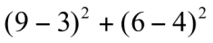 = 40

The second step of the CA is the partition of the households into clusters. The households’ profiles, defined by the variables, are transformed by the NLPCA into households’ quantified categories () which are used to compute the squared Euclidean distance between households. The algorithm k-means (MacQueen 1967, Andemberg, 1973) is employed to partition the households into clusters based on the squared Euclidean distance between households. The algorithm begins to define the center of each cluster which in this analysis was the average socioeconomic profile of the households belonging to each quintile of expenditure. Each household is assigned to the cluster with the smallest distance between the household and the center of the cluster (also called centroid, i.e. a household having the average characteristics of households belonging to that cluster). The analysis iteratively estimates cluster centers and then assigns each household to the closest cluster center. The iteration process terminates when the largest change in any cluster center is less then 1% of the minimum distance between initial centers.

Finally, the average score of the first factor (main socioeconomic composite index) was used to rank the clusters from the most deprived to the least deprived.

2.3 Depth of poverty

For this analysis, the depth of poverty (DPH) of a household is a measure of dissimilarity among households, with higher values defining better socioeconomic standards of living. In this analysis, each household was assigned a DPH according to the squared Euclidean distance between the household and the most deprived household. If the profile of a household was close (i.e. similar) to the profile of the most deprived household its squared Euclidean distance was small and its DPH was low. Vice-versa, if a household had a profile that was very distant (different) from that of the most deprived household its DPH was high. Since the squared Euclidean distance was an additive function, the contribution of the categories (e.g. protected, unprotected) of each variable (e.g. water supply) in determining the depth of poverty of the household could be evaluated. This allowed to assign to the original variables a score to determine the depth of poverty of each household (). The score was used to operationalize the results of the CA through a questionnaire (see 4.6).

2.4 Validation

To validate the analysis, the groups of households classified by the CA and by the quintiles of expenditure were compared in their prevalence of socioeconomic and biological proxies of deprivation (prevalence of stunting and mortality in children under five years of age).

3. Data source

The analysis was carried out on the data collected by the 1993 South Africa Living Standards and Development Survey. The following household’s variables were used in the analysis: race; residence; province; language; type of house; type of toilet; sources of water, lighting, cooking; ownership of a motor vehicle, bicycle, tv, telephone, radio, fridge, electric kettle and electric stove; debts; dependency ratio; head’s gender, age, education, travel for work, illness in the last two weeks and expressed needs.

4. Results

This section presents the results for rural and urban areas and it is divided into the results of the non linear principal component analysis (NLPCA), the cluster analysis (CA), the validation CA and the depth of poverty.

4.1 Non linear Principal Component Analysis

The NLPCA was applied to reduce the number of variables and to transform the remaining variables into factors. The variables that were not correlated (|ρ| < 0.4) with the first three factors (Table 1) were eliminated from the analysis. For the rural areas, the initial 25 variables were reduced to the following 13 variables: type of toilet; source of water; ownership of a motor vehicle, tv, telephone and fridge; presence of debts of the household; dependency ratio; and gender, age, education, travel for work and illness of the head of the household. For the urban areas the same variables were selected except for sources of water that was almost always (99 %) protected in urban areas.

For the rural areas, the first three factors explained 51% of the total variance and had different characteristics. The first factor; which was characterized by the ownership of durable goods, the education of the head of the household and the type of toilet; can be considered a socioeconomic index. The second factor, which was correlated with dependency ratio, age and travel for work of the head of the household, can be considered a composite index of vulnerability of the household. The third factor; which was characterized by the source of water supplies, the illness suffered by the head of household during the previous two weeks and the presence of debts; can be considered an index of heath, sanitation and access to credit. Factors beyond the first three were not considered because they explained less variability and were characterized by not more than one variable.

Table 1: Rural Areas. Correlation (component loadings) between the variables and the first three factors.

VARIABLE | FIRST FACTOR | SECOND FACTOR | THIRD FACTOR
Dependency Ratio. | 0.312 | 0.668 | -0.036
Ownership of a fridge. | -0.644 | 0.433 | 0.045
Ownership of a telephone. | -0.679 | 0.266 | 0.046
Ownership of a TV. | -0.600 | 0.423 | 0.075
Ownership of a motor vehicle. | -0.619 | 0.303 | 0.039
Source of water supplies | 0.314 | 0.187 | -0.476
The head of the household was sick in the previous two weeks. | 0.118 | 0.317 | -0.584
Education of the head of the household. | -0.654 | -0.028 | -0.046
Type of toilet. | -0.653 | 0.362 | 0.054
Migration of the head of the household. | -0.189 | -0.427 | -0.405
Age group of the head of the household. | 0.381 | 0.582 | 0.105
The household has some debts. | -0.182 | 0.130 | -0.620

For the urban areas, the first two factors had the same characteristics already described for the rural areas. Only the first two factors were taken into account because they explained more than 50% of the total variance and because the factors beyond the second one were characterized by only one variable

Table 2: Urban Areas. Correlation (component loadings) between the variables and the first two factors.

VARIABLE | FIRST FACTOR | SECOND FACTOR
Dependency Ratio. | -0.013 | 0.574
Ownership of a fridge. | -0.819 | 0.211
Ownership of a telephone. | -0.793 | 0.121
Ownership of a TV. | -0.751 | 0.227
Ownership of a motor vehicle. | -0.772 | -0.113
The head of the household was sick in the previous two weeks. | -0.070 | 0.451
Education of the head of the household. | -0.648 | -0.341
Type of toilet. | 0.588 | 0.025
Gender of the head of the household. | 0.300 | 0.364
Migration of the head of the household. | -0.067 | -0.445
Age group of the head of the household. | 0.070 | 0.694
The household has some debts. | -0.232 | 0.139

Figures 3a and 3b show, for rural and urban areas, the distribution of the variables according to their categories on the plane formed by the first two factors. The ownership of goods is positioned parallel to the first factor and is located on the left hand side. Categories related to water supplies; dependency ratio; illness, age, gender and emigration (travel for work) of the head of the household are located parallel to the second factor. The households using protected water supplies; with a head who was young, not sick and with tertiary education are located on the lower side of the second factor. It can be noted that the left hand quadrants of the plane formed by the first two factors contains the better-off households.
Figure 3a: Rural areas: NLPCA, Distribution of variables in the Socioeconomic/Vulnerability Plane.

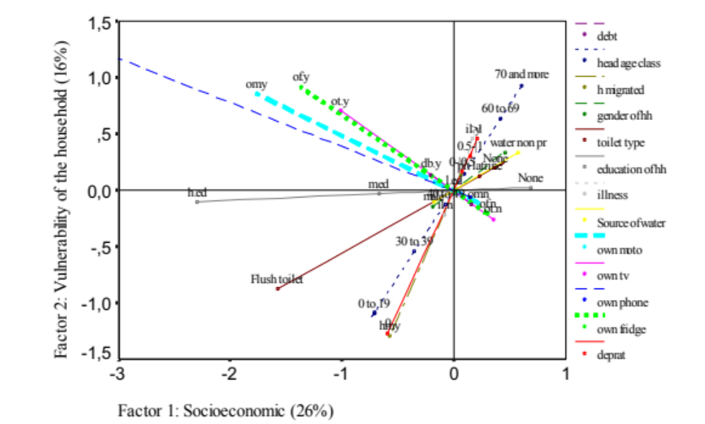
(*) The plane is formed by the first two factorial axes; the percentage in brackets indicates the proportion of the total variance explained by each factor
Legend: il.no, il.y, illness no, yes; op.n, op.y, ownership of phone no, yes; ot.n, ot,y, ownership of tv no, yes; of.n, of,y, ownership of fridge no, yes; om.n, om.y ownership of motor vehicle no, yes; water protec, water not pr, water protected, water not protected; 0, 0-0.5, 0.5-1, >1, dependency ratio (deprat); l.ed, m.ed, h.ed, education primary, secondary and tertiary; db.y, db.n, debt, yes, no; 0 to 19, 20 to 29, 30 to 39, 40 to 49, 50 to 59, 60 to 69, 70 and more, age group of the head of the household; none, pit latrine, flush toilet, no latrine, pit latrine, flush toilet; male, female, gender of the head of the household; hm.y, hm.n head migrated, yes, no.
Figure 3b: Urban areas: NLPCA, Distribution of variables in the Socioeconomic/Vulnerability Plane.
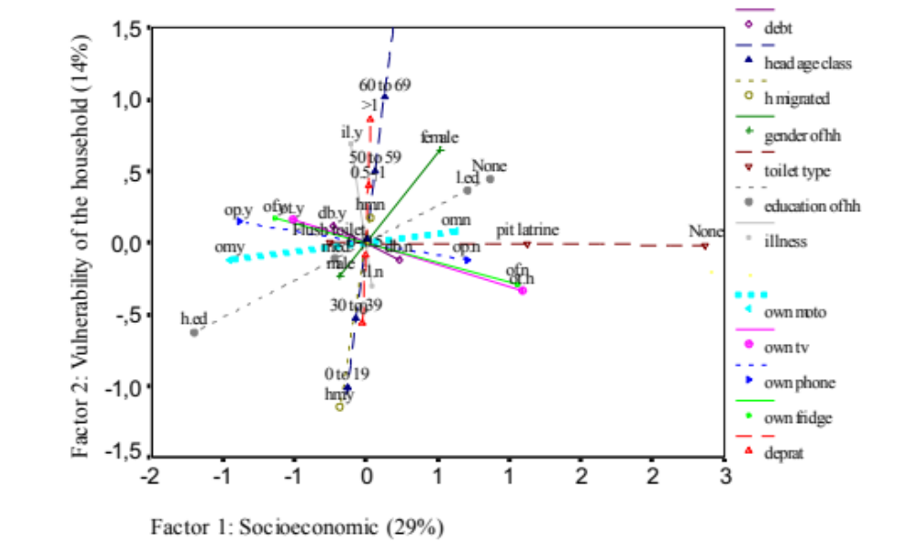
(*) The plane is formed by the first two factorial axes; the percentage in brackets indicates the proportion of the total variance explained by each factor
Legend: il.no, il.y, illness no, yes; op.n, op.y, ownership of phone no, yes; ot.n, ot,y, ownership of tv no, yes; of.n, of,y, ownership of fridge no, yes; om.n, om.y ownership of motor vehicle no, yes; 0, 0-0.5, 0.5-1, >1, dependency ratio (deprat); l.ed, m.ed, h.ed, education primary, secondary and tertiary; db.y, db.n, debt, yes, no; 0 to 19, 20 to 29, 30 to 39, 40 to 49, 50 to 59, 60 to 69, 70 and more, age group of the head of the household; none, pit latrine, flush toilet, no latrine, pit latrine, flush toilet; male, female, gender of the head of the household; hm.y, hm.n head migrated, yes, no.

Figure 4 a: Rural areas: frequency histogram Figure 4 b: Rural areas: frequency histogram
of z-score per capita total monthly expenditure. of the factorial score of the socioeconomic
composite index (first factor).

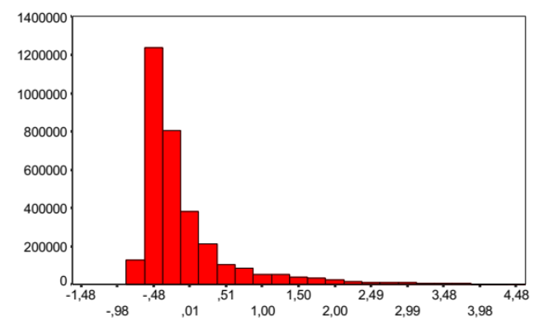 | 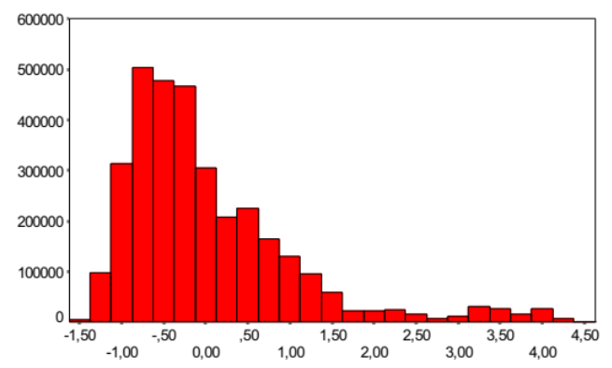

Figure 5 a: Urban areas: frequency histogram Figure 5 b: Urban areas: frequency histogram of
of z-score per capita total monthly expenditure. the socioeconomic composite index (first factor).
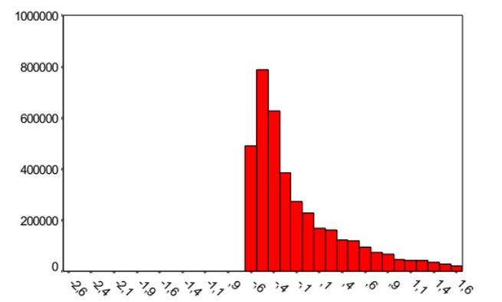 | 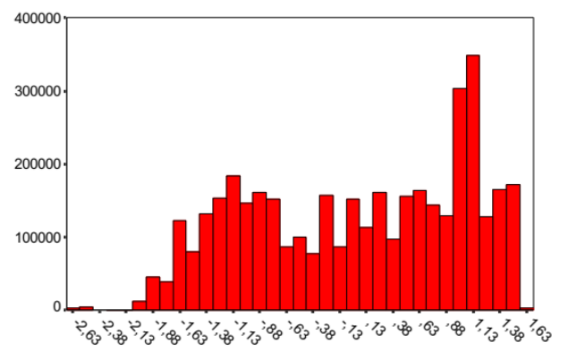

Figures 4 and 5 show, for the rural and urban areas, the frequency histograms of: a) the z-score of the per capita total monthly expenditure and b) the socioeconomic composite index (first factor). Because the socioeconomic index has a larger kurtosis () than the total monthly expenditure, it discriminates better households’ differences. The per capita total monthly expenditure does not seem to provide a good discriminating measure of the households’ characteristics, since in rural areas 65% of households are located in a small range of z-score corresponding to the interval between 50 and 260 Rands. The distributions in figures 4a and 4b have a strong negative skewness () indicating that the majority of the households in rural areas have socioeconomic conditions below the mean. The situation is opposite (positive skewness) in Figures 5a and 5b where households frequently present socioeconomic conditions above the mean.
4.2 Cluster Analysis

The process of identifying groups of households characterized by different standards of living was obtained through the CA. Following the NLPCA, which optimally standardized the key variables, the CA algorithm was used to classify households into groups that were homogeneous within themselves and heterogeneous among themselves. The standardized quantification of the variables, carried out by the NLPCA, allowed their comparability and the computation of the squared Euclidean distance between households, used by the CA to assign households to their respective clusters. To reduce the loss of information in the quantification of the original variables, 10 factors (99% of the total variance) were considered in the NLPCA.

Five homogeneous groups (clusters) were obtained through a clustering algorithm called k-means (section 2.2). Five clusters were chosen to allow the comparison with the five groups of households belonging to the five quintiles of the per capita total monthly expenditure. The initial clusters’ centers used by the algorithm were the 5 average profiles of the households belonging to the quintiles of the per capita total monthly expenditure. These clusters were ranked according to their average score on the first factor and were denominated as ultra-poor, poor, semi-poor, medium and richest standards of living. Figures 6a and 6b show the percentage distribution of the population belonging to the clusters, for rural and urban areas. It can be noted that the ultra-poor and the poor clusters represent almost 50% of the rural population and the 41% of the urban population.

Figure 6 a, b: Percentage distribution of the rural and urban population belonging to the five clusters.
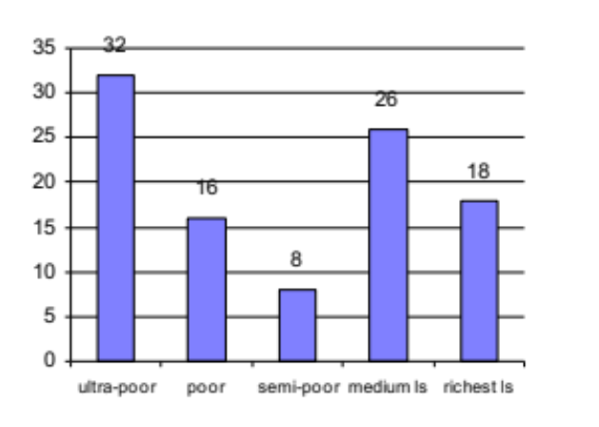  (a) rural population | 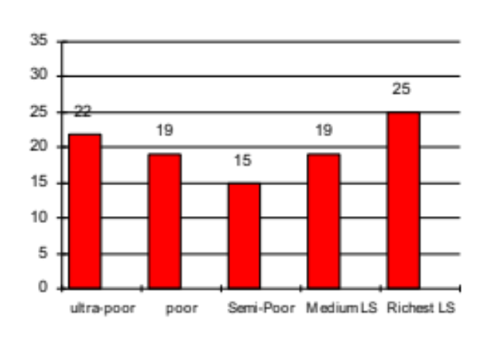  (b) urban population

To give a visual representation of the difference between the clusters, dendrograms () were obtained through the average linkage hierarchical clustering algorithm (Figures 7a and 7b). In the rural areas (Figure 7a) there is little difference between the ultra-poor, poor and semi-poor clusters; which could be considered one combined cluster. Therefore, the number of different rural clusters could be more realistically considered as three, which is also in line with the criterion proposed by Calinski and Harabasz (1974) for choosing the ideal number of clusters. In urban areas (Figure 7b), semi-poor and medium standards of living clusters are closer between each other than the other clusters. In this case the criterion proposed by Calinski and Harabasz (1974) suggests the presence of four clusters.

Figure 7 a, b: Dendrogram of the clusters.
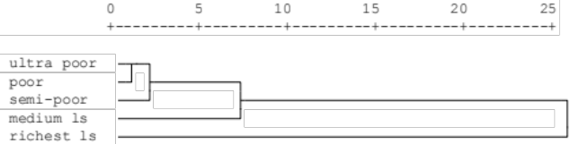  (a) rural area | 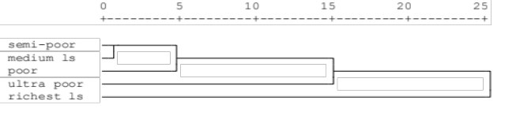  (b) urban area
A Close linkage between two groups indicates similarity between clusters

Tables 3a and 3b report the average per capita total monthly expenditure by cluster for the rural and urban areas. The ultra-poor and poor clusters have a per capita total monthly expenditure of Rand 130 and 144 respectively, which are below the Minimum Living Level of Rand 164.2, set by the Bureau of Market Research of the University of South Africa⁽⁾. The situation appears different in urban areas, where ultra-poor households have a per capita total monthly expenditure of Rand 235.

Table 3a: Rural Areas. Average total monthly expenditure (in Rand) by cluster.
Cluster 1 | Cluster 2 | Cluster 3 | Cluster 4 | Cluster 5
Ultra-Poor | Poor | Semi-Poor | Medium Living Standards | Richest Living Standards
131 | 144 | 210 | 249 | 763
ANOVA: F-ratio = 441334.441; Prob. F = 0.0000

Table 3b: Urban Areas. Average total monthly expenditure (in Rand) by cluster.
Cluster 1 | Cluster 2 | Cluster 3 | Cluster 4 | Cluster 5
Ultra-Poor | Poor | Semi-Poor | Medium Living Standards | Richest Living Standards
235 | 403 | 686 | 852 | 1791
ANOVA: F-ratio = 305136,619; Prob. F = 0.0000

Figures 8a, 8b and 9a, 9b, which give a graphic representation of the households on the factorial plane (against the first two and the first three factors), show that the poorest households are on the right hand side of the plane while the richest ones are on left hand side.

Figures 8 a, 8b : Location of the households in the socioeconomic-health plane.

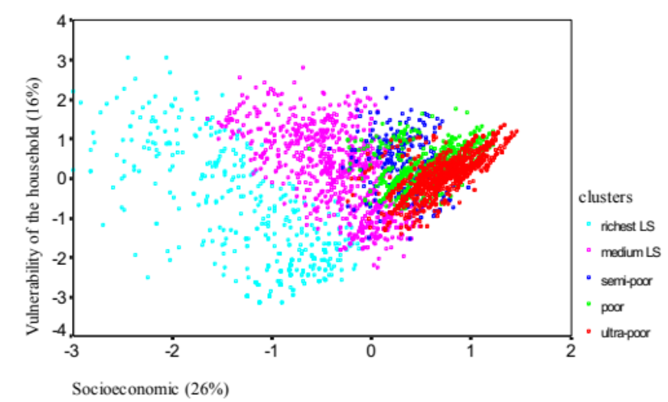  (a) rural areas | 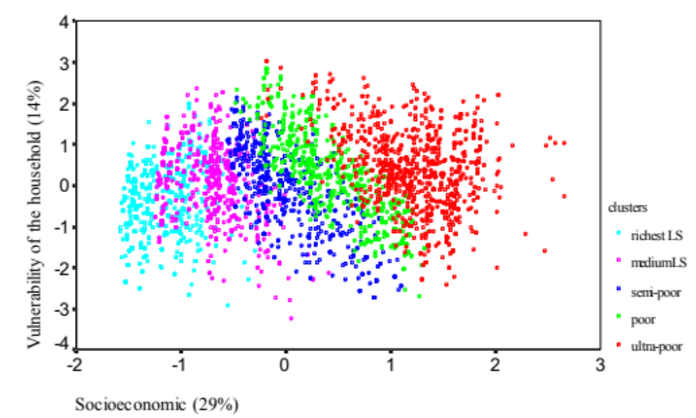  (b) urban area

Figure 9a,b: 3D representation of the cluster analysis.
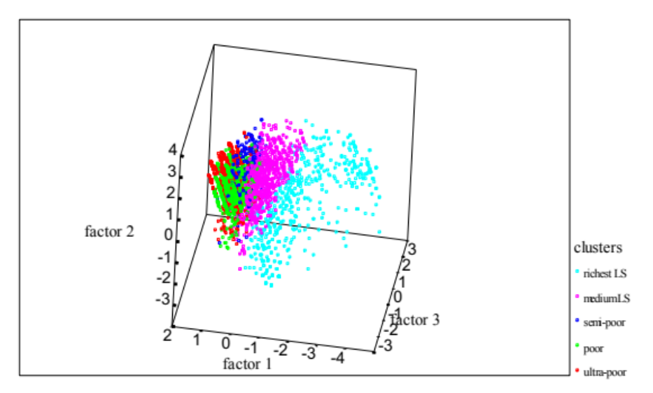  (a) rural areas | 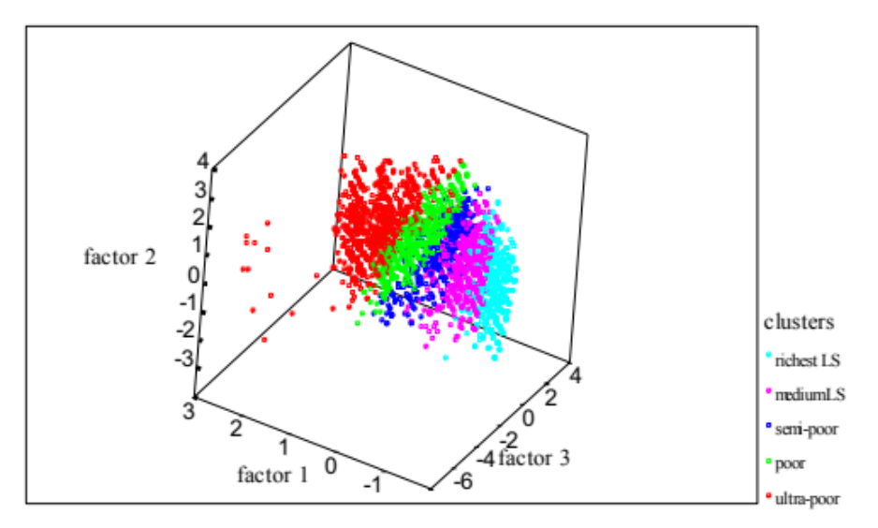  (b) urban areas

4.3 Profile of the five clusters

The typical households’ profiles are reported in boxes 1a through 5a for rural areas, and in boxes 1b through 5b for urban areas. The proportions reported in brackets represent the percentages of the households belonging to a cluster presenting a given characteristic.

Box 1a: ULTRA-POOR IN RURAL AREAS (32%)  - African (99%).  - Speaking Zulu (23%); Xhosa (28%) or North Sotho (19%).  - Rarely owning bikes (15%); fridges (0%); motor vehicles (1%); telephones (0%) or televisions (2%); but frequently owning radios (77%).  - Having a head who is female (42%); with no education (62%) or with primary education (37%); with age more frequently between 60 and 69 years (26%); unemployed (65%); or sick (12%).  - Living in a traditional dwelling (31%) or in a combination of buildings (28%).  - Using a pit latrine as toilet (62%) or not using any latrine (38%).  - Using unprotected water (32%).  - Using wood for cooking (74%) and candles for lighting (57%). | Box 1b: ULTRA-POOR IN URBAN AREAS (22%)  - African (90%).  - Speaking Xhosa (31%); South Sotho (20%); or Zulu (20%).  - Rarely owning bikes (11%); fridges (11%); motor vehicles (4%); telephones (3%) or televisions (24%); but frequently owning radios (70%).  - Having a head who is female (50%); with low education (48%) or no education (25%); with age more frequently between 30 and 39 years (24%); unemployed (43%); or sick (34%).  - Living in a shack (58%); in a house or part of a house (42%).  - Using a pit latrine as toilet (58%).  - Using protected water (98%).  - Using paraffin for cooking (61%) and candles for lighting (42%).
Box 2a: POOR IN RURAL AREAS (16%)  - African (100%).  - Speaking Zulu (38%); Xhosa (27%) or North Sotho (14%).  - Rarely owning bikes (18%); fridges (3%); motor vehicles (3%); television (4%) or telephones (0%); while more frequently owning radios (80%) .  - Having a head of the household who is female (12%) with no education (31%) or with primary education (44%); with age more frequently between 50 and 59 years (24%); currently unemployed (64%) or sick (83%).  - Living in a traditional dwelling (31%) or a combination of buildings (31%).  - Having a pit latrine (72%) or no latrine (26%).  - Using unprotected water sources (41%).  - Using wood (60%) or paraffin (26%) for cooking, and candles (63%) for lighting. | Box 2b: POOR IN URBAN AREAS (19%)  - African (79%).  - Speaking Zulu (27%); Xhosa (16%) or Afrikaans (17%).  - Less frequently owning bikes (11%); motor vehicles (4%); or telephones (10%); while more frequently owning fridges (45%); televisions (49%) and radios (74%).  - Having a head of the household who is female (26%); with primary education (40%); with age more frequently between 30 and 39 years (30%); currently unemployed (26%); or sick (29%).  - Living in a house (54%).  - Having a flush toilet (92%).  - Using protected water sources (100%).  - Using electricity for cooking (55%) and for lighting (66%).

Box 3a: SEMI-POOR IN RURAL AREAS (8%)  - African (99%).  - Speaking Zulu (31%); Xhosa (24%); North Sotho (16%) or Tswana (13%).  - More rarely owning bikes (19%); motor vehicles (4%); fridges (12%) or telephones (0%); but owning more frequently televisions (37 %) or radios (78%).  - With a household’s head who is female (83%); with no education (33%) or primary (43%) education; with age between 60 and 69 years (28%) or between 50 and 59 years (27%); unemployed (58%); or sick (38%).  - Living in a house(38%) or a traditional dwelling(27%)  - Having a pit latrine (72%) or no latrine (25%).  - Using protected water (76%).  - using wood (55%) or paraffin (30%) for cooking; and wood/paraf. (31%) or candles (55%) for lighting. | Box 3b: SEMI-POOR IN URBAN AREAS (15%)  - African (68%).  - Speaking Zulu (20%); Afrikaans (21%) or Xhosa (12%).  - More rarely owning bikes (14%); motor vehicles (83%) or telephones (34%); owning more frequently fridges (68%); televisions (82%) or radios (86%).  - With a household’s head who is female (33%); with primary (23%) or secondary education (67%); with age between 30 and 39 years (30%) or between 40 and 49 years (25%); employed (80%); or sick (20%).  - Living in an apartment (64%).  - Having a flush toilet (98%).  - Using protected water (100%).  - using electricity for cooking (83%); and for lighting (89%).
Box 4a: MEDIUM LIVING STANDARDS IN RURAL AREAS (26%)  - African (99%)  - Speaking Tswana (19%); Shangaan/Tsonga (14%); or Afrikaans (16%).  - Owning bikes (23%); fridges (35%); motor vehicles (16%); telephones (0%); television (51%) or radios (85%).  - Having a head of the household who is female (18%) with primary (42%) or secondary education (39%); between 40 and 49 years of age (29%); currently employed (72%) and sick (30%).  - Living in a house (59%).  - Using a pit latrine (86%); protected water (86%); candles (45%) for lighting and wood (40%) for cooking. | Box 4b: MEDIUM LIVING STANDARDS IN URBAN AREAS (19%)  - White (41%); African (25%); or Colored (21%).  - Speaking Afrikaans (41%); English (34%); or Zulu (19%).  - Owning bikes (43%); fridges (96%); motor vehicles (77%); telephones (75%); television (95%); or radios (94%).  - Having a head of the household who is rarely female (6%); with secondary (79%) education; between 30 and 39 years of age (39%); currently employed (85%); or sick (40%).  - Living in an apartment (83%).  - Using a flush toilet (99%); protected water (100%); and using electricity (95%) for cooking and for lighting (98%).
Box 5a: RICHEST LIVING STANDARDS IN RURAL AREAS (18)  - African (79%); or white (17%).  - Speaking Afrikaans (16%); Tswana (22%) or Shangaan/Tsonga (14%).  - Owning bikes (26%); fridges (44%); motor vehicles (34%); telephones (27%); televisions (50%) or radios (87%).  - With a head who is rarely female (10%) with primary (35%) or secondary education (42%); with an age between 30 and 39 years (32%); employed (93%); or sick (20%).  - Using a flush toilet (82%); protected water (99%); electricity (75%) for cooking and for lighting (75%). | Box 5b: RICHEST LIVING STANDARDS IN URBAN AREAS (25%)  - White (80%).  - Speaking Afrikaans (49%) or English (44%).  Owning bikes (48%); fridges (99%); motor vehicles (98%); telephones (97%); televisions (97%); or radios (98%).  - With a head who is rarely female (14%); with secondary (46%) or tertiary education (54%); with an age between 40 and 49 years (28%); employed (88%); or sick (26%).  - Using a flush toilet (100%); protected water (100%); using electricity (99%) for cooking and for lighting (99%).

4.4 Validation of the Cluster Analysis

The comparison between the clusters and the expenditure quintiles (see Annexes 1 and 2) confirmed that the analysis was correct in ranking the clusters from worst-off to better-off socioeconomic groups. The Figures in the annexes 1 and 2 show that the living conditions gradually improved from the first (ultra-poor) to the fifth (richest) cluster, and that the results of the CA was quite similar and sometimes better than the expenditure quintiles in classifying household groups with different living conditions. Also in terms of biological deprivation the CA was correct in classifying the households into groups with different levels of stunting and mortality among children under five years of age (table 5 and 6).

Table 5a: Rural Areas. Proportion of households with one or more children who died under five years of age.
(a) | Ultra-Poor | Poor | Semi-Poor | Medium LS | Richest LS
Cluster Analysis | 33.9 | 31.2 | 27.5 | 23.5 | 11.2

(b) | I quintile | II quintile | III quintile | IV quintile | V quintile
Quintiles of expenditure | 32.2 | 29.5 | 28.2 | 21.4 | 16.6

Table 5b: Urban Areas. Proportion of households with one or more children who died under five years of age.
(a) | Ultra-Poor | Poor | Semi-Poor | Medium LS | Richest LS
Cluster Analysis | 24.3 | 13.6 | 13.1 | 8.7 | 3.3

(b) | I quintile | II quintile | III quintile | IV quintile | V quintile
Quintiles of expenditure | 23.2 | 14.9 | 12.2 | 6.0 | 2.2

Table 6a: Rural Areas. Prevalence of stunting among children under five years of age (*).
(a) | Ultra-Poor | Poor | Semi-Poor | Medium LS | Richest LS
Cluster Analysis | 28.9 | 22.2 | 19.6 | 15.5 | 14.8

(b) | I quintile | II quintile | III quintile | IV quintile | V quintile
Quintiles of expenditure | 31.5 | 23.0 | 22.1 | 20.5 | 13.7

(*) whose height for age was below -2 standard deviations of the National Center for Heath Statistics reference standard (NCHS).

Table 6b: Urban Areas. Prevalence of stunting among children under five years of age (*).
(a) | Ultra-Poor | Poor | Semi-Poor | Medium LS | Richest LS
Cluster Analysis | 25.0 | 19.3 | 12.2 | 11.6 | 2.5

(b) | I quintile | II quintile | III quintile | IV quintile | V quintile
Quintiles of expenditure | 24.6 | 14.8 | 12.1 | 8.9 | 5.8

(*) whose height for age was below -2 standard deviations of the reference standard (NCHS)

4.5 Depth of Poverty

The depth of poverty of a household was measured as the squared Euclidean distance between its category quantifications and those ones of the worst-off household in the ultra-poor cluster, which was characterized by the living conditions described in box 6. The category quantifications of a household are reported in Tables 7a and 7b, for rural and urban areas respectively. The arithmetic mean of the category quantifications of the households belonging to the ultra-poor group is also reported. It can be noted that the quantifications’ arithmetic mean of the ultra-poor was close to the quantifications of the household with the worst conditions. Tables 8a and 8b show the contribution of each category in determining the depth of poverty of a household, for the rural and urban areas respectively. The depth of poverty of the household can be estimated by summing up the contribution of the categories observed in a given household (see questionnaire) ().

Box 6: Household with worst living conditions

The household does not own a fridge, a television a telephone, a motor vehicle; does not have a safe source of water supplies () and a toilet; the head of this household is a female, above 70 years of age, illiterate, who did not travel for work and did not have debts (in this case indebtedness is a proxy of access to credit)

Table 7a: Rural Areas. Category quantifications of the variables
Categories | - no | - yes | mean of the ultra-poor
Ownership of a fridge. | -0.47 | 2.12 | -0.47
Ownership of a telephone. | -0.22 | 4.62 | -0.22
Ownership of a TV. | -0.59 | 1.69 | -0.54
Ownership of a motor vehicle. | -0.35 | 2.85 | -0.31
Use of protected water supplies. | -0.55 | 1.83 | 0.20
The head of the household was sick in the previous two weeks. | -0.68 | 1.47 | -0.43
Travel for work of the head of the household. | -0.33 | 3.01 | -0.10
The household has some debts. | -0.90 | 1.11 | -0.16

Categories | 0 | 0-0.5 | 0.5-1 | > 1 | mean of the  ultra-poor
Dependency Ratio. | -1.89 | 0.26 | 0.46 | 0.69 | 0.50

Categories | none | primary | secondary | tertiary | mean of the  ultra-poor
Education of the head of the household. | -1.06 | 0 | 1.02 | 3.49 | -0.64

Categories | flush toilet | pit latrine | none | mean of the  ultra-poor
Type of toilet. | -2.41 | 0.36 | 0.57 | 0.44

Categories | - male | - female | mean of the  ultra-poor
Gender of the head of the household. | -0.63 | 1.59 | 0.30

Categories | 0-19 | 20-29 | 30-39 | 40-49 | 50-59 | 60-69 | 70 + | mean of the  ultra-poor
Age group of the head of the household. | -1.87 | -1.85 | -0.93 | -0.20 | 0.27 | 1.10 | 1.61 | 0.42

Table 7b: Urban Areas. Category quantifications of the variables
Categories | - no | - yes | mean of the  ultra-poor
Ownership of a fridge. | -1.29 | 0.77 | -1.07
Ownership of a telephone. | -0.89 | 1.12 | -0.82
Ownership of a TV. | -1.45 | 0.69 | -0.93
Ownership of a motor vehicle. | -0.81 | 1.23 | -0.73
The head of the household was sick in the previous two weeks. | -0.66 | 1.52 | 0.08
Travel for work of the head of the household. | -0.39 | 2.57 | -0.13
The household has some debts. | -1.00 | 1.00 | -0.23

Categories | 0 | 0-0.5 | 0.5-1 | > 1 | mean of the  ultra-poor
Dependency Ratio. | -1.27 | 0.45 | 0.71 | 1.27 | 0.33

Categories | none | primary | secondary | tertiary | mean of the  ultra-poor
Education of the head of the household. | -1.11 | -1.11 | 0.26 | 1.97 | -0.74

Categories | flush toilet | pit latrine | none | mean of the  ultra-poor
Type of toilet. | -0.45 | 2.07 | 3.23 | 1.25

Categories | - male | - female | mean of the  ultra-poor
Gender of the head of the household. | -0.59 | 1.69 | 0.55

Categories | 0-19 | 20-29 | 30-39 | 40-49 | 50-59 | 60-69 | 70 + | mean of the  ultra-poor
Age group of the head of the household. | -1.64 | -1.64 | -0.68 | 0.13 | 0.69 | 1.40 | 2.36 | 0.39

Table 8a : Rural Areas. Contribution of each category in determining the depth of poverty of a household.
Categories | - no | - yes
Ownership of a fridge. | 0.000 | 6.708
Ownership of a telephone. | 0.000 | 23.426
Ownership of a TV. | 0.000 | 5.198
Ownership of a motor vehicle. | 0.000 | 10.240
Source of water supplies is protected. | 0.000 | 5.664
The head of the household was sick in the previous two weeks. | 0.000 | 4.623
The head of the household has travelled for work. | 0.000 | 11.156
The household has some debts. | 0.000 | 4.000

Categories | 0 | 0-0.5 | 0.5-1 | > 1
Dependency Ratio. | 6.656 | 0.185 | 0.053 | 0.000

Categories | None | low Ed | med. Ed | high Ed
Education of head of the household. | 0.000 | 1.124 | 4.326 | 20.703

Categories | flush toilet | pit latrine | none
Type of toilet. | 8.880 | 0.044 | 0.000

Categories | - male | - female
Gender of the head of the household. | 4.928 | 0.000

Categories | 0-19 | 20-29 | 30-39 | 40-49 | 50-59 | 60-69 | 70 +
Age group of the head of the household | 12.110 | 11.972 | 6.452 | 3.276 | 1.769 | 0.260 | 0.000

Table 8b: Urban Areas. Contribution of each category in determining the depth of poverty of a household.
Categories | - no | - yes
Ownership of a fridge. | 0.000 | 4.244
Ownership of a telephone. | 0.000 | 4.040
Ownership of a TV. | 0.000 | 4.580
Ownership of a motor vehicle. | 0.000 | 4.162
The head of the household was sick in the previous two weeks. | 0.000 | 4.752
travel for work of the head of the household. | 0.000 | 11.156
The household has some debts. | 0.000 | 4.000

Categories | 0 | 0-0.5 | 0.5-1 | > 1
Dependency Ratio. | 6.452 | 0.672 | 0.314 | 0.000

Categories | none | primary | secondary | tertiary
education of head of the household. | 0.000 | 0.000 | 1.040 | 7.453

Categories | flush toilet | pit latrine | none
Type of toilet. | 13.542 | 1.346 | 0.000

Categories | - male | - female
gender of the head of the household. | 5.198 | 0.000

Categories | 0-19 | 20-29 | 30-39 | 40-49 | 50-59 | 60-69 | 70 +
Age group of the head of the household. | 16.000 | 16.000 | 9.242 | 4.973 | 2.789 | 0.922 | 0.000

Figures 11 and 12 show the squared Euclidean distances between the five clusters. The distance between the worst and the best cluster has been scaled to one, and all the other distances are a fraction of one. The distances between the ultra-poor cluster and the other clusters represent the depth of poverty of the clusters with respect to the ultra-poor, capturing the differences in extent of poverty among clusters. It can be noted that the ultra poor, the poor and the semi-poor clusters are relatively close to each other in rural areas, while they are more distant among each other in urban areas, confirming a higher homogeneity of the poorest groups in rural areas.

Figure 11: Clusters’ depth of poverty in rural areas.
Medium LS

0.320

0.688
Poor
0.037
Ultra-Poor
Richest LS
1.00
0.061
0.105
Semi-Poor

Figure 12: Clusters’ depth of poverty in urban areas.
Medium LS

0.525
0.09
0.214
Semi-Poor
0.309
Ultra-Poor
Richest LS
1.00

0.259
Poor

4.6 Questionnaire

The present analysis was operationalized to identify the most deprived households through two questionnaires built on the 13 and 12 key variables used in the analysis for rural and urban areas. These questionnaires are presented in Annexes 3 and 4 and can be used to determine the depth of poverty of a specific household according to the key variables. On the right hand side of each question is reported a score which is based on tables 8a and 8b. The score represents the contribution of each variable in determining the depth of poverty of the household. The household’s depth of poverty is estimated by summing up the individual scores.

Tables 9a and 9b provide the percentile distribution of the households’ score by cluster. These tables can be used to decide the cut-off point under which a household is considered poor. For example, in rural areas a cut-off point of 18 will identify about 60% of the ultra poor and poor, and 40% of the semi-poor; while the households belonging to the medium and richest clusters will be above this cut-off point. Similarly, in urban areas a cut-off point of 32 will identify 90% of the ultra-poor and 16% of the poor, while the other clusters will be above such cut-off point. It can be noted that, in terms of score, the poorest clusters are more homogeneous in rural areas than in urban areas.

The selection of the cut-off point will depend on the extent to which a given intervention needs to focus on the poorest clusters and on the population to be covered. For example, we estimated (data available on request) that, for urban areas, a cut-off point of 16.5 and 23 will cover 5% and 10% of the total urban population and will identify 20% and 46% of the ultra-poor, avoiding to include households from the other clusters.
Table 9a: Rural Areas. Percentile distribution of the households’ depth of poverty by cluster.
percentile | ultra-poor | poor | semi-poor | medium sl | richest sl
1 | 0.445 | 2.919 | 8.347 | 18.939 | 31.965
2 | 4.084 | 4.629 | 8.733 | 19.967 | 33.399
3 | 4.353 | 5.189 | 8.813 | 20.569 | 35.059
4 | 4.927 | 5.286 | 10.436 | 21.387 | 35.152
5 | 5.664 | 5.468 | 10.851 | 21.813 | 35.204
6 | 5.790 | 6.409 | 10.957 | 22.356 | 36.635
7 | 5.969 | 6.752 | 11.167 | 22.581 | 37.658
8 | 6.022 | 6.832 | 11.687 | 23.065 | 38.068
9 | 6.496 | 6.885 | 12.015 | 23.300 | 38.327
10 | 7.727 | 7.145 | 12.291 | 23.430 | 38.327
12 | 9.022 | 8.484 | 12.707 | 23.745 | 38.327
14 | 9.736 | 9.021 | 12.853 | 24.022 | 38.982
16 | 9.908 | 9.326 | 13.424 | 24.614 | 40.948
18 | 10.287 | 9.513 | 13.720 | 24.857 | 41.530
20 | 10.511 | 10.593 | 14.161 | 24.989 | 42.351
22 | 10.644 | 10.822 | 14.333 | 25.428 | 42.724
24 | 11.391 | 10.925 | 15.014 | 26.090 | 43.658
26 | 11.715 | 11.185 | 15.827 | 26.316 | 43.984
28 | 12.180 | 11.615 | 16.318 | 26.617 | 44.827
30 | 12.827 | 11.889 | 16.653 | 27.029 | 45.570
32 | 13.303 | 12.021 | 16.869 | 27.417 | 46.217
34 | 13.660 | 12.433 | 17.203 | 27.621 | 46.920
36 | 14.048 | 12.573 | 17.307 | 27.867 | 47.743
38 | 14.587 | 13.368 | 17.445 | 28.126 | 47.887
40 | 14.740 | 13.556 | 17.772 | 28.408 | 48.867
42 | 14.970 | 13.869 | 18.036 | 28.664 | 49.101
44 | 15.268 | 14.677 | 18.449 | 28.950 | 49.483
46 | 15.475 | 14.990 | 18.739 | 29.447 | 50.348
48 | 15.529 | 15.122 | 18.783 | 29.570 | 51.090
50 | 15.704 | 15.751 | 18.898 | 30.078 | 51.770
52 | 16.238 | 16.114 | 19.441 | 30.356 | 52.399
54 | 16.643 | 16.544 | 19.830 | 30.932 | 53.410
56 | 17.055 | 16.658 | 19.929 | 31.355 | 53.652
58 | 17.196 | 17.153 | 20.219 | 31.805 | 55.003
60 | 17.656 | 17.605 | 20.333 | 32.126 | 56.993
62 | 17.991 | 18.138 | 20.746 | 32.505 | 57.919
64 | 18.232 | 18.239 | 21.109 | 32.696 | 58.553
66 | 18.588 | 19.077 | 21.162 | 33.285 | 59.043
68 | 19.300 | 19.316 | 21.264 | 33.610 | 60.201
70 | 19.560 | 19.875 | 21.542 | 34.094 | 62.246
72 | 19.659 | 20.136 | 21.842 | 34.551 | 62.797
74 | 19.745 | 20.558 | 21.894 | 34.982 | 65.184
76 | 20.771 | 21.182 | 22.131 | 35.484 | 68.972
78 | 21.217 | 21.381 | 22.306 | 35.782 | 73.853
80 | 21.711 | 21.434 | 22.516 | 36.742 | 75.974
82 | 22.175 | 22.252 | 23.088 | 37.362 | 78.347
84 | 22.576 | 22.332 | 23.620 | 37.928 | 81.336
86 | 22.831 | 22.862 | 23.734 | 38.484 | 83.284
88 | 23.019 | 22.915 | 24.209 | 39.069 | 84.737
90 | 24.027 | 23.796 | 24.943 | 40.386 | 89.077
92 | 26.542 | 25.422 | 25.629 | 41.622 | 93.699
94 | 26.928 | 25.963 | 26.878 | 42.306 | 97.578
95 | 27.557 | 26.037 | 27.422 | 43.295 | 100.303
96 | 28.353 | 26.576 | 27.622 | 44.298 | 100.915
97 | 28.873 | 26.902 | 28.868 | 45.034 | 101.047
98 | 30.868 | 27.699 | 31.183 | 45.846 | 105.465
99 | 32.920 | 30.188 | 33.417 | 46.996 | 108.162

Table 9b: Urban areas. Percentile distribution of the households’ depth of poverty by cluster.
percentile | ultra-poor | poor | semi-poor | medium sl | richest sl
1 | 4.135 | 26.486 | 33.349 | 36.757 | 38.038
2 | 5.903 | 27.283 | 33.877 | 38.403 | 41.441
3 | 6.544 | 28.323 | 34.884 | 38.889 | 42.709
4 | 7.020 | 28.694 | 35.385 | 39.126 | 43.630
5 | 7..333 | 29.155 | 35.777 | 40.213 | 43.869
6 | 8.458 | 29.468 | 36.176 | 40.745 | 44.658
7 | 9.559 | 29.858 | 36.496 | 40.942 | 45.300
8 | 10.346 | 30.049 | 36.670 | 41.099 | 46.358
9 | 10.858 | 30.165 | 36.839 | 41.816 | 46.487
10 | 11.296 | 30.589 | 37.198 | 42.454 | 46.883
12 | 12.275 | 31.031 | 37.928 | 42.768 | 47.387
14 | 13.569 | 31.596 | 38.233 | 42.929 | 47.989
16 | 14.754 | 31.831 | 38.619 | 43.126 | 48.106
18 | 15.385 | 32.271 | 39.065 | 43.469 | 49.576
20 | 15.843 | 32.618 | 39.480 | 43.879 | 49.856
22 | 16.583 | 32.734 | 39.818 | 44.906 | 50.883
24 | 17.114 | 33.012 | 40.138 | 45.104 | 50.897
26 | 17.707 | 33.361 | 40.445 | 45.607 | 51.636
28 | 18.458 | 33.805 | 41.159 | 45.992 | 52.040
30 | 19.021 | 34.148 | 41.451 | 46.844 | 52.040
32 | 19.716 | 34.611 | 41.695 | 46.929 | 52.637
34 | 20.269 | 34.822 | 42.275 | 47.198 | 53.336
36 | 20.538 | 34.918 | 42.680 | 47.288 | 53.820
38 | 20.852 | 34.918 | 42.909 | 47.395 | 54.493
40 | 21.225 | 35.236 | 43.434 | 47.596 | 54.807
42 | 21.843 | 35.595 | 43.741 | 47.879 | 55.478
44 | 22.335 | 35.999 | 43.818 | 47.989 | 55.650
46 | 22.721 | 36.456 | 44.107 | 49.007 | 56.309
48 | 23.079 | 36.792 | 44.555 | 49.759 | 57.378
50 | 23.398 | 36.977 | 44.865 | 50.438 | 57.820
52 | 23.895 | 37.296 | 45.326 | 51.198 | 58.047
54 | 24.415 | 37.552 | 45.598 | 51.474 | 58.530
56 | 24.679 | 37.987 | 45.667 | 51.606 | 58.977
58 | 25.151 | 38.434 | 46.275 | 51.682 | 59.245
60 | 25.644 | 38.612 | 44.865 | 50.438 | 59.246
62 | 26.155 | 38.727 | 47.434 | 51.910 | 59.560
64 | 26.679 | 38.927 | 47.749 | 53.043 | 59.650
66 | 26.990 | 39.186 | 47.822 | 53.805 | 60.677
68 | 27.296 | 39.186 | 48.460 | 54.425 | 62.088
70 | 27.545 | 39.446 | 49.073 | 55.206 | 63.067
72 | 27.940 | 39.807 | 49.618 | 55.637 | 63.245
74 | 28.415 | 40.795 | 49.825 | 55.950 | 63.560
76 | 28.780 | 41.063 | 50.016 | 55.950 | 63.569
78 | 29.118 | 41.063 | 51.385 | 55.950 | 64.001
80 | 29.613 | 41.495 | 51.822 | 56.443 | 64.847
82 | 30.248 | 41.962 | 51.931 | 57.956 | 65.658
84 | 30.738 | 43.069 | 52.528 | 58.925 | 66.677
86 | 31.296 | 43.186 | 53.652 | 60.054 | 68.007
88 | 31.780 | 43.679 | 54.233 | 60.398 | 68.847
90 | 32.402 | 44.995 | 55.431 | 60.802 | 70.005
92 | 33.359 | 45.511 | 56.105 | 62.709 | 71.704
94 | 33.988 | 45.945 | 56.583 | 64.712 | 72.680
95 | 34.220 | 45.945 | 56.645 | 64.807 | 74.191
96 | 35.364 | 46.623 | 58.648 | 65.071 | 75.439
97 | 35.751 | 47.662 | 59.487 | 66.810 | 76.456
98 | 37.628 | 49.508 | 60.583 | 68.772 | 78.459
99 | 38.175 | 49.945 | 60.645 | 71.470 | 81.218

- Conclusions

The analysis achieved the objectives mentioned in the introduction. On the methodological side, the analysis has built a composite index of poverty which is based on several socioeconomic proxies. On the operational side, the analysis has identified questionnaires which have a strong statistical basis and that are at the same time easy to use. This was done through statistic techniques which avoid many of the methodological problems mentioned in the introduction.

The results of the analysis has several advantages compared to the more traditional poverty assessments. Although the NLPCA and the CA are not based on the expenditures, they provide similar results in terms of partitioning the population in groups with different levels of living conditions and biological deprivation. If the objective of the poverty classification is to identify disadvantaged households, in order to alleviate their conditions, this analysis has fully achieved such objective. Furthermore, the analysis is based on several indicators which can be used in areas where expenditure or income are not very meaningful measures of wealth and are difficult to measure.

One of the greatest advantage of the classification worked out by the analysis is its practical application to identify and target poor households. One limitation of the more traditional poverty classifications based on expenditures, is the lack of practical tools to identify poor households in field conditions. The measurement of the expenditure is time consuming and cannot be used for targeting or monitoring purposes. The major outcome of this study was the design of a questionnaire which could have several applications in various sectors, including the identification of poor households for safety net programs and the exclusion of poor households from paying for social services (e.g. health care).

Defining the scope of this type of analysis is essential to avoid confusion and unwanted criticism. It has been mentioned that the objective of this analysis was to establish a composite index of poverty to identify poor households, while other types of analysis are needed to define policies and strategies. On the other hand, analysis which are mainly geared towards the formulation of strategies may be insufficient to produce the expected outcome if some targeting and monitoring mechanisms, as those suggested by the present analysis are not in place. It is also clear that in the absence of data on expenditure, the classification of socioeconomic groups produced by the CA can be used to generate multivariate analysis for the formulation of policies and strategies to improve the conditions of the poorest clusters.

References

Andemberg M. R. (1973). Cluster Analysis for applications, New York: Academic Press.
Ball, G. H. & Hall, D. J. (1967). A clustering technique for summarizing multivariate data, Behavior
Science, 12, 153-155.
Calinki, T. and Harabasz, J. (1974). A Dendrite Method for Cluster Analysis, Communications in
Statistics.
Klasen, S. (1996). Poverty and Inequality in South Africa, unpublished paper.
MacQueen, J. B. (1967). Some methods for classification and analysis of multivariate observations,
Proceedings of the 5th Berkeley Symposium, 1, 281-297.
Gordon A. D. (1987), “A review of Hierarchical Classification,” The Journal of the Royal Statistical
Society, A, vol 150, 2, 119-137.
Gordon, A.D. (1996). Hierarchical Classification, In : Clustering and Classification, Eds., P. Arabie,
L. Hubert, and G. De Soete, New Jersey: Wold Scientific, River Edge.
Greenacre, M., Hastie, T. (1987). The Geometric Interpretation of Correspondence Analysis, Journal of American Statistical Association, 82, 398, 437-447.
Sen, A. K. (1992). Inequality Re-examined, Cambridge: Harvard University Press.
UNDP (United Nations Development Programme), (1997). Human Development report. Oxford University Press.
World Bank (1995). Key indicators of Poverty in South Africa. Washington DC.
World Bank (1997). World Development indicators, Washington, DC.
World Bank (1997). Annual Report, Washington, DC.

Annex 1
Rural Areas. Prevalence of key variables by clusters and quintiles of expenditure

10.1. Percentage of heads of households without education
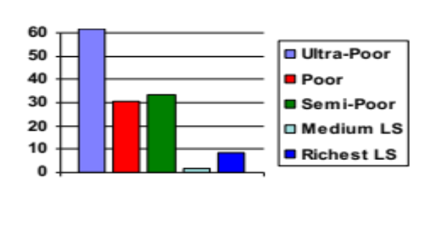  Clusters of households | 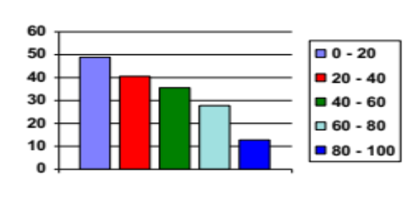  Quintiles of Expenditure

10.2. Percentage of households with electricity as source of lighting
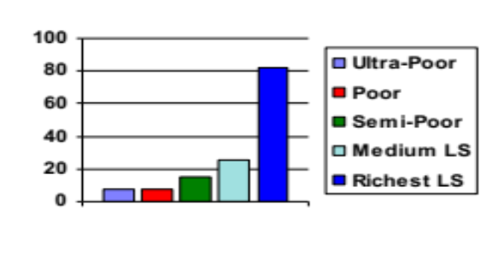  Clusters of households | 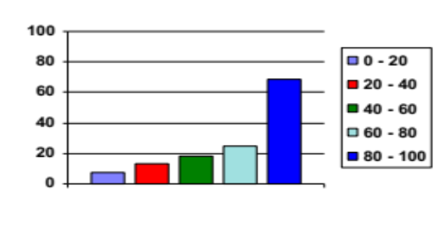  Quintiles of Expenditure

10.3. Percentage of households living in an house or part of a house
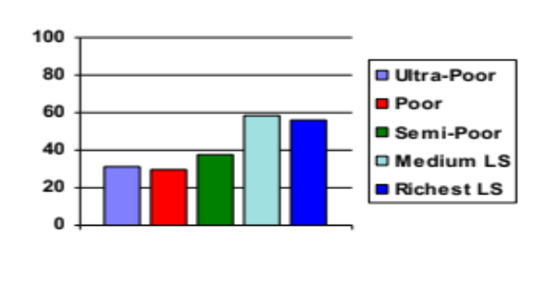 Clusters of households | 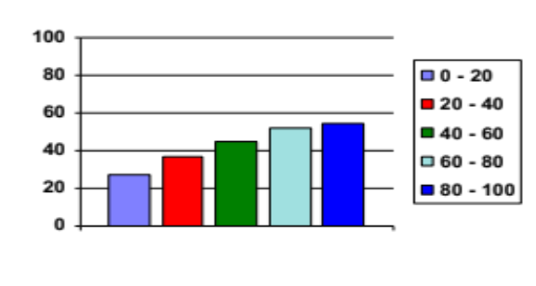  Quintiles of Expenditure

10.4. Percentage of households using an electric stove
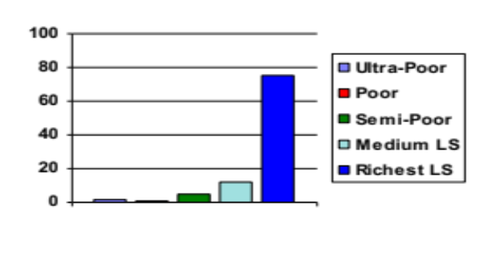  Clusters of households | 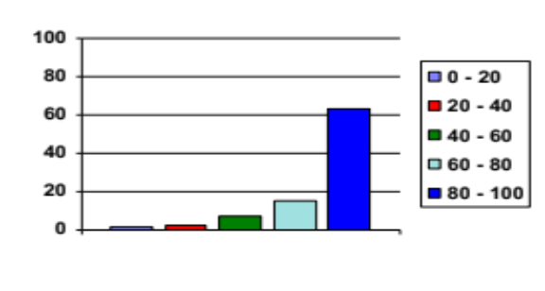  Quintiles of Expenditure
10.5. Percentage of households by type of toilet
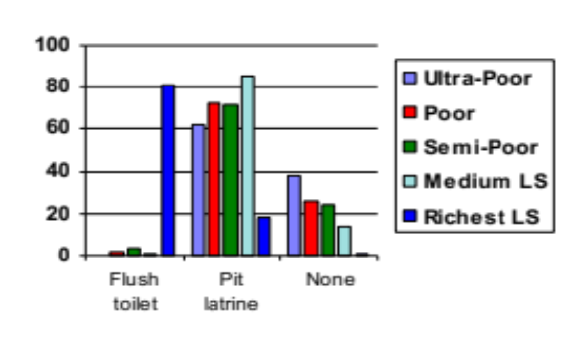  Clusters of households | 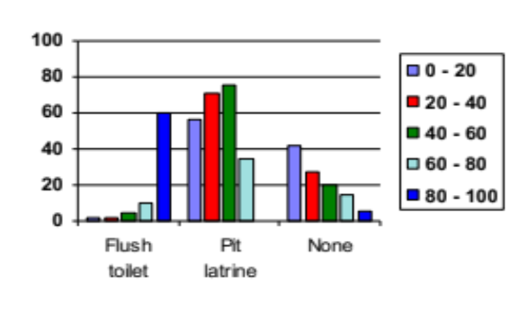  Quintiles of Expenditure

10.6 Percentage of households owning a bike
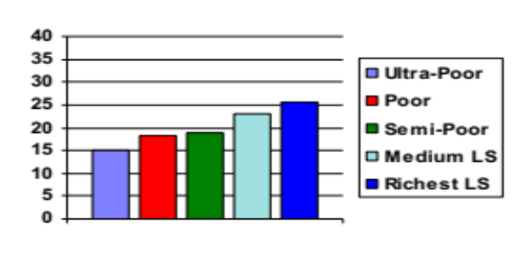  Clusters of households | 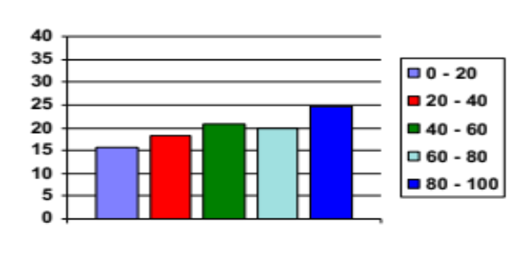  Quintiles of Expenditure

10.7. Percentage of households by race
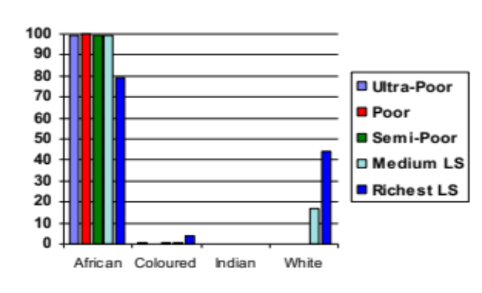  Clusters of households | 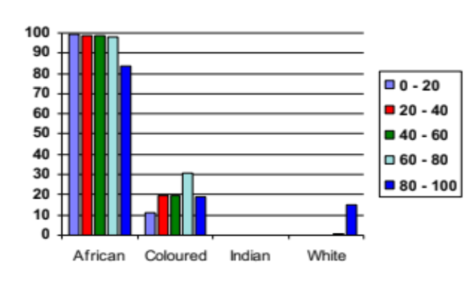Quintiles of Expenditure

10.8. Percentage of what the head of the household needs most
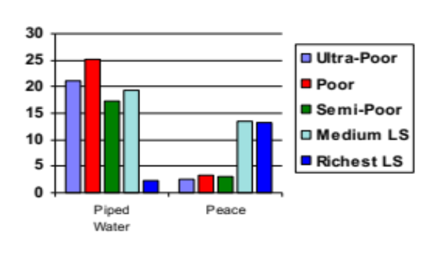  Clusters of households | 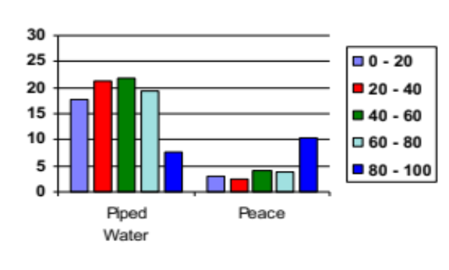  Quintiles of Expenditure
Annex 2
Urban Areas. Prevalence of key variables by clusters and quintiles of expenditure

11.1. Percentage of heads of households without education
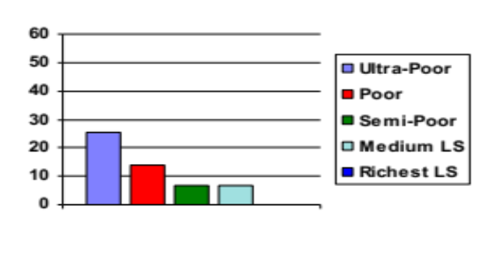  Clusters of households | 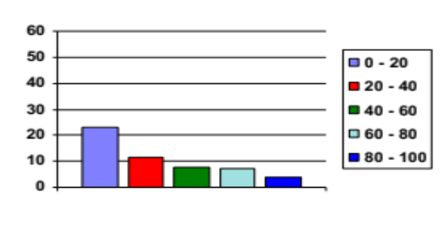  Quintiles of Expenditure

11.2. Percentage of households with electricity as source of lighting
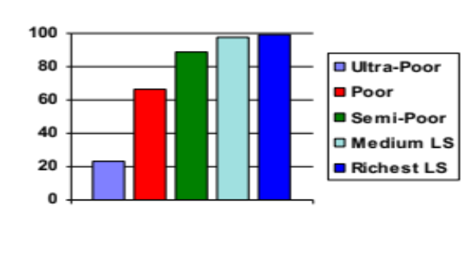  Clusters of households | 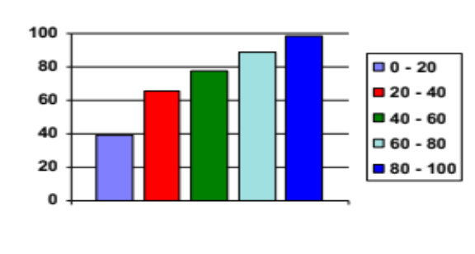  Quintiles of Expenditure

11.3. Percentage of households living in an house or part of a house
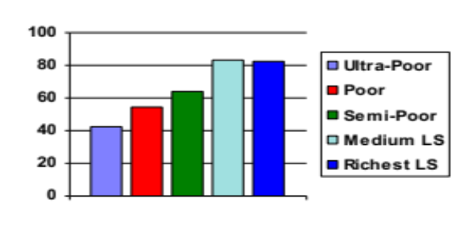  Clusters of households | 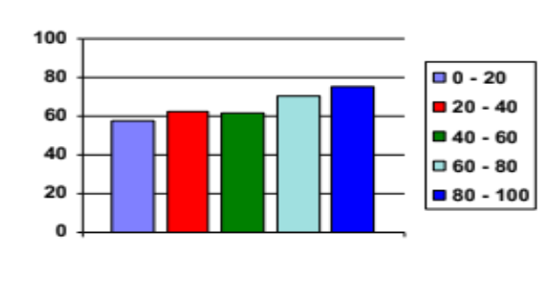  Quintiles of Expenditure

11.4. Percentage of households using electric stove
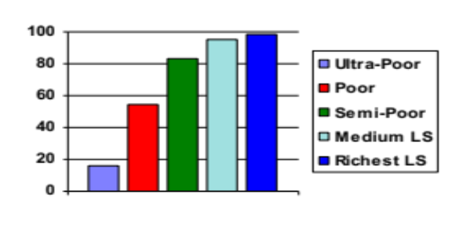  Clusters of households | 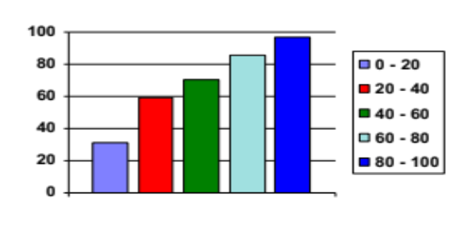  Quintiles of Expenditure

11.5. Percentage of households by type of toilet
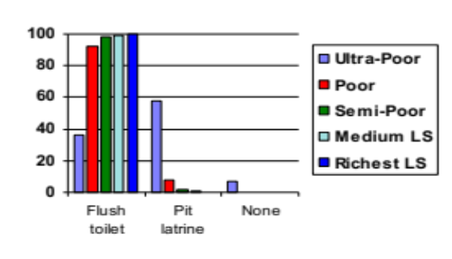  Clusters of households | 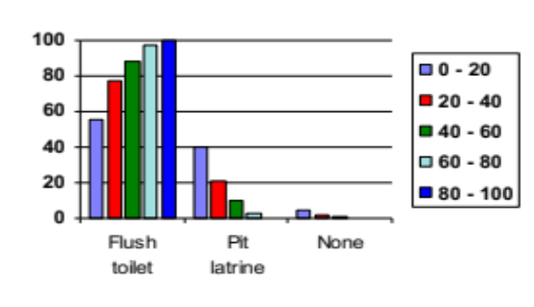  Quintiles of Expenditure

11.6. Percentage of households owning a bike
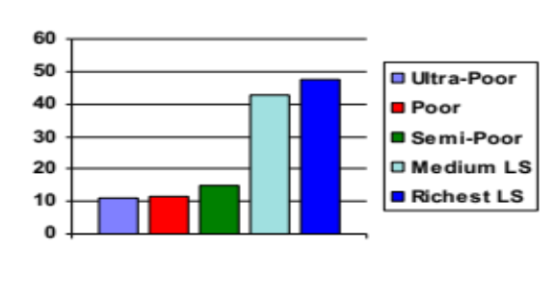  Clusters of households | 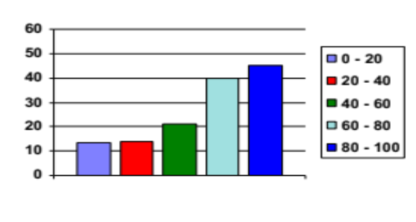  Quintiles of Expenditure

11.7. Percentage of households by race
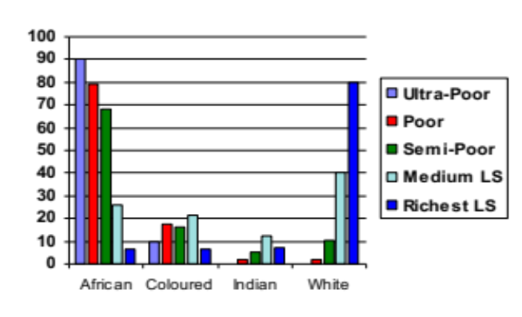  Clusters of households | 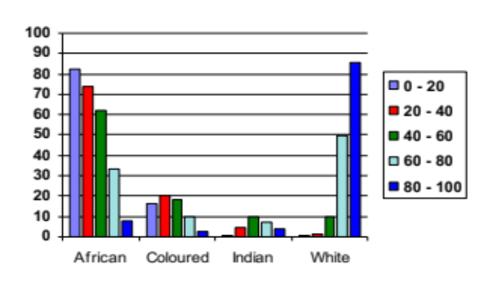Quintiles of Expenditure

11.8. Percentage of what the head of the household needs most
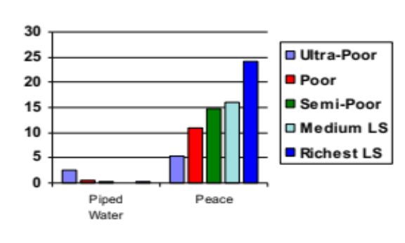  Clusters of households | 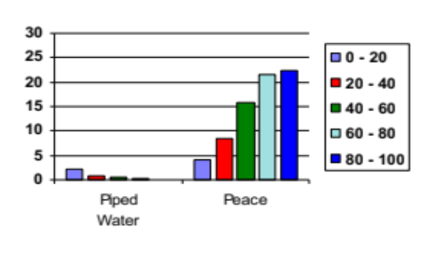  Quintiles of Expenditure
Questionnaire
Annex 3
to identify poor households in
Rural Areas of South Africa
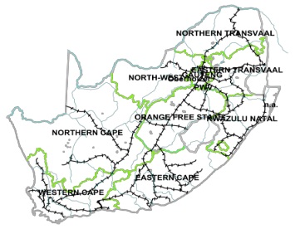

Household services score
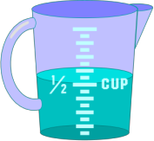
1 | What is the source of water used most often in this household for | Protected (Piped -internal, yard tap, public tap, borehole) | ❑ | 5.664
 | things like drinking or bathing and washing clothes? | Not protected (Rainwater, flowing river, stagnant water well) | ❑ | 0.000

Toilet
2 |  | Flush toilet | ❑ | 8.880
 | What is the type of toilet used in the household? | pit latrine | ❑ | 0.044
 |  | none | ❑ | 0.000

Household durable goods

In the following list of items does the household own?

3 | Motor vehicle, including | Yes | ❑ | 10.240
 | cars | No | ❑ | 0.000

4 | Fridge | Yes | ❑ | 6.708
 |  | No | ❑ | 0.000


5 | Television | Yes | ❑ | 5.198
 |  | No | ❑ | 0.000


6 | Telephone | Yes | ❑ | 23.426
 |  | No | ❑ | 0.000

Socioeconomic variable
How many members of the household have age


7 | (1) less than 16 or greater than 64 | 0 | ❑ | 6.656
 | (2) equal or greater than 16 and equal or less than 64 | 0´0.5 | ❑ | 0.185
 | divide (1) by (2) and select between | 0.5 ´ 1 | ❑ | 0.053
 | 0, 0 and 0.5, 0.5 and 1, greater than1 | greater than 1 | ❑ | 0.000

Characteristics of the head of the household


8 | Gender of the head of the household | Male | ❑ | 4.928
 |  | Female | ❑ | 0.000

AGE

9 |  | 0-19 | ❑ | 12.110
 |  | 20-29 | ❑ | 11.972
 |  | 30-39 | ❑ | 6.452
 | Age of the head of the household | 40-49 | ❑ | 3.276
 |  | 50-59 | ❑ | 1.769
 |  | 60-69 | ❑ | 0.260
 |  | 70 and more | ❑ | 0.000


10 |  | none | ❑ | 0.000
 | Education of the head of the household | primary education | ❑ | 1.124
 |  | secondary education | ❑ | 4.326
 |  | tertiary education | ❑ | 20.703

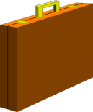

11 | Has the head of the household | Yes | ❑ | 11.156
 | traveled for work? | No | ❑ | 0.000


12 | Has the head of the household | Yes | ❑ | 4.000
 | any debt? | No | ❑ | 0.000


13 | Has the head of the household | Yes | ❑ | 0.000
 | been sick or injured during the past two weeks* | No | ❑ | 4.623
(*) This includes people who have some form of permanent injury, disability, or ailment.

Calculate the total score by adding up each individual score related to the presence or absence of the category of each variable.

Questionnaire
Annex 4
Annex 4
to identify poor households in
Urban Areas of South Africa

Household services score

Toilet
1 |  | Flush toilet | ❑ | 13.542
 | What is the type of toilet used in the household | pit latrine | ❑ | 1.346
 |  | none | ❑ | 0.000

Household durable goods

In the following list of items does the household own?


2 | Motor vehicle, including | Yes | ❑ | 4.162
 | cars | No | ❑ | 0.000

3 | Fridge | Yes | ❑ | 4.244
 |  | No | ❑ | 0.000

4 | Television | Yes | ❑ | 4.580
 |  | No | ❑ | 0.000

5 | Telephone | Yes | ❑ | 4.040
 |  | No | ❑ | 0.000

Socioeconomic variable
How many members of the household have age


6 | (1) less than 16 or greater than 64 | 0 | ❑ | 6.452
 | (2) equal or greater than 16 and equal or less than 64 | 0´0.5 | ❑ | 0.672
 | divide (1) by (2) and select between | 0.5 ´ 1 | ❑ | 0.314
 | 0, 0 and 0.5, 0.5 and 1, greater than1 | greater than 1 | ❑ | 0.000

Characteristics of the head of the household

7 | Gender of the head of the household | Male | ❑ | 5.198
 |  | Female | ❑ | 0.000

AGE

8 |  | 0-19 | ❑ | 16.000
 |  | 20-29 | ❑ | 16.000
 |  | 30-39 | ❑ | 9.242
 | Age of the head of the household | 40-49 | ❑ | 4.973
 |  | 50-59 | ❑ | 2.789
 |  | 60-69 | ❑ | 0.922
 |  | 70 and more | ❑ | 0.000

9 |  | none | ❑ | 0.000
 | Education of the head of the household | primary education | ❑ | 0.000
 |  | secondary education | ❑ | 1.040
 |  | tertiary education | ❑ | 7.453

10 | Has been the head of the household | Yes | ❑ | 11.156
 | traveled for work? | No | ❑ | 0.000

11 | Has the head of the household | Yes | ❑ | 4.000
 | any debt ? | No | ❑ | 0.000


12 | Has the head of the household | Yes | ❑ | 0.000
 | been sick or injured during the past two weeks* | No | ❑ | 4.752
(*) This includes people who have some form of permanent injury, disability, or ailment.

Calculate the total score by adding up each individual score related to the presence or absence of the category of each variable.

(?) This study was supported by the Italian Consultant Trust Fund
(? ) Human Development Report, United Nations Development Programme, Oxford University Press, 1997.
(?) technical note 1, 2 in: Human Development Report, United Nations Development Programme, Oxford University Press, 1997.
(?) A household profile is the sequence of the categories of the variables observed for that household (e.g. household with unprotected water sources, without latrine, with an illiterate head, etc.).
(? ) Variables need to be standardized through the NLPCA, so that different units and level of measurements cannot influence the dissimilarity between objects (e.g. households) and objects can be compared according to a standardized measure.
(?) A category quantification is an optimal score assigned by the NLPCA to quantify variables that are numeric and not numeric (nominal or ordinal).
(?) For example, in figure 2 households A and B are characterized by two standardized variables, X and Y, providing the following profiles: A (3, 4) and B (9, 6). If A represents the profile of the most deprived household, the depth of poverty of household B will be (9-3)²+(6-4)²=40. The contribution of the two variables in determining the depth of poverty of household B is (9-3)² =36 for X, and (6-4)²=4 for Y; therefore variable X is more important than Y in determining the distance (DHP) of the household B from the most deprived household A. Therefore, variable X reduces poverty more than variable Y.
(? ) A measure of the extent to which a distribution is more dispersed on the tails with respect to the normal distribution; with wider tails being characterized by larger kurtosis.
(? ) A distribution has: a) a negative skewness when the distribution is asymmetric and with more frequent values below the mean; and b) a positive skewness when the distribution is asimmetric and with more frequent values above the mean.
(?) A dendrogram is a graphical representation of a hierarchical clustering, representing a tree diagram (see Gordon 1987, 1996), the unit of measure is related to the factorial score.
(?) In: Key indicators of poverty in South Africa, Ministry of Reconstruction and Development and World Bank, South African Communication Service, 1995.
For example the depth of poverty of a household with profile: Owns a fridge, a television, but does not own neither a telephone nor a motor vehicle; uses safe water and a flush toilet; with a dependency ratio between 0.5 and 1 with a the head who is a male, between 40 and 49 years of age, with primary education, who traveled for work and with debts. is 6.708+5.198+0.000+0.000+5.664+8.880+4.928+3.276+1.124+11.156+4.040+0.053=51.027 in rural area; and 4.244+4.580+0.000+0.000+13.542+5.198+4.973+0.000++11.156+4.000+0.314=48.007 in urban areas.
(? ) This indicator is used only in rural areas since in urban areas almost all households have protected water.

