HOWTO: Circuit Maker → OSH Park

1. Generate Gerber layers into ZIP:

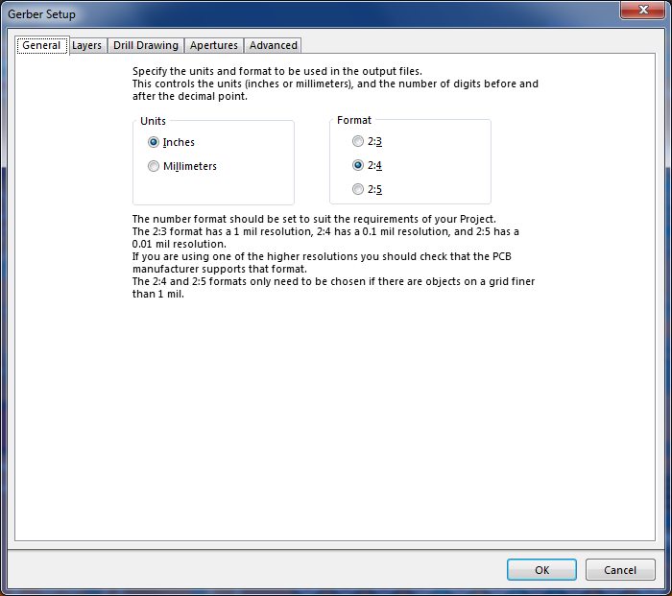

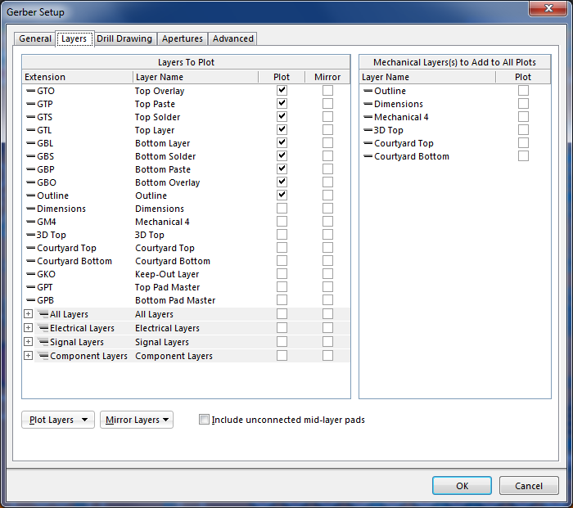

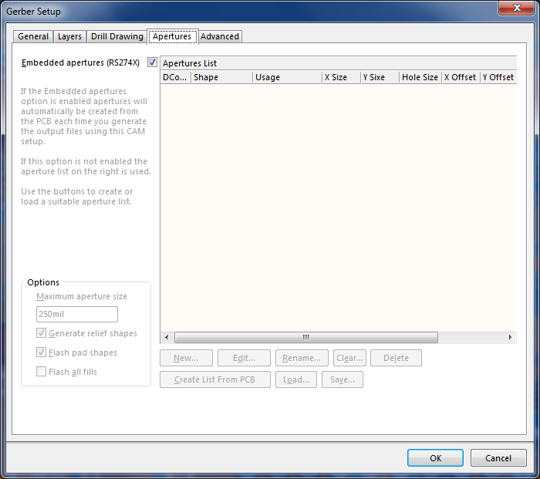

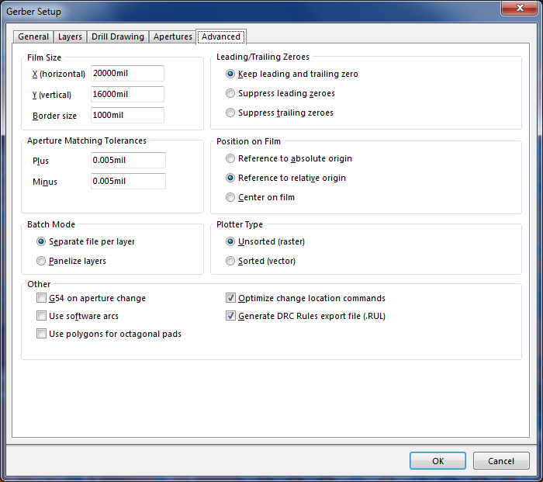

2. Generate NC-Drill File:
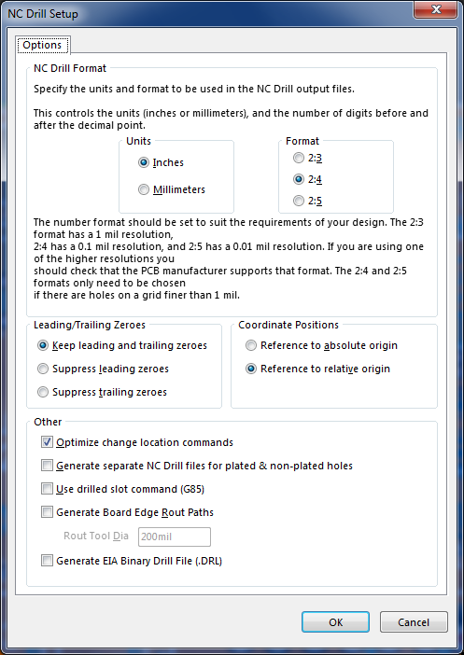

New ZIP file is created.

3. In the Gerbers ZIP file – rename .Outline to .GKO
4. Copy file .TXT from NCDrill ZIP to Gerbers ZIP
5. Upload Gerbers ZIP

