**Practical Task 1**

Figure 1: Gender wage gap 2015

Questions:



Answer: Costa Rica, Belgium, and Denmark.



Answer: Chile, Japan, and Korea.



Based on my research, the gender wage gap in Costa Rica is not 4% but 32% [1]. Therefore, data presented in Figure 1 must have been biased in some way to give false results.

According to Eurostat and Forbes, the primary cause of gender wage gap is maternity (which comes as no surprise to me) [2]. Women are generally paid equally to men for the same positions, but they often fall behind in terms of years of experience due to maternity leaves. Subsequently, women tend to sacrifice working hours and opt for shorter commutes to spend more time with their children and be closer to childcare facilities like kindergartens [3].

Therefore, the gender wage gap can be decreased by providing equal lengths of maternity leave for both mothers and fathers. Moreover, well-subsidized nurseries and kindergartens would also help.

Sources:

[1] [Statista](https://www.statista.com/statistics/803792/costa-rica-gender-gap-labor-market-category/#:~:text=Labor%20market%20gender%20gap%20index%20in%20Costa%20Rica%202023%2C%20by%20area&text=That%20year%2C%20the%20country%20scored,the%20income%20earned%20by%20men.)

[2] <https://ec.europa.eu/eurostat/statistics-explained/index.php?title=Gender_pay_gap_statistics>

[3] <https://www.forbes.com/advisor/business/gender-pay-gap-statistics/>

Questions:



Answer: In March 2020 isopropanol sales rocketed from 30-50 US CTS/Ib to over 100 US CTS/Ib. The trend was the same for isopropanol for domestic consumers, export, and tank trucks.

Answer: The COVID-19 pandemic initiated its lockdown in March 2020. Hand sanitizers, primarily composed of isopropanol, saw widespread use during the pandemic as a preventive measure against virus transmission, leading to a substantial surge in their sales. In a free market economy, heightened demand coupled with unchanged supply invariably leads to price hikes. Consequently, the price of isopropanol rose due to this increased demand.



Generally, for all continents higher CO2 emissions per person is connected to the higher GDP per capita. This trend is justified by the fact that wealthier people can buy more, including cars, meat, houses, and other things producing carbon footprint.

Africa has the biggest number of countries with both lowest CO2 production and GDP per capita. In Asia bigger countries noticeably produce more CO2 compared to smaller countries with the same GDP per capita. On average, they also produce more CO2 compared to African countries with the same GDP with might be due to higher temperatures in Africa without demand for heating. Moreover, Asian countries produce both smallest and largest CO2 emissions in the world.

In Americas bigger countries have both higher GDP and CO2 emissions. The y axis is in log scale, so the flattening in increase of emissions above 10,000 GDP is deceptive. Oceania and Europe show similar trends. There, the differences in sizes of countries and GDP per capita are quite similar. In Europe countries with highest GDP per capita produce less CO2 than slightly poorer ones. In general, in Europe for countries with GDP >10,000 there seem to be a plateau in CO2 production, even after taking into account a logarithmic nature of y scale.

**Practical Task 2**

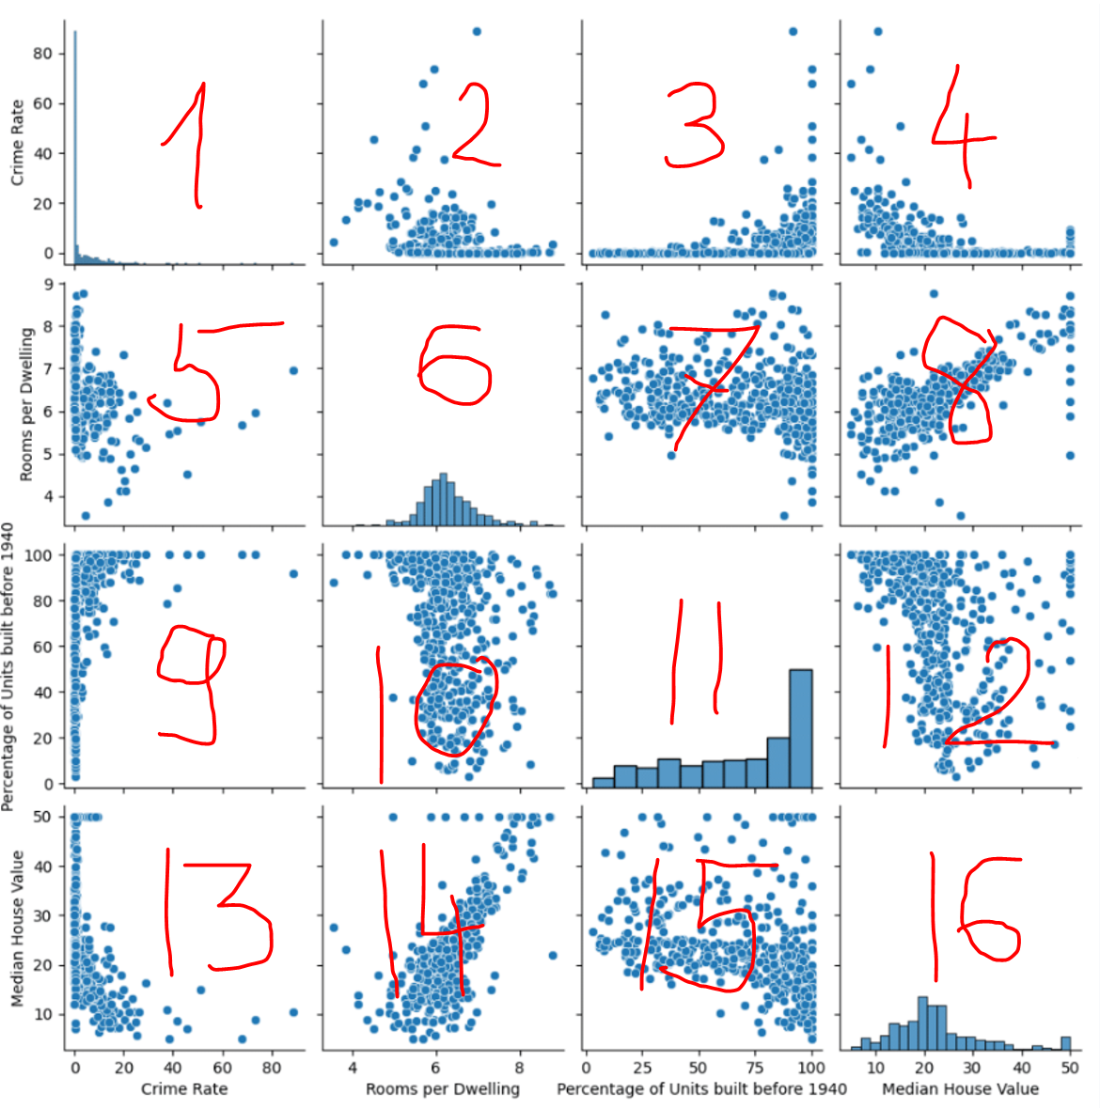

Questions:



Answer: The whole population of Boston is best represented by histograms, so graphs 1, 6, 11, 16. The crime rate in whole Boston is best represented by graph 1 and shows that Boston has a low crime rate.



Answer: The average number of rooms per dwelling in Boston is 6 (see graph 6).



Answer: See graphs 14 and 8. The more rooms per dwelling, the higher median house value.



Answer: See graph 11. Most of the houses are relatively old.



Answer: See graphs 12 and 15. The bigger the percentage of units built before 1940, the more diverse (wide-spread) the median house value.