 | Marker Use Only
 | Mark
Question | Part I
1
2
3
4
5
6
7
8
9
10
11
12
13
14
 | Part II
15
16
17
18
19
20
21
 | Part III
22

Total

Name: ____________________
Class: ________________( )
2024-2025
S2 MATH
PAPER I

CUHKFAA CHAN CHUN HA SECONDARY SCHOOL
2024-2025 Secondary Two Final Examination
MATHEMATICS PAPER I
Question-Answer Book

02/06/2025

8:15 am – 9:30 am (1¼ hours)

This paper must be answered in English

INSTRUCTIONS

- This paper consists of Three parts, Part I, Part II and Part III. Part I and Part II carry a total of 140 marks. Part III consists of a Challenging Question which is not a compulsory section. You may choose not to answer this question. Bonus marks will be given accordingly.
- Answer ALL questions in Part I and Part II, where Part III is optional. Write your answers in the spaces provided in this Question-Answer Book. Supplementary answer sheets will be supplied on request.
- Unless otherwise specified, all working must be clearly shown.
- Unless otherwise specified, numerical answers should be either exact or correct to 3 significant figures.
- The diagrams in this paper are not necessarily drawn to scale.
- No marks will be deducted for wrong answers.
Part I: Short Questions (80 marks) (All steps must be clearly shown.)
- Determine whether is an identity. (4 marks)
_____________________________________________________________________________________
_____________________________________________________________________________________
_____________________________________________________________________________________
_____________________________________________________________________________________
_____________________________________________________________________________________
_____________________________________________________________________________________
_____________________________________________________________________________________
- Factorize (a) 121p² – 4q².
(b) 49b² + 112b + 64. (4 marks)
_____________________________________________________________________________________
_____________________________________________________________________________________
_____________________________________________________________________________________
_____________________________________________________________________________________
_____________________________________________________________________________________
_____________________________________________________________________________________
_____________________________________________________________________________________
- Find the length of $\overset{⏜}{PQ}$ in the figure. (3 marks)
________________________________________________________________
193°
Q
O
P
7 cm
________________________________________________________________
________________________________________________________________
________________________________________________________________
________________________________________________________________

- In the figure, △ABC ~ △EFD. (5 marks)
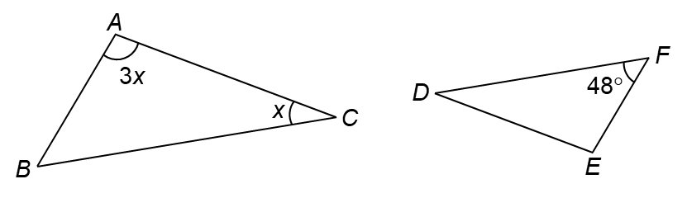
  - Find ∠B.
  - Hence, find ∠E.
_____________________________________________________________________________________
_____________________________________________________________________________________
_____________________________________________________________________________________
_____________________________________________________________________________________
_____________________________________________________________________________________
_____________________________________________________________________________________
_____________________________________________________________________________________
_____________________________________________________________________________________
_____________________________________________________________________________________
_____________________________________________________________________________________
_____________________________________________________________________________________

- In the figure, ABCD is a square. Find the value of x. (6 marks)
______________________________________________________________
A
9 cm
B
C
D
x cm
______________________________________________________________
______________________________________________________________
______________________________________________________________
______________________________________________________________
______________________________________________________________
______________________________________________________________
- Refer to the figure. Find the values of sin ∠P and cos ∠Q. (4 marks)
P
R
Q
37
12
35
(Give your answers in fractions.)
______________________________________________________
______________________________________________________
______________________________________________________
______________________________________________________
______________________________________________________
______________________________________________________

- The figure shows a right circular cylinder with volume 1152π cm³. Find the value of r. (4 marks)
18 cm
r cm

_____________________________________________________________________________________
_____________________________________________________________________________________
_____________________________________________________________________________________
_____________________________________________________________________________________
_____________________________________________________________________________________
_____________________________________________________________________________________
_____________________________________________________________________________________
_____________________________________________________________________________________
_____________________________________________________________________________________
_____________________________________________________________________________________
_____________________________________________________________________________________
- Simplify the following expressions. (12 marks)
- $\frac{8a}{4a-b}-\frac{2b}{4a-b}$ | - $\frac{5}{6a}-\frac{1}{2a}$
- $\frac{3q+1}{4(q-1)}×\frac{q-1}{2(3q+1)^{2}}$ | - $\frac{3y^{2}}{12xy}÷\frac{x^{3}y^{3}}{16x^{2}}$

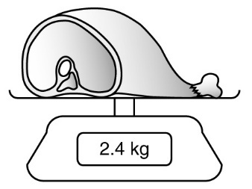
- The figure shows the weight of a loaf of meat measured by an electronic balance. The measured weight is
2.4 kg, correct to the nearest 0.1 kg.
Find its
  - maximum absolute error,
  - percentage error. (4 marks)
_____________________________________________________________________________________
_____________________________________________________________________________________
_____________________________________________________________________________________
_____________________________________________________________________________________
_____________________________________________________________________________________
_____________________________________________________________________________________
_____________________________________________________________________________________

- The cumulative frequency polygon below shows the lengths (in cm) of fish in an aquarium.
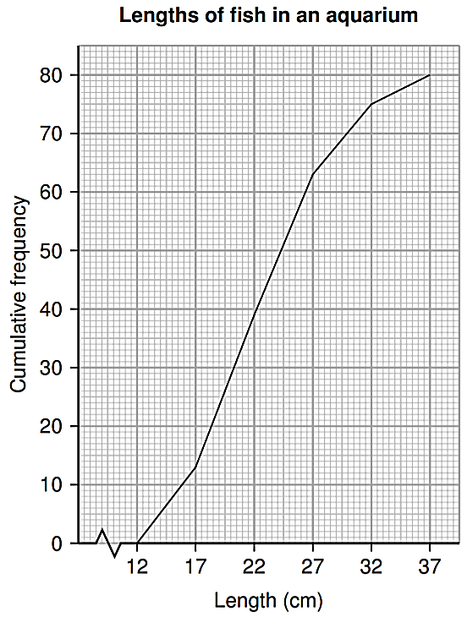
 | Find |  | the total number of fishes in the aquarium,
 |  | (ii) | the 60th percentile,
 |  | (iii) | the upper quartile.
(b) | Find the percentages of fish in the aquarium with lengths less than 17 cm. |  |  | (6 marks)
____________________________________________________________________________________
____________________________________________________________________________________
____________________________________________________________________________________
____________________________________________________________________________________
____________________________________________________________________________________
____________________________________________________________________________________
____________________________________________________________________________________
____________________________________________________________________________________
- Solve the following simultaneous equation $\left\{\begin{aligned}x+2y-4=0 \\ 3x-y-5=0\end{aligned}\right.$ . (6 marks)
____________________________________________________________________________________
____________________________________________________________________________________
____________________________________________________________________________________
____________________________________________________________________________________
____________________________________________________________________________________
____________________________________________________________________________________
____________________________________________________________________________________
____________________________________________________________________________________
____________________________________________________________________________________
____________________________________________________________________________________
____________________________________________________________________________________
____________________________________________________________________________________
____________________________________________________________________________________
____________________________________________________________________________________
____________________________________________________________________________________
____________________________________________________________________________________
____________________________________________________________________________________
____________________________________________________________________________________
____________________________________________________________________________________
____________________________________________________________________________________
____________________________________________________________________________________
____________________________________________________________________________________
____________________________________________________________________________________
____________________________________________________________________________________
____________________________________________________________________________________
- Solve the following inequalities and represent the solutions on number lines. (12 marks)
- −9 + x ≤ −12 | - −x − 2 > 6
  - 11 ≥ −1 − 6x

- If the sum of two consecutive even numbers is greater than 150, what is the smallest possible value of the smaller number? (6 marks)
____________________________________________________________________________________
____________________________________________________________________________________
____________________________________________________________________________________
____________________________________________________________________________________
____________________________________________________________________________________
____________________________________________________________________________________
____________________________________________________________________________________
____________________________________________________________________________________
____________________________________________________________________________________

- Simplify and rationalize the denominator of the result. (4 marks)
____________________________________________________________________________________
____________________________________________________________________________________
____________________________________________________________________________________
____________________________________________________________________________________
____________________________________________________________________________________
____________________________________________________________________________________
____________________________________________________________________________________
____________________________________________________________________________________
____________________________________________________________________________________
____________________________________________________________________________________

Part II: Long Questions (60 marks) (All steps must be clearly shown.)
- (a) Solve the inequality and represent the solutions graphically.
(b) Write down the least possible positive integer satisfying the inequality in (a). (9 marks)

____________________________________________________________________________________
____________________________________________________________________________________
____________________________________________________________________________________
____________________________________________________________________________________
____________________________________________________________________________________
____________________________________________________________________________________
____________________________________________________________________________________
____________________________________________________________________________________
____________________________________________________________________________________
____________________________________________________________________________________
____________________________________________________________________________________

- The figure is formed by 2 semi-circles. Find the perimeter of the shaded region. (8 marks)
_____________________________________________________________
_____________________________________________________________
_____________________________________________________________
_____________________________________________________________
_____________________________________________________________
_____________________________________________________________
_____________________________________________________________
_____________________________________________________________________________________
_____________________________________________________________________________________
_____________________________________________________________________________________
_____________________________________________________________________________________
_____________________________________________________________________________________
12 cm
6 cm
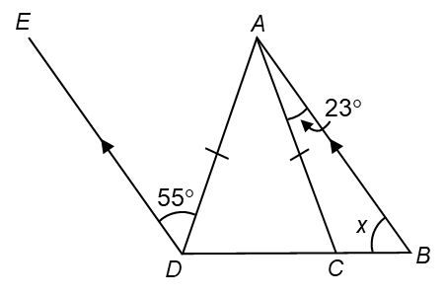
- In the figure, BCD is a straight line. AC = AD and BA // DE. Find x. (11 marks)
______________________________________________________
_______________________________________________________
_______________________________________________________
_______________________________________________________
_______________________________________________________
____________________________________________________________________________________
____________________________________________________________________________________
____________________________________________________________________________________
____________________________________________________________________________________
____________________________________________________________________________________
____________________________________________________________________________________
____________________________________________________________________________________
____________________________________________________________________________________
- A bag of sugar is labeled as having a weight of 5000 g, measured to the nearest 500 g.
  - What is the least possible weight of the bag of sugar?
  - Christy claimed that 15 such bags of sugar will have a total weight of 71.2 kg, measured to the nearest 0.1 kg. Do you agree with her? Explain your answer. (6 marks)

____________________________________________________________________________________
____________________________________________________________________________________
____________________________________________________________________________________
____________________________________________________________________________________
____________________________________________________________________________________
____________________________________________________________________________________
____________________________________________________________________________________
____________________________________________________________________________________
____________________________________________________________________________________
____________________________________________________________________________________
____________________________________________________________________________________
- In the figure, PSR is a straight line. It is given that PS = 11 cm, SR = 8 cm and $∠$PSQ = 47$°$. Find θ.
(6 marks)
____________________________________________________________
____________________________________________________________
____________________________________________________________
____________________________________________________________
_____________________________________________________________________________________
_____________________________________________________________________________________
_____________________________________________________________________________________
_____________________________________________________________________________________
_____________________________________________________________________________________
_____________________________________________________________________________________
_____________________________________________________________________________________
R
P
θ
47°
8 cm
11 cm
S
Q
- In the figure, ABC, CDE and AFE are straight lines. It is given that AB = BF = 5, BC = 2, CD = 7,
FD = $\sqrt{28}$ and DE = 6. Find the length of AE. (10 marks)
(Leave your answer in surd form.)
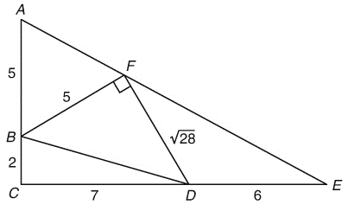
_____________________________________________________________________________________
_____________________________________________________________________________________
_____________________________________________________________________________________
_____________________________________________________________________________________
_____________________________________________________________________________________
_____________________________________________________________________________________
_____________________________________________________________________________________
_____________________________________________________________________________________
_____________________________________________________________________________________
_____________________________________________________________________________________
_____________________________________________________________________________________
_____________________________________________________________________________________
_____________________________________________________________________________________
_____________________________________________________________________________________
_____________________________________________________________________________________
_____________________________________________________________________________________
_____________________________________________________________________________________
_____________________________________________________________________________________
_____________________________________________________________________________________
_____________________________________________________________________________________
_____________________________________________________________________________________
_____________________________________________________________________________________
_____________________________________________________________________________________
_____________________________________________________________________________________
_____________________________________________________________________________________
_____________________________________________________________________________________
_____________________________________________________________________________________
_____________________________________________________________________________________
_____________________________________________________________________________________
_____________________________________________________________________________________
_____________________________________________________________________________________
_____________________________________________________________________________________
_____________________________________________________________________________________
_____________________________________________________________________________________
_____________________________________________________________________________________
_____________________________________________________________________________________
_____________________________________________________________________________________
_____________________________________________________________________________________
_____________________________________________________________________________________
_____________________________________________________________________________________
_____________________________________________________________________________________
_____________________________________________________________________________________
_____________________________________________________________________________________
_____________________________________________________________________________________
_____________________________________________________________________________________
_____________________________________________________________________________________
_____________________________________________________________________________________
_____________________________________________________________________________________
_____________________________________________________________________________________
- In the figure, PQR is a right-angled triangle with ∠QPR = 20°, ∠PQR = 90° and PQ = 12 cm. QRS is a sector with centre Q and PSR is a straight line. Find the area of sector QRS. (10 marks)
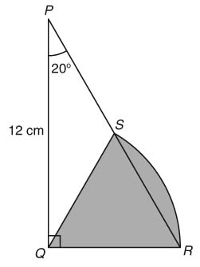
_____________________________________________________________________________________
_____________________________________________________________________________________
_____________________________________________________________________________________
_____________________________________________________________________________________
_____________________________________________________________________________________
_____________________________________________________________________________________
_____________________________________________________________________________________
_____________________________________________________________________________________
_____________________________________________________________________________________
_____________________________________________________________________________________
_____________________________________________________________________________________
_____________________________________________________________________________________
_____________________________________________________________________________________
_____________________________________________________________________________________
_____________________________________________________________________________________
_____________________________________________________________________________________
_____________________________________________________________________________________
_____________________________________________________________________________________

_____________________________________________________________________________________
_____________________________________________________________________________________
_____________________________________________________________________________________
_____________________________________________________________________________________
_____________________________________________________________________________________
_____________________________________________________________________________________
_____________________________________________________________________________________
_____________________________________________________________________________________
_____________________________________________________________________________________
_____________________________________________________________________________________
_____________________________________________________________________________________
_____________________________________________________________________________________
_____________________________________________________________________________________
_____________________________________________________________________________________
_____________________________________________________________________________________
_____________________________________________________________________________________
_____________________________________________________________________________________
_____________________________________________________________________________________
_____________________________________________________________________________________
_____________________________________________________________________________________
_____________________________________________________________________________________
_____________________________________________________________________________________
_____________________________________________________________________________________
_____________________________________________________________________________________
_____________________________________________________________________________________
_____________________________________________________________________________________
_____________________________________________________________________________________
Part III: Challenging Question (10 marks) (All steps must be clearly shown.)
This is not a compulsory part. Bonus marks will be given accordingly.
- In △PQR, ∠PRQ = 90°. S is a point on QR such that QS = SR and T is a point on PQ such that ST ⊥ PQ.
(a) (i) Prove that △PQR ∼ △SQT.
P
R
T
Q
S
(ii) Hence, prove that .
(b) By considering PT = PQ − QT, prove that .

_____________________________________________________________________________________
_____________________________________________________________________________________
_____________________________________________________________________________________
_____________________________________________________________________________________
_____________________________________________________________________________________
_____________________________________________________________________________________
_____________________________________________________________________________________
_____________________________________________________________________________________
_____________________________________________________________________________________
_____________________________________________________________________________________
_____________________________________________________________________________________
_____________________________________________________________________________________
_____________________________________________________________________________________
_____________________________________________________________________________________
_____________________________________________________________________________________
_____________________________________________________________________________________
_____________________________________________________________________________________
_____________________________________________________________________________________
_____________________________________________________________________________________
_____________________________________________________________________________________
_____________________________________________________________________________________
_____________________________________________________________________________________
_____________________________________________________________________________________
_____________________________________________________________________________________
_____________________________________________________________________________________
_____________________________________________________________________________________
_____________________________________________________________________________________
_____________________________________________________________________________________
_____________________________________________________________________________________
_____________________________________________________________________________________
_____________________________________________________________________________________
_____________________________________________________________________________________
_____________________________________________________________________________________
_____________________________________________________________________________________
_____________________________________________________________________________________
_____________________________________________________________________________________
_____________________________________________________________________________________
_____________________________________________________________________________________
_____________________________________________________________________________________
_____________________________________________________________________________________
_____________________________________________________________________________________
_____________________________________________________________________________________
_____________________________________________________________________________________
_____________________________________________________________________________________
_____________________________________________________________________________________
_____________________________________________________________________________________
_____________________________________________________________________________________
-END OF PAPER-

