 | Marker Use Only
 | Mark
Question | Part I
1
2
3
4
5
6
7
8
9
10
11
12
13
 | Part II
14
15
16
17
18
 | Part III
19

Total

Name: ____________________
Class: ________________( )
2024-2025
S2 MATH
PAPER I

CUHKFAA CHAN CHUN HA SECONDARY SCHOOL
2024-2025 Secondary Two First Term Examination
MATHEMATICS PAPER I
Question-Answer Book

13/01/2025

8:15 am – 9:30 am (1¼ hours)

This paper must be answered in English

INSTRUCTIONS

- This paper consists of Three parts, Part I, Part II and Part III. Part I and Part II carry a total of 140 marks. Part III consists of a Challenging Question which is not a compulsory section. You may choose not to answer this question. Bonus marks will be given accordingly.
- Answer ALL questions in Part I and Part II, where Part III is optional. Write your answers in the spaces provided in this Question-Answer Book. Supplementary answer sheets will be supplied on request.
- Unless otherwise specified, all working must be clearly shown.
- Unless otherwise specified, numerical answers should be either exact or correct to 3 significant figures.
- The diagrams in this paper are not necessarily drawn to scale.
- No marks will be deducted for wrong answers.
Part I: Short Questions (80 marks) (All steps must be clearly shown.)
- Show that −6x + 7 = −3(2x − 1) + 4 is an identity. (5 marks)

- If A, B and C are constants such that Ax² + 6(x + 2) ≡ −3x(x − B) + C, find the values of A, B and C.
(8 marks)

- Expand each of the following expressions by using identities. (7 marks)
(a) (h + 7k)(h − 7k) | (b) (5x − 9)² | (c) 8(5x + 1)²

- Factorize each of the following expressions. (7 marks)
(a) ab² + 3a²b | (b) −18x²y − 12xy² | (c) 16u² − 144v²

- Simplify each of the following expressions. (11 marks)
(a) $\frac{45p^{4}q}{30p^{2}q^{3}}$ | (b) $\frac{11hk+55k}{22hk}$
(c) $\frac{2h^{2}+4h-3hk-6k}{2h-3k}$ | (d) $\frac{9b}{2a}+\frac{7}{11b}$
- Make e the subject of the formula . (3 marks)

- Consider the formula 2(2v − 3u) = 1 − 11u. (6 marks)
(a) Make u the subject of the above formula.
(b) If the value of v is decreased by 5, write down the change in the value of u.

- Refer to the figure, show that the two triangles are similar. (5 marks)
A
B
C
D
F
E
8
18
22
11
4
9

- Refer to the figure, ΔBAC ∼ ΔJKL. Find x and y. (5 marks)
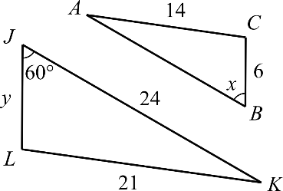

- Refer to the figure, parallelogram ABCD ∼ parallelogram EFGH. Find h. (3 marks)
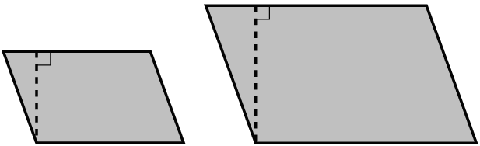
9 cm
h cm
8 cm
12 cm
A
B
C
D
F
E
H
G

- Refer to the figure, AEC and BCD are straight lines. Find the unknown. (5 marks)
C
B
A
E
x
49°
47°
62°
D

- Refer to the figure, BCD is a straight line and ΔABC is an equilateral triangle. Find x. (5 marks)
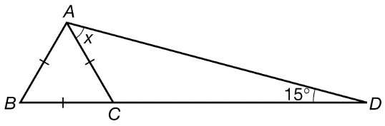

- Solve each of the following simultaneous equations by algebraic method. (10 marks)
(a) $\left\{\begin{aligned}y=3x+1 \\ 7x-2y=1\end{aligned}\right.$

(b) $\left\{\begin{aligned}2x+3y=9 \\ 7x-6y=26\end{aligned}\right.$

Part II: Long Questions (60 marks) (All steps must be clearly shown.)
- Mr. Lee has some $2 and $5 coins. The total value of the coins is $44. If the number of $2 coins is 1 more than that of $5 coins, find the numbers of $2 coins and $5 coins respectively. (11 marks)

- In the figure, ABDF and ACEG are straight lines. It is given that BC // DE // FG. (14 marks)
(a) Show that ΔABC ∼ ΔAFG.
(b) Find AC.
(c) Apart from those in (a), write down another pair of similar triangles. Hence, find DE.

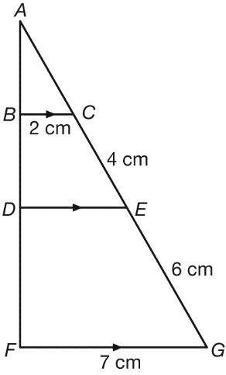

- In the figure, ABF and EADG are straight lines. Find a + b + c + d. (11 marks)
Hint: Extend BC to meet EG at H.
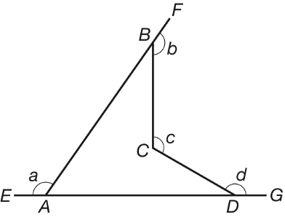

- (a) Factorize $4a^{2}+28ab+4{9b}^{2}$.
(b) Factorize $c^{2}-2cd+d^{2}$.
(c) Using the results of (a) and (b), factorize $4a^{2}+28ab+4{9b}^{2}-c^{2}+2cd-d^{2}$. (14 marks)

- Simplify $\frac{9x^{2}-6xy}{4x-2y}÷\left(\frac{y}{2x-y}-\frac{2y}{x}\right)$. (10 marks)

Part III: Challenging Question (10 marks) (All steps must be clearly shown.)
This is not a compulsory part. Bonus marks will be given accordingly.
- The mobile phone number of Jenny is 9648 13XX, where each X represents an unknown digit. The two Xs may not represent the same digit. The sum of all digits in the phone number is 38.
(a) If the difference between the last two digits is 3, find all the possible mobile phone number(s)
of Jenny.
(b) Consider the mobile phone number as a 8-digit number. If the last two digits are reversed, the
value of the new number is 9 greater than the original number. Find the mobile phone number
of Jenny.

-END OF PAPER-

