CUHKFAA Chan Chun Ha Secondary School
First Term Examination (2024-2025)
Secondary Two MATHEMATICS
PAPER 2
10:05a.m. -10:50a.m.
13-01-2025
Time allowed: 45 minutes

Name: ( ) Class: Marks: /30

- Read the instructions carefully on the Question Paper.

- When told to read this paper, you should check that the question paper has no missing pages. Look for the words ‘END OF PAPER’ on the last page.

- All questions carry equal marks.

- ANSWER ALL QUESTIONS. You are advised to mark all the answers on the Multiple-choice Answer Sheet with an HB pencil, so that wrong marks can be completely erased with a clean rubber.

- You should mark only ONE answer to each question. Two or more answers will score NO MARKS.

- No marks will be deducted for wrong answers.

There are 20 questions in Section A and 10 questions in Section B.
The diagrams in this paper are not necessarily drawn to scale.
Choose the best answer for each question.
Section A (1-20)
- (3x − 4)(3x + 4) =
- $3x^{2}-16$
- $3x^{2}-4$
- $9x^{2}-16$
- $9x^{2}-4$

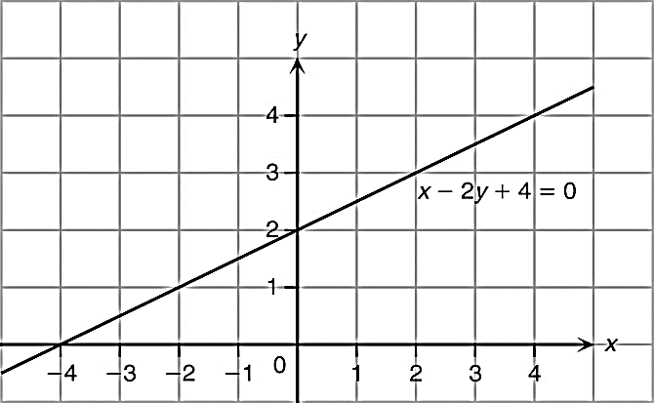
- Refer to the figure, which of the following ordered pairs is not a solution of the equation ?
- (–2, 1)
- (0, 2)
- (3, 2)
- (4, 4)

- In the figure, the sides of the regular octagon are produced. Find x.
x
x
x
x
x
x
x
x
  - 45°
  - 50°
  - 55°
  - 60°

- If P = 4T + 5, then T =
- $\frac{P}{4}-5.$
- $\frac{P-5}{4}.$
- $4(P-5).$
- $\frac{P+5}{4}.$
- It is given that . Find the value of b when a = 60 and E = 12.
  - 55
  - 10
  - 5
  - 1

- Which of the following may represent the graph of the equation ?
A. 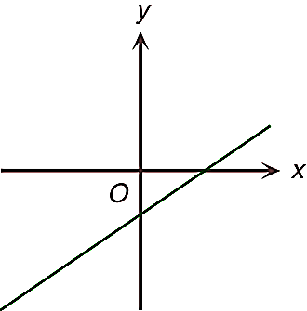 B. 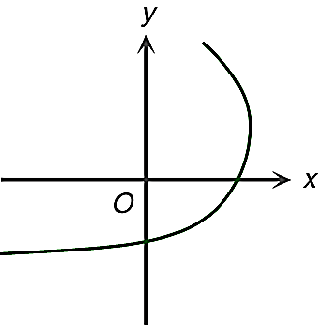
C. 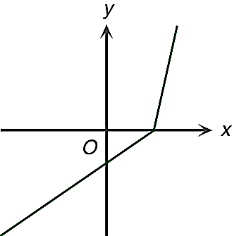 D. 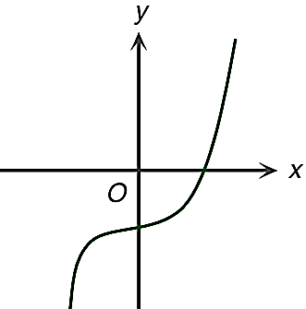

- Which of the following expressions have a factor 2 − m?
- 2n − mn − 2 + m
- 4 − m²
- m² − 4m + 4
  - I and II only
  - I and III only
  - II and III only
  - I, II and III

- Which of the following is NOT an identity?
- $\left(x-3\right)\left(x+5\right)=x^{2}+2x-15$
- $-x\left(2x+1\right)+4x=-2x^{2}+3x$
- $x\left(x\right)-\left(x+x\right)=-2x+x^{2}$
- $(2x)^{2}-x(x+2)=x^{2}-2x$

- If , then n =
  - $15$.
  - $m^{2}+15$.
  - $m^{2}-15$.
  - $15-m^{2}$.

- $pm-rm+pn-rn+qm+qn=$
- $(m+n)(p-q+r)$
- $(m+n)(p+q-r)$
- $(m-n)(p-q+r)$
- $(m-n)(p+q-r)$

- In the figure, Q is a point on PR such that QR = QT. If PR // TS and RS = ST, then ∠RST =
- 44°.
136°
T
Q
R
S
P
- 56°.
- 60°.
- 68°.

- Which of the following triangles is similar to △ABC as shown in the following figure?
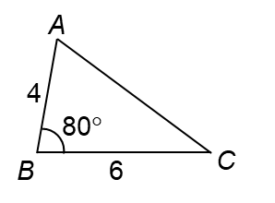

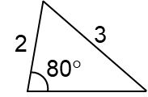
A. 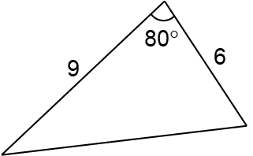 B.
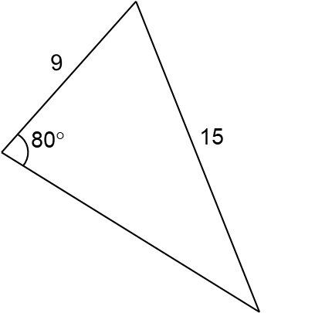
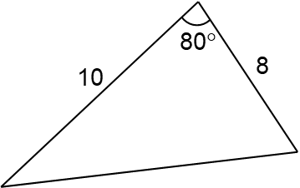
C. D.

- If a point P(a, −5) lies on the graph of the equation 8x + 3y − 9 = 0, then a =
  - −3
  - 1.
  - 3.
  - 6.

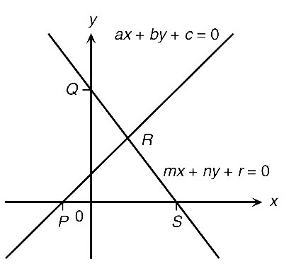
- The coordinates of which point in the figure represent the solution of $\left\{\begin{aligned}ax+by+c=0 \\ mx+ny+r=0\end{aligned}\right.$?
  - P
  - Q
  - R
  - S

- The figure shows two similar figures. Find y.
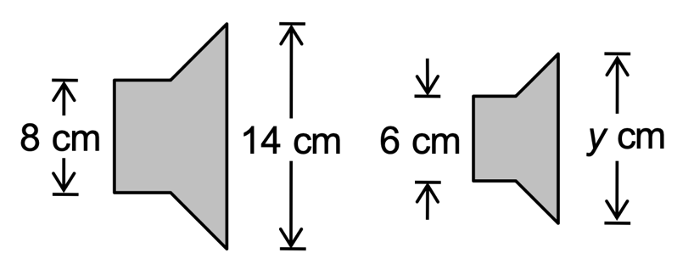
  - 7
  - 10.5
  - 14
  - 21

- Referring to the figure, find ∠BCD.
103°
255°
70°
A
B
C
D
  - 52°
  - 55°
  - 82°
  - 85°

- In the figure, ABE and BCD are straight lines and AB = CB. Find y.
152°
A
B
C
D
E
y
  - 28°
  - 56°
  - 76°
  - 84°

- Simplify $\frac{4}{m-4n}-\frac{7}{4n-m}.$
- $\frac{11}{m-4n}$
- $-\frac{3}{m-4n}$
- $\frac{11}{2m-8n}$
- $-\frac{3}{2m-8n}$

- Simplify $\frac{4a^{2}}{6a^{2}+8a}.$
- $\frac{2}{7a}$
- $\frac{2}{3+8a}$
- $\frac{a}{3a+2}$
- $\frac{2a}{3a+4}$

- Factorize $4d^{2}-20d+25.$
- $-(2d-5)^{2}$
- $-(2d+5)^{2}$
- $(2d-5)^{2}$
- $(2d+5)^{2}$

Section B (21 – 30)
- Factorize $20a-a^{2}-100$.
- $-(a+10)^{2}$
- $-(a-10)^{2}$
- $(a+10)^{2}$
- $(a-10)^{2}$

- Expand $\frac{1}{3}(6x-3y)^{2}$.
  - $4x^{2}-y^{2}$
  - $9x^{2}-3y^{2}$
  - $4x^{2}-4xy+y^{2}$
  - $12x^{2}-12xy+3y^{2}$

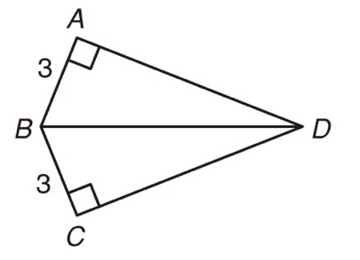
- Refer to the figure. The reason for △ABD ≅ △CBD is
- SSS.
- SSA.
- AAS.
- RHS.

- $\frac{2y}{3x-y}÷\frac{x}{2y-6x}×\frac{x}{y^{3}}=$

- $\frac{4}{y^{2}}$
- $-\frac{4}{y^{2}}$
- $\frac{x^{2}}{y^{2}(3x-y)^{2}}$
- $-\frac{x^{2}}{y^{2}(3x-y)^{2}}$
- If the circumference and the area of a circle are L cm and A cm² respectively, then
- $A=\frac{L}{4π}$.
- $A=\frac{L^{2}}{2π}$.
- $A=\frac{L^{2}}{4π}$.
- $A=\frac{L^{2}}{4π^{2}}$.

- If $\frac{2p}{3r}-\frac{q}{2s}=-1$, then r =
- $\frac{3ps}{4(q-2s)}$.
- $\frac{4ps}{3(q-2s)}$.
- $\frac{3qs}{4(p+2s)}$.
- $\frac{4qs}{3(p+2s)}$.

- In a Mathematics test, there are two sections A and B. Hilary gets 10 more marks in section A than in section B and her total mark is 50. If her marks in sections A and B are x and y respectively, which of the following pairs of simultaneous equations shows the relation between x and y?
- $\left\{\begin{aligned}x-y=10 \\ x+y=50\end{aligned}\right.$
- $\left\{\begin{aligned}x-y=10 \\ x-y=50\end{aligned}\right.$
- $\left\{\begin{aligned}y-x=10 \\ x+y=50\end{aligned}\right.$
- $\left\{\begin{aligned}y-x=10 \\ x-y=50\end{aligned}\right.$

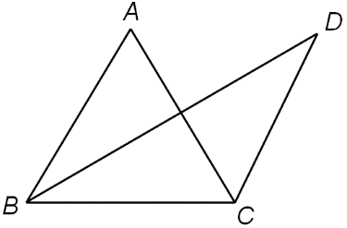
- In the figure, ABC is an equilateral triangle. AC and BD intersect at E. ∠ABD = ∠CBD and
∠ACB = ∠ACD. Which of the following are true?
- AC ⊥ BD
- AB = CD
- △BCD is an isosceles triangle.
  - I and II only
  - I and III only
  - II and III only
  - I, II and III

- Given that (3, −2) is the solution of the simultaneous equations $\left\{\begin{aligned}ax+by=6 \\ ax-by=18\end{aligned}\right.$ ,
find the values of a and b.
  - a = 3, b = 4
  - a = 4, b = 3
  - a = 2, b = 0
  - a = 4, b = 1

- In the figure, ADB, BEC and DEF are straight lines. AC // DF and ∠CFE = ∠DBE.
Which of the following are correct?

2 cm
6 cm
9 cm
C
A
B
D
E
F
- $BE = 2CE$
- $△CEF \sim △DEB$
- $CF=EF$
- I and II only
- I and III only
- II and III only
- I, II and III
END OF PAPER

