CUHKFAA Chan Chun Ha Secondary School
Final Examination (2025-2026)
Secondary Two MATHEMATICS
PAPER 2
10:05a.m. -10:50a.m.
08-06-2026
Time allowed: 45 minutes

Name: ( ) Class: Marks: /30

- Read the instructions carefully on the Question Paper.

- When told to read this paper, you should check that the question paper has no missing pages. Look for the words ‘END OF PAPER’ on the last page.

- All questions carry equal marks.

- ANSWER ALL QUESTIONS. You are advised to mark all the answers on the Multiple-choice Answer Sheet with an HB pencil, so that wrong marks can be completely erased with a clean rubber.

- You should mark only ONE answer to each question. Two or more answers will score NO MARKS.

- No marks will be deducted for wrong answers.

There are 20 questions in Section A and 10 questions in Section B.
The diagrams in this paper are not necessarily drawn to scale.
Choose the best answer for each question.
Section A
- In the figure, the radius of sector OB is 11 cm and ∠AOB = 36°. Find the arc length of the sector.
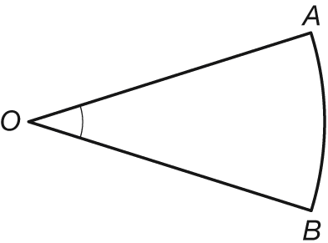
11 cm
36°
A. 2.2π cm
B. 4.4π cm
C. 8.8π cm
D. 12.1π cm

- The figure shows a right cylinder. Its height is 15 cm and its base radius is 7 cm. Find the curved surface area of the cylinder.
A. 105π cm²
7 cm
15 cm
B. 210π cm²
C. 308π cm²
D. 735π cm²

- Find the value of tan θ in the figure.
B
A
C
37
35
θ
12

A. $\frac{35}{12}$
B. $\frac{35}{37}$
C. $\frac{12}{35}$
D. $\frac{12}{37}$

- In the figure, x =
C
A
B
9 cm
57°
x cm
A. 7.55. (cor. to 3 sig. fig.)
B. 10.7. (cor. to 3 sig. fig.)
C. 13.9. (cor. to 3 sig. fig.)
D. 16.5. (cor. to 3 sig. fig.)

- In the figure, θ =
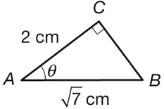

A. 15.9°. (cor. to 3 sig. fig.)
B. 16.6°. (cor. to 3 sig. fig.)
C. 37.1°. (cor. to 3 sig. fig.)
D. 40.9°. (cor. to 3 sig. fig.)

- The following table shows the distribution of the duration (in hour) of gale wind recorded in 49 stations during the passage of a typhoon.

Duration (hour) | 1 − 2 | 3 − 4 | 5 − 6 | 7 − 8
Frequency | 15 | 12 | 18 | 4

The corresponding cumulative frequency of the duration of gale wind recorded less than
6.5 hours is
A. 18.
B. 27.
C. 45.
D. 49.

- The histogram shows the distribution of a set of data.
Heights of 20 S.2B students
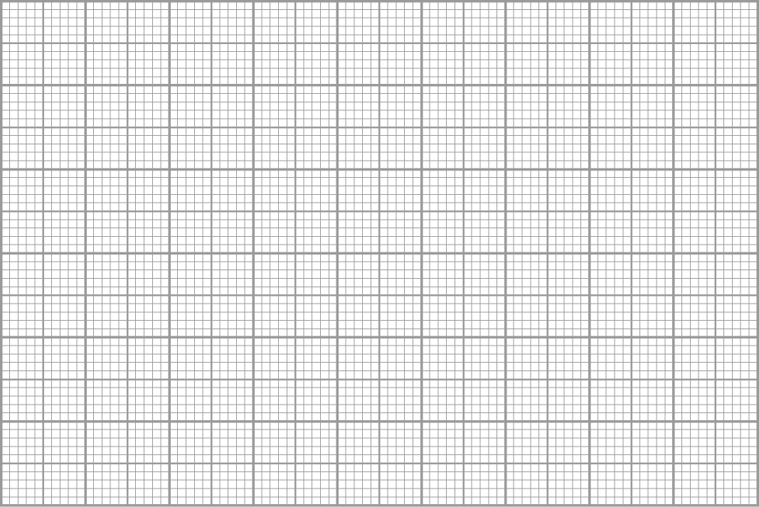

139.5 149.5 159.5 169.5 179.5
Height (cm)
8

6

4

2

0
Frequency
If the same set of data is presented by a cumulative frequency polygon, which of the following statistical charts could be obtained?
A.

129.5 139.5 149.5 159.5 169.5 179.5 189.5
Height (cm)
8

6

4

2

0
Cumulative frequency
B.

134.5 144.5 154.5 164.5 174.5 184.5 194.5
Height (cm)
8

6

4

2

0
Cumulative frequency
C.

129.5 139.5 149.5 159.5 169.5 179.5
Height (cm)
20

15

10

5

0
Cumulative frequency

D.

134.5 144.5 154.5 164.5 174.5 184.5
Height (cm)
20

15

10

5

0
Cumulative frequency

- The figure shows the number of crimes in each month in city X last year.
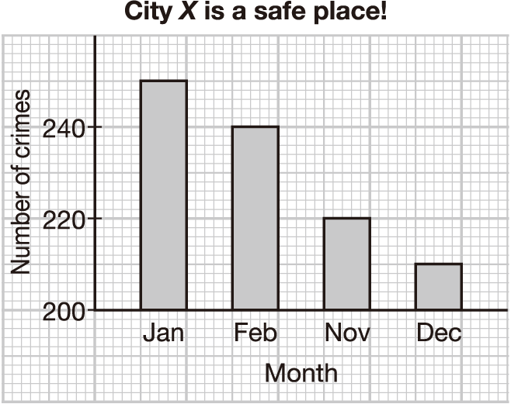
Which of the following is/are the misleading feature(s) of the figure?
I. The ratio of the widths of the bars
II. The items labelled on the horizontal axis
III. The scale of the vertical axis
A. I only
B. III only
C. I and II only
D. II and III only

- In the figure, ∠ABC = 90°, AB = 10.5 cm and BC = 5.6 cm. AC =
5.6 cm
B
A
C
10.5 cm
A. 11.9 cm.
B. 13.3 cm.
C. 14.7 cm.
D. 16.1 cm.

- Which of the following is not a right-angled triangle?
A. B.
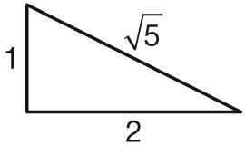
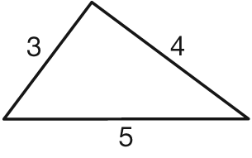
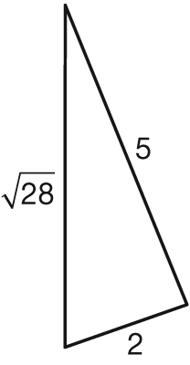
C. D.
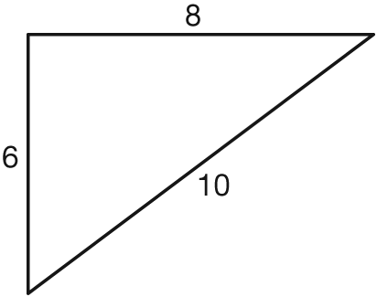

- The solution of 13 ≥ 9x − 14 is

A. x ≤ 3。
B. x ≤ $\frac{1}{9}$.
C. x ≥ 3.
D. x ≥ $\frac{1}{9}$.

- The solution of $\frac{x}{2}+\frac{5x}{6}$< −10 is
A. x < −1.25.
B. x > −1.25.
C. x < −7.5.
D. x > −7.5.

- The width of a hall is 35 m (correct to the nearest m). Which of the following is the lower limit
and the upper limit of the actual width of the hall?

Lower limit Upper limit
A. 30 m 40 m
B. 34 m 36 m
C. 34.5 m 35.5 m
D. 34.95 m 35.05 m

- The thickness of a piece of paper is 0.09 cm, correct to the nearest 0.01 cm. The relative error of the measurement is
A. $\frac{1}{8}$.
B. $\frac{1}{9}$.
C. $\frac{1}{16}$.
D. $\frac{1}{18}$.
- According to the given graphs, solve the simultaneous equations $\left\{\begin{aligned}x=y \\ x+y=4\end{aligned}\right.$ graphically.
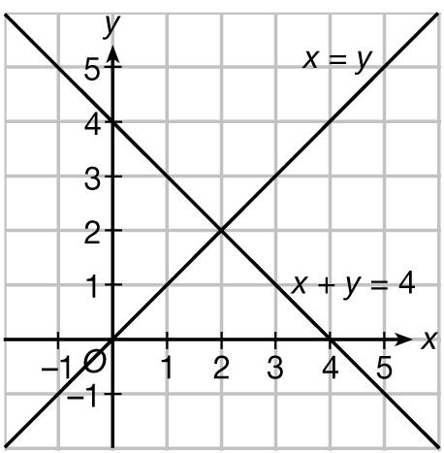
A. (0, 0)
B. (1, 2)
C. (2, 2)
D. (4, 0)

- (9r − 10s)² =
A. 81r² − 90rs + 100s²
B. 81r² − 180rs − 100s²
C. 81r² − 90rs − 100s²
D. 81r² − 180rs + 100s²

- x² − 5x + xy − 5y =
A. (x + y)(x − 5)
B. (x − y)(x + 5)
C. (y − x)(x − 5)
D. (y − x)(x + 5)

- In the figure, AD // BC and AC = BC. ∠ADC =
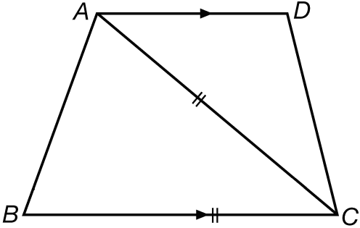
36°
70°
A. 102°.
B. 104°.
C. 106°.
D. 108°.

- The figure shows the exterior angles of a pentagon ABCDE. x =
A
E
B
C
x
35°
65°
P
Q
R
T
D
S
x
70°
A. 85°.
B. 90°.
C. 95°.
D. 100°.

- In the figure, ΔHKL ∼ ΔUTV. Find k.
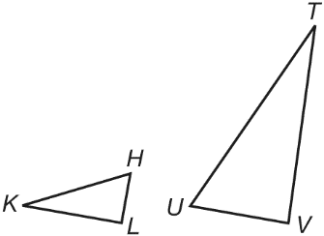
11
10
22
10
k
A. 15
B. 20
C. 22
D. 25

Section B
- In the figure, OAB is a sector with centre O. ∠AOB = 38° and the arc length of the sector is 12.9 cm. Find the area of the sector, correct to 3 significant figures.
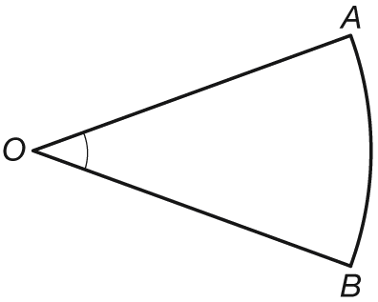
38°
A. 20.3 cm²
B. 39.9 cm²
C. 125 cm²
D. 249 cm²

- The figure shows a pipe in the shape of a hollow cylinder. The height and the outer base radius of the pipe are 2 m and 6 cm respectively. The thickness of the pipe is 0.5 cm. Find the volume of material required to make the pipe, correct to the nearest cm³.
Thickness 0.5 cm
2 m
6 cm
A. 3613 cm³
B. 3689 cm³
C. 3913cm³
D. 3927 cm³

- In the figure, AD and BE intersect at C. CD =
A
B
E
C
D
5 cm
45°
97°
A. 3.72 cm. (cor. to 3 sig. fig.)
B. 3.94 cm. (cor. to 3 sig. fig.)
C. 4.08 cm. (cor. to 3 sig. fig.)
D. 4.96 cm. (cor. to 3 sig. fig.)

- In the figure, PQRS is a parallelogram with PQ = 6 cm and QR = 8 cm. If the area of PQRS is 44 cm², find ∠SRQ correct to the nearest 0.1°.
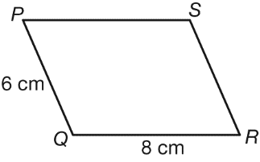
A. 48.6°
B. 53.1°
C. 61.7°
D. 66.4°

- The cumulative frequency polygon shows the prices (in $) of some calculators.
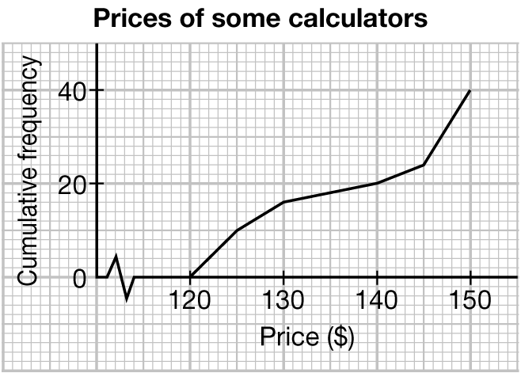
Find the 60th percentile of the prices.
A. $126
B. $130
C. $145
D. $150

- The solution of 3[2(3 − 5x) − 4x] ≤ 11 + 20(x + 5) is
A. x ≤ −1.5.
B. x ≤ 1.5.
C. x ≥ −1.5.
D. x ≥ 1.5.

- If x ≤ y and k < 0, which of the following MUST BE correct?
I. x + k ≤ y + k
II. ≤
III. x² ≤ y²

A. I and II only
B. I and III only
C. II and III only
D. I, II and III
- If the length and the width of a rectangle are measured as 15 cm and 10 cm respectively and all the measurements are correct to the nearest cm, then the least possible area of the rectangle is
A. 126 cm².
B. 137.75 cm².
C. 150 cm².
D. 162.75 cm².

- If $\left\{\begin{aligned}x-7y=11 \\ 3x+7y=-23\end{aligned}\right.$, then x + y =
A. −19.
B. −11.
C. −7.
D. −5.

- If 5x − 4y = ax − 3, then x =
A. $\frac{4y-3}{a+5}$.
B. $\frac{3-4y}{a-5}$.
C. $\frac{a+5}{4y-3}$.
D. $\frac{a-5}{3-4y}$.
END OF PAPER

