 | Marker Use Only
 | Mark
Question | Part I
1
2
3
4
5
6
7
8
9
10
11
12
13
14
15
 | Part IIA
16
17
18
19
20
 | Part IIB
21
22
23
24
25

Total

2023-2024
S3 MATH
PAPER I
Name: ____________________
Class: ________________( )

CUHKFAA CHAN CHUN HA SECONDARY SCHOOL
2023-2024 Secondary Three Final Examination
MATHEMATICS PAPER I
Question-Answer Book

03/06/2024

8:15 am – 9:30 am (1¼ hours)

This paper must be answered in English

INSTRUCTIONS

- This paper consists of Two parts, Part I and Part II. Part I and Part II carries of 70 and 70 marks respectively.
- Answer ALL questions in each part. Write your answers in the spaces provided in this Question-Answer Book. Supplementary answer sheets will be supplied on request.
- Unless otherwise specified, numerical answers should be either exact or correct to 3 significant figures.
- Unless otherwise specified, all working must be clearly shown.
- The diagrams in this paper are not necessarily drawn to scale.
- No marks will be deducted for wrong answers.

Part I: Short Questions (Level 1) (70 marks) <All steps must be clearly shown.>
- Factorize $a^{2}-4a+3$by cross-method. (4 marks)

- Factorize ${3a}^{2}+2ab-8b^{2}$by cross-method. (4 marks)

- Simplify and express the answers with positive indices. (4 marks)

- Let n is a positive integer, simplify $\frac{2^{n+1}}{2^{3}}$ and express the answers with positive indices.
(3 marks)

- The present value of a car is $30 000. If its value depreciates by 2% each year, find its value 3 years ago. (5 marks)

- A sum of $9000 is deposited at an interest rate of 2% p.a. for 3 years, compounded
half-yearly. Find the amount. (5 marks)

- The figure shows a pyramid VABCD of height 15 cm. Its base is a rectangle of length 8 cm and width 11 cm. Find the volume of the pyramid. (5 marks)
V
A
B
C
D
11 cm
15 cm
8 cm
- In the figure, ABCD is a parallelogram. CA = CD and ∠ACD = 42°. Find x. (5 marks)
42°
A
B
C
D
x

- In the figure, ADB, AGFC and BEC are straight lines. (3 marks)
Which line segment is
A
B
C
D
E
F
G

(a) a perpendicular bisector of △ABC? ______________

(b) an angle bisector of △ABC? __________________

(c) a median of △ABC? __________________

- Find the value of x in the following figure. (Leave the answer in surd form.) (4 marks)
6

x

30°

- In the figure, Shirley is 8 m away from the foot of the flagpole. The angle of elevation of the top P of the flagpole from Shirley is 28°. If Shirley’s eye level is 1.7 m above horizontal ground level, find the height of the flagpole. (5 marks)
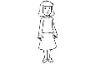
P
28°
8 m
1.7 m

- In the figure, C is the mid-point of AB. Find the coordinates of C. (4 marks)
0
x
y
A(5, –14)
B(–7, –2)
C

- Given two points M($-$2 , 7) and N($3$,$-5$), find the distance between M and N. (4 marks)

- In the figure, prove that $L_{1}$ and $L_{2}$ are parallel to each other. (5 marks)

y
0
x
(–10, 6)
(–8, 2)
(–2, 9)
(4, –3)
L₂
L₁

- The stem-and-leaf diagram below shows the distribution of the weights (in kg) of 20 students in a football club. (10 marks)
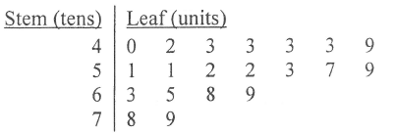

- Find the mean, the median and the mode of the above distribution.
(b) If one student is randomly selected from the team. Find the probability that
(i) the student weighs 52 kg
(ii) the student weighs over 58 kg.

Section IIA Long Questions (Level 2) (40 marks) <All steps must be clearly shown.>
- Simplify and express the answers with positive indices. (5 marks)

- Mrs Poon has 3 children. Find the probability that she has (5 marks)
(a) two sons,
(b) at least two daughters.

- In the figure, given that BCD is a straight line, AB$=2\sqrt{6}, CD=2, ∠ACD=θ,$
$∠ABC=45° and AD=x$. Find the unknowns.
(Leave the answers in surd form if necessary.) (6 marks)
x
45°
A
B
C
D
θ
2
- In the figure, two lighthouses A and B are located on a straight coastline. B is 3 km due east of A. The bearings of a ship (S) from A and B are 064° and 325° respectively. Find the shortest distance between the ship and the coastline, correct to the nearest m. (8 marks)

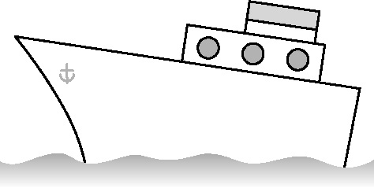
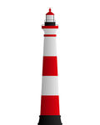
N
A
N
coastline
B
S
325°
64°
3 km

- In the figure, the line segment joining A(10, –6) and B(–5, –1) cuts the y-axis at the point P. Find AP : PB. (5 marks)
x
y
A(10, –6)
B(–5, –1)
O
P

- In the figure, O is the circumcentre of △ABC. M is the mid-point of AC. BOM is a straight line. If ∠OAC = 44°, find ∠OBA. (5 marks)
44°
A
B
C
M
O

- In the figure, an inverted empty right circular conical vessel is held vertically. The base radius and the height of the vessel are 5 cm and 12 cm respectively. (6 marks)
5 cm
12 cm
(a) Express the capacity of the vessel in terms of π.
(b) If some water is poured into the vessel and
the depth of the water is 3 cm, express the volume
of water in the vessel in terms of π.

Section IIB Long Questions (Level 3) (30 marks) <All steps must be clearly shown.>
- Cindy’ investment portfolio consists of 4 different stocks A, B, C and D. The following table shows the unit price of each stock and the weight of each stock that Cindy held last week.
(10 marks)
 | Stock A | Stock B | Stock C | Stock D
Unit price ($) | 3.2 | 7.9 | 9.1 | 6
Weight | 2 | 3 | x | 2
The weighted mean of the unit price of the stocks was $7.3 last week.
- Find the value of x.
- This week, the unit prices of the stocks change to $3.5, $7.8, $10.4 and $5.6 respectively.
(i) Find the weighted mean of the unit price of the stocks this week.
(ii) Find the percentage change in the weighted mean of the unit price of the stocks over these two weeks.

- In the figure, car A is parked on the horizontal ground and tree BC is planted on a slope (shaded region). The angles of elevation of top B and bottom C of the tree from car A are 41° and 18° respectively. The height of the tree is 7 m. Suppose A, B and C lie on the same vertical plane.
(a) Find the horizontal distance between the car and the tree.
(b) The driver of car A claims that the distance between his car and the bottom C of the tree is not more than 14 m? Do you agree? Explain your answer. (10 marks)
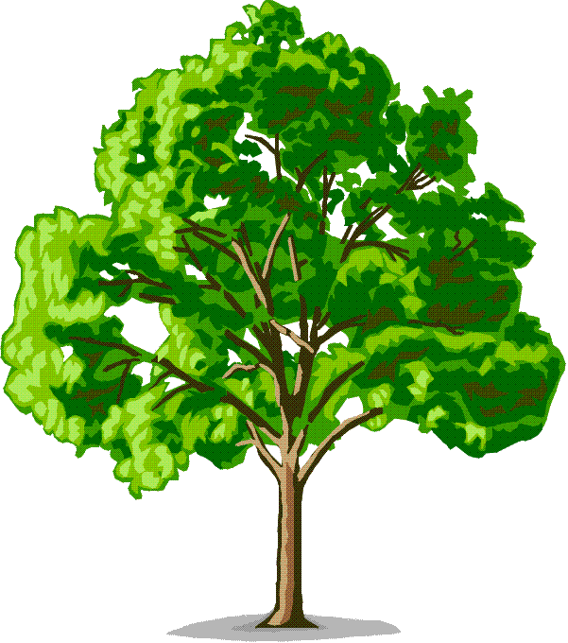
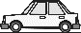
18°
41°

A
B
C
7 m
horizontal ground

- Let H stand for a head and T stand for a tail of a coin.
(a) Two fair coins are tossed once. List all the possible outcomes.
(b) In a game, two fair coins are tossed twice. One point is scored if two heads are obtained in each toss; otherwise, no point is scored.
(i) Find the probability of scoring
(1) 2 points,
(2) 1 point,
(3) 0 point.
(ii) The cost of playing the game once is $10. A $40 coupon and an $x coupon will be awarded for scoring 2 points and 1 point respectively. No coupons will be awarded for scoring less than 1 point. If it is a fair game, find the value of x.
(10 marks)

End of Paper

