 | Marker Use Only
 | Mark
Question | Part I
1
2
3
4
5
6
7
8
9
10
11
12
13
14
 | Part II
15
16
17
18
19
20

Total

Name: ____________________
Class: ________________( )
2024-2025
S3 MATH
PAPER I

CUHKFAA CHAN CHUN HA SECONDARY SCHOOL
2024-2025 Secondary Three First Term Examination
MATHEMATICS PAPER I
Question-Answer Book

09/01/2025

8:15 am – 9:30 am (1¼ hours)

This paper must be answered in English

INSTRUCTIONS

- This paper consists of Two parts, Part I, Part II. Part I and Part II carry a total of 140 marks.
- Answer ALL questions in Part I and Part II. Write your answers in the spaces provided in this Question-Answer Book. Supplementary answer sheets will be supplied on request.
- Unless otherwise specified, all working must be clearly shown.
- Unless otherwise specified, numerical answers should be either exact or correct to 3 significant figures.
- The diagrams in this paper are not necessarily drawn to scale.
- No marks will be deducted for wrong answers.
Part I: Short Questions (80 marks) (All steps must be clearly shown.)
- In the figure, I is the incentre of ΔABC. Find x. (4 marks)
A
C
B
18°
I
29°
x

- In the figure, O is the circumcentre of ΔABC. M and N are the mid-points of AB and BC respectively. Find x. (4 marks)
B
A
C
66°
O
x
M
N

- In the figure, ABCD is a rectangle. AC and BD intersect at O. OB = 11 cm, CD = 10 cm and
∠OAB = 63°. Find p, q and r. (6 marks)
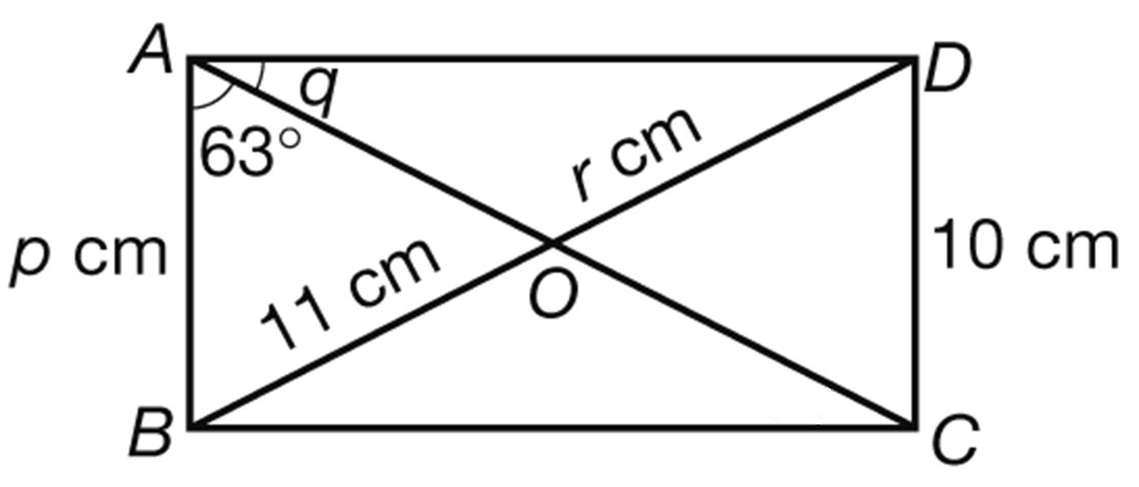

- In the figure, ABC, AGD and AFE are straight lines. Find a and b. (7 marks)
3a cm
(2a + 6) cm
A
B
C
D
E
F
G
7 cm
7 cm

88°
4b

- In the figure, VABCD is a right pyramid with a square base. M is the mid-point of BC. AB = 24 cm and VC = 37 cm. (8 marks)
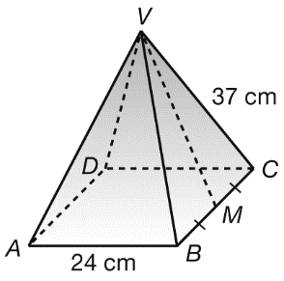
(a) Find VM.
(b) Find the total surface area of VABCD.

- In the figure, the base radius, the height and the slant height of the right circular cone are 15 cm, 8 cm and 17 cm respectively. Find the volume of the circular cone in terms of π. (4 marks)
17 cm
8 cm
15 cm

- P and Q are similar solids. Their corresponding heights are 6 cm and 15 cm respectively.
(6 marks)
(a) If the volume of Q is 1875 cm³, find the volume of P.
(b) If the total surface area of P is 1320 cm², find the total surface area of Q.

- Michael deposits $5000 in a bank. The simple interest rate is 3% per annum. How long will it take him to receive a simple interest of $750? (3 marks)

- Peter deposits $12 500 in a bank. The interest rate is 4% per annum compounded yearly. Find the amount he will receive after 2 years. (3 marks)

- Simplify each of the following expressions and represent the answer in positive index notation.
(10 marks)

 | - x²y⁷ × (x³y⁻⁴)² | - (u⁻²)⁻⁵ ÷ (9u)⁰

- Use scientific notation to represent the following values. (4 marks)

Value | Scientific notation
- 53 000 000 kg
- 0.000 000 013 m²

- Without using a calculator, convert 101001₂ into a denary number. (3 marks)

- Factorize the following expressions. (11 marks)

- 5ab − 30b | - a²b − 5ab − 2a + 10
- 64 − u²v² | - 49 − 14k + k²

- Factorize each of the following expressions by Cross Method. (7 marks)

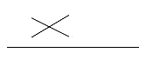
- x² + x − 6

=

- 5a² + 45a + 70.

=

Part II: Long Questions (60 marks) (All steps must be clearly shown.)
- Simplify (10a²b)⁻³ ÷ b⁻⁸ × 25a⁻⁵ and express the answer with positive indices. (5 marks)

- Factorize
(a) 6x² + xy – 2y²
(b) 8x – 4y – 6x² – xy + 2y² . (6 marks)

- In the figure, BEC is a straight line. D is the mid-point of AB. AC // DE. (15 marks)

A
E
B
C
7.5 cm
36 cm
D
39 cm
(a) Find ∠ABC.
(b) Find the area of ACED.

- In the figure, a right pyramid with a square base is put inside a tank. The dimensions of the tank are 25 cm by 20 cm by 16 cm. When the tank is fully filled with water, the water level is at AB.
(14 marks)
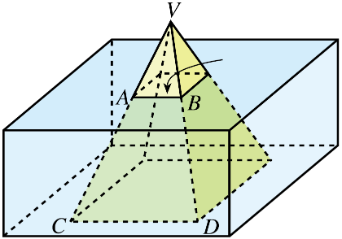
20 cm
16 cm
12 cm
25 cm
4 cm
(a) Find the height of the pyramid.
(b) A student claims that when the pyramid is taken out of the tank, the water level is less than
13.5 cm. Is the claim correct? Explain your answer.

- A solid metal hemisphere of radius 24 cm is melted and recast into some small metal spheres of radius 6 cm. (11 marks)

- Find the number of small spheres formed.
- Find the percentage change in the total surface area.

- Ben deposits $45 000 in a bank on 1 April 2020. The interest is compounded quarterly. The amount is $46 800 on 1 July of the same year. (9 marks)
(a) Find the interest rate per annum.
(b) Find the compound interest after 18 months (i.e., on 1 October 2021), correct to nearest dollars.

_______________________________________________________________________________________
-END OF PAPER-

