 | Marker Use Only
 | Mark
Question | Part I
1
2
3
4
5
6
7
8
9
10
11
12
 | Part II
13
14
15
16
17
18
19
20

Total

Name: ____________________
Class: ________________( )
2025-2026
S3 MATH
PAPER I

CUHKFAA CHAN CHUN HA SECONDARY SCHOOL
2025-2026 Secondary Three First Term Examination
MATHEMATICS PAPER I
Question-Answer Book

10/12/2025

8:15 am – 9:30 am (1¼ hours)

This paper must be answered in English

INSTRUCTIONS

- This paper consists of Two parts, Part I, Part II. Part I and Part II carry a total of 140 marks.
- Answer ALL questions in Part I and Part II. Write your answers in the spaces provided in this Question-Answer Book. Supplementary answer sheets will be supplied on request.
- Unless otherwise specified, all working must be clearly shown.
- Unless otherwise specified, numerical answers should be either exact or correct to 3 significant figures.
- The diagrams in this paper are not necessarily drawn to scale.
- No marks will be deducted for wrong answers.
Part I: Short Questions (80 marks) (All steps must be clearly shown.)
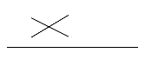
- Factorize the following expressions by Cross Method. (6 marks)
- z² + 17z + 70

- r² − 9r − 22

- (a) Simplify $\frac{a^{3}}{a^{-2}}$ and express the answer with positive indices. (2 marks)

(b) Simplify ${\left(\frac{a^{3}}{a^{-2}}\right)}^{4}$ and express the answer with positive indices. (4 marks)

- (a) Simplify h⁻³ ÷ (h⁻⁵)² × h⁰ and express the answer with positive indices. (5 marks)

(b) Simplify $\frac{4a}{(2a^{-3})^{-3}}$ and express the answer with positive indices. (6 marks)

- There are 4 Mathematics books, 7 Chinese books and 10 English books on a bookshelf. A book is randomly selected from the bookshelf.
(a) Find the probability of selecting a Chinese book.
(b) Find the probability of selecting a Chinese book or an English book. (5 marks)

- 3 fair coins are tossed. Denote head and tail by H and T respectively.
(a) List all possible outcomes in a tree diagram.
(b) Find the probability that at least 1 head is obtained. (5 marks)

- Tree diagram:
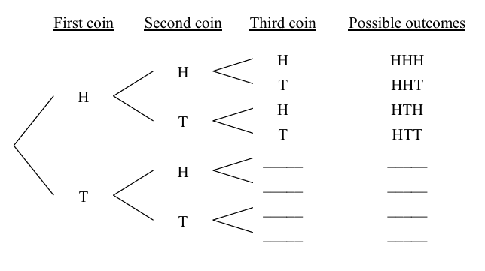

- A box contains n red balls, 6 green balls and 11 blue balls. If a ball is randomly drawn from the box, then the probability of drawing a green ball is $\frac{2}{7}$. Find the value of n. (5 marks)

- The following data show the volumes (in mL) of 8 drinks.
120 | 475 | 500 | 525 | 485 | 550 | 465 | 500
(a) Find the mean, the median and the mode of the volumes of these drinks.
(b) Which measure of central tendency is suitable to represent the volumes of these drinks?
Explain your answer. (9 marks)

- The following table shows Eva’s results of Mathematics assessments. (4 marks)
 | Homework | Quiz | Test | Examination
Mark | 96 | 80 | x | 76
Weight | 2 | 3 | 5 | 10

If Eva’s weighted mean mark is 77.6, find the value of x.

- A coffee shop sold 650 cups of coffee at $22 each yesterday. Today, the price of each cup of coffee has increased by 5% and the number of cups of coffee sold has decreased by 20%. Find
- the price of each cup of coffee today,
- the number of cups sold today,
- the income of selling cups of coffee today,
(d) the percentage change in the income of selling cups of coffee in these two days. (10 marks)

- In an experiment, the number of bacteria has increased by 20% per hour. If there are 23 040 bacteria now, find the number of bacteria two hours ago. (5 marks)

- There are 750 000 and 720 000 visitors to a theme park in 2021 and 2022 respectively. The number of visitors to the theme park decreases at a constant rate every year.
(a) Find the percentage change in the number of visitors to the theme park from 2021 to 2022.
(b) Find the number of visitors to the theme park in 2027, correct to the nearest 100. (8 marks)

- A sum of $60 000 is deposited at an interest rate of 8% per annum for 7 years, compounded quarterly. Find the amount correct to the nearest dollar. (6 marks)

Part II: Long Questions (60 marks) (All steps must be clearly shown.)
- There are 5 staff members in a department of a company. 3 of them are male. 2 staff members are randomly chosen to stay at the office for lunch. Find the probability that
(a) both staff members are male,
(b) at least one staff member is a male. (8 marks)

- In a game, a fair dice is thrown once. If the outcome is a ‘6’, $36 will be gained. If the outcome is a ‘3’, $9 will be gained. If the outcome is ‘1’, $1 will be gained. Otherwise, there will be no gain.
(a) Find the expected gain of the game.
(b) Suppose that a player has to pay $8 to join the game. Is the game favourable to the player?
Explain your answer. (6 marks)

- Brian deposits $312 500 in a bank at an interest rate of R% per annum, compounded half-yearly. He will receive an amount of $338 260.05 after 2 years.
- Find the value of R.
- Find the compound interest after 30 months. (Correct your answer to nearest dollar) (10 marks)

- Simplify ${({3a}^{-3}b^{2})}^{-2}÷{(\frac{{3b}^{-2}}{a})}^{3}$ and express the answer with positive indices. (6 marks)

- Let r be a positive integer. Simplify 4^{4r} × 2^{−5r} ÷ 32⁻² and express the answer with positive indices in base 2. (6 marks)

- The following table shows the distribution of the numbers of rooms in some living units.
Number of rooms | 0 | 1 | 2 | 3 | 4
Number of living units | k | 17 | 13 | 4 | 1
It is given that k is a positive integer.
(a) If the median of the distribution is 1, write down
(i) the least possible value of k,
(ii) the greatest possible value of k.
(b) If the mean of the distribution is 1, find the value of k. (6 marks)

19. Factorize
(a) 4a³ − 12a²b,
(b) 4a³ − 12a²b − ab² + 3b³. (7 marks)

20. (a) Factorize 2x² – 13xy – 7y²
(b) Factorize 2x² – 13xy – 7y² + 2x – 14y.
(c) Using the result of (b), factorize 2x² – 13xy – 7y² – 15y – 2. (11 marks)

-END OF PAPER-

