CUHKFAA Chan Chun Ha Secondary School
Final Examination (2025-2026)
Secondary Three MATHEMATICS
PAPER 2
10:05a.m. -10:50a.m.
04-06-2026
Time allowed: 45 minutes

Name: ( ) Class: Marks: /30

- Read the instructions carefully on the Question Paper.

- When told to read this paper, you should check that the question paper has no missing pages. Look for the words ‘END OF PAPER’ on the last page.

- All questions carry equal marks.

- ANSWER ALL QUESTIONS. You are advised to mark all the answers on the Multiple-choice Answer Sheet with an HB pencil, so that wrong marks can be completely erased with a clean rubber.

- You should mark only ONE answer to each question. Two or more answers will score NO MARKS.

- No marks will be deducted for wrong answers.

There are 20 questions in Section A and 10 questions in Section B.
The diagrams in this paper are not necessarily drawn to scale.
Choose the best answer for each question.
Section A (1-20)
1. 14a²b − 21ab² =
A. 7a(2ab − 3b²).
B. 7b(2a² − 3ab).
C. 7ab(2a − 3b).
D. 7ab(2ab − 3b).

2. Simplify (a⁻²)³ · a⁵ ÷ a⁴ and express the answer with a positive index.
A. $\frac{1}{a^{5}}$
B. $\frac{1}{a^{3}}$
C. $a^{5}$
D. $\frac{1}{a}$

3. A laptop is sold at $7200. After a discount, its selling price becomes $6120. Find the percentage decrease in the selling price.
A. 12%.
B. 15%.
C. 17%.
D. 18%.

4. The figure shows a pyramid VABCD of height 18 cm. Its base is a square of side 8 cm. The volume of the pyramid is

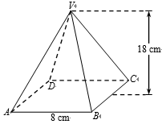
A. 144 cm³.
B. 152 cm³.
C. 288 cm³.
D. 384 cm³.

5. In the figure, ABCD is a parallelogram. Find x.
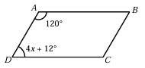
A. 12°
B. 13°
C. 14°
D. 15°

6. In the figure, ABCD is a rhombus. AC and BD intersect at E. ∠BAE = 42°. Find y.
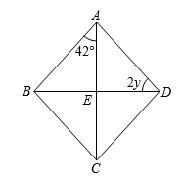
A. 16°
B. 20°
C. 24°
D. 28°

7. If θ is an acute angle and 7 tan θ − 7 = 0, then θ =
A. 10°
B. 30°
C. 60°
D. 45°

8. Refer to the figure. Find the true bearing of E from O.
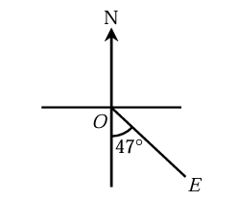
A. 043°
B. 047°
C. 133°
D. 227°
9. If M(4, −1) is the mid-point of P(a, 5) and Q(7, b), then a + b =
A. −10.
B. −6.
C. 1.
D. 5.

10. The median of a set of data x, 8, 9, 11, 15 and 19 is 13. Which of the following is a possible value of x?
A. 14
B. 15
C. 16
D. 17

11. If θ is an acute angle, then (1 – sin θ)(1 + sin θ) =
A. 1 – 2 sin θ
B. 2 cos² θ – 1
C. –cos² θ
D. cos² θ

12. The diameter of a sphere is 36 cm. Express the volume of the sphere in terms of π.
A. 1296π cm³
B. 7776π cm³
C. 24 429π cm³
D. 62 208π cm³

13. Which of the following is the correct scientific notation form for 388 000?
A. 388 × 10³
B. 38.8 × 10⁴
C. 3.88 × 10⁵
D. 0.388 × 10⁶

14. Consider the set of data: 9, 12, x + 1, y − 5, 8, 9, 12, 6.
If the mode of the set of data is 8, find the values of x and y.
A. x = 4, y = 8
B. x = 5, y = 14
C. x = 6, y = 12
D. x = 7, y = 13
15. A card is drawn randomly from a deck of 52 playing cards. Find the probability that the card drawn is a black number card with a number smaller than 7.
A. $\frac{5}{26}$
B. $\frac{3}{13}$
C. $\frac{5}{13}$
D. $\frac{6}{13}$

16. If θ is an acute angle and sin (θ + 5°) = cos 14°, then θ =
A. 9°
B. 59°
C. 71°
D. 85°

17. Convert 2⁸ + 2⁷ + 39 to a binary number.
A. 11100111₂
B. 11101101₂
C. 110100111₂
D. 110101101₂

18. Tracy deposits $4000 in a bank at an interest rate of 6% per annum. Find the simple interest that Tracy will receive after 3 months.
A. $40
B. $60
C. $80
D. $240

19. The distance between two points A(2, 1) and B(5, 5) in a rectangular coordinate plane is
A. 3 units
B. 4 units
C. 5 units
D. 7 units

20. In the figure, ABCD is a parallelogram. E and F are points on BC and AD respectively such that
AE ⊥ BC and CF ⊥ AD.
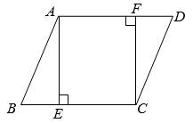
Which of the following must be true?
I. ∠BAE =∠DCF
II. △ABE ≅ △CDF
III. ∠EAF = 90°
A. I and II only
B. I and III only
C. II and III only
D. I, II and III

Section B (21-30)
21. Find the inclination of an inclined plane of gradient 3 : 10.
A. 16.7°, correct to 3 significant figures
B. 18.4°, correct to 3 significant figures
C. 71.6°, correct to 3 significant figures
D. 73.3°, correct to 3 significant figures

22. The figure shows two houses AB and CD with heights 3.2 m and 4.5 m respectively. E is a point on the horizontal ground such that B, E and D lie on the same straight line. The angles of elevation of the tops A and C from E are as shown. Find the distance between the two houses.
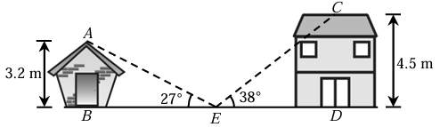
A. 11 m, correct to the nearest m.
B. 12 m, correct to the nearest m.
C. 13 m, correct to the nearest m.
D. 14 m, correct to the nearest m.

23. In the figure, the straight line L passes through A(−18, 3) and B(6, −15) and cuts the x-axis at C. The coordinates of C are
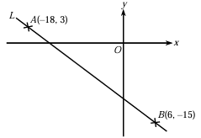
A. (−16, 0).
B. (−14, 0).
C. (−12, 0).
D. (−8, 0).

24. There are two cashiers X and Y in a department store. Amy and Bonnie each chooses a cashier randomly to check out. Find the probability that both of them check out at cashier X.
A. $\frac{1}{4}$
B. $\frac{1}{3}$
C. $\frac{1}{2}$
D. $\frac{3}{4}$

25. A sum of $80 000 is deposited in a bank for 2 years. Three accounts X, Y and Z all use the same nominal annual interest rate of 6%, but X compounds yearly, Y compounds half-yearly and Z compounds monthly. Let A_{X}, A_{Y} and A_{Z} be the corresponding amounts after 2 years. Which of the following is correct?
A. A_{X} < A_{Y} < A_{Z}
B. A_{X} < A_{Z} < A_{Y}
C. A_{Z} < A_{Y} < A_{X}
D. A_{X} = A_{Y} = A_{Z}

26. The figure shows a solid right circular cone of slant height 34 cm. If the circumference of the base is
60π cm, then the volume of the circular cone is
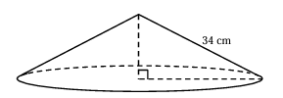
A. 3840π cm³.
B. 4800π cm³.
C. 10 200π cm³.
D. 40 800π cm³.

27. In the figure, ABCD is a rectangle. BE and CE intersect AD at M and N respectively and ∠EAM = ∠EDN.

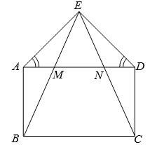
Which of the following must be true?
I. EM = EN
II. ∠BMN =∠CNM
III. △EAB ≅ △EDC
A. I, II and III
B. I and III only
C. II and III only
D. I and II only

28. In the figure, PSQ and QTR are straight lines. PT is the angle bisector of ∠QPR and PT⊥QR. RS is the perpendicular bisector of PQ. PT and RS intersect at O.
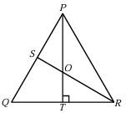
Which of the following must be true?
I. O is the in-centre of △PQR.
II. O is the circumcentre of △PQR.
III. △PQR is an equilateral triangle.

A. I and II only
B. I and III only
C. II and III only
D. I, II and III

29. 25x² − (2y − 5z)² =
A. (25x + 2y − 5z)(25x − 2y + 5z).
B. (5x + 2y − 5z)(5x − 2y − 5z).
C. (5x − 2y + 5z)(5x + 2y + 5z).
D. (5x + 2y − 5z)(5x − 2y + 5z).

30. The figure shows two buildings AB and PQ. The height of building AB is 90 m. The angle of depression of the top P of the shorter building from the top A of the taller building is 36°, while the angle of elevation of the top A of the taller building from the bottom Q of the shorter building is 54°. Find the height of the building PQ.
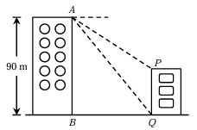
A. 42.5 m, correct to 3 significant figures.
B. 43.6 m, correct to 3 significant figures.
C. 44.8 m, correct to 3 significant figures.
D. 45.1 m, correct to 3 significant figures.

END OF PAPER

