 | Marker Use Only
 | Mark
Question | Part I
1
2
3
4
5
6
7
8
9
10
11
12
13
14
 | Part II
15
16
17
18
19
20
21
 | Part III
22

Total

2025-2026
Name: ______________________
Class: ________________( )
S2 MATH CP
PAPER I

CUHKFAA CHAN CHUN HA SECONDARY SCHOOL
2025-2026 Secondary Two Final Examination
MATHEMATICS Compulsory Part
PAPER I
Question-Answer Book

08/06/2026

8:15 am – 9:30 am (1¼ hours)

This paper must be answered in English

INSTRUCTIONS

- This paper consists of Three parts, Part I, Part II and Part III. Part I and Part II carry a total of 140 marks. Part III consists of a Challenging Question which is not a compulsory section. You may choose not to answer this question. Bonus marks will be given accordingly.
- Answer ALL questions in each part. Write your answers in the spaces provided in this Question-Answer Book. Supplementary answer sheets will be supplied on request.
- Unless otherwise specified, numerical answers should be either exact or correct to 3 significant figures.
- Unless otherwise specified, all working must be clearly shown.
- The diagrams in this paper are not necessarily drawn to scale.
- No marks will be deducted for wrong answers.
Part I: Short Questions (80 marks) (All steps must be clearly shown.)

1. Find the value of sin θ , cos θ and tan θ in the figure. (Give the answers in fractions.) (3 marks)
5
θ
3
4

2. Referring to the figure, find θ. (2 marks)
θ

16.4

3.6

3. (a) Solve the inequality 11x – 13 ≥ 2x + 50 and represent the solutions graphically. (4 marks)

(b) Write down the least integer satisfying inequality in (a). (1 mark)

4. Factorize each of the following expressions. (11 marks)
(a) 3x²y + 18x | (b) x² + 3x + xy + 3y
(c) x² + 18x + 81 | (d) 4x²(3x – 1) + 9(1 – 3x)

5. Make k the subject of the formula c(2h + k) = dk. (4 marks)

6. The figure shows △HDR.
H
D
R
15 cm
17 cm
8 cm

(a) Prove that △HDR is a right-angled triangle.
(b) Find the area of △HDR. (6 marks)

7. In the figure, find x. (4 marks)
D
A
x
114°
114°
78°
66°
x
A
B
C
D
66°
114°
78°
66°
x
A
B
C
D
C
78°
114°
78°
66°
x
A
B
C
D
B

114°
78°
66°
x
A
B
C
D
114°
78°
66°
x
A
B
C
D
114°
78°
66°
x
A
B
C
D
114°
78°
66°
x
A
B
C
D
114°
78°
66°
x
A
B
C
D
114°
78°
66°
x
A
B
C
D
114°
78°
66°
x
A
B
C
D
114°
78°
66°
x
A
B
C
D

8. In the figure, ∠BAC and ∠BCD are right angles. It is given that AB = 21 cm, AC = 20 cm and
∠CBD = 32°.
C
20 cm
A

D
21 cm
32°

B
- Find BC.
- Find BD. (5 marks)

9. In the figure, D and E are points lying on AB and BC respectively such that AC // DE.
A
B
C
D
E
2
3
6

(a) Prove that △ABC ∼ △DBE.
(b) Find AC. (8 marks)

10. Solve the simultaneous equations 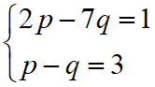 by algebraic method. (6 marks)

11. The following data show the lengths (correct to the nearest 1 s) of 24 TV commercials.
68 | 74 | 90 | 74 | 93 | 66 | 72 | 80
97 | 89 | 77 | 75 | 56 | 93 | 98 | 64
65 | 76 | 52 | 71 | 65 | 83 | 86 | 94
(a) Complete the following frequency distribution table. (3 marks)
Length (s) | Class mark (s) | Frequency
50 – 59

(b) Draw a frequency polygon to present the data. (5 marks)

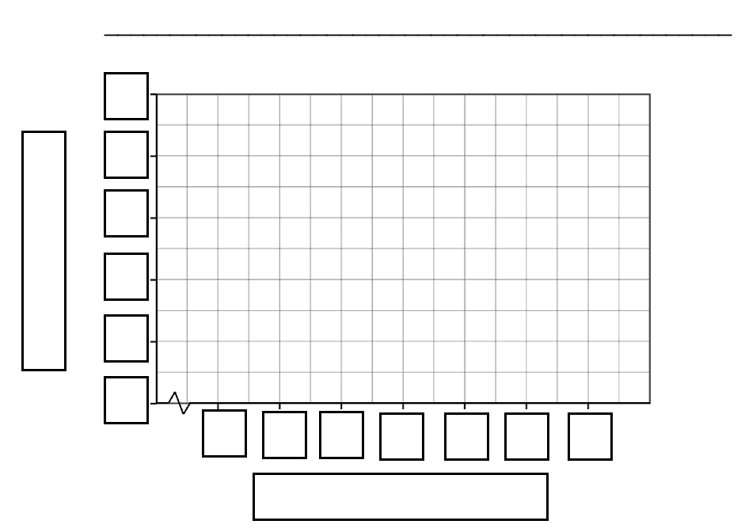
54.5
2
0
12. The figure shows a right circular cylinder.
O
12 cm
7 cm

(a) Find the curved surface area of the cylinder.
(b) Find the total surface area of the cylinder.
(c) Find the volume of the cylinder. (7 marks)
(Leave the answers in terms of π.)

13. The following figure is sector OAB.
12 cm
260°
B
A
O

(a) Find the area of sector OAB.
(b) Find the perimeter of sector OAB. (6 marks)

14. (a) Rationalize the denominator of $\frac{5}{\sqrt{3}}$.
(b) Hence, simplify . (5 marks)

Part II: Long Questions (60 marks) (All steps must be clearly shown.)

15. If x(2Ax + 3B) – 28 ≡ (6x – 7)(3x + 4), where A and B are constants, find A and B. (8 marks)

16. (a) Factorize
(i) 4b² – 9,
(ii) 4b² – 12b + 9.
(b) Using the results in (a), simplify . (7 marks)

17. In a shop, a profit of $25 and $35 are made in selling each football and each basketball respectively.
If 50 footballs and basketballs are sold in total and the total profit made is greater than $1500,
find the minimum number of basketball sold. (6 marks)

18. A can of pineapple is said to be regular if its weight is measured as 800 g correct to the nearest 5 g.
(a) Find the least possible weight of a regular can of pineapple.
(b) Wendy claims that the total weight of 6 regular cans of pineapple can be measured as 4.7 kg
correct to the nearest 0.1 kg. Do you agree? Explain your answer. (8 marks)

19. In the figure, D and E are points lying on BC.
A
B
C
D
E
48°
54°
15°

- Find ∠ABC.
- Find ∠AED.
- Prove that △ADE is an isosceles triangle. (10 marks)

20. In the figure, AD = 7 cm, BC = 12 cm, ∠ABC = 90°, ∠BAD = 35° and ∠BCD = 31°.
A

B

C

D

35°

31°

7 cm

12 cm

Find AB. (11 marks)

21. The figure shows an empty container which consists of two right circular cylindrical parts. The base
radii of the bottom part and the top part are 5 cm and 12 cm respectively. The heights of the bottom part
and the top part are 16 cm and 15 cm respectively. It is given that 976π cm³ of water is filled into the
container.
15 cm
16 cm

(a) Find the volume of the container.
(b) Find the depth of water in the container.
(c) Find the area of the wet surface of the container. (10 marks)

Part III: Challenging Question (10 marks)
[This is not a compulsory part. You are encouraged to answer this question.]
22. (a) In the figure, O is the centre of a circle. If $\overset{⏜}{AEC}:\overset{⏜}{ADB}$ = a : b, find ∠AOC : ∠AOB.
A
B
C
O
D
E

(b) In the figure, P, Q, R and S are points lying on a circle of radius 6 cm. It is given that
$\overset{⏜}{PQ} :\overset{⏜}{RS} :\overset{⏜}{QR} :\overset{⏜}{PS}$ = 3 : 4 : 5 : 6. Using the result in (a),find the perimeter of
the quadrilateral PQRS.
P

Q

R

S

END OF PAPER

