Name: ____________________
Class: ________________( )
2025-2026
S4 MATH CP
PAPER II

CUHKFAA CHAN CHUN HA SECONDARY SCHOOL
2025-2026 Secondary Four Final Examination

MATHEMATICS Compulsory Part
PAPER 2

03/06/2026

11:05 am – 12:20 pm (1¼ hours)

INSTRUCTIONS
- Read carefully the instructions on the Answer Sheet. After the announcement of the start of the examination, you should first write your Name Class and Class Number and insert the information required in the spaces provided. No extra time will be given for writing your Name, Class and Class number after the ‘Time is up’ announcement.
- When told to open this book, you should check that all questions are there. Look for the words ‘END OF PAPER’ after the last question.
- All questions carry equal marks.
- ANSWER ALL QUESTIONS. You are advised to use an HB pencil to mark all the answers on the Answer Sheet, so that wrong marks can be completely erased with a clean rubber. You must mark the answer clearly; otherwise you will lose marks if the answers cannot be captured.
- You should mark only ONE answer for each question. If you mark more than one answer, you will receive NO MARKS for that question.
- No marks will be deducted for wrong answers.
There are 30 questions in Section A and 15 questions in Section B.
The diagrams in this paper are not necessarily drawn to scale.
Choose the best answer for each question.

Section A
1. If 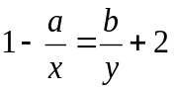, then x =
A. 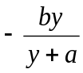.
B. 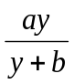 .
C. 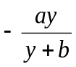.
D. 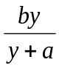 .

2. a² − b² + 2b −1 =

A. (a – b – 1)(a + b – 1).

B. (a – b – 1)(a + b + 1).

C. (a – b + 1)(a + b – 1).

D. (a – b + 1)(a – b – 1).

3. 0.006121784 =
A. 0.00612 (correct to 3 decimal places).
B. 0.006121 (correct to 4 significant figures).
C. 0.0061218 (correct to 5 significant figures).
D. 0.00612178 (correct to 6 decimal places).

4. (2 ⋅ 4^{n – 1})² =
A. 2^{2n – 2}.
B. 2^{2n – 1}.
C. 2^{4n – 1}.
D. 2^{4n – 2}

5. The total price of two adult tickets and three student tickets of a film is $275 while the total price of four adult tickets and five student tickets of the film is $505. Find the total price of one adult ticket and two student tickets.

A. $115
B. $140
C. $160
D. $185

6. If Albert is taller than Betty by 20% and Betty is shorter than Cathy by 30%, then

A. Albert is shorter than Cathy by 10%.
B. Albert is shorter than Cathy by 16%.
C. Albert is taller than Cathy by 4%.
D. Albert is taller than Cathy by 19%

7. A sum of $50 000 is deposited at an interest rate of 6% per annum for 3 years, compounded quarterly. Find the amount correct to the nearest dollar.

A. $59 000
B. $59 551
C. $59 755
D. $59 781

8. If 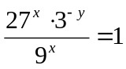, then x : y =

A. 1 : 1.
B. 2 : 1.
C. 3 : 2.
D. 1 : 2.

9. If x² + 2x − 5 = m has two distinct real roots, find the range of values of m.

- m > −5
- m > −6
- m < −5
- m < −6

10. If a and b are non-zero numbers such that 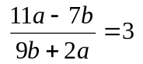, then a : b =
A. 5 : 34
B. 9 : 34
C. 34 : 5
D. 34 : 9

11. The quadratic equation x² + (k – 3)x + 6 – 2k = 0 has one double real root. Which of the following may be a root of the equation?

A. –1
B. 3
C. 4
D. 15

12. Simplify 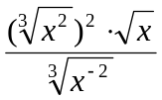.
A. 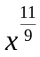
B. 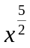
C. 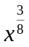
D. 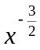

13. The point P is translated rightwards by 6 units to the point Q. If the coordinates of the reflection image of Q with respect to the y-axis are (−8, 2), then the coordinates of P are
A. (2, 2).
B. (14, 2).
C. (–2, –2).
D. (–14, –2).

14. Simplify 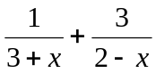.
A. 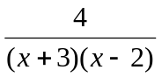
B. 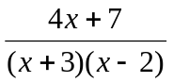
C. 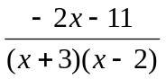
D. 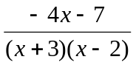

15. Let f(x) = x² + kx + 4, where k is a constant. If f(x + 1) – f(x) = 2x – 1, then k =
A. –4.
B. –2.
C. 0.
D. 2.

16. Let g(x) = 3x³ − kx + 4. If g(x) is divisible by x − 2, find the remainder when g(x) is
divided by x + 1.

A. 15
B. −7
C. 21
D. 7

17. P(x) is a polynomial. When P(x) is divided by 3x – 4, the remainder is R. If P(x) is
divided by 4 – 3x, then the remainder is

A. R.
B. −R.
C. .
D. 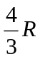.

18. Solve the equation (x + k)² = 9k².
A. x = 2k
B. x = 8k
C. x = –10k or x = 8k
D. x = –4k or x = 2k

19. Which of the following statements about the graph of y = − (x − 1)² + 4 is true?
A. The graph opens upwards.
B. The graph does not cut the x-axis.
C. The y-intercept of the graph is 4.
D. The graph passes through the point (2, 3).

20. When a polynomial f(x) is divided by x² – x – 6, the remainder is –4x + 1. Find the remainder when f(x) is divided by x – 3.
A. –11
B. –7
C. 9
D. 13

21. If a < 0 and −1 < b < 0, which of the following may represent the graph of y = (ax − b)² + b?
A. B.
x
y
O
x
y
O
C. D.
x
y
O
x
y
O

22. If the straight lines 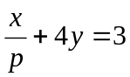 and y + px + q = 0 are parallel, then p =
A. 2 or –2.
B. 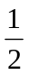 or 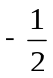.
C. 2 or .
D. 1 or –1.
23. If a > 0, b < 0 and c > 0, which of the following graphs represents the straight line
bx + cy = a?
A. B.

C. D.

24. In the figure, ABCD is a rectangle. BE and CE intersect AD at M and N respectively.
∠EAM = ∠EDN. Which of the following must be true?
D
A
B
C
E
M
N
I. EM = EN
II. ∠BMN = ∠CNM
III. △EAB ≅ △EDC

A. I and II only
B. I and III only
C. II and III only
D. I, II and III

25. In the figure, . If AB = l, then CD =

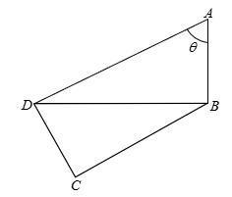
- 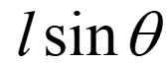.
- 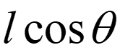.
- 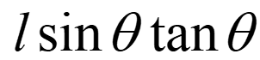.
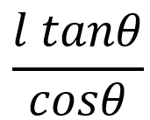
.
D. .

26. If the straight lines hx + ky + 15 = 0 and 4x + 3y – 5 = 0 are perpendicular to each other and intersect at a point on the x-axis, then k =
- –12
- –4
- 3
- 16

27. Which of the following is the least?

A. 1 111⁴ ⁰⁰⁰
B. 2 222³ ⁵⁰⁰
C. 3 333³ ⁰⁰⁰
D. (−4 444)² ⁵⁰⁰

28. Solve 4^{2x} – 3(4^{x}) – 4 = 0.
A. x = 1
B. x = 4
C. x = –1 or 4
D. x = –1 or 1

29. If 5^{x} = a, then 625^{x} =
A. 4a.
B. a⁴.
C. a³.
D. a².

30. In △ABC, AB = 24 cm, ∠ABC = 30° and ∠ACB = 80°. D is a point on BC such that AD bisects
∠BAC. Find the length of BD, correct to 3 significant figures.
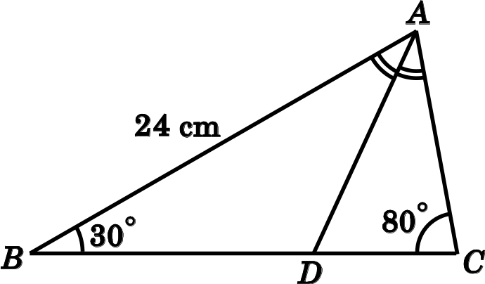
A. 13.2 cm
B. 15.2 cm
C. 22.9 cm
D. 37.9 cm

Section B
31. The H.C.F. and L.C.M. of three expressions P, Q and R are abc² and 27a⁴b²c⁵ respectively.
If P = 27ab²c³ and Q = 9a²b²c⁵, then R =
A. ab²c³.
B. a⁴bc².
C. 3ab²c³.
D. 3a⁴bc².

32. Convert the decimal number 11 × 2⁹ + 2⁶ + 5 × 2⁴ – 3 × 2⁴ to a binary number.
A. 111001100000₂
B. 11100110000₂
C. 101100110000₂
D. 1011001100000₂

33. 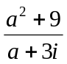 =
A. a + 3i
B. a – 3i
C. 3 + ai
D. 3 – ai

34. Let a and b be non-zero real numbers. If z = (8 + 10i)(a + bi) is a purely imaginary number,
find a : b.
A. 3 : 4
B. 4 : 5
C. 4 : 3
D. 5 : 4

35. If k is a real number, then 3k – 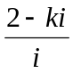 =
A. 4k + 2i.
B. 2k – 2i.
C. 2k + 2i.
D. 4k – 2i.
36. 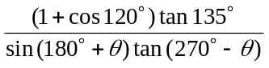 =
A. 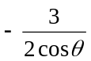.
B. 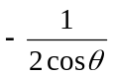.
C. 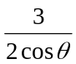.
D. 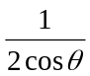.
37. If α and β are the two roots of the equation x² + 8x – k = 0, then α² – 3αβ + β² =
A. 64 – 3k.
B. 64 + 3k.
C. 64 – 5k.
D. 64 + 5k.

38. The graph in the figure shows the linear relation between x and log₄ y. If y = mn^{x}, then n =
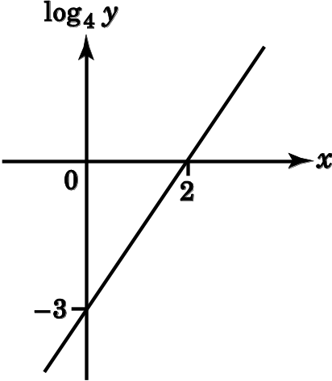
A. 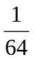.
B. .
C. 8.
D. 64.

39. For 0° ≤ θ < 360°, how many roots does the equation 5 cos²θ + sin θ – 5 = 0 have?
A. 2
B. 3
C. 4
D. 5

40. Let α and β be the roots of the quadratic equation x² + mx + n = 0, where m and n are non-zero constants. Which of the following has the roots 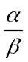 and 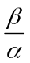?
A. x² + (m² – 2n)x + 1 = 0
B. nx² + (2n – m²)x + n = 0
C. nx² + (m² – 2n)x + n = 0
D. nx² – nx – (m² – 2n) = 0

41. If 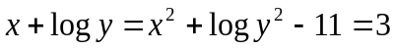, then y =
A. 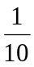.
B. ‒1 or 5.
C. or 100 000.
D. 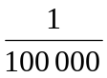 or 10.

42. In the figure, ADB is a straight line. AC ⊥ BC. 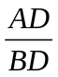=
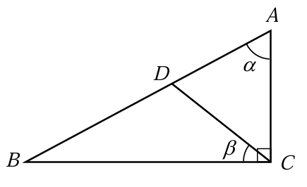
A. 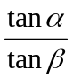.
B. 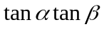.
C. 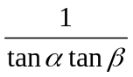.
D. 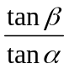.

43. The figure shows the rectangle ABCD, where AD = 295 cm and CD = 480 cm. Let P, Q and R be the points lying on AB, BC and CD respectively such that AP = 319 cm, BQ = 138 cm and DR = 240 cm. Denote the point of intersection of AQ and PR by S. Find DS correct to the nearest cm.
D
R
C
A
P
B
Q
S
A. 355 cm
B. 356 cm
C. 362 cm
D. 363 cm

44. The figure shows the graphs of y = a^{x} and y = b^{x}, where a and b are constants. Which of the following must be true?
y = a^{x}
x
y
0
k
y = b^{x}
I. a > 1 and 0 < b < 1
II. k = 1
III. ab = 1

A. I and II only
B. I and III only
C. II and III only
D. I, II and III

45. The figure shows the graph of 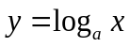 and the graph of 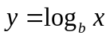 on the same rectangular coordinate system, where a and b are constants. If a vertical line L cuts the graph of , the graph of and the x-axis at A, B and C respectively, which of the following are true?
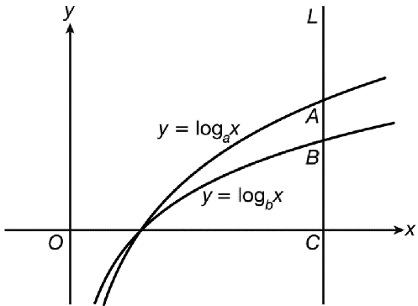
I. 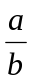> 1
II. ab > 1
III. 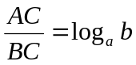
A. I and II only
B. I and III only
C. II and III only
D. I, II and III

End of paper

